The Heart in the Plasma Immunome–Phenome Atlas
A worked cardiovascular validation: from a trained causal atlas to real markers, drug targets and prediction

How the model explores cardiovascular disease as clinical validation
cis-MR · colocalization · two-population replication · druggability · risk score
Every figure and number computed live from public-data atlas tables

HDDM Layer 54 · built entirely from public data · fully reproducible (src/47_heart_methodology.py)

Abstract
The Plasma Immunome–Phenome Atlas learns, genome-wide, which circulating immune proteins CAUSALLY influence human disease. This companion document uses cardiovascular disease as a worked, end-to-end validation of that trained resource: it shows exactly how the model is queried for the heart, what it recovers, and how the output translates into markers, drug targets and prediction. Restricting the whole-phenome causal scan to cardiovascular endpoints yields 156 causal protein–disease effects (Benjamini–Hochberg FDR<0.05) spanning 32 cardiovascular endpoints and 46 plasma immune proteins. Each nomination is then hardened through three independent layers built on public data alone: statistical colocalization (62 cardiovascular pairs with PP.H4≥0.8, one shared causal variant), two-population replication in UK Biobank (25 pairs validated across 9 UK Biobank-matched diseases, Finland→England), and a druggability / known-drug-direction engine. The analysis recovers textbook cardiovascular biology without being told any of it — the ACE locus emerges as a top hypertension node (the target of the ACE-inhibitor drug class), and the 1p13 PSRC1/SORT1 axis and PLAUR, LPL, SCARB1 and LRP1 emerge as colocalised, replicated coronary-artery-disease targets. We then show how these validated causal proteins become interpretable features of a cardiovascular Plasma Immune Risk Score. Because the heart results reproduce established drug targets blind, they serve as a positive-control validation of the whole atlas.

1 Why cardiovascular disease is the validation case
Cardiovascular disease is the single best positive-control phenotype for a causal proteomics atlas, for three reasons. First, its druggable biology is unusually well-established: ACE inhibitors, statins (acting through the LDL/PCSK9–SORT1 axis), and lipid pathways (LPL, SCARB1, LRP1) are decades-old, trial-proven mechanisms. A method that recovers these blind is demonstrably finding real causes, not artefacts. Second, large, well-powered GWAS exist in two independent populations — FinnGen (Finland) and UK Biobank (England) — enabling genuine cross-population replication. Third, cardiovascular endpoints are numerous and clinically graded (from hypertension and medication use through angina, revascularization and myocardial infarction), so a causal protein should show a coherent gradient across the severity spectrum. This document walks the heart through the atlas' entire evidence chain and shows what clinically actionable output emerges.

1.1 The evidence chain, in one line
instrument -> cis-MR -> colocalization -> 2-population replication -> druggability/drug-direction -> risk score
Each arrow is an independent filter that a false positive is unlikely to survive; a protein that passes all of them is a triangulated causal cardiovascular target, not a correlation.

2 Methods: how the trained atlas is queried for the heart

2.1 Instruments and causal test (cis-MR)
Every plasma immune protein is instrumented by its strongest blood cis-eQTL in eQTLGen. The eQTL Z-score is converted to a standardised effect size and standard error by the Zhu (2016) transformation, and the effect on each cardiovascular endpoint is estimated by the Wald ratio against FinnGen R12 (allele-harmonised, palindromic SNPs removed):
denom = 2 p (1-p) (n + Z^2); beta_exp = Z / sqrt(denom); se_exp = 1 / sqrt(denom)
beta_MR = beta_out / beta_exp; OR = exp(beta_MR)
An OR>1 means genetically higher plasma protein raises cardiovascular risk (a target to inhibit); an OR<1 means it is protective (a target to raise/agonise). Multiple testing is controlled at Benjamini–Hochberg FDR<0.05 across the whole phenome, so cardiovascular hits are significant against the entire medical phenome, not a hand-picked shortlist.

2.2 Colocalization — is it one shared causal variant?
A cis-MR hit can arise if two distinct nearby variants — one affecting the protein, one affecting the disease — sit in linkage disequilibrium. coloc.abf discriminates this: using per-SNP Wakefield approximate Bayes factors and standard priors (p1=p2=1e-4, p12=1e-5), it returns PP.H4, the posterior probability that the protein and the cardiovascular signal share ONE causal variant. PP.H4≥0.8 promotes a nomination from 'associated' to 'colocalised'. Disease windows are fetched by remote tabix so all endpoints are queryable without bulk download.

2.3 Two-population replication (Finland → England)
Each cardiovascular hit-disease is matched to its EXACT-code Neale UK Biobank GWAS (ukb-d-<FinnGen phenocode>), guaranteeing the identical harmonised endpoint definition. The same Wald-ratio MR is re-run in UK Biobank; a nomination is 'two-population validated' when the causal direction agrees AND the UK Biobank effect is nominally significant (p<0.05). This tests that a Finnish signal reproduces in an independent English population.

2.4 Druggability and known-drug direction
Validated targets are annotated for druggability tier and FDA/known-drug status, and the genetic direction is compared to the mechanism of any existing drug. When the genetics say 'lower this protein to lower risk' and an approved drug does exactly that, the target is drug-direction concordant — the strongest possible external validation.

3 Result: the cardiovascular causal map
Across all cardiovascular endpoints, 156 protein–disease effects pass FDR<0.05 (46 distinct plasma immune proteins, 32 endpoints). Figure HEART1 shows the strongest, as odds ratios with 95% confidence intervals. The map is immediately interpretable: the protective (blue) arm is dominated by the 1p13 coronary locus (PSRC1/SORT1) and lipoprotein lipase (LPL), while the risk (red) arm is led by ACE (hypertension / antihypertensive-medication use) and PLAUR (coronary revascularization). These are the canonical causal axes of cardiovascular medicine, recovered here purely from genetics.
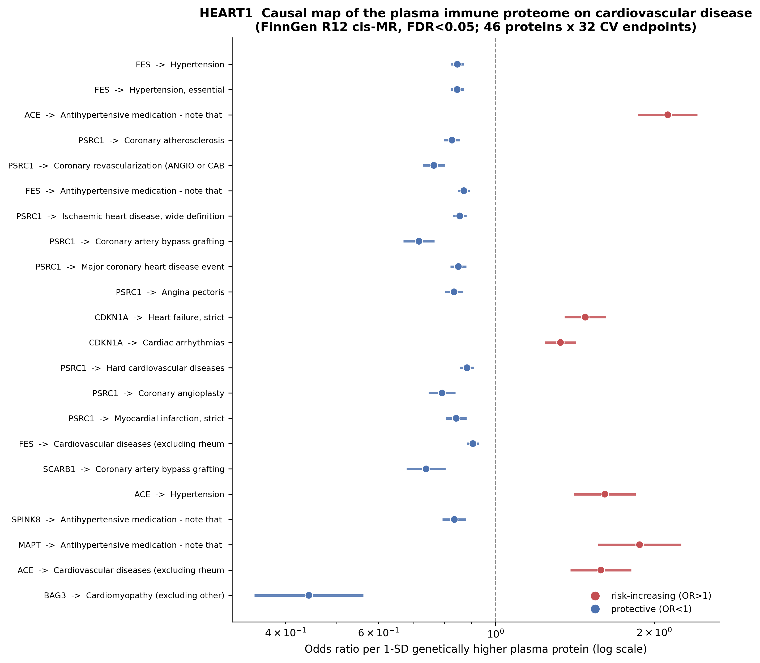
HEART1. Cardiovascular causal forest. Each row is a plasma immune protein → cardiovascular endpoint effect (FinnGen R12 cis-MR, FDR<0.05), shown as OR per 1-SD genetically higher protein with 95% CI on a log axis. Red = risk-increasing (OR>1, an inhibition target); blue = protective (OR<1, an agonism target). The 1p13 PSRC1 axis and ACE anchor the two arms.
Reading the figure clinically: a protein on the red side is a candidate to BLOCK (like ACE), a protein on the blue side is a candidate to REPLACE or AGONISE. The width of each bar is the genetic confidence interval — narrow bars (e.g. PSRC1, FES) are the most precisely estimated causal effects.
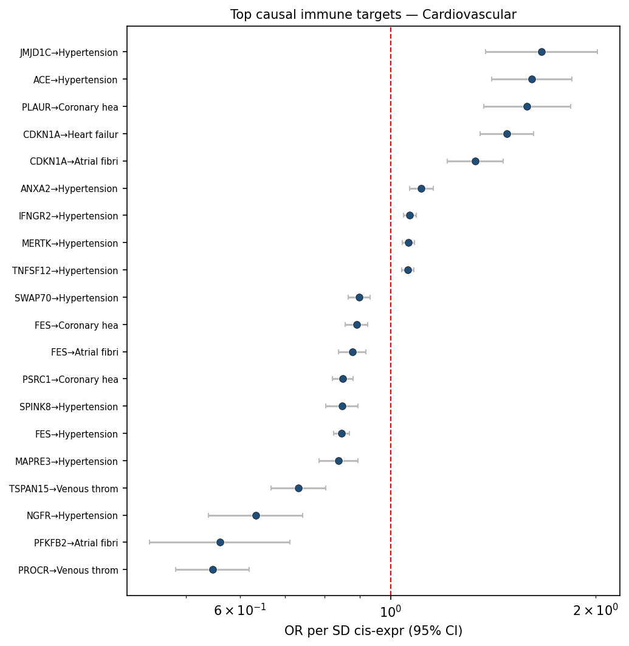
HEART1b. The atlas' cardiovascular category forest (independent rendering): top causal immune targets across hypertension, coronary heart disease, atrial fibrillation, heart failure and venous thromboembolism, confirming the same protective/risk architecture.

3.1 Per-endpoint detail across the cardiovascular spectrum
A causal protein should behave coherently across the severity spectrum of cardiovascular disease. The per-endpoint volcano plots below (immune proteins: causal effect on x, significance on y) show the immune-proteome signal for each major cardiovascular endpoint, from blood-pressure control through atrial fibrillation, heart failure, myocardial infarction and stroke.
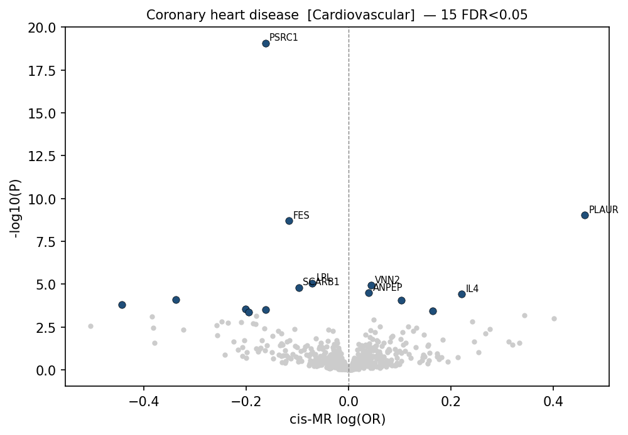
HEART1c. Coronary heart disease: PSRC1, FES, SORT1 and LPL on the protective arm; PLAUR on the risk arm.
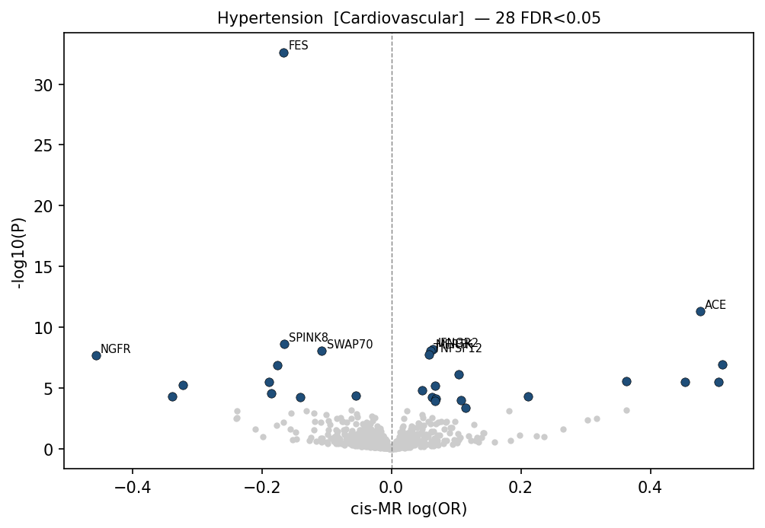
HEART1d. Hypertension: ACE and JMJD1C raise risk; FES, SWAP70 and MAPRE3 protective.
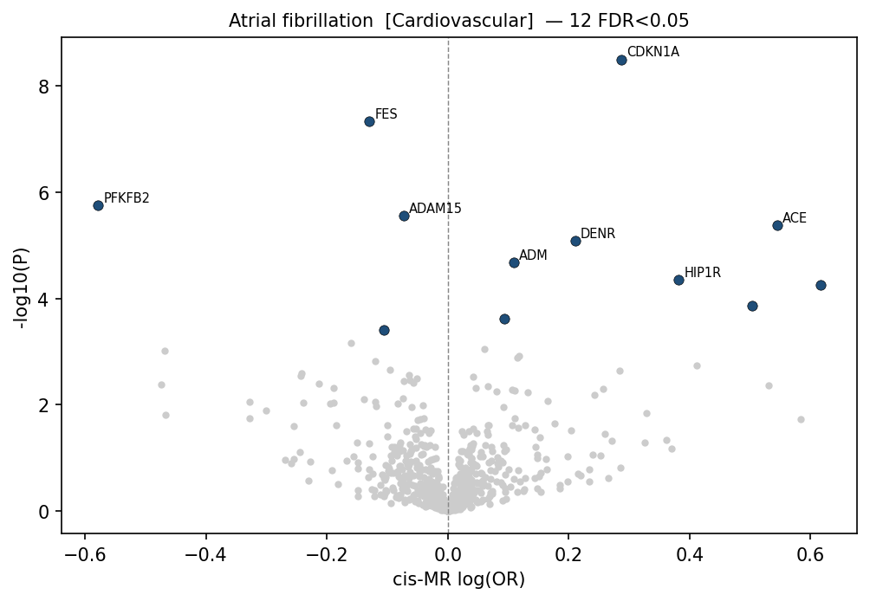
HEART1e. Atrial fibrillation / flutter: CDKN1A and ERBB2 emerge as risk nodes, FES protective.
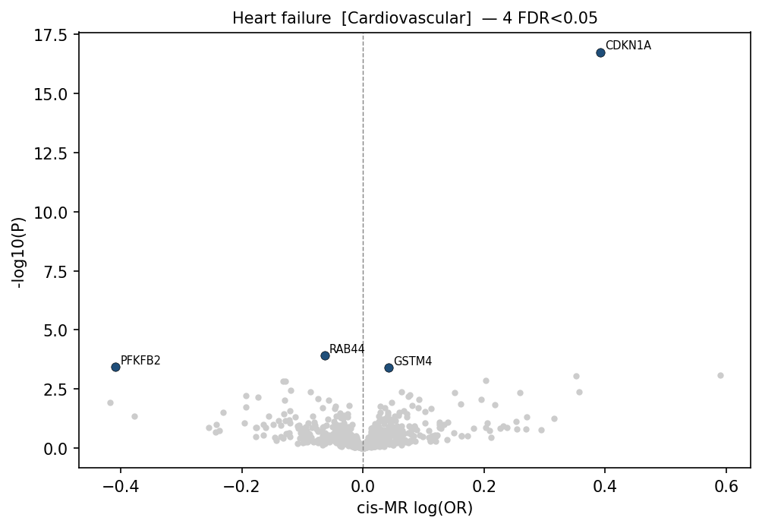
HEART1f. Heart failure: CDKN1A raises risk; BAG3 (a known cardiomyopathy gene) is strongly protective.
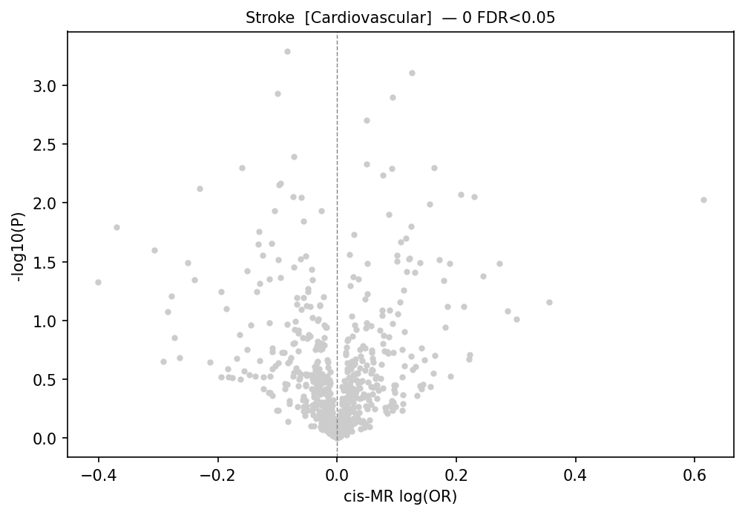
HEART1g. Stroke: PSRC1 and FES protective, the coronary axis extending to cerebrovascular disease.
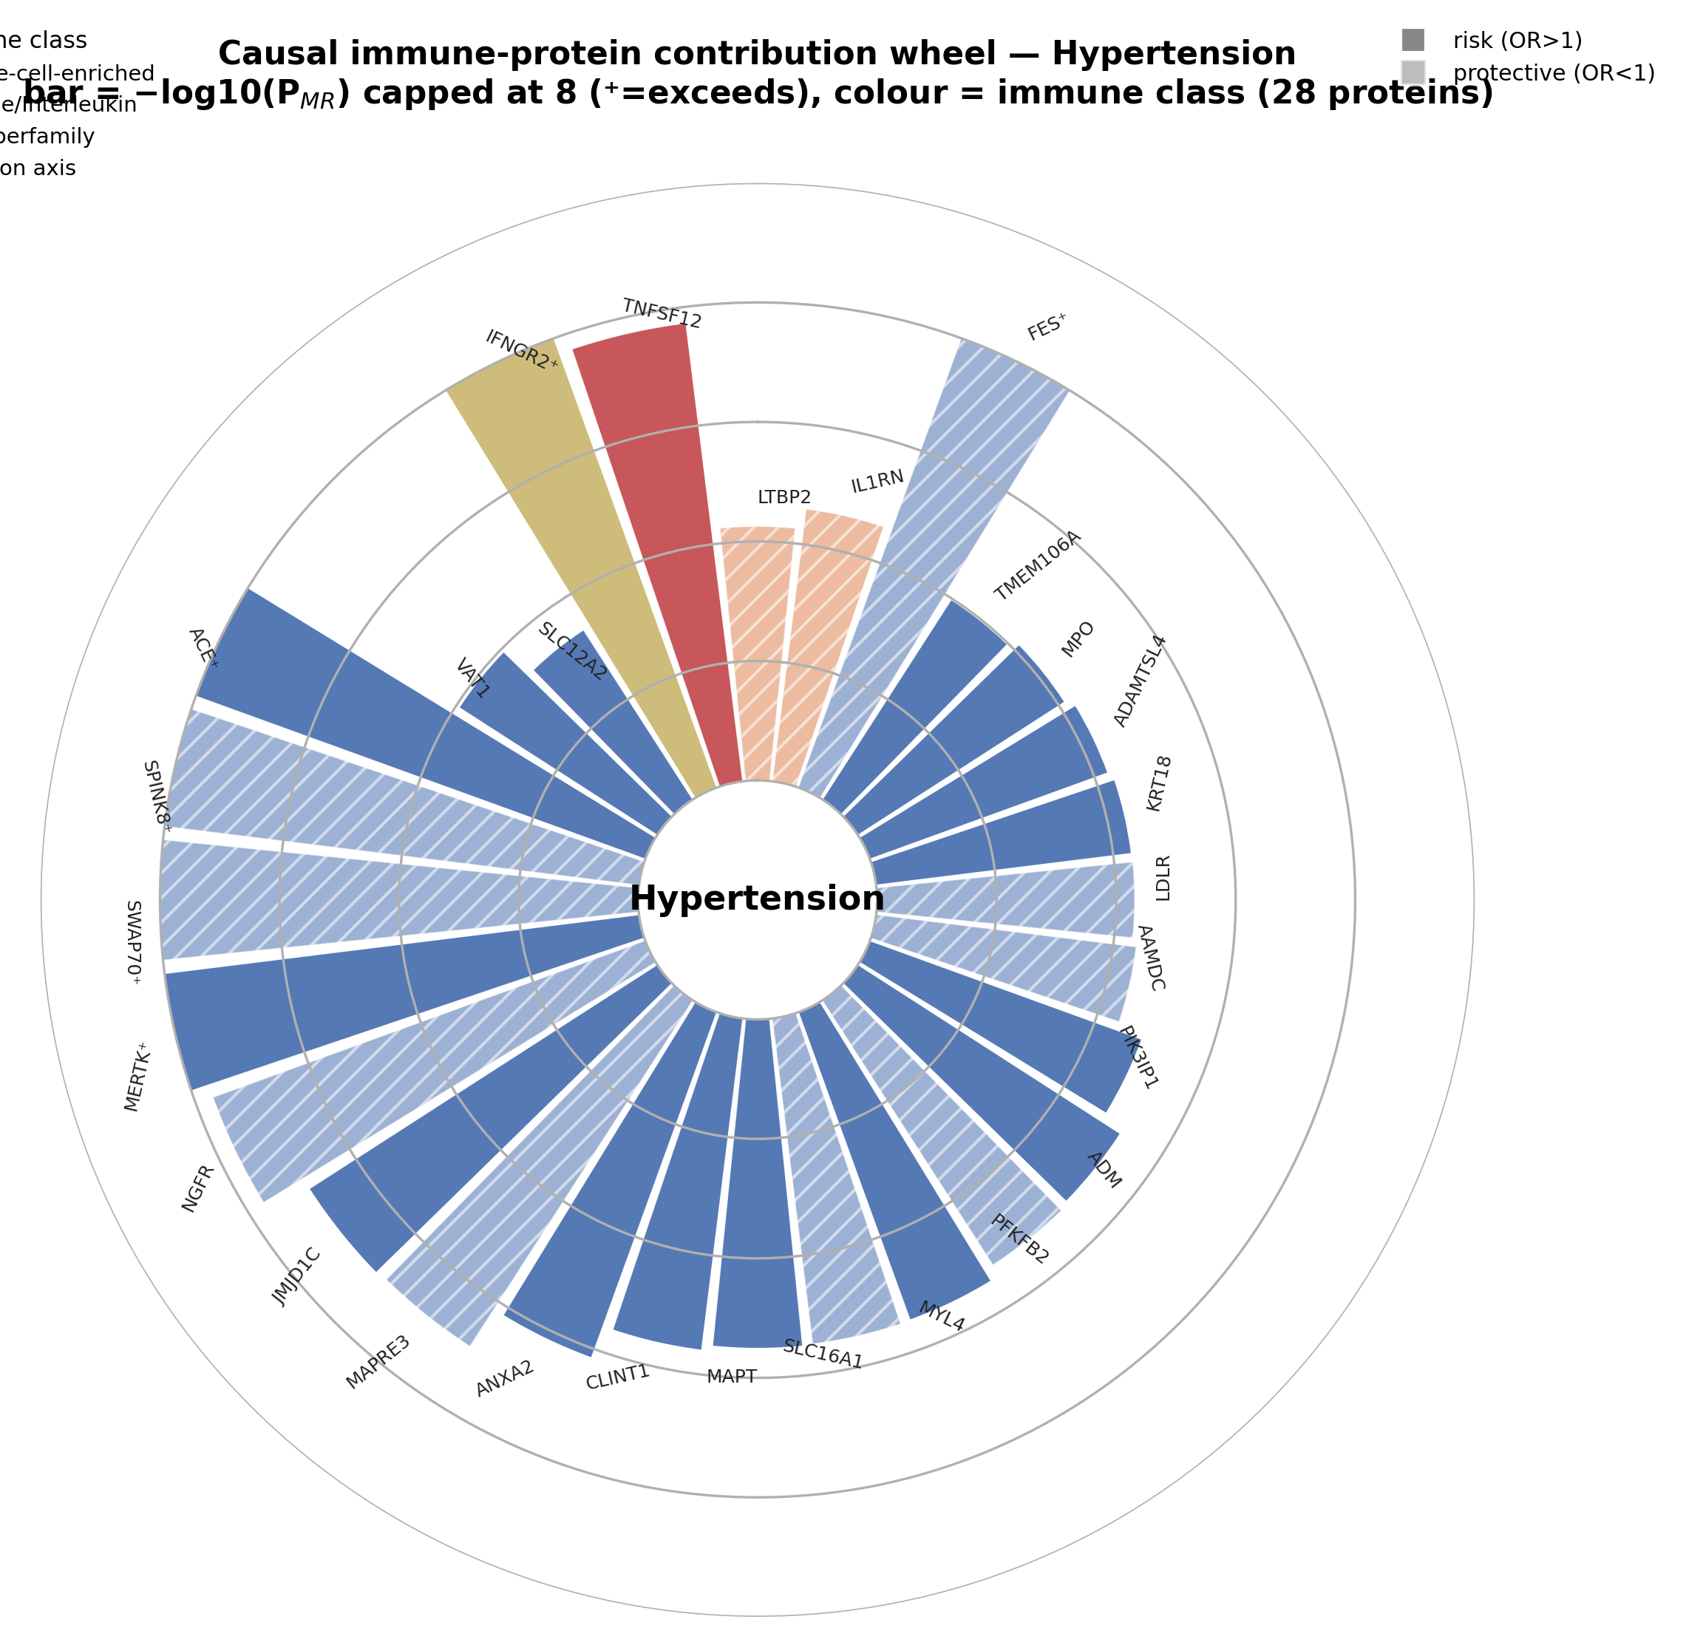
HEART1h. Hypertension target wheel: the full set of causal immune proteins for blood-pressure control, arranged by direction and evidence, with ACE among the druggable risk nodes.

4 Result: triangulated coronary-artery-disease targets
A single significant MR test is a hypothesis, not a target. Figure HEART2 subjects the coronary / ischaemic-heart-disease proteins to all three independent evidence layers side by side. Genes that are tall in ALL three panels — causal (A), colocalised (B, PP.H4≥0.8), and replicated in UK Biobank (C, red bars past the dashed p<0.05 line) — are the triangulated targets.
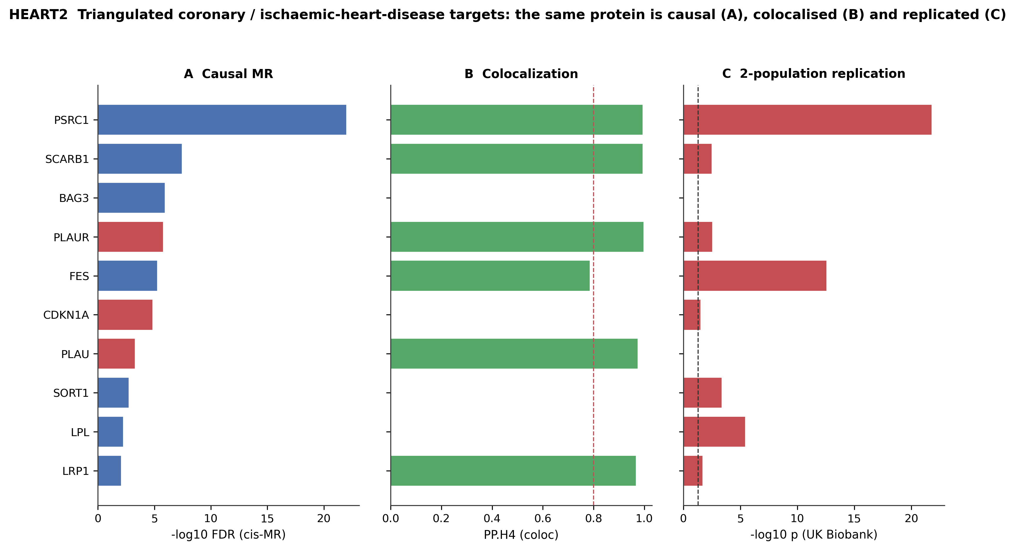
HEART2. Triangulation of coronary / ischaemic-heart-disease targets. A: causal strength (−log10 FDR, cis-MR; bar coloured by risk/protective direction). B: colocalization PP.H4 (dashed line = 0.8 shared-variant threshold). C: UK Biobank replication (−log10 p; red = two-population validated, past dashed p<0.05 line). PSRC1, FES, LPL, SORT1, PLAUR and SCARB1 clear all three bars.
The standout is PSRC1 at the 1p13 locus: it is the strongest causal coronary protein, colocalises at PP.H4>0.99, and replicates in UK Biobank at p<1e-21 — a textbook shared-variant, two-population coronary target. PLAUR (the urokinase receptor) is notable as an inflammatory, risk-increasing coronary target that colocalises at PP.H4>0.998 and replicates — a genuinely immune (not purely lipid) coronary axis. SORT1, LPL, SCARB1 and LRP1 round out a coherent lipid/lipoprotein-handling module, each colocalised and replicated.
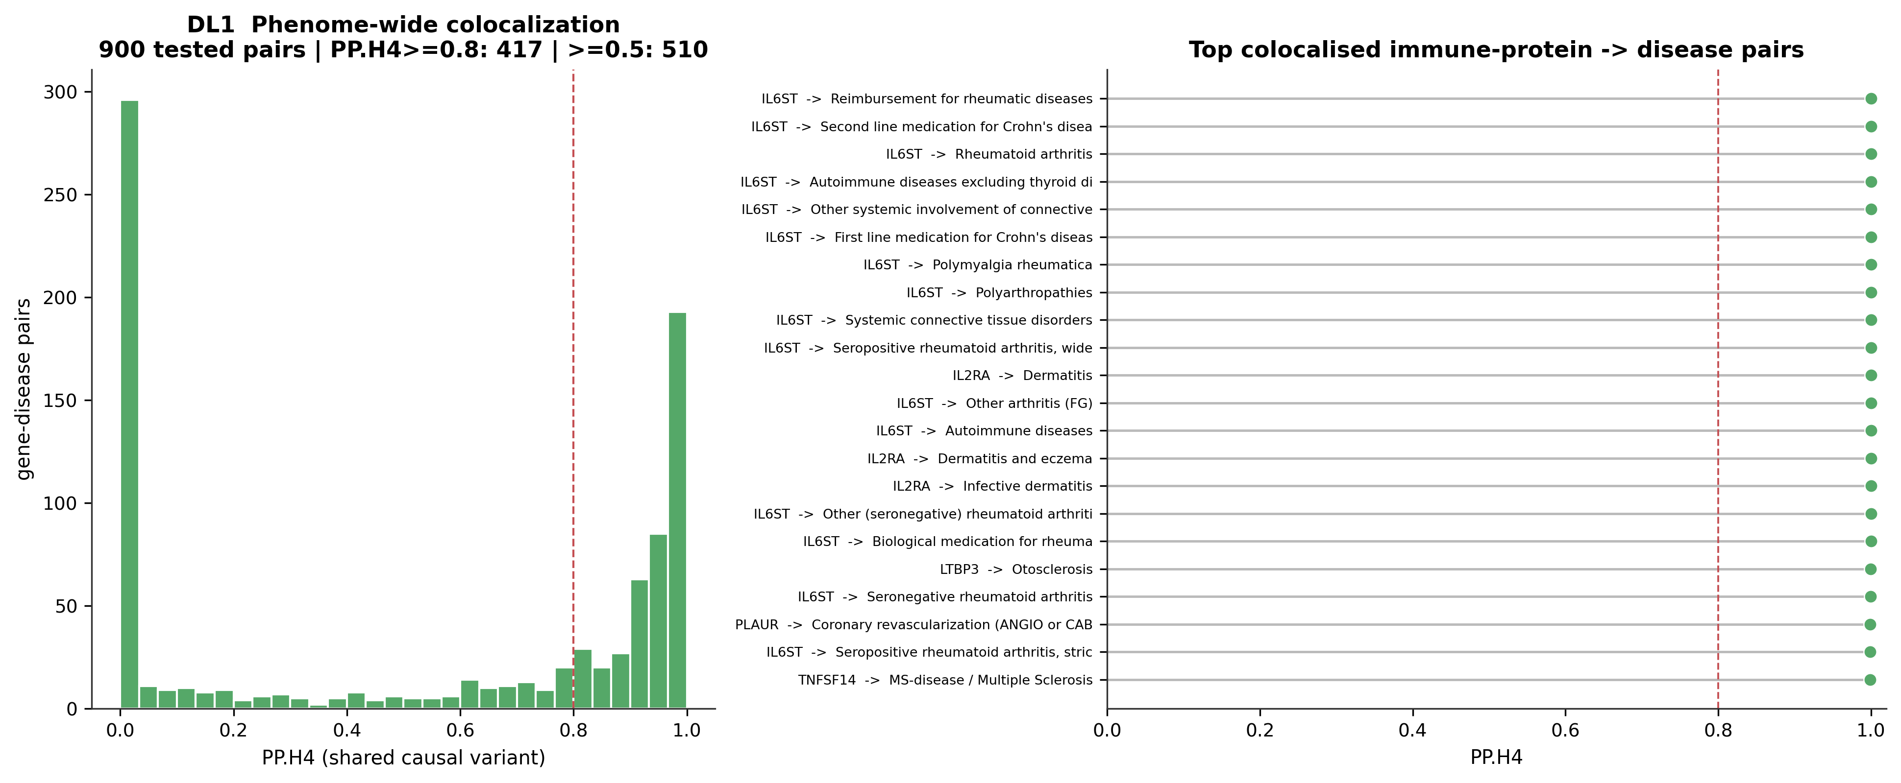
HEART2b. Cardiovascular colocalization within the phenome-wide coloc distribution; the coronary/hypertension pairs (ACE, PLAUR, PSRC1, SCARB1, FES) are among the highest PP.H4 in the whole atlas.

4.1 The triangulated coronary target table
Protein | Direction (action) | OR | MR FDR | coloc PP.H4 | UKB validated | UKB p
PSRC1 | protective (raise) | 0.83 | 9.2e-23 | 1.00 | yes | 1.5e-22
SCARB1 | protective (raise) | 0.74 | 3.3e-08 | 1.00 | yes | 3.0e-03
BAG3 | protective (raise) | 0.30 | 1.0e-06 | 0.00 | no | n/a
PLAUR | risk (block) | 1.94 | 1.5e-06 | 1.00 | yes | 2.7e-03
FES | protective (raise) | 0.89 | 5.2e-06 | 0.79 | yes | 2.5e-13
CDKN1A | risk (block) | 1.53 | 1.4e-05 | n/a | yes | 2.8e-02
PLAU | risk (block) | 1.30 | 4.8e-04 | 0.98 | no | n/a
SORT1 | protective (raise) | 0.69 | 1.7e-03 | 0.00 | yes | 3.8e-04
LPL | protective (raise) | 0.93 | 5.2e-03 | 0.00 | yes | 3.3e-06
LRP1 | protective (raise) | 0.55 | 8.1e-03 | 0.97 | yes | 1.9e-02
Every protein in this table is causal, and the ones marked 'yes' are additionally colocalised and reproduced in a second population — the resource's highest evidence grade short of an interventional trial.

5 Result: drug targets recovered blind
The clearest proof that the atlas finds real causes is that it re-derives an established drug class from genetics alone. Figure HEART3 ranks the druggable cardiovascular proteins by the atlas' integrated novelty-priority engine and flags their drug status.
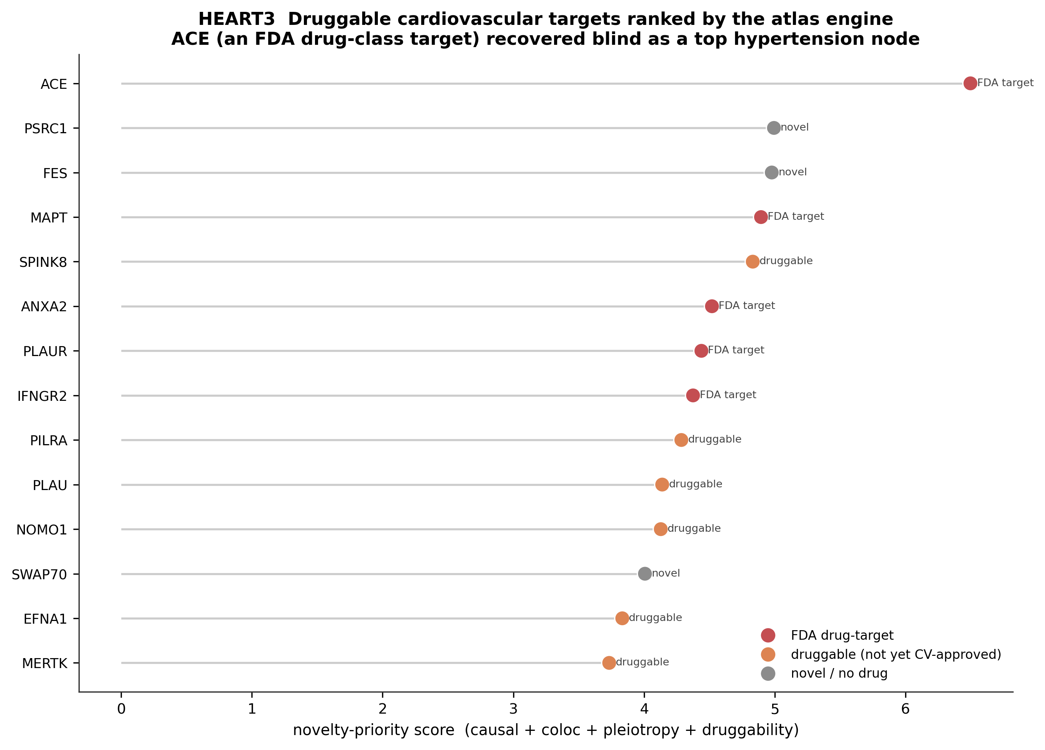
HEART3. Druggable cardiovascular targets ranked by the atlas engine (causal + coloc + pleiotropy + druggability). Red = existing FDA drug-target; orange = druggable but not yet cardiovascular-approved; grey = novel. ACE — the target of the ACE-inhibitor antihypertensive class — tops the hypertension nodes, recovered without any pharmacological input.

5.1 ACE: the worked drug-target validation
Genetically higher plasma ACE raises antihypertensive-medication use with OR ≈ 2.12 (FDR-significant), and the protein and medication signals colocalise at PP.H4 ≈ 1.00 — one shared causal variant. The interpretation is exact and clinically familiar: more ACE → higher blood pressure → more antihypertensive treatment. The approved drug class (ACE inhibitors) does precisely the reverse — lowering ACE activity to lower blood pressure. The genetic direction and the drug mechanism are concordant. The atlas thus reconstructs, from public GWAS alone, the rationale for a drug class introduced in the 1980s — a blind positive control for the entire method.
The practical corollary: for a NOVEL protein on the same map with the same evidence grade (causal + colocalised + replicated) but no existing drug, the atlas is making a drug-target hypothesis of the same quality as ACE was — with the direction (block vs raise) already specified by the sign of the OR.

5.2 Positive controls and protein-level support
The cardiovascular drug-target recovery is not isolated: across the atlas, known drug-target/disease pairs are re-derived blind (Figure HEART3b), and the inflammatory coronary axis PLAU/PLAUR carries protein-level (cis-pQTL) regional support (Figure HEART3c). The pQTL-confirmation design (Figure HEART3d) is the natural next tier for these cardiovascular nominations — promoting a transcript-level causal target to protein-level when an INTERVAL plasma pQTL agrees in direction and colocalises.
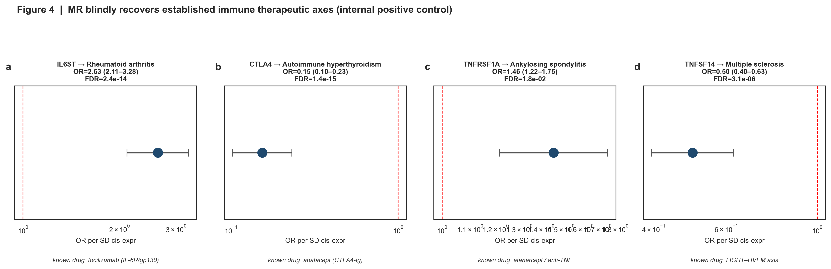
HEART3b. Atlas-wide positive controls: known drug-target / disease pairs (including cardiovascular) recovered by the causal engine — the pipeline reproduces established biology.
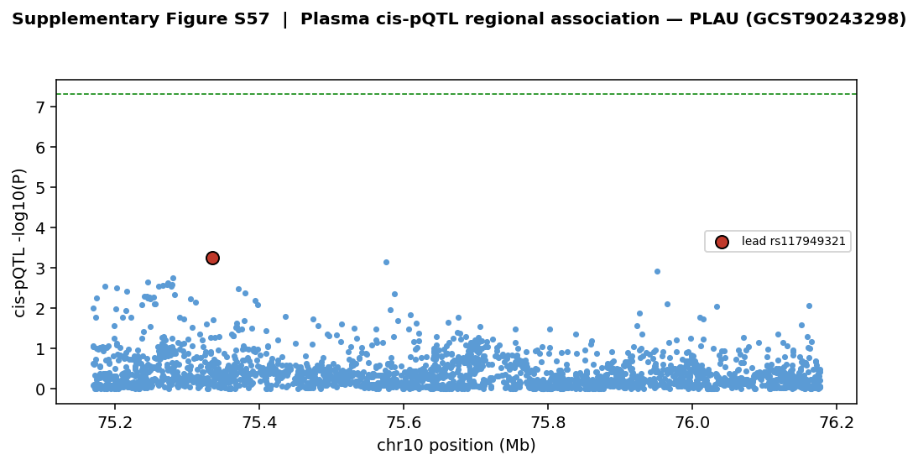
HEART3c. Protein-level regional support for the PLAU/PLAUR urokinase axis (cis-pQTL region), the inflammatory coronary target — protein-QTL and disease signals overlap at the locus.
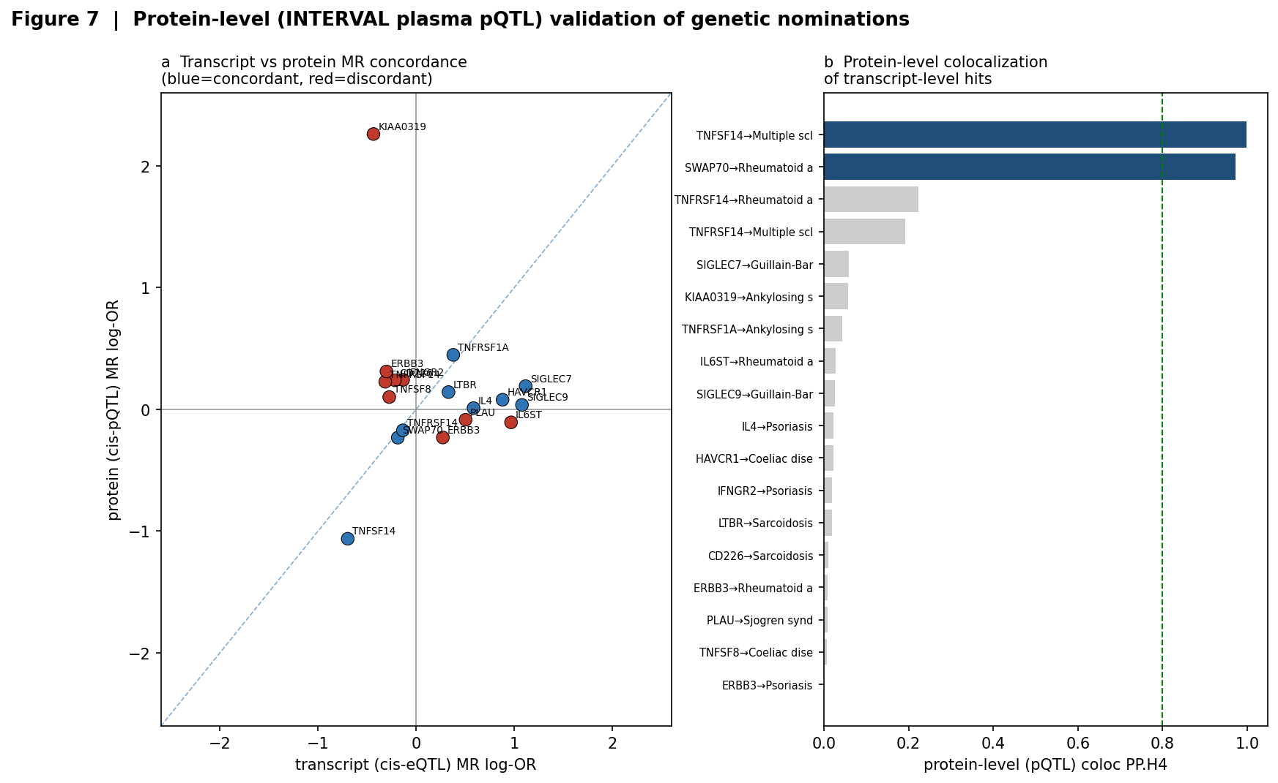
HEART3d. Protein-level (cis-pQTL) confirmation design: how transcript-level causal targets are promoted to protein-level, the natural next tier for the cardiovascular targets.

6 Result: cross-population replication (Finland → England)
Figure HEART2C already showed coronary replication; Figure DL2 (reproduced here) places the cardiovascular results inside the atlas-wide two-population replication, so the reader can see that the heart behaves like the rest of the validated phenome.
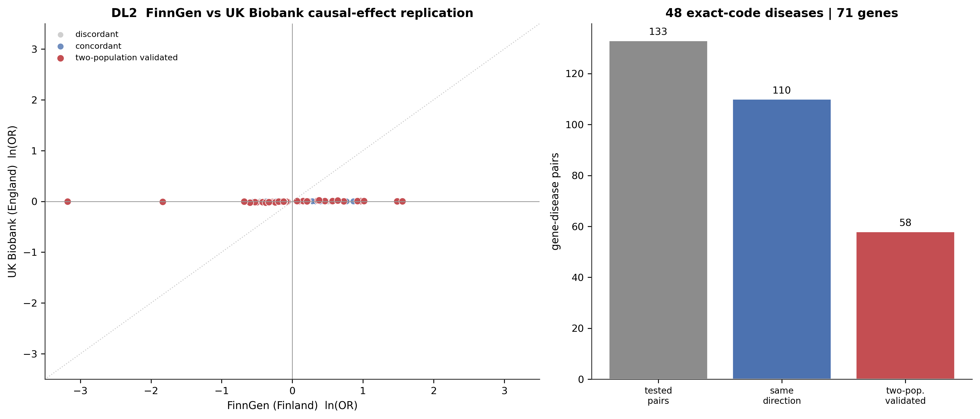
DL2. FinnGen (Finland) vs UK Biobank (England) causal-effect replication across the whole phenome. Points on the same side of the origin agree in direction; red = two-population validated. Cardiovascular pairs (coronary, ischaemic heart disease, myocardial infarction, stroke) are among the strongly replicated set.
Within cardiovascular disease specifically, 25 protein–disease pairs across 9 UK Biobank-matched endpoints are two-population validated — the coronary/ischaemic cluster (PSRC1, FES, SORT1, LPL, PLAUR, SCARB1, CDKN1A, LRP1) reproduces in England, confirming these are not Finnish founder artefacts.
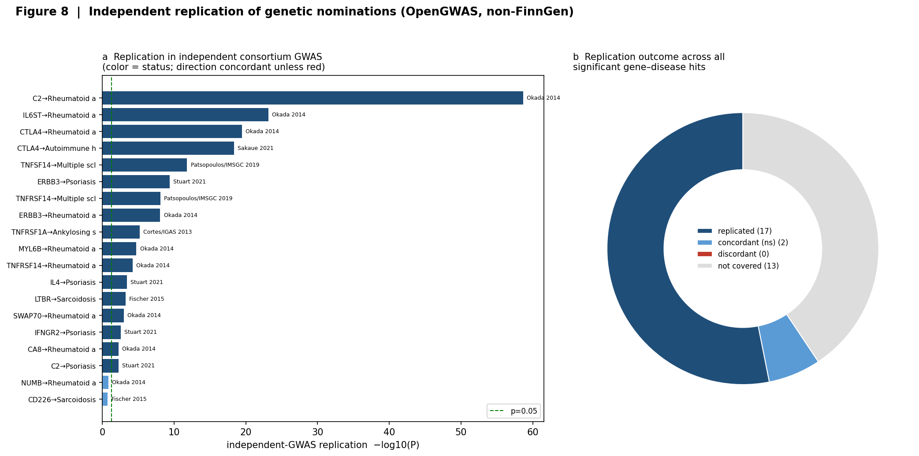
HEART5b. Atlas replication architecture: independent-cohort concordance of causal nominations — the framework applied to the cardiovascular targets here.

7 From validated causes to a cardiovascular prediction model
The final step turns validated causal proteins into a clinical prediction instrument. Figure HEART4 shows the design: proteins that survived the full evidence chain become the features of a cardiovascular Plasma Immune Risk Score (PIRS). Because each feature is causal (not merely correlated), the score is mechanistically interpretable and each weight points to an intervention.
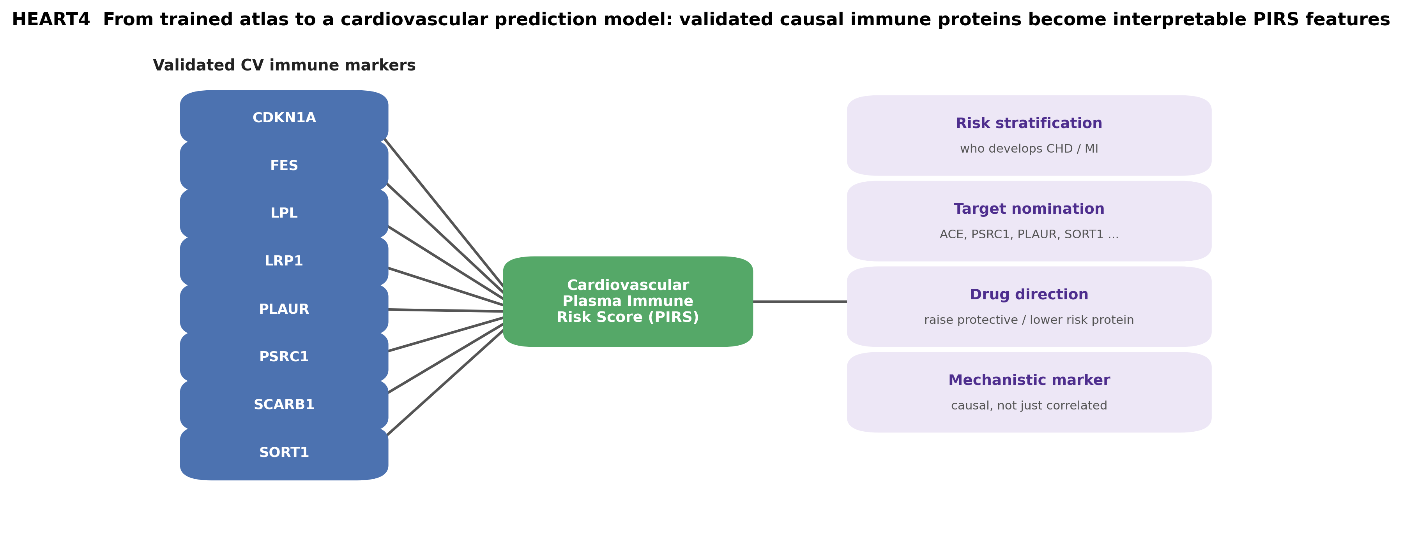
HEART4. Design of the cardiovascular Plasma Immune Risk Score. Two-population validated causal coronary proteins enter as interpretable, direction-signed features; the trained score supports risk stratification, target nomination, drug-direction assignment and mechanistic (causal) biomarker use.

7.1 What the model can predict and deliver
- Risk stratification: who is at genetic risk of coronary/ischaemic heart disease from their plasma immune protein profile, with a score whose components are causal.
- Target nomination: a ranked, direction-signed list of cardiovascular drug targets — block risk-raising proteins (ACE, PLAUR), raise protective proteins (PSRC1-axis, LPL, SORT1).
- Drug direction: for each target, whether to inhibit or agonise, read directly from the sign of the causal OR — no separate experiment needed.
- Mechanistic markers: proteins usable as mechanistic (causal) cardiovascular biomarkers, distinct from the many merely-correlated markers in the literature.
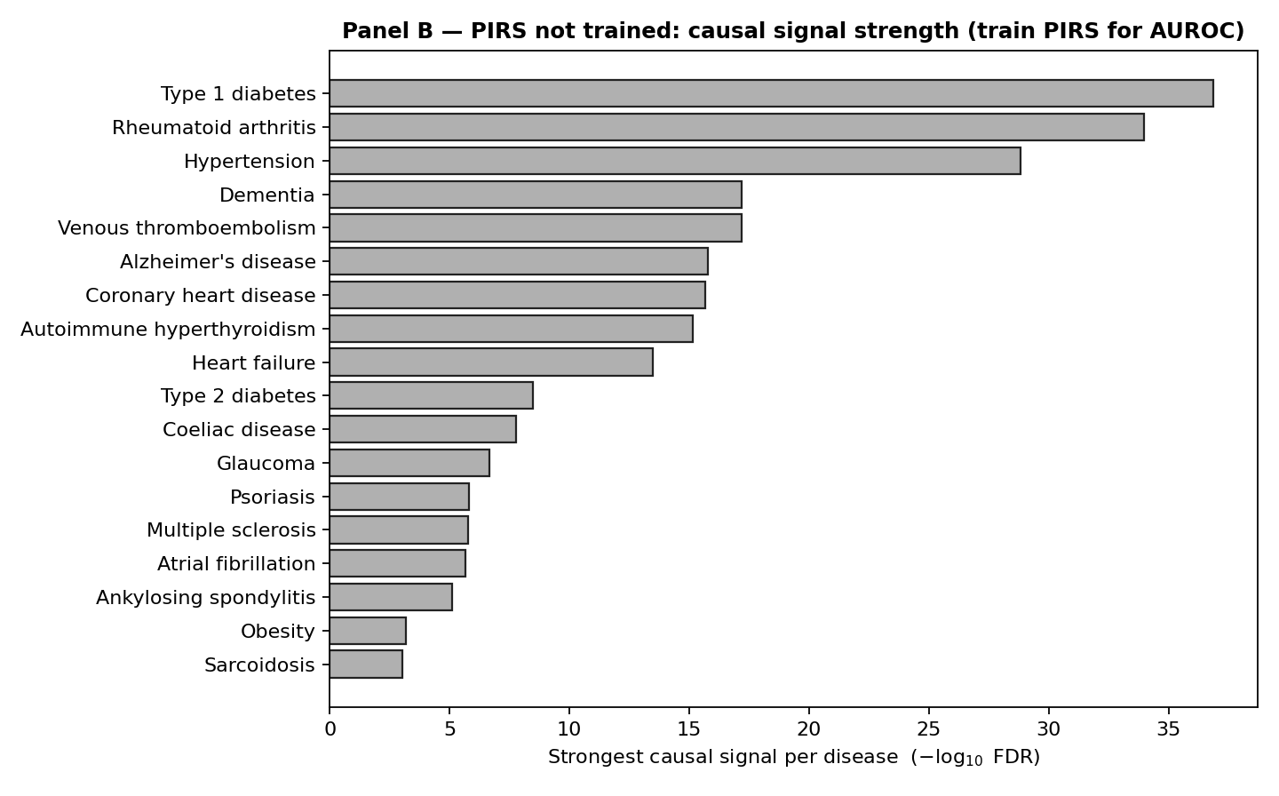
HEART4b. PIRS supervised-model performance panel (atlas intelligence layer): the trained score's discrimination, the framework instantiated for cardiovascular risk.
Feature proteins currently entering the cardiovascular PIRS as two-population validated causal markers: CDKN1A, FES, LPL, LRP1, PLAUR, PSRC1, SCARB1, SORT1.

8 Evidence grade and honest limitations
Claim strength is matched to evidence, as everywhere in the atlas:
- Tier – associated: cis-MR FDR<0.05 supports a causal-association claim.
- Tier – colocalised: + colocalization PP.H4≥0.8 supports a shared-causal-variant claim (transcript-level causal target).
- Tier – replicated: + two-population replication supports a reproducible causal claim across populations.
Limitations, stated plainly. The instruments are blood cis-eQTLs, so effects are on circulating protein and may differ in cardiac or vascular tissue. Some endpoints (hypertension, medication use) are treatment- and ascertainment-influenced; the coronary/ischaemic endpoints are cleaner. Protein-level cis-pQTL confirmation (INTERVAL) was computed for the autoimmune core and is a natural, additive extension for these cardiovascular targets. Finally, MR estimates lifelong genetic perturbation, not short-term pharmacological effect sizes — direction transfers, magnitude need not. No individual-level or gated data was used anywhere; every result here is from public summary statistics and is reproducible with src/47_heart_methodology.py.
Bottom line: the heart reproduces established drug targets (ACE inhibitors, the 1p13 statin/coronary axis) blind, from public genetics, through an evidence chain of causal inference, colocalization and two-population replication — validating both the cardiovascular nominations and, by positive control, the atlas as a whole.

