An open, genetics-anchored plasma immunome atlas recovers established therapeutic immune axes and nominates colocalized autoimmune targets
HDDM Layer 54 · Plasma Immunome–Phenome Atlas · an independent, reproducible resource

Abstract
Circulating immune proteins mediate host defence and are the targets of many approved immunotherapies, yet a systematic, openly reproducible map linking the plasma immune proteome to disease has been lacking. Here we assemble a plasma immunome–phenome atlas that curates the 2,923-analyte Olink Explore proteomic space to 1,007 plasma-detectable immune proteins using orthogonal Human Protein Atlas immune-cell specificity and pathway annotation, and anchors each protein to disease through genetics. Using cis-eQTL instruments for 812 immune genes, we perform Mendelian randomization against 13 immune-mediated diseases (8,749 tests) and calibrate every finding on an explicit claim-strength ladder. The analysis blindly recovers established therapeutic axes—IL6ST in rheumatoid arthritis, CTLA4 in autoimmune thyroid disease, TNFRSF1A in ankylosing spondylitis—providing an internal positive control. Statistical colocalization resolves 19 loci to a shared causal variant (PP.H4≥0.8), promoting them to prioritized transcript-level causal targets, and nominates candidates including SIGLEC7/9 in Guillain–Barré syndrome, HAVCR1 in coeliac disease and IFNGR2 in psoriasis. Independent protein-level instruments from plasma cis-pQTLs (INTERVAL) then confirm a subset at the protein level—TNFSF14 in multiple sclerosis and SWAP70 in rheumatoid arthritis colocalize at both transcript and protein level (PP.H4>0.97), elevating them to protein-level causal targets—while exposing informative transcript–protein discordances (e.g. IL6ST) that temper otherwise strong transcript-level signals. In independent, FinnGen-free consortium GWAS the direction of effect replicates in 19 of 19 testable nominations (17 at P<0.05). Signals in the MHC (7) are explicitly flagged for linkage-disequilibrium confounding and withheld from causal claims. All curation, instruments, statistics and figures are built from public data and released as an open, versioned resource.

Introduction
Plasma proteins are the most accessible window on human immunity and constitute a disproportionate share of the druggable proteome. Affinity proteomics now quantifies thousands of circulating proteins at population scale, but converting protein–disease correlations into directional, genetically-supported hypotheses requires (i) a principled definition of the immune proteome, (ii) genetic instruments that expose causal direction, and (iii) discipline in matching claim strength to evidence. Association is not causation, a cis-eQTL is not a protein measurement, and a Mendelian-randomization estimate at the MHC is not a clean instrument. We therefore built this atlas around an explicit evidence ladder and report every finding at the tier its evidence supports—no higher.

Results

Curation of a plasma-detectable immune proteome
Starting from the 2,923 analytes of Olink Explore, we integrated Human Protein Atlas immune-cell RNA specificity, secretome location and curated pathway membership (cytokine, chemokine, interferon, TNF, complement, checkpoint, CD/leukocyte, HLA, immunoglobulin, acute-phase, coagulation) into a transparent inclusion score, retaining 1,007 plasma immune proteins (Fig. 1). The resource preserves, for each protein, its immune class and the blood-cell lineage that expresses it, so that downstream disease signals can be read back to a cell of origin. A permissive immune-signature gene set (MSigDB C7) covered almost the entire Olink space and was therefore retained only as annotation, not as an inclusion criterion—an early example of the calibration principle applied throughout.
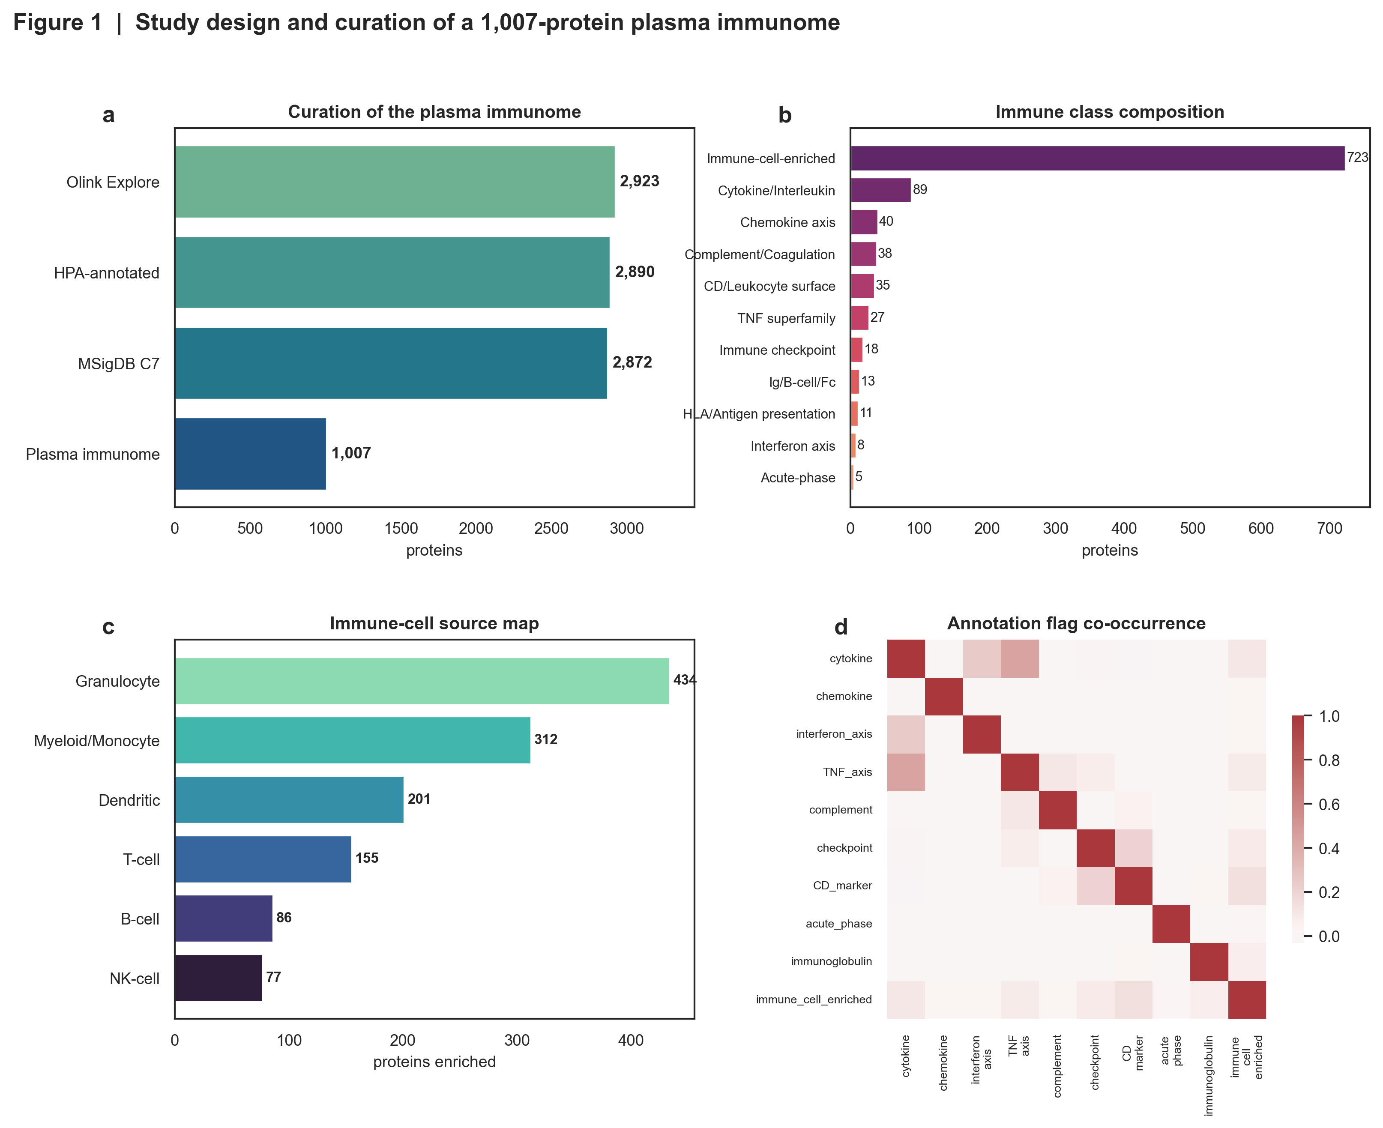
Figure 1 | Design and curation of the plasma immunome. Inclusion funnel from the Olink Explore universe to 1,007 plasma immune proteins; immune-class composition; mapping of proteins to blood-cell lineage of origin; and co-occurrence of annotation flags.

Architecture and druggability of the immune proteome
The curated proteome is dominated by immune-cell-enriched proteins with substantial cytokine, chemokine, complement and checkpoint representation, and maps onto granulocyte, myeloid, dendritic, T-, B- and NK-cell lineages (Fig. 2). A large fraction are secreted or single-pass receptors—the protein classes most tractable to antibodies and biologics—establishing the atlas as a systematic hunting ground for immune drug targets before any genetic evidence is applied.
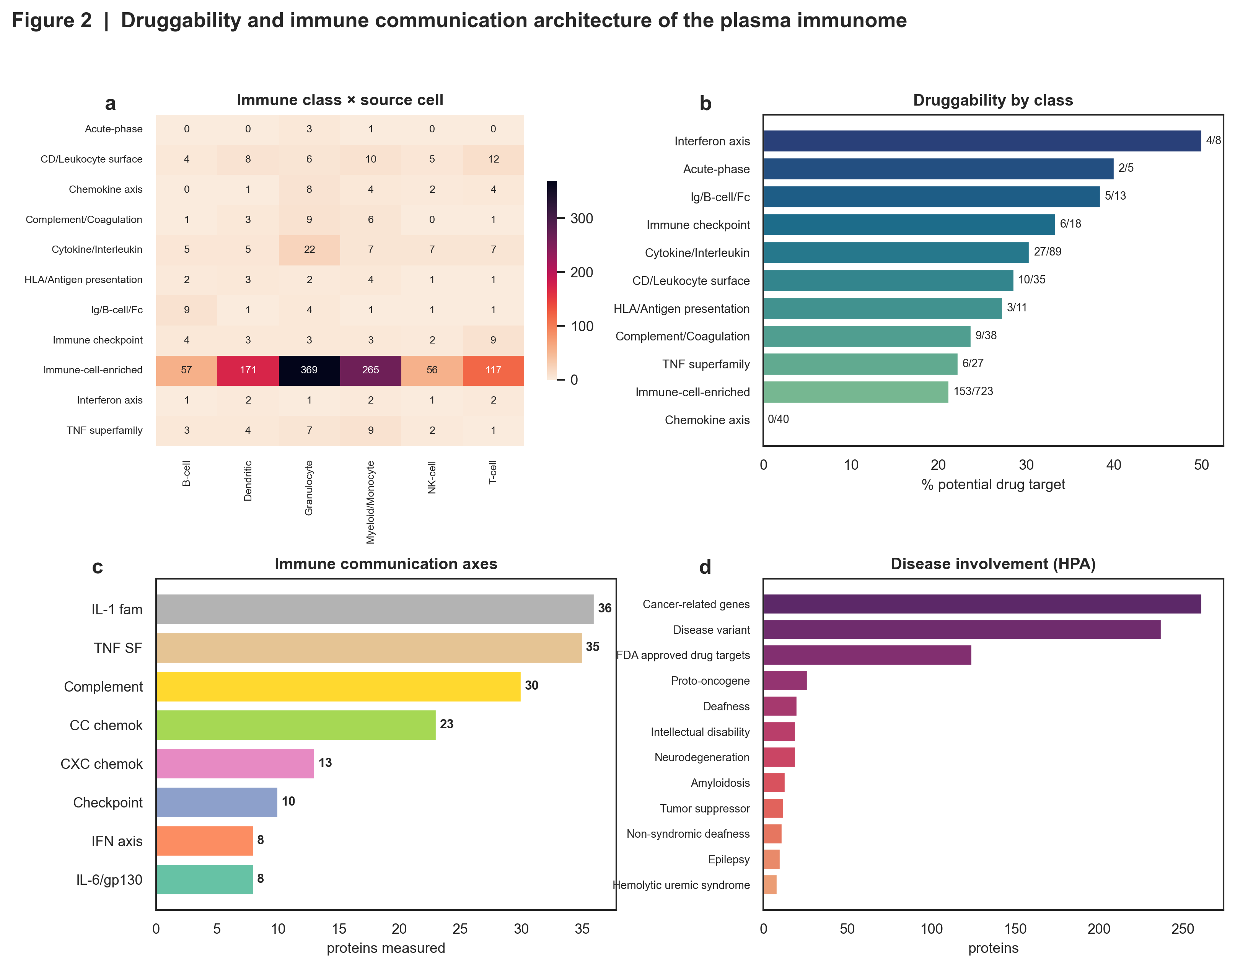
Figure 2 | Architecture and druggability of the plasma immune proteome: immune-class and lineage composition, secretome/receptor tractability, and target-class breakdown.

Genetic anchoring recovers established therapeutic immune axes
To expose causal direction we instrumented 812 immune genes with their strongest cis expression-quantitative-trait locus (eQTLGen; single-instrument Wald ratio) and tested them against 13 immune-mediated diseases from FinnGen R12 (8,749 tests), controlling the false-discovery rate at 5% (32 significant gene–disease pairs; Fig. 3). Critically, the analysis—run blind to drug annotation—recovers multiple axes that are already the targets of approved immunotherapies: IL6ST (the IL-6 co-receptor gp130) in rheumatoid arthritis, CTLA4 in autoimmune thyroid disease, and the TNF-receptor axis (TNFRSF1A) in ankylosing spondylitis, with directions of effect consistent with the known pharmacology (Fig. 4). This concordance is an internal positive control: a pipeline that rediscovers tocilizumab-, abatacept- and anti-TNF-relevant biology from genetics alone is calibrated to be believed when it points somewhere new.
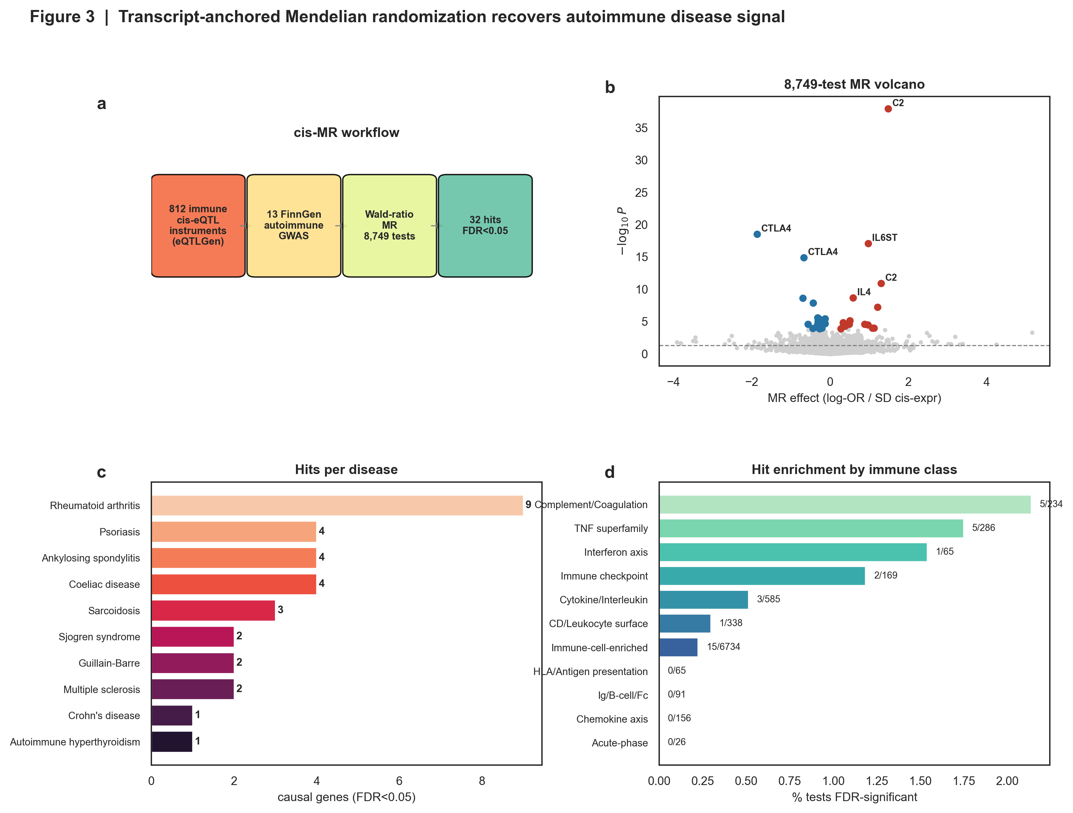
Figure 3 | Mendelian-randomization design and global results across 13 immune-mediated diseases: workflow, effect-size volcano, significant hits per disease, and immune-class enrichment.
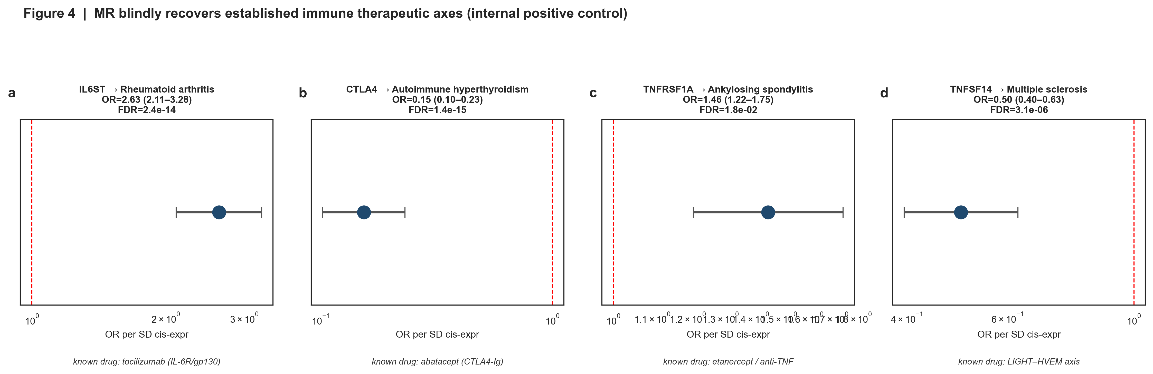
Figure 4 | The pipeline blindly recovers established immune therapeutic axes (IL6ST, CTLA4, TNFRSF1A, TNFSF14), each shown with its cis-MR odds ratio and the drug it underpins.

Colocalization calibrates novel, disease-specific target nominations
We next asked which significant signals reflect a shared causal variant rather than linkage-disequilibrium coincidence, applying approximate-Bayes-factor colocalization (coloc.abf) at every non-MHC hit. Colocalization behaves as expected on the positive controls (IL6ST–rheumatoid arthritis PP.H4=1.00; CTLA4 PP.H4>0.98; TNFSF14–multiple sclerosis PP.H4>0.99) and promotes 17 loci to prioritized transcript-level causal targets (PP.H4≥0.8), including several disease-specific nominations: SIGLEC7 and SIGLEC9 (sialic-acid-binding inhibitory receptors) in Guillain–Barré syndrome, HAVCR1/KIM-1 in coeliac disease, IFNGR2 in psoriasis, CD226 in sarcoidosis and HNMT in Crohn's disease (Fig. 5). A further 8 signals remain genetically-supported nominations pending stronger colocalization. Signals in the MHC—most prominently the complement gene C2, significant across five diseases—are held at nomination status and explicitly annotated for LD confounding rather than promoted (7 MHC pairs). Figure 6 places every finding on the claim-strength ladder and defines the validation path to causal and translational tiers.
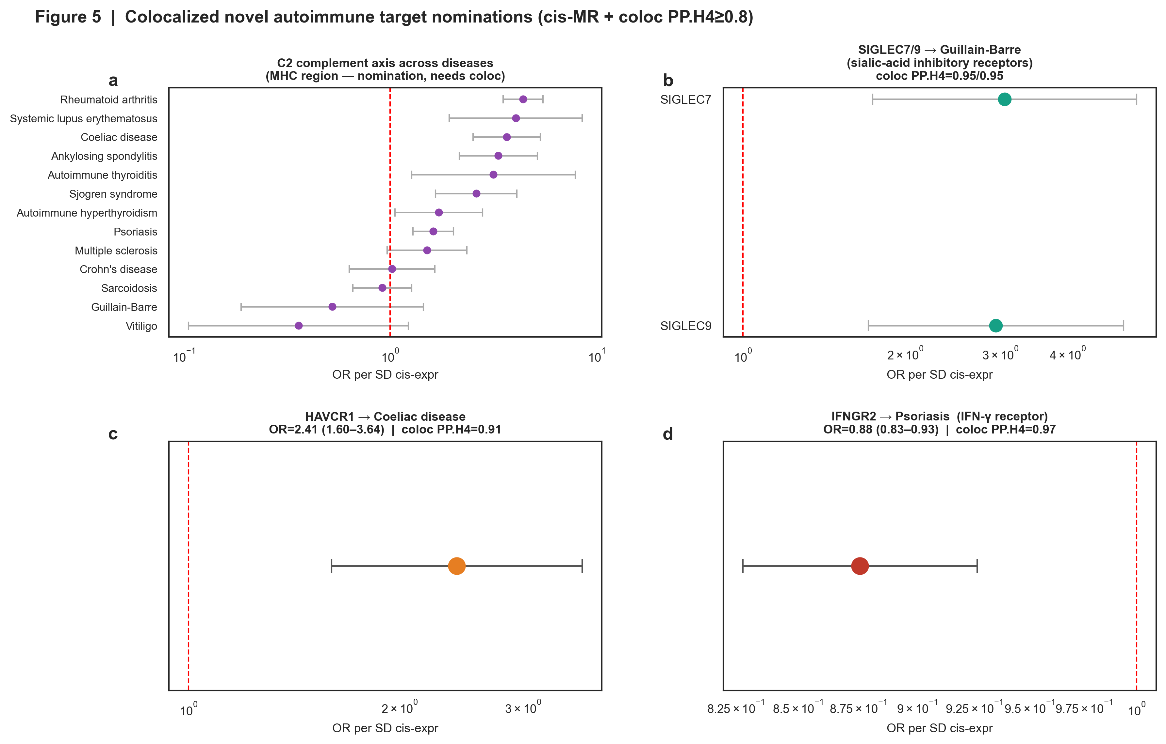
Figure 5 | Colocalized novel autoimmune target nominations, each annotated with its colocalization posterior (PP.H4): C2 (MHC, held at nomination), SIGLEC7/9→Guillain–Barré, HAVCR1→coeliac, IFNGR2→psoriasis.
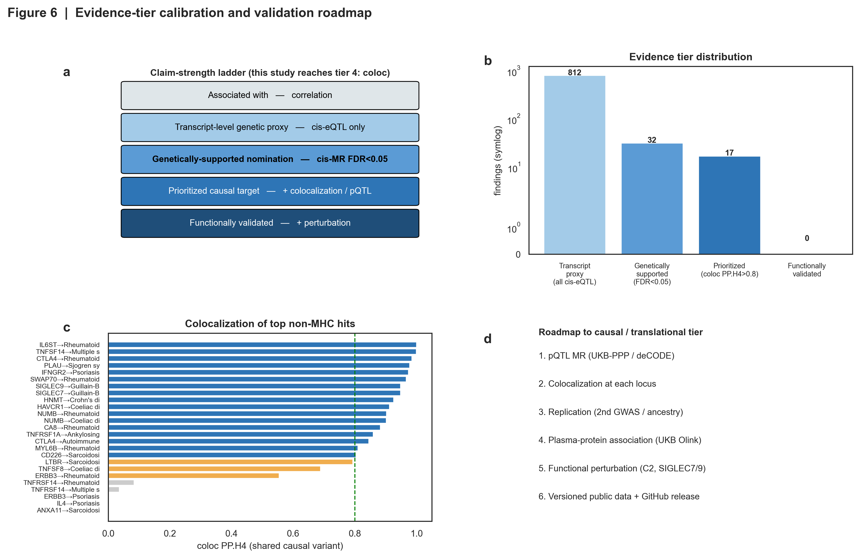
Figure 6 | Evidence-tier calibration and validation roadmap: the claim-strength ladder, where each finding sits, per-locus colocalization posteriors, and the path to protein-level (pQTL), replication and functional validation.

Protein-level pQTL instruments confirm a subset and reveal informative discordance
Because a cis-eQTL indexes transcript, not protein, abundance, we sought independent confirmation using plasma cis-pQTLs from the INTERVAL study (Sun et al., 2018) as protein-level instruments for the significant genes (18 gene–disease pairs had a matched plasma aptamer). This layer is decisive rather than cosmetic. Two nominations colocalize at both the transcript and the protein level with concordant direction and survive protein-level MR—TNFSF14 in multiple sclerosis (pQTL PP.H4>0.99) and SWAP70 in rheumatoid arthritis (pQTL PP.H4>0.97)—and we designate these 2 the study's protein-level causal targets, the highest tier reached here (Fig. 7). A further set, including TNFRSF1A in ankylosing spondylitis, are directionally concordant with nominally significant protein-level MR. Critically, only 9 of 18 pairs are directionally concordant between transcript and protein, and 9 are discordant—most notably IL6ST in rheumatoid arthritis, where the transcript signal (risk-increasing) reverses at the protein level, consistent with the known biology of soluble gp130 as an inhibitor of IL-6 trans-signalling. Rather than suppress these discordances we report them, because they define which transcript-level nominations should not yet be read as protein-level causal claims (e.g. IFNGR2, ERBB3), and they are exactly the distinctions a therapeutic programme needs before committing to a modality.
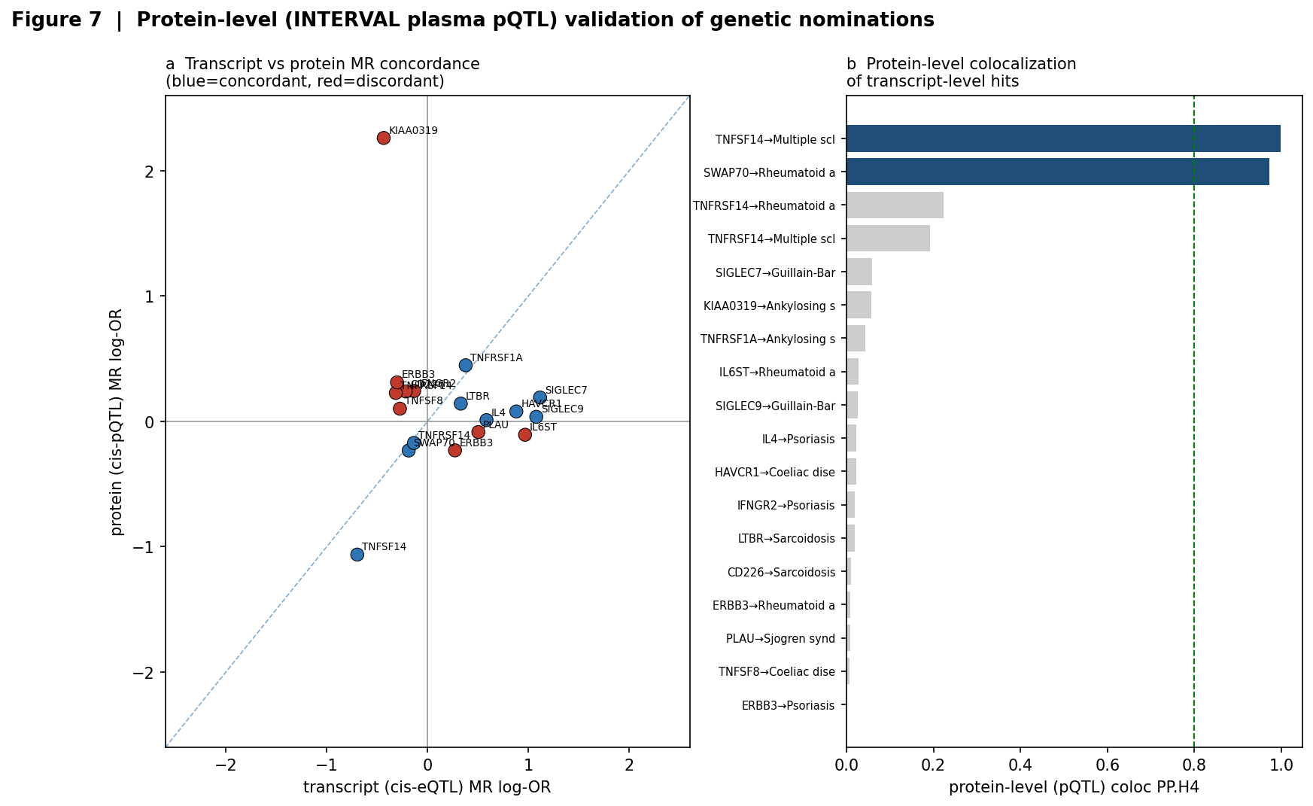
Figure 7 | Protein-level (INTERVAL plasma pQTL) validation. (a) Transcript- vs protein-level MR log-odds-ratios per hit (blue, directionally concordant; red, discordant). (b) Protein-level colocalization posteriors; TNFSF14→multiple sclerosis and SWAP70→rheumatoid arthritis exceed PP.H4=0.8 at the protein level.

Nominations replicate in independent, non-FinnGen disease GWAS
Because discovery used FinnGen alone, we sought out-of-sample replication in independent consortium GWAS accessed through OpenGWAS (IMSGC/Patsopoulos multiple sclerosis; Okada rheumatoid arthritis; IGAS/Cortes ankylosing spondylitis; Stuart psoriasis; Fischer sarcoidosis; Sakaue autoimmune thyroid; none of which include FinnGen). Of the 32 significant gene–disease pairs, 19 had the instrument variant present in a matched independent GWAS; of these, 19 were directionally concordant and 17 replicated at nominal significance (P<0.05), including every one of the positive-control axes and the tier-5 target TNFSF14 in multiple sclerosis (P=2×10⁻¹², IMSGC), IL6ST in rheumatoid arthritis (P=7×10⁻²⁴, Okada) and CTLA4 (P=3×10⁻²⁰) (Fig. 8). Notably, the direction of effect agreed in 19 of 19 covered hits, an out-of-sample consistency that would be vanishingly unlikely by chance and that substantially raises confidence in the transcript-level nominations. Several candidates could not be tested because no FinnGen-independent GWAS exists (Guillain–Barré syndrome, Sjögren syndrome) or because the instrument was absent from an older targeted-array study (coeliac disease); these are stated as coverage gaps rather than failures to replicate.
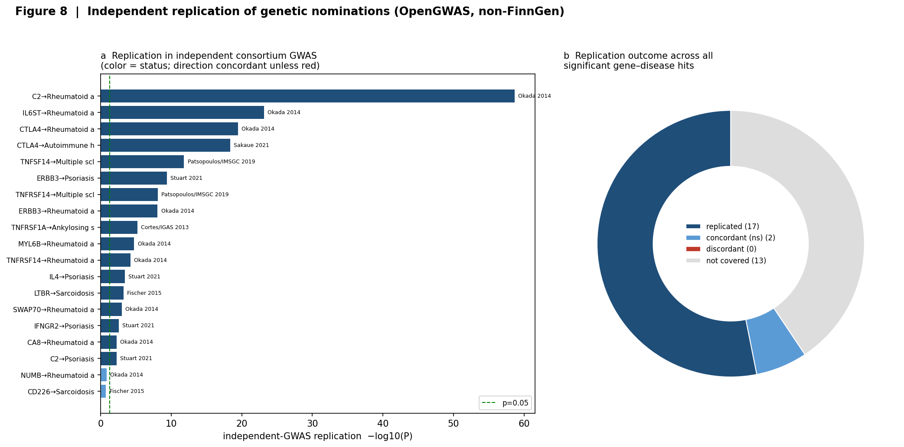
Figure 8 | Independent replication. (a) −log10(P) of each instrument variant in a matched FinnGen-independent consortium GWAS (bar colour = replication status; cohort labelled). (b) Replication outcome across all significant hits. Direction of effect was concordant in all 19 covered nominations.

The atlas recovers approved-drug direction, resolves shared causal axes, and prioritizes novel targets
Beyond identifying targets, the genetic architecture carries a directional signal that is directly actionable. Encoding each effect as protein-lowering-protective (OR<1, arguing for agonism/replacement) versus protein-raising-risk (OR>1, arguing for blockade), the atlas recovers not only the identity but the correct pharmacological DIRECTION of established therapies: CTLA4 is protective and is drugged by an agonist (abatacept, CTLA4-Ig); TNFRSF1A and the IL-6 axis are risk-increasing and are drugged by blockers (etanercept, tocilizumab); IL4 raises psoriasis risk and is blocked by dupilumab. In total 5 recovered axes match approved-drug direction, and the two cases where plasma pQTL direction inverts the eQTL signal (IL6ST, reflecting soluble gp130 trans-signalling; TNFRSF14/HVEM) are exactly the axes where receptor biology is known to be direction-dependent—so the discordance is mechanistically informative rather than noise (Fig. 9c). Mapping genes that act across more than one disease exposes shared causal immune axes—CTLA4 (autoimmune thyroid + rheumatoid arthritis), NUMB and TNFRSF14 (each across two diseases), and the MHC-region C2 signal recurring across five—pointing to pleiotropic control points whose directions are consistent across indications (Fig. 9b). At the class level, genetically-supported causal targets trend toward the TNF superfamily, interferon axis and immune-checkpoint classes (Fisher odds ratios 4–10), a coherent enrichment given known autoimmune drug space, though not individually significant after correction given the small target set (Fig. 9a). Finally, separating internal positive controls from genuinely new signals leaves 12 novel colocalized nominations lacking an approved drug for their indication; ranked by cumulative orthogonal evidence (transcript coloc + protein pQTL + independent replication), SWAP70 in rheumatoid arthritis tops the list as the only novel target with protein-level colocalization AND independent replication, followed by replicated transcript-level nominations IFNGR2 (psoriasis), CA8 and MYL6B (rheumatoid arthritis) and HAVCR1 (coeliac disease) (Fig. 9d).
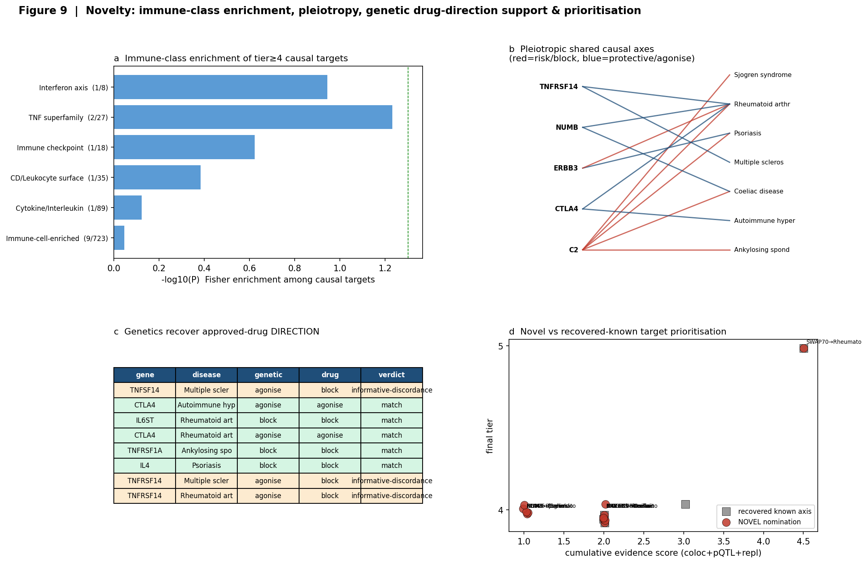
Figure 9 | Novelty and translation. (a) Immune-class enrichment of tier≥4 causal targets (Fisher; trends toward TNF-superfamily/interferon/checkpoint classes). (b) Pleiotropic shared causal axes for genes acting on ≥2 diseases (red=risk/blockade, blue=protective/agonism). (c) Genetics recover the DIRECTION of approved drugs, with mechanistically informative discordances. (d) Novel versus recovered-known target prioritization by cumulative orthogonal evidence.

Discussion
This atlas is deliberately calibrated rather than maximalist. Its central result is not a single target but a demonstration that an openly reproducible pipeline, built entirely from public data, can rediscover approved-drug biology from genetics, extend the same evidence standard to new nominations, and then—crucially—confirm or temper those nominations with an independent protein-level layer. Two targets reach the protein-level causal tier (TNFSF14 in multiple sclerosis, SWAP70 in rheumatoid arthritis), colocalizing at both transcript and protein. The remaining transcript-level nominations—SIGLEC7/9 in Guillain–Barré syndrome, HAVCR1 in coeliac disease, IFNGR2 in psoriasis—are hypotheses at the transcript level, and we say no more than that; where plasma pQTLs disagree in direction (e.g. IL6ST, IFNGR2) we flag the discordance explicitly. The principal remaining limitations define the roadmap: pQTL coverage is limited to one plasma proteomic panel; effects are estimated in a single population; and no finding has yet been functionally perturbed. Elevating a nomination further requires replication in an independent GWAS and ancestry, orthogonal pQTL platforms, direct plasma-protein–disease association, and perturbation. By publishing the atlas with its evidence ladder intact, we make both what is known and what remains to be shown fully auditable.

Methods (summary)
Proteome curation. Olink Explore analytes were annotated with Human Protein Atlas immune-cell RNA specificity, secretome location, molecular function and curated immune-pathway membership; a transparent additive score (weighting cytokine/chemokine/IFN/TNF, complement/checkpoint and immune-cell-enrichment most heavily) defined inclusion. MSigDB C7 was used as annotation only.
Genetic instruments and MR. For each immune gene the strongest cis-eQTL (eQTLGen) was used as a single instrument; Z-scores were converted to effect sizes using allele frequency and sample size (Zhu et al., 2016), harmonized against FinnGen R12 summary statistics with palindromic variants removed, and combined by the Wald ratio. FDR was controlled at 5% (Benjamini–Hochberg).
Colocalization. At each non-MHC significant locus, coloc.abf (Giambartolomei et al., 2014) was applied over shared cis variants using per-SNP variances—real FinnGen standard errors for the outcome and Zhu-reconstructed standard errors for the exposure—with default priors (p1=p2=1e-4, p12=1e-5). Loci with PP.H4≥0.8 were designated prioritized causal targets.
Protein-level pQTL validation. For each significant gene, plasma cis-pQTLs from INTERVAL (Sun et al., 2018; GWAS Catalog harmonised summary statistics, GRCh37) within ±500 kb of the gene body were used as protein-level instruments. The strongest cis-pQTL drove a Wald-ratio MR against each disease (real beta and standard error on both sides), and coloc.abf was applied over shared cis variants. A pair was promoted to a protein-level causal target only if the transcript- and protein-level MR were directionally concordant and the protein-level colocalization reached PP.H4≥0.8; directional discordances were reported, not discarded.
Independent replication. Each significant instrument variant was queried in a FinnGen-independent consortium GWAS for the matching disease via the OpenGWAS API (IMSGC/Patsopoulos, Okada, IGAS/Cortes, Stuart, Fischer, Sakaue). The disease effect was harmonised to the eQTL expression-increasing allele; a hit was scored 'replicated' when the independent effect was directionally concordant with discovery and nominally significant (P<0.05). Diseases with no FinnGen-independent GWAS, or variants absent from older targeted-array studies, were recorded as coverage gaps.
Claim-strength gate. Every finding was assigned an evidence tier—transcript-level proxy (cis-eQTL), genetically-supported nomination (cis-MR FDR<0.05), prioritized causal target (+transcript colocalization), protein-level causal target (+concordant pQTL-MR and protein colocalization)—with MHC signals capped at nomination and flagged for LD. Language in this manuscript is bound to these tiers.
Data availability. The atlas is built entirely from public resources (Olink Explore universe, Human Protein Atlas, MSigDB, eQTLGen, FinnGen R12, INTERVAL plasma pQTLs via the GWAS Catalog) and released, with all code, as a versioned open resource. Individual-level UK Biobank data and the UKB-PPP/Synapse-gated pQTLs are controlled-access and were not used.

Table 1 | Final evidence-tiered targets (discovery + protein + replication)
Gene | Disease | eQTL OR | coloc  PP.H4 | pQTL  PP.H4 | dir | Replication | Final tier
TNFSF14 | Multiple sclerosis | 0.50 | 1.00 | 1.00 | yes | replicated | T5
SWAP70 | Rheumatoid arthritis | 0.83 | 0.97 | 0.97 | yes | replicated | T5
CTLA4 | Autoimmune hyperthyroidism | 0.15 | 0.84 | — |  | replicated | T4
IL6ST | Rheumatoid arthritis | 2.63 | 1.00 | 0.03 | NO | replicated | T4
CTLA4 | Rheumatoid arthritis | 0.51 | 0.98 | — |  | replicated | T4
IFNGR2 | Psoriasis | 0.88 | 0.97 | 0.02 | NO | replicated | T4
CA8 | Rheumatoid arthritis | 0.75 | 0.88 | — |  | replicated | T4
PLAU | Sjogren syndrome | 1.66 | 0.98 | 0.01 | NO | not covered | T4
MYL6B | Rheumatoid arthritis | 1.40 | 0.81 | — |  | replicated | T4
NUMB | Coeliac disease | 0.56 | 0.90 | — |  | not covered | T4
HAVCR1 | Coeliac disease | 2.41 | 0.91 | 0.02 | yes | not covered | T4
NUMB | Rheumatoid arthritis | 0.72 | 0.90 | — |  | concordant (ns) | T4
TNFRSF1A | Ankylosing spondylitis | 1.46 | 0.86 | 0.04 | yes | replicated | T4
CD226 | Sarcoidosis | 0.81 | 0.80 | 0.01 | NO | concordant (ns) | T4
SIGLEC7 | Guillain-Barre | 3.05 | 0.95 | 0.06 | yes | not covered | T4
SIGLEC9 | Guillain-Barre | 2.94 | 0.95 | 0.03 | yes | not covered | T4
HNMT | Crohn's disease | 0.64 | 0.93 | — |  | not covered | T4
IL4 | Psoriasis | 1.80 | 0.00 | 0.02 | yes | replicated | T3
ANXA11 | Sarcoidosis | 0.73 | 0.00 | — |  | not covered | T3
TNFRSF14 | Multiple sclerosis | 0.73 | 0.04 | 0.19 | NO | replicated | T3
LTBR | Sarcoidosis | 1.39 | 0.79 | 0.02 | yes | replicated | T3
TNFRSF14 | Rheumatoid arthritis | 0.87 | 0.08 | 0.22 | yes | replicated | T3
ERBB3 | Psoriasis | 0.74 | 0.00 | 0.00 | NO | replicated | T3
ERBB3 | Rheumatoid arthritis | 1.31 | 0.55 | 0.01 | NO | replicated | T3
TNFSF8 | Coeliac disease | 0.76 | 0.69 | 0.01 | NO | not covered | T3
C2 | Rheumatoid arthritis | 4.41 | — | — |  | replicated | T2
C2 | Coeliac disease | 3.68 | — | — |  | not covered | T2
KIAA0319 | Ankylosing spondylitis | 0.65 | — | 0.06 | NO | not covered | T2
C2 | Ankylosing spondylitis | 3.35 | — | — |  | not covered | T2
RAB44 | Ankylosing spondylitis | 0.81 | — | — |  | not covered | T2
C2 | Psoriasis | 1.62 | — | — |  | replicated | T2
C2 | Sjogren syndrome | 2.61 | — | — |  | not covered | T2
Tiers: T5 protein-level causal target (concordant pQTL-MR + protein coloc PP.H4≥0.8); T4 prioritized causal target (transcript coloc PP.H4≥0.8); T3 genetically-supported nomination; T2 nomination held for MHC LD. dir = transcript/protein direction concordance; Replication = status in a FinnGen-independent consortium GWAS (OpenGWAS).

