

Durak Program Guide

OOP 4200

Simon Yarrow, Jesse Revell, Stephen Asencio, Jimmy Paul

April 17th, 2020

**Starting a New Game**

Upon launching the application, you will see the game table: the blue rectangle is for the player hand, the green rectangle is for the table where the cards are played, and the red rectangle is for the opponent’s hands. The deck and trump card are displayed on the left-hand side.

To start a new game, click the “New Game” button in the bottom left of the window (see picture below: the button in the red circle). This button will be automatically selected when you first open the program.

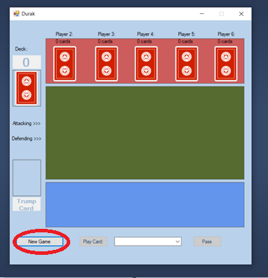

**Configuring the Game Settings**

Upon clicking the “New Game” button, a “Game Settings” form will pop up with options for the number of players in the game (ranging from 2 – 6 players, including the user) as well as number of cards in the deck. Make a choice and click Start. You can also click Exit to return to the main window.

**NOTE: The 24-card deck is disabled for 5 and 6 player games since there are simply not enough cards in the deck to support that number of players. Options in this form will disable and re-enable themselves automatically depending on what is currently selected.**

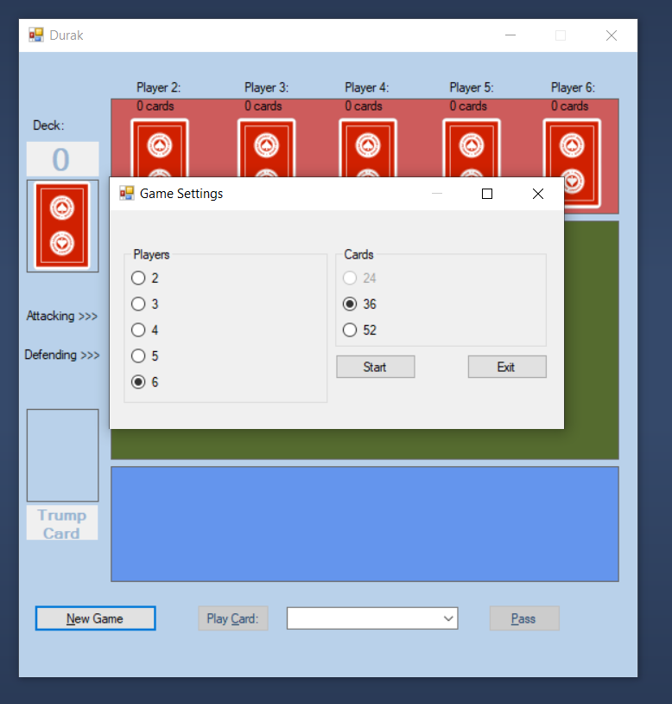

**The Game Begins!**

The game has begun! In the image below, the game has been set up for a 36-card deck with 4 players. Note how players 5 and 6 have 0 cards despite this being the first bout of the game.

At the bottom of the window, below the user’s hand and the drop-box representing that hand, the game will indicate when it is the user’s turn, and whether they are attacking or defending. Play cards by either selecting them from the drop-down box and hitting the “Play Card” button, or by clicking the card within your play area. If an attempt is made at an illegal play, a Message Box will pop up to that effect. Choose a different card and try again. If there are no legal (or desirable) plays, press the “Pass” button to pass the turn.

**NOTE: The number of cards remaining in the deck is displayed in the label over top of the deck (12, in this case) while the trump card is displayed underneath, always clearly visible to the player.**

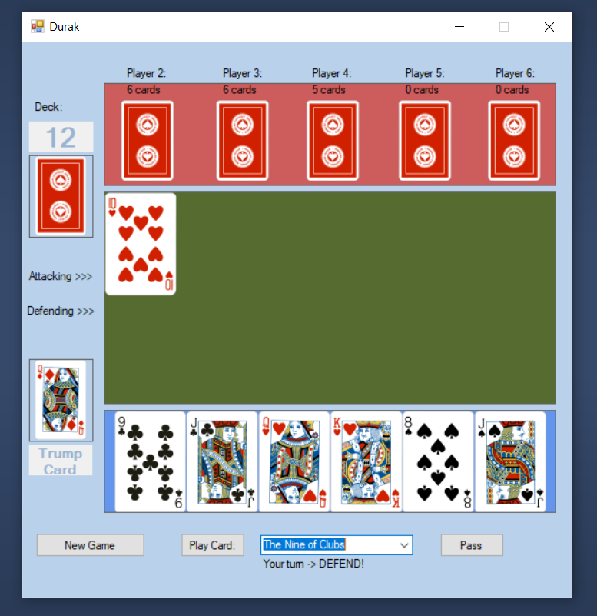

**The Game Ends!**

The game ends when no cards remain in the deck and every player has run out of cards… except for that 1 unlucky person. As you can see, the players Player 2 through Player 6 are at 0 cards. This means that you, the user, are the loser of this game. The MessageBox pops up to notify that the game is over and specifies who is the loser – a.k.a. the “durak”.

**NOTE: When the Trump Card is drawn, a new label appears overtop of it specifying which player drew that card. However, the card image remains visible so that the player can always see what the trump suit is.**

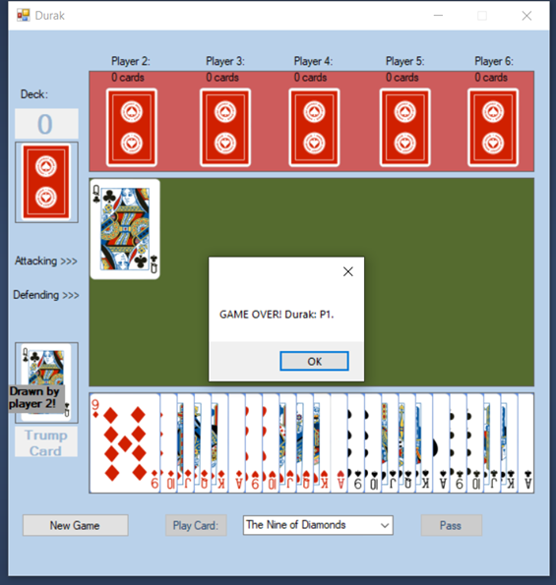

**Starting Another Game?**

Whether you have just lost a game or won your game, or whether you just want to give up the current game and start again, you can click the “New Game” button at any time to bring up the “Game Settings” form. Creating a new game will scrap the currently played game in favour of an entirely fresh start.

**Exiting the Game**

Durak can be exited or closed at any time by clicking the ‘X’ in the top right corner of the main window. (Clicking the ‘X’ in the top right corner of the Game Settings menu or of any pop-up Message Box will simply close that particular pop-up, returning you to the main window.)