**Final Project report**

**Oakland Assist**

**Paul Hudzik | Nick McWHerter | Eric Giannetti | James Walker | Zachary Miller | Ryan Dehem**

1. **Abstract ( 1 page)**

**Problem:** There currently are no social event tracking applications specific to Oakland University.

**Solution:** In light of this, we sought to develop the first event scheduling and location tracking application of its kind. It allows users to place on a map general locations (points-of-interest) where events are held, with specific details.

**Purpose:**

* Apply structured analysis and design methods.
* Analyze and design object-oriented systems.
* Compare and choose appropriate methods, tools, and techniques for Systems analysis and design.
* Collaborate as a team member in analysis and design activities.
* Plan and manage information system projects throughout the development life cycle.

b) to analyze a problem, and identify and define the computing requirements appropriate to its solution;

c) to design, implement and evaluate a computer-based system, process, component, or program to meet desired needs;

d) to function effectively on teams to accomplish a common goal;

i) to use current techniques, skills, and tools necessary for computing practice;

j) to use and apply current technical concepts and practices in the core information technologies of human computer interaction, information management, programming, networking, and web systems and technologies.

k) to identify and analyze user needs and take them into account in the selection, creation, evaluation and administration of computer-based systems.

l) to effectively integrate IT-based solutions into the user environment.

**Conclusion:** Through our endeavors, we largely achieved our goals and created a working prototype of our vision. The skills we learned through class lectures, and through working as a team, helped us design and implement our ideas.

**2-Introduction: background, details of problem, significance, related works, team contribution (maximum 2 pages)**

We thought of this idea for organizing Oakland University events because it represents a strong real-life business case in that there are tons of events at Oakland University but when we asked ourselves when and where these events were we didn't know.

We concluded that for our business case it was clear that there was a need a tool that would allow students to see when and where there are events happening on campus. Our project let us practice gathering requirements and designing a software solution to solve the problem of locating on-campus events in the above situation. For example, a requirement of our project may be that event organizers, university students, and faculty all need to know where an event is scheduled to occur. As part of our design process we could choose to implement a GPS map that would allow users to see where they are on campus and see the locations and schedules, and potentially even directions to events near them. We would also get an opportunity to practice the various software development principles you discussed (Waterfall, Agile, etc.) while using an Android development environment which will prove very valuable for future mobile software development.

At the beginning of the course, we weren’t sure what we were going to be able to accomplish being that none of our team members had a strong programming background. Since Nick already had some experience with Android Studio, we wanted to develop a useful mobile app for Oakland University students. Currently, students have to follow different mediums to learn about events on campus, whether it be Facebook, Oakland’s Website, or Individual Student orgs. Without a central hub for events on campus, it can be hard to decide as a student what you can do in your spare time at Oakland.

Fortunately, Nick was able to balance the coding aspect of the project, while the design and analysis portions were distributed amongst the team. The different backgrounds and skills of us complemented each others’ well. We had good communications, and very few problems outside of general design disagreements.

Overall, the project turned out to be a success in that we have a functioning prototype that may lay the foundations for future applications of its kind.

**3-Project planning and requirement specification (selected material from Home assignment 1)**

**Requirements**

Must Do:

* Beacons must connect with android app
* Beacons must send data to android app
* Beacons must last at least several weeks on batteries unattended
* Admins must be able to change data being sent from beacons

Should Do:

* App should be convenient to open
* Beacons should be placed in convenient locations
* Beacons should be easy to service and replace
* Beacons should be able to be programmed easily by admins
* Beacon batteries should last months to years

Could Do:

* Be used for special events around campus
* Have different settings based on different user groups

Won’t Do:

* Integrate with gps or google maps
* Allow standard users to modify existing and school sponsored beacon data

Constraints:

* MUST connect with the android app
* MUST send data to android app
* Beacons MUST send data to the android app
* Beacons MUST last more than a few weeks on battery unattended
* Beacons MUST be able to be managed and modified by administrators

**4-Project Analysis (structured and object oriented) see home assignment 2 and 3**

**Data Flow Diagrams:**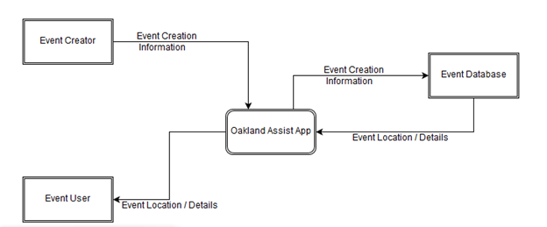

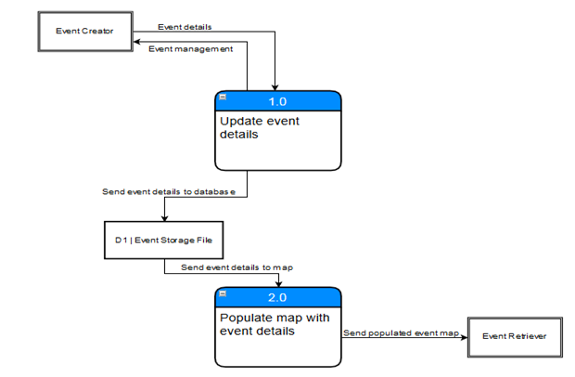

**Sequence Diagram:**

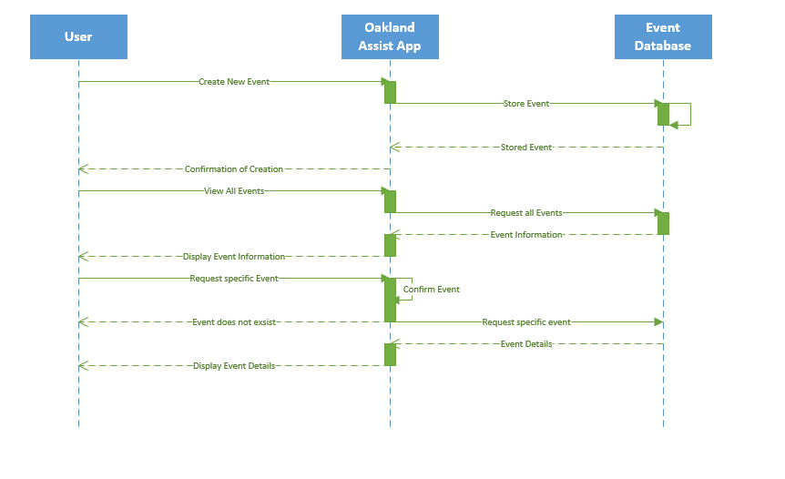

**Use Case Diagram:**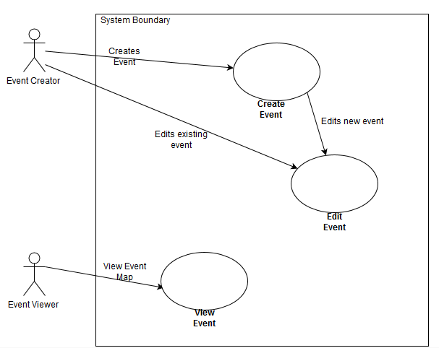

**5-Project Design specification**

**Design Specification: Map View**

**1. Narrative Overview**

a. Interface/Dialogue Name: Map View

b. User Characteristics: Users will view the map and event locations

c. Task Characteristics: Used to graphically show events

d. System Characteristics: Uses google maps GUI

e. Environmental Characteristics: Android Touch Controls

**2. Interface/Dialogue Designs**

a. Form/Report Designs: GPS Pins show event locations

b. Dialogue Sequence Diagram and Narrative Description:

The Map view will have GPS pins that can be selected to create a dialog that shows Event, building names, etc.

Map>Pin Details.

3. Testing and Usability Assessment

a. Testing Objectives: Ensure map interface is usable

b. Testing Procedures: Allow users to attempt to navigate the map and select and event.

c. Testing Results

I. Time to Learn: Low time to learn, users are familiar with google maps GUI

II. Speed of Performance: Speed is satisfactory.

III. User Satisfaction: Users enjoyed the easy and familiar experience.

**Design Specification: Event List View**

1. Narrative Overview

f. Interface/Dialogue Name: Event List View

g. User Characteristics: Users will view the events in a list format

h. Task Characteristics: Used to show events and details

i. System Characteristics: Uses a list

j. Environmental Characteristics: Android Touch Controls

2. Interface/Dialogue Designs

c. Form/Report Designs: Report shows the events and their time, location, date

d. Dialogue Sequence Diagram and Narrative Description: N/A

3. Testing and Usability Assessment

d. Testing Objectives: Ensure list is clear to users

e. Testing Procedures: Allow users to attempt to view the important event details.

f. Testing Results

I. Time to Learn: Low time to learn

II. Speed of Performance: Speed is satisfactory.

III. User Satisfaction: Users were able to read information, may increase text size

**6- 1-2 page Summary of Project Implementation done and architecture/complete plan (home assignment 06) and others self-studied material & pseudo code of algorithm:**

**Implementation Plan:**

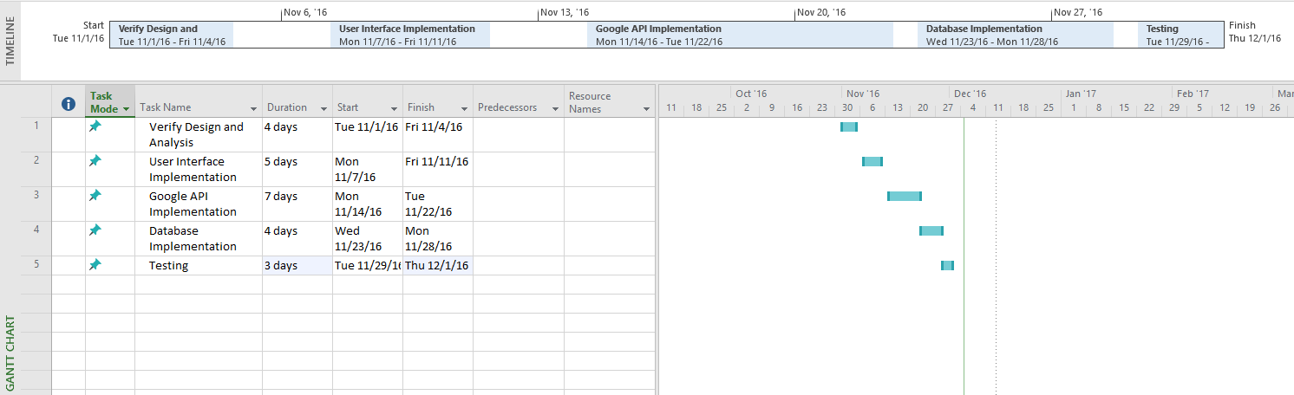

**Our plan for implementing this project is to follow the AGILE method of coding and to use the various software development strategies that we learned about throughout this course. We plan to develop this project using group meetings as well as individual coding. Nicholas McWherter is our lead programmer and he coded the vast majority of the application, however we did involve the entire group throughout many group meetings.**

**The first step in planning this program implementation is to ensure that all of our design and analysis is correct and will be applicable to our program. We will go over all of our class diagrams, state diagrams, sequence diagrams, and discuss as a group about if changes should be made. Once we verify that our design specifications are satisfactory for the first iteration we will begin coding.**

**After verifying our design, the first area of the program that we will begin coding will be the User Interface. We will use our previous mock design diagrams in order to code our fully working interfaces for the application. For this step we will need to use the Android UI tools and functions such as using Android toasts to display various system messages.**

**With the UI complete we will be able to focus on the integration of our Google Maps API and setting that up to be specific to Oakland University. We will need to become familiar with the API and implement our necessary functions such as locking the map to OU’s area and including numerous GPS pins that will be used to identify buildings. This part of the coding will be very important as it will serve as the base for the rest of our app’s functions.**

**Once we have setup our Google API we will begin working on connecting our project to the database. We will be using firebase as it has integration with android and we will be able to allow users to send in event details and locations. This will also allow us to continue with future programming to allow users to track their own events and setup their own personal schedules.**

**With all of that complete we will begin extensive testing of our application and ensure everything is ready for a production environment. Following the testing we will release our program and be ready for any future issues and development that may be needed.**

**(Implemented Code is attached to the moodle submission)**

**How grading of project will be done (see syllabus and details below):**

**Average of presentations of HW1 to HW6 (30%)**

**Documentation and Implementation (as per defined in syllabus): planning (20%), analysis and design (65%), coding (15%)**

**Extra credit: 10-15 points towards Final Grade for successful working prototype. This means if you didn’t get 10% in class participation or unable to get good grade in mid-term or Final, still one can get >= B+ grade in this class.**

**Appendix A**

**Course objectives (select those that are achieved). Do ensure that you selected only that you achieved.**

* **Apply structured analysis and design methods.**
* **Analyze and design object-oriented systems.**
* **Compare and choose appropriate methods, tools, and techniques for Systems analysis and design.**
* **Collaborate as a team member in analysis and design activities.**
* **Plan and manage information system projects throughout the development life cycle.**

**Course Outcomes (select only those that you achieved).Do ensure that you selected only that you achieved.**

**a) to apply knowledge of computing and mathematics appropriate to the discipline;**

**b) to analyze a problem, and identify and define the computing requirements appropriate to its solution;**

**c) to design, implement and evaluate a computer-based system, process, component, or program to meet desired needs;**

**d) to function effectively on teams to accomplish a common goal;**

**e) An understanding of professional, ethical, legal, security, and social issues and responsibilities;**

**f) to communicate effectively with a range of audiences;**

**g) to analyze the local and global impact of computing on individuals, organizations and**

**society;**

**h) Recognition of the need for, and we will be able to engage in, continuing professional development;**

**i) to use current techniques, skills, and tools necessary for computing practice;**

**j) to use and apply current technical concepts and practices in the core information technologies of human computer interaction, information management, programming, networking, and web systems and technologies.**

**k) to identify and analyze user needs and take them into account in the selection, creation, evaluation and administration of computer-based systems.**

**l) to effectively integrate IT-based solutions into the user environment.**

**m) An understanding of best practices and standards and their application.**

**n) to assist in the creation of an effective project plan.**