**Robotics: Assignment III**

(Team Assignment)

Robot Vision

Due: 2021/12/13 13:00 pm

Cameras are one of the most commonly used sensors for a robot to gather visual/spatial information of its environment. With the help of image processing, a robot can analyze the image of the immediate

environment imported from the camera and use the result to determine the appropriate action to take.

In this assignment, you will learn how to model the relationship of an image and the real environment with camera calibration and how to use the camera model to estimate the position of an object in the real world.

**Part A: Camera Calibration**

Camera calibration is the process of estimating the parameters of a pinhole camera model, such as focal length and principal point. This process is required for cameras before doing image processing. In this part, you should get familiar with the camera model, and the meaning of camera parameters.

1. There is a C/C++ implementation in OpenCV library [1]. For those who use OpenCV first time, you can refer to [2]. Follow the example code it provides. If you are more familiar with MATLAB, you can also download the toolbox [3].
2. Print the checkerboard pattern in **“AssignmentIII\part_a”** on a sheet. Measure the physical size of the squares.
3. Find a camera that you want to calibrate, e.g. your phone’s camera, webcam etc. Use the camera to capture 20 images with checkerboard for calibration. Try to shoot from different angle for each image. Please provide a clear description about what camera you use.

*Note: Usually, commercial cameras – such as those found in cellphones, laptops, etc. – have an autofocus feature which will change the intrinsic parameters of the camera dynamically. You must disable this feature when taking pictures your calibration dataset to get a satisfactory result. For Android devices, if your default camera app cannot disable it you can try the Camera FV-5 Lite app.*

1. Follow the instructions on the webpage to get all the intrinsic parameters. Write down your results and describe how do get it. Second, please interpret the physical meaning of each intrinsic parameter in your report in your own words. For those who use MATLAB, please refer to

http://www.vision.caltech.edu/bouguetj/calib_doc/htmls/example.html

1. Undistort the 20 images you captured and a new image of another object. Show those 21 sets of original and undistorted images in report and briefly comment what is the effect of this transformation.

**Part B: Object Detection**

Given an image taken from a camera, please use the algorithm you have learned in the section of binary machine vision of Lecture 6 (p.36- p.41) to write a program to process the image and to mark the foreground object(s). We have provided some examples of basic image processing functions in OpenCV (main.cpp). For MATLAB users, you can find corresponding functions in the MATLAB Toolbox[3].

<http://www.vision.caltech.edu/bouguetj/calib_doc/>

**Input Image:**

We provide 4 images in **“AssignmentIII/part_b/images”** for testing. Your program should take the file name of the image from the standard input.

**Output Results:**

Your program should output the coordinate of the centroid, principal angle and principle line of all the object(s) in the following format and print the pixel coordinate on the image either.

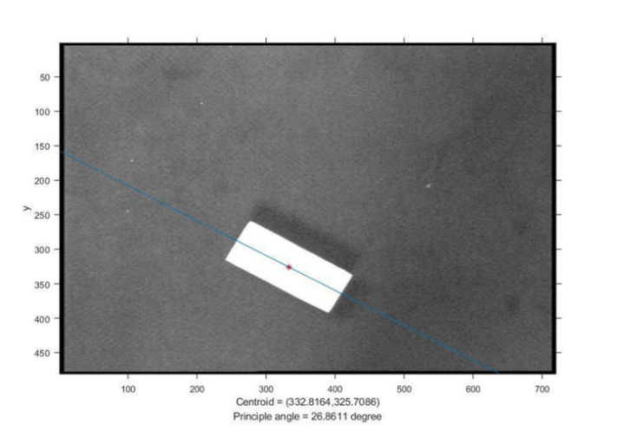

**Submission**

Upload the source code of Part A (hw3_a.cpp/hw3_a.m/hw3_a.py) about how do you get intrinsic parameters of your camera, Part B (hw3_b.cpp/hw3_b.m/ hw3_b.py) and your team report (hw3_report.pdf) in a zip file (hw3_your group.zip) to NTUCOOL. **Only one member per team should submit the file.** Please make sure your code can be successfully built and run before submission. Late submission will not be accepted.

**Evaluation Criteria**

* Report in English
* Brief and concise
* Define the division of work within your team

**Reference**

[1] Camera Calibration and 3d Reconstruction in OpenCV

http://docs.opencv.org/master/d4/d94/tutorial_camera_calibration.html

[2] “A very brief Introduction to OpenCV.ppt” in Files/AssignmentIII/ on NTU COOL

[3] Jean-Yves Bouguet. Camera Calibration Toolbox for MATLAB

**Suggestion**

This work will be implemented on a robotic arm in assignment 4. You will use the Robotic Operating System (ROS) to control the arm. The ROS can be only coded with python and C++. It is recommended that you use python to complete this assignment.