# header

# Test Procedure For Control4 Rev111

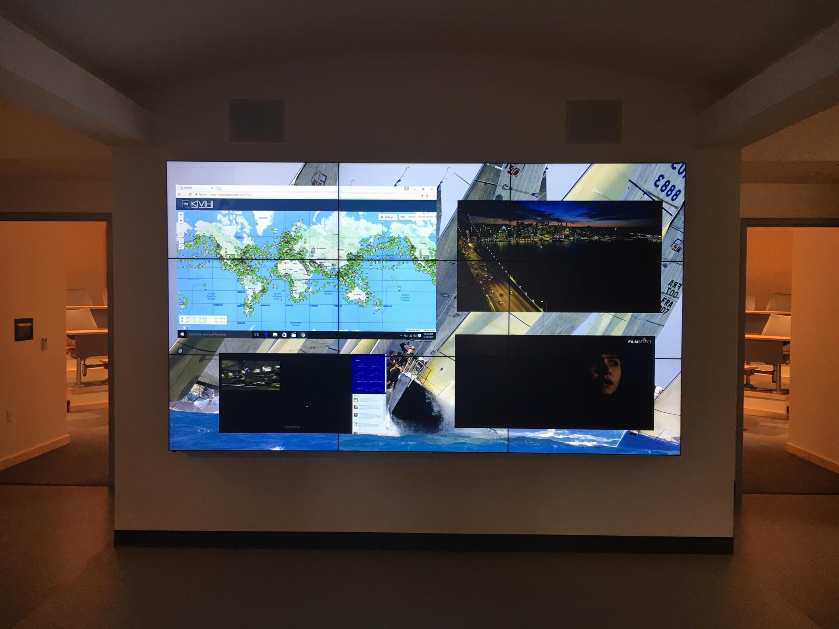

## Initial test setup

The initial test setup should start without the Skreens AV proxy installed. To verify this, execute the follow steps:

* Open the Composer application.
* Connect to: Local System.
* Double click on the Control4 IP address.
* Look in the system design window for Skreens AV.
* If it is already loaded, right click on it and press delete.
* Close Composer and cycle the power on the C4 unit.

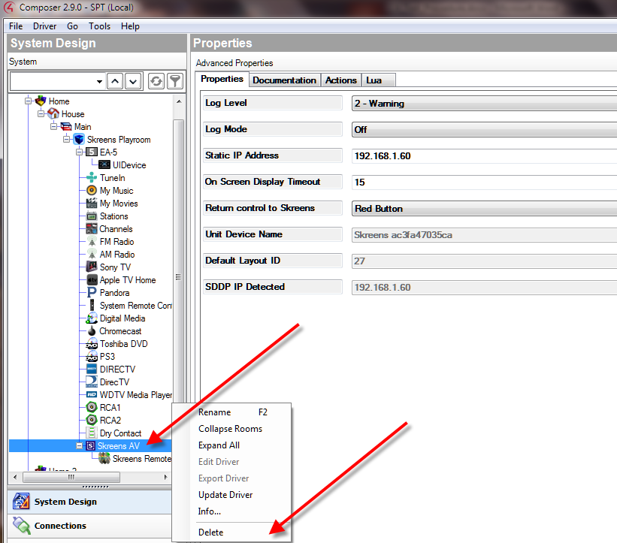

## Skreens SDDP process running and detected by C4 test

Restart Composer just like the steps in section 1.1

The Kai unit has a SDDP process running that broadcasts it’s IP address continuously based on the information found in a file called sddp.conf located in the /etc directory. If the process is running and all the values in the config file are correct, you should see an entry in the Items window, Discovered tab. If this entry is not there, something is wrong with the SDDP process, or the sddp.conf file has issues.

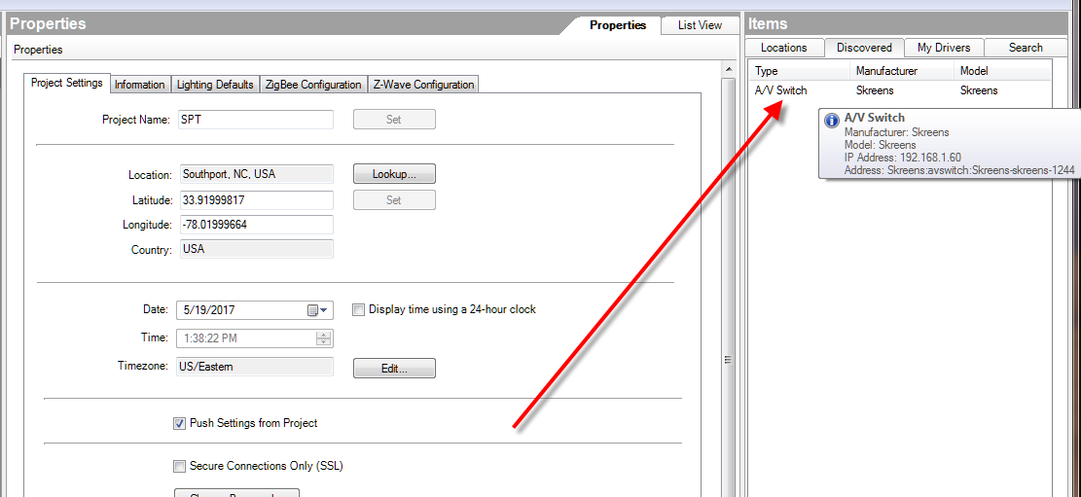

If this entry is listed, double click on it, and the Skreens AV proxy driver will automatically get loaded into the System Design window.

## SDDP connections to the Skreens AV Device test

Click on Connections, and then Network. In the IP Network Connections window, you should see the Skreens AV Device listed.

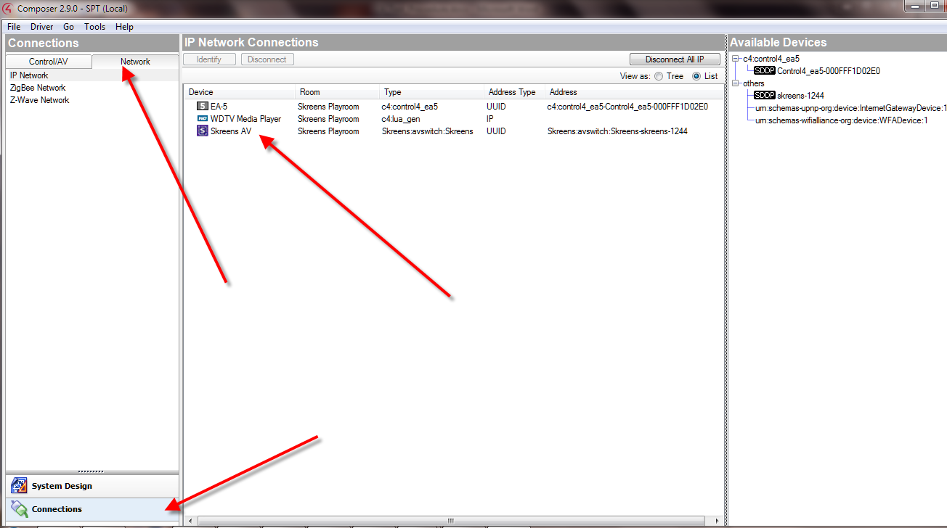

Click on the Skreens AV entry and press Identify on the top of the window. You should get a pop that looks like this.

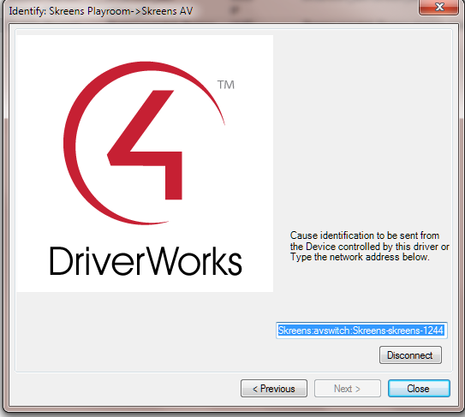

Next press disconnect, and then close. You should see that address field for the Skreens device get cleared. In the available devices window, you then drag and drop the SDDP Skreens device over to the IP Network Connections window and place it on the Skreens AV Entry.

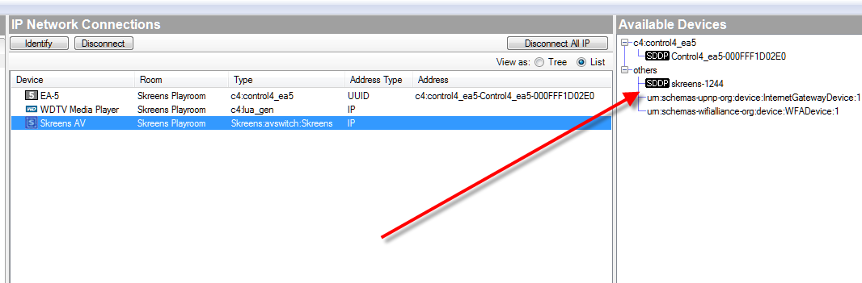

Click on the Skreens AV icon in the system design window, and select the properties tab. At this point the Skreens AV proxy driver now knows what the Kai’s IP address is from the SDDP logic.

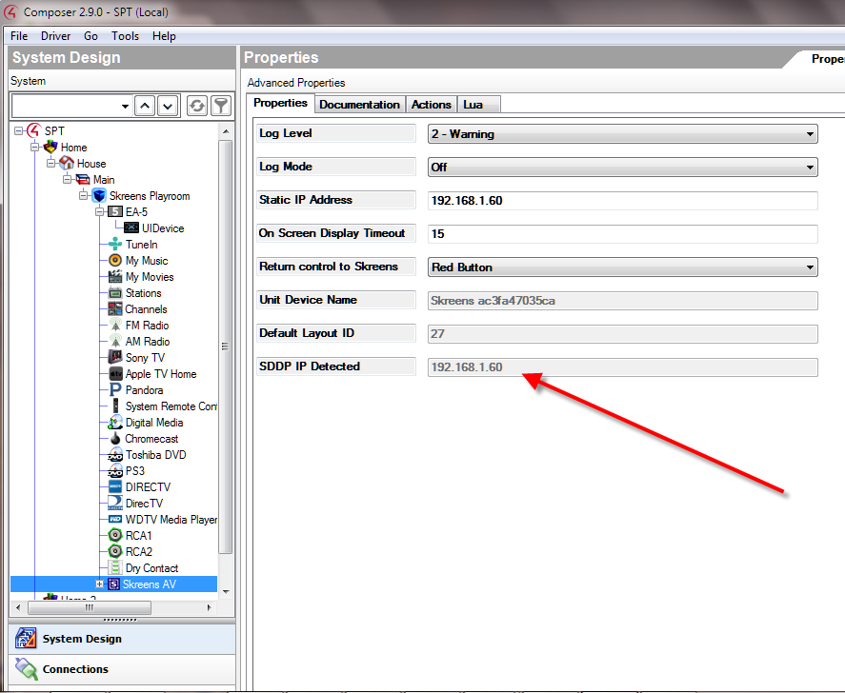

## SDDP Notify Alive, Search Response test

Press Tools, and then System Manager. This will open up a separate window. Press the SDDP Trace tab. Here you should start getting SDDP trace entries. They could be Search, or Notify Alive entries. Click on the first search response entry and you will see on the right an entry called Max-Age. This is the amount of time in between Notify Alive entries. Make sure this time is approximately correct. I’ve found that it is a little quicker than the defined time. Also on the bottom right, check for no errors found.

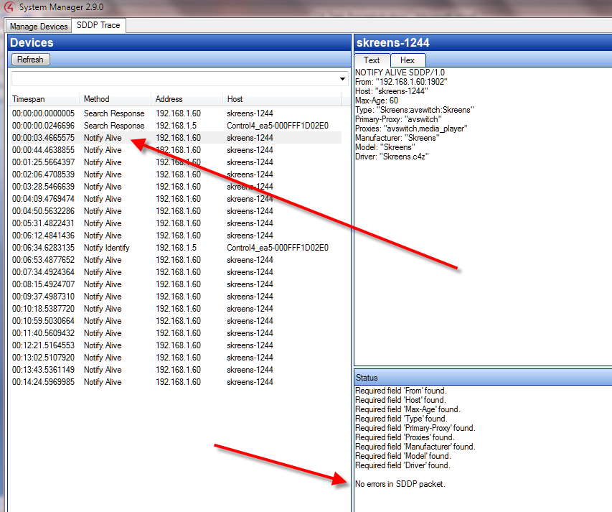

## Hooking up devices to the Skreens AV Proxy

During the previous steps from section 1.1, we deleted and reinstalled the Skreens AV proxy. This also deleted any previous devices that were connected to the Skreens AV proxy. On the C4 remote or apps, press the watch button. There will not be an entry for any Skreens devices. So now we need to hookup a few devices to our proxy.

Here is an example of connecting an apple TV to the Skreens device on HDMI 3. Select Connections, and then press Apple TV. On the right Drag and drop the HDMI output to the Skreens AV Source #3.

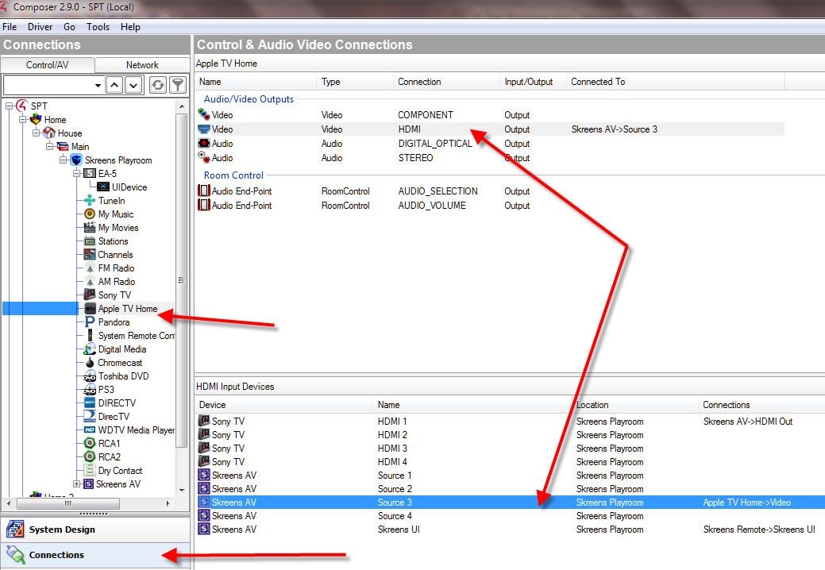

## Hooking up the Skreens AV Proxy to a TV

Here is an example of connecting a Sony TV HDMI input 1, to the Skreens device output. Select Connections, and then press Sony TV. On the right Drag and drop the HDMI input 1 to the Skreens AV HDMI Output.

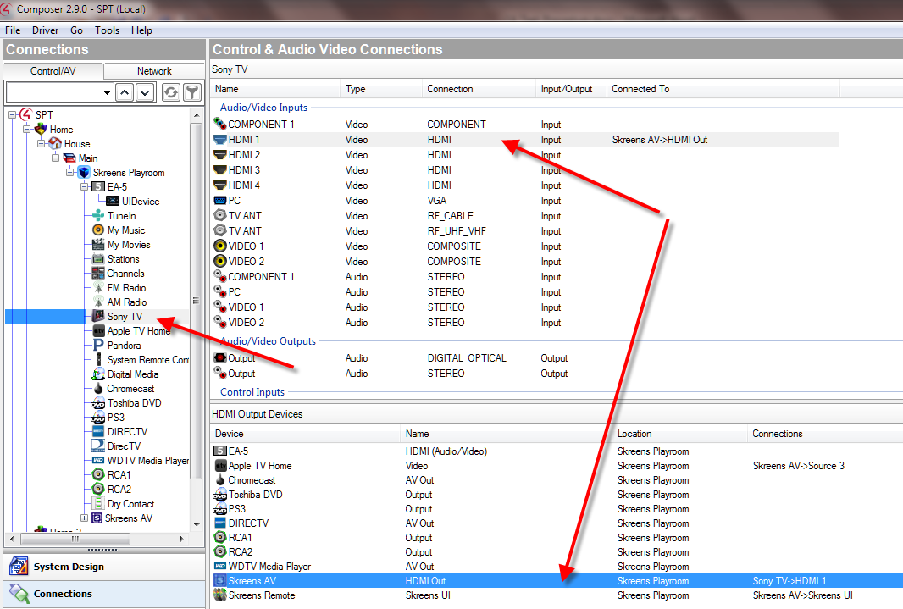

After all connections are made, restart Composer before continuing.

Press FILE, and then Refresh Navigator to sync up the remote or app with the current connections. Now when you press the watch button on the remote, you should see 2 Skreens proxies. Select Skreens Remote, and you are now ready to control OSD layouts.

## Return control to Skreens Test

When you use an app or the remote, and want the ability to press a single key to return back to the Skreens proxy, this option will give you the choice to assign a single key.

When a layout is loaded, the Skreens Remote proxy gives up control to allow the selected device take control. To allow the Skreens proxy to obtain control back, you can select one of the 4 special keys used to perform this operation. Select a few of these keys and test to make sure that operate properly.

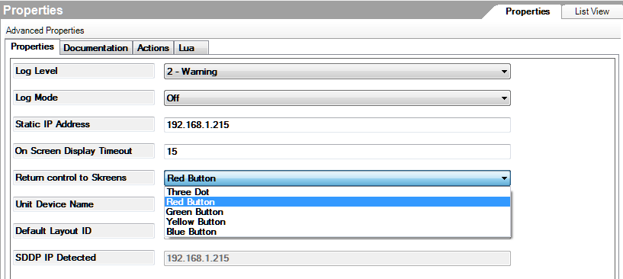

## OSD Device Names Test

Press Connections, and then SkreensAV. Look that 4 AV inputs listed on the right. With the remote press INFO. The Names on the display should match.

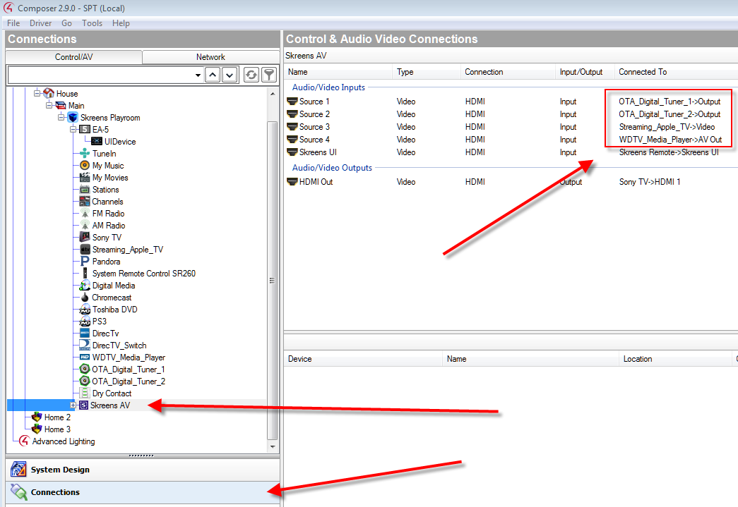

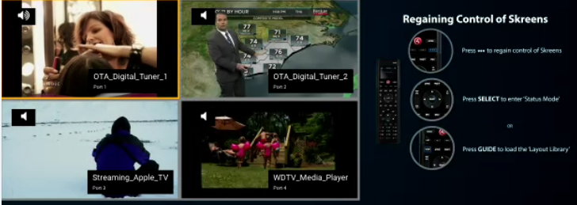

## One Screen Display Timeout Test

Whenever any of the On Screen Display modes are initiated, the display will remain active for a preset time before timing out and canceling. This time period is based on the remote being idle for the entire timeout period. Any remote navigation will reset the timeout back to the beginning of the timeout period.

Press System Design, and then SkreensAV. Click on the properties tab and check the On Screen Display Timeout value. Press the INFO button on the remote or app. Count the number of seconds the INFO OSD is present. It should match our timeout value.

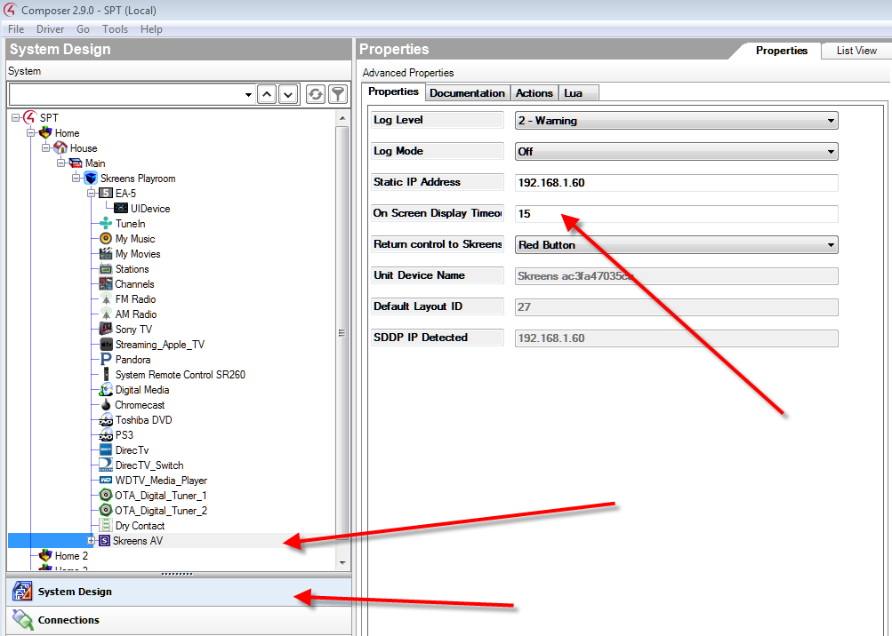

## LAYOUTS Control Test

At this point we will start using the C4 remote. On the remote press the “WATCH” button, and select “Skreens Remote”.

Press the GUIDE key on the C4 remote, or the EJECT key on your smart phone app or the PC/MAC App. A series of layout diagrams appear on the bottom of the display. Here you can navigate to a specific layout using the left and right arrow keys, and make your selection by pressing SELECT. Select a few layouts to make sure they get loaded properly.

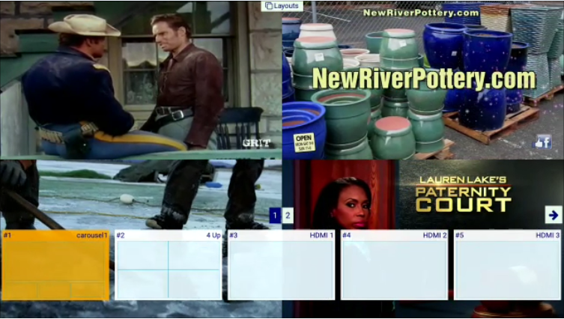

## STATUS Control Test

Status control is initiated by pressing the SELECT key when no other OSD mode is selected. A yellow frame will appear to determine which window has the focus. The right and left arrow keys are used to navigate to other windows.

At this point, you can either press the SELECT key to move the audio to the currently selected window, or you can press the PLAY key to bring the currently selected window to full screen. For either of these operations, the audio will follow the selected window. Test both PLAY and SELECT operations.



## SWAP Control Test

Swap control navigation uses the CH+ and CH- keys to swap windows from one position to another. The example layout below illustrates how to watch a program of interest in a large window, and when another interest starts playing, you can quickly swap windows to start watching the other program in the large window.

Select a multiple window layout similar to the one below, and press the CH+ and CH- to test this feature.



## INFO Control Test

INFO Control displays the video content for all 4 inputs, plus an illustration of the remote control layout.

Press the INFO button on the remote or app, and you should see the display look something like the picture below. Use the left and right arrow keys to navigate through each of the 4 input devices. Press SELECT, and the selected device should go to full screen.

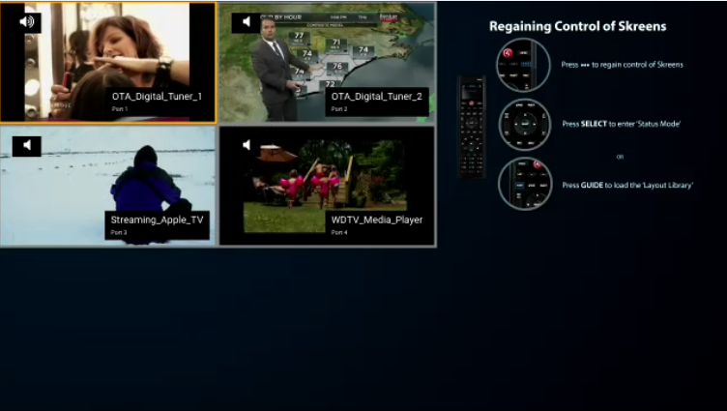

## Selecting a default layout Test

To obtain a list of available layout and associated IDs, select the “Actions” tab, then select “Select Default Layout”. A window will pop up that has an entry for “Layouts”. By pressing the 3 dot button in the upper right corner, a second window will pop up with a “Layout Inventory “ list of available layouts. Select the layout that you want for the default layout and press OK.

Startup a web browser and enter the URL <http://kai_ip/web>, where kai_ip is the IP address of the kai unit being used for this test. Navigate to the CHOOSE A LAYOUT page. Make sure that the default layout you selected is highlighted with a yellow star. If no layouts are displayed try reloading the driver, or restart Composer, then try this again.

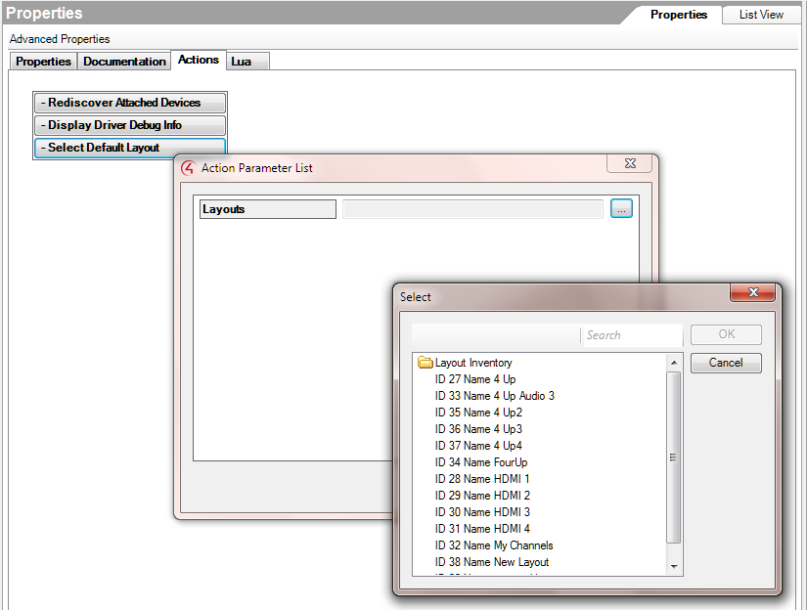

## Test Results Check List

PAGE Results Test Description

-----------------------------------------------------------------------------------------

1.1 PASS/FAIL : Initial test setup

1.2 PASS/FAIL : Skreens Verify the SDDP process is running and detected by C4 test

1.3 PASS/FAIL: SDDP connections to the Skreens AV Device test

1.4 PASS/FAIL : SDDP Notify Alive, Search Response test

1.5 PASS/FAIL: Hooking up devices to the Skreens AV Proxy

1.6 PASS/FAIL : Hooking up the Skreens AV Proxy to a TV

1.7 PASS/FAIL: Return control to Skreens Test

1.8 PASS/FAIL : OSD Device Names Test

1.9 PASS/FAIL : One Screen Display Timeout Test

1.10 PASS/FAIL : LAYOUTS Control Test

1.11 PASS/FAIL: STATUS Control Test

1.12 PASS/FAIL : SWAP Control Test

1.13 PASS/FAIL : INFO Control Test

1.14 PASS/FAIL : Selecting a default layout Test

Contents

1 Test Procedure For Control4 Rev1.0 1

1.1 Initial test setup 2

1.2 Skreens Verify that the SDDP process is running and detected by C4 test 3

1.3 SDDP connections to the Skreens AV Device test 4

1.4 SDDP Notify Alive, Search Response test 7

1.5 Hooking up devices to the Skreens AV Proxy 8

1.6 Hooking up the Skreens AV Proxy to a TV 9

1.7 Return control to Skreens Test 10

1.8 OSD Device Names Test 11

1.9 One Screen Display Timeout Test 12

1.10 LAYOUTS Control Test 13

1.11 STATUS Control Test 14

1.12 SWAP Control Test 15

1.13 INFO Control Test 16

1.14 Selecting a default layout Test 17

1.15 Test Results Check List 18