# header

# Skreens AV QA Test For URC Rev0.87

### OSD Layouts Test

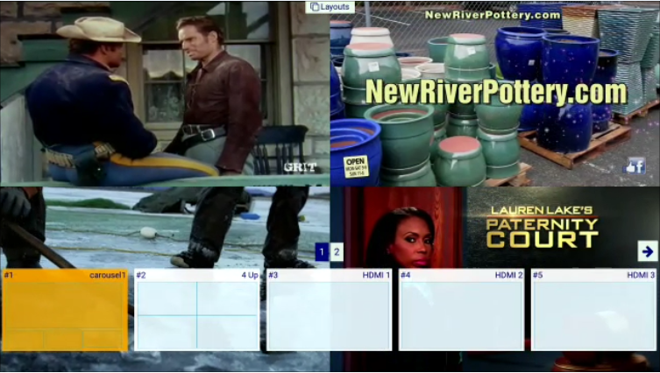

Keys used are: GUIDE, LEFT, RIGHT, SELECT, EXIT

Test 1: Press GUIDE, which will initiate “LAYOUTS” OSD mode. Press RIGHT a few times, then LEFT a few times. Navigate the layout that you want to go to full screen, and then press SELECT.

Did the selected layout go to full screen? __________

Test 2: Press GUIDE, which will initiate “LAYOUTS” OSD mode. Press RIGHT a few times, then LEFT a few times. Navigate the layout that you want to go to full screen, and then press EXIT.

Did the original layout remain the same? __________

Test 3: Press GUIDE, which will initiate “LAYOUTS” OSD mode. Press RIGHT a few times, then stop pressing keys for longer than 15 seconds. This should trigger an OSD timeout, and exit OSD mode.

Did the original layout remain the same? _________

### OSD Status Test



Using the “LAYOUTS” OSD test, Select the 4-Up layout that looks like the illustration above.

Keys used are: SELECT, LEFT, RIGHT, PLAY, EXIT

Test 1: Press SELECT, which will initiate “STATUS” OSD mode. Press RIGHT a few times, then LEFT a few times. The audio should track the window being selected. Next press EXIT to dismiss OSD mode.

Did the audio track the selected window? __________

Test 2: Press SELECT, which will initiate “STATUS” OSD mode. Press RIGHT a few times, then LEFT a few times. The audio should track the window being selected. Next press PLAY. The selected window should go to full screen.

Did the selected window go to full screen? __________

### OSD Swap Test



Using the “LAYOUTS” OSD test, select a layout that looks similar to the illustration above. One large window and others small.

Keys used are: SELECT, UP, DOWN, PLAY, EXIT

Test 1: Press SELECT, which will initiate “STATUS” OSD mode. Press UP a few times, then DOWN a few times. The smaller windows will swap places with the larger window. The large window should start with port 1, then for press UP to swap port 1 with port 2. Next UP key press with swap port 2 with port 3 etc…

Next press EXIT to dismiss OSD mode.

Did the window swap places properly? __________

### OSD Help Test

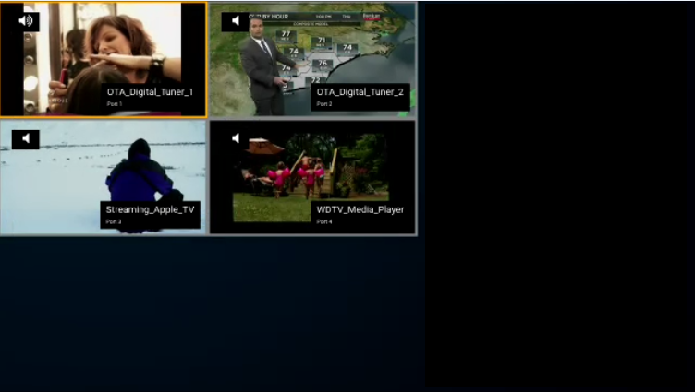

Keys used are: INFO, LEFT, RIGHT, ENTER, EXIT

Test 1: Press INFO, which will initiate “HELP” OSD mode. Press RIGHT a few times, then LEFT a few times. Navigate the port that you want to go to full screen, and then press SELECT.

Did the selected port go to full screen? __________