# header

# Skreens AV Switch For URC Rev0.86

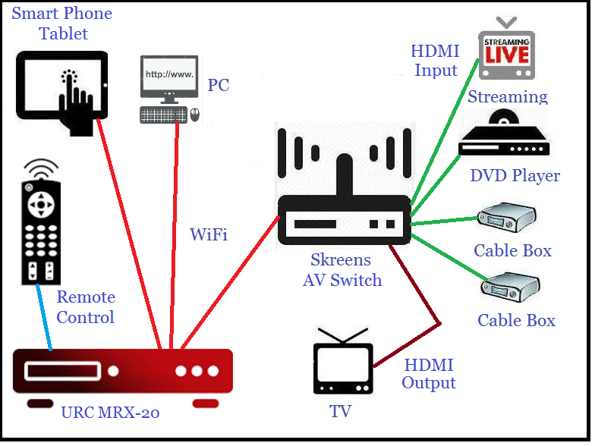

## Skreens On Screen Display Operation

The On Screen Display (OSD) control consists of 5 options: Layout, help, status, swap, and info. These 5 options are detailed below.

### One Screen Display Timeout

Whenever any of the On Screen Display modes are initiated, the display will remain active for a preset time before timing out and canceling. This time period is based on the remote being idle for the entire timeout period. Any remote navigation will reset the timeout back to the beginning of the timeout period.

### Layouts Control

Layouts control is initiated by pressing the GUIDE key on the remote, or the URC Mobile 2.0 app.

Once the layout control is initiated, a series of layout diagrams appear on the bottom of the display. Here you can navigate to a specific layout using the left and right arrow keys, and make your selection by pressing SELECT.

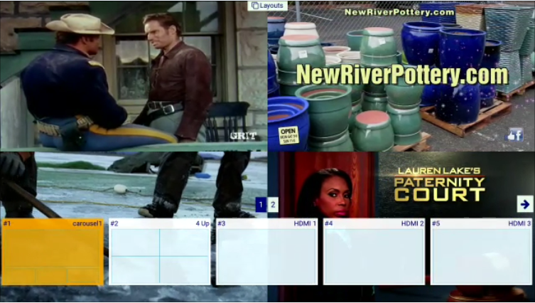

### Status Control

Status control is initiated by pressing the SELECT key when no other OSD mode is selected. A highlighted frame will appear to determine which window has the focus. The right and left arrow keys are used to navigate to other windows. At this point, you can press the PLAY key to bring the currently selected window to full screen. The audio will follow the selected window.



### Swap Control

Swap control is initiated by pressing the SELECT key to enter STATUS mode, navigation uses the UP and DOWN keys to swap windows from one position to another. The example layout below illustrates how to watch a program of interest in a large window, and when another interest starts playing, you can quickly swap windows to start watch the other program in the large window.



### Info Control

Info Control displays the video content for all 4 inputs, plus an illustration of the remote control key descriptions.

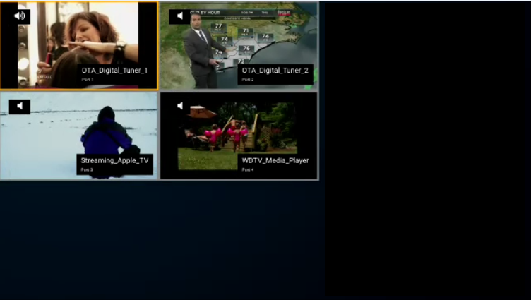

## Skreens Remote Control key definitions

Skreens remote control keys are used to navigate through a series of video screen layouts and to alter audio sources. Below is the list of keystrokes and a definition for each.

### GUIDE

Enters LAYOUTS OSD mode: Displays a layout selector strip on the bottom of the display.

### SELECT

The SELECT key has multiple functions. When none of the OSD modes are active, SELECT enters OSD status mode. If any of the OSD modes are active, SELECT is used to initiate any sequence that should be executed.

### INFO

Enters INFO OSD mode: Displays the video content for all 4 inputs, plus an illustration of the remote control definitions.

### MENU

Enters MENU OSD mode: Displays a list of other available command, like what is supported for Alexa command.

### RIGHT

While in OSD status mode: Navigates to the right by one.

### LEFT

While in OSD status mode: Navigates to the left by one.

### UP

While in OSD status mode - Swap UP sequence.

### DOWN

While in OSD status mode - Swap Down sequence.

### CH+

Sequences forward through the available layouts.

### CH-

Sequences backwards through the available layouts.

### Exit

Cancels all On Screen Display (OSD) modes.

### PLAY

While in OSD status mode: the selected window goes to full screen.

### PREV or Back

Used to jump back to the previous video/audio configs.

### SKIP+

Cycle audio selection forward.

### SKIP-

Cycle audio selection backward.

### Minus / Dot

Used as the HOME layout.