Abstract

Game engine are graphical framework that abstract the underline system dependency libraries from the game developers. Almost all game engines are well architecture and with advance build in mathematical libraries. Though before game engine; games where designed from scratch working directly with the underline system API, making then not possess portability and too much time consumption doing things over and over gain. A good examples is the Atari 2600. In most text books the building block of game engine involves a lot of sub-routines for example; Renderer engine: This is the core that deals with vertices operations and image projection on the screen. The graphical low level API that was used is the WebGL. WebGL run directly on your web browser some web browsers like Google Chrome, Mozilla Firefox have built in support for WebGL. The rendering engine used to developed the Java Swing is thee Graphics2D with support for Opengl and Direct X give two options for developers to choose what support they wants.
The Physics core is the core that deals with collision physics; determined how object interact with each others ray tracing, shadowing and lighting.
Sound core: this is the core that deals with sound management and abstract the underline operating system features. Sometimes is necessary to understand how things works and how to advance or improved on the existing ones. That is the main aim of this project. Understanding how game engine rendering system works. Nowadays users enjoy good graphics designed application with advance features that enable easy interactive mode and smooth animations.
Artificial Intelligence: Computer models mimicking human behaviours, object simulations, behavioural detection and others. Making the models look intelligent as if they think. The core responsible for such behaviours are modules into a group of subroutine called AI.
The writer will focus on how the rendering system of a game engine are developed using mathematical and physics models. It also explained some of the mathematics used and how computer models are graphical renderer to the GPU (graphical processing unit) hardware, since we are working will modern graphical hardware the graphics pipeline was explained.
The computer language of choice here is the JavaScript programming language, though one can actually used any computer language like Java, Python, C/C++ and others not mention.
Furthermore, the phony shading model was used in the rendering system for lighting and shading the world space coordinates (ray tracing, lighting and reflection and shadow).

The paper also described some brief explanation about some of the mathematics used in 2D and 3D graphics. The rendering architecture is built on the (Model View Controller)MVC designed pattern with a working prototype of the designed renderer engine.

Literation Review

Almost every modern game are build on top of a particular game engine. And all game engine or graphical user interface are designed with the help of a rendering engine. The rendering engine is what produces the images you see on your screen. If its poorly designed it process poor graphics.

So what is a game engine? Martin Skogevall defined it as “the thing that takes care of all the behind the scenes calculations and functions, everything that is not in fact the actual game, which is the idea, the script and the artworks“. Well the game engine core is the rendering engine itself. It produce the actual artworks of the game and how they are position and arrange in memory.

Despite the name game engine it does not mean it's only used for gaming applications, it can be used for any application that required graphical simulations for examples physics simulations, image processing and architectural works etc.
The rendering engine is the main concern in this project and how its works and the mathematics and physics required to build one from scratch are investigated and explained.

Why designed one from scratch?
There are many game engine some of them are very good for examples Unity,4A Engine, Corona, Frostbite and others. Most of them are not open sources meaning they are not free you have to pay for it to used it to developer a commercial application. Some are poorly documentation. Already designed game engine will not give you full controller of the somewhere and hidden the knowledge of how they works. For example when you build you game engine for you own games you have free will not afraid that tomorrow the open source company may charge or stop supporting the engine.
You have full controls and make you understand the graphical hardware better. Game developer are said to be very good in games when they understand how the hardware works.

The Graphical Hardware
Is an electronic component used to generate digit image pixels on the screen. Its mostly a computer components. Wikipedia(2015) defined it as a computer hardware that generates graphics and allow them to be display. Modern graphical hardware comes with their own CPU called the GPU which can be programmable with a Graphical Shader languages.
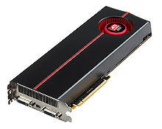

Fig. 1 Graphical Hardware (wiki,2015).

Almost everything classified as a digital computers have a graphical hardware; example are camera, television, phones and even nowadays your digit watch.
Computer graphics are improving everyday, and since processing power of the CPU is growing progressively and the invention of hardware acceleration processing unit(GPU) millions of graphics vertices can be generated per nano seconds.

In earlier computer graphics the graphical hardware are close, that means programmers where not give more privileges to controller how the hardware render their vertex(position or points, geometry location) on the screen, optimizing is only done in the CPU. Making earlier poor and slow in rendering.
There are two types of graphical cards;
1) The integrated and
2) The dedicated graphical cards.

1). The integrated graphical cards comes with the mother board fused together and share the same RAM(Random Access Memory) with the CPU usually developed by Intel for their devices. It reduces total amount of memory available for the CPU and slow your machine when your computer is processing a large images.
2). The dedicated graphical cards have its own ram and does not share the CPU ram. They are not attached to the mother board and have more processing power than the integrated graphical cards.
Users who used their application for mostly video processing are required to used that, thought is possible to have both cards in your computer by slotting a dedicated graphical cards, this will stop the integrated graphical card to stop working and all jobs will be done in the dedicated graphical cards.

Parts of the Graphical Cards

1) The video memory; this is built in the ram. Therefore dedicated graphical cards have their own video memory cause they have their own ram which make them produces a smooth graphics on the screen since they don’t share memory with the GPU. But if one uses an integrated card there the graphical card have to share memory with the CPU.

2). Display Drivers; is a pieces of software that enable the computer to communicated with the graphical card. This is becomes graphical cards have their own set of instructions or language and the computer have different set of instructions. For both to be able to understand each other the graphical card manufacturer have to developer a driver for the cards for the particular hardware operating system they are running on.

The question during my research was how do we have to program this Graphical hardware just as we do the normal computer CPU. Luckily the GPU have its own c-like language that can be used to program the hardware. This language are used just like the way we used SQL language through a main language to query a database.
The GPU programming language are as many as the normal computer languages. Those days to communicate with the GPU one have to used a graphical API such as Opengl and the Direct X API ,with the invention of GPU general purpose language like OpenCL and CUDA one don't need API to be able to program the CPU.

1) Open CL: is a graphical general programming language standards which is vendor independent supported in almost all graphical hardware. Open CL is supported in many hardware actively on Intel, AMD, Nvidia and ARM platforms.

2) CUDA developed and launch by NVIDIA 2006. its was developed to ingoing the graphical processing power GPU but to leverage parallel computer. Its allow the c programming language to program hardware.
GPU are stream processing hardware and the hardware can only be used in certain manners unlike the CPU. Even though GPU was primary developed for graphics processing purpose, they are also used to leverage parallel computing.
Stream are set of records in which each element in its are compute the same way. GPU are designed to be able to manipulated vectors and matrix, fragment and primitives per element of the stream in parallel.

For example translating every vertices of a triangle by (2,3); each vertex have to be process one by one by the GPU (Stream base processor) in parallel.

Assume the triangle have three vertex (v1,v2,v3) then each will be translated separating in parallel. You can only work with one of the data at a time. The stream power of a GPU gives modern graphical programmer more power to manipulate vertices before they can be render, mapping each element element of the triangle to the data of the Shader program reducing the computing time in parallel(Map reduction).

In our project we are going to used one of the opengl GPU language called the OpenGL Shader Language to program the GPU. The reason we are using the opengl there are a lot of built functions that will help used communicated directly to the GPU and its supported in almost every computer today.

Graphical Hardware Pipeline
The graphical hard operate in stages called the graphical pipeline sometimes refers to as the rendering pipeline. The OpenGL Shading Language book (aka "The Orange Book") as recorded by http://goanna.cs.rmit.edu.au/~gl/teaching/rtr&3dgp/notes/pipeline.html.

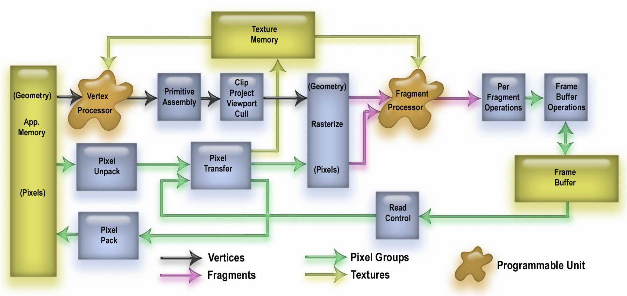

(sources: http://goanna.cs.rmit.edu.au/~gl/teaching/rtr&3dgp/notes/pipeline.html)

Rendering pipeline is a sequences of operation stages that the graphical hardware goes to render an image on the user screen. The opengl Shader language will be used in this project to program the GPU for rendering saving us platform depended codes using OpenCL directly.

OpenGL Shader language uses a Shader program to manipulate graphics and vertex, vectors lighting and able to create suffocated models with real life looks.

What is a Shader Program

Vertex Shader Program

Fragment Shader Program

Geometry Shader Program

Rendering Engine Architecture

are built was investigated and the mathematical and physics involved in building such system where also explored.

References
https://en.wikipedia.org/wiki/Graphics_hardware

https://en.wikipedia.org/wiki/General-purpose_computing_on_graphics_processing_units

