**Set UP Stage:**

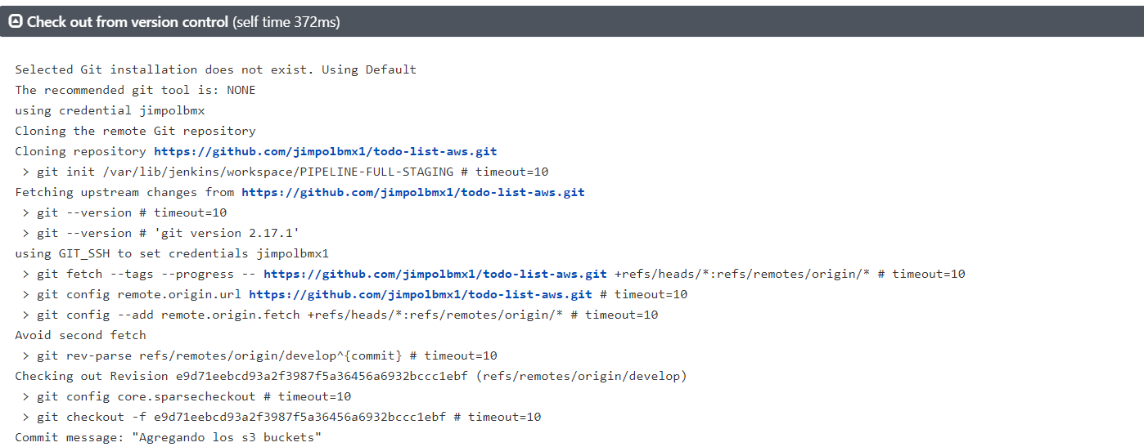

**Test Stage:**

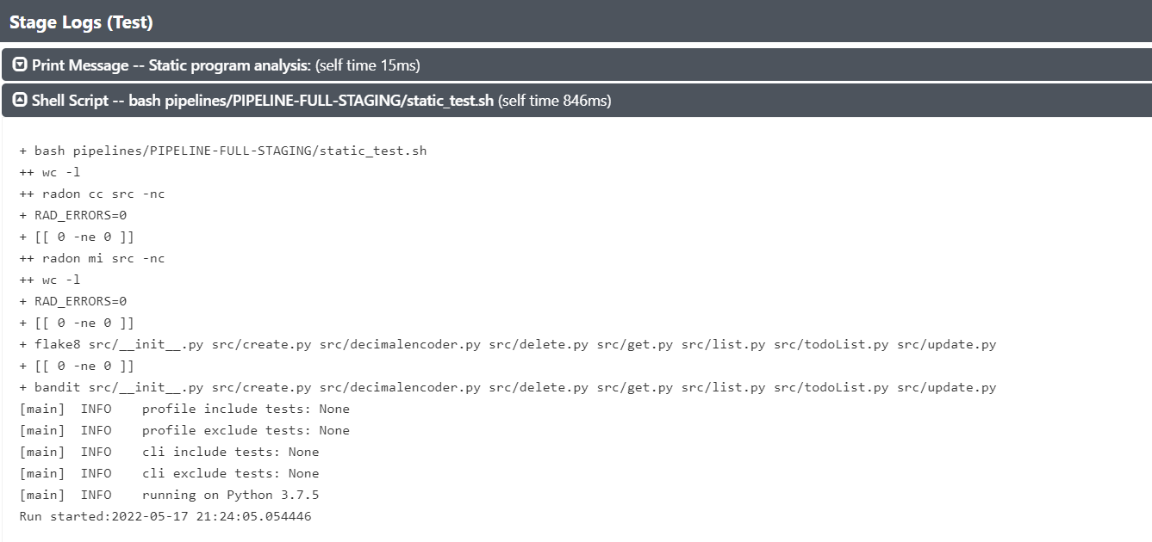

**Build Stage:**

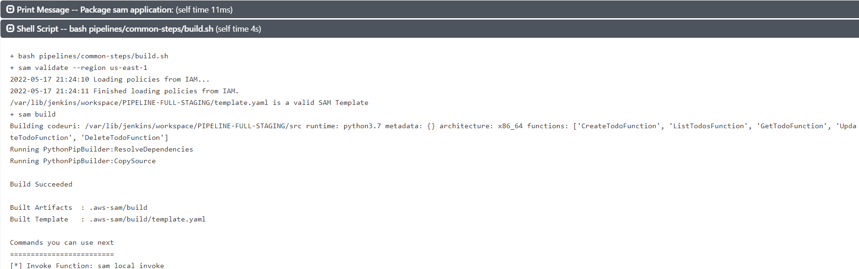

**Deploy Stage:**

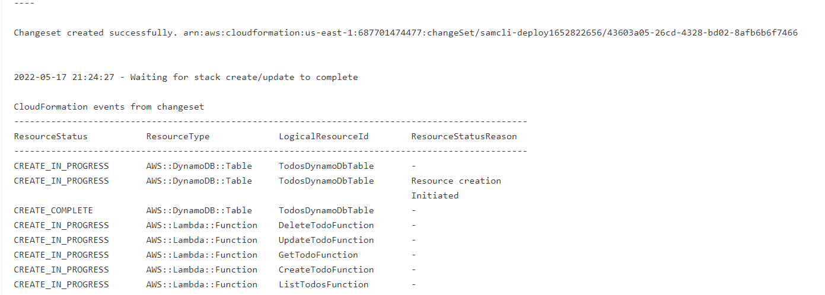

**Integration Test after deploy:**

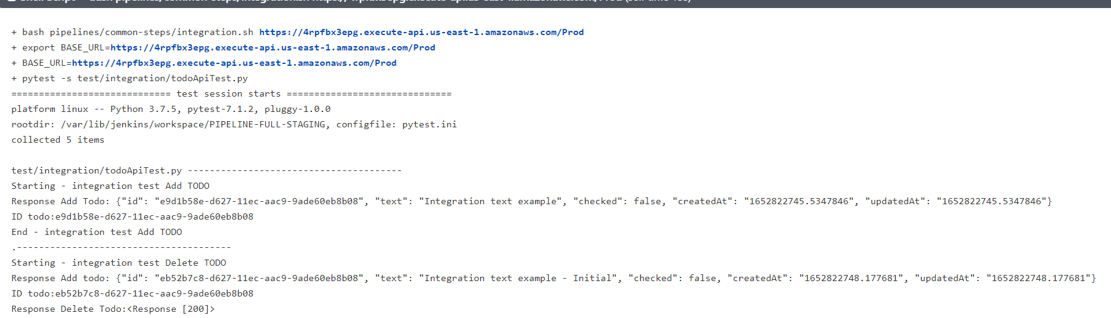

**Declarative: Post Actions:**

