James Quach

Bala Sundaram

Physics-362

9/20/2015

Assignment 1

1) 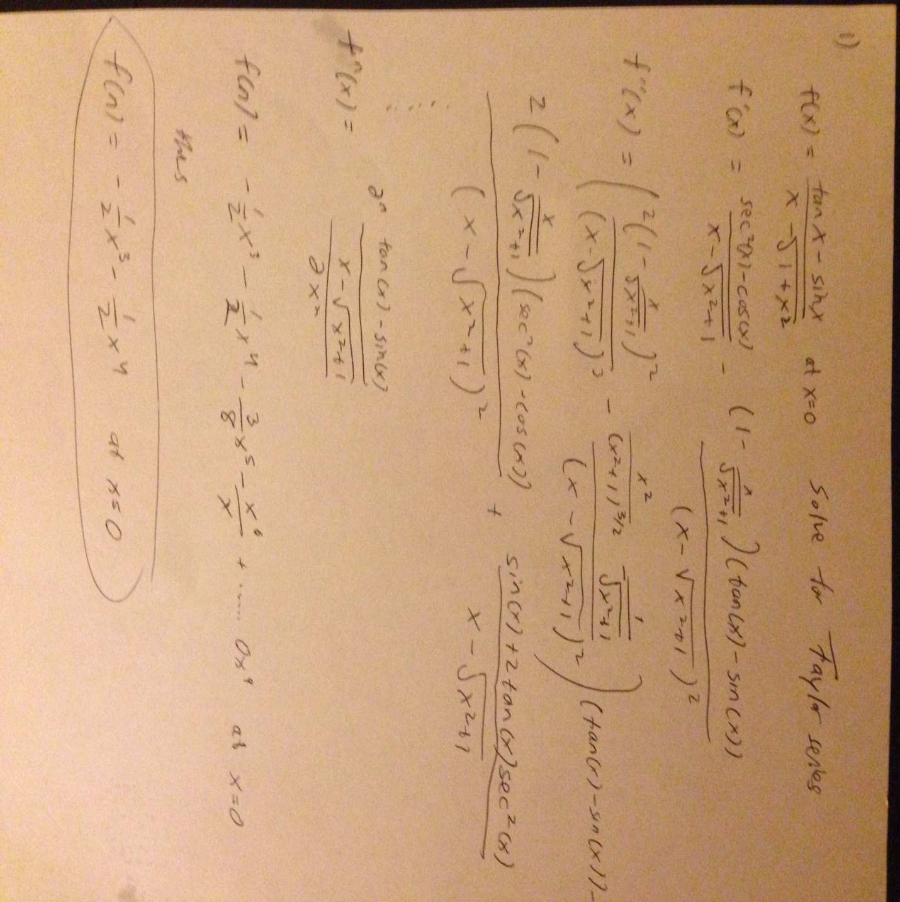

2) 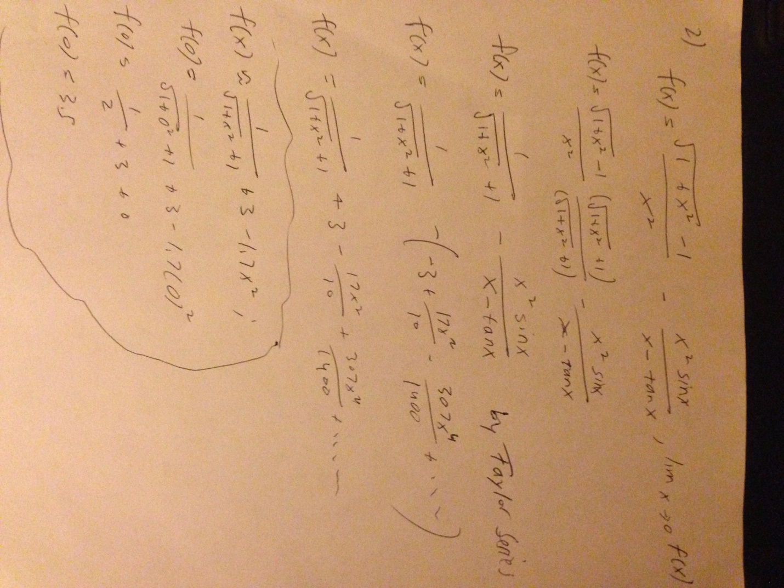

3)

a)

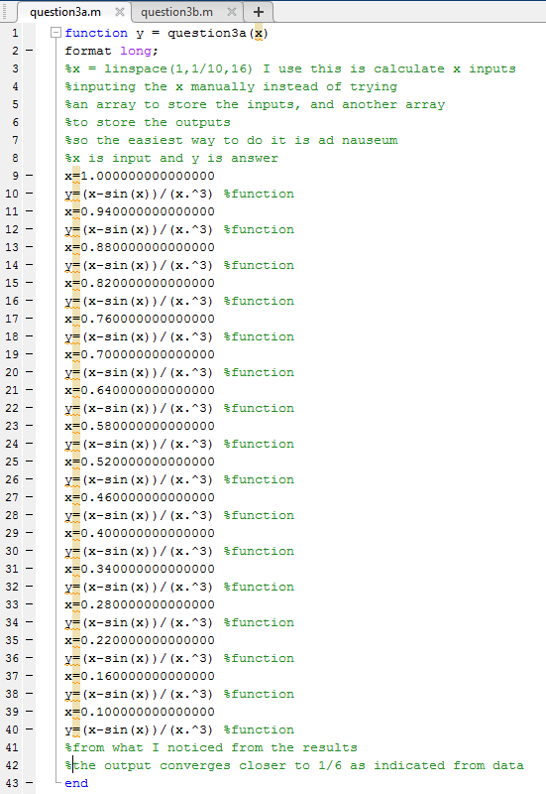

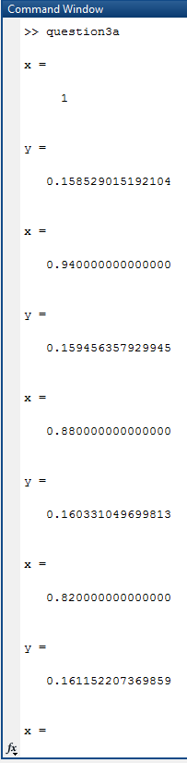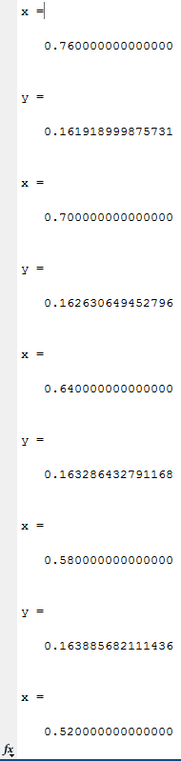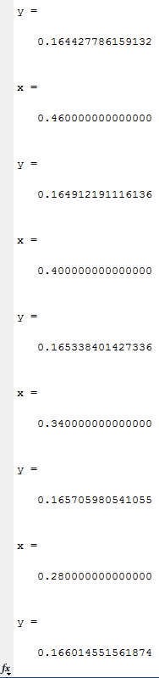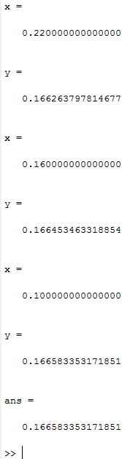

From the results of the function is converges closer to 1/6 as x converges to zero.

b)

