VIEWS AND VISTAS
The Newsletter of the

WEST GRANVILLE PRESBYTERIAN CHURCH
6935 North 107th Street
Milwaukee, WI 53224-4316
414-353-8680

Web-site = www.westgranville.org
E-mail church at WGPC@westgranville.org
E-mail Pastor Anderson at pastord@westgranville.org

Vol. 38, No. 5 May 2015
From the Minister

Welcome to Parish Nurse Lil Sullivan
Commissioning Service Sunday, May 3, 2015

The Session and Member Care Committee welcome Lil Sullivan as our new Parish Nurse.
Lil has been a registered nurse for over 45 years. She has worked in a variety of settings in hospitals and in the community. She has experience in medical nursing, coronary intensive care, hospice care, public health nursing, child, adolescent and adult psychiatric nursing, and school nursing. She is currently employed at Milwaukee Public Schools as a case manager providing safe care to the many school children with chronic health conditions. She participates on multi-disciplinary evaluation teams for children with special needs, assuring that their complex health issues are managed safely when they are at school. Lil is humbled and very honored to be the Parish Nurse at West Granville Presbyterian Church. She looks forward to the opportunity to minister in a special way to this wonderful congregation.

Peace, Pastor Dee

Worship in May
May 03 5th Sunday of Easter Holy Communion
Adult Choir
Commissioning of Lil Sullivan as Parish Nurse
Scripture: I Corinthians 11: 23-26 I Received
Sermon: Sacred Blood: Ebola & Human Care

May 10 6th Sunday of Easter
Mother’s Day
Special Music: Church Mice-Children’s Choir
Baptism of Parker Tamio Barnes
Scripture: Deuteronomy 6:4 Love God
Sermon: Loving God

May 17 Confirmation Sunday
Last day of Sunday School regular classes
Recognition of Sunday School Mission Project: Chicken Points
Special Music: Church Mice-Children’s Choir

May 24 Pentecost — Wear RED
Color change to red
Memorial Day Weekend observed
No Choir practice
Scripture: Psalm 91 God my Refuge
Sermon: Remembering Rabbi Gittelsohn

May 31 Trinity Sunday
10:30 Service
Color change to white
Senior High Recognition Sunday
Sabbatical Commissioning: Reverend Barbara Jordan Participating
Adult Choir

Worship in June
Summer Worship: 9:30 AM

June 07 9:30 Summer Worship Begins
Holy Communion
Guest Preacher: Rev. Barbara Jordan
CONCERNS OF THE CHURCH
Congratulations
Alison Crane and Mark Radigan on their Wedding, April 4, 2015.

Military Deployment
Dominic Bichler, United States Air Force Reserves
Tim Calvert, United States Navy Reserves

Immediate Need
John Grigg, surgery
Brandon Anderson, heart surgery
Ruby Tylenda-Emmons, heart procedures
Ellen and Francis Daniel, special care
Dawn Famularo, lymph cancer
Cindy Clay, breast cancer
Anna Bartowitz, continuing recovery
Elizabeth Sandretti, breast cancer
Dan Ryan, surgery
June Campbell, stroke recovery, Alexian Health Care Center

Long Term
Nicki Rupke, special care
Marjorie Holmes, continuing care
Madison Ford, special needs and continuing care

Hospice Care
Kay Baake, in Kenosha
Matt Fehr’s father
David Lambert’s mother
Dawn Rupke’s mother

SENIOR RECOGNITION
Sunday, May 31st 10:30 worship will be our Senior High Recognition Sunday. We will celebrate the graduations of Diana Essoka, April Fehr, Kali Grogan, Melissa Hrovat, and Zack Pogorzelski. This will also be our Sabbatical Send-off Ceremony. The Adult Choir will sing.

PULL-TABS STILL NEEDED
We continue to collect the pull-tabs from soda and soup cans. You
may bring them to the cardboard Ronald McDonald house in the office.
CONFIRMATION CLASS — MAY 17TH CONFIRMATION SUNDAY
We are grateful for the 6 wonderful young people who have shared our Confirmation Journey. Thank you also to Tom Ramlow who served as my co-leader for the year.

7th Grade
Alison Alderden, Brooke Hartman, Lauren Meyer, Ethan Pogorzelski

8th Grade
Austin Berlin, Keisha Chirambo

We began with a Retreat at Camp Stronghold in Illinois with Joy Hartman, Tom Ramlow and Pastor Dee as leaders.

During the past year we have met each Thursday evening to study the Old Testament - Hebrew Bible; the New Testament - Greek Bible and Presbyterian History and Beliefs. The Confirmands have visited other congregations including a Jewish Synagogue and Greek Orthodox Church. They will be taking a trip to West Granville Cemetery for a history walk.

On May 7 they will take their Third Unit Exam.
On May 14 at 6:00 pm in a special meeting they will be examined with the Session.
On May 17 the Confirmands will each take part in leading the worship service.

Picture taking will take place shortly after 10:00 in the Sanctuary.
May God Bless these young people as we celebrate now and as they
continue their walk on the journey of faith and life.

OPEN CIRCLE
Flower Sale orders of potted geraniums and hanging baskets will be due May 10 to pick up May 17. There will be order forms in the narthex, Perseverance Hall, and with Open Circle ladies. See Nancy Baum and/or Deb Crane for details.
Stay tuned for news of a Saturday morning when we will make no-sew fleece blankets for a women’s shelter.
Sunday, June 21, Father’s Day, will be our Strawberry Festival.
Donations received will be donated to local missions.
SUCCESSFUL BRIDGES BUILT BETWEEN FAITH-BASED ORGANIZATIONS AND POLICE
Presbytery of Milwaukee Fresh Impressions – April 8, 2015 Compiled by Donna Holmes, Communication Associate

For about three years there has been a successful liaison between neighborhood congregations in Milwaukee’s Northwest side and District Four of the Milwaukee Police Department.

The churches represented are of multiple faiths. The topic which unites these groups is community development, particularly the area opposite West Granville, at 107th and Mill Road. Chief Flynn of the Police Department has called the forum a model for the city. Just two weeks ago, Captain Beecher from District Four was the guest speaker at West Granville, for the neighborhood block watch meeting. Meetings include community representation from Sojourner Peace Center, the Assistant District Attorney, and a probation parole officer. This mix of representatives keeps the conversations on task, sometimes steering to safety conversations which might turn unmanageable.

This summer, the group is planning another community outreach event with the local Maple Tree School (MPS). This winter, the group has practiced Adopt-a-Block, walking one of the blocks in the neighborhood with police and congregations every other Saturday, engaging residents and fostering conversation. It has been an exciting group.

In April, the Rev. Dee Anderson co-hosted a pastors’ breakfast at West Granville, to create more opportunity to bring the neighborhood pastors together. In the midst of trying times, the group is pleased to have a strong, working, first-name-basis relationship with police and the faith-based community.

The Presbytery of Milwaukee asked both Officer Tracey Geniesse and The Rev. Dee Anderson about possible preconceived notions that were overcome during this three-year journey. Rev. Dee Anderson’s response follows:
The motivation was to change the pattern of an incident occurring in the neighborhood and police responding after the fact. We wanted to bring together the community partners, the faith-based congregations and the police resources to work proactively on community development. This has been a dynamic partnership with a group willing to exchange ideas, plan events and shared the resources of our faith groups and work closely with police to identify problems as well as plan positive outreach events.

The following comments are Officer Tracey Geniesse’s response to the same question of preconceived notions overcome. Officer Geniesse is the Community Liaison Officer for District Four. The faith-based group started in District Four about four and a half years ago. So this had started before I was placed in my current position. I became part of the Faith based group in September of 2012. I wasn't sure what the purpose of the group was at that point. My preconceived notion was: with all of the different denominations, how is everyone going to be in a group setting? But from the moment I began to experience the group, everyone had the same goals. The group’s concern was, how do we reach people in need, who are in need of resources and how do we reduce crime in the area? We as a team needed to begin building relationships in the neighborhoods to build the bridge and fill that gap between the Police, Faith and the community? So we as a group came up with this mission statement:

“Our purpose as a Faith Based Group without bounds of any religious and community organizations is to stabilize our neighborhoods by bringing the resources of our respective organizations together to help the people see, and gain, a path which turns them away from crime and instills hope for a better future. The focus is the communities we serve.”

We have in the past and are currently working on several neighborhoods in the District Four area. We have a community event in each of these neighborhoods yearly. The group provides food, activities, resources and entertainment for the day. We also have an Adopt-A-Block in our Millwood area, every other Saturday the group meets, walks through the neighborhood. We clean up garbage, shovel snow, pass out food and offer resources by going door to door. We have also started up a Community Action Team. This means if we have a critical incident in the area, pastors will come to the scene and offer resources to meet the family’s needs, as well as prayer. For more information, please contact Rev. Anderson or Officer Tracey Geniesse, Community Liaison Officer, District Four Milwaukee Police Department.

Save the Date: Millwood Park Neighborhood Outreach Event
Saturday, June 20, 11-3:00 PM
106th and Jonen Street
West Granville is looking for Volunteers to host the Food Table.
We will post a sign-up sheet shortly.

PERSEVERANCE SCHOLARSHIP AWARDS
Congratulations to April Fehr, Melissa Hrovat, and Zack Pogorzelski for their outstanding applications and as recipients of the WGPC Perseverance Scholarships. Each of these students will graduate high school with grade point averages of over 4.0 and are currently involved in serving the community as well as many school activities. All three applicants are amazing young people very deserving of this award.
- April plans to attend San Jose State University pursuing a degree in Kinesiology to eventually become a Physical Therapist.
- Melissa will be attending UW–Madison, pursuing a major in either biomedical engineering or actuarial science. She will also minor in German and hopes to study abroad for at least one semester.
- Zack plans on pursuing a degree in biology and/or biochemistry while attending Wartburg College in Iowa. After receiving his bachelor’s degree, Zack plans to enroll in a graduate program at either UW-Madison or the University of Kentucky in Plant Pathology, Biotechnology, or Agricultural Engineering and become a plant pathologist.
The amount awarded will be $350 each and will be used for money for school. ~ The Perseverance Scholarship Committee

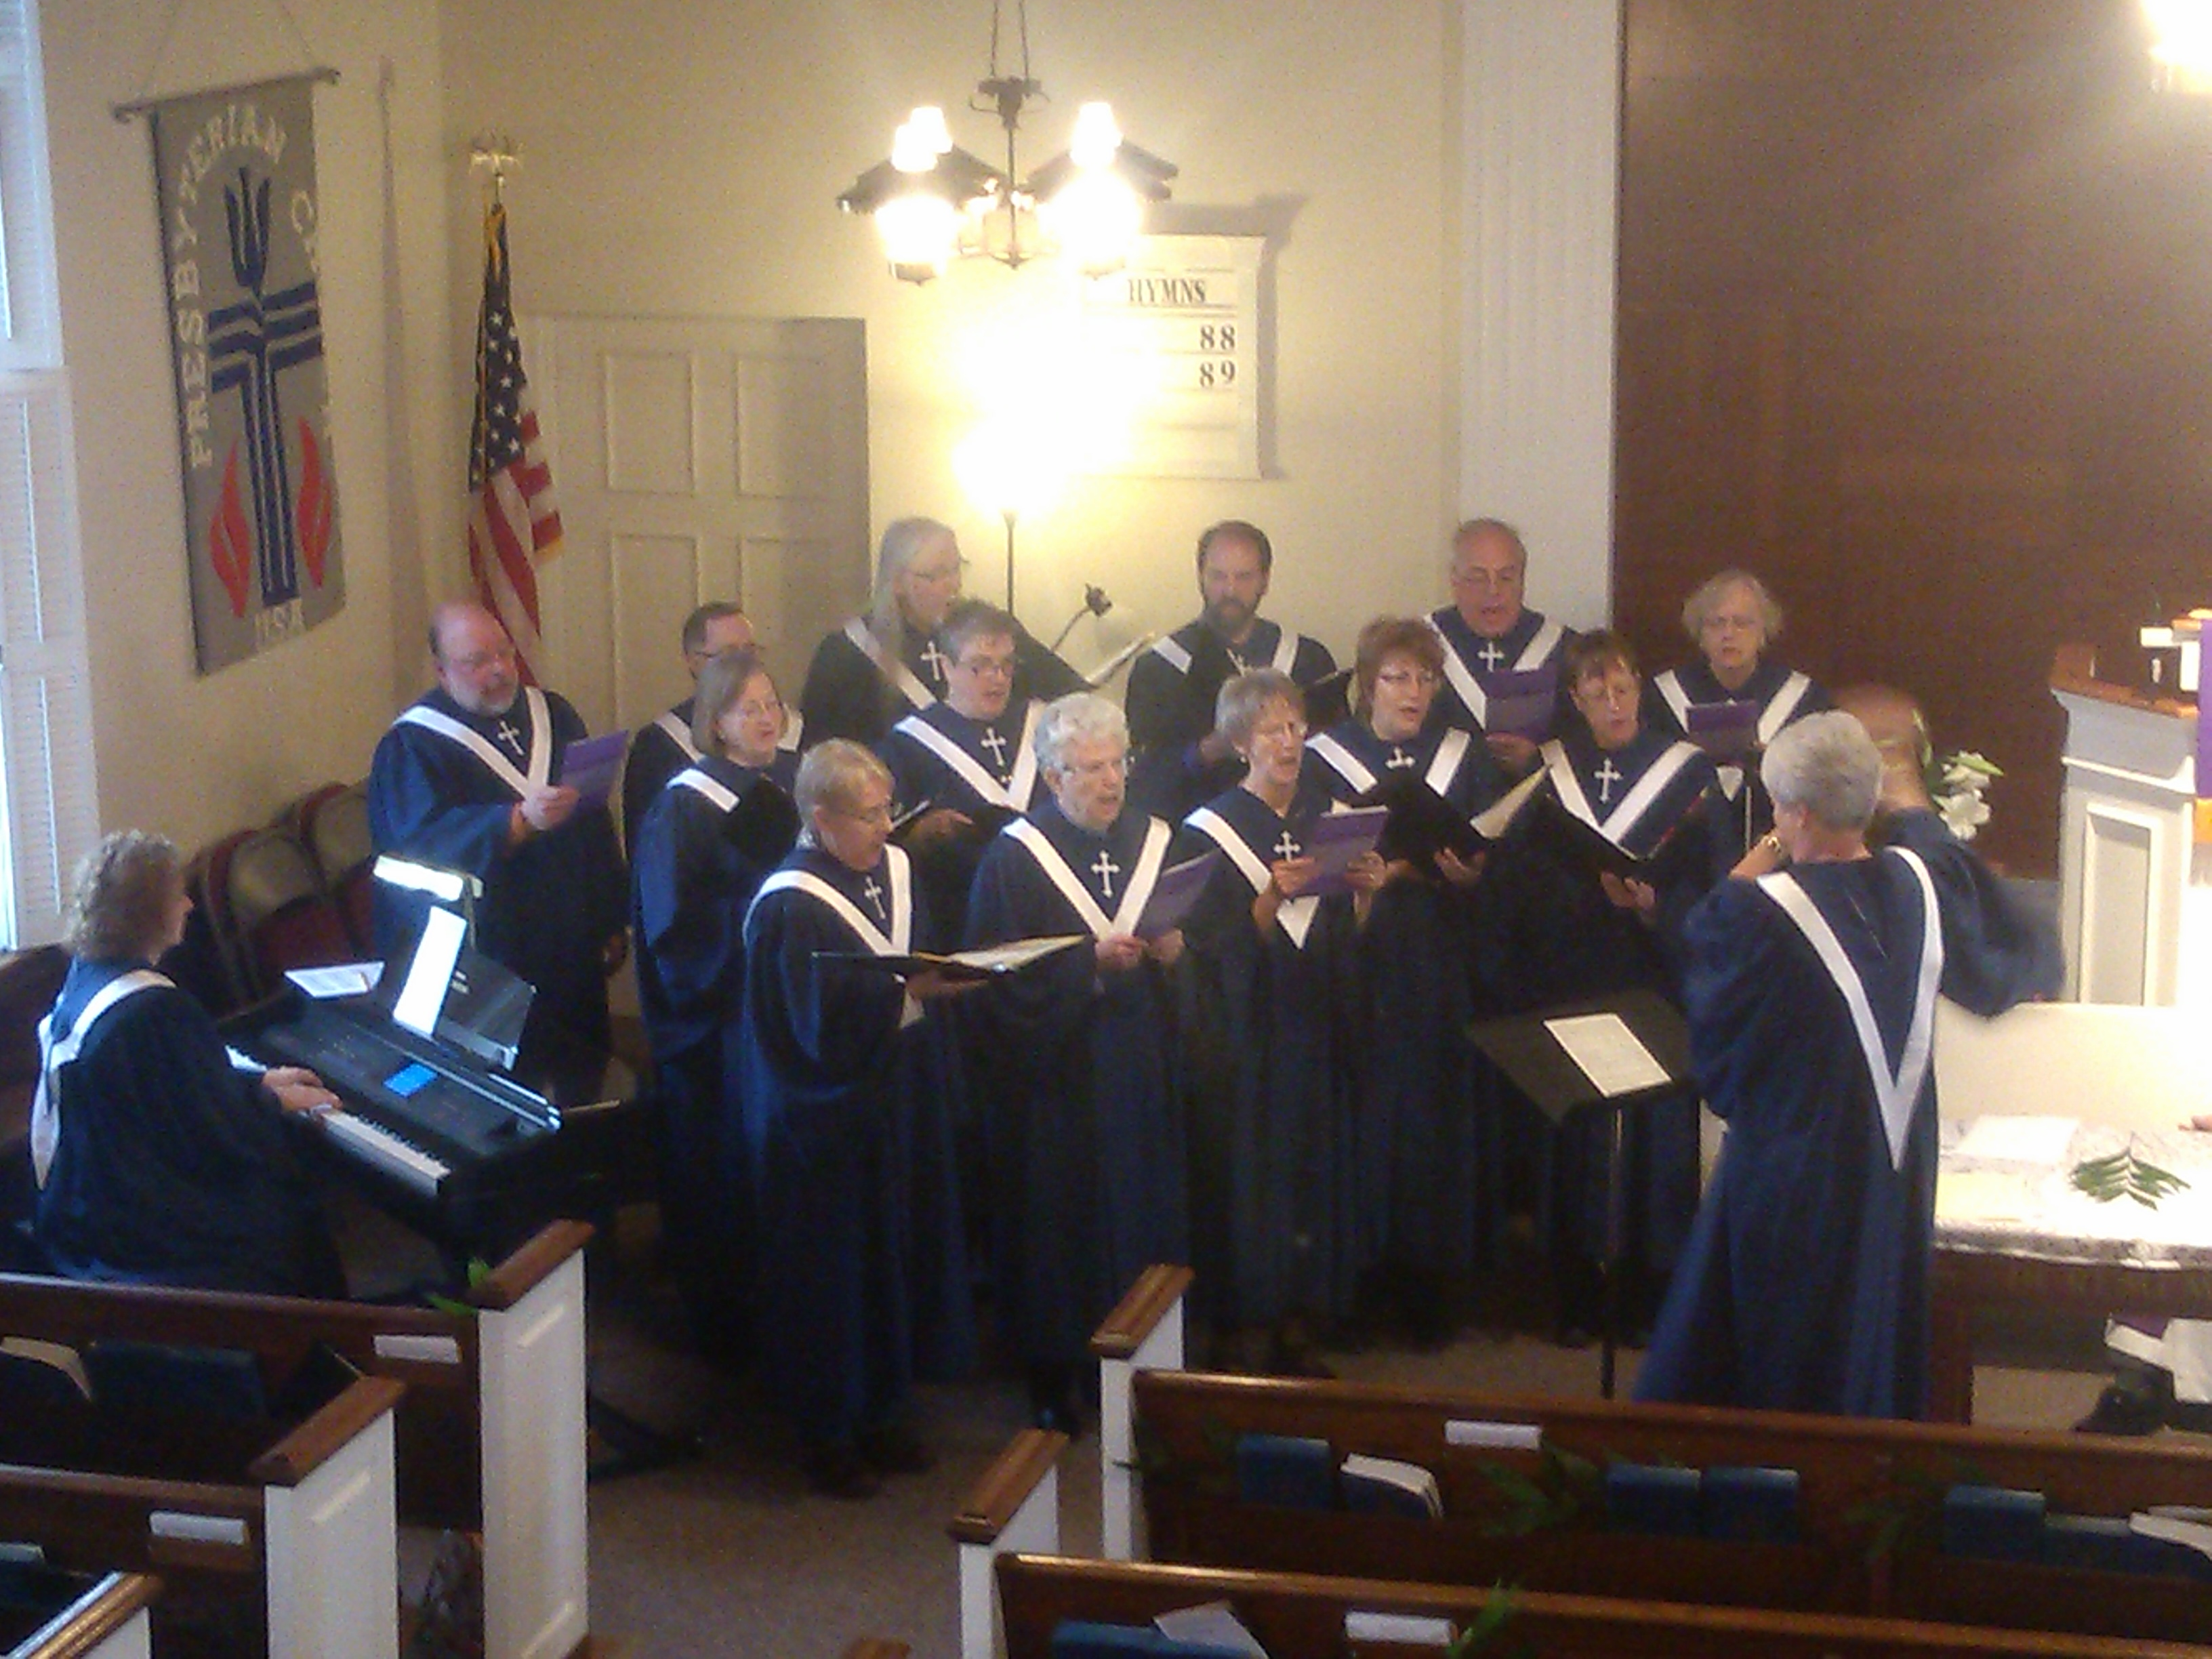
Consolidated General Fund 31 March, 2015
Operating Statement
Income
YTD pledged receipts 37,585
YTD prepaid pledged receipts 15,400
YTD non-pledged receipts 3,051
YTD per capita 3,690
YTD other income 541
2014 balance forward 6,238
TOTAL $66,505
Expenditures
Payroll 26,537
Programs 869
Mission 2,087
Operations 18,812
TOTAL $48,305
Balance on hand $18,200

Per Capita receipts are still below the forecasted budget. If you have paid your Per Capita, Thank You! Remember we pay $30.00 to the Presbytery
for every church member, active or less than active. Please, if you haven't yet, consider paying your Per Capita donation.
Your continued financial commitment helps keep our church programs running. Thank you! The Finance Committee

LUNCH BUNCH
The Lunch Bunch will dine together on Friday, May 8 at 1:00 p.m.
and on the second Friday of each month. All ages are welcome.
See Nancy Baum for location and directions.

BOOK RELEASE EVENT AND RECEPTION
for Scott Prill’s debut novel
Into the Realm of Time: A Novel of the Fourth Century Roman Empire
Saturday, May 9, 4:00, Boswell Book Co., 2559 N. Downer Ave., Milwaukee
Reception following at Pizza Man, 2597 N. Downer Ave., Milwaukee

WGPC VALUES
What does it mean to be a member at West Granville?
Check out our newest video from award-winning photojournalist David Clay!
Click the link to view the West Granville YouTube Video
THANK YOU NOTES
Dearest Friends, Your gift of love … your gift of support … your constancy through the years … have strengthened and encouraged me reminding me always of God’s presence among us.
Thank you for the beautiful reception on March 22! I enjoyed every loving moment. I appreciate you, my beautiful church family. Love, Donna Blommel

Dear Scott and Marcie: Thank you so much for the beautiful Easter-Lily! I enjoy its beauty and the sweet smell! It reminds me so much of the pure, innocent white of our Lord Jesus, who sacrificed so much for us sinners! Through him we have the chance for everlasting life! The older we get, the more we thank him for all he has done!
Wishing you and your family a wonderful Easter!! Nelly

Dear Friends, I am enjoying and appreciate the beautiful Easter Lily plant delivered by Nancy Adams – it is sharing window space with the Poinsettia plant that continues in full bloom! You are in my thoughts and remembered in prayer. Thank you for remembering me. Janet Beltman

Dear Pastor Dee, The Church of the Good Hope Food Pantry would like to express our sincere thank you for your donations on 3/15 for $250.00 and on 4/15 for $248.00. We truly value the help that your church offers to the pantry to feed those, so they will not go without. We are blessed to be blessed by others.

CAMP STRONGHOLD REGISTRATION
Stronghold Camp & Retreat Center is pleased to announce their online registration system is now open. Go to http://www.strongholdcenter.org/onlinereg.html
Stronghold is excited about the registration process and the capabilities provided so that you can register now, update information later, and make payments at your convenience.
Stronghold Camp & Retreat Center reservations@strongholdcenter.org
815-732-6111 ext 613 www.strongholdcenter.org
West Granville again offers a $50 scholarship per camper. The Milwaukee Presbytery offers a Camp Corbin Scholarship as well for up to $150 per camper (or half the cost of camp).

WORSHIP ATTENDANCE
March 29 Palm Sunday 129 April 2 Maundy Thursday 47
April 5 7:00 73 10:30 139
April 12 77 April 19 111

WHAT BROUGHT YOU TO WEST GRANVILLE?

WHAT KEEPS YOU COMING BACK?

My husband and I visited several churches in the area. They were all very welcoming, however West Granville had what we wanted: a traditional service and a minister who actually taught a sermon, not acted it out; and an organist, not a band.

Initially, convenience to home. Now, a 25 minute-drive, but well worth it. The strength of this church is the members’ quality of character and Dee and Cindy. We appreciate the quiet leadership that allows project success. New members? Possibly mailing Stoney Hills’ previous membership with an invitation to attend our church.

A sincere sense of community and extended family.

The people were friendly and I always felt this was my church home even when I lived in Las Vegas for many years. When I returned to the area, some of the congregation had changed, but were still friendly. I like Dee’s interpretation of the Bible.

We moved to Menomonee Falls in 1951. My parents made the association with West Granville church as one of our first family connections. It has become one of the best legacies that they could have given me.

Two things. 1. My wife has a long history with West Granville.

2. Dee Anderson. I came to know Dee during the many family events. I believe that West Granville is lucky to have such an amazing minister. I enjoy his sermons, personal connection with the congregation, and his interpretation of Christianity. Finally, I am very comfortable at West Granville.

My neighbor brought me here. I joined. I was confirmed Presbyterian. She brought me back.

COFFEE HOUR HOSTS: 3: LaPorte 10: Cannestra 17: Alderden

COMMUNION GROUP: Deb Bascom, Jean Casey, Hildegard Essoka,
Pat Lorbiecki, Jo Ann Olson, Mark Savage

USHER / GREETER TEAM: Noel & Nancy Adams, Lynn Fehr,
Barbara Hackbarth, Dennis Hockerman, Lee Saunders
BIRTHDAYS AND ANNIVERSARIES IN MAY
- Ben Anderson
2 Kelly Grogan
2 Karolyn Kummer
3 John Grigg
5 Sarah Von Drasek
6 Elizabeth Sandretti & Ed Kress, 2006
6 Matt Fehr
8 Jeff Prill
10 Billie & Ken Alderden, 1997
12 Stephen & Carol Buck, 1979
13 Meghan Emory
14 Karl & Pamela Mayer, 1988
15 Robert Streich
15 Lee Saunders
18 Audrey Bonnett
19 John T. Lorbiecki
21 Chris & Michelle Pogorzelski, 1994
22 Wendy Suyama
24 Helen & Jim Sewrey, 1953
25 Deborah Crane
26 Elizabeth Tylenda & Arnold Gutkowski, 1979
27 Robert Stroschin
28 Christine Prill
28 Cade Radder
29 John & Bridget Rhode, 1994
30 Kent & Marna Tess-Mattner, 1975
30 Stephen Savage
30 Joseph Hrovat
31 Elizabeth Tylenda

If your dates are missing or in error, please inform the church office.

WEST GRANVILLE PRESBYTERIAN CHURCH
Dee M. Anderson, Pastor
Angie Murray, Church Secretary
Carol Buck, Newsletter Editor, cagbuck@sbcglobal.net
Please submit June newsletter articles by Sunday, May 16.

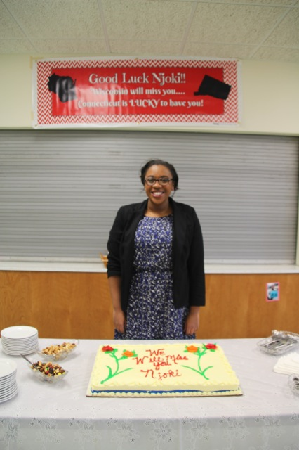
These sentences actually appeared in [other churches’!] bulletins and newsletters or were announced at church services:
The Fasting & Prayer Conference includes meals.
--------------------------
Scouts are saving aluminium cans, bottles and other items to be recycled. Proceeds will be used to cripple children.
--------------------------
The sermon this morning: 'Jesus Walks on the Water.'
The sermon tonight: 'Searching for Jesus.'
--------------------------
Ladies, don't forget the rummage sale. It's a chance to get rid of those things not worth keeping around the house. Bring your husbands.
--------------------------
Don't let worry kill you off - let the Church help.
--------------------------
For those of you who have children and don't know it, we have a nursery downstairs.
--------------------------
Next Thursday there will be try-outs for the choir.
They need all the help they can get.
--------------------------
John Smith and Jane Doe were married on October 24 in the church.
So ends a friendship that began in their school days.
--------------------------
At the evening service tonight, the sermon topic will be 'What Is Hell?' Come early and listen to our choir practice.
--------------------------
Eight new choir robes are currently needed due to the addition of several new members and to the deterioration of some older ones.
--------------------------
Please place your donation in the envelope along with the deceased person you want remembered.
--------------------------
The church will host an evening of fine dining, super entertainment and gracious hostility.
--------------------------

