Temperature Distributions in the Protosatellite Disks of
Uranus, Jupiter, Neptune and Saturn and Common
Structure in Their Satellite Systems

James C. Lombardi Sr. Professor Emeritus,
Physics Department, Allegheny College, Meadville, PA, USA; james.lombardi@allegheny.edu

ABSTRACT

We observe similar structures in the orbital radii of satellite and ring systems of Uranus, Jupiter and Neptune. This stimulates an investigation that the evolution of these systems and Saturn's system is initiated by a common mechanism that involves the interaction of radiation with their subnebulae (protosatellite disks). A model is presented that is characterized by resonance created through stimulated radiative molecular association (SRMA) reactions. In this model thermal energy is extracted from a protoplanetary disk at specific distances from the protoplanet wherever there is a match between the local thermal energy of the disk and the energy of photons impinging on the disk. Radiation is supplied by a portion of the hydrogen molecule's spectrum for the Uranian, Jovian and Neptunian disks and a portion of the hydrogen atom's spectrum for the Saturnian disk. Findings shed light on the early evolution and structure of satellite systems including the complicated ring system of Saturn. They also link satellite orbital radii size distributions to shapes of temperature distributions (TD's) in protosatellite disks. Theoretically determined TD's in the protosatellite disks of Uranus (Mousis 2004) and Saturn (Mousis Gautier and Bockelee-Moran, 2002) are essential to the present investigation.

KEYWORDS: planets, protoplanets, protosatellites, protoplanetary disks, subnebula, atoms, molecules, spectra, satellite systems, radiative molecular association

1. INTRODUCTION

This investigation deals with the satellites that are created in the mid-planes of the protosatellite disks of Uranus, Jupiter, Neptune and Saturn. These satellites have orbits with small eccentricities and inclinations relative to the planet's equatorial plane and are generally called regular satellites. However for ease of discussion here they are usually simply referred to as satellites. Section 2.1 introduces relationships among the orbital radii of regular satellites and rings of Uranus, Jupiter and Neptune. Subsequent sections present a model that explains these relationships and also the structure of the satellite systems of the four giant gas planets in the solar system. In this model regular satellites are formed where disk temperatures have certain values with these values depending on the energies of photons that exist in the disk. We propose the connection between temperature and photon energy to be a result of resonance involving stimulated radiative molecular association (SRMA).

In this investigation TD stands for the midplane temperature distribution or portion of a temperature distribution in the protosatellite disk of a protoplanet. Results of this investigation rely heavily on the theoretically determined TD's in the protosatellite disks of Uranus (Mousis 2004) and Saturn (Mousis Gautier and Bockelee-Moran, 2002).

This paper is a rewrite of Lombardi (2015a). Lombardi (2015b) was a follow-up for Lombardi (2015a) and now it should be a follow-up for this paper.
2. RESULTS AND DISCUSSION

Table 1 contains the names of known regular satellites of Uranus, Jupiter, and Neptune and their orbital radii (lengths of the semi-major axis) in units of R_{U} = 25,559 km, R_{J} = 71,492 km and R_{N} = 24,766 km, the equatorial radii of Uranus, Jupiter and Neptune respectively (NASA 2021). I.e. if r is the orbital radius of a Uranian satellite, then r/R_{U} is its orbital radius in units of R_{U}. In the case of Uranus, satellites with orbital radii less than r/R_{U} = 2.3 are not listed in Table 1 but are considered later. For Jupiter and Neptune all of the known regular satellites are listed. Values for the index i are listed in the first column of Table 1. It will become apparent why the indices have their particular listed values in later sections. All satellites and orbital radii in the same row are associated with the same value of i. Note that Cupid in the Uranian system does not have a value of i assigned to it. The reason for this is in section 2.1.b.

2.1.a. The Linearity of the Uranian vs Jovian and
Uranian vs Neptunian Orbital Radii

Fig. 1 is a graph of orbital radii of a certain set of contiguous Uranian satellites (excluding Cupid) versus the orbital radii of all the Jovian satellites. Each point is for the two radii with the same i value. No other set of pairings of Uranian and Jovian satellite orbital radii produces a graph that is fitted by a straight line nearly as well as the one used to make Fig. 1.
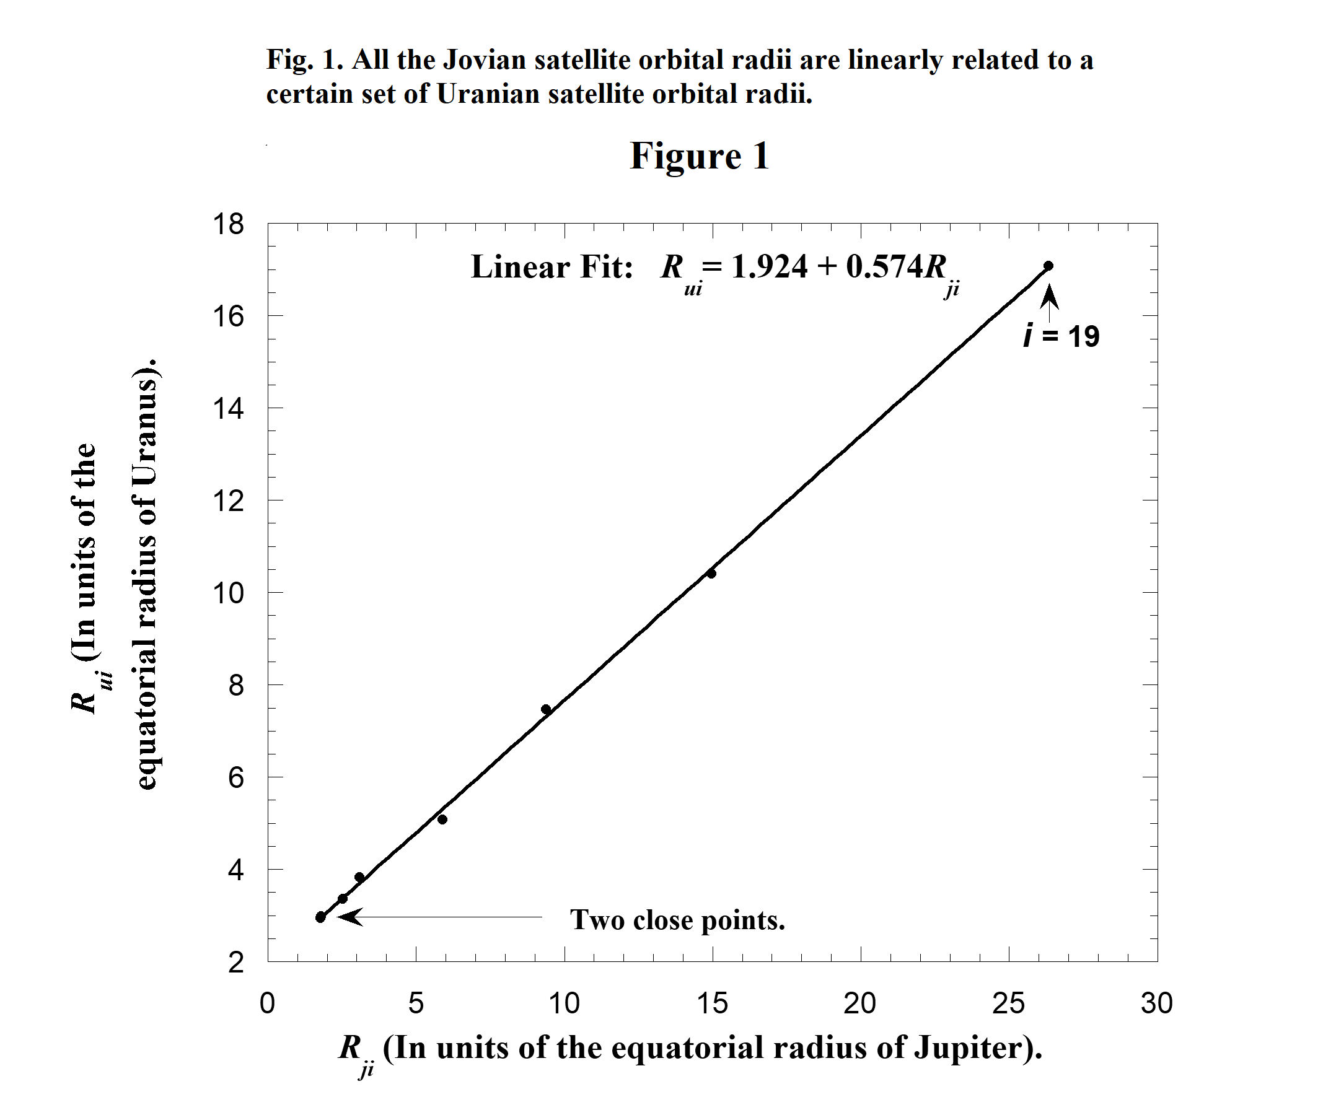
Fig. 2 is a graph that is similar to Fig. 1 except Fig. 2 is for Uranian and Neptunian satellites. The graph is also well fitted by a straight line except for the Mab-Hippocamp point where i = 15 as seen in Table 1. This discrepancy is discussed in section 2.1.b.
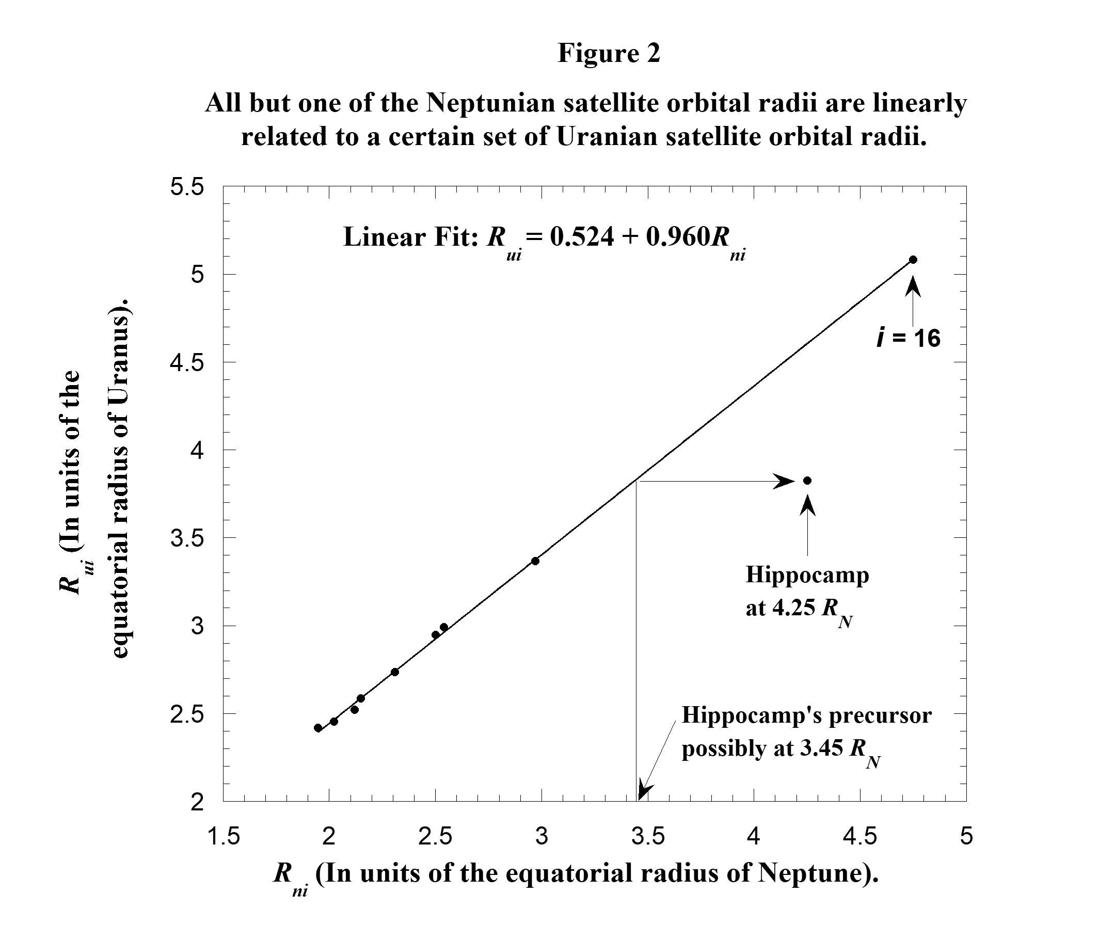
The equations of the best-fit lines to the graphs in Figs. 1 and 2 are
Rui = 1.924 + 0.574Rji (1)
and Rui = 0.524 + 0.960Rni , (2)
where Rui is the orbital radius of the i ^{th} Uranian satellite in units of R_{U} . Similar definitions hold for Rji and Rni. Ring Galle in Neptune's system lies inside the innermost satellite. Its width is large and optical depth low (NASA 2021). Ring Galle is not included in the present analysis.

2.1.b. Details Concerning Cupid and Hippocamp

We mentioned above that Cupid in the Uranian system does not have a value of i assigned to it in Table 1 nor is it included in future analysis. Cupid, Belinda (i = 11) and Perdita (i = 12) are part of a triplet in which each member has nearly the same orbital radius. This triplet is associated with doublets in the system of Jovian and Neptunian systems. If we assign a value of i to each of the three satellites in the triplet, we do not arrive at good linear fits as seen in Figs. 1 and 2. Possibly sometime during the evolution of a doublet in the Uranian system the two members collide resulting in the triplet as seen in Table 1.

The Mab-Hippocamp point (where i =15 for both satellites) in Fig. 2 is far from the linear fit. Mab's orbital radius together with Thebe's orbital radius creates a point in Fig. 1. The fact that the points in Fig. 1 (including Mab's) are well fitted by a straight line suggests strongly that, the Mab-Hippocamp point in Fig. 2 is not positioned well because of the value of Hippocamp's orbital radius, not Mab's. Table 2 indicates that Hippocamp's mass is small compared to the masses of the other nearby satellites. Perhaps a precursor of Hippocamp experiences an impact that shatters it leaving Hippocamp as a fragment. Indicated in Fig. 2 are the orbital radius of 4.25R_{N} for Hippocamp and the approximate orbital radius of 3.45R_{N} for its precursor.

2.1.c. Eqs. (1) & (2) as Transformation Equations for Orbital Radii

Consider Table 1. The Jovian distribution of orbital radii starts with R_{j11} and ends with R_{j19} . Eqs. (1) can be used to scale and shift the radial coordinates that describe the Jovian system so all the R_{ji} from R_{j11} to R_{j19} span the same normalized radial coordinates as does the portion of the Uranian system from
R_{u11} to R_{u19}. The 0.574R_{ji} term in Eq. (1) scales the radial distance associated with the R_{ji} and the constant 1.924 shifts the origin of the system. Therefore if we substitute a value of R_{ji} into Eq. (1) we calculate a transformed value of R_{ji} (call it R_{Tji}) that is close to the corresponding value of R_{ui}. The same idea holds for the transformation of the R_{ni} values (call each one R_{Tni}) by using Eq. (2). Table 3 contains the scaled (transformed) orbital radii of satellites of Jupiter and Neptune along with the orbital radii of all the regular satellites and rings of Uranus (NASA 2021).

To visualize the usefulness of transformed orbital radii consider Fig. 3 which is constructed using Table 3. (For its construction only the listed orbital radii in Table 3 are necessary. The indices (i values) will be discussed later). The top panel is the distribution of transformed Neptunian orbital radii. The middle panel is the distribution of transformed Jovian orbital radii. The bottom panel is the distribution of all the Uranian satellite orbital radii, not just those that overlap with the Neptunian and Jovian satellites. Notice the Neptunian and Jovian line graphs have points (actually vertical lines or large dots) that line up closely with radii in the Uranian distribution and also with each other. The single exception is Hippocamp's point as expected.

The positions corresponding to the surfaces of Jupiter and Neptune are each determined by substituting the number 1 into the right side of Eq. (1) and Eq. (2) respectively. The transformed surface radial coordinates for the Jovian disk and the Neptunian disk are 2.498 and 1.484 respectively. These are both compared to the Uranian surface coordinate of 1. The fact that they are considerably larger than 1 indicates that the region where the Uranian satellites are created is comparatively larger than the corresponding normalized regions for Jupiter and Neptune. This may help to explain why there are more satellites in the Uranian system than in each of the Jovian and Neptunian systems.

