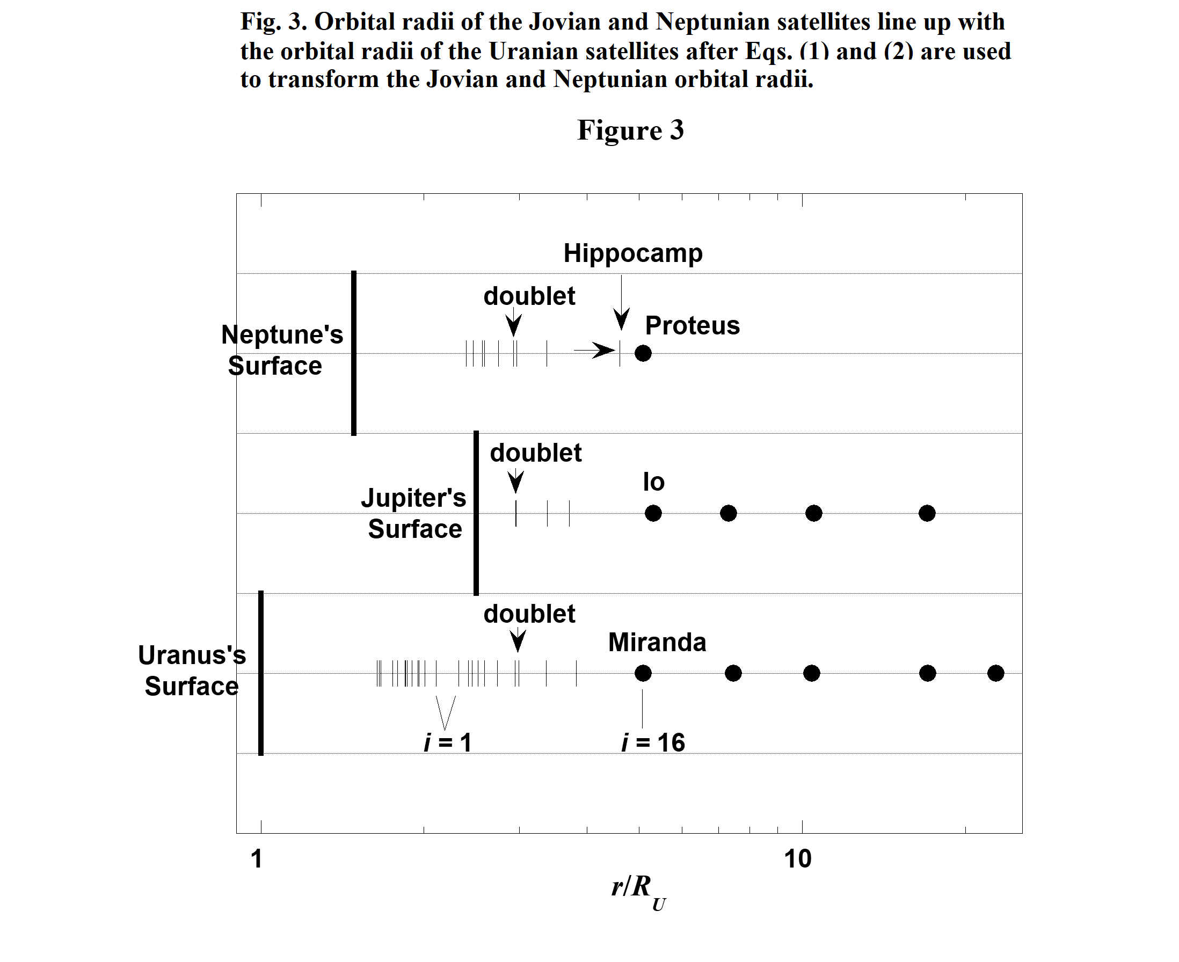
In Fig. 3 the large dots in the Uranian line graph correspond to Uranus's major satellites. In the Jovian graph large dots represent the Galilean satellites. In the Neptunian graph Proteus is by far the most massive regular satellite as seen in Table 3. We observe the most massive satellites exist at and beyond orbital radii for which i = 16. Later discussions in the present investigation will link distributions of satellite orbital radii to protosatellite disks. Fig. 3 and this linkage indicates that massive satellites are created in similar regions of protosatellite disks.

2.2.a. A Smooth Relationship Exists Between Photon Energies in the
H₂ Spectrum and the Orbital Radii of Uranian Satellites

The linearity of the graphs in Figs. 1 and 2 suggests a common mechanism creates the primordial rings around Uranus, Jupiter and Neptune which evolve into satellites. The present investigation explores the possibility that photons corresponding to molecular hydrogen (H₂) lines interact with molecules in the protosatellite disks of Uranus, Jupiter and Neptune and through the SRMA mechanism initiate the creation of primordial rings. Such lines are prominent in the spectra of nebulae. Draine and Bertoldi (1996) have modeled the spectrum of the reflection nebula NGC 2023, and Martini et al. (1999) have observed the spectra of four reflection nebulae including NGC 2023. In both of these investigations, the

7
large spectral peaks in the range 5560 – 4290 cm⁻¹ (1.80 – 2.33 μm) all correspond to S-branch
transitions (lines) in the H₂ spectrum. The segment of the H₂ spectrum that we focus on is shown in Fig. 1 of Martini et al. (1999) which is a model spectrum for the reflection nebulae they observed. Fig. 4 in the present investigation is a similar model spectrum developed using photon energies (E_{p}'s) and spectral intensities (I 's) from Black and van Dishoeck (1987). E_{p}'s in Fig. 4 and throughout this paper are in wave numbers (cm⁻¹). Also in Fig. 4 each index i is associated with a particular S-branch transition. That is, each i value stands for a particular transition in H₂.

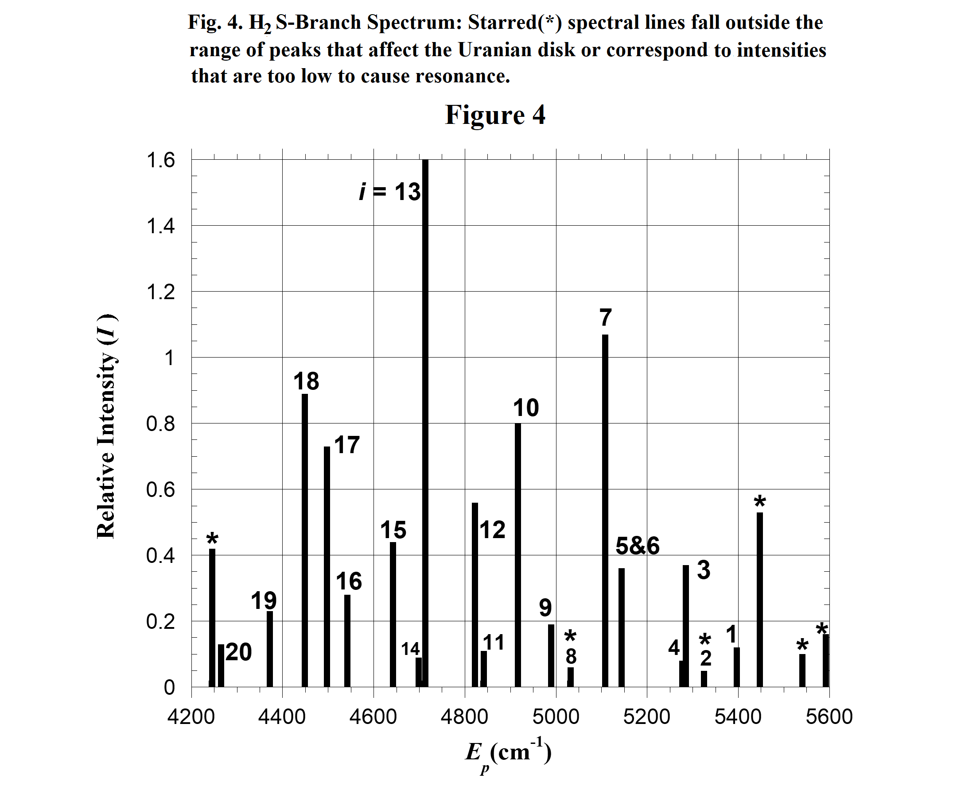
The origin of the photons in the H₂ spectrum that initiate the key SRMA reactions in a disk is not identified in the present investigation. Perhaps they come from H₂ molecules that reside in the the disk. Or perhaps they come from the protosun, presumably a typical T Tauri star. The H₂ spectrum is observed as a component of the overall spectra of T Tauri stars (Beckwith, Gatley, Matthews and
Neugebauer 1978, and Herczeg et al. 2006). Furthermore, FUors and EXors (Hartmann, Kenyon and Hartigan 1993) are subclasses of T Tauri's. These objects are characterized by short-lived magnitude changes of up to 6 magnitudes with rise times on the order of months to years (Appenzeller and Mundt 1989, and Herbig 1977). Possibly the protosun in such a short lived state delivers the photons that initiate resonance rings in protoplanetary disks.
8
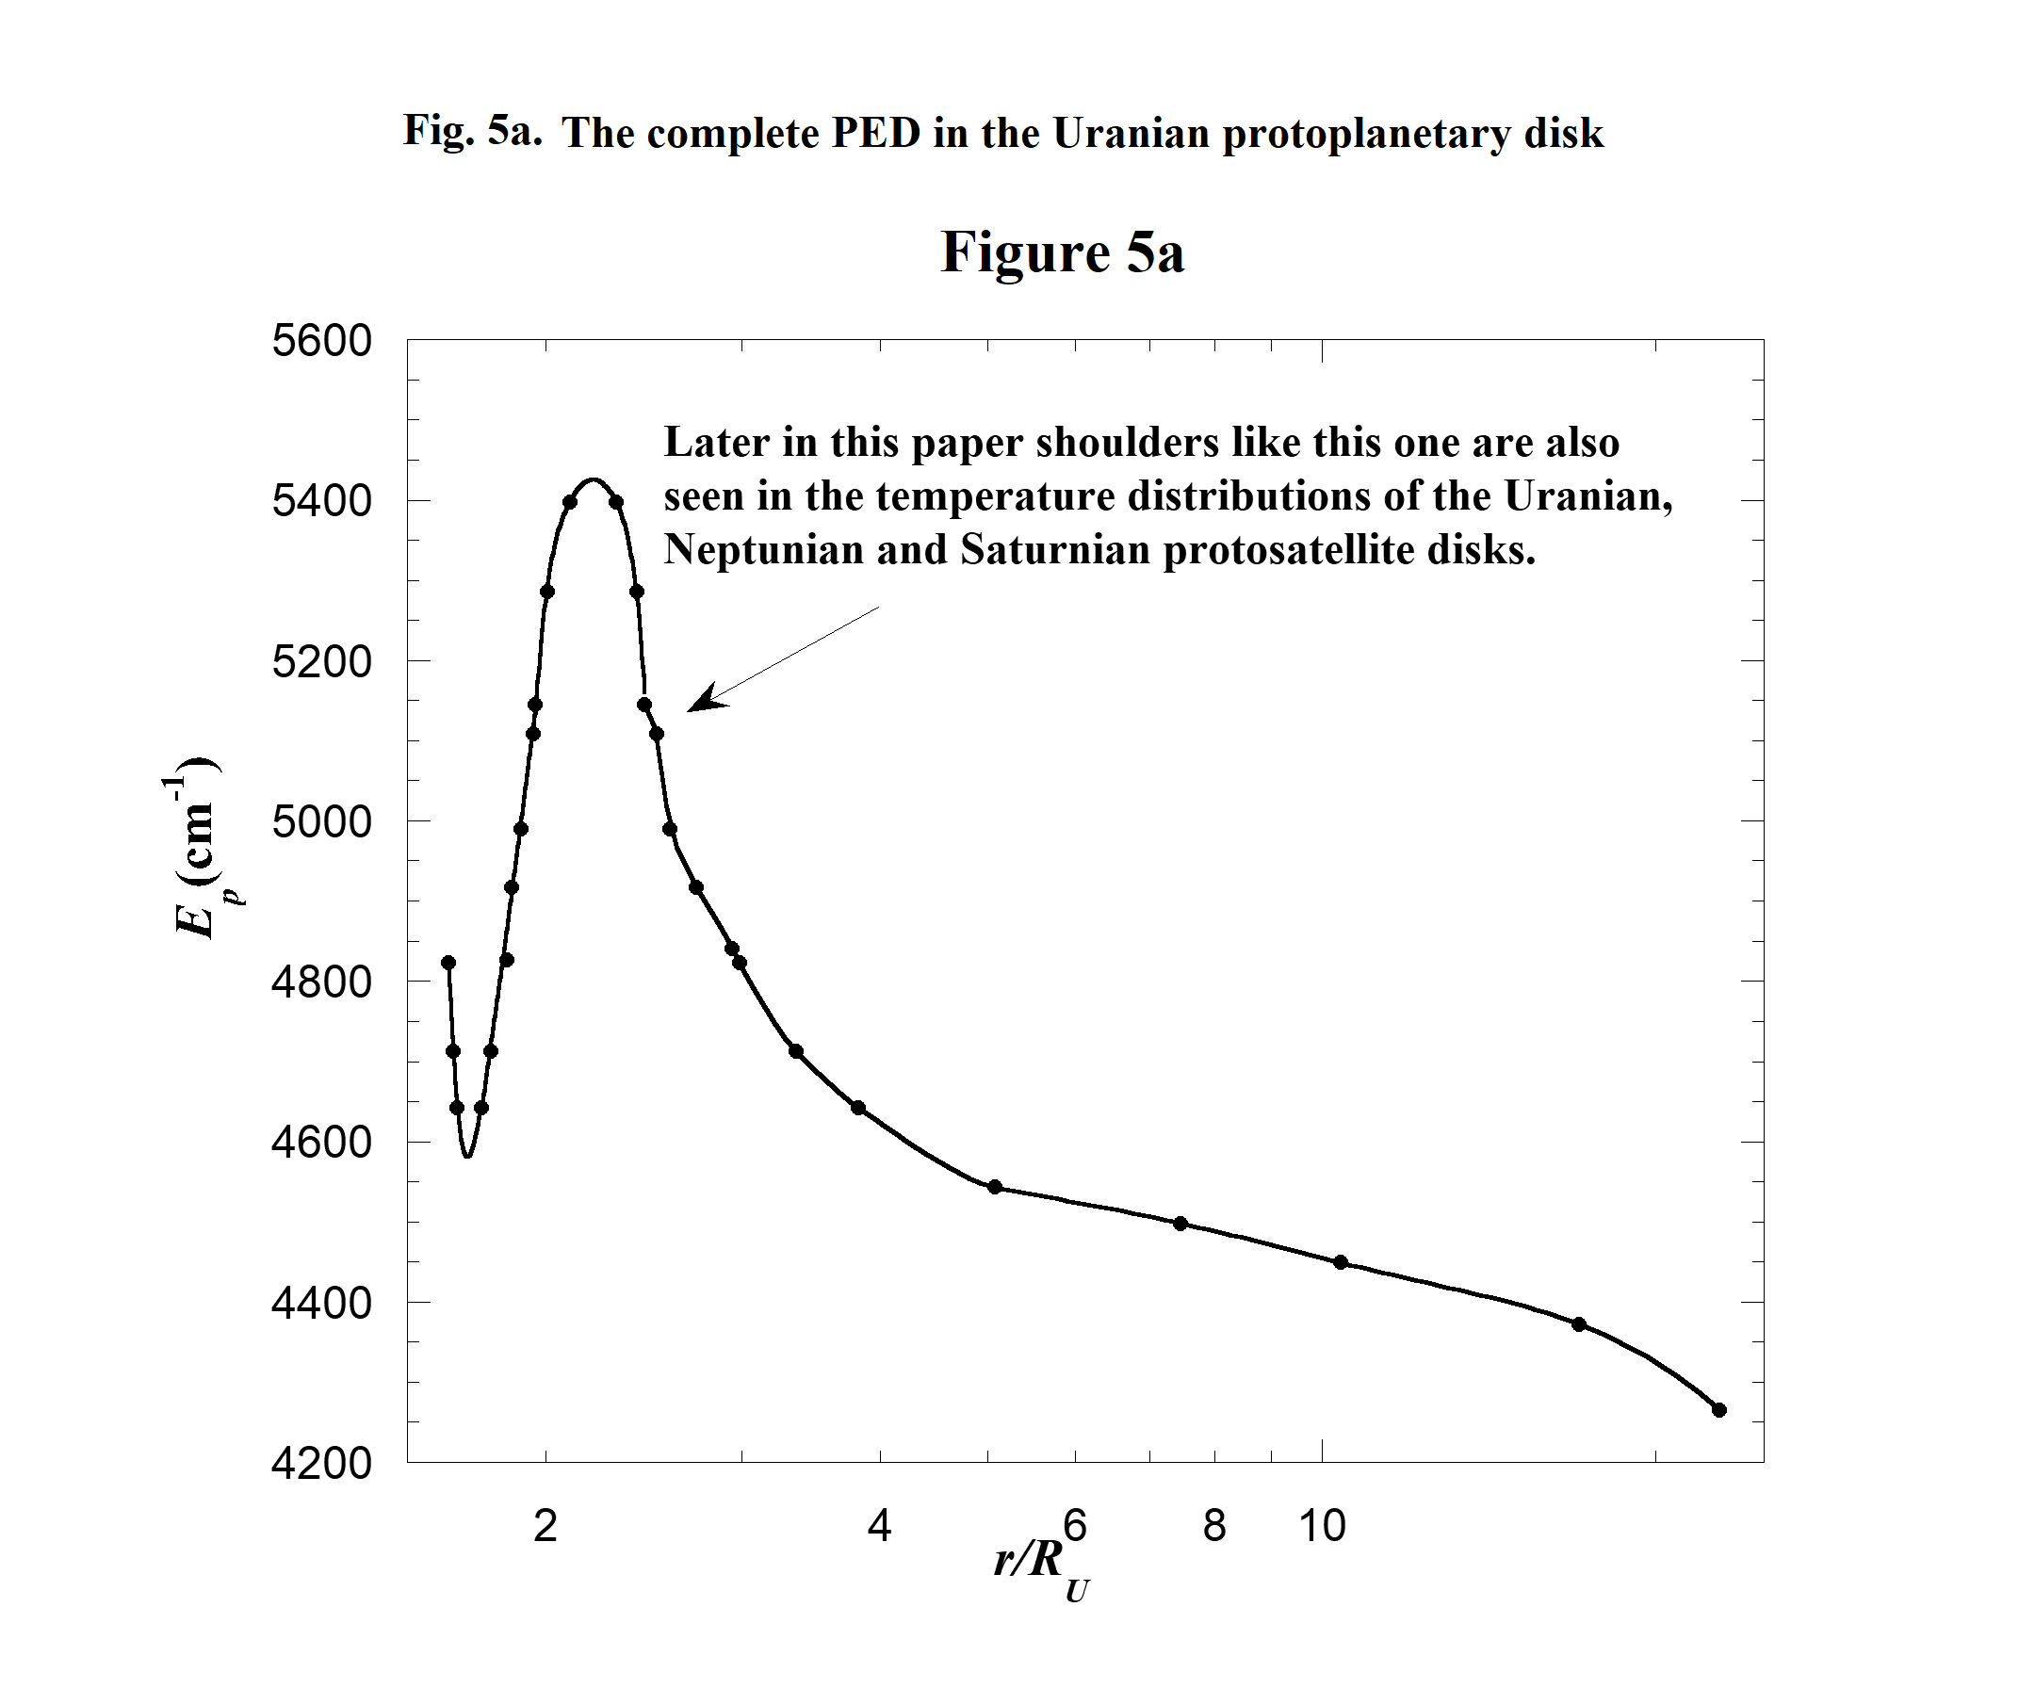
Table 4 lists the complete set of regular Uranian satellites and their orbital radii (R_{ui}) in units of the equatorial radius of Uranus. The subscript i is a reminder that each orbital radius depends on an H₂ spectral line or in some cases a close pair of lines. Table 4 also contains data related to the spectral lines mentioned above. Each R_{ui} is paired with a particular value of E_{p} or a weighted average of two E_{p}'s if two spectral lines are very closely spaced. This particular set of pairings produces a smooth graph of E_{p} vs R_{ui} which is referred to as a photon energy distribution (PED). The PED has a dip, peak and a long tail as seen in Fig. 5a. The method used for establishing the particular set of pairings (R_{ui}, E_{p}) in Table 4 is given in section 2.2.b. Later, more credence is given to the concept of the PED when it is linked to the temperature distribution (TD) of the Uranian protosatellite disk.

9

10

11
Note that spectral lines appear in Table 4 one to three times because the PED has a dip and a peak in it. Also Fig. 4 shows closely spaced lines corresponding to indices 3&4, 5&6 and 13&14. In these cases a weighted average of E_{p}'s is used with the weighting factors being the corresponding spectral intensities. The closely spaced lines with indices 11&12 have their E_{p}'s averaged for ring 6 and ring η (ring η is known to have two components (French et al. 1991)). But they are resolved for the “doublet” Belinda and Perdita. Two spectral lines with indices 2 and 8 are omitted from the analysis because they have low relative intensity as is indicated in Table 4 and Fig. 4 and they cannot be paired with orbital radii. Cupid's orbital radius is also omitted from the analysis as previously mentioned.

2.2.b. The Determination of the Relationship Between E_{p} Values and
Orbital Radii Given in Table 4 and Figs. 5a & 5b
The following are the steps taken to develop the PED's in Figs. 5a and 5b. By trial and error it is determined that if the R_{ui}'s for rings α, β, η, γ, δ and satellite Cordelia are paired with E_{p}'s corresponding to i 's 15, 14&13, 12&11, 10, 9 and 7 respectively as in Table 4, then a plot of E_{p} vs R_{ui} is well fitted by a straight line shown by the straight dashed portion of the curve in Fig. 5b. The point for ring η is noticeably the furthest away from the straight line fit. It is interesting that the radius of ring η is very near the 3:2 Inner Lindblad Resonance of the satellite Cressida (Chancia et al. 2017). Perhaps the radius of ring η has been affected by its interaction with Cressida.
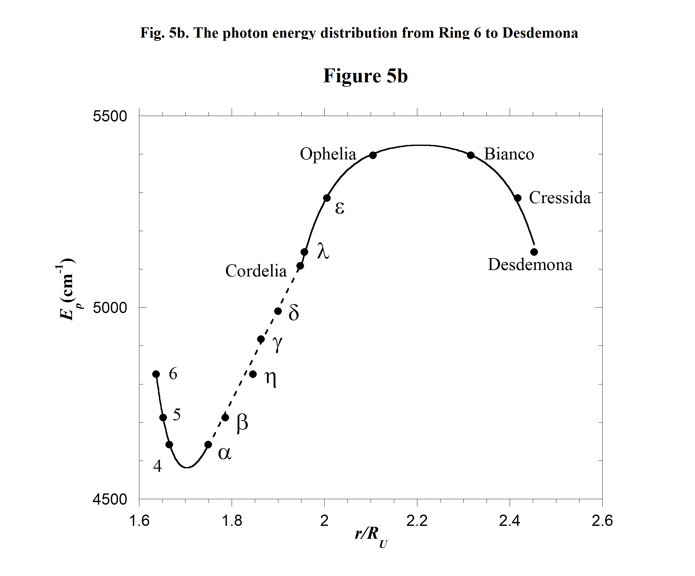
When we pair rings 6, 5 and 4 (the three innermost rings) incorrectly with i 's 18, 17 and 16 (which might be the expected inward extension of i 's) a discontinuity is created as seen in Fig. 5c. If instead we use the i 's 12&11, 14&13 and 15 for the three innermost rings a smoothly varying dip becomes apparent as seen in Fig. 5b.
12
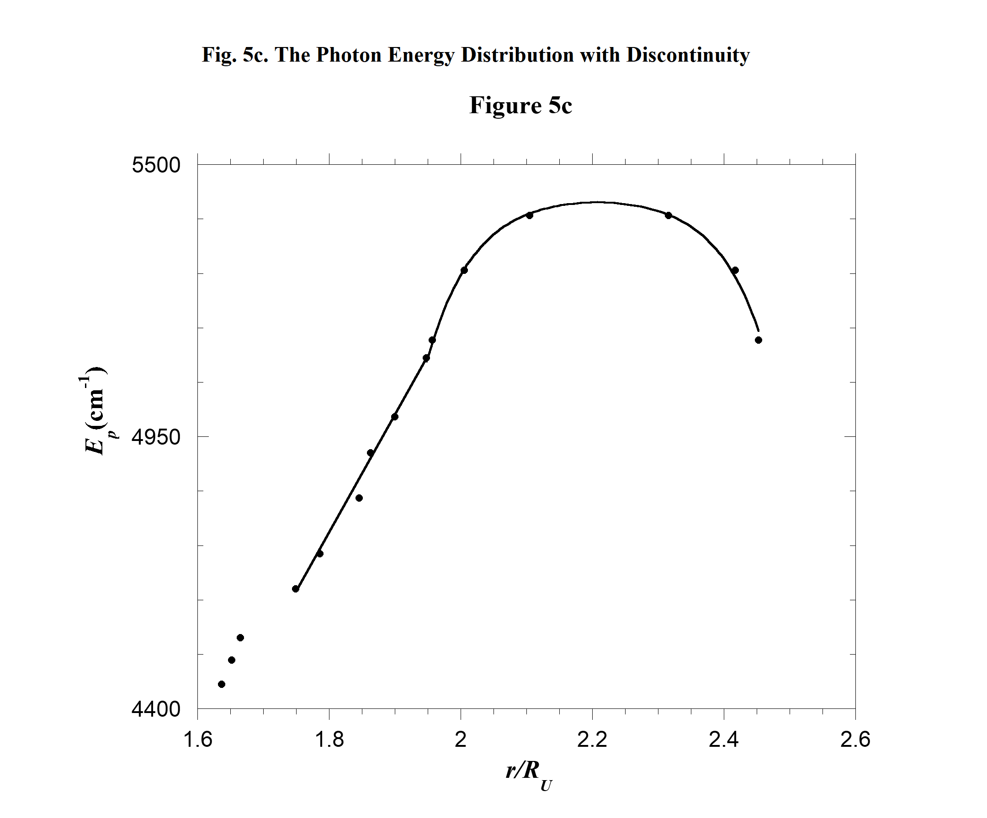
A similar situation occurs for the region from Cordelia to Desdemona in Fig. 5b. If we don't assume a peak occurs there, a discontinuity occurs because of the wide radial gap between Ophelia and Bianca. If we assume a peak, then we find the curve is smoothly varying, symmetric and centered at r/R_{U} = 2.21 where r is the radial coordinate in units of km. This point is half-way between Ophelia and Bianca as seen in Fig. 5b.
Notice that Bianca is assigned i = 1 just as for Ophelia. In Table 4 and Fig. 5a, the rest of the PED beyond Bianco does not have any more dips or peaks and each satellite in turn is assigned an ever increasing i or pair of i 's all the way out to i = 20 for Oberon the last regular satellite.
2.3.a. Comparing the PED in Figure 5a to TD's of the Solar Nebula
Given that processes which govern the behavior of protosatellite disks and the protoplanetary disk (solar nebula) are similar (Mousis et al. 2002, Mousis 2003, and Mousis and Alibert 2006), we now compare the PED in Figs. 5a to temperature distributions (TD's) calculated by Lin and Papaloizou (1985, hereafter L&P (1985)) for the solar nebula. Fig.18 of L&P (1985) contains two sets of graphs showing midplane TD's of the solar nebula for two different times during what are called upward and downward transition waves. We find the PED in Fig. 5b to be similar in shape to the L&P (1985) solar nebula TD's. Both types of L&P (1985) TD's are peaked and have characteristics similar to those of the PED in Fig. 5a. To the right of the peak in the L&P (1985) TD at the onset of the transition, there is a negatively sloped tail just as in the PED in Fig. 5a. Also, in the L&P (1985) distribution near the end of the downward transition and to the left of the peak, the TD has a dip just as in the PED in Fig. 5a.
13

