2.3.b. Assumptions Related to the PED in Figure 5a and
the TD of the Uranian Protosatellite Disk
The observations in the last section cause us to explore the possibility that the PED in Fig. 5a is related to the TD of the Uranian protosatellite disk. To do this we first make a series of simplifying assumptions: 1. The present day orbital radii of the Uranian satellites and rings (R_{u}) are the same or nearly the same as the orbital radii of the primordial rings from which they evolved. If migration does affect Uranian satellite orbital radii, the migration is uniform for all the satellites. 2. The Uranian rings and regular satellites evolved from primordial rings that were born in the Uranian protosatellite disk. 3. Each primordial ring is associated with the local mid-plane temperature of the disk. 4. Each of these T's is related to a photon energy (E_{p}) in the portion of the H₂ spectrum in Table 4. 5. The relationship between T and E_{p} is linear and of the form
T = C₁(E_{p} + C₂), (3)
where C₁ and C₂ are constants empirically determined in section 2.3.c.
Section 2.6 and Appendix 3 theoretically link E_{p}'s to specific disk temperatures (T's) in the linear form of Eq. (3).
2.3.c Determination of C₁ and C₂
Mousis (2004) derives a series of TD's for a “water-rich” Uranian protosatellite disk. Each TD is for a different time t after the disk is formed by an assumed impact to Uranus's surface. Fig. 1 of Mousis (2004) has seven TD's with t values for the first three equal to 1x10⁴, 2x10⁴ and 5x10⁴ years. Fig. 6 in
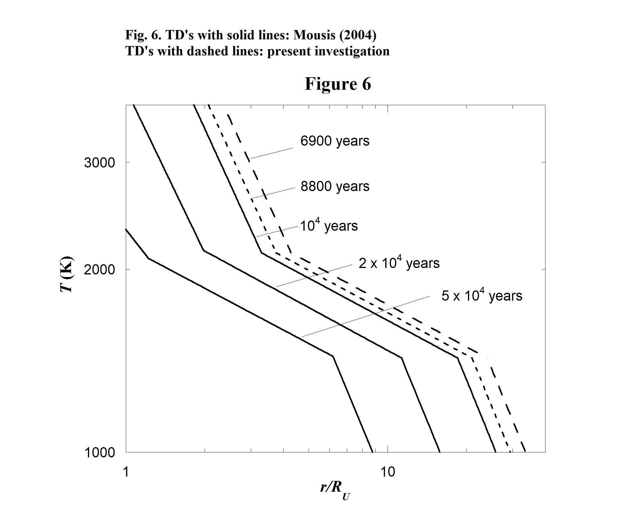
14
the present investigation includes reproductions of the first three Mousis TD's (each represented by solid straight line segments) and two TD's (dashed line segments) constructed in the present investigation by using the similarities among the first three Mousis TD's. Appendix 1 is a discussion of the method used for the reproduction of the Mousis TD's and for the construction of the two dashed TD's. The t values for TD's are indicated in Fig. 6. Three of these are from Mousis (2004) and the other two associated with the dashed TD's are t = 8800 and 6900 years. A discussion of how these two t 's are determined is in Appendix 2.
Table 4 and the time dependent series of TD's in Fig. 6 are used to determine the parameters C₁ and C₂ in Eq. (3). Because graphs in Fig. 6 do not contain a dip and a peak as is seen in the Uranian PED in Fig. 5a, the only E_{p}'s and R_{ui}'s used in the process are those in the PED's “tail” for which i = 9 – 20 in page 2 of Table 4. This parameters are found as follows. Many trial sets of C₁ and C₂ are used in Eq. (3). For each set of C₁ and C₂, a set of T 's is calculated with each T in a set corresponding to an E_{p} and a R_{ui} in Table 4. Then each set of T 's and R_{ui} 's is graphed to make a trial TD and the trail TD is compared to the TD's in Fig. 6.
Best fits to the Mousis (2004) TD's for which t = 1x10⁴, 2x10⁴ and 5x10⁴ years are found and the best of the three is the one for the earliest time t = 1x10⁴ years shown in Fig. 7. But it is seen that a Mousis type TD for an earlier time would most likely be fitted even better. Various earlier time Mousis
type TD's are constructed using a method discussed in Appendix 1. By trial and error it is found that the TD corresponding to t = 8800 years is fitted best of all. This TD and the fitted data are given in Fig. 8. The corresponding parameters are C₁ = 2.315K∙cm and C₂ = -3720 cm⁻¹. The time t = t₀ = 8800 years is the approximate time when the Uranian satellites start their formation. The best fit to the TD for t = 6900 years is given in Fig. 9. It is interesting to compare Figs. 7, 8 and 9. The times t₀ = 8800 and 6900 years are determined in Appendix 2.
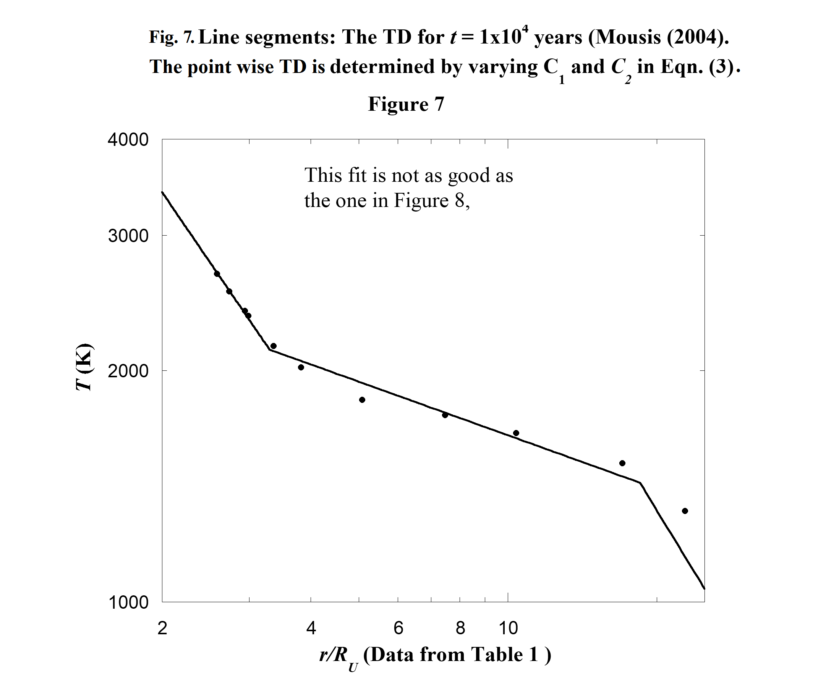
15
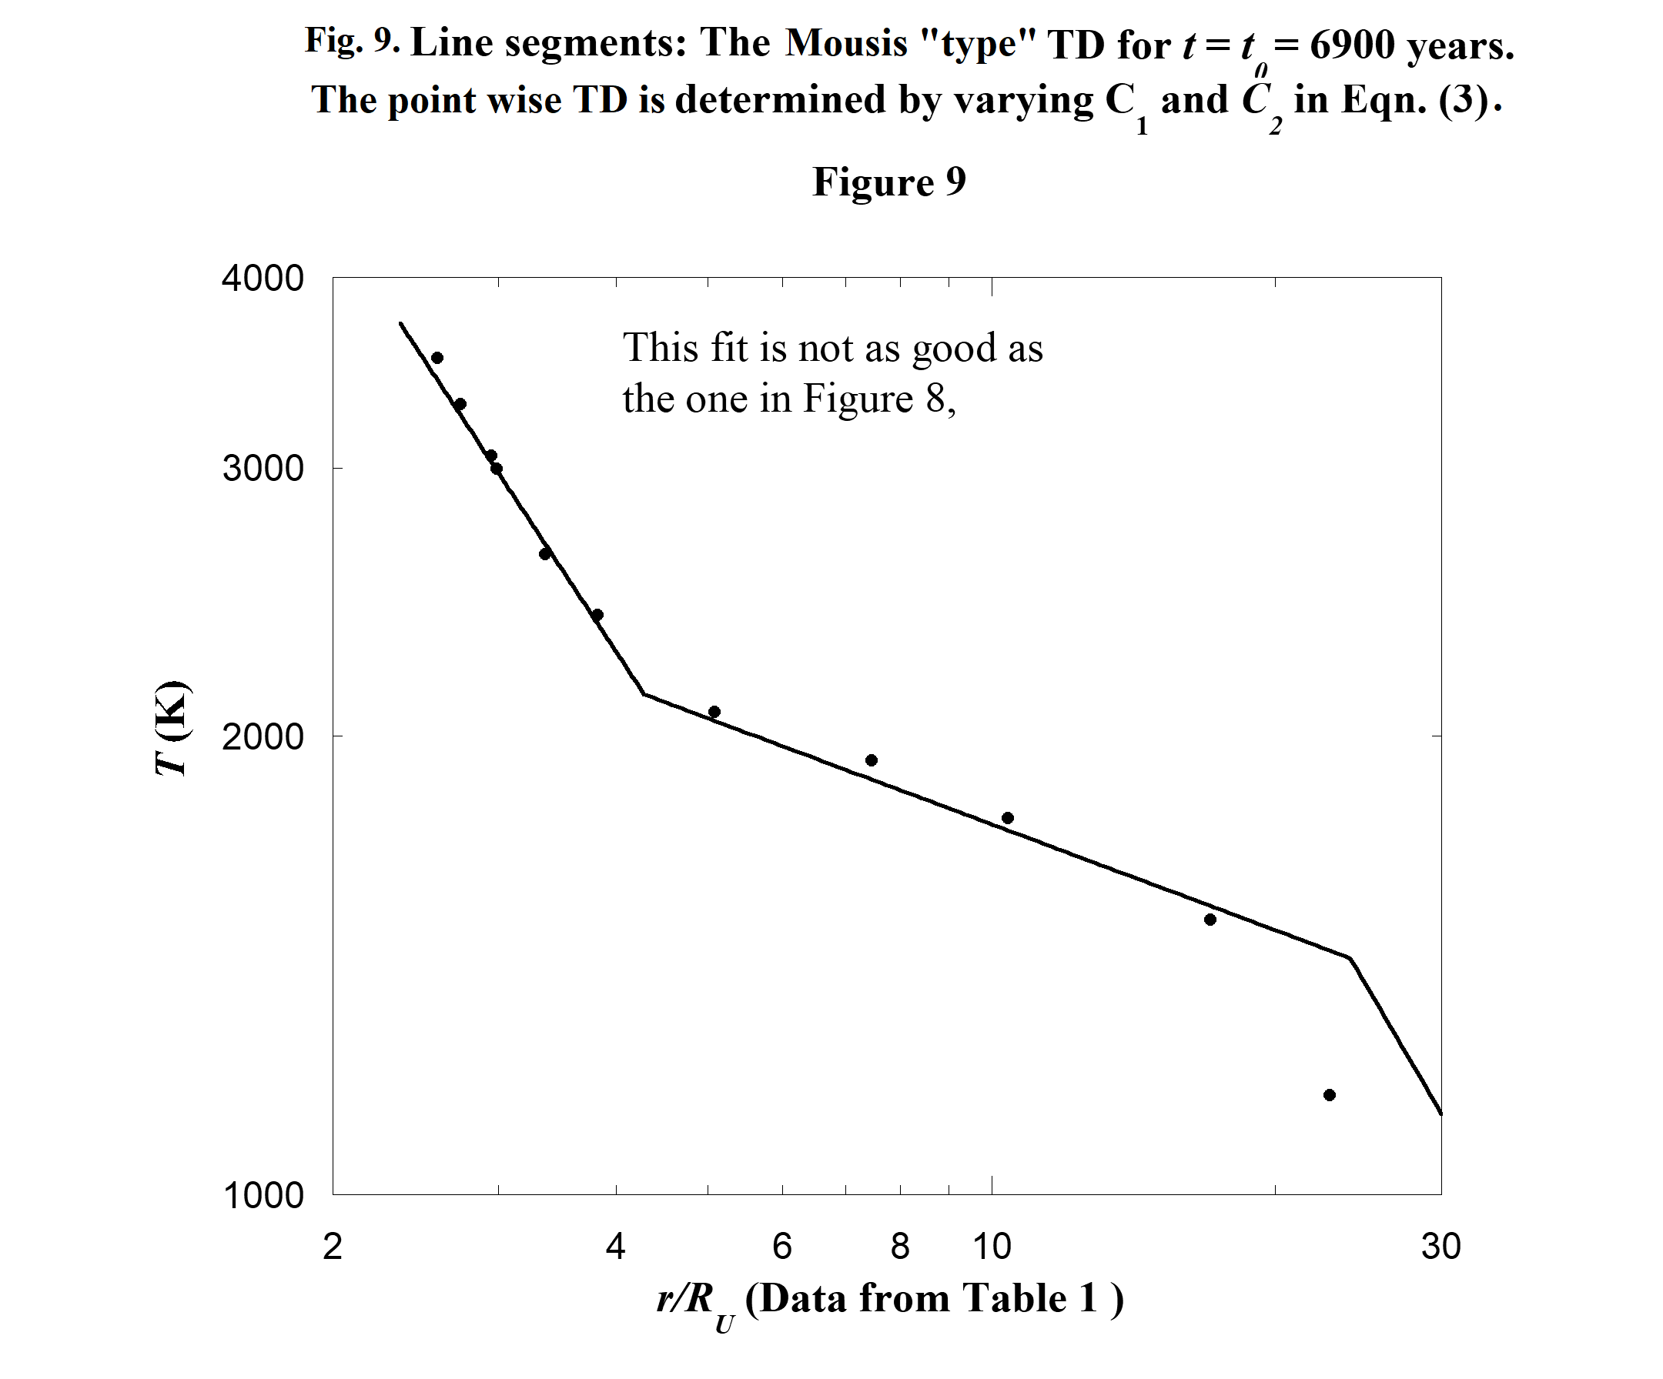
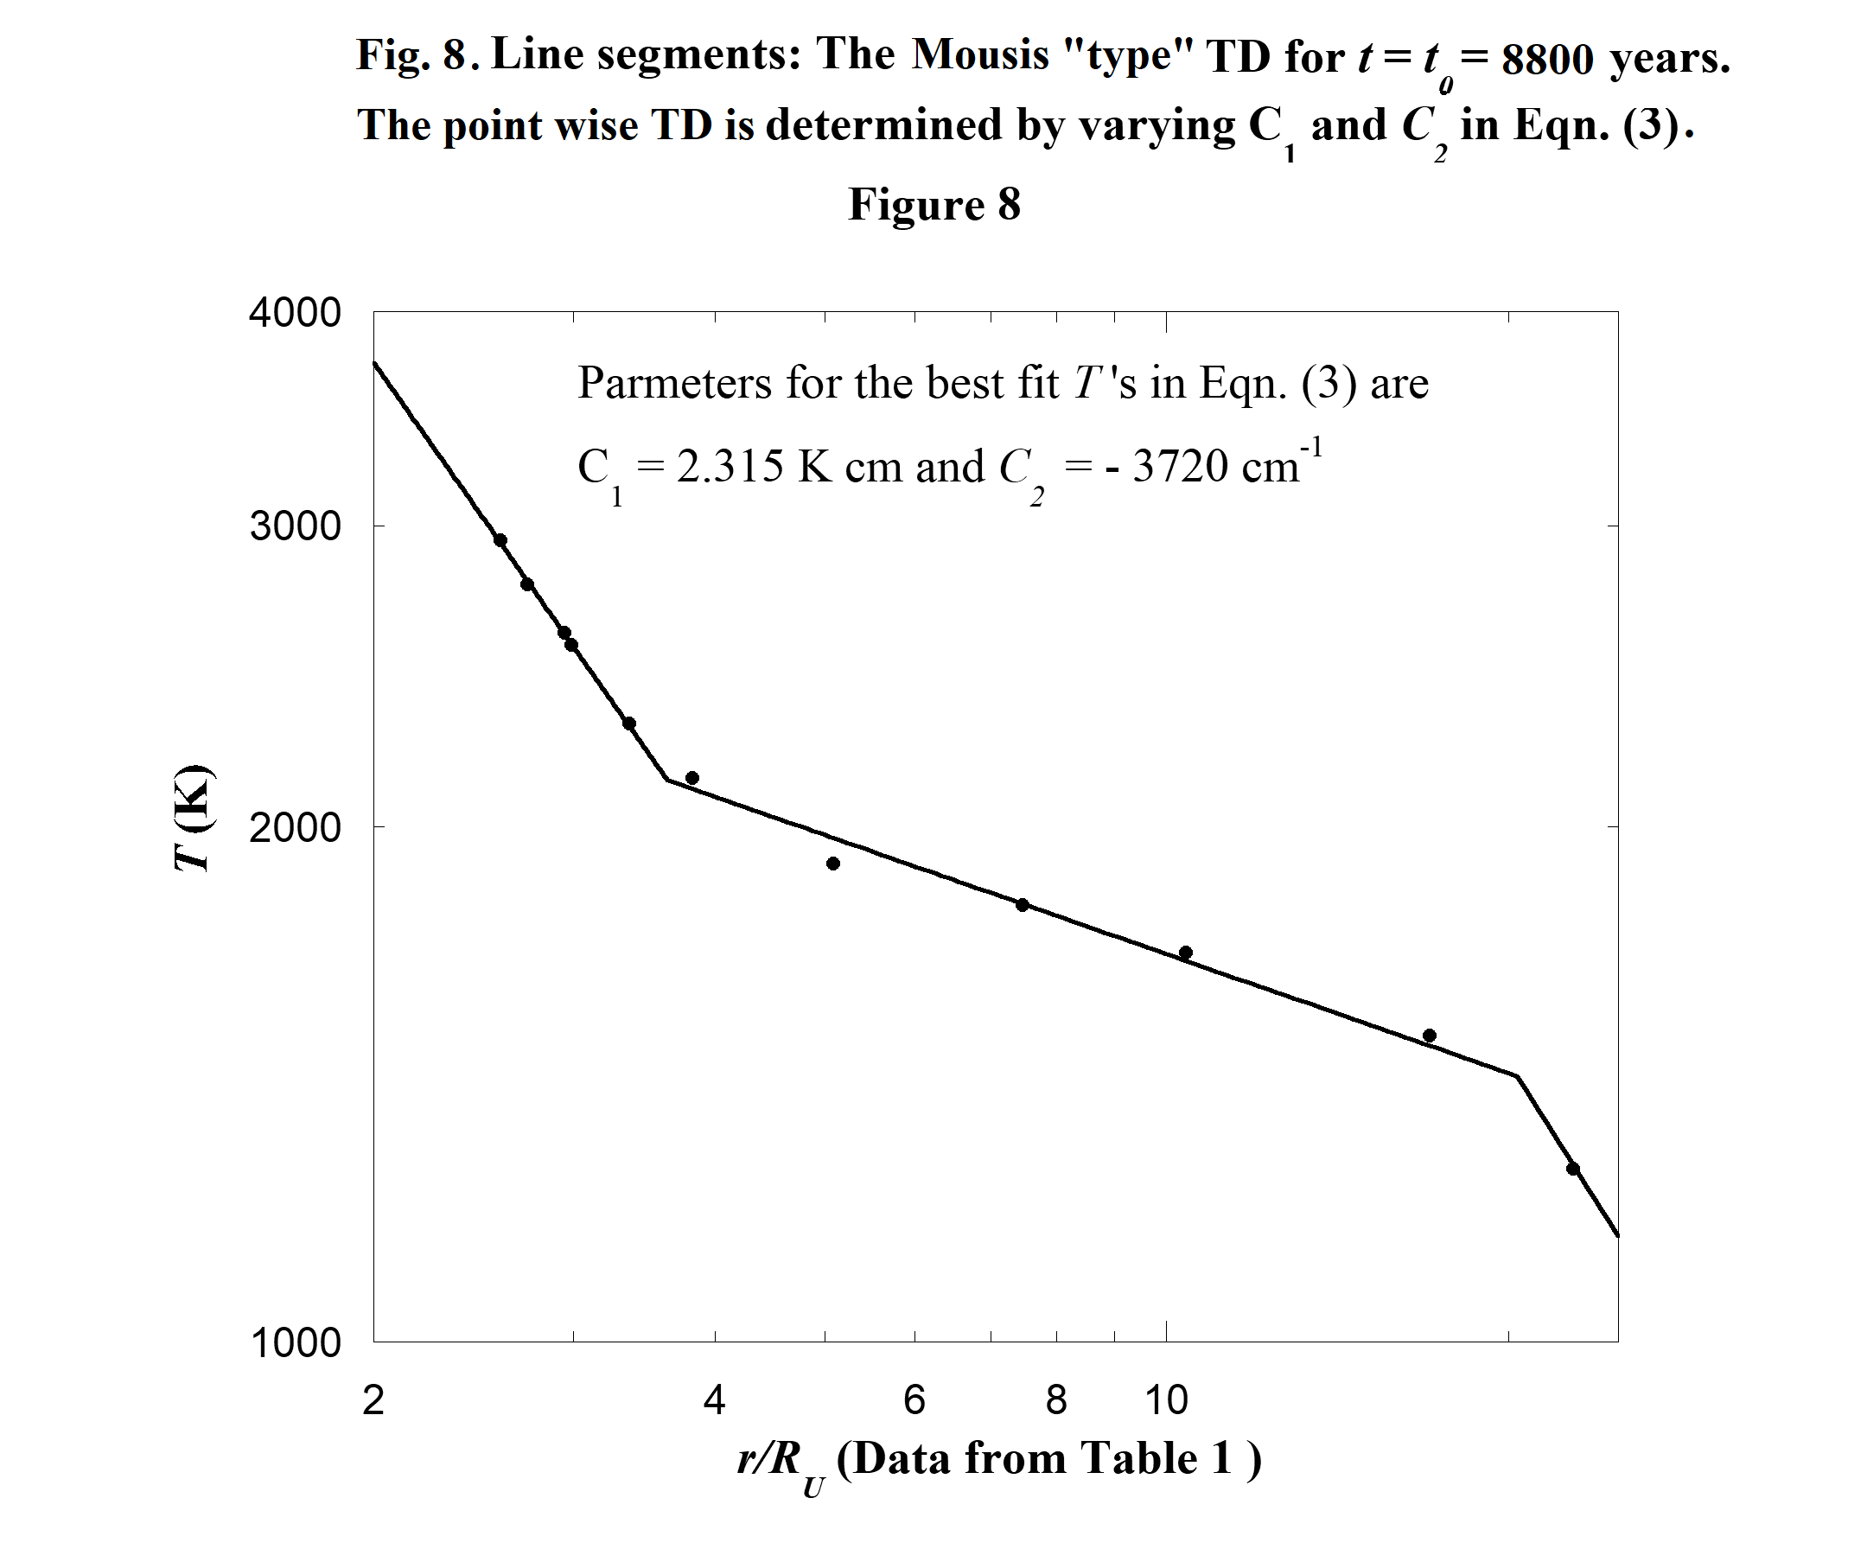
16
2.4. The Overlap of the Uranian, Jovian and Neptunian TD's
Table 2 contains transformed orbital radii of the Jovian and Neptunian satellites. It is used in section 2.1.c to construct Fig. 3. Now we use it again to construct the scaled Jovian and Neptunian TD's seen in Fig. 10. This figure also includes the graphs shown in Fig. 8 for the Uranian TD for which t = t₀ = 8800 years. Fig. 10 shows the generally precise overlap of the three TD's. As discussed in section 2.1.c, this overlap cannot continue inward to smaller orbital radii because the Jovian and Neptunian protosatellite disks are relatively closer to their respective planets than is the Uranian disk from Uranus. Interestingly, in the upper left the shape of the Uranian and Neptunian TD's both show a “shoulder”. In a future discussion we see a similar shoulder in Saturn's TD.
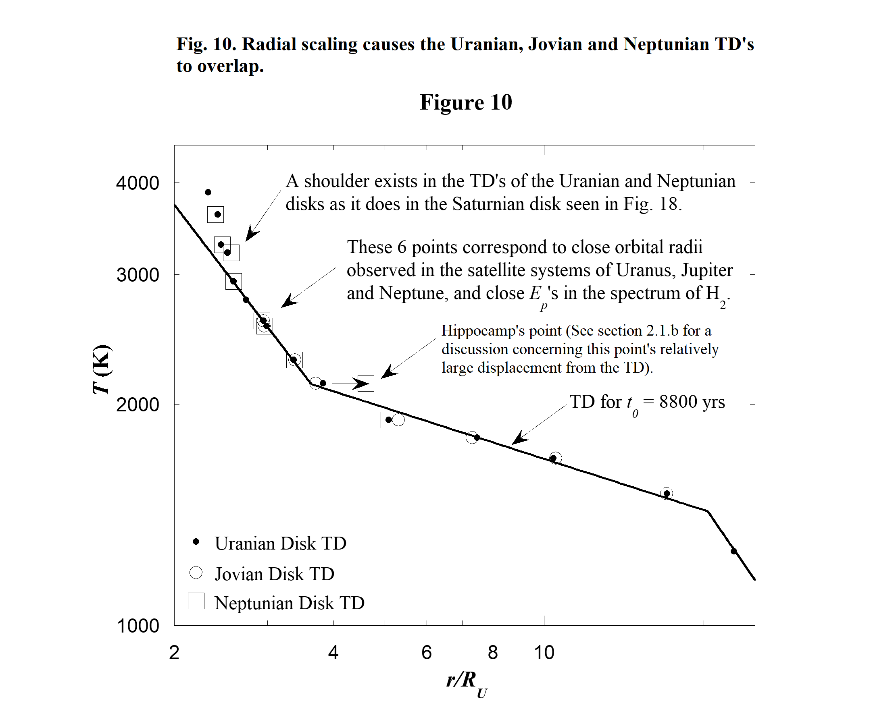
In the present model Uranian satellites begin their formation 8800 years after the the Uranian protosatellite disk was formed. Because the Jovian and Neptunian TD's overlap the Uranian TD for
which t = 8800 years, we may think it is possible to draw conclusions about the times when the Jovian and Uranian satellites begin their formation. But this is not true. For the most part, TD's corresponding to different times in the vicinity of t = 10⁴ years can be transformed from one to another simply by linearly scaling the radial coordinate system associated with one of them. So Eqs. (1) and (2) scale TD's with respect to both time and space but we don't know to what degree for each.
17

18
2.5. The Complete TD for the Uranian Protosatellite Disk
Eq. (3) relates T's to E_{p}'s. The constants in this relationship are determined in section 2.3.c by fitting data to the “tail” of the Uranian disk TD. We now assume Eq. (3) holds for the complete Uranian disk TD. Table 5 lists the complete set of calculated T's, and Fig. 11 shows the complete point-wise TD. Because the relationship between T and E_{p} in Eq. (3) is linear, the Uranian TD and PED have similar shapes. Therefore the Uranian disk TD also shows characteristics described by L&P (1985) for the solar nebula as described in section 2.3.a. Notice the present investigation diverges from the Mousis “type” graph at a point just to the right of the peak. A similar result is seen later in Fig. 18 where Saturn TD's are compared.
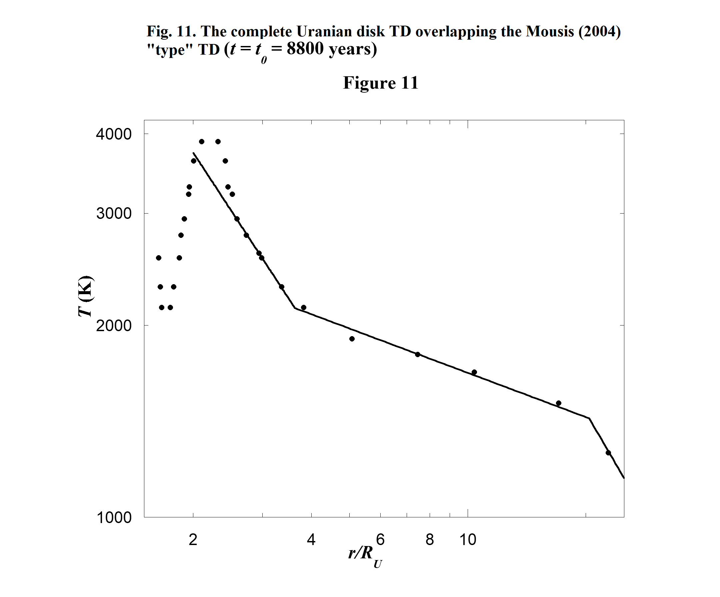
2.6. Why are T and E_{p} related in the Form Given by Eq. (3)?

Stancil and Dalgarno (1997) have used the mechanism of SRMA to study rate coefficients for the production of the molecule LiH from the atoms Li and H in the early universe. The form of the reaction describing SRMA is
A + B + hν → AB + 2hν, (4)
where A and B are atoms or molecules that associate to make the molecule AB. The photon hν on the left side of Eq. (4) stimulates the process during which a second photon is created with the same energy and direction of motion as the first. And so there are two photons symbolized on the right side.
19

