26

27
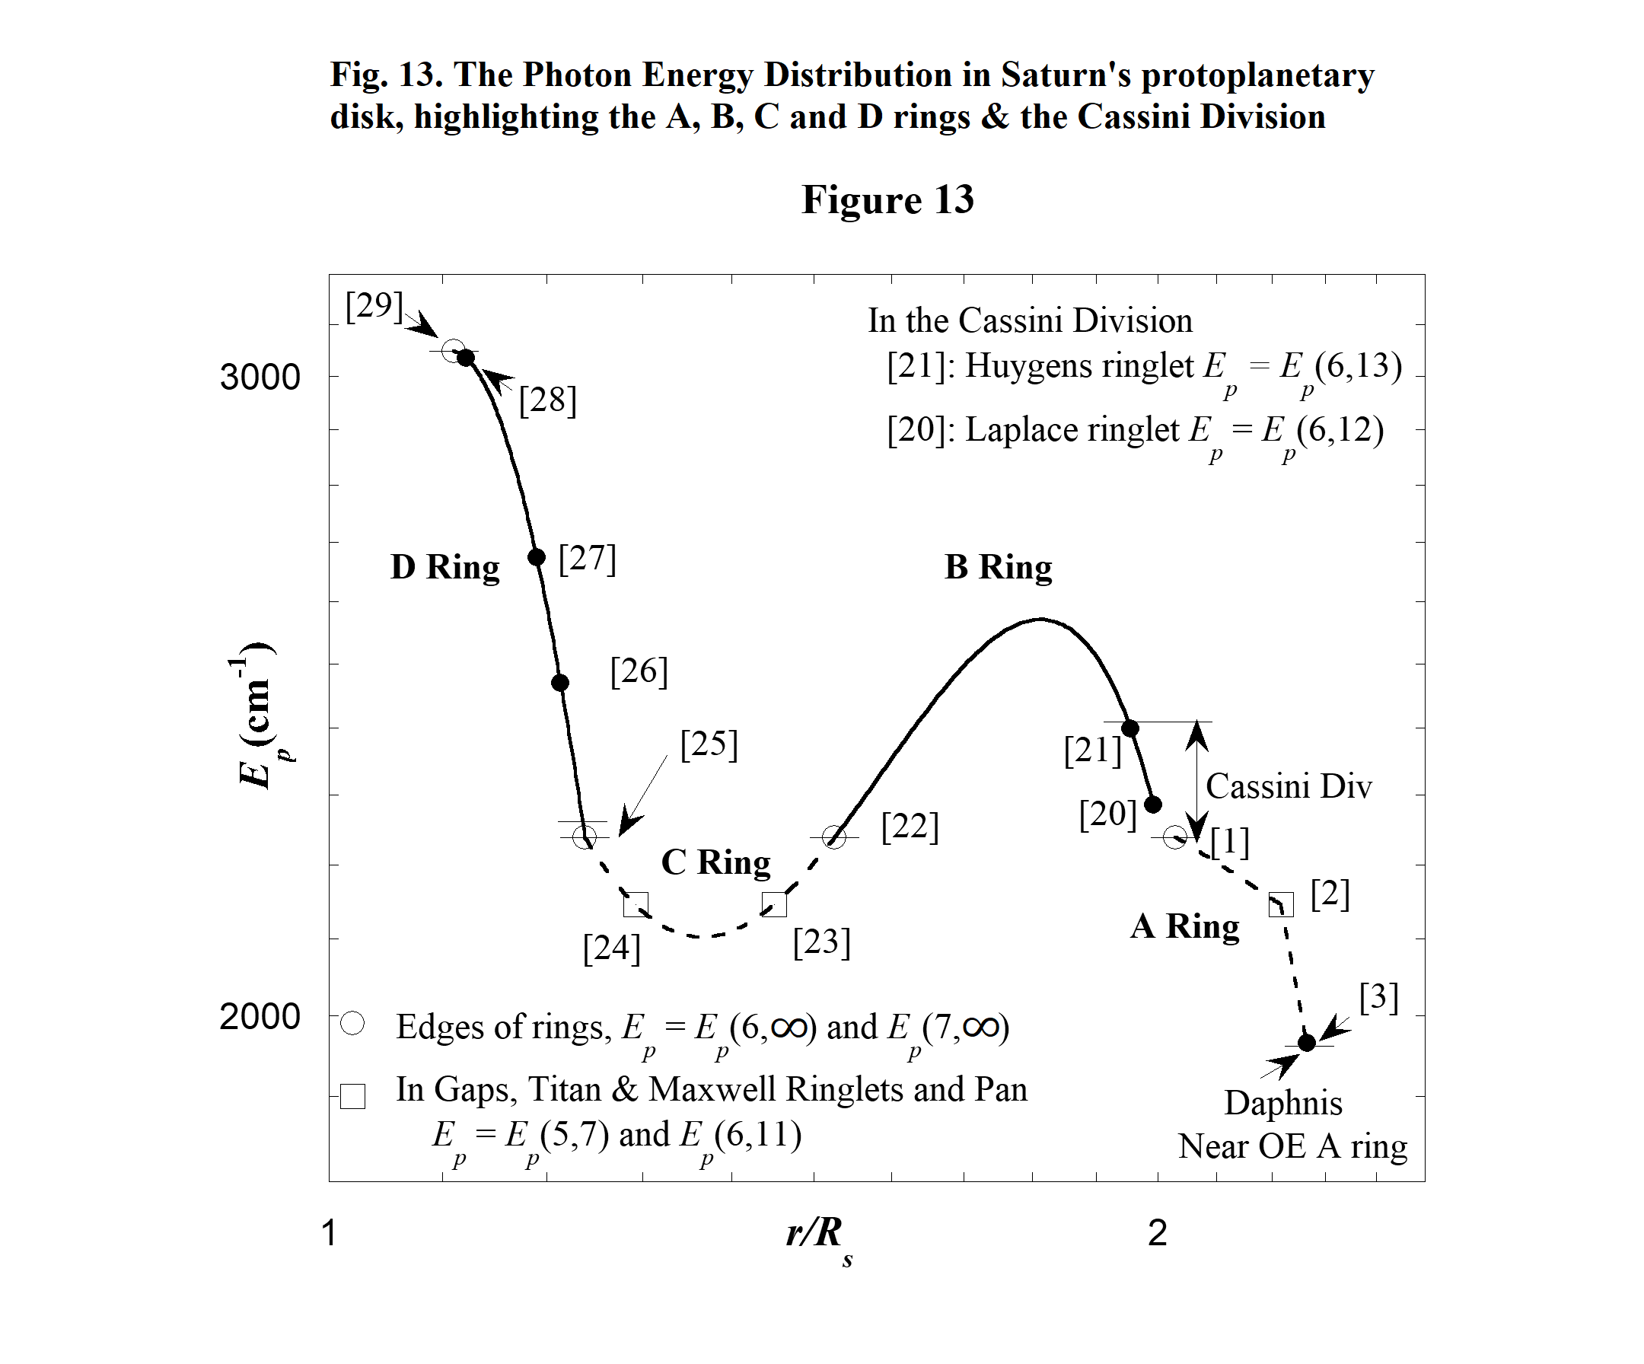
Furthermore Table 8 reveals there are just three bolded E_{p}'s that fall within the D ring. These E_{p}'s are associated with the three ringlet radii. Figure 13 shows the resulting PED from index [22] to index [29] to be a smooth curve that defines a dip in the PED of Saturn's protosatellite disk.

2.7.c. The B Ring, Cassini Division and Resonance Ring Widths

In the present model the broad rings of Saturn are created by overlapping adjacent resonance rings. Outside the region of Saturn's broad rings, resonance rings do not overlap. Whether they overlap or not depends on their width. The width of resonance rings within the wide rings undoubtedly depend on a few factors, e.g. the local temperature gradient, and the dust and gas densities in the rings. The variability in these factors could explain why the inner edge of the B ring extends inward all the way to the outer edge of the C ring while the outer edge does not extend outward all the way to the inner edge of the A ring, and the Cassini Division exists between the A and B rings. On average the optical depth of the Cassini Division is low (French et al. 2020), but it is not completely void of material and there are eight gaps (Planetary Society 2021) in the Cassini Division. Among these are the Laplace and Huygens Gaps each with a ringlet within its boundaries.

28
The optical depth of the two ringlets is large and the ringlets are narrow compared to the other features in the Cassini Division, as seen in the optical depth profile of the Cassini Division (French et al. 2020 Fig. 2 & Jerousek et al. 2020 Fig.1). Therefore, the Laplace and Huygens ringlets are the dominant features in the Cassini Division. In Table 8 there are just two E_{p}'s, E_{p}(6,12) and E_{p}(6,13), that have values corresponding to the Cassini Division and they are paired with the Laplace [20] and Huygens [21] ringlets in Table 9 and Figs. 13 and 14. The width of these ringlets are about 40 and 20 km respectively and the difference in their radii is about 2,200 km (French et al. 2020 Fig. 2).
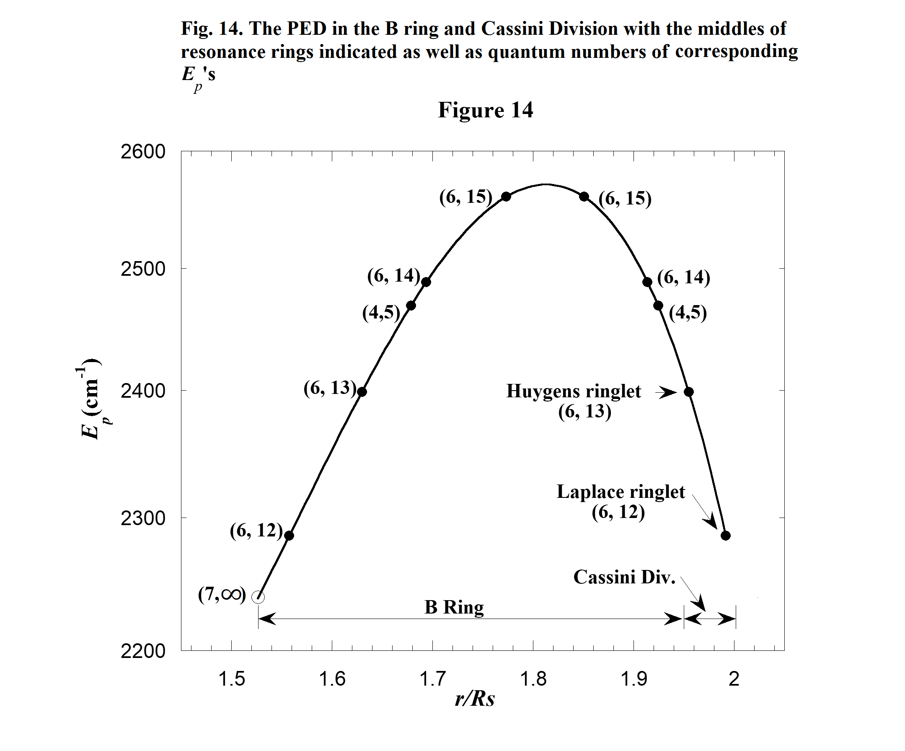
The peaked solid curve in Fig. 13 approximates the PED in the region of the B ring and Cassini Division. It is determined as described in Appendix 4. In this approximation the peak value in the PED is slightly larger than E_{p}(6,15). Therefore E_{p}(6,15) is the largest E_{p} value contributing to the B ring as indicated in Table 8. Using Table 8 and Fig. 14, we can count the number of just barely overlapping resonance rings that create the B ring by counting the E_{p}'s that create resonance (Three of them are counted twice). Starting from the inner edge of the B ring and moving outward to the outer edge we have E_{p}(6,12), E_{p}(6,13), E_{p}(4,5), E_{p}(6,14), E_{p}(6,15), E_{p}(6,15), E_{p}(6,14), E_{p}(4,5). There are 8 overlapping resonance rings. Assuming they barely overlap, the average width of a resonance ring is

29
approximately 1/8th the width of the B ring or approximately 3200 km. This is about 100 times wider than the Laplace and the Huygens ringlets in the Cassini Division where the optical depth is low.

In Table 8, [26] is paired with E_{p}(4,5) and this resonance causes a ringlet in the D ring. We might expect photons with energy E_{p}(4,5) to affect the B ring in the same way they affect the D ring. If this were the case, there would be two ringlets corresponding to the E_{p}(4,5) resonance also observed in the B ring with one on each side of the PED peak. The lack of these ringlets is likely related to the larger density of material that presumably existed in the B ring over the D ring when resonance rings existed. Presently the optical depths of the B and D ring are 0.4-2.5 and 10⁻⁵ respectively (NASA 2021).

2.8. The Temperature Distribution in Saturn's Protosatellite Disk

Mousis, Gautier and Bockelee-Moran (2002) (in the future referred to as MGB) have theoretically derived a series of six TD's for the Saturnian subnebula (protosatellite) disk. Their TD's are shown in their Fig. 1. The first four of these are reproduced in Fig. 15. (The reproduction is achieved by analyzing coordinates of points on the MGB TD curves with the photo editor GIMP). We now investigate the relationship between the MGB TD's and the E_{p}'s and r/R_{s} values listed in Table 7.
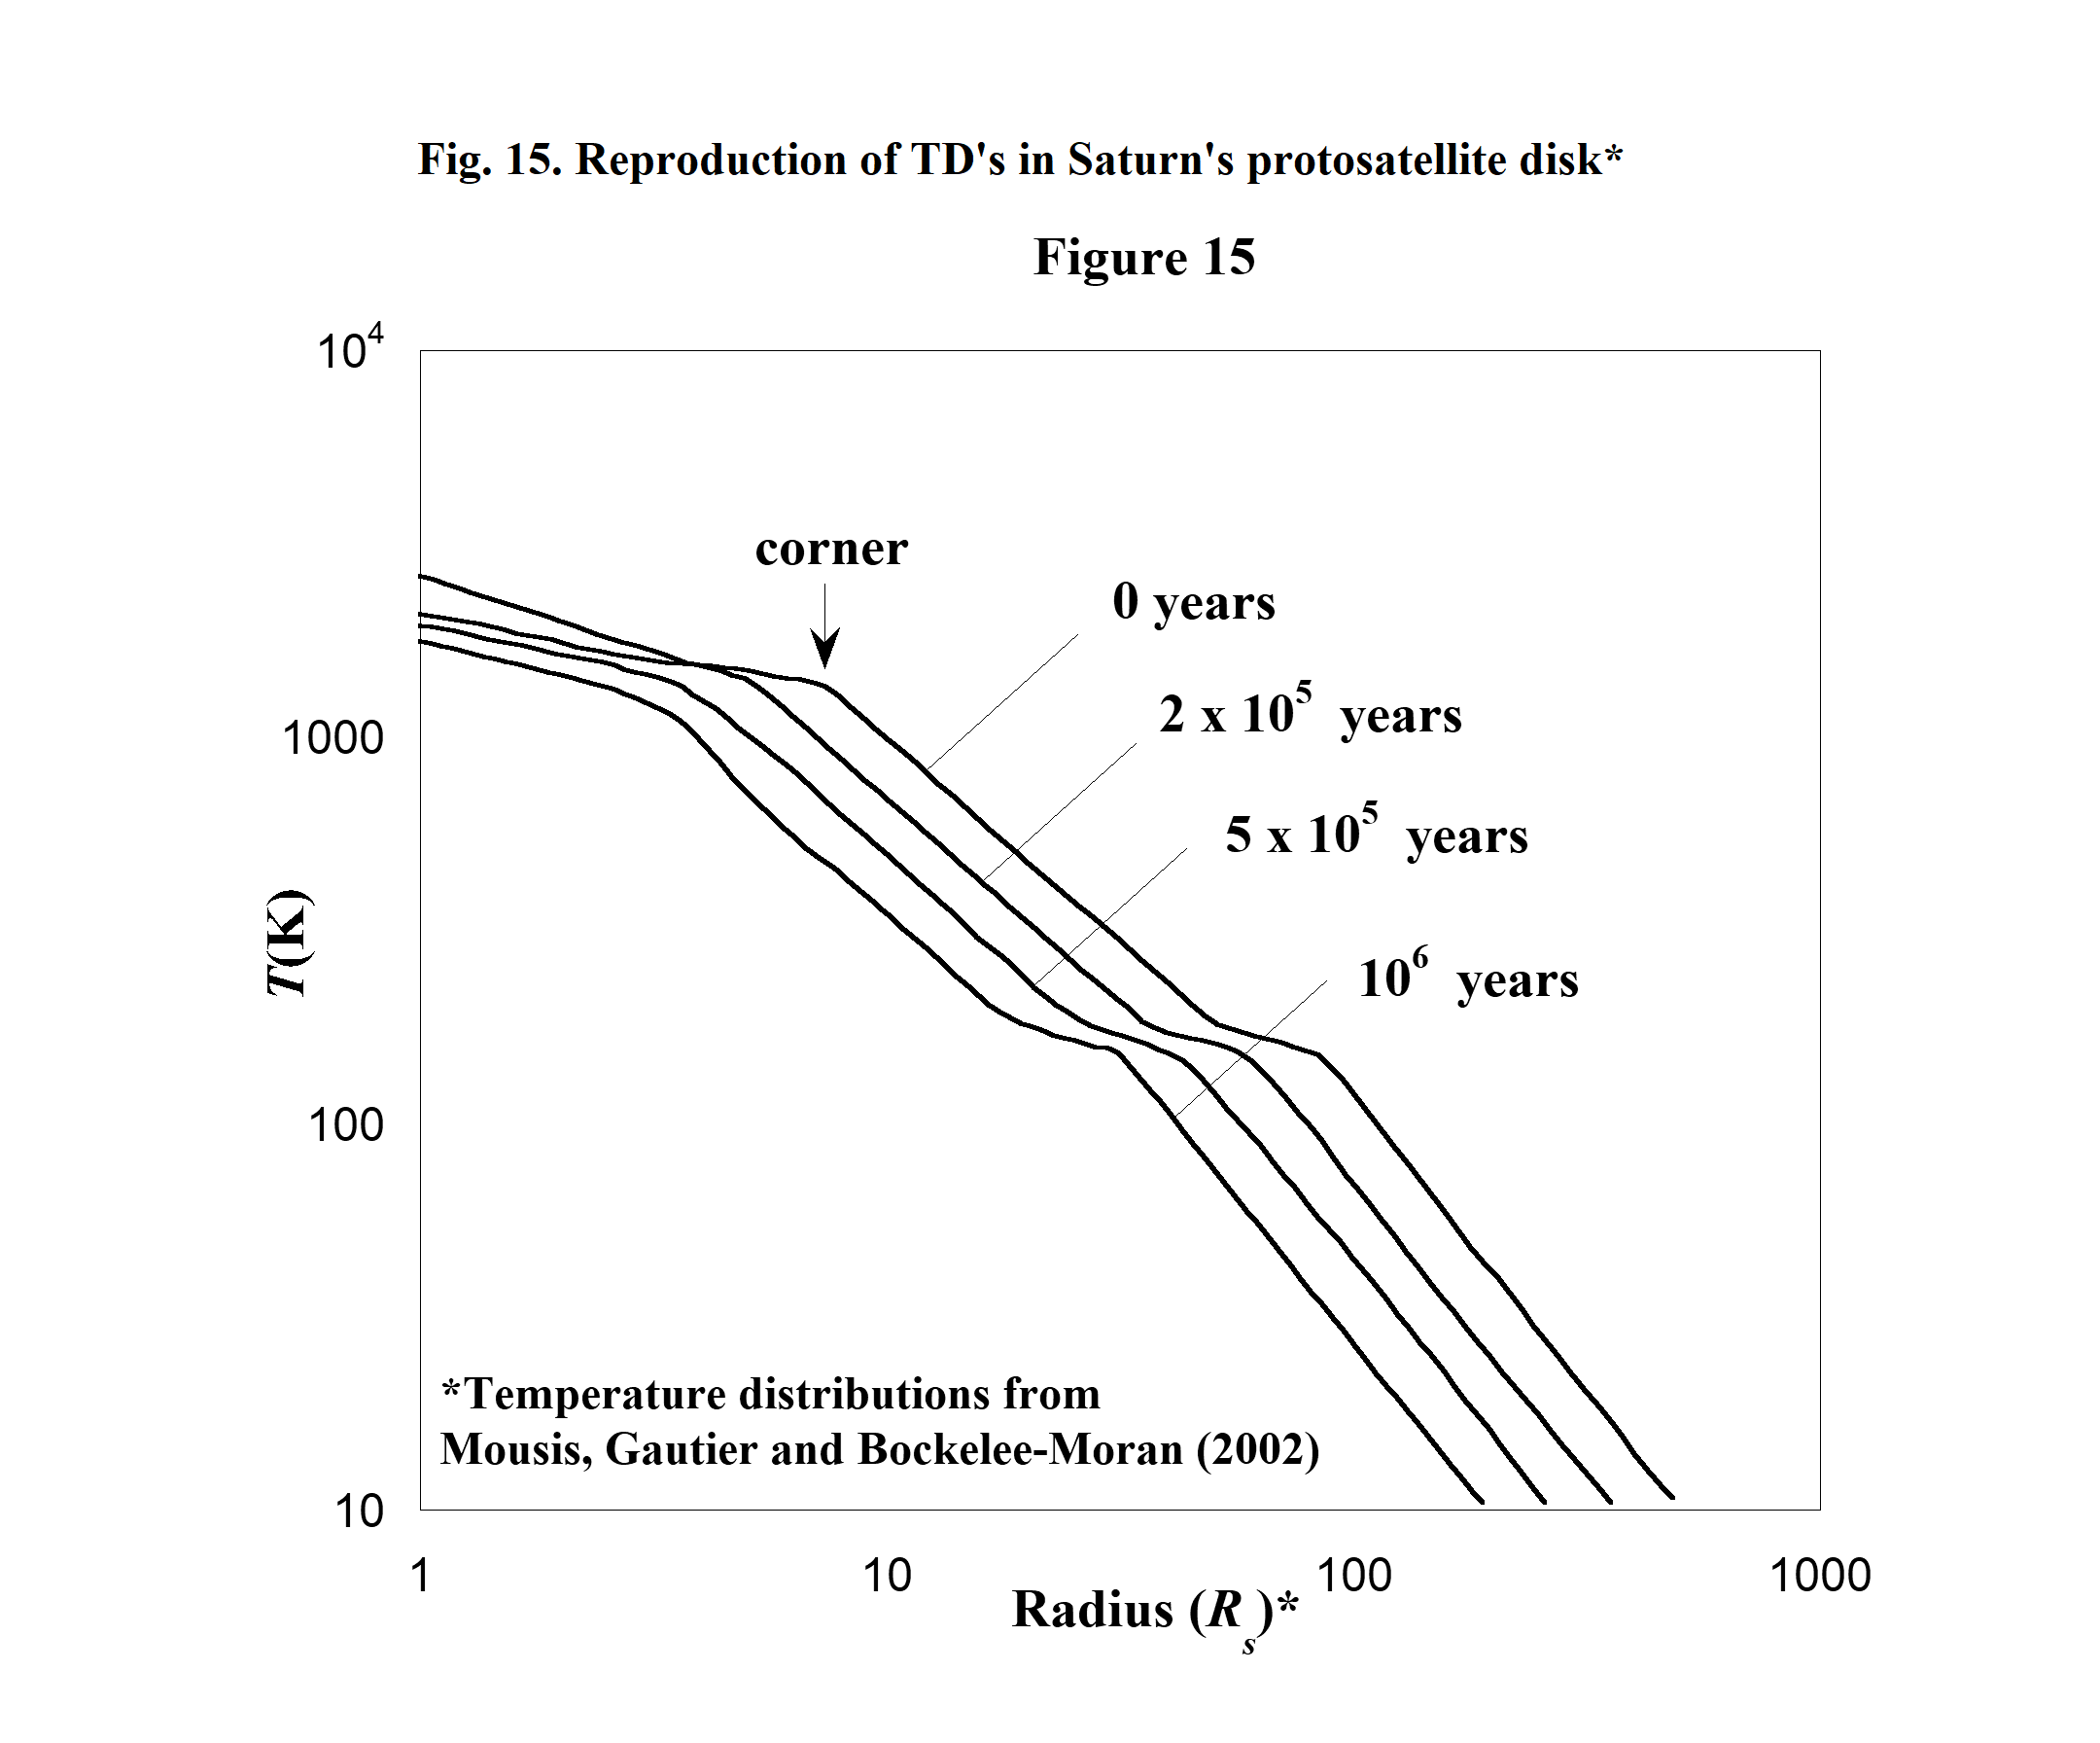
30
As in section 2.3.b for Uranus, we assume Saturn's rings and regular satellites evolved from primordial rings that were born in the Saturnian protosatellite disk with each primordial ring associated with the local mid-plane temperature T of the disk. Each of these T 's is related to one of the E_{p} values previously discussed for the Saturnian disk. We again assume the relationship between T and E_{p} is linear and of the form
T = C'₁(E_{p} + C'₂), (7)
where C'₁ and C'₂ are constants to be empirically determined. To determine these constants we use Eq. (7) with the r/R_{s} values and E_{p}'s in Table 7. A trial set of C'₁ and C'₂ is used to calculate a T for each E_{p} in Table 7. Then these T 's and their corresponding values of r/R_{s} are used to construct a trial TD. This TD is compared to the TD curves in Fig. 15. After many iterations it is determined that no good fit can be found to any of the MGB TD's. Fig. 16 shows the fit to the MGB TD for which t = 5 x 10⁵ years.
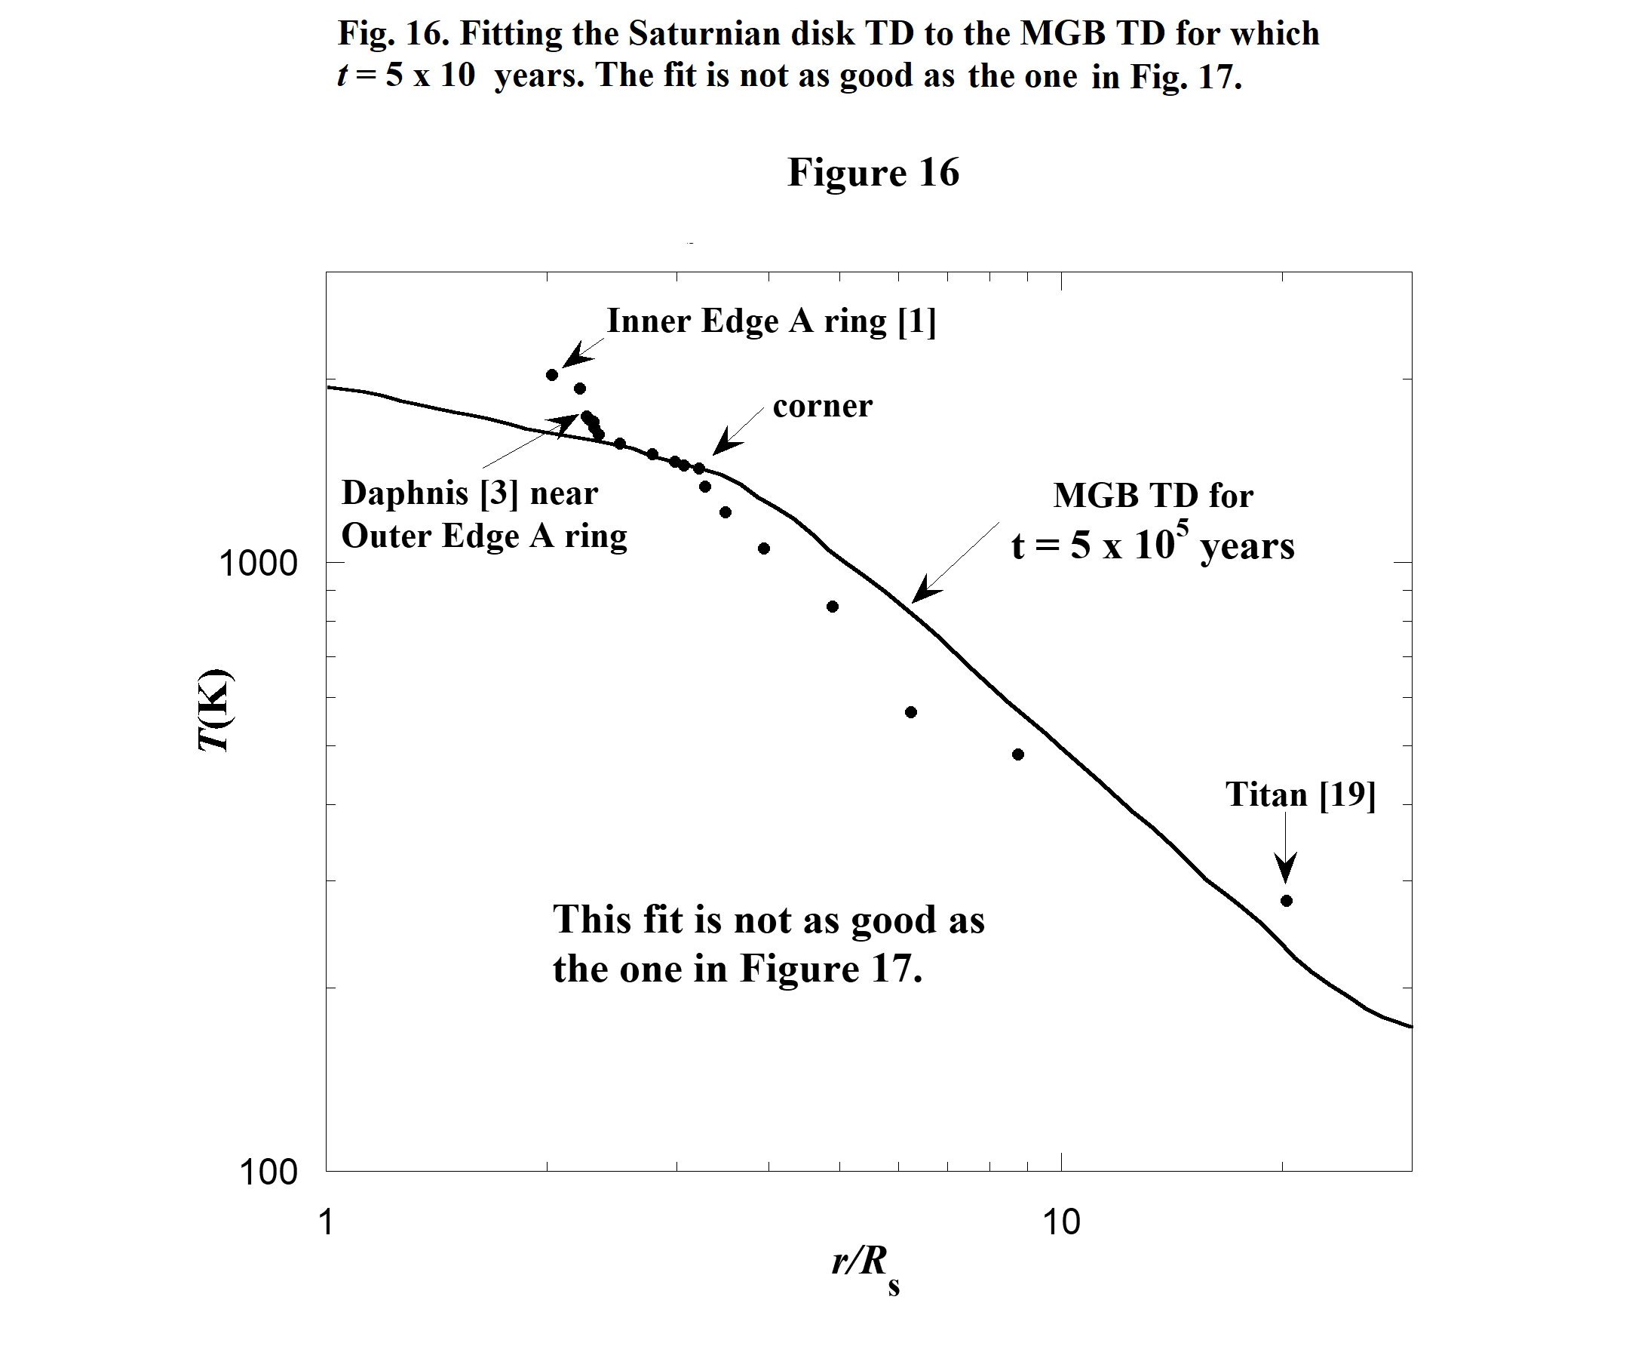
The fit is not good but the shape of the trial TD (the collection of data points) gives a hint on how to proceed. A corner in the trial TD is identified in Fig. 16. And notice the MGB TD for which t = 0 in Fig. 15 also has a corner. Perhaps these corners can be made to overlap and hopefully this will produce

31

