a good fit of the Table 7 data to the MGB TD for which t = 0 years. A linear scaling of the r/R_{s} values in Table 7 to larger values, call them (r/R_{s})', is assumed.

(r/R_{s})' = - a + (a + 1)(r/R_{s}), (8)

where a is a third adjustable constant along with C'₁ and C'₂. Perhaps, if the MGB TD's in Fig. 15 were to be linearly compressed by reasonably altering parameters used to calculate these TD's, it would not be necessary to transform orbital radii by means of Eq. (8). This form for Eq. (8) ensures that orbital radii of satellites and rings that are close to Saturn's surface are not altered very much. (Note: When (r/R_{s}) =1 so does (r/R_{s})'). Also the larger the orbital radius the larger the alteration. Subsequently the (r/R_{s})' values, not the r/R_{s} values, are used in the fitting process.

2.8.a. Fitting the MGB TD for which t = 0 years

The data from Table 7 is used to fit the MGB t = 0 year TD by adjusting the constant a in Eq. (8) along with C'₁ and C'₂. The best fit parameters are a = 2.20, C₁' = 1.080 K∙cm and C₂' = - 462 cm⁻¹. The best fit to the t = 0 year TD is in Fig. 17.
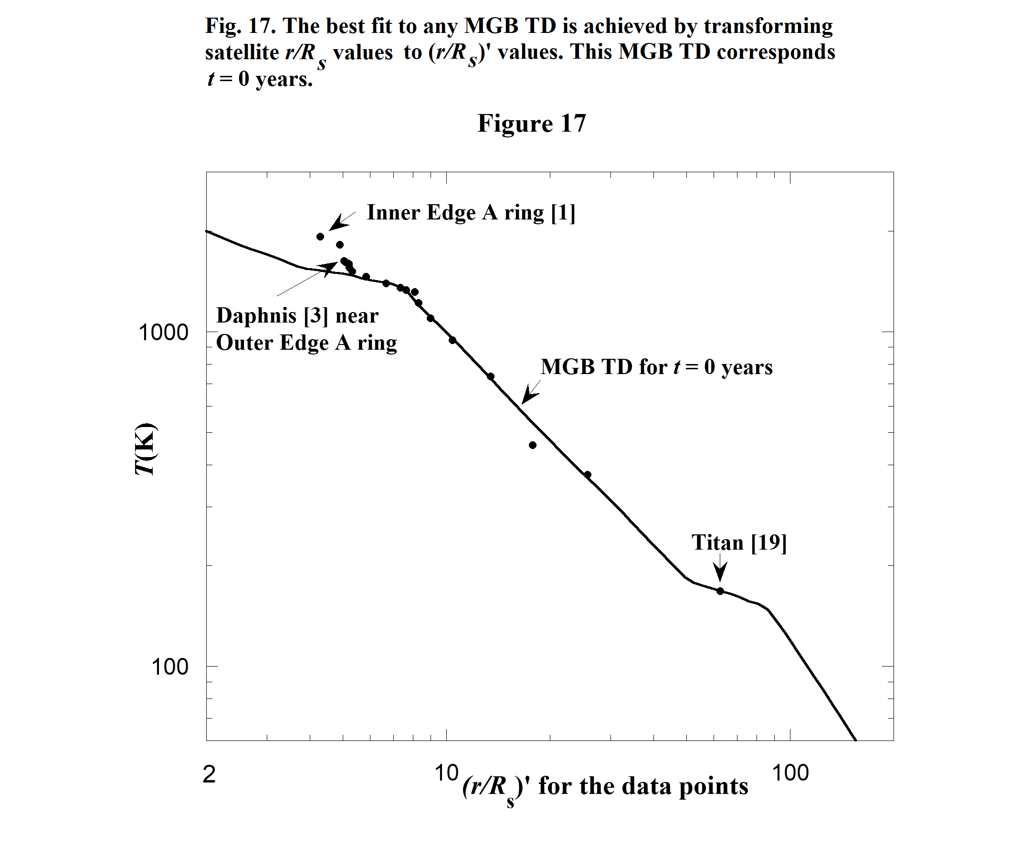

32
Eq. (7) and the best fit parameters are used with Table 9 to determine the complete Saturnian disk TD seen in Fig. 18. Also shown there is the MGB TD for which t = 0 years. The complete TD found in the present investigation has a peak just as in the Uranian disk TD. Note the present model TD diverges from the MGB TD in the region of Saturn's A ring which is positioned on the side of the peak. This divergence is similar to the one in the Uranian and Neptunian disk TD's in Fig. 10. Additionally, just up from the points of divergence there is a small shoulder in the side of the TD's peak. This is reminiscent of the small shoulder in a similar spot in Fig. 10 the composite TD for the disks of Uranus Jupiter and Neptune.
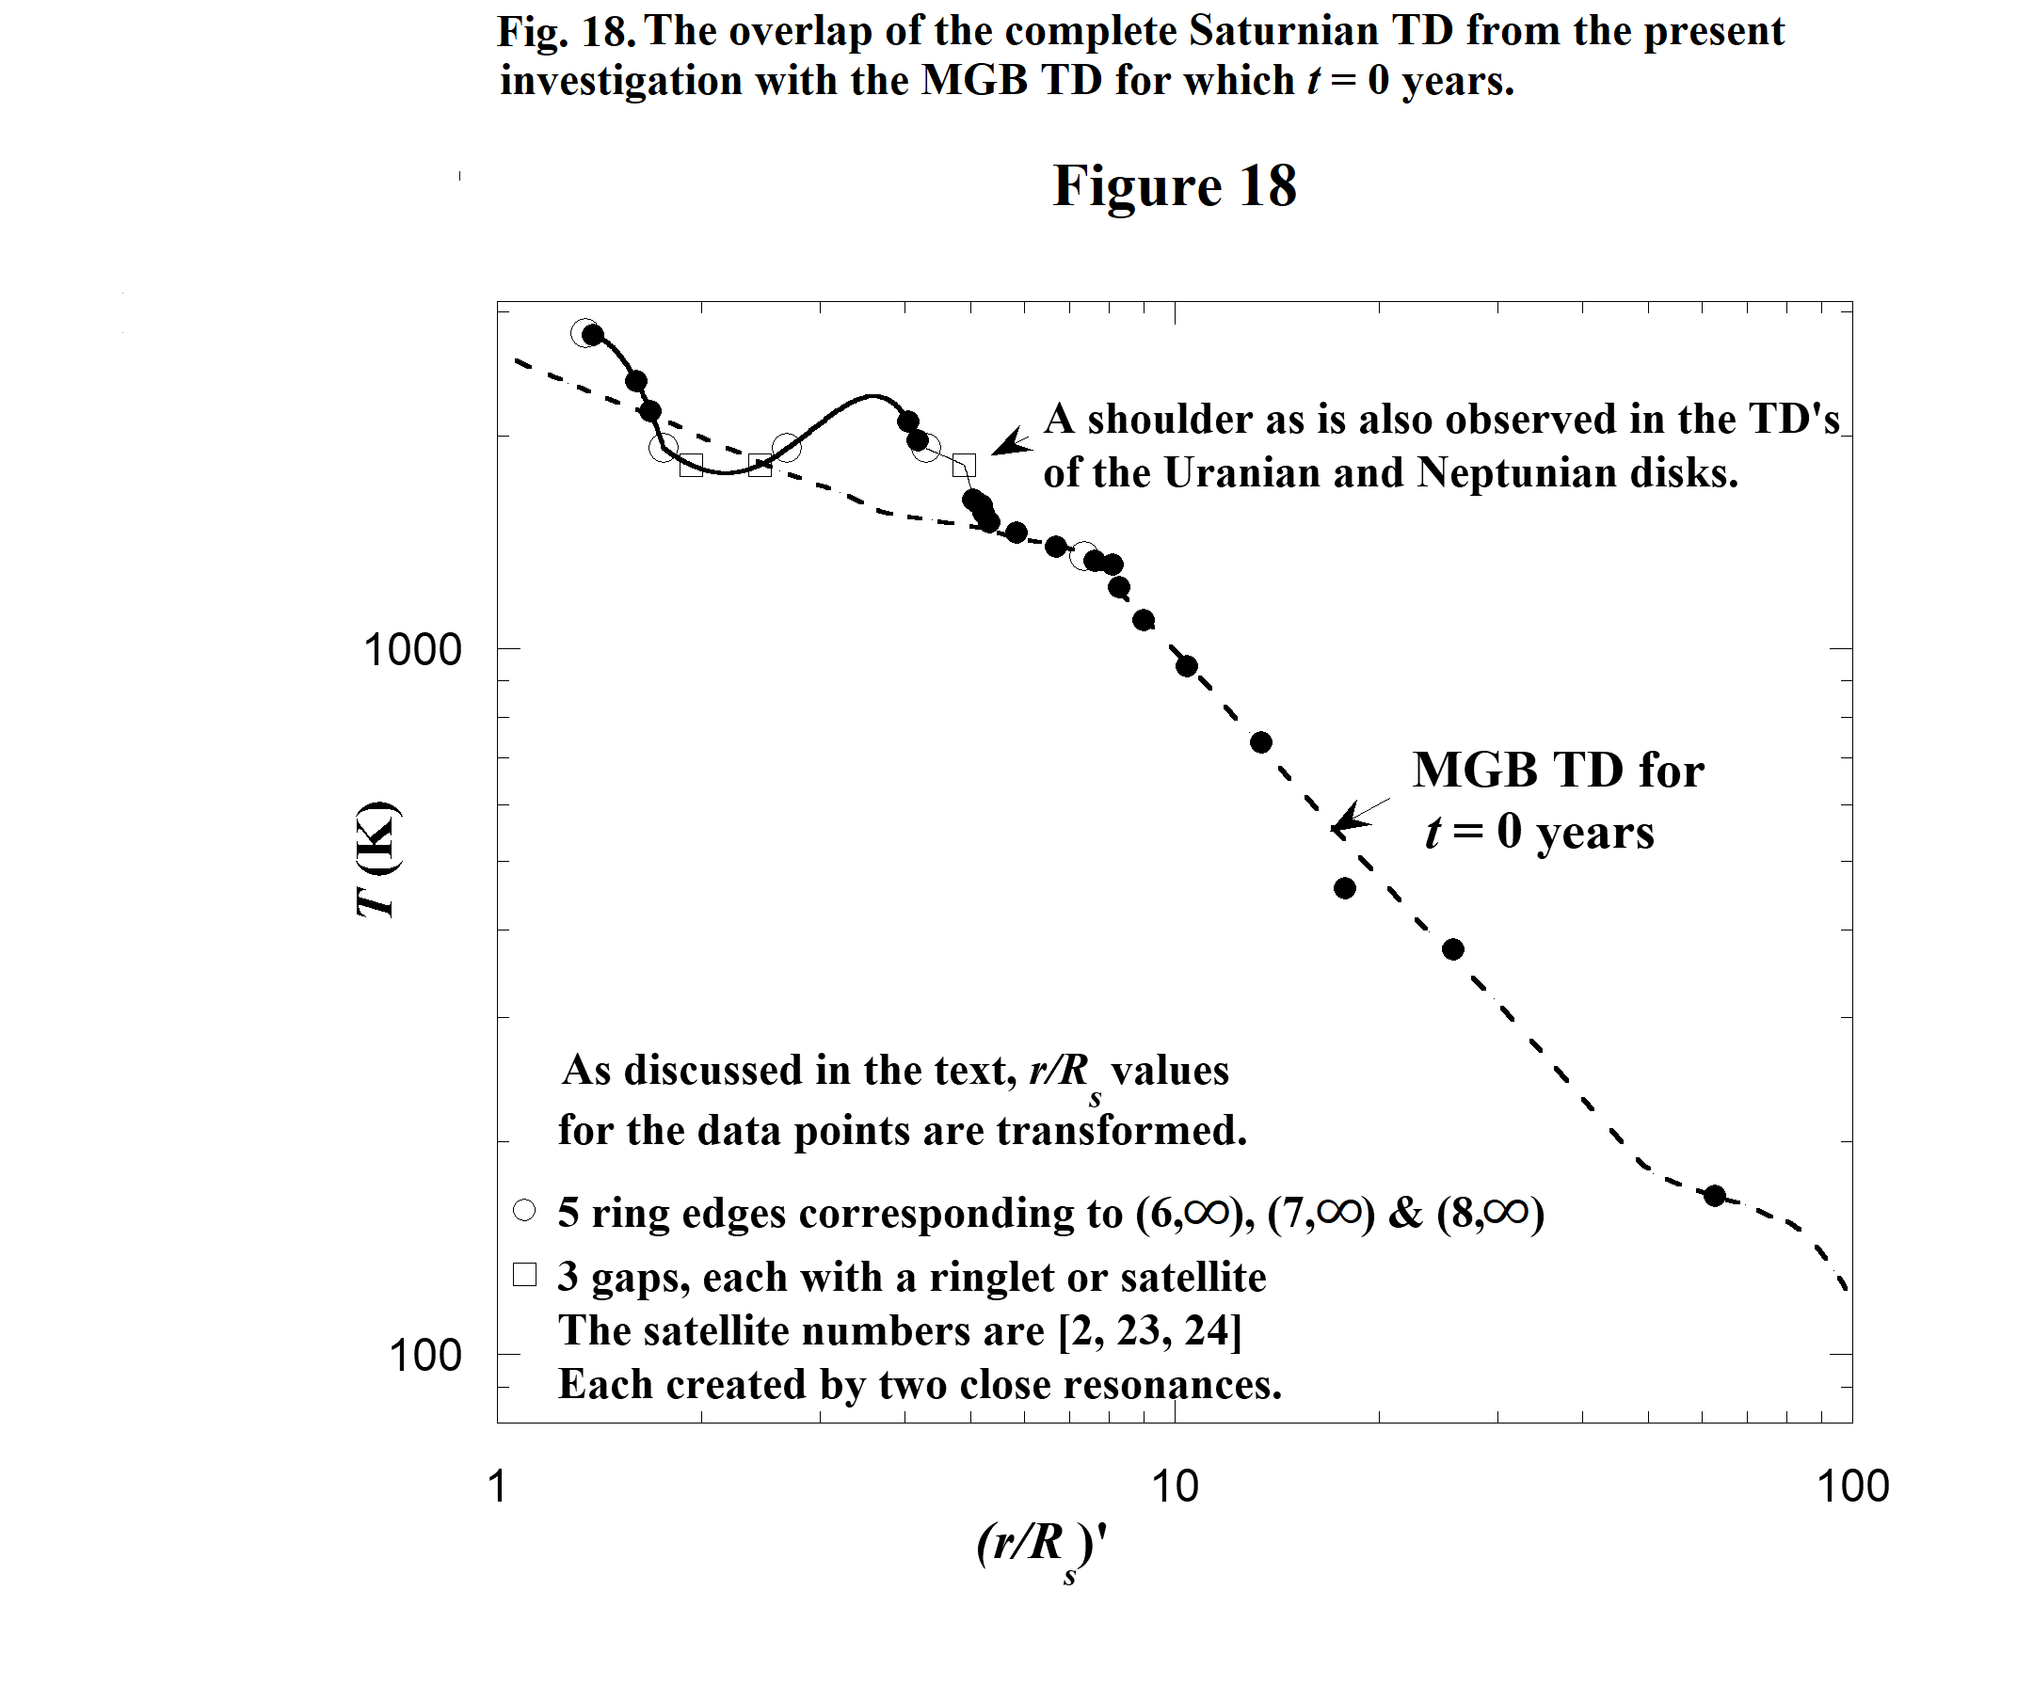
With the determined values of C₁' = 1.080K∙cm and C₂' = - 462 cm⁻¹ substituted into Eq. 7 we have

T = 1.08K∙cm (E_{p} - 462cm⁻¹ ), (9)

In section 2.6 we compared the empirically determined T(E_{p}) (Eq. (6a)) for the Uranian satellite investigation to the theoretical T(E_{p}) (Eq. (5)). These equations are

T = (hc/k)(E_{p} – Δ) (5)
and T = 1.609(hc/k)(E_{p} – 3720 cm⁻¹). Uranian satellites (6a)
33
Similarly we now compare the empirically determined T(E_{p}) (Eq. (9)) for the Saturnian satellite investigation to Eq. (5) by writing Eq. (9) in terms of the factor hc/k. The result is

T = 0.751(hc/k)(E_{p} - 462cm⁻¹ ), Saturnian satellites (9a)

where 0.751(hc/k) = C₁' = 1.080 K∙cm.
The leading constants (1.609 and 0.751) on the right sides of Eqs. (6a) and (9a) are both in reasonable agreement with the leading constant (1) on the right side of the theoretical relationship Eq. (5). However the fact that the two empirical constants differ by a factor of 2 is interesting. As mentioned before, Appendix 3 contains the derivation of Eq. (5) for the case of A and B colliding and associating to form AB. It also includes a similar derivation for a relationship between T and E_{p} that involves third body assisted stimulated radiative molecular association (3rdBA SRMA). The proposed reaction is discussed in Appendix 3. The result is

T = (hc/2k)( E_{p} – Δ). (10)

Note the additional factor of 2 in the denominator of Eq. (10) compared to Eq. (5) above.

We comparing (Eq. (9)) to Eq. (10) by rewriting Eq. (9) in terms of the factor hc/2k. The result is

T = 1.502(hc/2k)(E_{p} - 462cm⁻¹ ), Saturnian satellite (9b)

where 1.502(hc/2k) = C₁' = 1.080 K∙cm.

The leading constant 1.502 in Eq. (9b) is in agreement with the leading constant of 1.609 in Eq. (6a). The agreement suggests that 3rdBA SRMA could be the key reaction that triggered satellite evolution in the Saturnian disk. The approximations made in Appendix 3 are similar for both cases presented there. Therefore if they were relaxed in both, possibly the leading constants in Eqs. (6a) and (9b) would still be in agreement.

3. FURTHER DISCUSSION AND CONCLUSIONS

If the collection of matter that leads to satellites in protoplanetary disks were mainly due to the force of gravity we would not expect the plots of Uranian satellite orbital radii vs. Jovian satellite orbital radii (Fig. 1) and Uranian satellite orbital radii vs. Neptunian satellite orbital radii (Fig. 2) to be so well fitted by straight lines. Also this investigation indicates that satellite migration is not a large factor in the evolution of planetary systems unless it is a uniform effect without satellites crossing orbits.

The empirically determined value for Δ = 3720 cm⁻¹ in Eq. (6a) may be helpful in the identification of the reactants A and B. The energy Δ is associated with a transition the molecule AB undergoes during the molecule's association. Black and van Dishoek (1987) list transition energies and relative spectral intensities in H₂. The (1,0)O(3) transition has an energy 3568 cm⁻¹ and spectral intensity considerably higher than all other transitions near it in the spectrum. The energies (3720 and 3568 cm⁻¹) are in reasonable agreement. Similarly Δ = 462 cm⁻¹ in Eq. (9b) is in reasonable agreement with the transition energy 354 cm⁻¹, associated with the (0,0)S(0) transition in H_{2,} which has the largest spectral intensity in the H₂ spectrum (Black and van Dishoek 1987). Furthermore, Latter and Black (1990) study the
34
formation of H₂ by radiative association. The reaction mechanism in their study is similar to SRMA
except it is without stimulation. They show their mechanism requires a stabilizing photon be emitted by the H₂ during its formation. In the present model outlined in section 2.6 the stabilizing photon's energy is E_{p} =│ΔK│+ Δ, where Δ is possibly the energy of the (1,0)O(3) or (0,0)S(0) transition in H₂.

The Colombo, Maxwell and Encke Gaps and their ringlets are produced by two closely spaced resonances associated with E_{p}(5,7) and E_{p}(6,11). The two together seemingly caused resonances that
were strong enough to clear the gap regions and produce ringlets. Without this fortunate situation and without the well defined positions of ring edges associated the series limit E_{p}(7,∞), it would be impossible to determine the shape of the Saturnian Disk TD in the region of the C ring.

The present model predicts resonance rings are created early in the evolution of the Uranian and Saturnian protosatellite disks. Furthermore it seems that the matter that forms satellites is efficiently collected in these rings. If these are true, the accretion time scale is most certainly shortened from what it would be if no resonance rings existed.

The smoothness of the Uranian disk PED in Figs. 5a and 5b supports the model presented in this paper. The only point on the PED noticeably displaced corresponds to ring η. As pointed out in subsection 2.2.b this displacement could be due to gravitational resonant interaction with the satellite Cressida (Chancia et al. 2017). Also supporting the present model is the good quality of the fits of the three TD's determined in this investigation for the Uranian, Jovian and Neptunian disks to the Mousis (2004) TD (see Fig. 10) as
well as the Saturnian disk TD fit to the Mousis, Gautier and Bockelee-Moran (2002) TD (see Fig. 17).

Results of the present investigation indicate rings of Saturn developed at the same time all its regular satellites developed. This is in conflict with findings from the Cassini spacecraft. Cassini measurements reveal a lower than expected total ring mass which in turn suggests the rings are only 10-100million years old (Iess et al. 2019).

Interestingly this investigation indicates the possibility that the quantum nature of matter has put its stamp not only on atomic but also and planetary systems.

ACKNOWLEDGMENTS

I would like to thank members of the Allegheny College Physics Department for supporting my studies in this area for many years, especially Professors Richard Brown and James (Jamie) Lombardi Jr. Many thanks to Jamie for his editorial assistance with this paper, especially for suggesting that the factors (hc/k) and (hc/2k) be included in Eqs. (6a) and (9b) for easier comparison of various equations and for suggestions concerning the discussion of the derivations in Appendix 3. Also, many thanks to Jerry Staub for reading and commenting on various versions of this present paper and to Jim Fitch for recently reviving my desire to continue working in this area. I also acknowledge the tremendous amount of experimental and theoretical work carried out by others that is essential for this investigation.

35
REFERENCES
Appenzeller, I., and R. Mundt 1989. T Tauri stars. Astron. Astrophys. Rev. 1 291-334.

Augustovičová L., V. Špirko, W. P. Kraemer and P. Soldán 2013. Radiative association of He+2 Revisited. A&A. 553
Black J., and E. F. van Dishoeck 1987. Fluorescent Excitation of Interstellar H₂. ApJ. 322 412-449.

Chancia R, O., M.W. Hedman, and R. G. French 2017, Weighing Uranus' Moon Cressida with the η Ring. AJ. 154:153 1-8.

Dalgarno A., and S. Lepp 1987. Chemistry in the early universe. I.A.U.S. 120 109-120.

Draine B. T., and F. Bertoldi 1996. Structure of stationary photodissociation fronts. ApJ. 468 269-289.

Elliot J. L. 1979. Stellar occultation studies of the solar system. Ann. Rev. Astron. and Astrophys. 17
445-475.

Farinella P., F. Marzari, and S. Matteoli 1997. The Disruption of Hyperion and the origin of Titan's atmosphere. AJ. 113 2312-2316.

Fraser H. J., M. R. S, McCoustra, and D. A. Williams 2002. The molecular universe. Astron. Geophys. 43 10-18

French R. G., P. D. Nicholson, C. C. Porco and E. A. Marouf 1991. Dynamics and structure of the uranian rings. In Uranus (J. T. Bergstralh, E. D. Miner and M. S. Matthews Eds.) pp. 327-409. Univ. of Arizona Press, Tucson.

French R., C. Mcghee-French, P. Nicholson, M. Hedman, N. Rappaport, E. Marouf, P. Longaretti, J. Hahn 2020. Unusual One-Armed Density Waves in the Cassini Division of Saturn’s Rings. Icarus. 339, pp.113600. 10.1016/j.icarus.2019.113600. hal-02404628

Hedman M. M., J. A. Burns, M. S, Tiscareno,C. C. Porco, G. H. Jones, E. Roussos, N. Krupp, C. Paranicas and S. Kempf 2007a. The source of Saturn's G ring. Science. 317 653-656

Hedman M. M., J. A. Burns, M. R. Showalter, C. C. Porco, P. D. Nicholson, A. S. Bosh, M. S. Tiscareno, R. H. Brown, B.J. Buratti, K. H. Baines and R. Clark 2007b. Saturn's dynamic D ring. Icarus. 188 89-107

Hartmann, L., S. Kenyon, and P. Hartigan 1993. Young stars: episodic phenomena, activity and variability. In Protostars & Planets III. (E. H. Levy and J. I. Lunine, Eds.) Univ. of Arizona Press. pp. 497-518.

Herbig, G. H. 1977. Eruptive phenomena in early stellar evolution. ApJ 217 693-715.

Herczeg G. J., J. L. Linsky, F. M. Walter, G. F. Gahm, and C. M. Johns-Krull 2006. The origins of fluorescent H₂ emission from T Tauri stars. AAS. 165 256-282.
36
Iess L., B.Militzer, Y. Kaspi, P. Nicholson, D. Durante, P. Racioppa, A. Anabtawi, E. Galanti, W. Hubbard, M. J. Mariani, P. Tortora, S. Wahl, M. Zannoni 2019. Measurement and implications of Saturn's gravity field and ring mass. Science 364

Jerousek R. G., J. E. Colwell, M. M. Hedman, R. G. French, E.A. Marouf, L. W. Esposito, P. D. Nicholson 2020. Saturn’s C ring and Cassini division: Particle sizes from Cassini UVIS, VIMS, and RSS occultations. Icarus. 344, pp.113565
JPL 1999. https://www.jpl.nasa.gov/images/epsilon-ring-of-uranus
via the Internet. Accessed January 2022

Kwan J., and W. Fischer 2011. Origins of the H, He I and Ca II line emission in classical T Tauri stars. MNRAS. 411 2383-2425.

Lin D. N. C., and J. Papaloizou 1985. On the dynamical origin of the solar system. In Protostars & Planets II (D. C. Black, and M. S. Matthews Eds.) pp. 981-1072. Univ. of Arizona Press, Tucson. Referred to as L&P(1985) in the present paper.

Lombardi J. C. 2015a. Stimulated Radiative Molecular Association in the Early Solar System: Orbital Radii of Satellites of Uranus, Jupiter, Neptune, and Saturn. https://arxiv.org/abs/1506.00268 via the Internet. Accessed

Lombardi J. C. 2015b. Stimulated Radiative Molecular Association in the Early Solar System II. Orbital Radii of the Planets and Other Satellites of the Sun
https://arxiv.org/abs/1508.06598 via the Internet. Accessed January 2022

Martini P., K. Sellgren and D. L. DePoy 1999. Near-infrared spectroscopy of molecular hydrogen emission in four reflection nebulae: NGC 1333, NGC 2023, NGC 2068, and NGC 7023. ApJ. 526 772-787.

Mousis, O., D. Gautier and D. Bockelée-Moran 2002. An evolutionary turbulent model of Saturn's subnebula: Implications for the origin of the atmosphere of Titan. Icarus 156 162-175.

Mousis, O. 2004. Modeling the thermodynamical conditions in the uranian subnebula – Implications for regular satellite compositions. A&A 413 373-380.

Mousis, O., and Y. Alibert 2006. Modeling the jovian subnebula. II. Composition of regular satellite ices. A&A 448 771-778

NASA 2021, Lunar and Planetary Science. Available at: https://nssdc.gsfc.nasa.gov/planetary/
via the Internet. Accessed throughout 2021.

NASA 2022, Planetary Data System. Available at: https://pds-rings.seti.org/saturn/saturn_tables.html
via the Internet. Accessed January 2022

Planetary Society 2021, Available at: https://planetary.org/space-images/panoramic-scan-across
via the Internet. Accessed November 2021.

37

Stancil P. C. and A. Dalgarno 1997. Stimulated radiative association of Li and H in the early universe. ApJ. 479 543-546.

Turk M. J., P. Clark, S. C. O. Glover, T. H. Greif, T Abel, R. Klessen, and V. Bromm 2011. Effects of varying the three-body molecular hydrogen formation rate in primordial star formation. ApJ. 726:55 (11pp)

APPENDIX 1
Mousis Temperature Distributions

Section A1.a. Reproduction of Mousis TD's in Figure 6

Figure 6 includes reproductions of three TD's from Mousis (2003). These are the three TD's that are labeled t = 1x10⁴, 2x10⁴ and 5x10⁴ years. The graphic editor GIMP is used to determine the coordinates of critical points in Figure 1 of Mousis (2003). Each of these TD's is represented mostly by straight line segments when plotted using logarithmic scales. The only exception is the curved, very top portion of the t = 1x10⁴ TD which is not reproduced in Figure 6 of the present investigation. Each of the straight line segments in Figure 6 is of the form T = βr ^{n}, where r is the radial coordinate in the disk and β and n are constants that determine the position and slope of the straight line segments. The various values of β and n are used to reproduce the Mousis TD's in Figure 6.

Section A1.b. Construction of Dashed TD's in Figure 6

Similarities among the three Mousis TD's make it possible to construct the two dashed TD's in Fig.6.

    - The top segment of each Mousis TD connects to the top of its middle segment at approximately the same temperature. And the bottom segment of each TD connects to the bottom of its middle segment at approximately the same temperature. Call these temperatures T₁ and T₁' in the TD for which t = 1x10⁴ years.
    - Each segment in a TD is nearly parallel to a corresponding segment in the other two TD's. I.e. they have nearly the same n. Call these n values, n₁, n₂ and n₃ in the TD for which t = 1x10⁴ years.

The dashed TD's in Fig.5 are just two in a series of trial TD's constructed for the present investigation. Just one of these TD's (for which t = t₀ = 8800 years) is fitted well by the fitting process described in subsection 2.3.c. Because the dashed TD's in Figure 5 are close to the Mousis t = 1x10⁴ year TD, the approximate similarities mentioned above can be taken to be nearly exact and each trial TD is determined as follows.
- Temperatures where its segments connect are T₁ and T₁', the temperatures mentioned in similarity 1 mentioned above.
- Its three segments have n values, n₁, n₂ and n₃ just as in similarity 2 mentioned above.
- The value of β for the middle segment of the dashed TD is taken to be a few percent larger than what it is in the Mousis TD for which t = 1x10⁴ years. Appendix 2 explains how t is determined from this new β.
35
- The two radial coordinates r₁ and r₁', for the points where segments connect, can be found by applying the relationship T = βr^{n} to each end of the middle segment where T is either T₁ or T₁'.
- Repeated use of the equation T = βr^{n}, determines the β values for the rest of the segments.
- Knowing β and n for each segment determines the trial TD.

APPENDIX 2

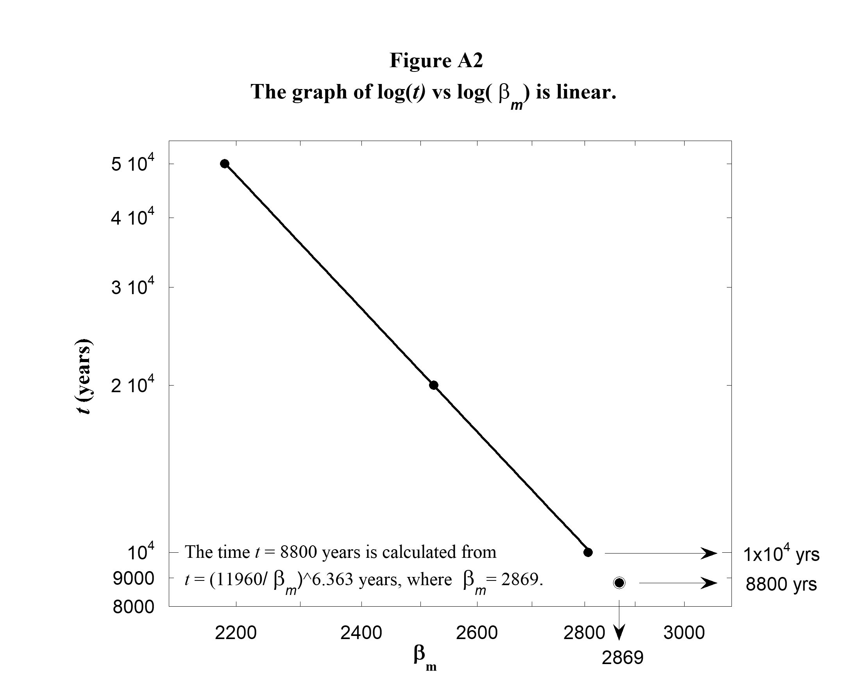
Finding the Time When the Uranian Satellites Begin Their Evolution

The three TD's in Figure 6 associated with t = 1 x 10⁴, 2 x 10⁴, and 5 x 10⁴ years are all reconstructed from Figure 1 in Mousis (2003). Each segment of these TD's is characterized by an equation of the
form T = β r^{n}, as discussed in Appendix 1. Figure A2 utilizes the values of β for the three middle segments for the reconstructed Mousis TD's: we are calling them β_{m} . The values of β_{m} are measured, as described in Appendix 1, to be 2807, 2523 and 2183 for times t = 1 x 10⁴, 2 x 10⁴, and 5 x 10⁴ years respectively. Because the graph of log(t ) vs log(β_{m} ) is linear, the relationship between t and β_{m} has the form
t = constant x β_{m} ^{- P}

and the best fit to the data is t = (11960/β_{m} )^{6.363}. The well fitted TD in Fig.8 has β_{m} = 2869. We
39
extrapolate the graph in Figure A2 to earlier time by substituting this value of β_{m} into the above equation. The result for t is t₀ = 8800 years, the time when the Uranian satellites begin their evolution. This is also the t value for one of the dashed TD's in Fig. 6. For the other dashed TD in Fig 6, β_{m} is arbitrarily taken to be 6% larger than the β_{m} in the Mousis TD for which t =1 x 10⁴ years. The t value for the other dashed TD is found in the same way to be 6900 years.

APPENDIX 3
The Relationship Between T and E_{p}
Section A3.a. Case 1: Protosatellite Disks of Uranus, Jupiter and Neptune
We use the model presented in section 2.6 to derive T as a function of E_{p}. The following relationship, Eq. (4) in the main text, is an expression of the SRMA that is key to the present discussion,
A + B + hν → AB + 2hν. (4)
In this reaction A and B, with momenta p_{A} and p_{B,} collide to form AB with the momentum p_{AB}. A more accurate calculation to determine T(E_{p}) would include the realistic effect of a range of possible angles between p_{A} and p_{B}. before the collision. However a likely angle between p_{A} and p_{B} is 90⁰. For the sake of simplifying the calculation, we calculate T(E_{p}) for the single case of p_{A} and p_{B} being perpendicular
p_{AB}² = p_{A}² + p_{B}². (A3.1)
Also the momentum of p_{AB} is about 30,000 times greater than momentum of the photon created during the collision. Therefore there is no need to account for the photon's momentum in Eq. (A3.1). The kinetic energies of A, B and AB are K_{A} = ½p_{A}²/m_{A} , K_{B} = ½p_{B}²/m_{B}, and K_{AB} = ½p_{AB}²/m_{AB,} where m_{A}, m_{B}, and m_{AB} are the respective masses and m_{AB} has a value that is extremely close to m_{A} + m_{B}. With these expressions, Eq. (A3.1) becomes
m_{AB} K_{AB} = m_{A} K_{A +} m_{B} K_{B} (A3.2)
There is likely a range of kinetic energies associated with the A's and B's that participate in SRMA resonance. However we simplify our calculation by defining K_{mp} as the most probable kinetic energy of the A's and B's that participate. The most probable speed in a Maxwell-Boltzmann distribution is v_{mp} = (2kT/m)^{½}, where m is the particle mass. Particles with this speed have a kinetic energy of kT and we take K_{A} = K_{B} = K_{mp} = kT.
All of this together yields K_{AB} = K_{mp} (m_{A +} m_{B})/m_{AB} = K_{mp,} (final kinetic energy) (A3.3)
where (m_{A +} m_{B})/m_{AB} is extremely close to unity.
Also K_{A} + K_{B} = 2K_{mp} (initial kinetic energy) (A3.4)
and the change in kinetic energy of the system during the association that creates AB is
ΔK = (K_{AB} – (K_{A} + K_{B})) = – K_{mp} = – kT . (A3.5)
By conservation of energy, the energy of the created photon (hν) is
E_{p} =│ΔK│+ Δ, (A3.6)

40
where the energy Δ, accounts for a transition that may occur in the molecule during its association.
From Eqs. (A3.5) and (A3.6)
T = (1/k)(E_{p} – Δ). (A3.7)
In the analysis E_{p}'s are in the units of wave numbers. To account for this we multiply the right side of Eq. (A3.7) by hc where h is Planck's constant and c is the speed of light. Also the value of (hc/k) is 0.014388 K∙m = 1.4388 K∙cm. Therefore we have
T = (hc/k)(E_{p} – Δ) . (A3.8)
This is also Eq. (5) in the main text.
A3.b. Case 2: Third Body Assisted Stimulated Radiative Molecular Association as the
Possible Key Reaction that Triggered Satellite Evolution in the Saturnian disk
For Saturn's disk, Eq (9) in section 2.8 is determined by adjusting the parameters a, C₁' and C₂' so that
T 's calculated from Eq. (7) fit the MGB (2002) TD for which t = 0 years. The result is
T = (1.080 K∙cm)(E_{p} – 462 cm⁻¹) (from fit). (9)
Because the constant 1.080 K∙cm in Eq. (A3.8) is about one half the constant 2.315 K∙cm in Eq. (6) for Uranus's disk, we expect the key SRMA reaction for Saturn's disk to involve a different number of atoms or molecules. Third body assisted association (Fraser, McCoustra, and Williams 2002 & Turk et. al. 2011) is characterized by
A + B + C = AB + C. (A3.9)
In this reaction C assists in the association of A and B to form AB. We propose the following reaction
which is a combination of Eqs. (4) and (A3.9).
A + B + C + hν → AB + C + 2hν. (A3.10)
In Eq. (A3.10) both C and hν assist the radiative molecular association. Therefore Eq. (A3.10) characterizes third body assisted stimulated radiative molecular association. This is actually a 4-body interaction because of the requirement that a photon also must participate in the collision. Generally speaking 4-body interaction are less likely than 3-body interactions. However in this case the photon on the left side of Eq. (A3.10) is a readily available resonant photon with exactly the correct direction of motion to participate in a collision which in turn further enhances resonance. This should make the 4-body interaction more likely than it would otherwise be.
We now derive a formula that is close to the empirical Eq. (9) found for Saturn's disk. We make the simplifying approximation that C moves off in the same direction and at the same speed as does AB after the collision. But also physically speaking, it seems likely for C to travel with AB in order for C to assist in the association of A and B to make AB. So the magnitude of the final momentum of the system is equal to the sum of the magnitudes of the momenta of AB and C. In addition to formulas we used in Case 1 above, we have K_{ABC} = ½p_{ABC}²/m_{ABC},where K_{ABC} is the sum of the kinetic energies of AB and C, (i.e. the final kinetic energy of the system) and p_{ABC} is the magnitude of the system's momentum. Also, m_{ABC} = m_{AB} + m_{C}, where m_{C} is the mass of C and K_{C} is its kinetic energy before the collision. The vectors p_{A}, p_{B} and p_{C} are the momenta of A, B and C before they collide. Again, while realizing there is likely a range of angles between these vectors, we simplify the calculation by taking these
41
vectors to be perpendicular for resonant reactions. We therefore consider A, B and C approaching each other as if each one is moving along one of the axes in a three-dimensional Cartesian coordinate system. Therefore
(p_{ABC})² = p_{A}² + p_{B}² + p_{C}², (A3.11)
and (m_{AB} + m_{C}) K_{ABC} = m_{A} K_{A} + m_{B} K_{B} +m_{C} K_{C} (A3.12)
Assuming again that K_{A} = K_{B} = K_{C} = K_{mp} and (m_{A} + m_{B} +m_{C} )/(m_{AB} + m_{C}) = 1 we have
K_{ABC} = K_{mp} (m_{A} + m_{B} +m_{C} )/(m_{AB} + m_{C}) = K_{mp} (final kinetic energy) (A3.13)
Also K_{A} + K_{B} + K_{C} = 3K_{mp} (initial kinetic energy) (A3.14)
And ΔK = (K_{ABC} – (K_{A} + K_{B} + K_{C} )) = – 2K_{mp} = – 2kT (where K_{mp} = kT). (A3.15)
As in the last derivation E_{p} =│ΔK│+ Δ (A3.16)
And this time T = (hc/2k)(E_{p} – Δ) (A3.17)
Note the 2 in the denominator of the first factor on the right side of Eq. (A3.10). A 2 does not appear in Eq. (A3.8)
Appendix 4

The Construction of the Approximate Curve Used for the
B Ring Portion of the PED in Figs. 13 and 14
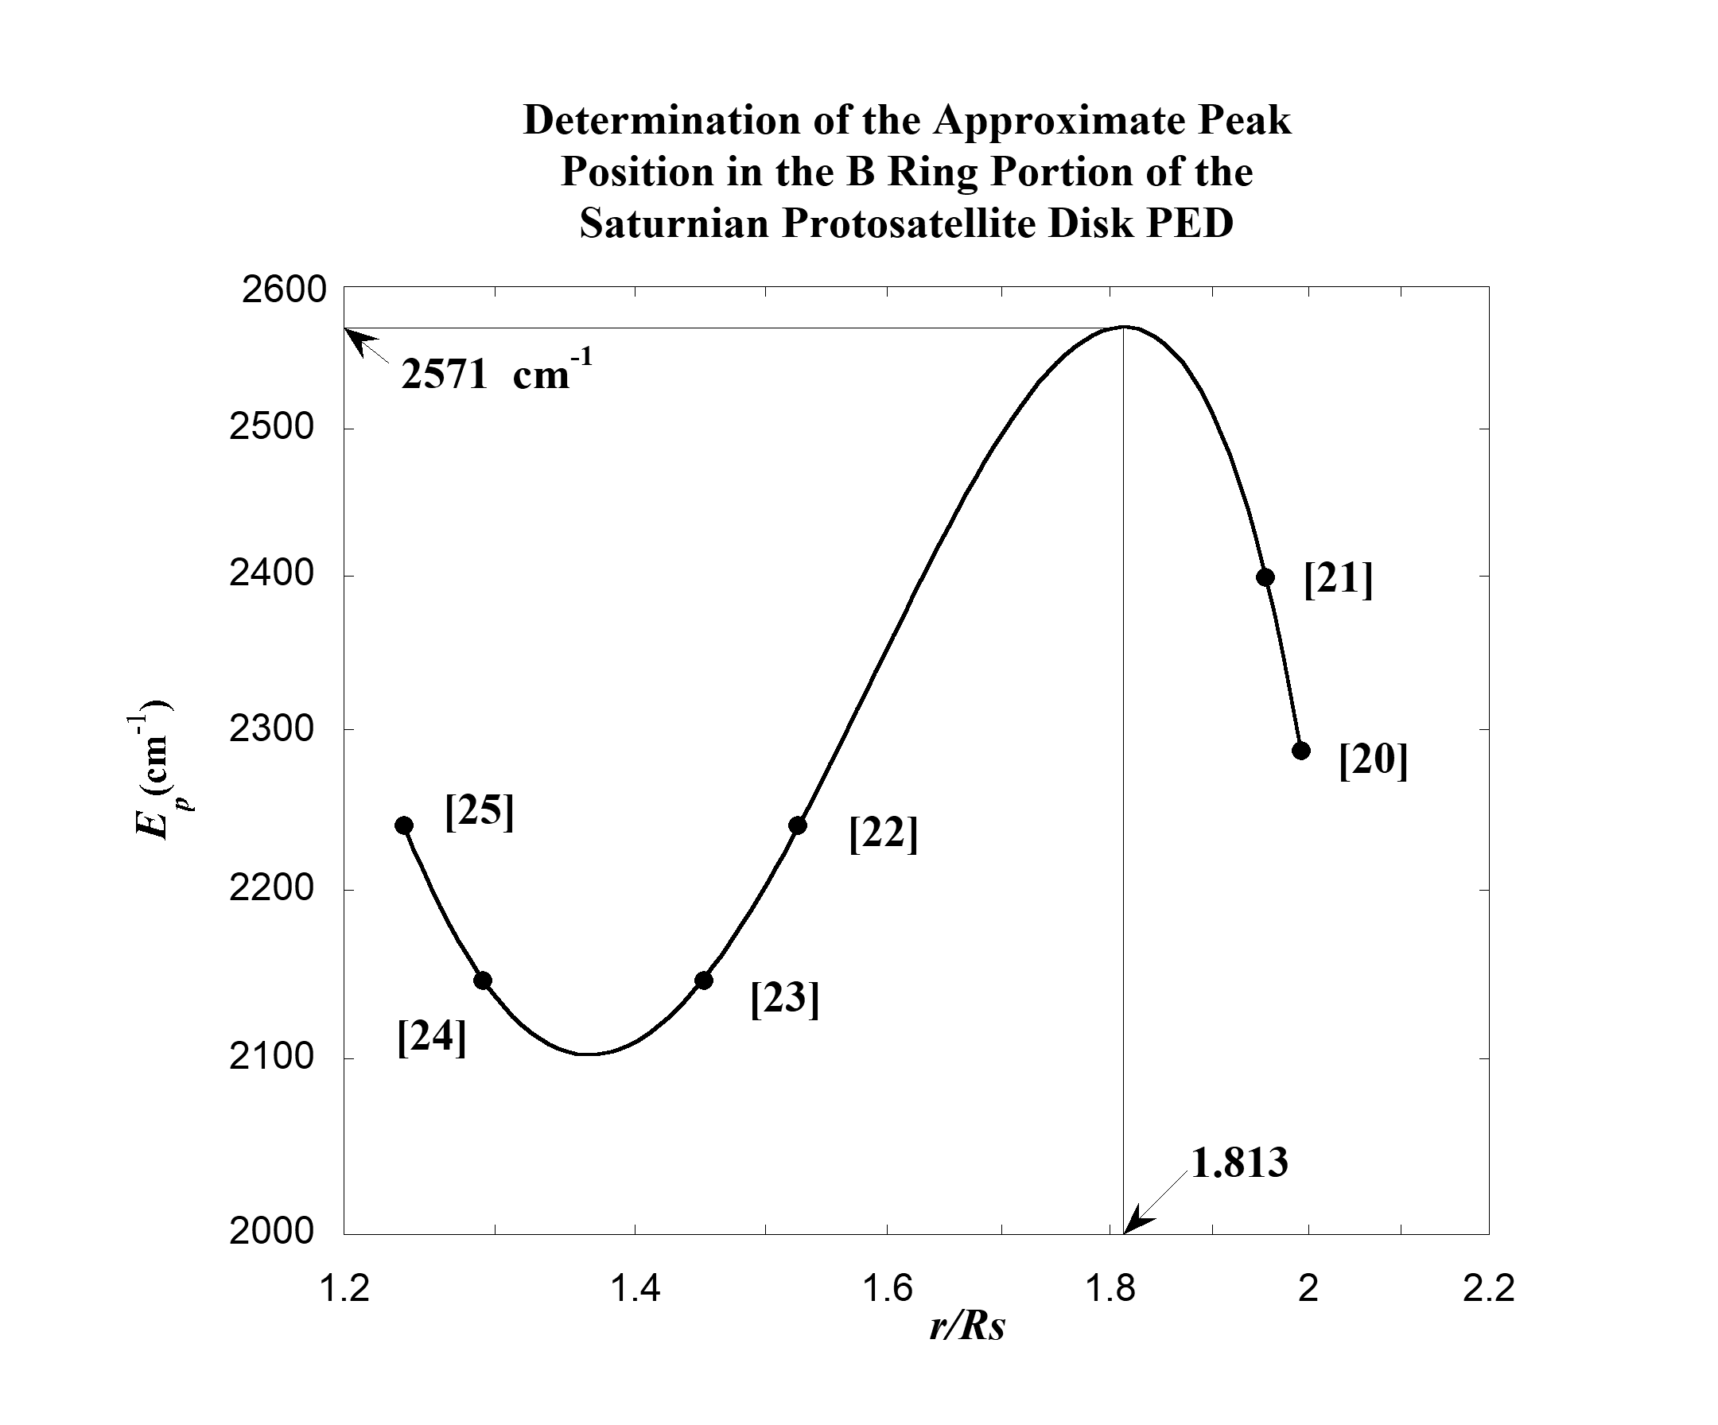
42
The present investigation does not indicate that any well defined resonance rings contribute to the creation of the B ring portion of the PED associated with Saturn's protoplanetary disk. Subsection 2.7.c
indicates the B ring evolved from of a number of wide resonance rings. Therefore it is necessary to make a reasonable approximation for the shape and magnitude of the PED in this region. This is
achieved by (1) assuming the PED's value and slope are continuous across the boundary between the C
and B rings and (2) assuming the PED passes through the two key points associated with the Huygens and Laplace ringlets. The four points that are associated with the C ring and the two points associated with the Huygens and Laplace ringlets are all fitted with one continuous function in the form of a cubic polynomial. This curve is used for the curve of the PED in the figure above and to fit the C ring and the Cassini Division as well as approximate the B ring in Figs. 13 and 14 in the main text.

An equation for the cubic polynomial in the figure is
E_{p} = 2571 – 7060(r/R_{s} – 1.8130)² - 10540(r/R_{s} – 1.8130)³.
The curve has a maximum value of E_{p} = 2571 cm⁻¹ at r/R_{s} = 1.8130 and a minimum value of E_{p} = 2102 cm⁻¹ at r/R_{s} = 1.3666.

43

