CHAPTER THREE

REQUIREMENTS ANALYSIS AND DESIGN OF THE NEW SYSTEM

3.1 Introduction
This chapter presents the requirements analysis and design of the AI-Powered Technical Proposal and Cost Estimation System developed for Jimstech Innovations Nigeria Limited. The design is based on the implemented React and TypeScript prototype in the project codebase, which provides authentication, role-based dashboards, requirement analysis, proposal generation, cost estimation, timeline prediction, technology recommendation, repository management, client management, reporting, template management, integrations, and security audit modules.
The new system addresses the manual proposal preparation problem by providing a structured workflow where users capture project requirements, allow AI-assisted logic to analyze the project scope, generate proposal content, estimate cost, predict timeline, recommend technology stacks, and store historical project records for future reference.

3.2 Requirements Analysis
The system requirements were derived from the operational needs of software development firms and from the modules implemented in the application. The main actors are Engineer, Project Manager, Sales Officer, and Administrator. Each actor has access to the modules required for their responsibilities through role-based access control.
Actor | Main Responsibilities
Engineer | Captures requirements, reviews AI analysis, creates proposals, estimates costs, predicts timelines, recommends technology, and uses the project repository.
Project Manager | Coordinates proposals, reviews and approves outputs, manages clients, templates, reports, project timelines, and repository records.
Sales Officer | Captures client requirements, creates proposals, estimates cost, manages clients, and tracks business reports.
Administrator | Manages system-level functions including integrations, security audit logs, reports, templates, clients, proposal review, and repository oversight.
Table 1: Actors Description

3.3 Functional Requirements
Register users, authenticate users, and redirect them to role-specific dashboards.
Capture project details, client details, requirements, integrations, and complexity indicators.
Analyze submitted requirements and present complexity, category, risk, and missing requirement results.
Generate structured technical proposal sections with tone and detail controls.
Generate cost estimations with module-wise cost breakdowns, confidence score, and historical comparison.
Predict project timelines using phases, milestones, dependencies, and risk indicators.
Recommend technology stacks with match scores, alternatives, pros, cons, and implementation considerations.
Maintain project repository, client directory, proposal review, reports, templates, integrations, settings, and audit logs.

3.4 Non-Functional Requirements
The system must be usable, responsive, maintainable, secure, and extensible. The implemented frontend uses reusable UI components, accessible Radix UI primitives, Tailwind CSS styling, role-based route filtering, and a dashboard layout. For production deployment, Supabase authentication, PostgreSQL storage, row-level security, encrypted credentials, and audit logging are specified.

3.5 UML Design

3.5.1 Use Case Diagram
The use case diagram shows how the four user roles interact with the main functions of the system.
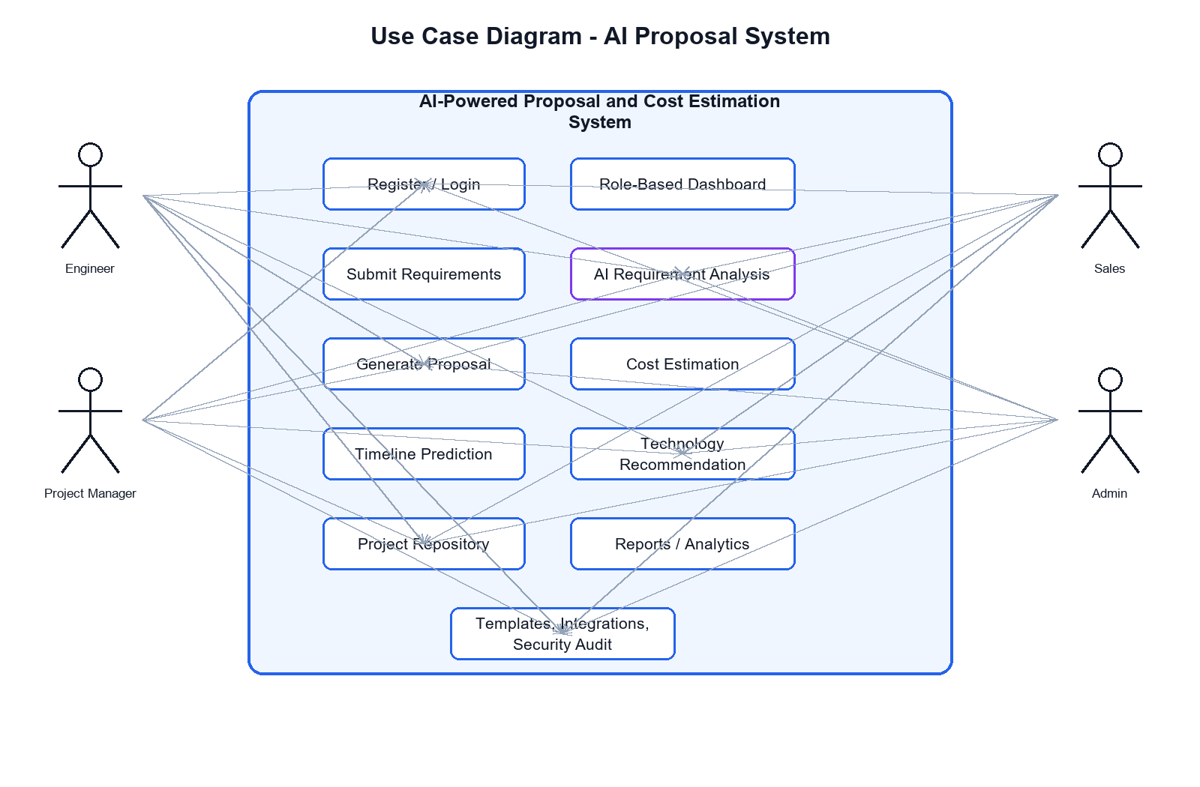
Figure 2: Use Case Diagram of the AI-Powered Proposal and Cost Estimation System

3.5.2 Use Case Descriptions
Use Case | Actor | Description | Pre-condition | Post-condition
Create Account | All users | Creates a user profile with role information. | User opens registration page. | Account details are stored.
Login | All users | Authenticates the user and loads the role-based dashboard. | User has credentials. | User session is created.
Submit Requirements | Engineer, Project Manager, Sales | Captures project and requirement data. | User is authenticated. | Requirement record is available.
Generate Proposal | Engineer, Project Manager, Sales | Produces editable proposal content. | Requirements exist. | Draft proposal is stored.
Generate Cost Estimation | Engineer, Project Manager, Sales | Calculates cost breakdown and confidence score. | Project scope exists. | Cost report is generated.
Predict Timeline | Engineer, Project Manager | Generates phases and milestones. | Project complexity is known. | Timeline is available.
Manage Security and Integrations | Administrator | Maintains audit, permissions, and external services. | Admin is authenticated. | Settings are updated and logged.

3.5.3 Class Diagram
The class diagram models the main entities that support the implemented workflow. The Project entity is central because proposals, requirements, cost estimations, timeline predictions, and technology recommendations are linked to a project record.
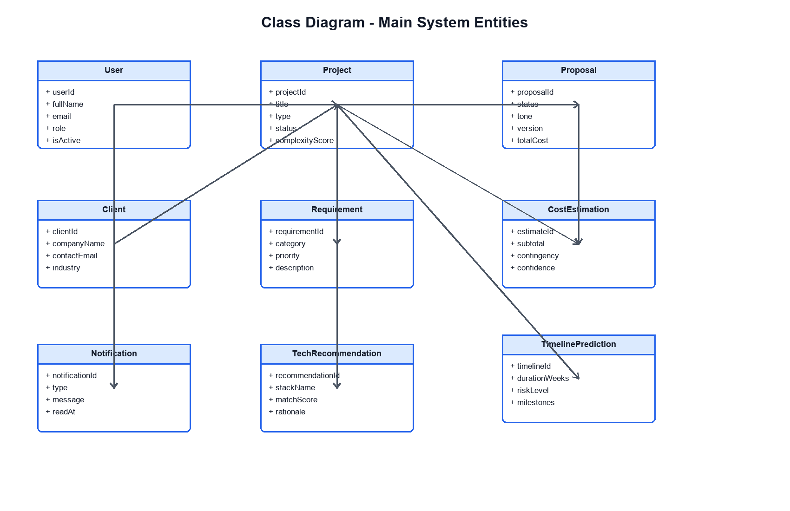
Figure 3: Class Diagram

3.5.4 Sequence Diagrams
The following sequence diagrams describe the main interaction flows implemented in the prototype.
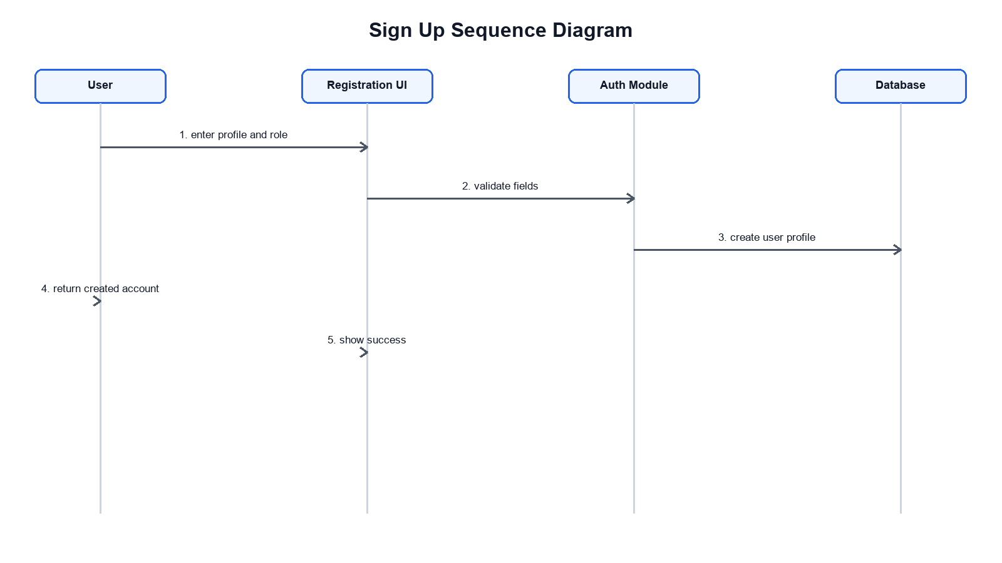
Figure 4: Sign Up Sequence Diagram
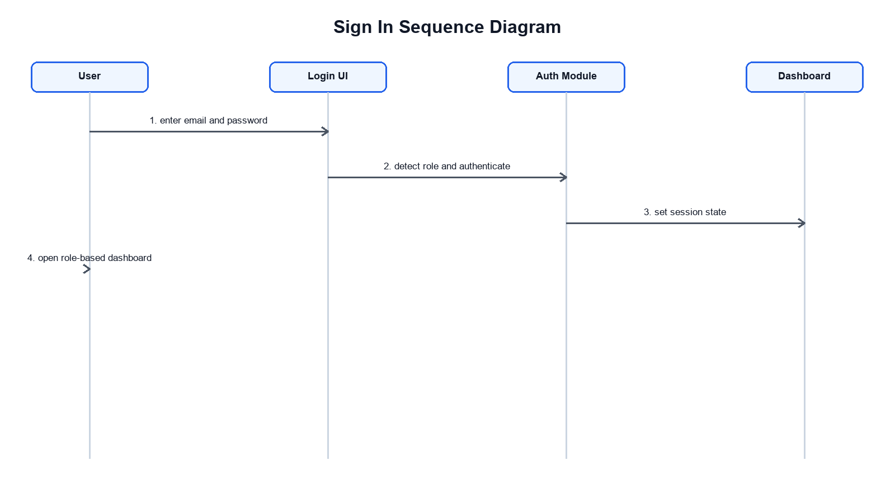
Figure 5: Sign In Sequence Diagram
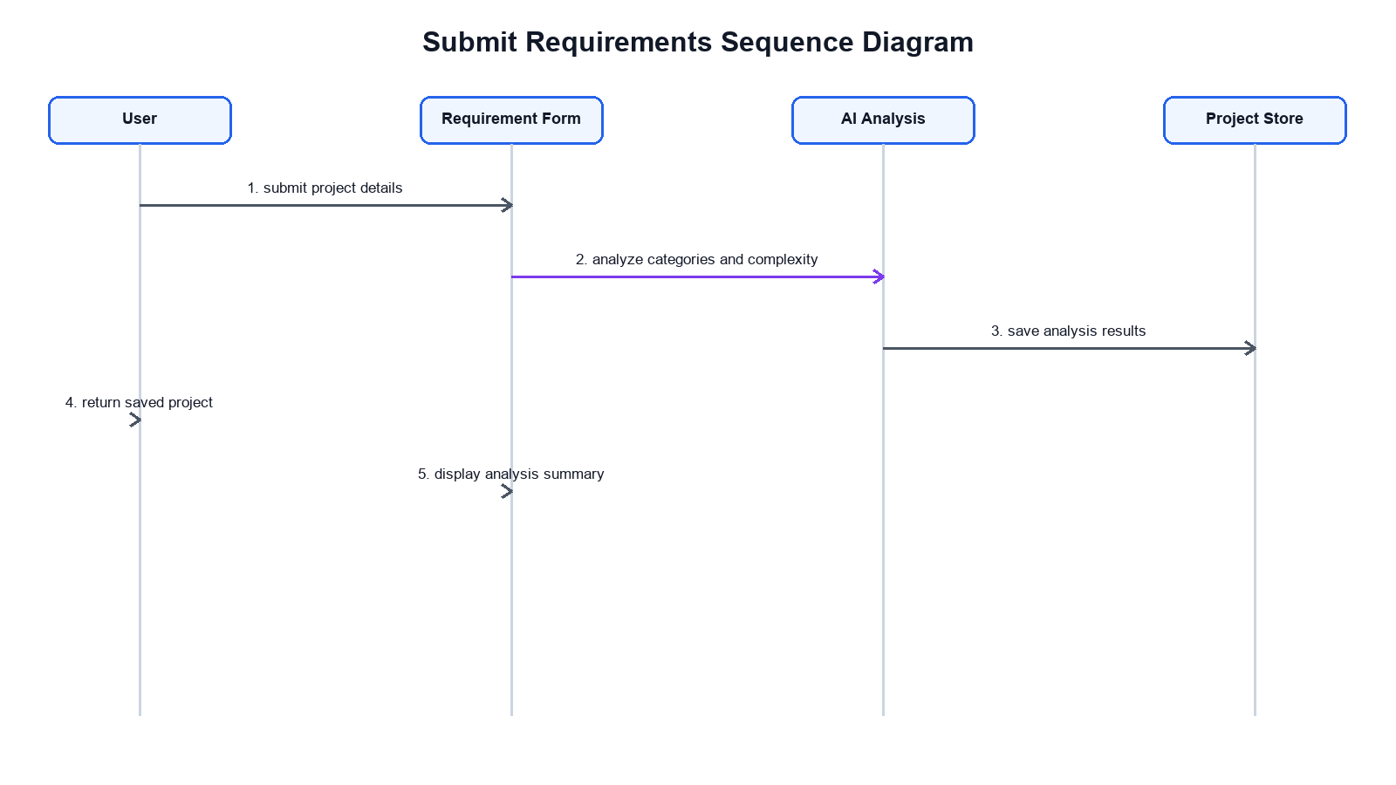
Figure 6: Submit Project Requirements Sequence Diagram
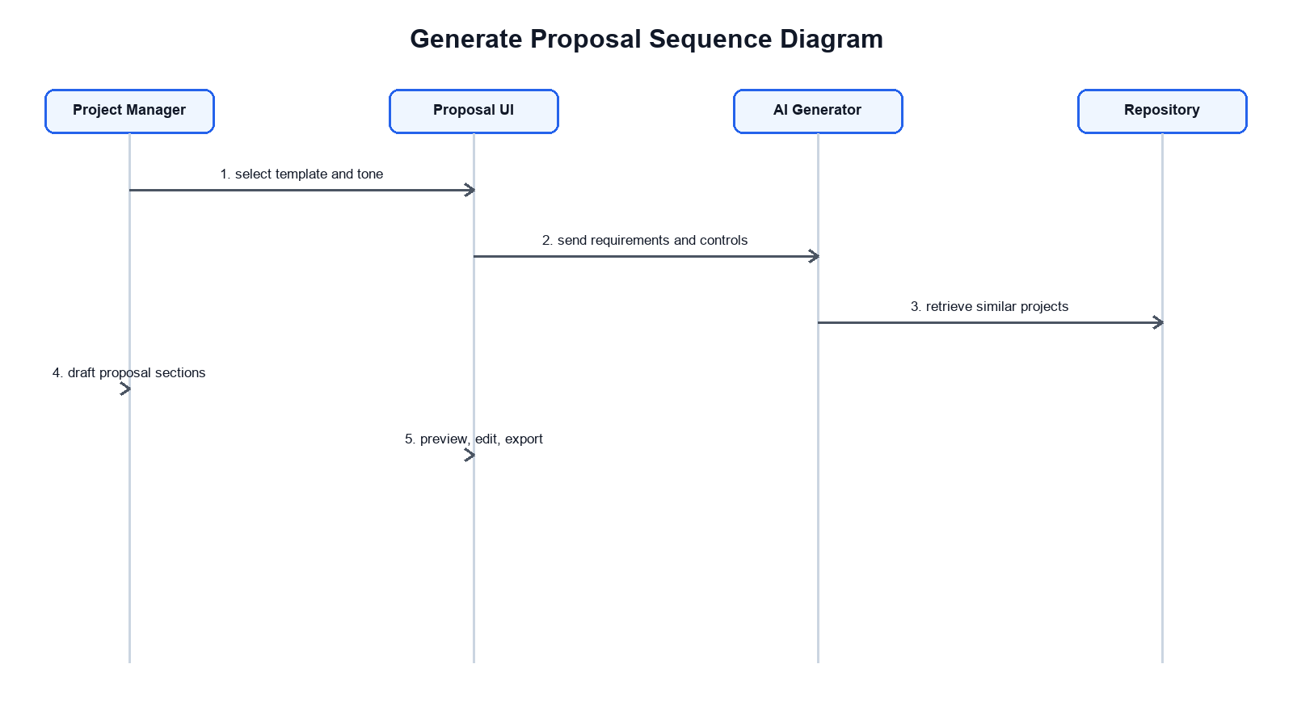
Figure 7: Generate Proposal Sequence Diagram
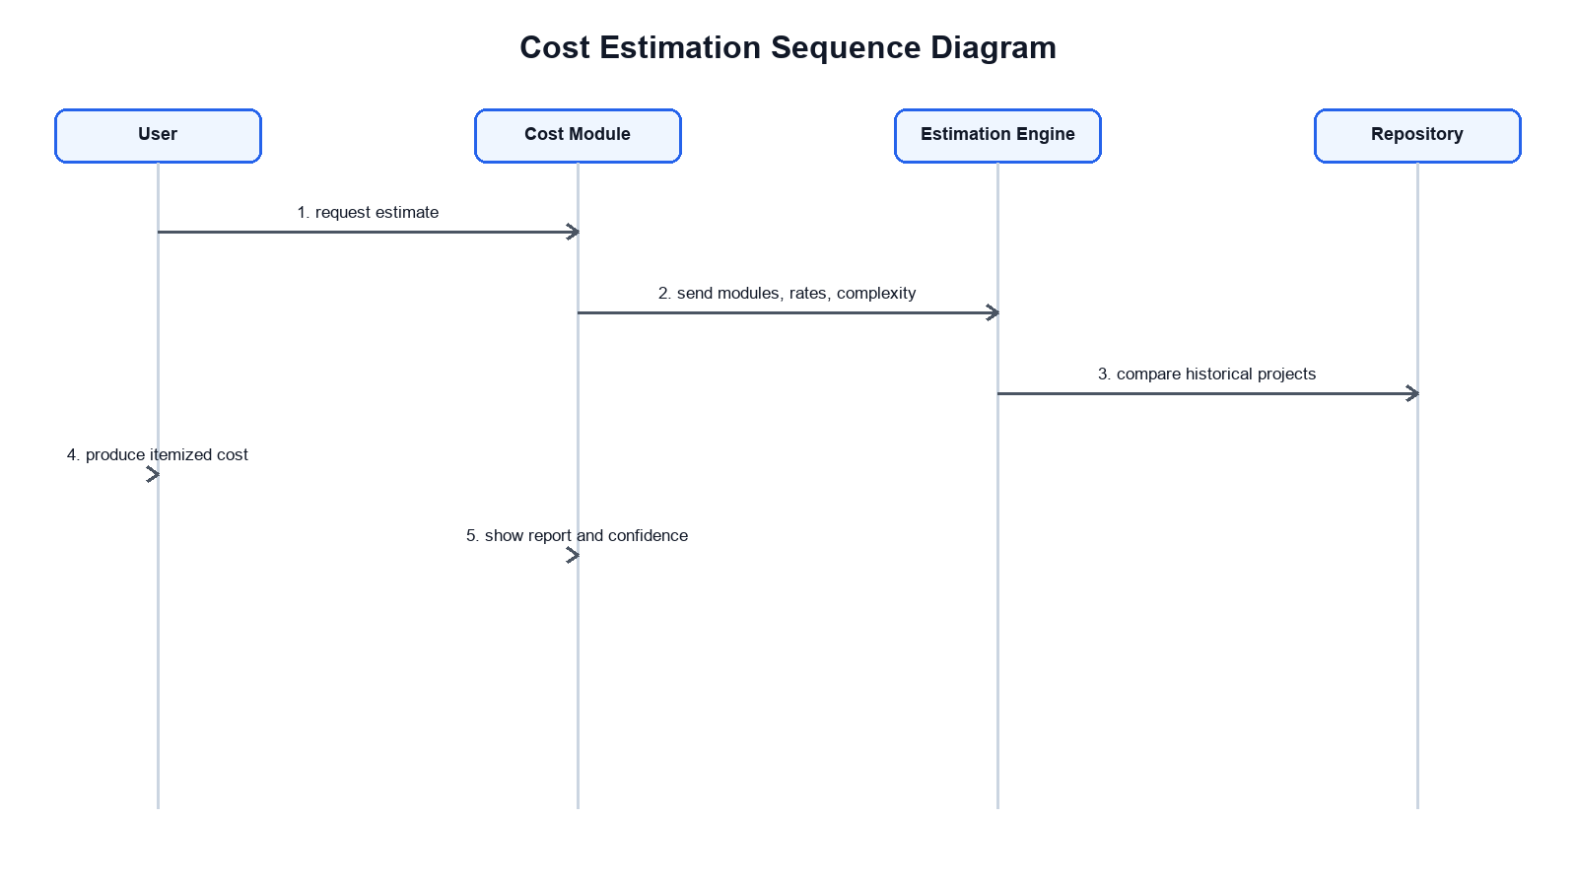
Figure 8: Cost Estimation Sequence Diagram
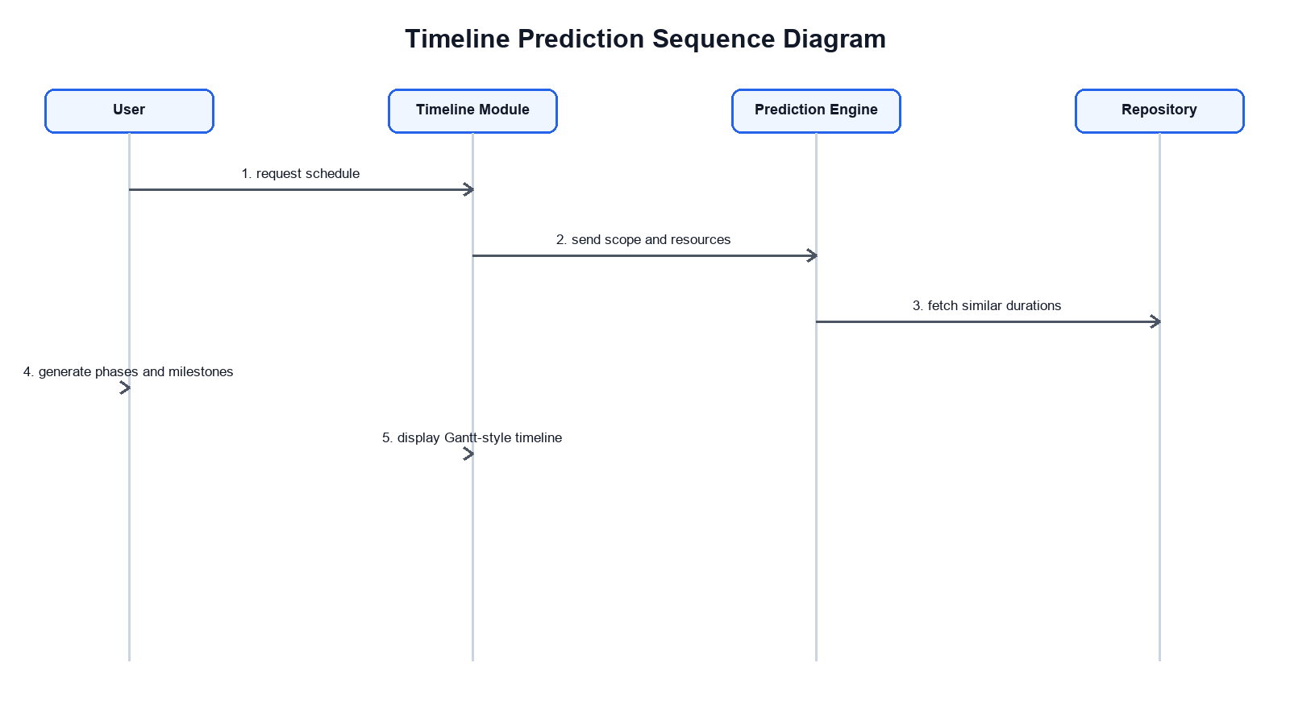
Figure 9: Timeline Prediction Sequence Diagram
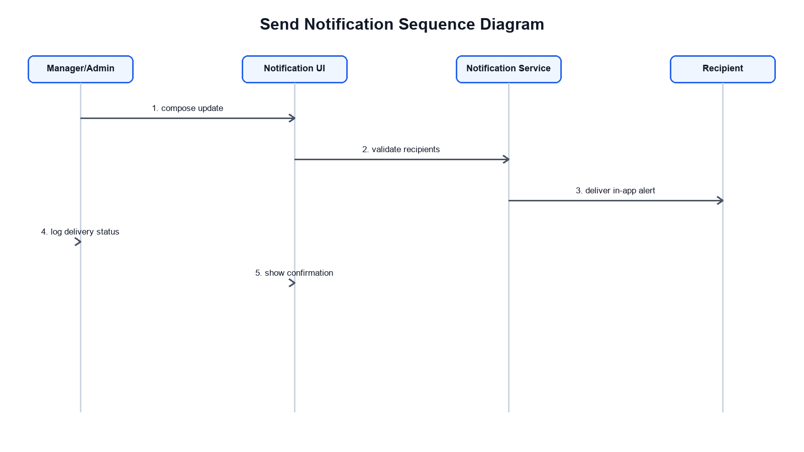
Figure 10: Send Notification Sequence Diagram

3.5.5 Activity Diagram
The activity diagram presents the full workflow from requirement capture to proposal export.
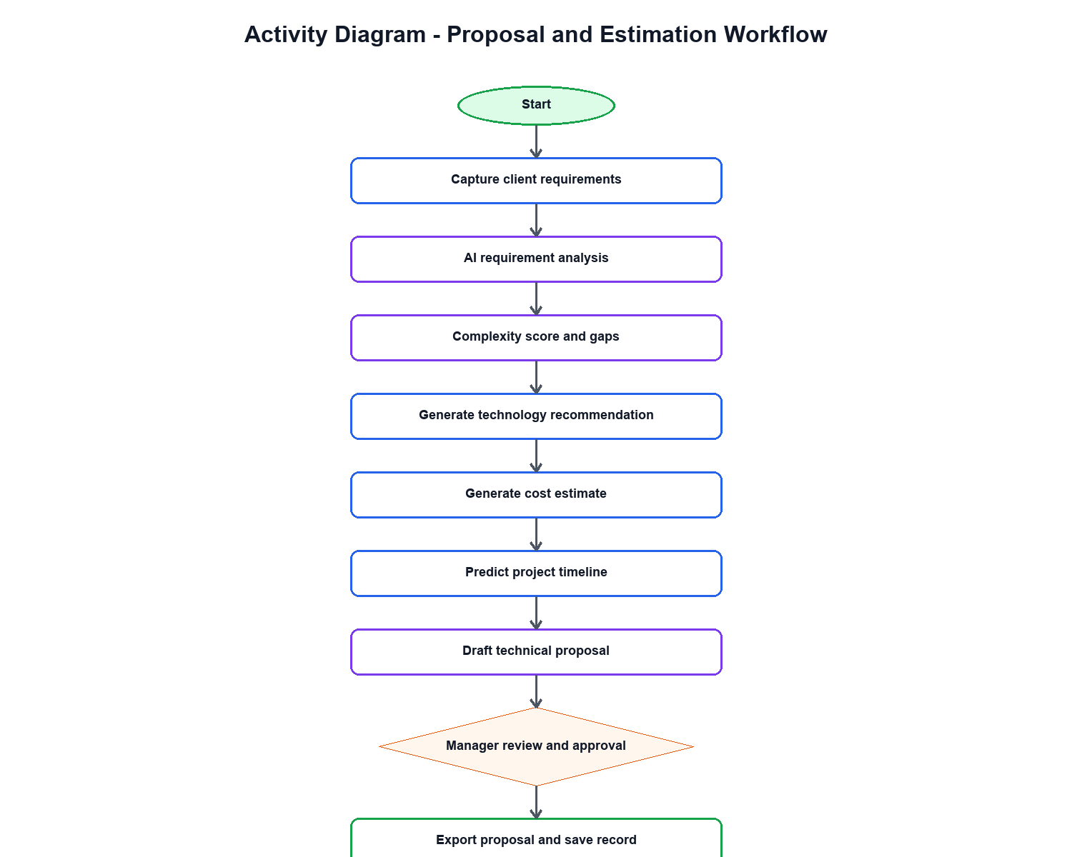
Figure 11: Activity Diagram

3.6 Database Design
The implemented prototype currently uses realistic frontend mock data. For deployment, Supabase PostgreSQL is proposed as the persistent database layer.
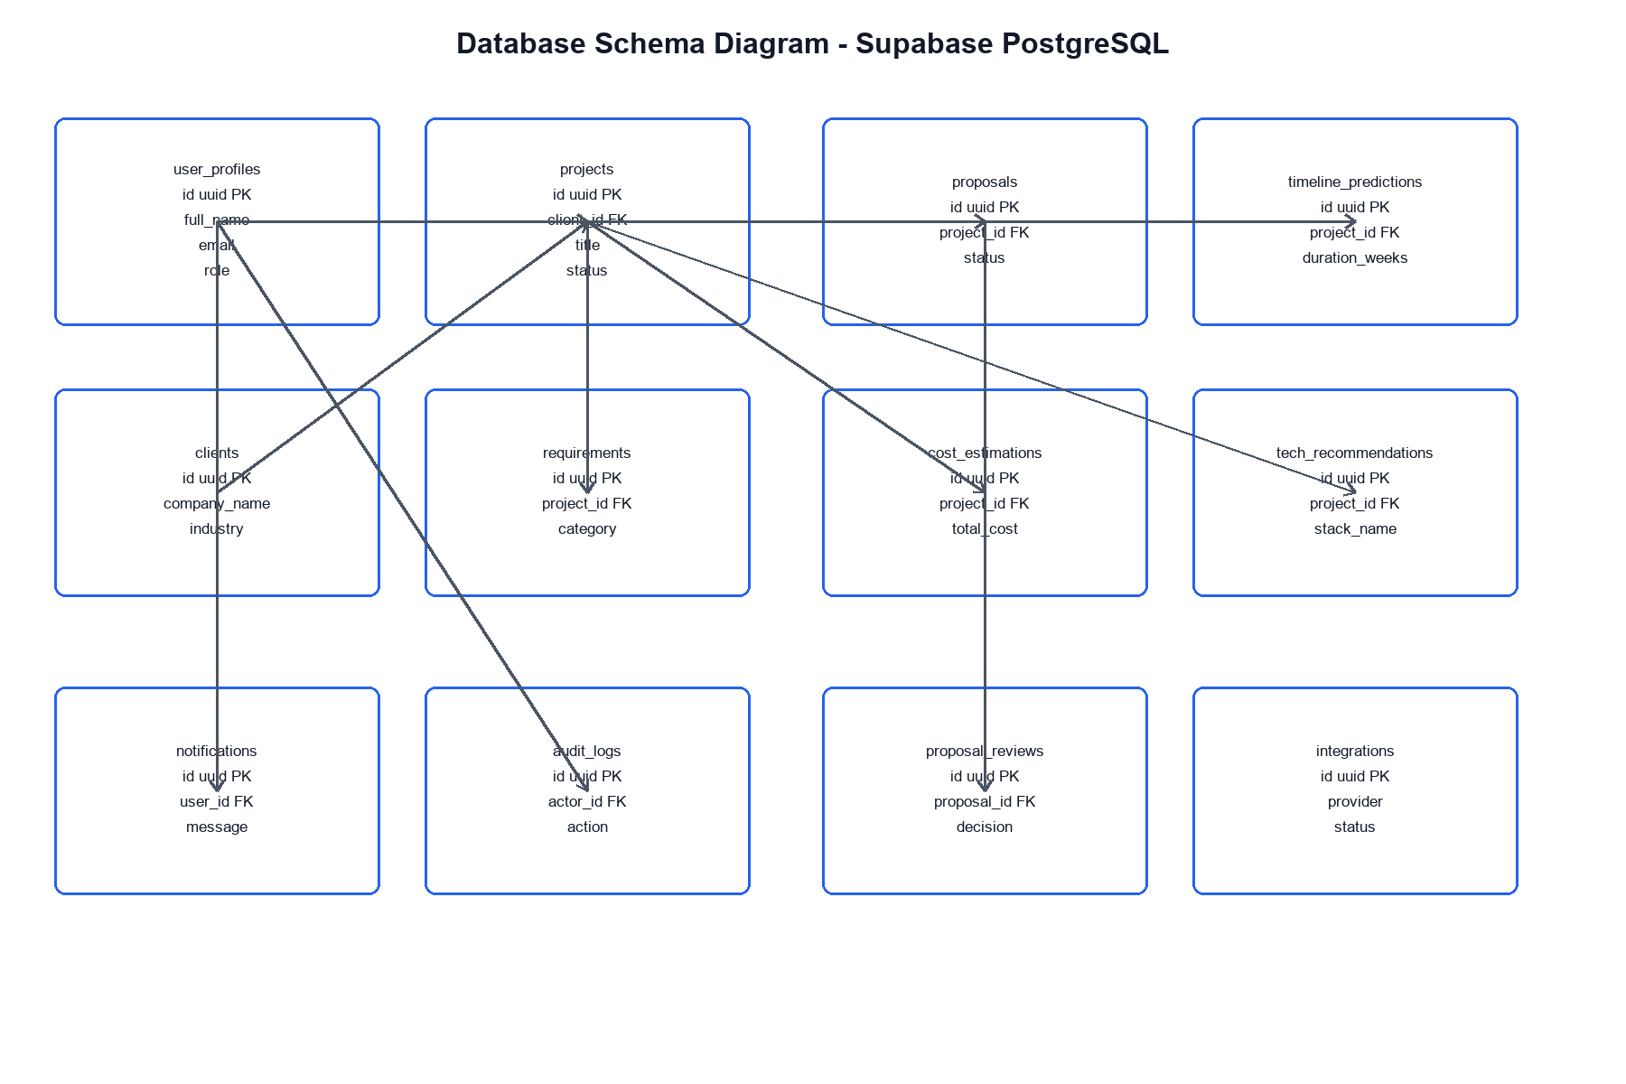
Figure 12: Database Schema Diagram

3.6.1 Data Dictionary
Table | Purpose | Key Fields
user_profiles | Stores application user profile and role data. | id, full_name, email, role, is_active
clients | Stores client organizations and contact details. | id, company_name, contact_name, contact_email, industry
projects | Stores project scope, status, type, complexity, and client ownership. | id, client_id, title, project_type, status, complexity_score
requirements | Stores individual requirement entries and priorities. | id, project_id, category, priority, description
proposals | Stores generated proposal records and approval status. | id, project_id, created_by, title, status, version
cost_estimations | Stores estimation totals and confidence scores. | id, project_id, total_cost, confidence_score
timeline_predictions | Stores predicted duration, risk, and scheduling summary. | id, project_id, duration_weeks, risk_level
tech_recommendations | Stores stack recommendations and match scores. | id, project_id, stack_name, match_score
proposal_reviews | Stores approval decisions and comments. | id, proposal_id, reviewer_id, decision
audit_logs | Stores accountability logs. | id, actor_id, entity_type, entity_id, action

3.7 System Architecture Design
The architecture uses a React single-page frontend developed with TypeScript, Vite, Tailwind CSS, Radix UI components, Lucide icons, Recharts, and Sonner notifications. In production, the frontend connects to Supabase Authentication and PostgreSQL through service APIs. AI-assisted logic is represented as a separate application layer responsible for analysis, generation, estimation, prediction, and recommendation.
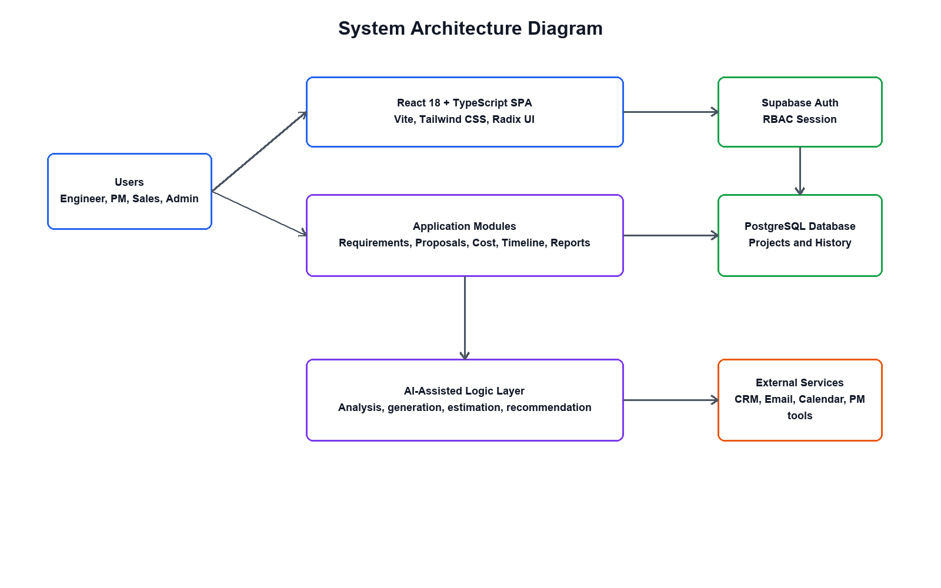
Figure 13: System Architecture Diagram

CHAPTER FOUR

IMPLEMENTATION OF THE NEW SYSTEM

4.1 Introduction
This chapter describes the implementation of the AI-Powered Technical Proposal and Cost Estimation System. The delivered prototype is a web-based dashboard application built with React 18 and TypeScript. It demonstrates the complete proposal workflow through role-based navigation, structured forms, AI-styled analysis outputs, charts, tables, review queues, reports, integrations, and audit screens.

4.2 Technologies and Tools Used
Technology / Tool | Use in the System
React 18 with TypeScript | Frontend component architecture and typed UI implementation.
Vite | Development server and build tool.
React Router DOM v7 | Client-side routing and protected route flow.
Tailwind CSS v4 | Responsive styling and consistent visual design.
Radix UI Components | Accessible UI primitives.
Lucide React | Application icons.
Recharts | Charts for dashboards, reports, cost breakdowns, and analysis results.
Sonner | Toast notification support.
Supabase PostgreSQL | Proposed production authentication, storage, policies, and audit persistence.
Visual Studio Code | Development environment.

4.3 Implementation Structure
The source code is organized under src. The main entry point is src/main.tsx, while src/app/App.tsx defines authentication state, route mapping, and protected routes. The src/app/layouts/dashboard-layout.tsx file implements the common sidebar, top navigation, user menu, and role-filtered navigation items. Functional pages are grouped by domain under src/app/pages.

4.4 Role-Based Access Control Implementation
Role-based access control is implemented through navigation filtering and protected route checks. Sensitive routes such as proposal review, template management, integrations, and security audit are guarded so unauthorized users are redirected to the dashboard. The implemented roles are engineer, project-manager, sales, and admin.

4.5 Presentation of the New System
The following screenshots were captured from the running implementation and show the key screens used in the thesis.
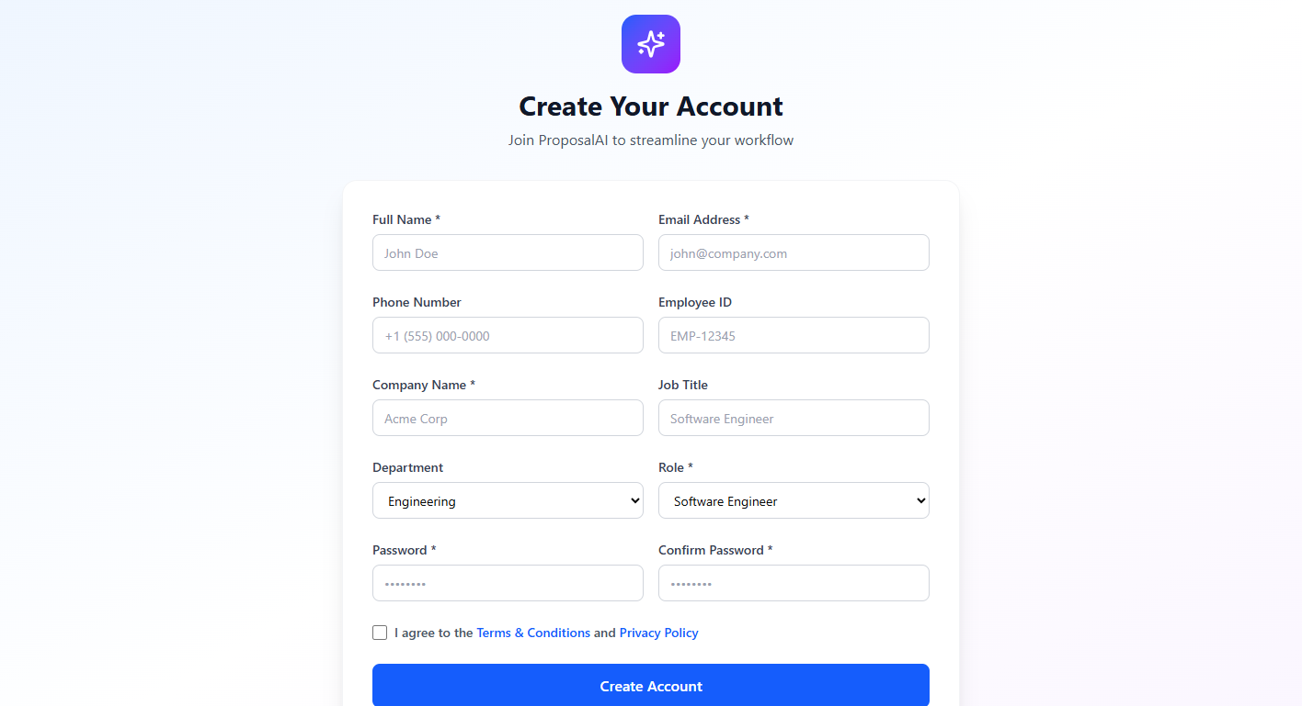
Figure 14: Sign Up / Registration Page
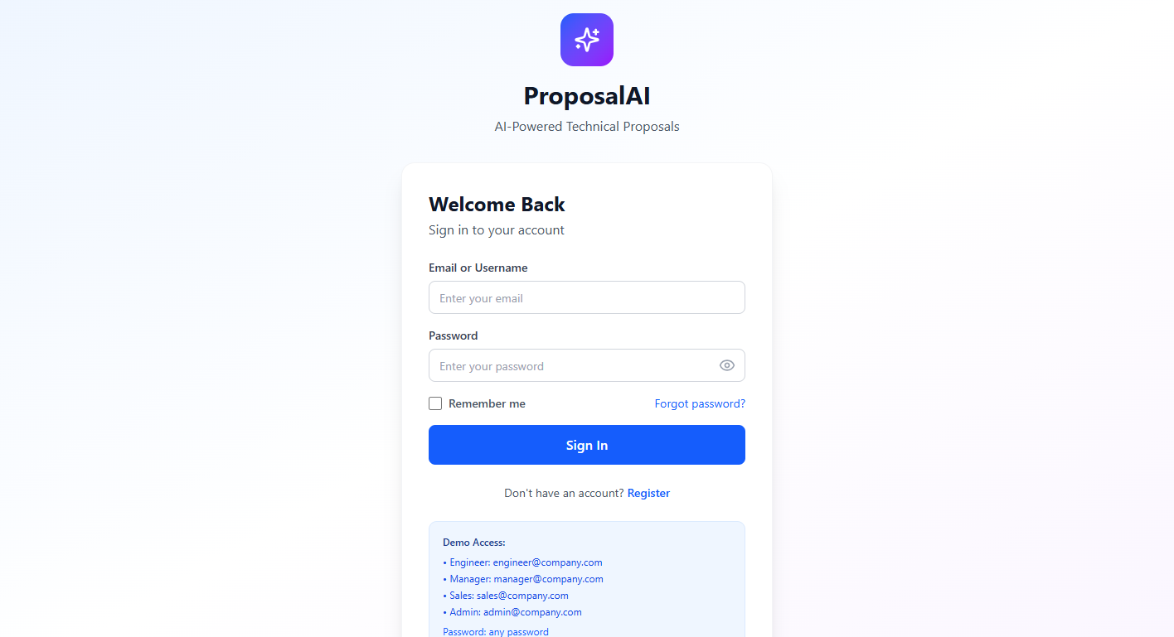
Figure 15: Login Form

Figure 16: Dashboard - Project Manager View

Figure 17: Requirement Analysis Module

Figure 18: Proposal Generation Module

Figure 19: Cost Estimation Report Page

Figure 20: Admin / System Management Page

4.6 Module Implementation Summary
Module | Implementation Summary
Authentication and Profile | Login, registration, forgot password, profile, and role redirection screens.
Dashboards | Separate engineer, project manager, sales, and admin dashboards.
Requirement Analysis | Multi-step requirement capture and AI-styled analysis result presentation.
Proposal Generation | Template selection, section navigation, generation state, content preview, and export controls.
Cost Estimation | Module-wise cost breakdown, resource assumptions, confidence score, and chart-based report.
Timeline Prediction | Phase breakdown, milestones, Gantt-style visualization, and risk indicators.
Technology Recommendation | Stack recommendation, alternatives, comparison matrix, and rationale.
Repository and Clients | Historical project browsing, project details, client directory, and client profiles.
Reports, Templates, Integrations, Security | Analytics dashboards, template library, integration status, permission matrix, and audit logs.

4.7 Software Testing
Testing focused on confirming that the prototype runs successfully, routes are reachable after authentication, role-based dashboards load correctly, and the major module pages render without blocking runtime errors. Manual browser testing was performed using the demo credentials documented in the README. The project was verified through the local Vite development server at http://127.0.0.1:5173.
Test Case | Expected Result | Status
Login as manager@company.com | Project Manager dashboard opens. | Passed
Open requirements module | Requirement form is displayed. | Passed
Open proposal generation module | Proposal workspace is displayed. | Passed
Open cost estimation module | Cost report and charts are displayed. | Passed
Login as admin@company.com and open security | Security and audit page is displayed. | Passed
Attempt restricted modules by role | Unauthorized modules are hidden or guarded. | Passed

4.8 Hardware and Software Requirements
Requirement Type | Minimum Requirement
Client Device | Laptop or desktop computer with modern web browser.
Processor | Intel Core i3 or equivalent and above.
Memory | 4 GB RAM minimum; 8 GB recommended.
Network | Internet or local network connection for deployed use.
Software | Modern Chromium, Edge, Firefox, or Safari browser.
Development Environment | Node.js, npm, Visual Studio Code, and Git.
Production Backend | Supabase project with PostgreSQL database and authentication enabled.

4.9 Chapter Summary
The implementation demonstrates a complete frontend prototype of the AI-Powered Technical Proposal and Cost Estimation System. The Supabase schema supplied separately provides the production database foundation required to persist the data currently represented by frontend mock data.

