Crowdfunding platforms like Kickstarter and Indiegogo have been growing in success and popularity since they began in the late aughts. Everyone from indie creators to famous celebrities have utilized crowdfunding to launch new products and generate buzz, but not every project has found success.

Getting funded on a crowdfunding website requires meeting or exceeding the project's initial goal, so many organizations spend months looking through past projects in an attempt to discover some trick for finding success. For this week's homework, you will organize and analyze a database of 1,000 generated sample projects in order to uncover any hidden trends.

Create a report in Microsoft Word and answer the following questions.

**Given the provided data, what are three conclusions we can draw about crowdfunding campaigns?**

Based on the analysis, the most campaigns started are in the theater category (344) and the least amount being in the journalism category (4). This means you could be competing with many others also looking for funding when starting a theater campaign. Though, more than half (54%) of all Crowdfunding campaigns in the theater category are successful.

If you are interested in starting a music campaign, world music has the highest success rate at 100%, while indie rock music has the lowest success rate at 51%.

Overall, looking at all categories there is not a strong correlation between the date a campaign is created and the outcome of the campaign.

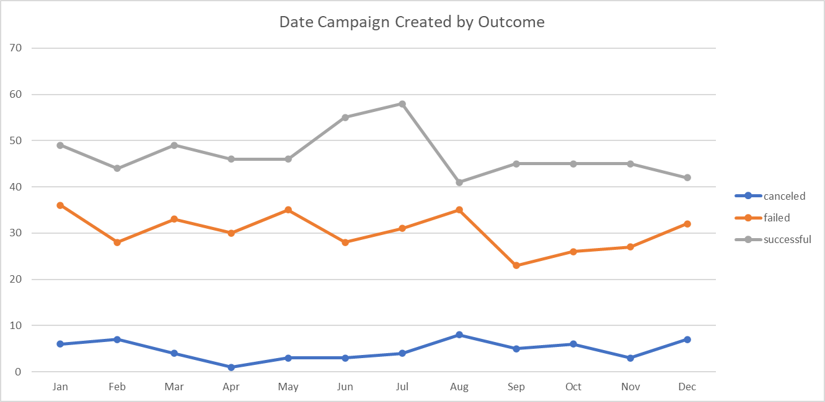

**What are some limitations of this dataset?**

Over the 10-year period of this data set we only have a sample of 1000 campaigns. Based on the growing popularity of crowdfunding I would question the sample size.

I would have liked to know a more specific area these campaigns and projects are being started. This could have told us if all the successful theater campaigns were started in a specific part of the US, i.e. California. I may want to choose a campaign category more successful for the region in which I want to execute my project.

**What are some other possible tables and/or graphs that we could create, and what additional value would they provide?**

Another possible table and graph that could have been created would be the time it took from Date Created to Date Ended. This could have given us insight on the average time a successful campaign takes compared to an unsuccessful campaign. E.g., campaigns lasting less than x months are X% more likely to be unsuccessful.

A second possible table and graph that could have been created would be an average donation amount by campaign category, also divided by successful and unsuccessful outcomes. This could provide insight into if some starting a new campaign should market to a smaller number of people/organizations that may make larger donations or a mass amount of donors who more than likely would provide small amounts of donations.