

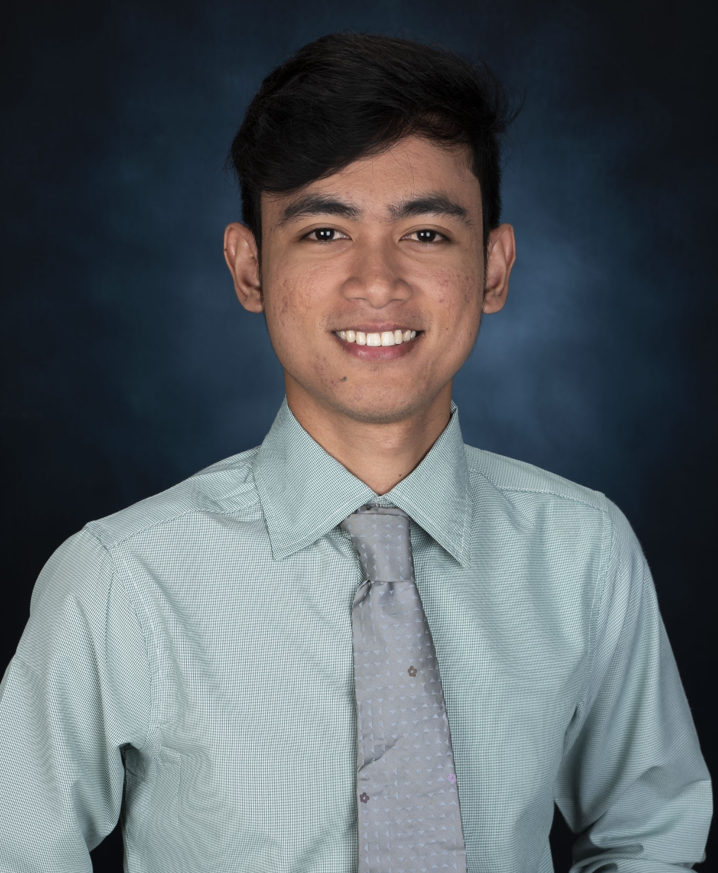

**PROFILE**

I am graduate of Bachelor of Science in Computer Engineering; I have my passion and initiative to take responsibilities as well as my dedication to work. I am an optimistic and currently developing myself in terms of decision-making and tasks management. I have the ability to communicate in an appropriate manner and act in conformity with ethics at all times.

**EDUCATIONAL BACKGROUND TERTIARY**

**TERTIARY**

Southern Luzon State University Lucban, Quezon

Bachelor of Science in Computer Engineering 2013- 2019

**SECONDARY**

Manuel S Enverga University Foundation Catanauan, Quezon

2009-2013

**PRIMARY**

Manuel S Enverga University Foundation Catanauan, Quezon

2003-2009

**PERSONAL INFORMATION**

**Age :** 21 yrs. old

**Birthdate :** November 19,1997 **Birth of place :** Catanuan, Quezon

**Civil Status :** Single

**Height** : 5’6

**Nationality :** Filipino

**Religion :**Seventh Day Adventist

**Language :** Filipino and English

**CHARACTER REFERENCE**

**Engr. Jerwin Obmerga**

Instructor, College of Engineering Southern Luzon State University

**0947 471 7003**

**Engr. Renato R. Maaliw III, PhD IT**

Chairman, Computer Engineering

College of Engineering

Southern Luzon State University

**0998 900 1045**

**Samantha D. Siao**

IT Supervisor  
Pierre and Paul Solutions Inc.

**09171831210**

**Jimuel Z. Madrigal**

Brgy. 02 Catanauan, Quezon, Mobile Number: 09663867740

# Email[: madrigaljimuel5@gmail.com](mailto:jobelleeeee020@gmail.com)

## OBJECTIVES

To acquire suitable position that will give opportunity to apply the knowledge that I have gained, my aptitude to adapt and learn rapidly, my capability to work well with others and will challenge and strengthen my education and professional skills. Lastly, to obtain knowledge learning experience essential to my career growth.

## SKILLS

 Ability to determine and negotiate requirements, priorities and delivery deadlines.

 Can effectively deal with multiple tasks simultaneously and coordinate time efficiently.

 Having a good oral and written communication and flexible in doing task and priorities.

 Computer Literate in:

o Microsoft Office (Word, Excel and PowerPoint)

 Knowledge about Programming in Java, C, PHP and Laravel.

 Knowledge in AutoCAD, Sketchup and Vray.

## EXPERIENCE

**On the Job Training at Pierre and Paul Solutions Inc.**

as Web Developer, Mandaluyong

June 2018 - August 2018

## SEMINARS ATTENDED

**The 16th Youth Congress on Information Technology**

University of the Philippines Campus, Diliman, Quezon City | September 26, 2018

**Raspberry Pi Training Workshop using Python Southern Luzon** State University, Lucban, Quezon | April 2018

**PLC Programming Workshop**

Southern Luzon State University, Lucban, Quezon | March 13,2019

**Arduino Development from Idea to Deployment**

Southern Luzon State University, Lucban, Quezon | April 2019

*……………………………………………………………………...*

*I hereby certify that the above information is true and correct to the best of my knowledge and belief.*

## 

## JIMUEL Z. MADRIGAL

Applicant