- INTRODUCTION
Robotics education increasingly relies on Computer-Aided Design (CAD) models to bridge the gap between theoretical kinematics and physical robot structure. This assignment requires each group to inspect a provided SolidWorks robot assembly, interpret it as a functional robotics system, and prepare a simple motion demonstration using MATLAB, Simulink, or Simscape Multibody.
This report documents the work carried out by the group on the selected 4-DOF robotic arm model, covering assembly inspection, structural classification, joint analysis, motion planning, simulation preparation, and a discussion of the robot's practical applications and limitations.

- SELECTED ROBOT ZIP FILE
ITEM | DETAIL
Selected ZIP file | 4-dof-robotic-arm-10_snapshot.zip
Assembly folder | 4-dof-robotic-arm-10. snapshot.2
Robot type | 4-DOF articulated robotic arm with a cutting-tool end-effector
Group number | 4

- CAD ASSEMBLY INSPECTION
Files found in the Assembly Folder
After extracting the ZIP file, the following files were identified inside the folder
- Assem1.SLDASM
- 01. Base.SLDPRT
- 0.6 Revolver.SLDPRT
- 0.3 Link C22.SLDPRT
- 02. Link C33 Conne.SLDPRT
- 0.4 Link C33.SLDPRT
- 0.7 Combiner.SLDPRT
- 0.5 Tool Holder.SLDPRT
- 0.8 Cutter.SLDPRT

Complete Assembly Screenshot

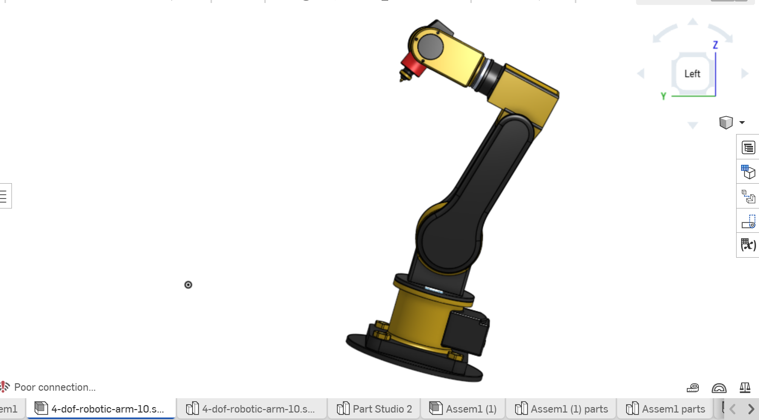
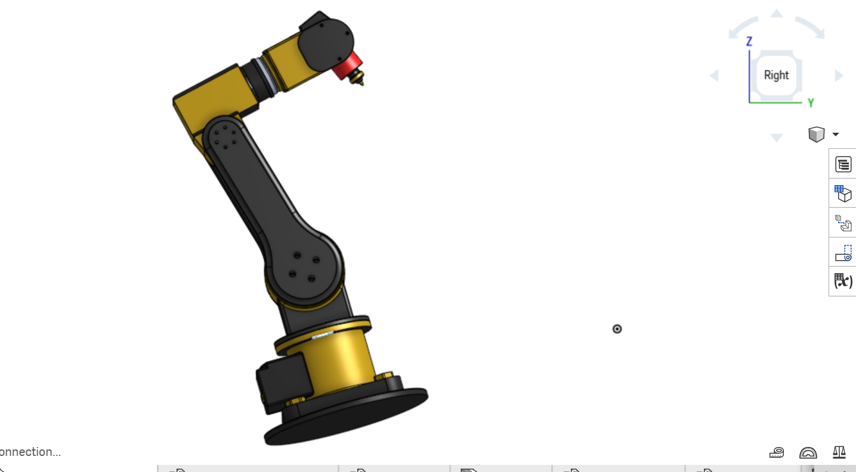
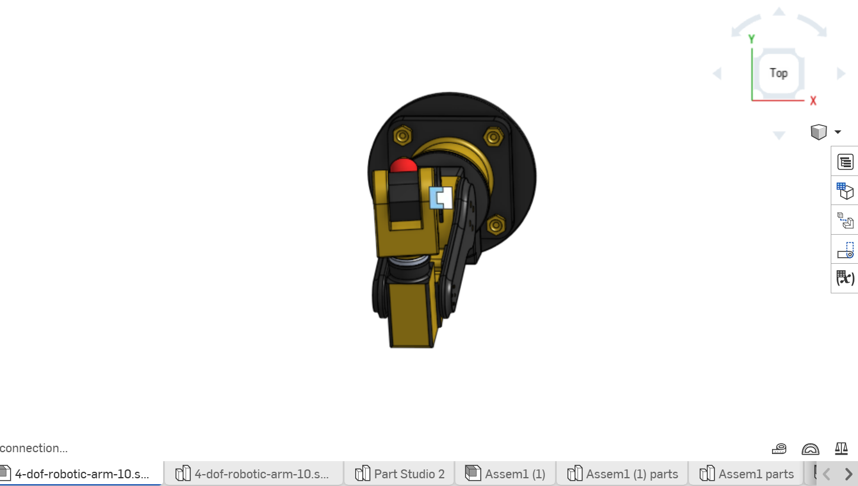
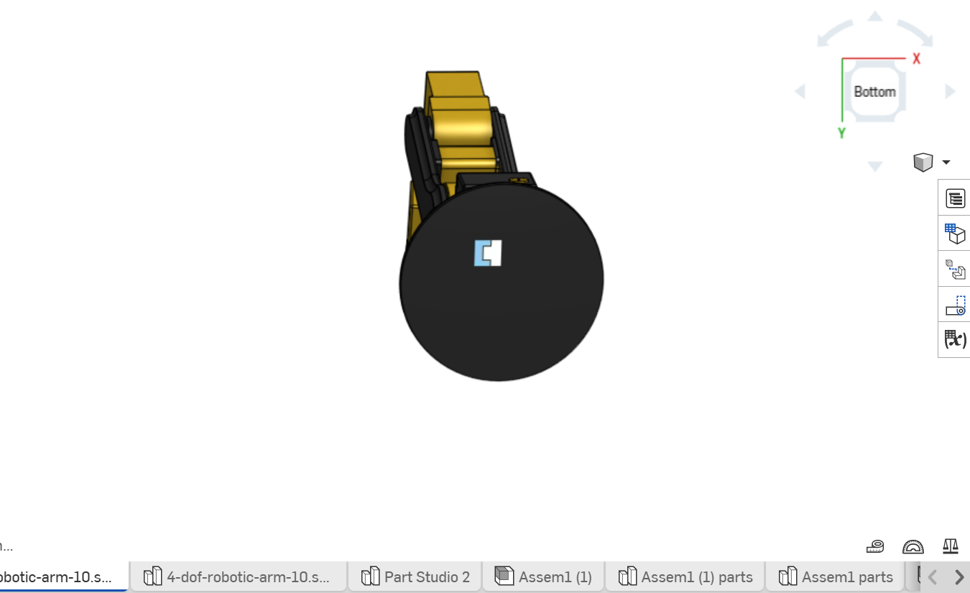
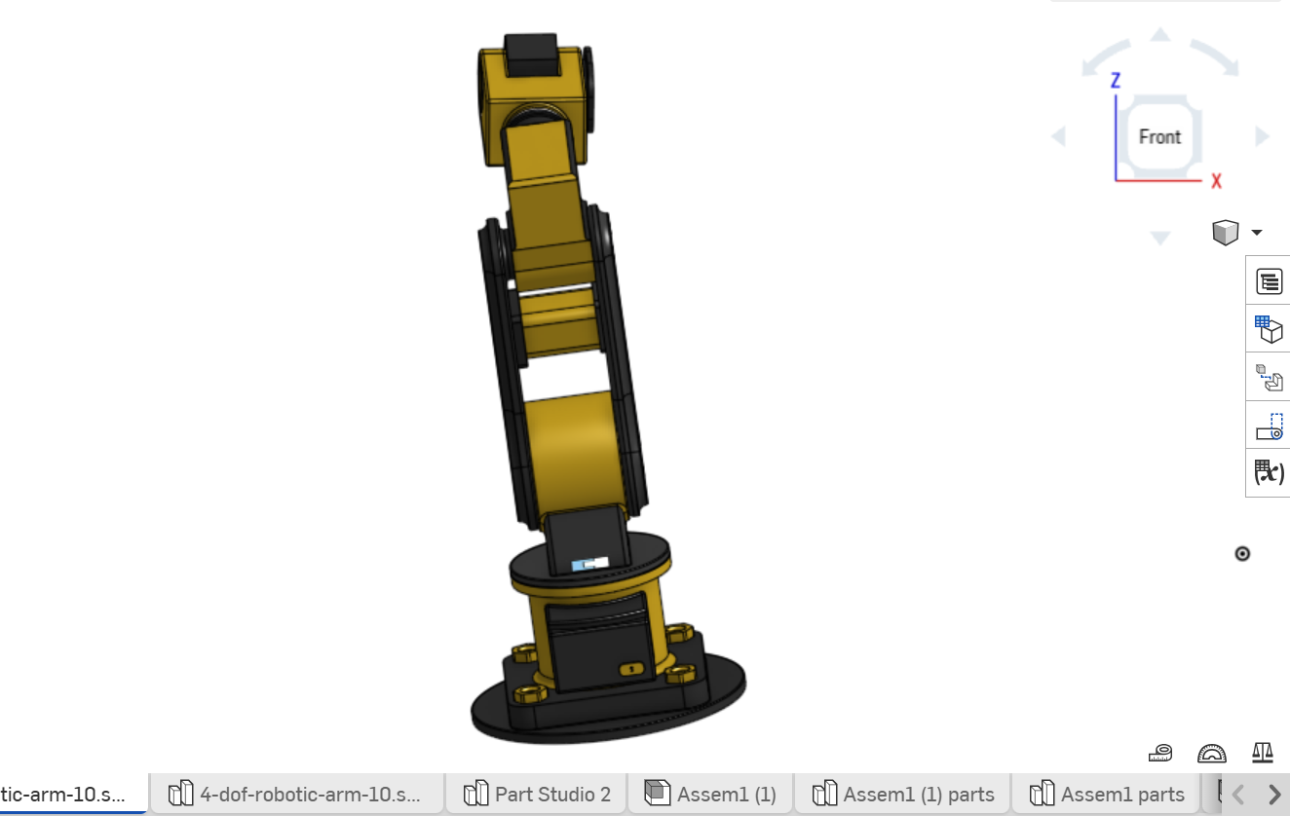
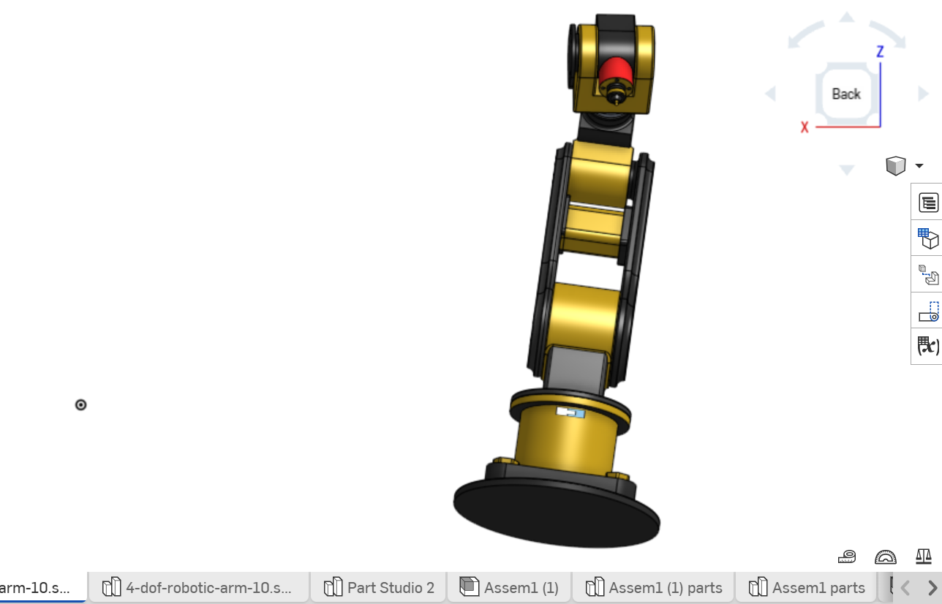

Important Parts and Their Functions
File Name | Physical part | Function
Assem1.SLDASM | Main assembly | Contains the complete robot model and mate relationships
01. Base.SLDPRT | Base | Fixed foundation; anchors the robot to the world frame
0.6 Revolver.SLDPRT | Waist/turret | Rotates the arm horizontally about the vertical axis
0.3 Link C22.SLDPRT | Upper arm link | Provides the main lift/reach motion from the shoulder
02. Link C33 Conne.SLDPRT | Elbow connector | Joins Link C22 to Link C33, transferring elbow motion
0.4 Link C33.SLDPRT | Forearm link | Extends or folds the forearm relative to the upper arm
0.7 Combiner.SLDPRT | Wrist joint part | Combines forearm motion with tool orientation at the wrist
0.5 Tool Holder.SLDPRT | End-effector mount | Holds and positions the cutting tool at the wrist
0.8 Cutter.SLDPRT | End-effector (tool) | Performs the cutting/trimming action; the robot's working tool

- ROBOT TYPE AND DOF IDENTIFICATION
ITEM | DESCRIPTION
Selected ZIP file | 4-dof-robotic-arm-10_snapshot.zip
Robot type | Articulated robotic arm (4-axis serial manipulator)
Estimated DOF | 4 (four revolute joints: waist, shoulder, elbow, wrist)
Main Application | Cutting, trimming, or pointing tasks using a fixed cutting-tool end-effector
Reason for classification | The assembly shows a serial chain of four moving connections; Base to Revolver (waist), Revolver to Link C22 (shoulder), Link C22 to Link C33 via the connector (elbow), and Link C33 to Combiner to Tool Holder (wrist); matching the 4-DOF articulated arm naming of the source file, rather than the linear-stage arrangement of a Cartesian or cylindrical robot

- LINK AND JOINT IDENTIFICATION
A link is a rigid part of the robot; a joint is a connection that allows relative motion between two links. The table below lists the joints identified from the part structure of the assembly.

JOINT NUMBER | Connected Parts | Joint type | Motion Description | Axis/Direction
J1 | Base to Revolver | Revolute | Rotates the whole arm horizontally (waist) | About vertical axis
J2 | Revolver to link C22 | Revolute | Raises/lowers the upper arm (shoulder) | About horizontal shoulder axis
J3 | Link C22 to link C33 (via Link C33 Conne) | Revolute | Folds/extends the forearm (elbow) | Parallel to shoulder axis
J4 | Link C33 to Tool Holder (via Combiner) | Revolute | Orients the cutting tool (wrist) | Perpendicular/along tool axis

- ROBOT MOTION REFERENCE POINTS
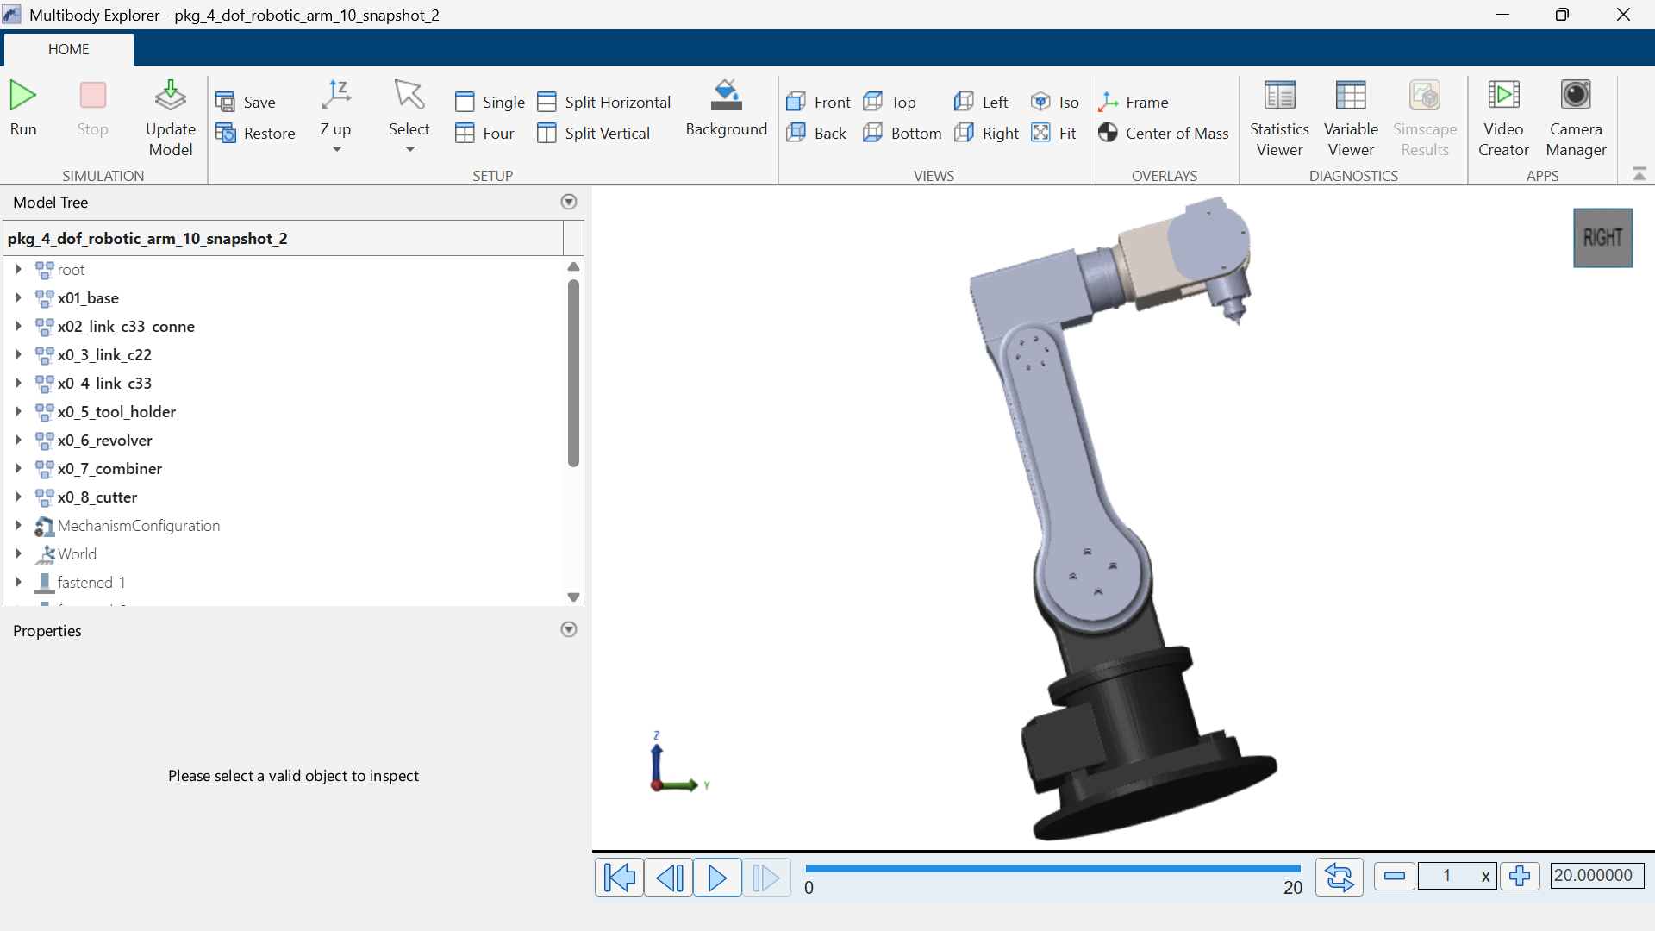

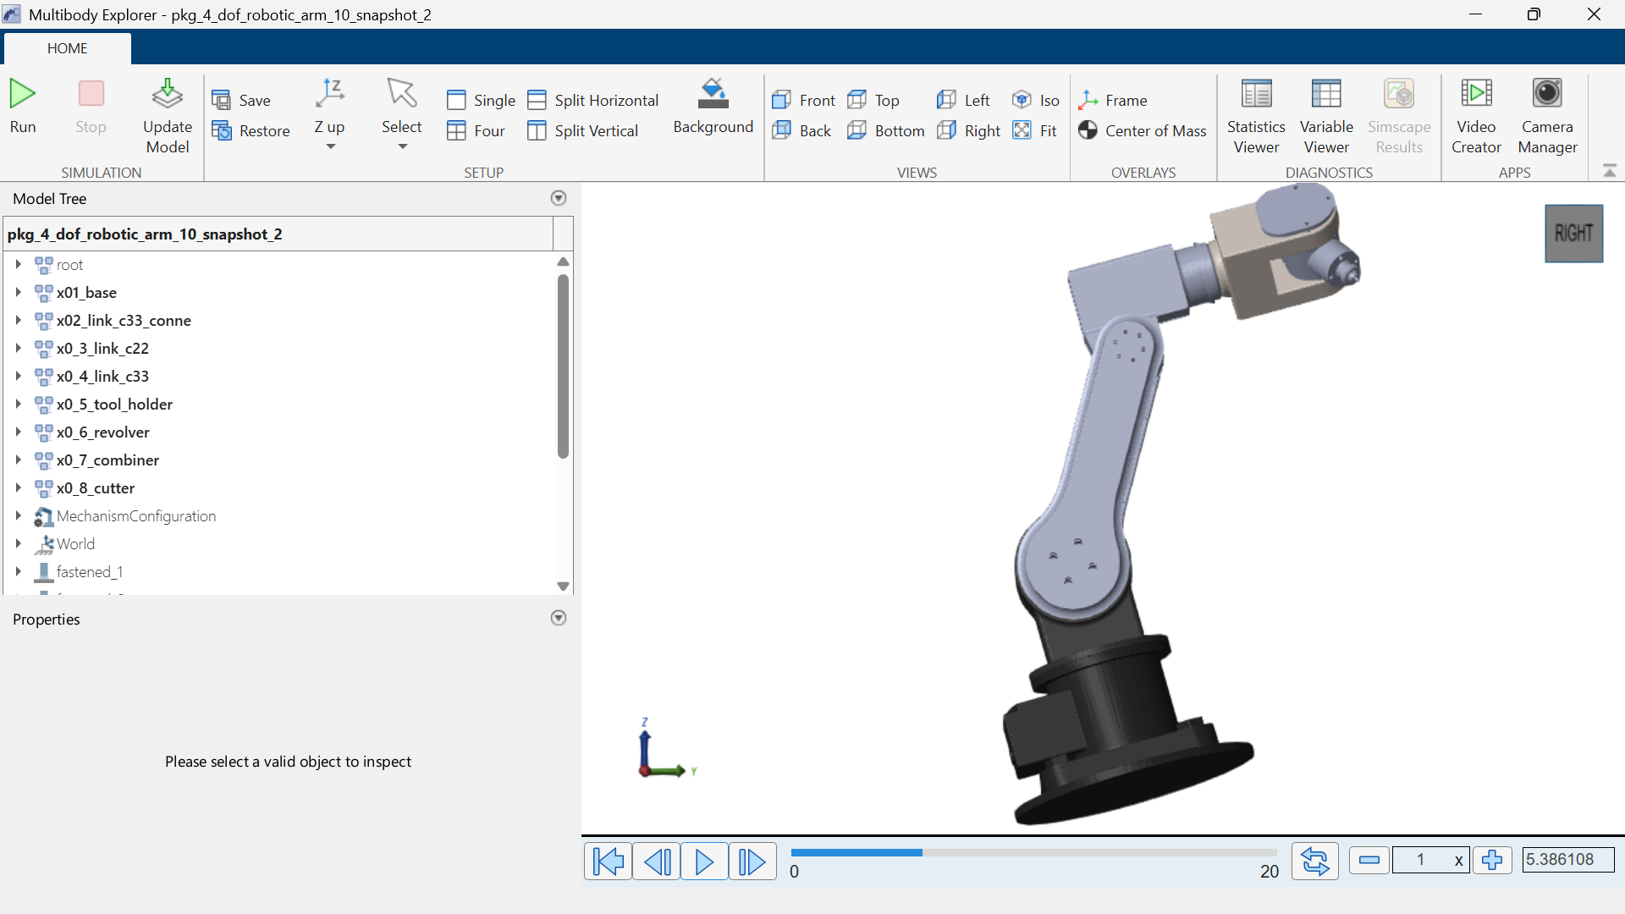

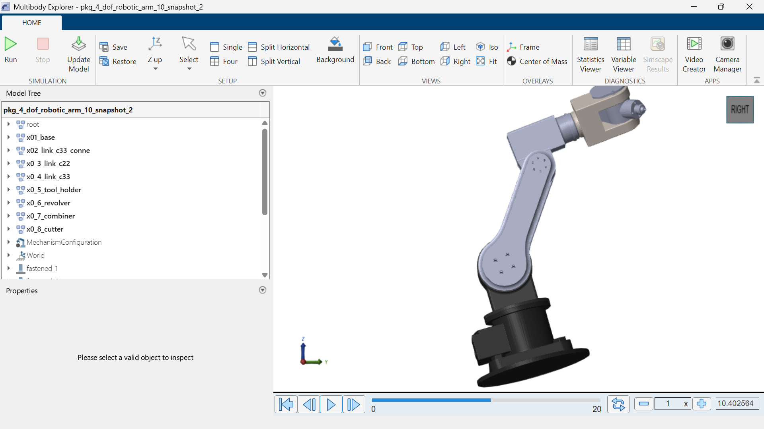

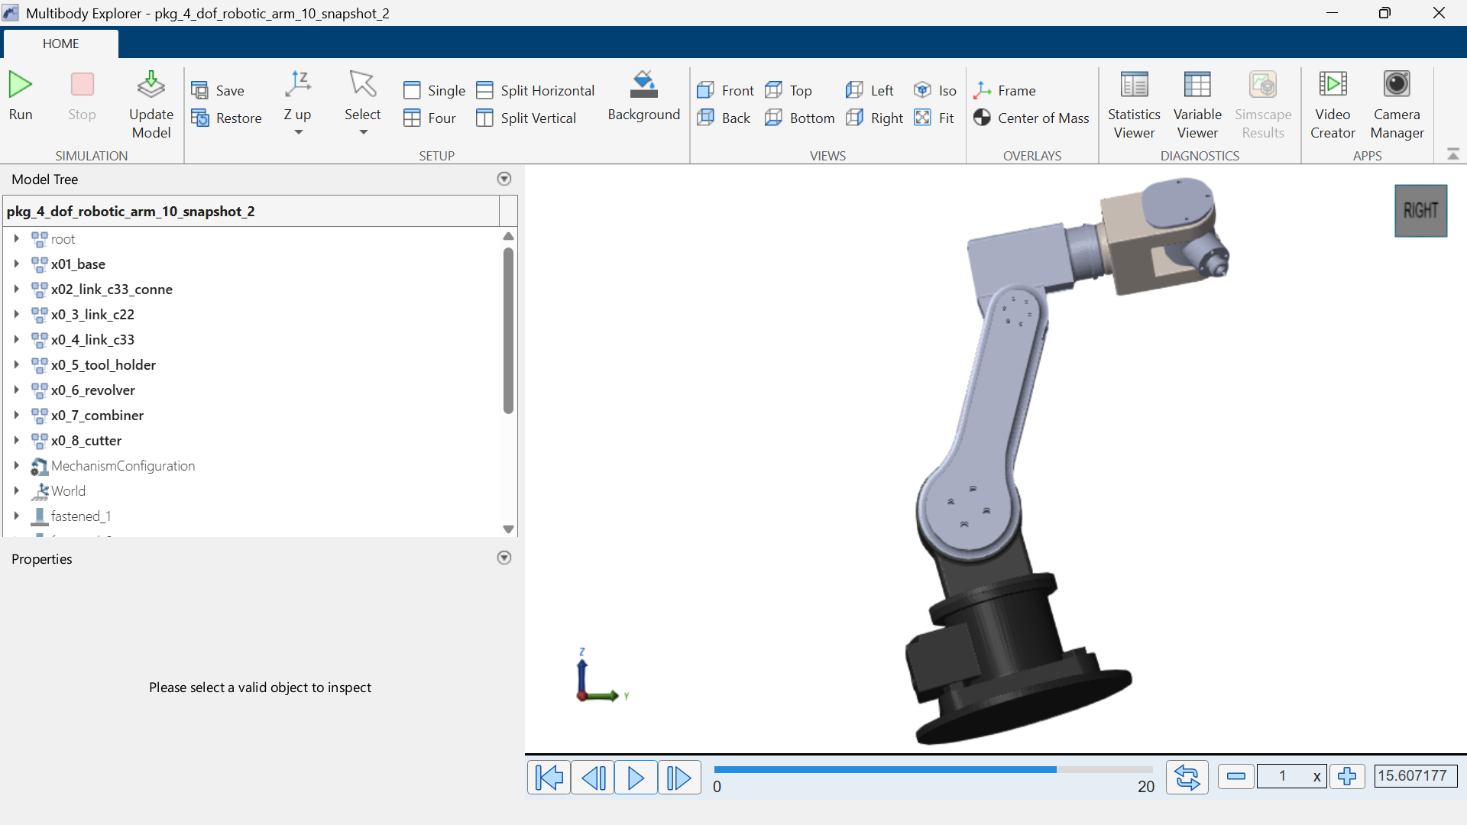

Motion path: the robot begins at the home position with all four joints at zero. The waist (J1) rotates toward the target, the shoulder and elbow (J2, J3) extend to bring the Cutter above the target material, and the wrist (J4) orients the tool to the correct cutting angle before the cutting action is performed.

Reference Point | Description | Robot Condition
Home position | Starting position of the robot | All joints at 0°, arm at rest
Target position | Position where the cutter reaches the material | Cutter positioned above target
Cutting position | Position where the cutting action occurs | Wrist lowered/oriented, cutter engaged
Final position | End of the movement | Arm withdraws and returns toward home

- BASIC ROBOT MOTION DESCRIPTION
- Joint 1 (waist, at the Revolver) moves first, rotating the entire arm toward the target.
- Joint 2 (shoulder, Link C22) and Joint 3 (elbow, Link C33) rotate/extend together to bring the Cutter into the working area above the target.
- The end-effector (Cutter) reaches the target through the combined motion of all four joints, with Joint 4 (wrist, at the Combiner/Tool Holder) setting the correct approach angle.
- At the cutting position, the Cutter engages and performs the cutting action on the target material.
- At the final position, the arm withdraws the Cutter and may return toward the home position, completing the cycle.
Step | Robot Action | Joint/Parts Involved | Expected Effect
1 | Start from home position | All joints | Robot begins from rest
2 | Rotate waist toward target | Joint 1 / Revolver | Robot turns toward the material
3 | Extend shoulder and elbow | Joint 2 / Joint 3 (Link C22, Link C33) | Cutter moves into working area
4 | Orient wrist | Joint 4 / combiner-tool holder | Cutter reaches material at correct angle
5 | Engage cutter | End-effector | Cutting action performed on target
6 | Withdraw and return | All joints | Robot completes the task

- MATLAB/SIMULINK MULTIBODY PREPARATION
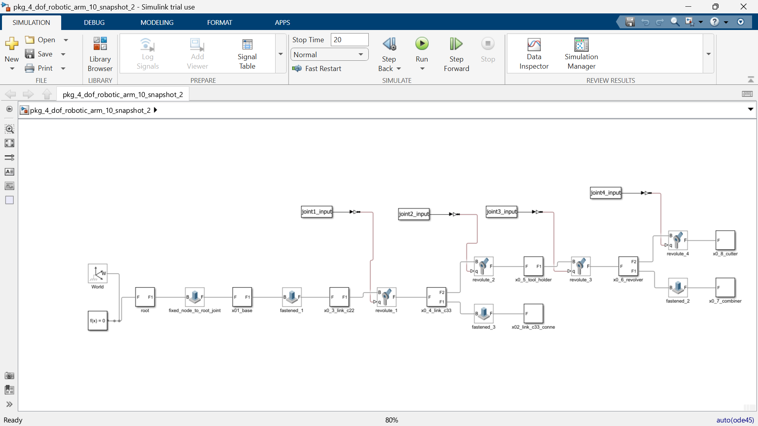

- ROBOT MOTION DEMOSTRATION
Motion objective: rotate and position the arm so that the Cutter end-effector moves from the home position to a target cutting position and back, within a maximum time of 2 seconds.

Time | J1(Waist) | J2(Shoulder) | J3(Elbow) | J4(Wrist) | End-Effector State
0.0s | 0° | 0° | 0° | 0° | Home / Retracted
0.5s | 20° | 15° | -10° | 5° | Moving to target
1.0s | 35° | 25° | -20° | 10° | Cutting position — engaged
1.5s | 20° | 15° | -10° | 5° | Withdrawing
2.0s | 0° | 0° | 0° | 0° | Home / Stop

Replace the joint angle values above with the actual values used or observed for this robot model; they must be consistent with the joint ranges and axis directions identified in Section 5.

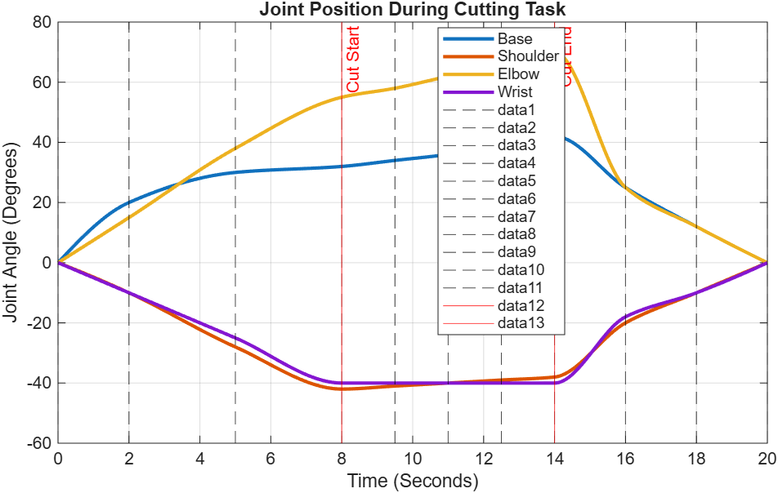

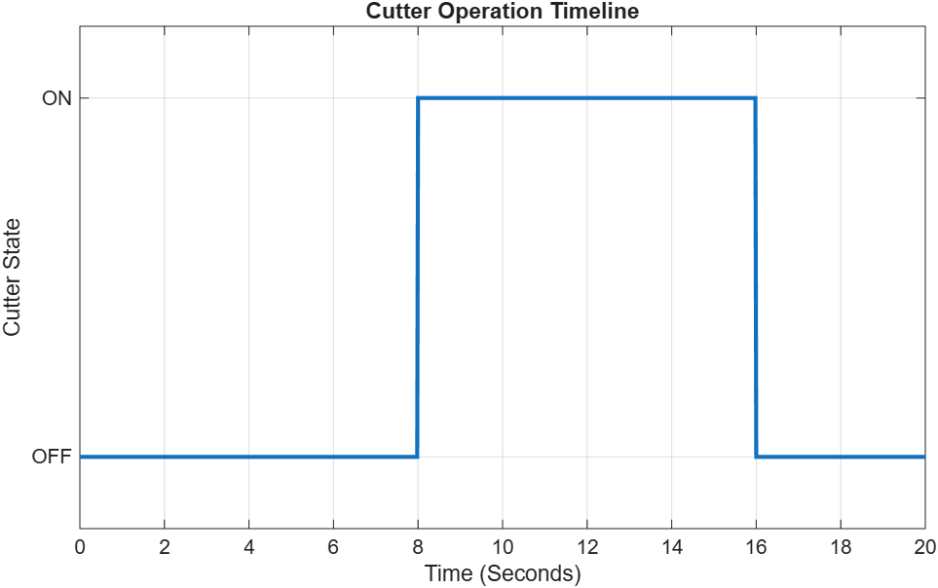

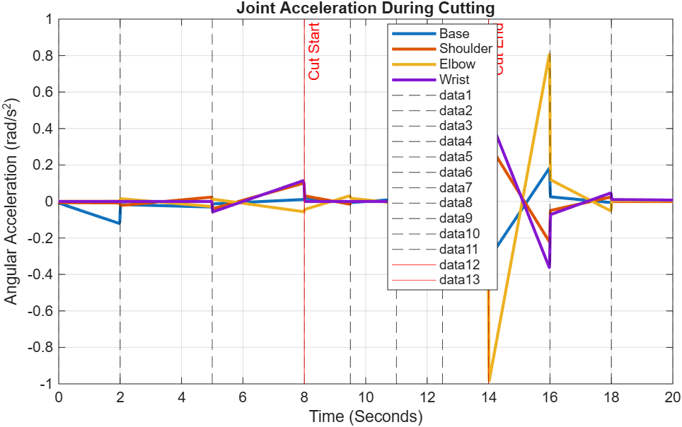

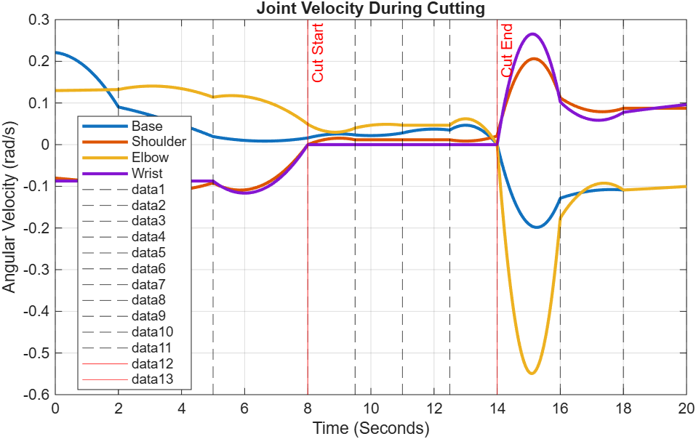
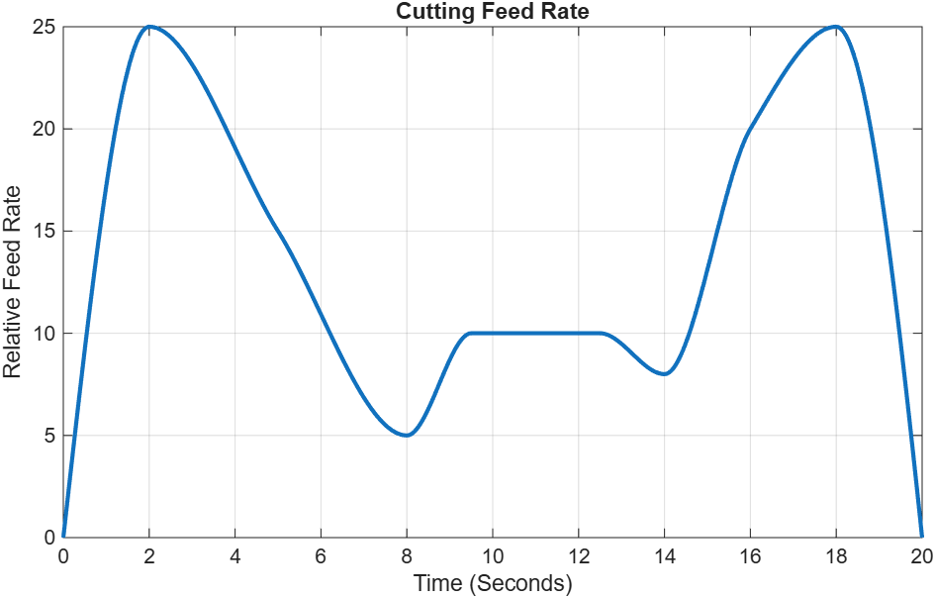

During the 2-second motion, the robot rotates from its home configuration toward the target, engages the Cutter at the 1.0 s mark to simulate the cutting action, then withdraws back toward the home position by 2.0 s.

- WORKSPACE OR REACHEABILITY OBSERVATION
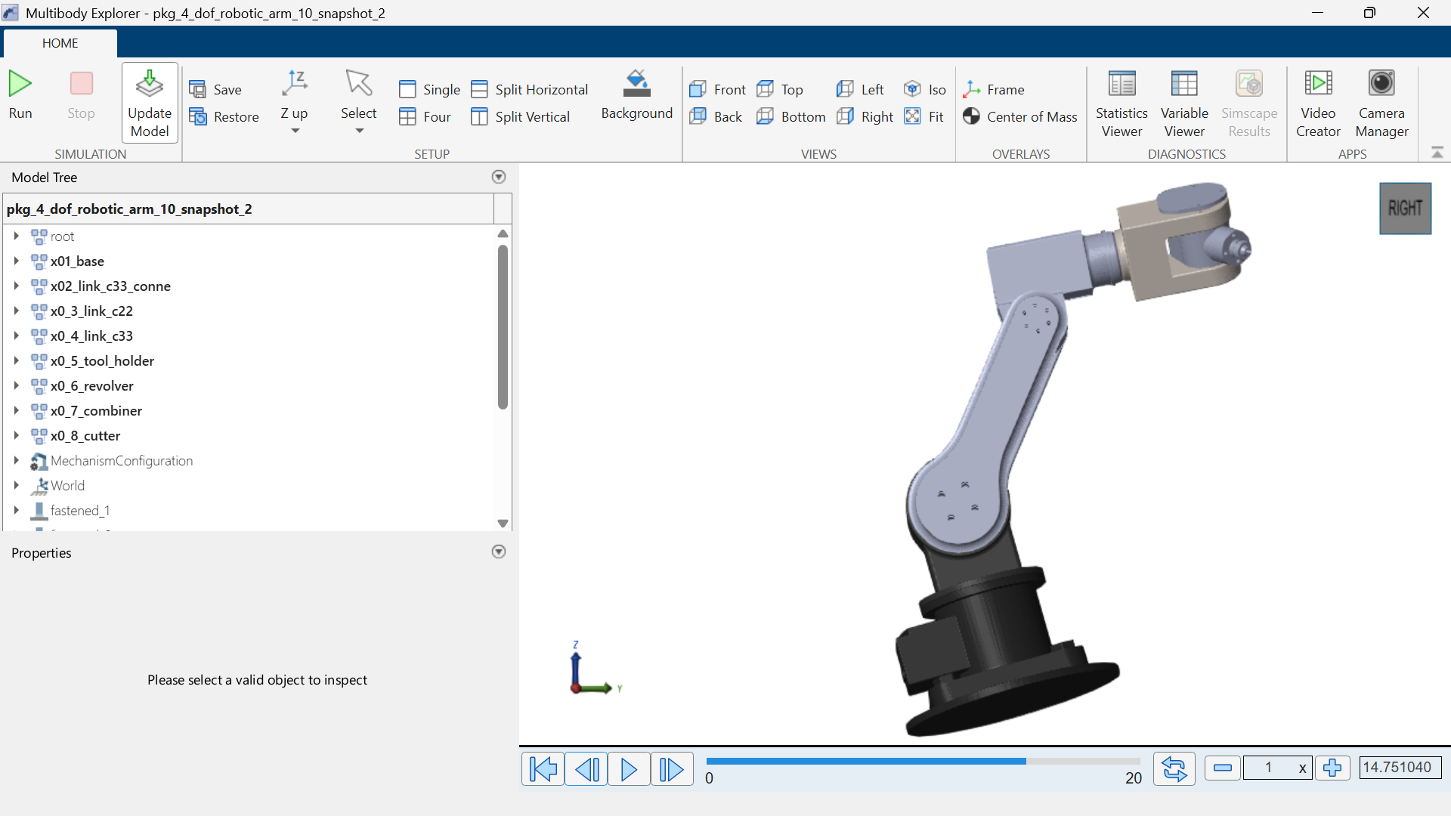
By manually sweeping Joints 1–4 through their available range in SolidWorks (and cross-checking in Simulink), the approximate reachable envelope of the Cutter was observed to be a roughly fan-shaped/toroidal region centred on the base, bounded by the combined lengths of Link C22 and Link C33 and by the joint limits. Positions directly above the base (within the minimum reach) and positions beyond the fully extended arm length are not reachable.
Maximum reach: approximately [insert measured/estimated value] mm from the base axis, based on the sum of the Link C22 and Link C33 lengths in the fully extended configuration.
Motion limitations observed: reduced cutting accuracy near full extension, joint limit restrictions at the wrist (Combiner) that constrain achievable cutting angles, and potential self-collision between the arm and the base at extreme waist rotation.
Based on this workspace, the robot is well suited to cutting or trimming tasks within its mid-range reach, but is not suitable for targets very close to its own base or beyond the maximum arm extension.

- PRACTICAL APPLICATIONS AND LIMITATIONS
Robot Type | Possible application
4-DOF articulated arm with cutting tool (selected type) | Automated cutting/trimming stations, light material processing, precision pointing/marking tasks, educational robotics demonstrations

Limitations identified
- Limited reach beyond the combined length of Link C22 and Link C33
- Payload and cutting-force capacity not specified in the CAD model — assumed light-duty for this demonstration
- Only 4 DOF limits full 3D orientation control of the cutter compared to a 6-axis arm
- Risk of self-collision or singularities near full extension or joint limits
- Mates at the Link C33 Conne connector and Combiner wrist joint were not automatically detected during Simscape import, requiring manual correction
- Actuator/motor specifications were not included in the downloaded CAD files, limiting torque or speed analysis
- Cutter blade/tool specifications (material, sharpness, cutting force) are not modelled, limiting analysis of the actual cutting process

- CONCLUSION
This assignment demonstrated how a downloaded SolidWorks CAD assembly; the 4-dof-robotic-arm-10 model; can be interpreted as a functional robotics system, from identifying the Base, Revolver, links, connector, Combiner, Tool Holder, and Cutter end-effector, to classifying the robot as a 4-DOF articulated arm. The group mapped the mechanical structure to a joint table, defined practical motion reference points around a cutting task, and outlined a MATLAB/Simscape Multibody import approach to demonstrate a simple target-and-cut motion within the required 2-second window. Challenges expected during the Simulink import process (particularly around the connector and wrist combiner parts) were anticipated and documented, reinforcing the practical gap that often exists between an ideal CAD model and a simulation-ready robot model. Overall, the exercise strengthened the group's understanding of robot classification, kinematic chains, and the workflow required to move from CAD geometry to motion simulation.

- REFERENCES
- Course robotics lecture notes, CT 322 University of Dodoma, 2026
- SolidWorks Help Documentation: Assembly mates and motion Study.
- MathWorks Documentation: Simscape Multibody, importing CAD Assemblies (mathworks.com).
- MathWorks Documentation: Simulink Multibody Joint Blocks (mathworks.com).

- APPENDICES
Appendix A: Additional SolidWorks screenshots

