ATMEGA32 USART SERIAL DATA MONITORING SYSTEM

CHAPTER ONE

1. Introduction
Embedded systems are dedicated computer systems designed to perform specific functions within larger electronic systems. They are widely used in industrial automation, communication systems, medical equipment, robotics, consumer electronics, and automotive applications. One of the most common methods of communication in embedded systems is asynchronous serial communication using the Universal Synchronous and Asynchronous Receiver Transmitter (USART).
The ATmega32 microcontroller contains an integrated USART peripheral that enables reliable serial communication with external devices such as computers, sensors, Bluetooth modules, GSM modules, and other microcontrollers. This project demonstrates the implementation of a USART-based serial communication system capable of transmitting and receiving data between an ATmega32 microcontroller and a computer terminal.
The original project specification focused on USART communication, command processing, switch monitoring, LED indication, and serial terminal interaction. To improve usability and provide local feedback directly from the embedded system, the project was enhanced by integrating a 16×2 HD44780 LCD operating in 4-bit mode. The LCD allows the system to display startup messages, system status, and user feedback without relying solely on the serial terminal.
The entire system was designed using KiCad for schematic capture and PCB layout, programmed using MPLAB XC8 in Visual Studio Code, and verified through simulation in SimulIDE before hardware implementation.

1.1 Objectives

General Objective
To design, implement, and test an ATmega32 USART-Based Serial Data Monitoring System capable of communicating with a computer terminal while displaying real-time system information on a 16×2 LCD module.

Specific Objectives
The specific objectives of this project are to:
- Configure the ATmega32 USART peripheral for asynchronous serial communication.
- Develop firmware capable of transmitting and receiving serial data.
- Implement a command interpreter capable of processing user commands.
- Interface a 16×2 HD44780 LCD using the 4-bit communication mode.
- Design the complete circuit schematic using KiCad.
- Design and verify a printed circuit board (PCB).
- Simulate the complete system using SimulIDE.
- Verify correct operation through software and hardware testing.

CHAPTER TWO

2. System Design

2.1 Overall System Architecture
The system consists of five major subsystems working together to provide communication between the user and the microcontroller.
These subsystems include:
- ATmega32 Microcontroller
- USB-to-Serial Interface
- 16×2 LCD Module
- Push Buttons
- Status LEDs
The ATmega32 acts as the central processing unit of the system. It receives commands from the serial terminal through the USART interface, processes those commands, updates the LCD display accordingly, and controls output indicators such as LEDs.

Figure 2.1 Overall System Block Diagram
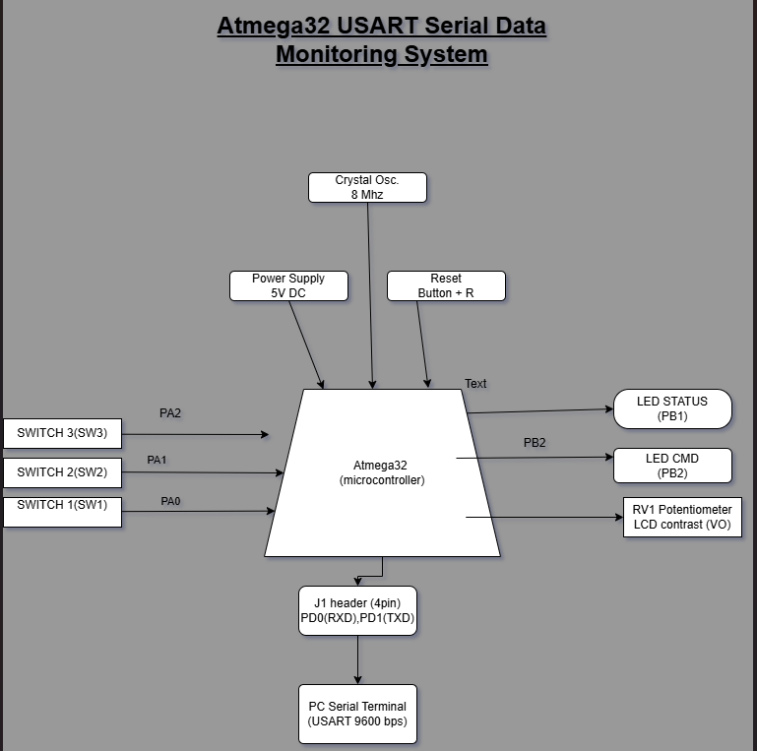
Description of the Block Diagram
The computer communicates with the ATmega32 through the USB-to-Serial converter using asynchronous serial communication. Commands entered through the serial terminal are received by the microcontroller, interpreted by the firmware, and appropriate responses are transmitted back to the terminal.
The LCD provides local display of system messages such as startup notifications and command responses. Push buttons allow user interaction with the microcontroller, while LEDs provide visual indication of system operation.

2.2 System Pin Mapping
The following table shows the hardware connections between the ATmega32 and external devices.
Component | Pin | Connected To
LCD RS | PC0 | Register Select
LCD RW | GND | Write Only
LCD EN | PC2 | Enable
LCD D4 | PC3 | LCD Data
LCD D5 | PC4 | LCD Data
LCD D6 | PC5 | LCD Data
LCD D7 | PC6 | LCD Data
USART RX | PD0 | USB Serial TX
USART TX | PD1 | USB Serial RX
SW1 | PA0 | Push Button
SW2 | PA1 | Push Button
SW3 | PA2 | Push Button
LED1 | PB1 | Status LED
LED2 | PB2 | Command LED

Explain that these connections were selected to simplify firmware development while minimizing the number of microcontroller pins required by the LCD through the use of 4-bit communication.

CHAPTER THREE

3. Hardware Implementation

3.1 Schematic Design
The schematic was developed using KiCad and represents the electrical connections of the entire system. The design includes the ATmega32 microcontroller, crystal oscillator, reset circuit, LCD module, LEDs, push buttons, USB-to-Serial interface, and power supply connections.
Special attention was given to ensuring correct power distribution, proper decoupling, and reliable clock generation through the external 8 MHz crystal oscillator.

Figure 3.1 Complete KiCad Schematic
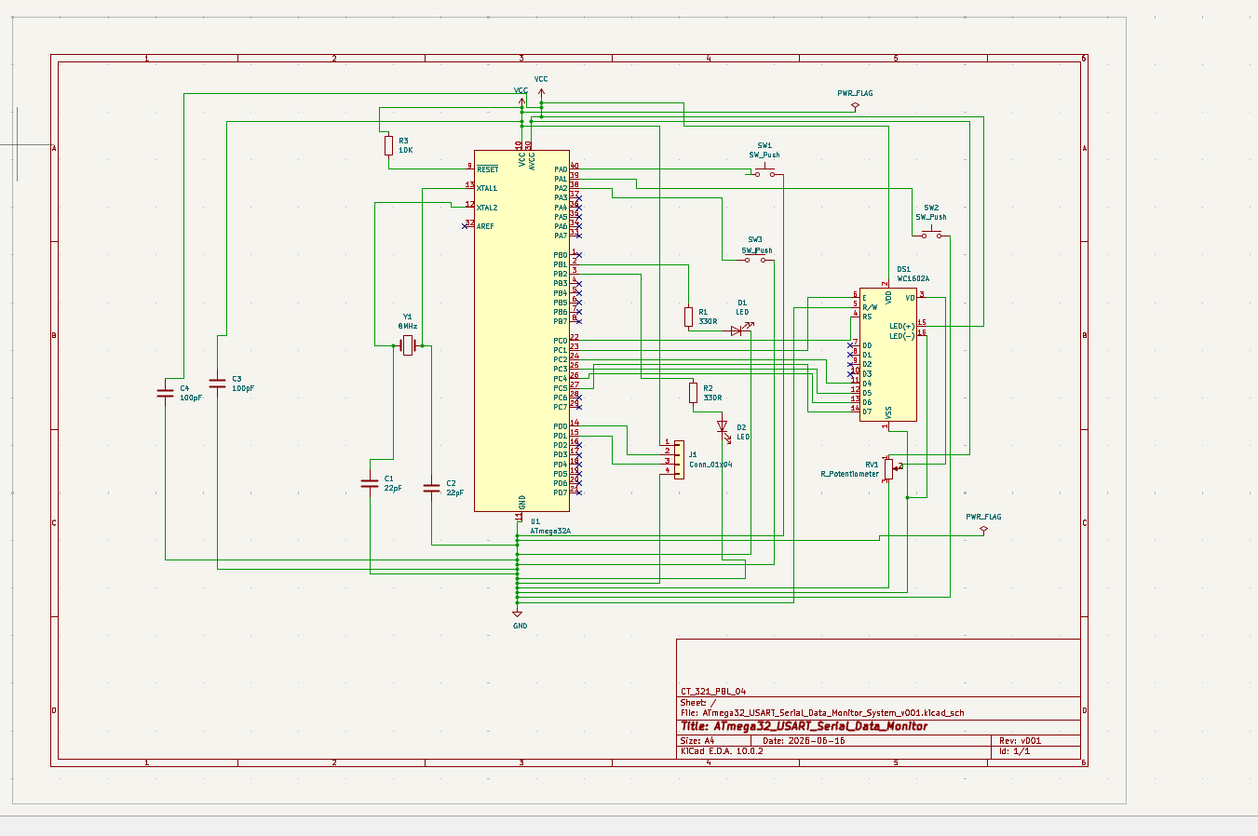
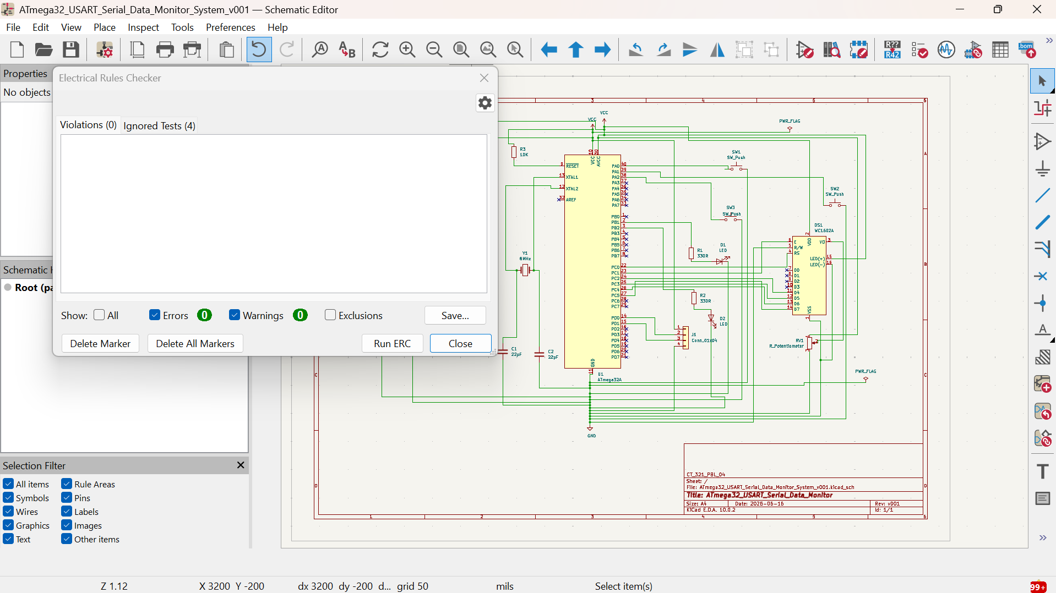

3.2 PCB Layout
After verifying the schematic using the Electrical Rules Checker (ERC), footprints were assigned to all components and the PCB was generated using KiCad PCB Editor.
Component placement was performed to reduce routing complexity while maintaining good electrical practices. Signal traces were routed to minimize crossings and improve maintainability. Design Rule Check (DRC) was performed to ensure that there were no clearance or connectivity errors before finalizing the PCB.

Figure 3.2 PCB Layout
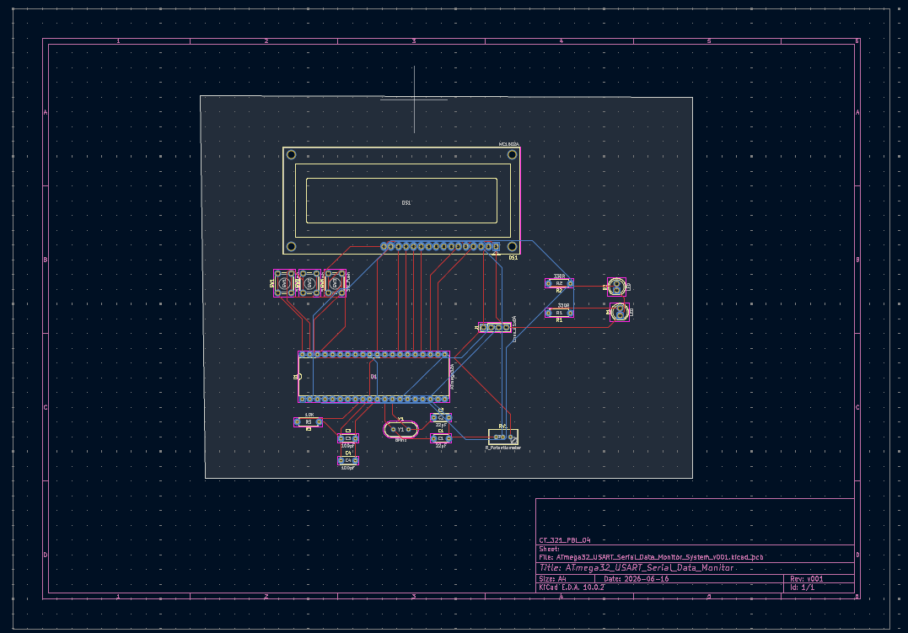

3.3 PCB 3D View
The three-dimensional view of the PCB was generated to verify component placement, orientation, and mechanical appearance before fabrication.

Figure 3.3 PCB 3D View
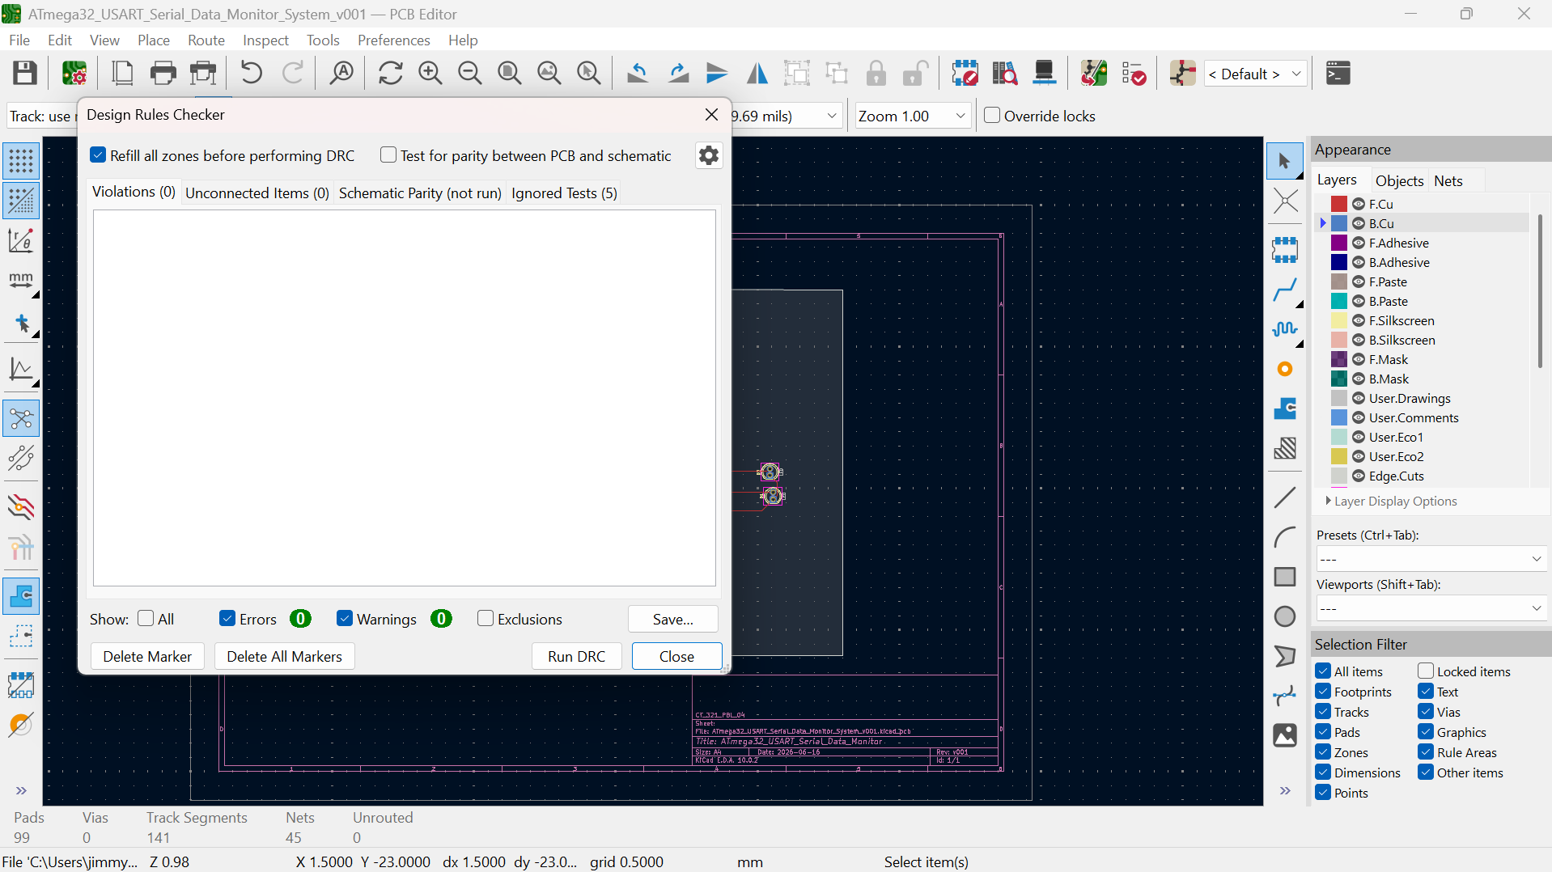
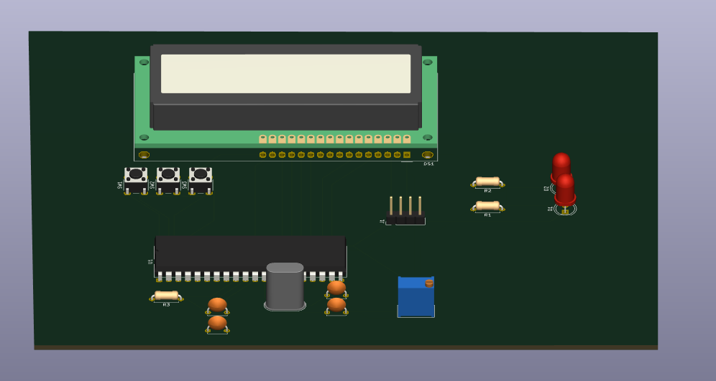z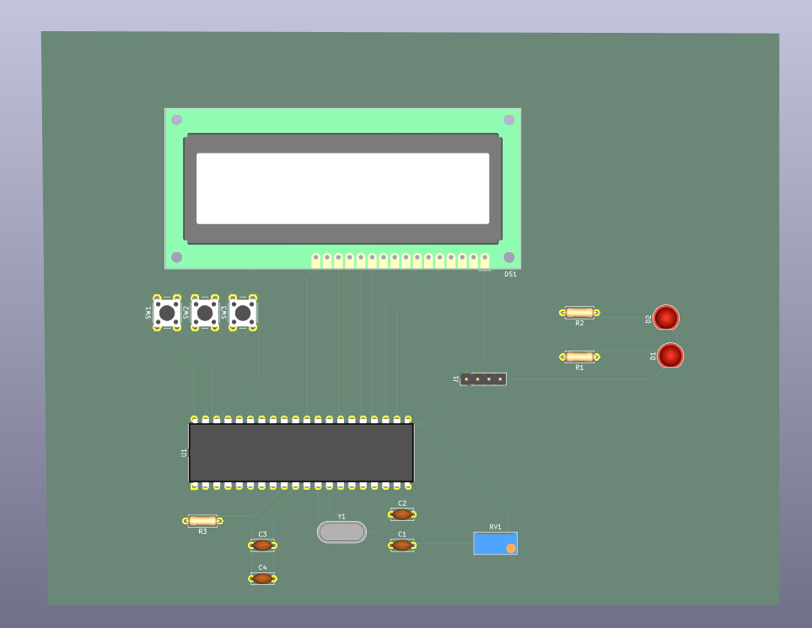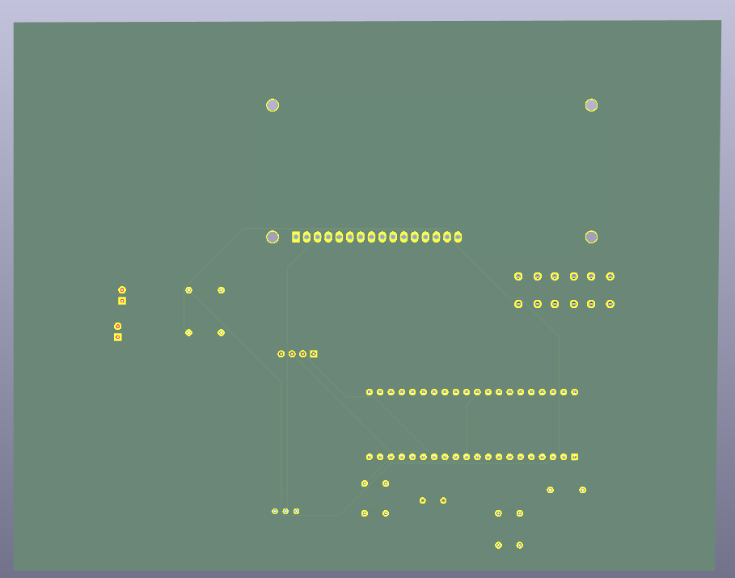

CHAPTER FOUR

4. Software Implementation
The firmware was developed in C using MPLAB XC8 within Visual Studio Code. To improve readability and simplify maintenance, the software was divided into separate modules based on functionality.
include/
usart.h
lcd.h
commands.h

src/
main.c
usart.c
lcd.c
commands.c
Each source file performs a specific task, making the project modular and easier to debug.

4.1 Main Program
The main.c file initializes all hardware peripherals before entering an infinite execution loop. During initialization, the USART module, LCD module, and other required peripherals are configured. The LCD displays a startup message indicating that the system is ready.
Inside the main loop, the firmware continuously waits for characters received through the USART. Once a complete command is entered, the command interpreter processes it and sends the appropriate response back to both the serial terminal and the LCD.

Figure 4.1 Main Program Flowchart
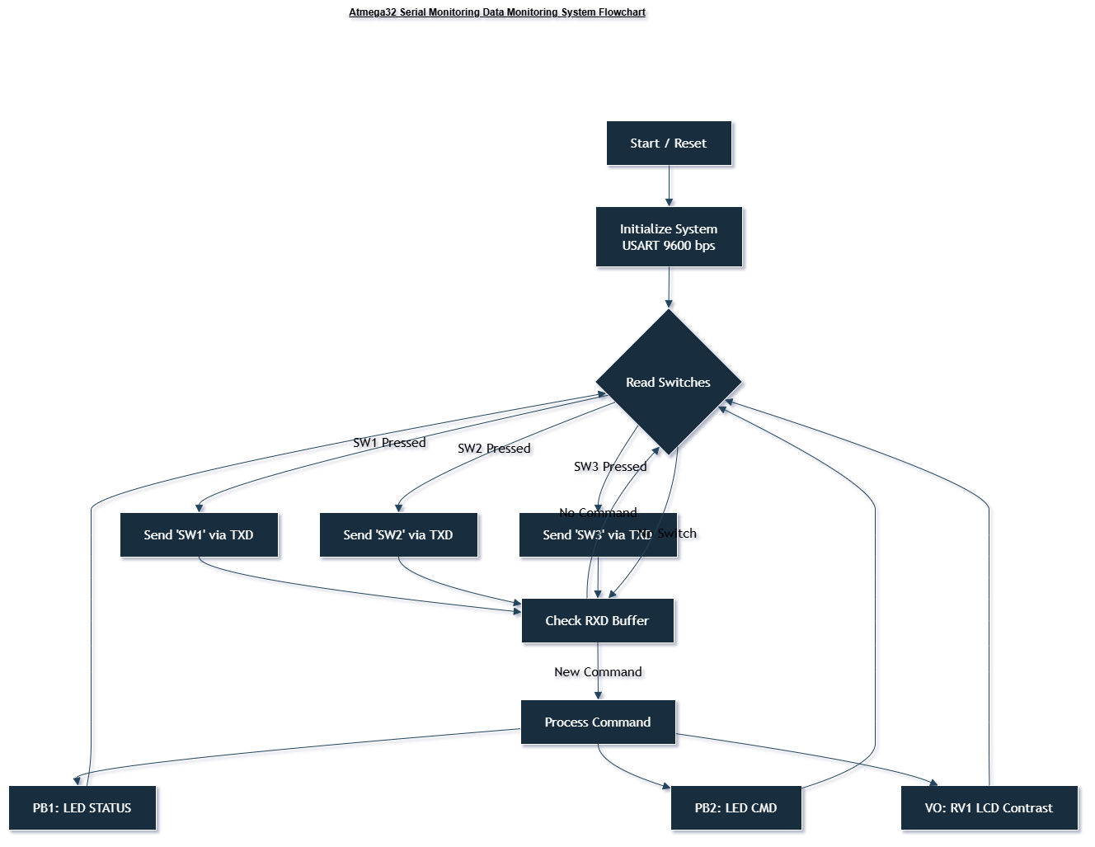

4.2 USART Driver
The USART driver provides all functions required for serial communication.
The implemented functions include:
- USART_Init() – Configures the baud rate and communication parameters.
- USART_SendChar() – Sends a single character.
- USART_SendString() – Sends an entire string.
- USART_ReceiveChar() – Receives one character from the serial terminal.
The USART is configured to operate at 9600 baud, 8 data bits, 1 stop bit, and no parity (8N1).

4.3 LCD Driver
A complete LCD driver was developed to operate the HD44780 LCD in 4-bit mode.
The driver performs:
- LCD initialization
- Command transmission
- Character transmission
- String printing
- Cursor positioning
- Screen clearing
Using 4-bit communication reduces the number of GPIO pins required from eleven to seven.

4.4 Command Processing
The command processing module interprets user commands received through the USART interface. Three commands are currently implemented:
- HELLO – Displays a greeting message.
- STATUS – Displays current system information.
- INVALID COMMAND – Returned whenever an unrecognized command is entered.
This modular approach allows additional commands to be added in future versions with minimal modification to the existing firmware.

CHAPTER FIVE

5. LCD Integration
One of the major enhancements introduced during the project was the addition of a 16×2 HD44780 LCD module. The LCD provides immediate visual feedback directly from the embedded system, reducing dependence on the serial terminal for monitoring system status.
The LCD operates in 4-bit mode using six control and data lines connected to Port C of the ATmega32. During system startup, the LCD displays "USART READY" followed by "Monitoring...", indicating that initialization has completed successfully.
When commands are processed, the LCD updates its display to reflect the current operating state of the system.

Figure 5.1 LCD Startup Screen
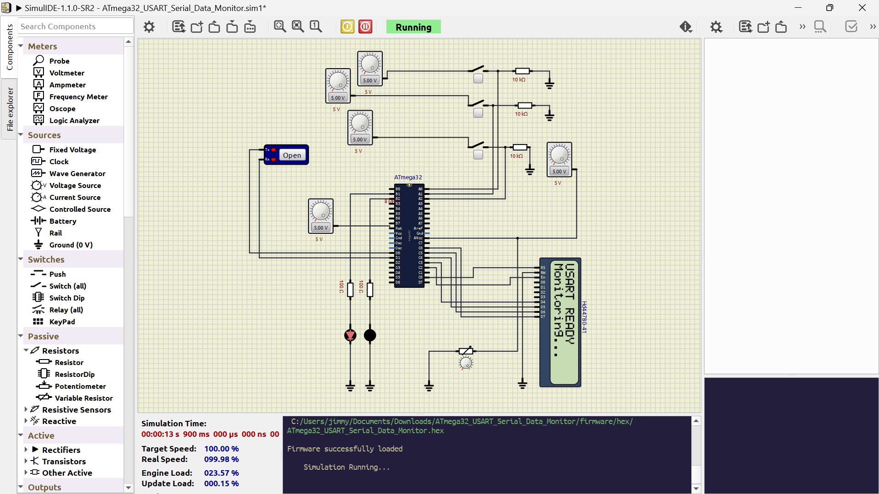

CHAPTER SIX

6. Simulation and Testing
Simulation was carried out using SimulIDE to verify the operation of the complete embedded system before physical implementation.
Testing confirmed correct:
- LCD initialization
- USART transmission
- USART reception
- Command processing
- LCD message display
- LED operation
The simulation environment greatly simplified debugging by allowing real-time observation of signal behavior and firmware execution.

Figure 6.1 HELLO Command
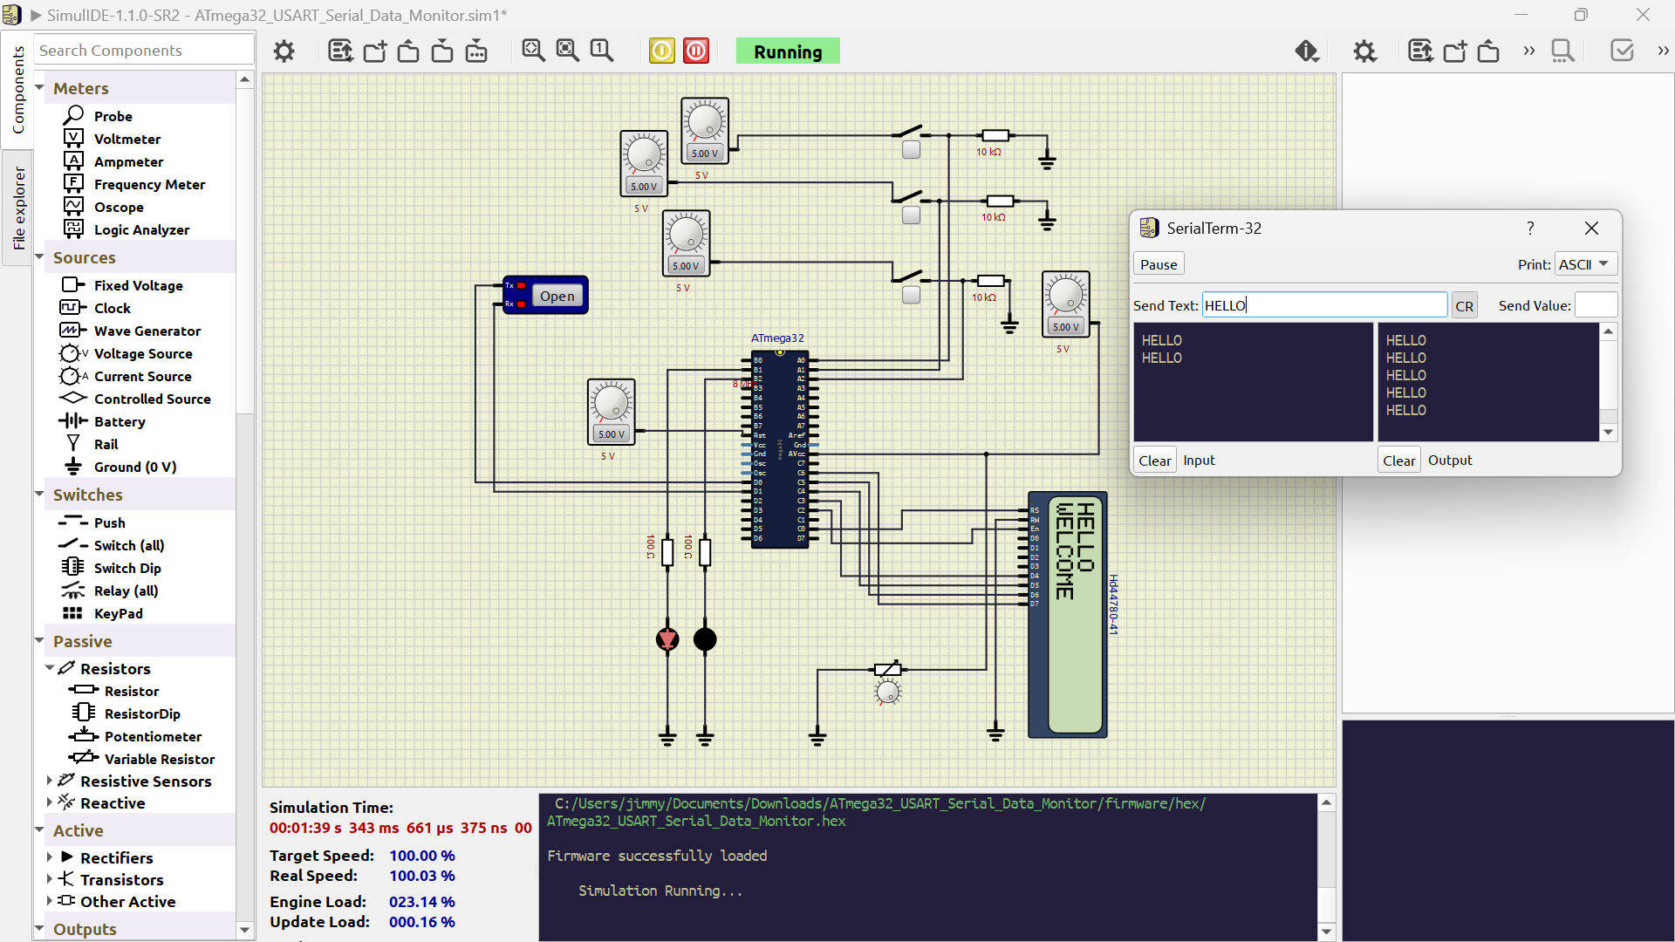

Figure 6.2 STATUS Command
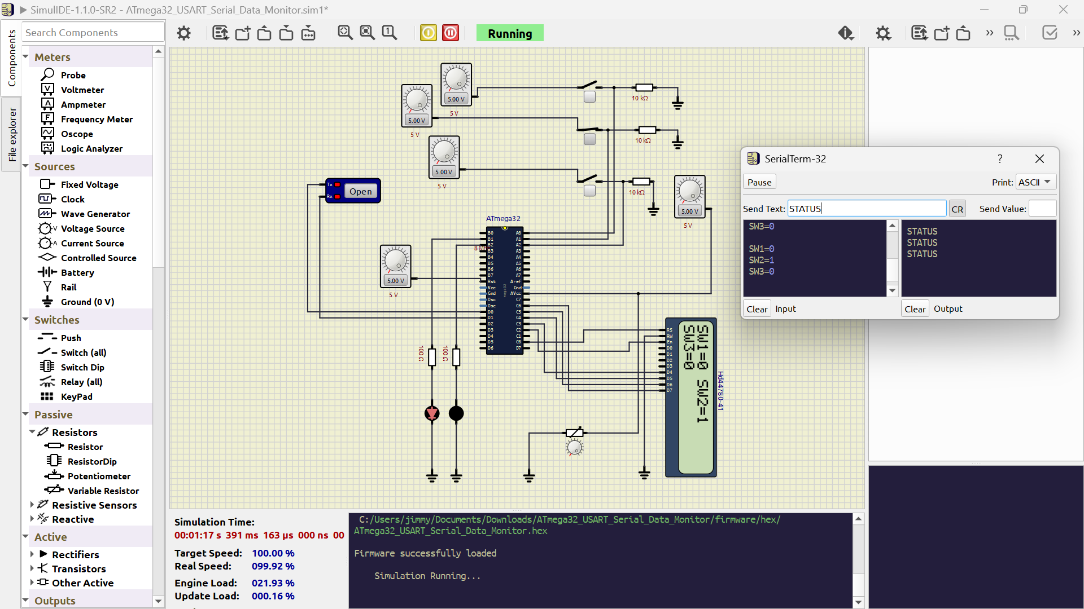

Figure 6.3INVALID COMMAND
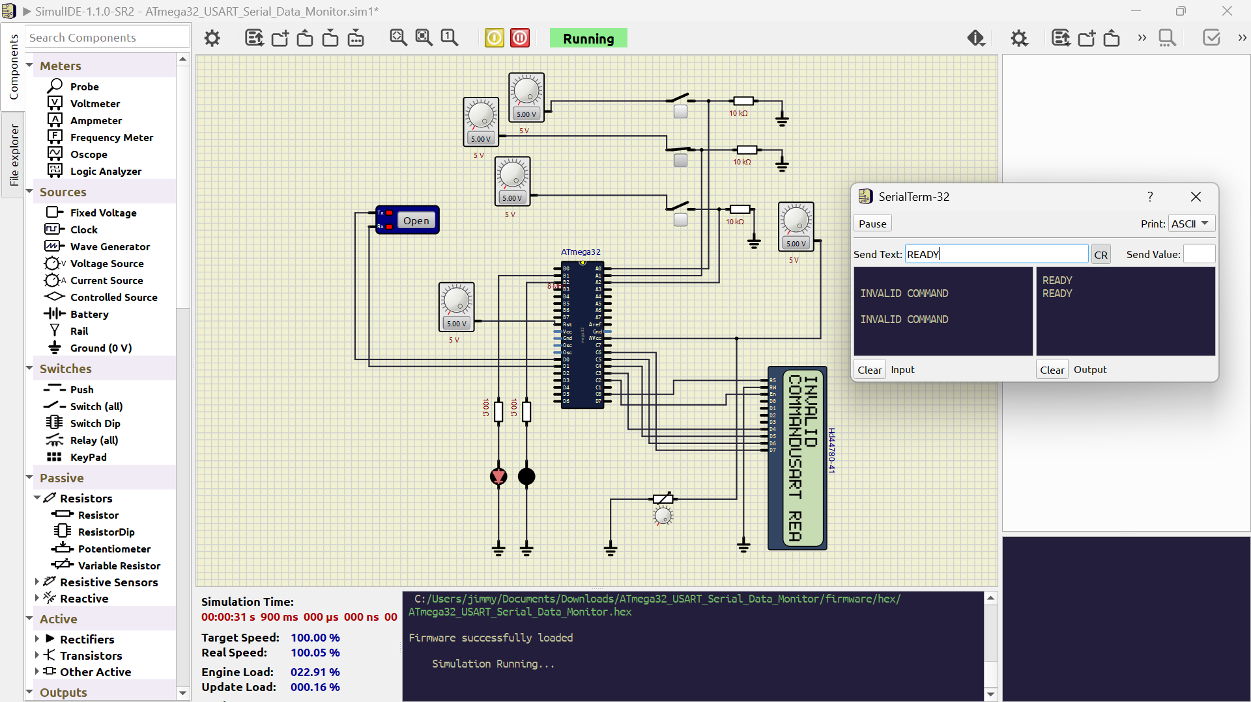

CHAPTER SEVEN

7. Challenges Encountered
Describe each issue in a short subsection, for example:
- LCD initialization sequence and timing.
- Incorrect LCD pin mapping.
- Missing first character during string display.
- XC8 compiler configuration issues.
- MPLAB include-path and IntelliSense configuration.
- SimulIDE wiring corrections.
- PCB ERC and DRC errors and their resolution.
For each challenge, explain the cause, the troubleshooting process, and the implemented solution.

CHAPTER EIGHT

8. Results and Discussion
The implemented system successfully achieved the project objectives. The USART interface reliably transmitted and received serial data at 9600 bps, while the LCD displayed startup messages and system feedback in real time. Commands such as HELLO and STATUS were processed correctly, and invalid commands were appropriately detected and reported.
The schematic and PCB designs passed KiCad's Electrical Rules Check (ERC) and Design Rules Check (DRC), confirming the correctness of the hardware design. Simulation in SimulIDE further validated the interaction between the firmware and hardware components before deployment.
The addition of the LCD significantly enhanced the usability of the system by providing immediate local feedback without requiring continuous observation of the serial terminal.

CHAPTER NINE

9. Conclusion
The project successfully demonstrates the design and implementation of an ATmega32 USART-Based Serial Data Monitoring System. The system reliably performs asynchronous serial communication, processes user commands, and provides both terminal-based and LCD-based feedback. Through the integration of a 16×2 HD44780 LCD, the project extends the original specification by improving user interaction and system observability. The modular hardware and software architecture also provides a solid foundation for future enhancements, such as additional commands, sensor interfacing, EEPROM data storage, or wireless communication modules.

REFERENCES
Microchip Technology Inc. ATmega32 Datasheet.
Microchip Technology Inc. AVR Instruction Set Manual.
Hitachi. HD44780U LCD Controller/Driver Datasheet.
Microchip Technology Inc. MPLAB XC8 C Compiler User's Guide.
KiCad Documentation.
SimulIDE Documentation.

