Program: Review-Comments Stats (RCS)

Review-Comments Stats (RCS) is a program that gets stats for a Word file’s review-comments.

Example program-use:
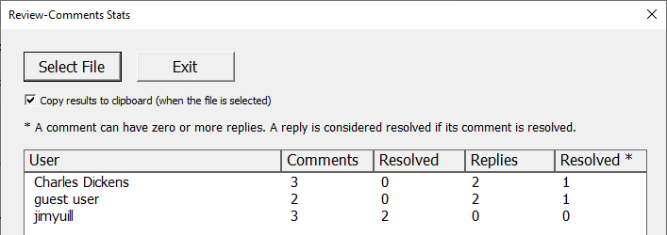

- How to install the program:
  - Download the present Word file. It contains the program.
  - Antivirus software may prevent the Word file from being downloaded or opened, or prevent the file’s program from running. How to fix this depends on your antivirus program
  - In Windows, unblock the downloaded file:
    - https://support.microsoft.com/en-gb/topic/a-potentially-dangerous-macro-has-been-blocked-0952faa0-37e7-4316-b61d-5b5ed6024216
  - Open Word and enable the file’s macros:
    - https://support.microsoft.com/en-us/office/enable-or-disable-macros-in-microsoft-365-files-12b036fd-d140-4e74-b45e-16fed1a7e5c6
  - If you update Word’s Trust Center settings, it may be necessary to close all instances of Word, and re-open the document.

- How to run the program:
  - Open the present Word file
  - Ensure Print Layout is enabled (click on: View : Print Layout).
  - Click on the button above (“Click to Run...”).
  - The program window will open (shown above).
  - To save output to the clipboard, click on “Copy results to clipboard”.
  - To specify the Word file to process, click on “Select File”.

- Trouble-shooting:
  - If two identical buttons are visible, click on View : Print Layout.
  - When RCS is run, a temporary Word file is created, and its name starts with "~RCS_temp_". After RCS runs, if the file is not deleted, the file can be deleted manually.
  - Additional info on enabling macros in Word files:
    - https://learn.microsoft.com/en-us/DeployOffice/security/internet-macros-blocked
    - https://www.microsoft.com/security/blog/2016/03/22/new-feature-in-office-2016-can-block-macros-and-help-prevent-infection/

- Program safety and reliability:
The program is a Word “macro”, which is included in the present Word doc. The program is written in Word VBA.
The program’s source-code can be viewed via:
- Press Alt+F11.
- Double click on rcs_UserForm, as shown below
- Click on View : Code

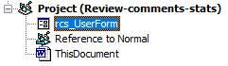

In developing the program, steps were taken to ensure the code is safe and reliable:
- The selected Word file is not altered nor opened in write-mode.
- For the selected Word file, a temporary copy is made. The copy is used to get the review-comment stats.
- The program's code is commented, tested, and open-source.
- The program checks for input and output errors, e.g., in copying the input Word-doc
- The program is compatible with Windows 10's AMSI system, which monitors VBA code for safe operation.

MIT License, Copyright (c) 2023-present Jim Yuill
https://jimyuill.com/
https://github.com/jimyuill

