**WordWebNav Demo Document**

This document is distributed in the WordWebNav (WWN) repo. Its purposes are:

* Demonstrate the features of WWN web-pages, using typical Word-document formatting
* Provide a regression test for WWN's program create_web_page.py

This document was created using:

* Word 16 ( version 2105)
* Word's default Normal.dotm

**The headings, below, are for testing WWN's table-of-contents processing, for the navigation pane.**

All 9 heading-levels are used, and they should appear in WWN's document-navigation pane.

The Latin-looking text was auto-generated by Word, using the lorem() function  
(<http://wordfaqs.ssbarnhill.com/DummyText.htm>).

# Heading, level 1-1

Lorem ipsum dolor sit amet, consectetuer adipiscing elit. Maecenas porttitor congue massa. Fusce posuere, magna sed pulvinar ultricies, purus lectus malesuada libero, sit amet commodo magna eros quis urna. Nunc viverra imperdiet enim.

Fusce est. Vivamus a tellus. Pellentesque habitant morbi tristique senectus et netus et malesuada fames ac turpis egestas. Proin pharetra nonummy pede.

Mauris et orci. Aenean nec lorem. In porttitor. Donec laoreet nonummy augue.

# Heading, level 1-2

Lorem ipsum dolor sit amet, consectetuer adipiscing elit.

## Heading, level 2-1

Lorem ipsum dolor sit amet, consectetuer adipiscing elit. Maecenas porttitor congue massa. Fusce posuere, magna sed pulvinar ultricies, purus lectus malesuada libero, sit amet commodo magna eros quis urna.

### Heading, level 3-1

Lorem ipsum dolor sit amet, consectetuer adipiscing elit. Maecenas porttitor congue massa. Fusce posuere, magna sed pulvinar ultricies, purus lectus malesuada libero, sit amet commodo magna eros quis urna.

#### Heading, level 4-1

Lorem ipsum dolor sit amet, consectetuer adipiscing elit. Maecenas porttitor congue massa. Fusce posuere, magna sed pulvinar ultricies, purus lectus malesuada libero, sit amet commodo magna eros quis urna.

##### Heading, level 5-1

Lorem ipsum dolor sit amet, consectetuer adipiscing elit. Maecenas porttitor congue massa. Fusce posuere, magna sed pulvinar ultricies, purus lectus malesuada libero, sit amet commodo magna eros quis urna.

###### Heading, level 6-1

Lorem ipsum dolor sit amet, consectetuer adipiscing elit. Maecenas porttitor congue massa. Fusce posuere, magna sed pulvinar ultricies, purus lectus malesuada libero, sit amet commodo magna eros quis urna.

Heading, level 7-1

Lorem ipsum dolor sit amet, consectetuer adipiscing elit. Maecenas porttitor congue massa. Fusce posuere, magna sed pulvinar ultricies, purus lectus malesuada libero, sit amet commodo magna eros quis urna.

Heading, level 8-1

Lorem ipsum dolor sit amet, consectetuer adipiscing elit. Maecenas porttitor congue massa. Fusce posuere, magna sed pulvinar ultricies, purus lectus malesuada libero, sit amet commodo magna eros quis urna.

Heading, level 9-1

Lorem ipsum dolor sit amet, consectetuer adipiscing elit. Maecenas porttitor congue massa. Fusce posuere, magna sed pulvinar ultricies, purus lectus malesuada libero, sit amet commodo magna eros quis urna.

# Heading, level 1-3

**This section tests single-level lists**

* First
* Second
* Third
* Fourth

1. First
2. Second
3. Third
4. Fourth

**This section tests multi-level lists**

* Level 1-1
  + Level 2-1
    - Level 3-1
      * Level 4-1
        + Level 5-1

Level 6-1

Level 7-1

Level 8-1

Level 9-1

Level 9-2

Level 8-2

Level 7-2

Level 6-2

* + - * + Level 5-2
      * Level 4-2
    - Level 3-2
  + Level 2-2
* Level 1-2

1. Level 1-1
   1. Level 2-1
      1. Level 3-1
         1. Level 4-1
            1. Level 5-1

Level 6-1

Level 7-1

Level 8-1

Level 9-1

Level 9-2

Level 8-2

Level 7-2

Level 6-2

* + - * 1. Level 5-2
      1. Level 4-2
    1. Level 3-2
  1. Level 2-2

1. Level 1-2

# Heading, level 1-4

**This section tests:**

* WWN's fix for a bug in Word's HTML, in which paragraph-text is incorrectly made white, when it should be black. One configuration in which the bug often occurs is with a paragraph immediately after a table.
* Proper formatting of a table
* Formatting of an image pasted into the document

The table was created using these options:

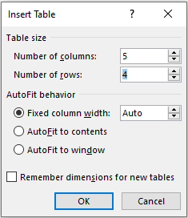

|  |  |  |  |  |
| --- | --- | --- | --- | --- |
| **Heading** | **Heading** | **Heading** | **Heading** | **Heading** |
| 1, 1 | 1, 2 | 1, 3 | 1, 4 | 1, 5 |
| 2, 1 | 2, 2 | 2, 3 | 2, 4 | 2, 5 |
| 3, 1 | 3, 2 | 3, 2 | 3, 3 | 3, 4 |

<Start> first paragraph just after the table. Testing WWN's Word-HTML bug fix. <End>

<Start> second paragraph just after the table. <End>

<Start> third paragraph just after the table. <End>

# Heading, level 1-5

**This section tests the generated web-page's horizontal scrolling**

Lorem ipsum dolor sit amet, consectetuer adipiscing elit. Maecenas porttitor congue massa. Fusce posuere, magna sed pulvinar ultricies, purus lectus malesuada libero, sit amet commodo magna eros quis urna. Nunc viverra imperdiet enim. Fusce est. Vivamus a tellus. Pellentesque habitant morbi tristique senectus et netus et malesuada fames ac turpis egestas. Proin pharetra nonummy pede. Mauris et orci. Aenean nec lorem. In porttitor. Donec laoreet nonummy augue. Suspendisse dui purus, scelerisque at, vulputate vitae, pretium mattis, nunc. Mauris eget neque at sem venenatis eleifend. Ut nonummy. Fusce aliquet pede non pede. Suspendisse dapibus lorem pellentesque magna. Integer nulla. Donec blandit feugiat ligula. Donec hendrerit, felis et imperdiet euismod, purus ipsum pretium metus, in lacinia nulla nisl eget sapien.

## Heading, level 2-1: This heading is long, to verify the web-page's table-of-contents pane scrolls correctly

This section has a wide image, and it extends beyond the Word document's margins.

The image is not copyrighted, and is from: <https://unsplash.com/photos/J7D2hjgPR2s>

The image links to a photo in the same directory as the present document: included-photo.jpg

<https://superuser.com/questions/38870/in-microsoft-word-how-can-i-link-to-an-image-from-the-web-which-updates>

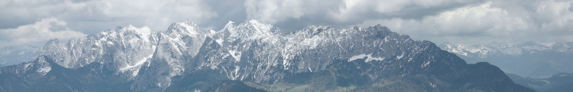

# Heading, level 1-6

**This section tests standard text formatting:**

**A bold paragraph.**

An underlined paragraph

*An italics paragraph.*

~~A struck paragraph.~~

A highlighted paragraph.

# Heading, level 1-7

**This section tests references within the document.**

This is a cross-reference to another section: Heading, level 1-1

This is an inserted table-of-contents. The options used are:

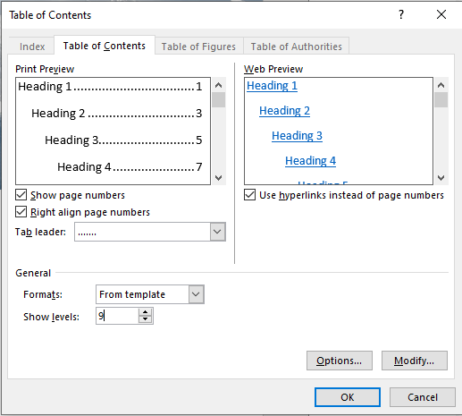

Table-of-contents inserted here

<paragraph before table-of-contents>

Heading, level 1-1 1

Heading, level 1-2 1

Heading, level 2-1 1

Heading, level 3-1 1

Heading, level 4-1 1

Heading, level 5-1 1

Heading, level 6-1 1

Heading, level 7-1 1

Heading, level 8-1 1

Heading, level 9-1 1

Heading, level 1-3 1

Heading, level 1-4 3

Heading, level 1-5 3

Heading, level 2-1: This heading is long, to verify the web-page's table-of-contents pane scrolls correctly 4

Heading, level 1-6 4

Heading, level 1-7 4

<paragraph after table-of-contents>