To start the study:

1. Open PsychoPy Coder 
2. Plug in Pupil Core eye tracker and open Pupil Capture 
3. Calibrate Pupil Core by pressing ‘C’ once or by clicking the C button on the left hand side.`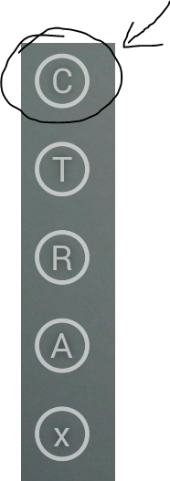
4. Open the UniformityIllusion.py file using the Coder’s open file function. Then, run the experiment in PsychoPy Runner by clicking the green “Run” button.

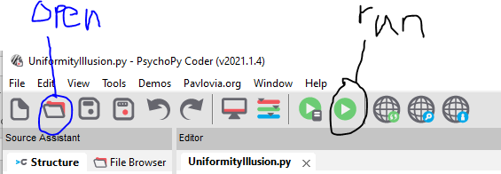

1. The experiment should now run. Make sure that the participant is looking at the screen.
2. PsychoPy data will be saved to the data folder in PsychoPyUniformityIllusion. Pupil data is currently saved to C:\Users\hesselmann\recordings.



1. Open Pupil Player 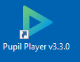
2. View the recording by dragging a recording folder into Pupil Player, as shown in the image below.

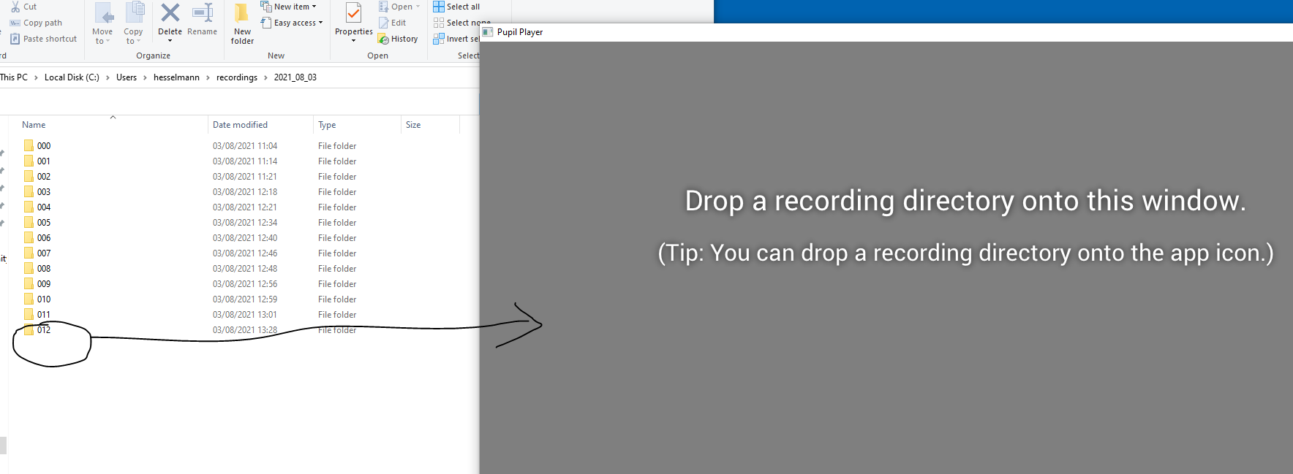

1. Export the data as excel files by clicking the down arrow. This will save the exported excel files to an ‘exports’ folder in the recording folder.

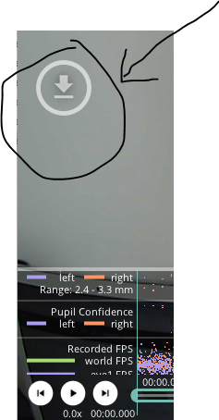

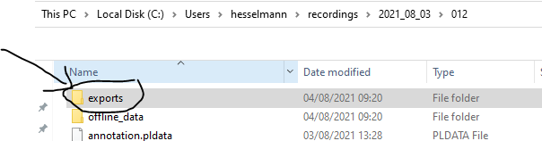

1. Refer to <https://docs.pupil-labs.com/core/software/pupil-player/#raw-data-exporter> for a detailed description of how the data is saved.