Wildfire Risk in NC Peatlands and the Effect of Restoration on Burned Area
Jim Zhang
The Nature Conservancy (TNC)
September 2026

Introduction
This project compared the credibility of several satellite fire products in assessing the occurrence, burn severity, and burned area of fires in North Carolina (NC) peatlands (Fig. 1). It then examined whether peatland restoration (via rewetting) reduced burned area in 6 restored NC peatland sites (Fig. 2) compared to ecologically similar non-rewetted areas.
However, the small number of restoration sites and their relatively recent restoration years precluded conclusive claims about the impact of peatland restoration on burned area.
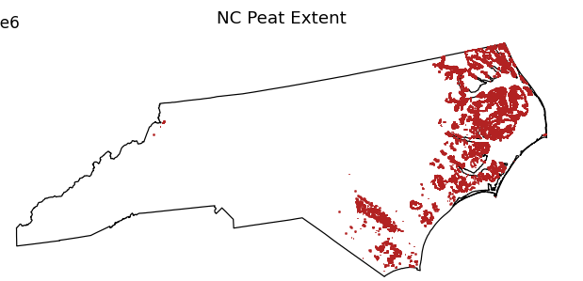
Figure 1. NC peat extent in red, defined as >80% major-component histosol gSSURGO pixels.

Figure 2. The six completed TNC restoration sites, each marked with a red star and labelled with its completion year.
Site | Completed | Burned pixel-years, pre | Burned pixel-years, post
Dare Bombing Range WMP | 2019 | 357 | 124
ARNWR Restoration East | 2019 | 38 | 2
ARNWR WMP | 2019 | 2 | 0
PLNWR Flood Resilience | 2021 | 12 | 0
GDSNWR Pasquotank Headwaters | 2023 | 0 | 0
Angola Bay Restoration Area | 2026 | 0 | 0
Table 1. Restoration sites and their burned pixel-years. Only two sites record any post-restoration fire, and 124 of the 126 post-restoration burned pixel-years are at one site.

Methods

Preprocessing

North Carolina Mask
Raw data was clipped to North Carolina, based on the bounds from https://www2.census.gov/geo/tiger/GENZ2018/shp/cb_2018_us_state_500k.zip, and saved as processed data.

North Carolina Peatland Mask
Analyses were conducted within North Carolina peatland extent, defined as pixels with at least 80% major-component histosol in gSSURGO (Fig. 1).
Shared Analysis Grid
All layers (e.g., fire products, reference fire perimeters, treatment polygons, covariates) were reprojected onto a shared EPSG:5070 grid at 500m for equal comparison. In binary layers (i.e., burned area), any subcell having a value of 1 (i.e., burned) lit up the whole cell. Continuous covariate layers (e.g., elevation) were warped onto the shared grid using an area-weighted average (e.g., GLO30_DEM has 30m resolution, and a single 500 m grid pixel thus takes the average of the GLO30_DEM pixels within its extent). Categorical covariate layers (e.g., land cover) were warped onto the shared grid using the majority class of their pixels within a single shared grid pixel.
Treated and Control Pixel Definition
TNC restoration sites were read from Box/Database/Peat Restoration/NC_Pocosin_Restoration_Sites_2026/ NC_Pocosin_Restoration_Sites_2026.shp. Sites with an end year of zero were defined as incomplete while sites with a non-zero end year were defined as completed. The end year was used as the restoration year.
Treated pixels were defined as those within completed site polygons following their respective restoration years. Control pixels were drawn both from the population of peat pixels outside any completed site polygon, and from pixels within completed sites prior to their respective restoration years.
Climate Covariates
Climate variables were derived from GHCN daily station records rather than from rasters. Growing degree days were built two ways from the same records: a long-run station normal over a 1991-2020 baseline, and one value per station per calendar year. scPDSI was built per year only because it is a self-calibrating index whose normal is near zero. All climate covariates were interpolated onto the shared grid by inverse-distance weighting from the nearest stations, with weights proportional to the inverse squared distance in EPSG:5070 meters. The normals (e.g., GDD normal) are static and were used for matching treated and control pixels in both models.

Comparison Against Reference Datasets
Fire products were scored against independent reference perimeters (NIFC IFPH and GeoMAC for large fires, restricted to incidents of >100 acres; TNC Coastal Plain fire history for small preserve and prescribed burns). Each reference event (indexed i= 1… n) was rasterized onto the same 500m, EPSG:5070 grid as the fire products, with any perimeter overlap lighting a cell, then compared against the product’s burned mask for that event’s own year within a 5 km buffered window around the event’s perimeter. All counts below are grid cells, not acres. Comparison scores were derived from the following values:
- tp_{i} = cells inside the reference perimeter that the product flagged as burned.
- fn_{i} = cells inside the reference perimeter that the product did not flag.
- fp_{i} = cells the product flagged as burned inside the 5 km window but outside the reference perimeter.
Two comparison scores were computed for each event:
$${Recall}_{i}=\frac{{tp}_{i}}{{tp}_{i}+{fn}_{i}}$$
$${Precision}_{i}=\frac{{tp}_{i}}{{tp}_{i}+{fp}_{i}}$$
Recall is the primary metric used to compare fire products, since a ground-truth reference fire is known to have occurred inside the perimeter and thus false negatives are unambiguously failures of the product to detect a reference fire. Precision is also reported, but not weighed as strongly for comparisons, because the reference datasets do not contain all fires in their respective areas, so a product burn outside a perimeter might be a real fire the reference didn’t record rather than a false alarm; and a perimeter is an outer boundary containing unburned area as well, so it overestimates the true burned area within the perimeter, increasing the false positive rate and falsely decreasing the precision.
To compare the suitability of products for detecting both large and small fires, two recall scores were computed.
$${Recall}_{pooled}=\frac{\sum_{i=1}^{n}{{tp}_{i}}}{\sum_{i=1}^{n}{\left({tp}_{i}+{fn}_{i}\right)}}$$
$${Recall}_{mean event}=\frac{1}{n}\sum_{i=1}^{n}{\frac{{tp}_{i}}{{tp}_{i}+{fn}_{i}}}$$
Pooled recall is dominated by large fires while mean event recall counts each fire once regardless of size, detecting the omission of small fires.
$$Detection rate=\frac{1}{n}\sum_{i=1}^{n}{1\left({tp}_{i}>0\right)}$$
Detection rate is the fraction of fire events the product caught at all (i.e., had any detected pixel within the fire perimeter). It’s the only meaningful metric for VIIRS, which detects fire counts rather than burned area.
$${Precision}_{mean event}=\frac{1}{\left|D\right|}\sum_{i∈D}{\frac{{tp}_{i}}{{tp}_{i}+{fp}_{i}}}$$
Mean event precision is averaged over D, the set of events where the product flagged at least one cell inside the 5 km buffered window, since precision is undefined for the rest.
Severity products were not scored against the references, because fire perimeters carry no severity information.

Logistic regression model
Restored (treated) pixels were first matched with unrestored (control) pixels before fitting. This was done via 1:1 nearest-neighbor matching of treated and control pixels using minimum Mahalanobis distance across continuously varying covariates (i.e., elevation, histosol percentage, GDD normal, soil organic matter, available water capacity, soil site index and Height Above Nearest Drainage), and via exact matching across categorical covariates (i.e., land cover and soil drainage class). Each control was used at most once, and treated pixels with no control pixel within one standard deviation in Mahalanobis space were dropped. This produced 1,189 matched pairs.
Each matched pixel contributes one row per year of the MCD64A1 record (2001-2026), giving 61,750 pixel-years with a binary burned response and MCD64A1 coverage. Annual burn probability was modeled with a logistic regression on treatment status (whether a pixel was treated), that year’s scPDSI, plus continuously varying covariates (i.e., elevation, GDD normal, soil organic matter, available water capacity, soil site index and Height Above Nearest Drainage; histosol percentage was held out because it was near constant across pixels). Standard errors were clustered on the restoration site (six clusters, with each matched control inheriting its treated pixel’s site), and each term was tested with a two-sided Wald z test against these clustered standard errors. Odds ratios are reported per standard deviation for each covariate, and for treated relative to control pixels for treatment status.

Difference-in-differences (DiD) model
The Callaway and Sant’Anna staggered DiD model estimates the average treatment effect on the treated (ATT): the change in annual burn probability at restored pixels after restoration, relative to the change over the same years at their matched control pixels, aggregated across restoration cohorts (Callaway & Sant’Anna, 2021; Castro et al., 2026). This model assumes parallel trends between treated and control pixels in the absence of treatment, conditional on the matched covariates. If the ATT differs systematically from zero in the pre-treatment period, however, then this assumption likely does not hold.
This model also matched treated and control pixels, but by finding the most similar control pixel to each treated pixel based on the minimum Mahalanobis distance of a propensity and prognostic score (Castro et al., 2026) estimated from both continuously varying covariates (i.e., elevation, histosol percentage, GDD normal, soil organic matter, available water capacity, soil site index and Height Above Nearest Drainage) and categorical covariates (i.e., land cover and soil drainage class), with additional exact matching across categorical covariates. The propensity score matches pixels based on the probability of being treated in a given treatment year conditional on covariates, while the prognostic score matches pixels based on their baseline fire risk absent treatment conditional on covariates. Each control was used at most once within a cohort, though different cohorts could reuse the same control pixels, and treated pixels with no control pixel within one standard deviation in Mahalanobis space were dropped. This produced 1,227 matched pairs across four cohorts and six sites.
Group-time average treatment effects were estimated using the doubly robust estimator of Callaway and Sant’Anna (2021) and aggregated into an overall ATT and an event study by time since restoration whose pre-treatment periods serve as the parallel-trends check. Standard errors were clustered on the restoration site using a multiplier bootstrap with simultaneous confidence bands.

Results

Fire Product Comparisons
Prior to any analysis, a fire occurrence product and several burned area and severity products were considered for characterizing wildfire risk in North Carolina Peatlands (see the Fire Product Comparison and Recommendation Notes tabs in fire_product_comparison.xlsx for details). Based on spatial resolution, temporal coverage, and detection of small fires, the most suitable datasets for assessing fire occurrence, burned area, and burn severity were determined to be VIIRS Active Fire, GABAM, and SE FireMap, respectively.
However, upon inspecting the burn severity data overlaid over North Carolina (Fig. 3), it was determined that the burn severity products were too sparse over North Carolina peatlands and none of these products were considered in further analyses.
Figure 3. Burn severity products over North Carolina for 2017. a, MTBS. b, SE FireMap. c, MOSEV.
The fire occurrence and burned area products were then compared with ground truth reference datasets over North Carolina peatlands (Fig. 4; see Methods) to determine which products were the most accurate in the study area. Pooled recall on NIFC IFPH was comparably high for FireCCI51 (0.740), MCD64A1 (0.773) and FireCCIS311 (0.724), suggesting these products are suitable for detecting large fires. However, pooled recall on TNC Coastal Plain was only reasonably high for FireCCIS311 (0.520), suggesting this is the only product that is suitable for detecting both large and small fires. VIIRS behaves as expected of a fire occurrence product, with high detection rates but low recall.
Figure 4. Comparison of burned area products against ground truth reference datasets. a, GeoMAC, fires ≥ 100 acres. b, NIFC IFPH, fires ≥ 100 acres. c, TNC Coastal Plain fire history.
Based on these accuracy results, the FireCCIS311 burned area product was initially chosen for modeling. However, because this product only began in 2019, it lacked pre-treatment data for the 3 completed restoration sites that began in 2019, and so the MODIS MCD64A1 product, which began in 2000, was used for modeling instead. The below results are reported using the MODIS MCD64A1 product.

Impact of Restoration on Burned Area
Next, the impact of restoration on burned area was assessed using a logistic regression model and a difference-in-differences (DiD) model (Callaway & Sant’Anna, 2021; Castro et al., 2026).

Logistic Regression
The logistic regression model produced no significant effect of treatment on burned area (OR 1.48, 95% CI [0.49, 4.50], p = 0.48). The only covariates that significantly affected burned area were elevation (OR 0.17 per standard deviation, 95% CI [0.04, 0.67], p = 0.01) and pdsi (OR 0.67, 95% CI [0.48, 0.94], p = 0.02), with drier years and lower-lying pixels burning more.
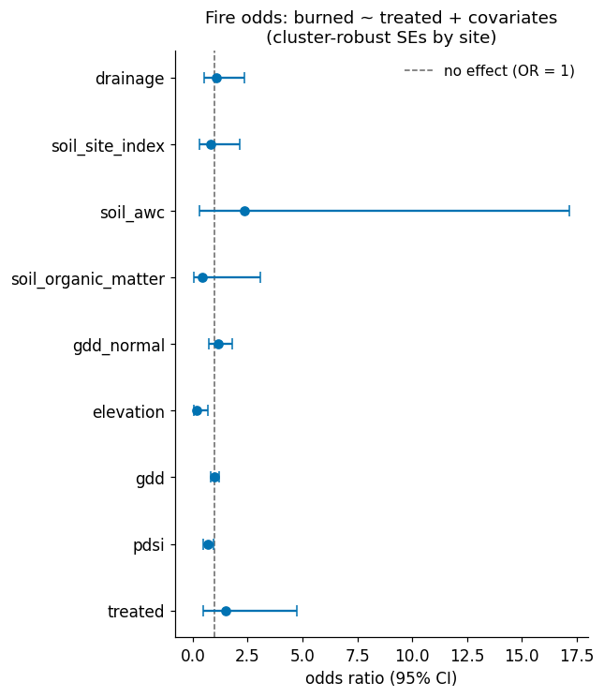
Figure 5. Odds ratios with 95% confidence intervals from the matched logistic model, with standard errors clustered by restoration site.

Difference-in-differences
The DiD model results are inconclusive because the assumption of parallel burned area trends between treated and matched control pixels prior to restoration appears not to hold (Figs. 6,7). The ATT in the pre-treatment period should remain near zero assuming parallel trends, but it swings from 0.088 to -0.094 to -0.064 from eight to seven to three years before restoration.
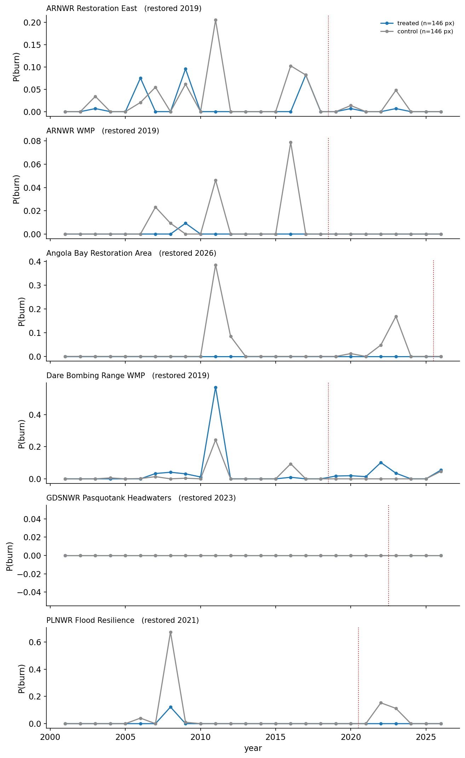
Figure 6. Burn rate by site for treated pixels versus their matched controls. Each panel is one restoration site; P(burn) is the fraction of that group’s pixels burning in that year, and the dotted red line marks the site’s restoration year. Pixels inside a restoration site are plotted as treated in every year, including years before restoration. Note that the y-axis scale differs between panels.
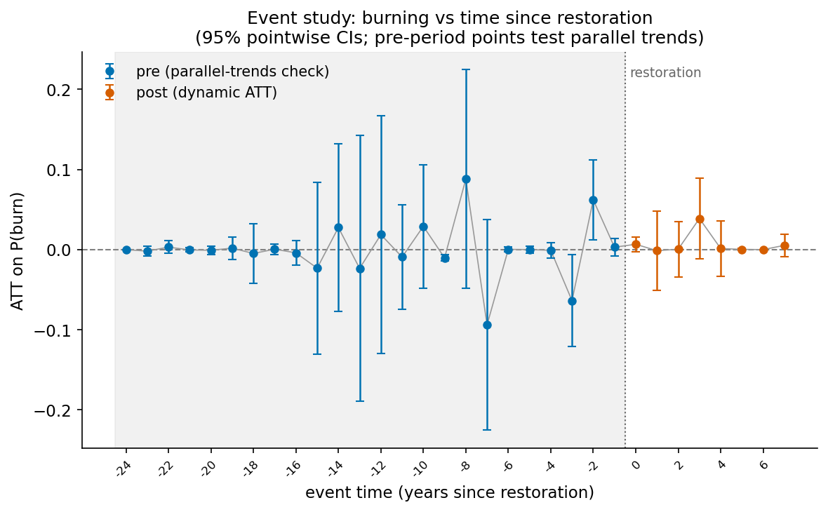
Figure 7. Matched DiD results with 95% confidence intervals. ATT = average treatment effect on the treated. Blue points left of the restoration line are pre-treatment and serve as the parallel-trends check; orange points to the right of it are the treatment effect.

Next Steps
Next steps
- Get hydrological site data from eric that can split each restoration site into 5 or 6 pieces?
- Use planned, but not yet completed, restoration sites as the candidate control pool rather than all of NC peatlands
  - This might improve the parallel trends assumption
- Fire return interval might be reduced? This is the time between consecutive fires
  - Though this would require a pixel be burned twice, which is highly unlikely..

Figure plan
- Raw burn rate for matched and control pixels – don’t need any figures for matching itself I think or the covariates; just describe the matching procedure in the methods and say what covariates I matched on
  - Put this in for modis – fix the spacing between year labels on the x axis first though.
  - A is raw burn rate by event time, B is raw burn rate by calendar year.
- Put figure for logistic regression results
  - Say this was a first pass attempt at modeling the impact of treatment on burned area, given covariates.
- Put figure for DiD modeling results
  - Put in the site-level clustered SE results, rather than the pixel level. Caveat that this is inconclusive because of the low number of site-years in the dataset.
- Oh maybe put in the raw burn rate for pdsi and gdd by year.

- Factors best predicting fire – maybe encapsulate this under “impact of restoration on burned area” (and/or make that term more general)
  - Uh definitely not treatment. Check the covariate plots for these results. Or might need to get the coefficients from the logistic regression instead of the DiD model, which I don’t think outputs how much each individual covariate contributes to the propensity and prognostic scores.

ReferencesCallaway, B., & Sant’Anna, P. H. C. (2021). Difference-in-Differences with multiple time periods. Journal of Econometrics, 225(2), 200–230. https://doi.org/10.1016/j.jeconom.2020.12.001
Castro, M., Ritonga, R., Masuda, Y., Asyhari, A., Novita, N., Gangga, A., Erbaugh, J., Cheptoo, G., Yeo, S., & Leavitt, S. (2026). Effective restoration can avoid peatland fires: Large scale counterfactual assessment in Kalimantan, Indonesia. iScience, 29(6), 116041. https://doi.org/10.1016/j.isci.2026.116041

Cat email-
- Could you add some more notes in your PPT or write up a quick Word document outlining: 1) what you’ve done to date; 2) detailing what decisions you made (e.g., which products you suggest and why); 3) explaining which factors best predict fire; and 4) your suggestions on next steps if you had more time?
- Also, one thing I was curious about, in your final model, do you have PDSI and GDD and not any other temperature or precipitation metrics? If so, that’s perfect, if you have PDSI, GDD, Tmax, Tmin, Precip, or any combination of those, can you remove the other temperature and precipitation predictors and just keep PDSI and GDD? I’d be curious about those model outputs especially. If you don’t have time to do that, could you provide your R code?

