**WANG RUIJUN**



***PROFESSIONAL SUMMARY***

Dynamic and motivated professional with a proven record of generating and building relationships, managing projects from concept to completion, designing educational strategies, and coaching individuals to success.

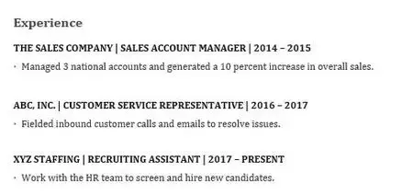***WORK HISTORY***

***SKILLS***

* Executive team leadership
* Multimillion pound
* management expertise for South East region
* Client/vendor relations
* Marketing/product line development
* Staff/training policy development
* effective presentations, and developing opportunities that further establish organizational goals.

***EDUCATION***

XIAMEN UNIVERSITY MALAYSIA

Bandar Kota Warisan, Sepang, Selangor

Bachelor of Engineering in Computer Science and Technology (Honours) GPA3.8