## Final Exam – PROG1815 Programming Concepts II

Please read the following instructions carefully before beginning the exam

1. ~~The Final Exam upload folder on eConestoga is available on April 29~~~~th~~ ~~from 1:00 PM until 3:45 PM EDT~~
   1. ~~Submissions will not be accepted after that time, including email.~~
   2. ~~Zip and upload your solution periodically, and plan to finish with several minutes to spare.~~
      * ~~Your latest submission will be marked~~
      * ~~If you attempt to upload in the last few minutes and are unsuccessful, you will appreciate the fact you paused to zip and upload 15 minutes ago.~~
2. ~~Using Visual Studio, create a windows project called XXFinalExam, where XX are your initials.~~

## Overview

You are working on a form to record vaccination information, which is saved to file through an encapsulated class.

~~Do not create a global collection such as an Array, a List, a ListBox or even a String to store multiple records in memory or on the GUI.~~ ~~These will be deleted and converted to local variables before marking.~~

### Vaccination Class

~~Create a separate class file called~~ ***~~Vaccination~~***~~. Methods are instance methods unless stated otherwise.~~

1. Properties:
   1. ~~VaccinationId – Int32~~, unique, ~~greater than zero.~~
   2. ~~PatientName – String,~~ ~~required,~~ ~~at least 2 words~~, ~~each at least 2 letters~~, ~~could include other characters~~
   3. ~~Contact – String~~, ~~required~~, must be either an email or ~~a phone number (pattern 123-123-1234)~~
   4. ~~AppointmentDate – DateTime~~, ~~displayed 2021-04-29,~~ ~~must be in future for an Add~~
   5. ~~AppointmentTime – DateTime~~, ~~displayed 08:10 AM,~~ ~~must be between 8:00 AM and 9:00 PM~~
   6. ~~FollowupRequired – Boolean~~, ~~default true~~.
   7. ~~FollowupDate – DateTime~~, ~~displayed 2021-05-27~~
   8. ~~FollowupTime – DateTime, displayed 08:10 AM~~
2. ~~Class-level Get methods suggested~~: ~~GetVaccinationRecord~~s, ~~GetVaccinationRecordById~~, ~~GetUniqueVaccinationId~~
3. Save method:
   1. ~~Calls the object’s Edit method~~
   2. ~~If FollowupRequired is true:~~
      1. Sets the FollowupDate to the same day of the week, 4 weeks after the AppointmentDate.
      2. ~~Sets the FollowupTime to be the same as the AppointmentTime.~~
   3. ~~If VaccinationId is not on file, call the object’s Add method.~~
   4. ~~If VaccinationId is on file, call the object’s Update method.~~
4. ~~Add method (private):~~
   1. ~~Adds the Vaccination object to file.~~
   2. ~~Throws any exception encountered back to the caller, with a lead-in identifying the action attempted.~~
5. ~~Update method (private):~~
   1. ~~Replaces the record having the same VaccinationId~~ ~~with this update object.~~
   2. ~~Throws any exception encountered back to the caller, with a lead-in identifying the action attempted.~~
6. ~~Edit method:~~ 
   1. ~~Verifies the criteria mentioned in the properties~~.
   2. ~~All error messages are thrown at once in an exception, one field per message,~~ ~~delineated so as to display one message per line.~~
7. ~~ToString override method~~
   1. ~~Returns the Vaccination object’s properties in a single delimited string.~~
8. ~~Class-level Parse method~~
   1. ~~Takes a string (a record from file), creates a Vaccination object and populates it from the string.~~
9. ~~Class-level CheckFile method suggested, to confirm or create the output file, if missing (“vaccination.txt” in the current directory).~~

### VaccinationSchedule Form

1. ~~Create the following form with your name in the caption, as shown.~~
   1. ~~The display area at the bottom is a RichTextBox or a DataGridView, your choice. If using a RichTextBox, I suggest using a Courier font … just say’n.~~

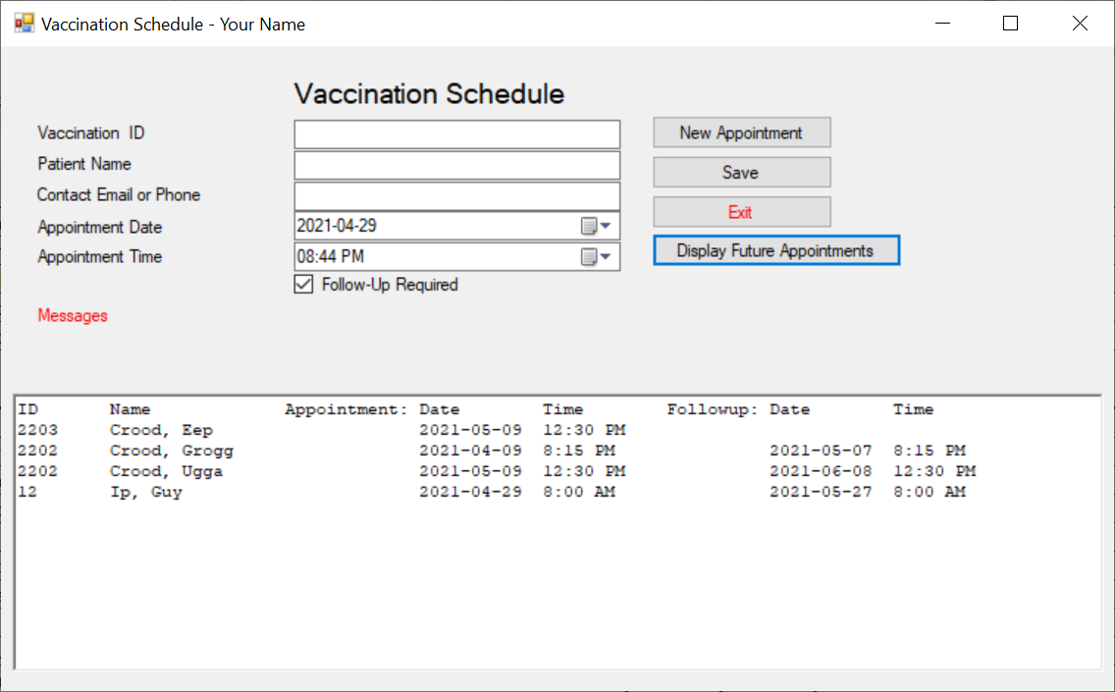

1. ~~New Appointment button:~~
   1. ~~Clear the input controls~~ ~~and use the class’ GetUniqueVaccinationId to pre-load the VaccinationId.~~
2. ~~Save button~~ 
   1. ~~Create an object of the Vaccination class and populate its properties from the input fields.~~
   2. ~~Pass the object to its Save method.~~
   3. ~~Catch and display any exceptions in a message label or the display area.~~
3. ~~Exit button:~~
   1. ~~Closes the form~~
4. Display Future Appointments button:
   1. ~~Fetch all Vaccination records from file, ordered by PatientName~~.
   2. ~~Display each Vaccination object with an AppointmentDate or FollowupDate (see Grogg) for today or later, as shown:~~
      1. ~~Align each field under the appropriate heading~~
      2. ~~Dates & Times formatted as shown~~
      3. Only show the FollowupDate & Time if FollowupRequired is true