## Programming Concepts II – In-class 4

~~There is a plagiarism checker called MOSS that teachers can use to determine if students copied from each other, or if a student copied parts from multiple other students. One problem is that some Visual Studio projects like ASP.NET have upwards of 400 files. The other problem is that while the student’s name is on their download folder, the file you want to examine does not have their name on it.~~

You are to create a program that looks into a folder where there is a sub-folder for each student (with their name on it). Your code is to pick a student subfolder, record its filename, then drill down through the multiple layers of sub-sub-sub folders looking for a filename that matches a given wildcard expression. Once you find the file, you are to replace append the student’s subfolder’s name to the filename, and write the file to a separate folder. Repeat the process for each student subfolder.

~~There is a zip file on the course site with an initial project and another zip file with sample student uploads. The person that started this project decided to go to a cottage for a month, without WiFi. The project so far requests the starting folder, then creates a list of all the student folder names.~~

Double-click the List Files button and write the code to extract a file from each student’s subfolder, by pattern, to a separate folder, with the student’s name appended to the filename.

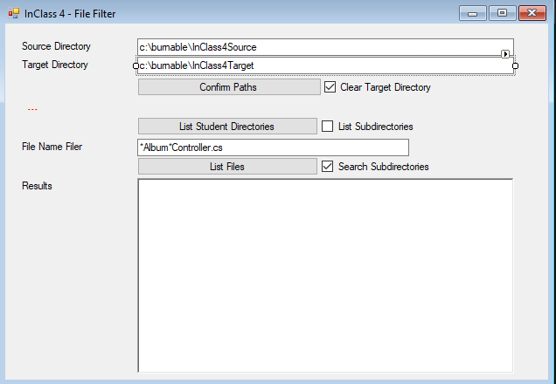

When I find move it to target file and as moving cut the file name (student name should be in front of the file name)

