## In-Class 2 – Alarm Clock

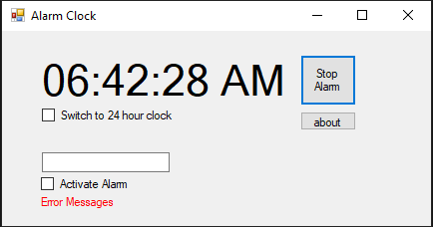

~~This is the design of the alarm clock. The (sample) text in the time label and in the alarm time~~ **~~textbox~~** ~~are just to see what they’ll look like when the clock is running – when created it must always show the current time.~~

~~Double-click the form to create a Form Load method. Load the current time into the time label … hour, minute second, AM/PM.~~

~~You might also save the form’s background colour into~~ a global System.Drawing.Color variable … ~~just say’n.~~

~~From the~~ *~~Component~~* ~~category in the toolbox, add a clock timer~~ ~~and an alarm timer~~. ~~Have each issue a~~ *~~Tick~~* ~~event once a second. The clock timer is always active~~. ~~When it issues a~~ *~~tick~~* ~~event, update the clock display and,~~ if *Alarm Activate* is checked, check the alarm time.

~~when “switch to 24 hour clock” is checked - display the clock in 24 hour format (0-24 example 1PM=13) - the AM/PM must not be shown.~~

The alarm timer is initially inactive. When the displayed time equals the alarm time and Alarm Active is checked, activate the alarm timer. Every time it issues a tick event, play a sound … you may wish to alternate the clock face from red to green & back on each tick.

When *Stop Alarm* is clicked or the *Alarm Active* checkbox is unchecked, de-activate the alarm timer and reset the background colour (if you were changing that too)

~~To play a sound:~~

~~System.Media.SoundPlayer player = new System.Media.SoundPlayer();~~

~~player.SoundLocation = @"c:\windows\media\Windows Logoff Sound.wav";~~

~~player.Play();~~

Marking:

1 – current time is displayed & stays current

2 – alarm sounds if alarm time equals clock time and Alarm Active is checked.

3 – alarm stops sounding when *Stop Alarm* is clicked