**Assignment 2**

**~~Important Notes:~~**

* ~~This is an individual assignment.~~
* ~~I will be checking for borrowed or copied assignments. All work is to be done from scratch, you may not use any templates or other assistances.~~
* ~~An in-class demo is required for full marks.~~
* ~~This assessment is out of 20 marks total.~~

# ~~Tasks:~~

~~In this assignment, you are to develop a web application for an online store. The type of store that you design, and its products and inventory is left to your discretion.~~

1. ~~HTML Static Content - Web Form~~
   * ~~The front end must collect~~ **~~all~~** ~~the information needed to ship the purchased items to the customer. I have included a few in the wireframe which are mandatory and must be included in your form.~~ **~~(2 marks)~~**
   * ~~At least 3 products should be available for purchase. The application’s business logic must handle the products correctly.~~ **~~(2 marks)~~**
2. JavaScript - Form Validation
   * ~~All JavaScript code must be located in an external script file.~~ **~~(1 mark)~~**
   * The following user inputs must be validated:
     + - 6 Mandatory fields **(2 marks)**
       - 2 fields using regular expression **(2 marks)**
       - ~~At least one product should be bought and the value input in the product input boxes should be a number.~~ **~~Do not use input type number in HTML.~~****~~(2 marks~~)**
   * ~~If any errors exist, display a compound message that includes all the error messages. Do not use a JavaScript popup box for this purpose.~~ **~~(1 mark)~~**
   * ~~Generate a receipt to give to the customer, including all the shipping documentation.~~ **~~(2 marks)~~**
   * ~~Calculate and include sales tax for~~ **~~each~~** ~~province/territory in Canada.~~ **~~(2 marks)~~**
   * ~~As part of your receipt, calculate and include the shipping cost based on the delivery time selected by the user.~~ **~~(2 marks)~~**
     + ~~Add $40.00 if the delivery time selected is 1 day~~
     + ~~Add $30.00 if the delivery time selected is 2 days~~
     + ~~Add $20.00 if the delivery time selected is 3 days~~
     + ~~Add $10.00 if the delivery time selected is 4 days~~
3. ~~In Class Demo~~ **~~(2 marks)~~**

~~Please refer to the wireframes on the next page to get an idea on what the input/output may look like. You are free to choose the design, fonts and colors as long as you fulfill the minimum requirements mentioned above. You can name your online shop as per your liking and the product names too.~~

# Submissions:

To submit this assignment, place all your work into a single folder. Zip this folder and submit the zipped file to eConestoga. No cover sheet is required for this assignment. A good way to make sure everything is correct, is to unzip the file you are submitting on a different location on your computer and making sure everything works.

Error messages, invoice, -> hidden and none

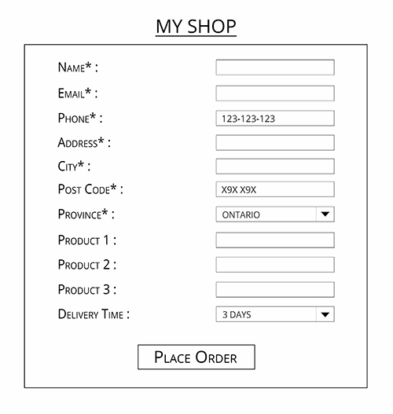

xxx-xxx-xxxx

Enter a number

Enter a number

Enter a number

Place order click -> check -> if required field is missing, show an error messga -> hide main -> show invoice (date, product number is how many -> calculate the total)

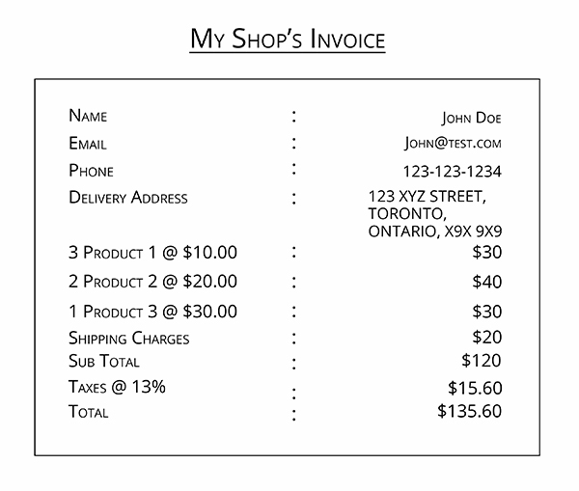

For invoice just make a div and show

