**In-Class Task 3**

# Important Notes:

* This is an individual assignment.
* I will be checking for borrowed or copied assignments. All work is to be done from scratch, you may not use any templates or other assistances.
* An in-class demo is required before the end of the lab period for full marks.
* This assessment is out of 10 marks total.

# Background:

The purpose of this assignment is to provide you hands-on experience programming with repetition structures in JavaScript.

# Tasks:

Create a web page that will display a countdown to a rocket blasting off.

1. HTML Content **(2 mark)**

~~Create a web page that contains a button and an image of a rocket ship (attribute the image source properly).~~

1. ~~When the user presses the button, a countdown should display on-screen.~~ **~~(2 mark)~~**
2. The ~~countdown should begin at 10 and decrement by integer steps of 1.~~ **~~(1 mark)~~**
3. ~~When the countdown reaches 0, the display should output “BLASTOFF!” instead of the number 0. Do not continue the countdown after this point.~~ **~~(2 marks)~~**
4. HTML Static Content - Instructions **(1 mark)**

~~Be sure to explain to the user what your web application is supposed to do. Include details on how to use the application.~~

1. Programming Style and Standards **(2 marks)**

~~It is a good idea to practice conforming to a set of programming standards. Refer to the posted summary of the Programming Standards used by the CP/CPA programs.~~

# Sample Output:

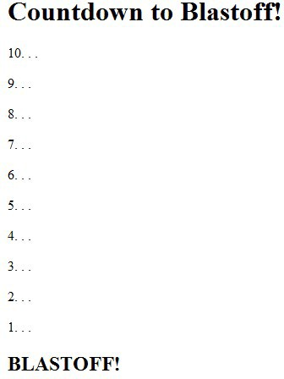

**Enhancements:**

There are no marks for the enhancement but you can try to do the following to improve your JavaScript skills:

* JavaScript - Animation

When the countdown finishes, move the rocket ship image up the page.

# Submissions:

To submit this assignment, place all your work into a single folder. Zip (or RAR) this folder and submit the zipped file to eConestoga. No cover sheet is required for this assignment. A good way to make sure everything is correct; is to unzip the file you are submitting on a different location on your computer and making sure everything works.