**Technical Specification**

* Program Organization

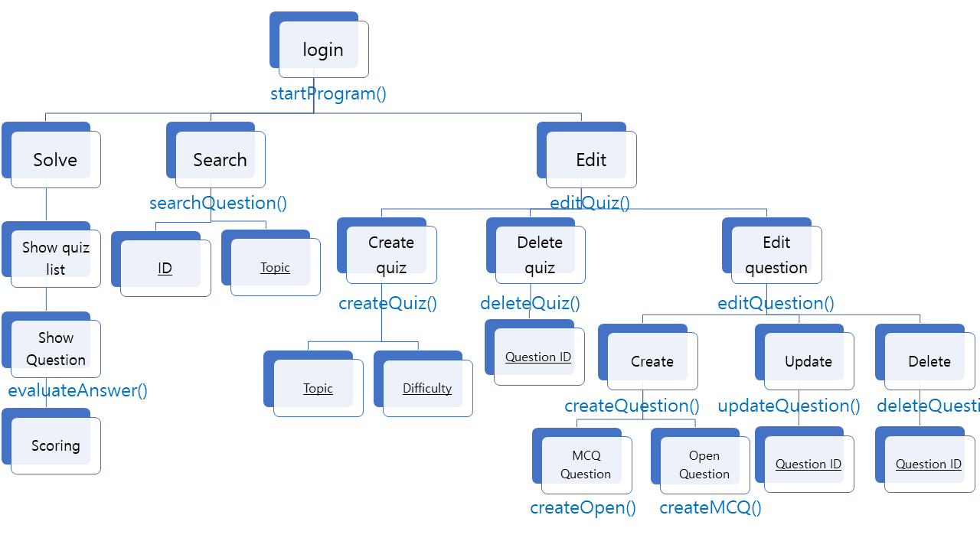

Blue: using method

Underlined: input value

* Database Organization

Underlined: primary key

Blue: foreign key

Bold: table name

Non-bold: attributes

