**User Guide**

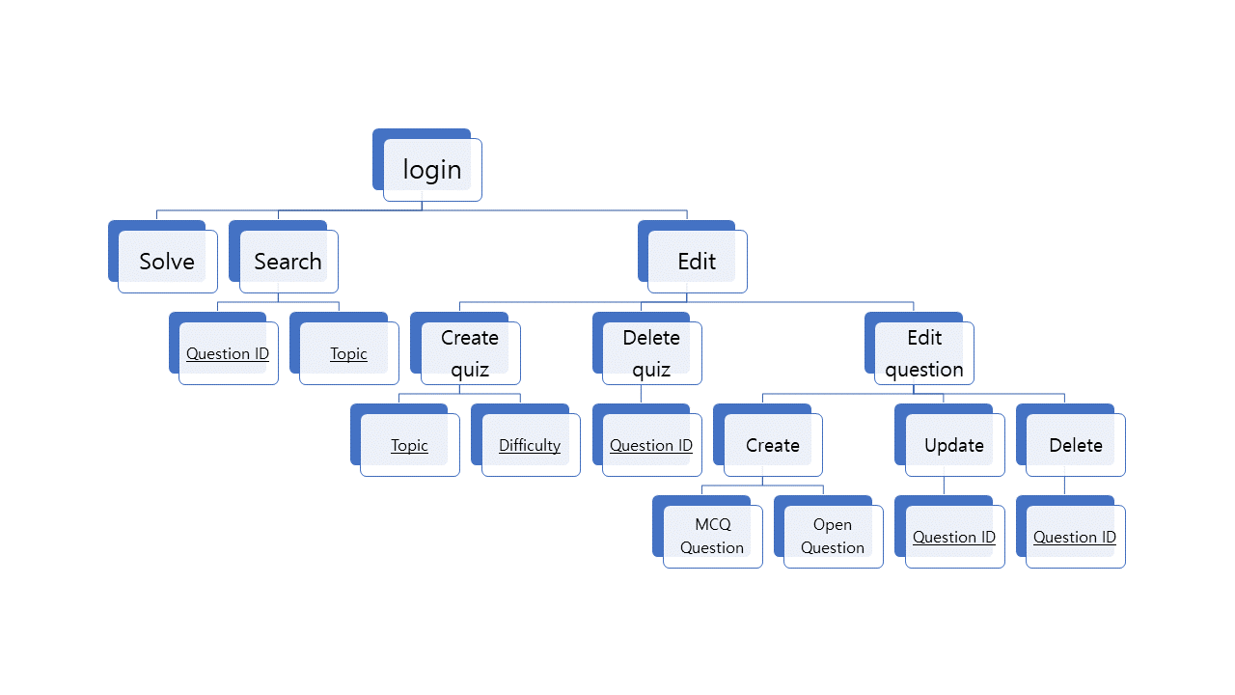

(Lined items are input values)

* Login  
  - Enter the name and ID of user  
  - At first time, you are automatically subscribed to the entered content  
  - From next time, you can get your previous data using name and ID
  + Solve   
    - Show the quiz list you can solve  
    - Select one quiz and solve  
    - MCQs are auto-scored at the end of the program
  + Search  
    - Search question by several type
    - ID  
      - Search question by its unique ID
    - Topic  
      - Search question by its topic
  + Edit  
    - Edit quiz or questions
    - Create quiz  
      - Create new quiz in several methods
      * Topic  
        - Create quiz with questions which have same topics  
        - Enter the quiz name and the topic you want to create the quiz
      * Difficulty   
        - Create a quiz with the specified difficulty  
        - This function will be updated in the future
    - Delete quiz  
      - Delete quiz which have the title you entered
  + Edit question
    - Create
      * MCQ Question  
        - Create MCQ(Multiple Choice Question)  
        - Make question and choices
      * Open Question  
        - Create Open Question  
        - Make question only
    - Update  
      - enter the ID of question you want to update
    - Delete  
      - enter the ID of question you want to delete