# Create a Web API with ASP.NET Core and Visual Studio Code

Reference:

<https://docs.microsoft.com/en-us/aspnet/core/tutorials/web-api-vsc?view=aspnetcore-2.1&viewFallbackFrom=aspn%E2%80%A6>

Summary

1. First install Node.js (8.11.1 or later) and Npm (5.6.0 or later) before installing C# for Visual Studio Code.
2. It is making slow in the action, “The *TodoApi* folder opens in Visual Studio Code (VS Code). Select the *Startup.cs* file.” in the section “[Create the project](https://docs.microsoft.com/en-us/aspnet/core/tutorials/web-api-vsc?view=aspnetcore-2.1#create-the-project)”.

*Installing c# dependencies...*

*Platform: win32, x86_64*

*Downloading package 'OmniSharp for Windows (.Net 4.6 / x64)' (22457 KB) ......*

1. Need to Stop and press any key to close web server tasks in Terminal of VS, then Press Debug (F5) to build and run the program for testing if you added a new method for implementing the CRUD operations into a controller class and saved all.
2. The following action can be ignore. “Remove the launchUrl property to force the app to open at *index.html*—the project's default file.” in the section “[Call the Web API with jQuery](https://docs.microsoft.com/en-us/aspnet/core/tutorials/web-api-vsc?view=aspnetcore-2.1#call-the-web-api-with-jquery)”.

Environment

* Browser

Google Chrome Version 66.0.3359.181 (Official Build) (64-bit)

* OS

Windows edition---

Windows 10 Pro @2017 Microsoft Corporation. All Rights reserved.

System---

Processor: Intel(R) Core(TM)2 Quad CPU Q6600 @ 2.40GHz 2.40Ghz

Installed memory(RAM): 8.00GB

System type: 64-bit Operating System,x64-based processor

* Node.js : node-v8.11.3-x64
* VSCodeSetup-x64-1.24.1
* dotnet-sdk-2.1.300-win-x64

Test in Google Chrome

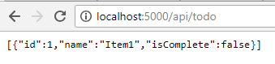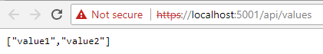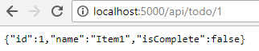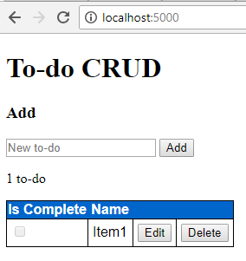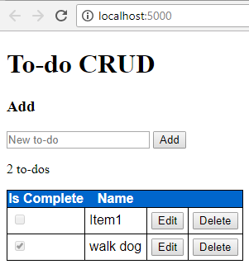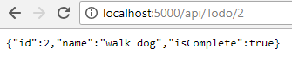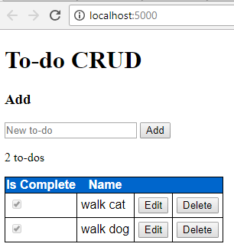

Test in Postman

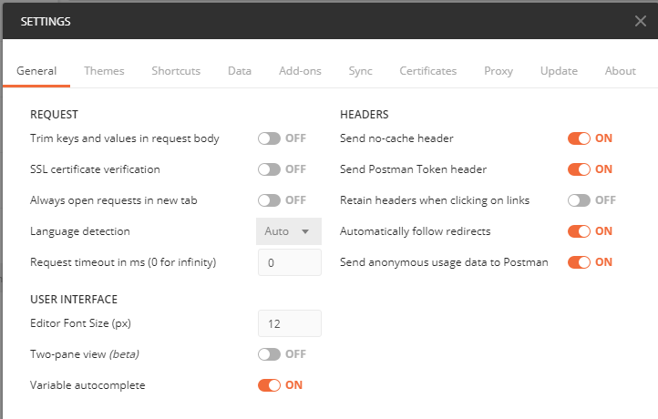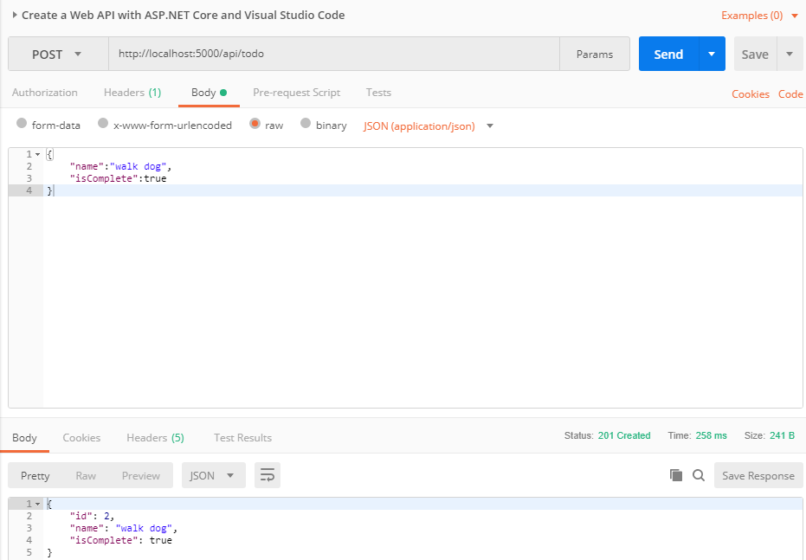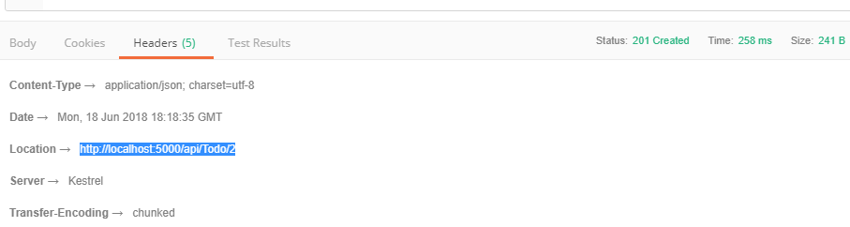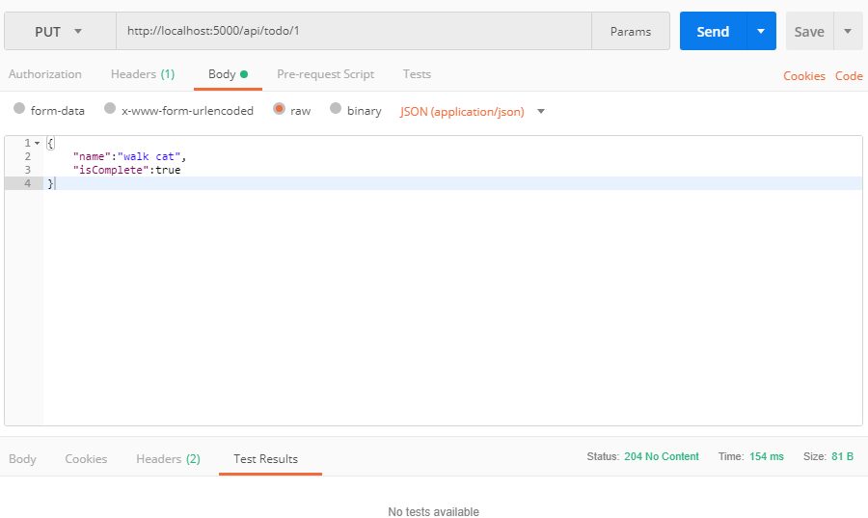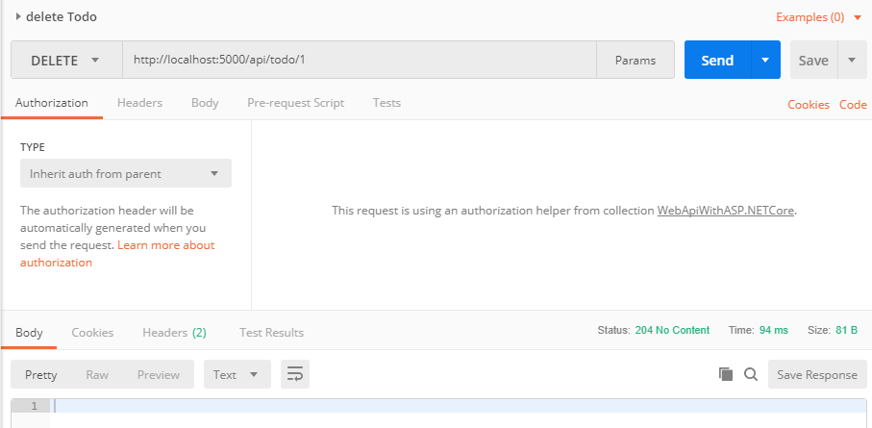

Install progress

* [.NET Core 2.1 SDK or later](https://www.microsoft.com/net/download/all)
* [Visual Studio Code](https://code.visualstudio.com/download)
* [C# for Visual Studio Code](https://marketplace.visualstudio.com/items?itemName=ms-vscode.csharp)

1. [.NET Core 2.1 SDK or later](https://www.microsoft.com/net/download/all)

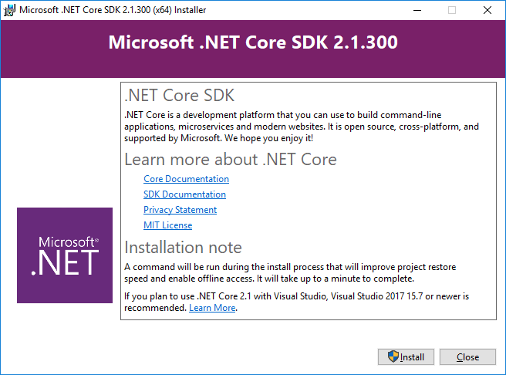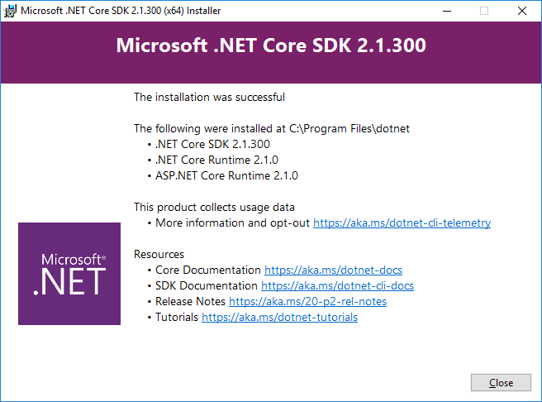

1. [Visual Studio Code](https://code.visualstudio.com/download)

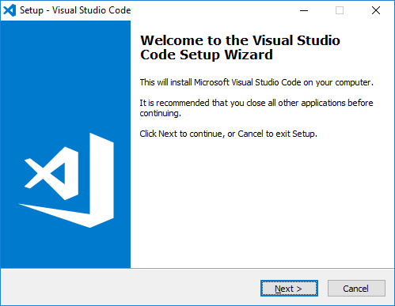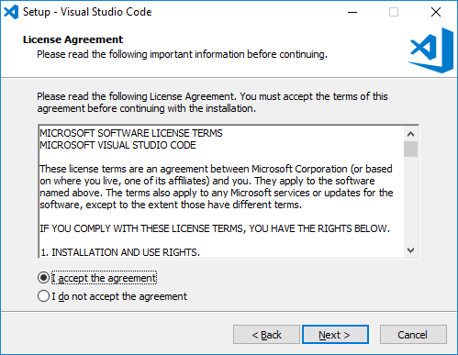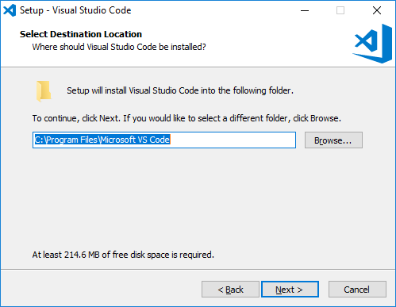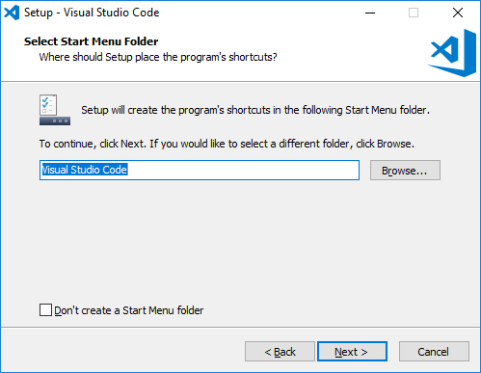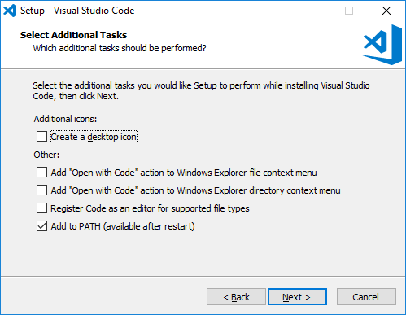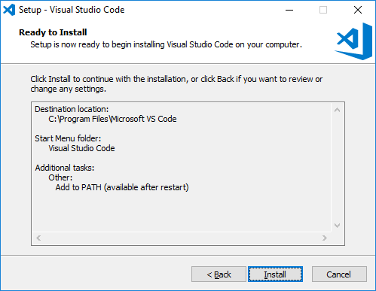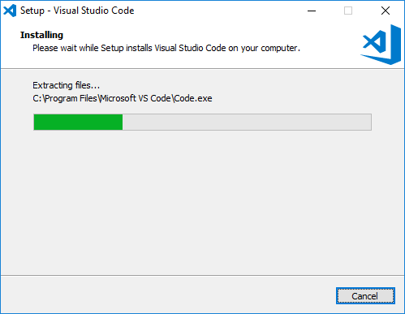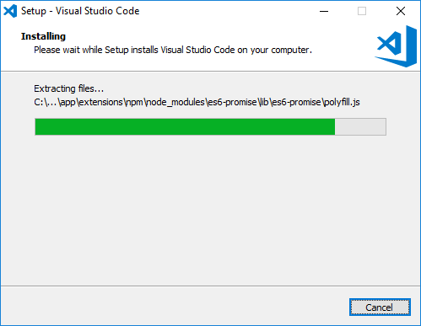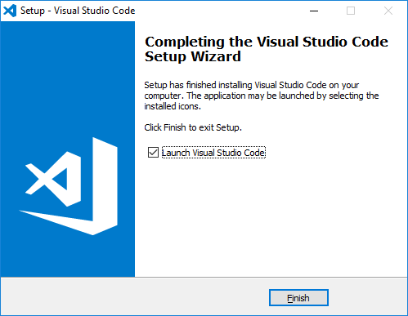

1. [C# for Visual Studio Code](https://marketplace.visualstudio.com/items?itemName=ms-vscode.csharp)
   1. Install Node.js

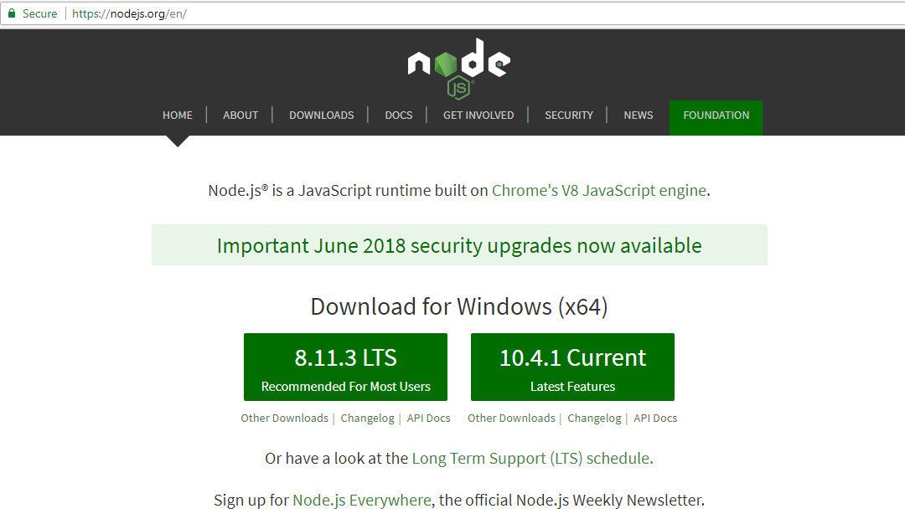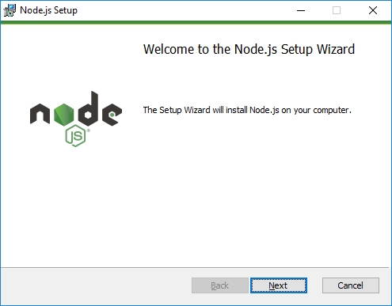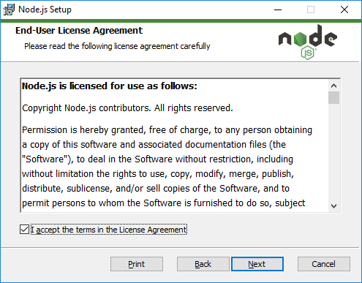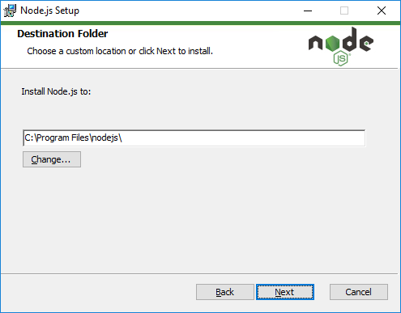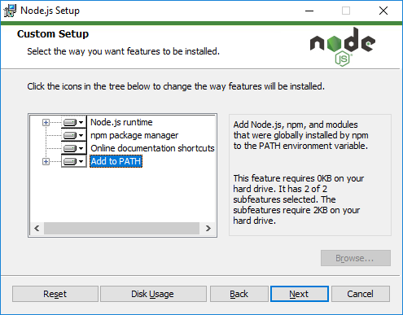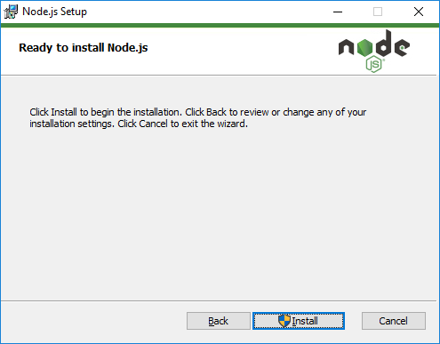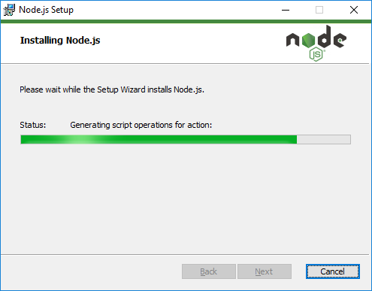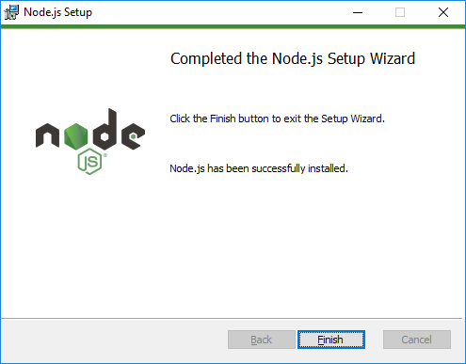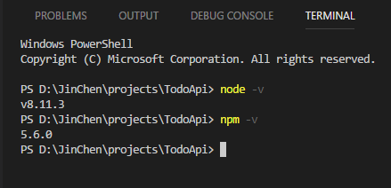

* 1. Install C# for Visual Studio Code

