Links
Quick Links:
- Zoom meeting:
[NOT VISIBLE ON GITHUB]
- Github:
https://github.com/jin-yu-yang/VITA-Management-System-Demo
Documentations for Developers
https://github.com/jin-yu-yang/VITA-Management-System-Demo/tree/main/docs/developer
- AI tools Research by Kelvin: CSE416 AI Coding Tools - Claude Pro
- Milestone Spec: Lecture: Milestone reviews and presentations
- Team (where you also put your doc link): https://docs.google.com/spreadsheets/d/15dyhUxoyXW_u1OOfFWPHjH3BCqwAyA_Qiock84QgP7w/edit?gid=0#gid=0
- Topic presentation signup sheet: https://docs.google.com/spreadsheets/d/1tfEug7_PQLpu-zZSDW_Run7M4O2_37pUZLtNx_oZMi0/edit?usp=sharing
- Apas, a tool that allows to share Claude/Codex (you still need a machine as host)
  - cli: https://github.com/shuaimu/apas
  - web: https://apas.mpaxos.com
- Mako, a test cloud db (pending document release): https://cloud-test.makodb.com/
- Website Functions References
  - DS160 application,
  - PA COMPASS,
  - fafsa,
  - linkandlearn,
  - taxslayerprovita

Spec

VITA Site Management System
Project Specification Document
CSE 416 — Software Engineering Project
Prepared in partnership with PCDC (Philadelphia Chinatown Development Corporation)
Fall 2026
Team: Cody Chi · Hailey Zheng · Jinyu Yang · Kelvin Chiu · Manqi Lu

1. Overview
The VITA Site Management System (project name: ViTally) is a bilingual (English/Chinese) web application designed to digitize and streamline case management for a Volunteer Income Tax Assistance (VITA) site operated by PCDC. The system replaces a largely paper- and phone-based process with an online workflow that carries a tax return case from client intake through preparation, quality review, and completion, while giving clients, volunteers, and administrators role-appropriate visibility into each case's status.
This document consolidates the team's planning notes, requirements discussions, pre-survey findings, and design drafts produced during the first weeks of the project into a single specification to guide implementation and to serve as the Milestone 1 project proposal.

2. Background: The IRS VITA Program & PCDC

2.1 What is VITA?
VITA stands for Volunteer Income Tax Assistance — a community-based program supported by the IRS that trains volunteers to provide free tax preparation services to eligible taxpayers (low-to-moderate-income taxpayers, individuals with disabilities, and people with limited English proficiency). The IRS provides limited grants to help run a VITA site, awarded based on each site's report and proposal — which is part of why better data and reporting matter to PCDC directly.
As a VITA volunteer, typical responsibilities include:
- Reviewing tax documents such as W-2s, 1099s, and similar forms.
- Entering income, deductions, and tax credits into tax preparation software.
- Checking taxpayer information for accuracy.
- Giving tax advices to taxpayers
VITA generally handles relatively straightforward individual tax returns; more complex tax situations fall outside the program's scope.

2.2 What is PCDC?
PCDC (Philadelphia Chinatown Development Corporation) is a Philadelphia-based nonprofit that has run a free VITA tax preparation program for its community for over 10 years. PCDC's VITA site is the real-world site the team is using as its case study, and the source of the problem research, pre-survey findings, and workflow details throughout this document.

3. Problem Statement & Motivation

3.1 Who this is for, and what hurts today
This project is for VITA volunteers, PCDC site administrators, and the taxpayers (clients) they serve. Today, the process relies on repeated paperwork and gives volunteers and administrators limited visibility into each client's progress through the pipeline.

3.2 Current Site Service Models
PCDC currently accepts and processes cases through three separate channels:
Channel | How it works
Same Day | Full on-site process with same-day service, held on 4–5 weekends per season.
Drop-off | The client drops documents off in person on weekdays; volunteers work remotely; admin staff coordinate the handoff.
Online | Fully remote: online submission → remote preparation → identity verification over Zoom → completed return delivered by email.

3.3 Quantified Pain Points
- Volunteer–client imbalance — roughly 20 active volunteers serve 700+ requests each season, with inconsistent availability and varying certification levels. This raises a core question the system needs to help answer: how do we assign cases efficiently?
- Limited, tightly stretched grant funding — IRS grant funding works out to less than $10 per case when divided evenly, without accounting for operating costs or case complexity.
- No data-driven case management — the site has no dedicated data role, which limits its ability to report impact and secure future grants.

3.4 Current Bottlenecks
- The process typically begins with taxpayers bringing in physical documents; volunteers must manually review and enter that information, and a second certified volunteer must review the return before submission.
- No centralized case tracking across the three service channels (status, documents, turnaround time), and no unified volunteer-matching system by availability, certification level, or language.
- Service capacity depends heavily on the number and certification level of available volunteers, and the workflow remains labor-intensive and dependent on volunteer availability.
- Manual, ad hoc communication (phone calls, emails) adds administrative workload, delays, and errors — and gives taxpayers little visibility into the status of their return before it is submitted to the IRS (see the direct quotes in Section 4). They often do not know whether documents have been reviewed, whether a volunteer is actively preparing the return, whether something is missing, or whether the return is waiting for quality review, which drives repeated phone/email contact with volunteers.
- No consolidated data across channels limits visibility into demand, volunteer utilization, and bottlenecks — and, combined with the lack of a dedicated data role, limits the site's ability to report impact for future grant applications.
- Manual document intake, data entry, and limited virtual-service capacity all represent clear opportunities for improved efficiency through automation and digital document processing.

3.5 Why This Requires a Semester Project
This is not a weekend script — it requires several interconnected workflows (intake, assignment, preparation, quality review, and filing) tied together for every tax return submitted, shared data across roles, real user accounts, sensitive document handling, bilingual support, and audit logging.

4. Voice of the User: Pre-Survey Findings
Before drafting requirements, the team ran an informal pre-survey to gather concerns directly from people who use the current PCDC VITA process — clients, volunteers, and site administration. A full structured questionnaire was deferred due to time constraints, but the responses below already surface concrete, recurring pain points that directly inform the feature list in Section 8.

4.1 Clients
Ms. Xu (Case #619, TY2022–2025)
“The office hotline is never reachable. Every time, I have to physically go to the office just to check my case status or find out what documents are missing, and it's hard for me to walk.”
Mr. Li (Case #344, TY2024–2025)
“Everything is communicated by phone. Sometimes I don't understand, and sometimes I forget what documents I still need to bring by the time I get home. I wish they could text me instead — but even when they say they'll text, it often never comes, and I have to call again to follow up.”
Ms. Liu (Case #512, TY2025)
“My case was actually simple, but while I was waiting on-site, I noticed Case #526 got finished before mine. I don't know why, and I don't know how much longer I'll have to wait. When I asked, I was just told to wait a bit more.”

4.2 Volunteers
Liu Fen (TY2024 & TY2025 Volunteer)
“My schedule has always been flexible, but I happened to miss the workflow training session. Because of that, I didn't really understand the workflow for a long time — it took a while before I gradually figured it out. The admin team also didn't realize I was actually flexible until much later, so cases weren't assigned to me early on. I wish there was a more intuitive way to see what cases are available for me to take.”
Roger (Volunteer, 20+ years with VITA; CPA / retired accountant)
“Sometimes I see a lot of simple cases sitting there with no one working on them, so I just pick them up myself. Meanwhile, complex cases end up going to newer volunteers instead, who then keep coming to me with questions. Honestly, it would probably be more efficient if the complex cases were just assigned directly to me.”

4.3 Site Administration
Eunice (Site Coordinator, 2022–2023)
“When we're at work trying to reach clients, they're usually at work too, so phone calls often don't go through. On top of that, clients tend not to trust voicemails or text messages from an unfamiliar number. Also, a lot of our clients don't know how to use Zoom, and many have mobility issues, which makes identity verification really difficult for them.”
Together, these accounts point at the same handful of gaps the system needs to close: real-time, self-serve status visibility for clients; a case-claiming experience that matches work to volunteer availability and skill level instead of first-come-first-served; and communication that does not depend entirely on synchronous phone calls.

5. Goals & Purpose of the Website
The website gives taxpayers a single place to upload and manage documents, track the real-time status of their return, see what actions they still need to take and what information is missing, and receive status notifications — while also helping VITA volunteers manage their caseload more efficiently.
Primary goals:
- Reduce repeated manual paperwork for volunteers and staff.
- Give every role real-time visibility into case status.
- Streamline the tax filing workflow to reduce manual work and errors, using a secure, scalable database to store and manage client information.
- Support both English- and Chinese-speaking clients throughout the experience.

6. Users & Roles
The system supports three roles, each with a distinct set of permissions:
Role | Description | Key Permissions
Client | The taxpayer submitting documents for return preparation. | Submit an intake application; upload documents; check case status; print, correct, or withdraw an application.
Volunteer | A certified VITA volunteer who prepares or reviews returns. | Claim cases; communicate with clients; check the status of claimed cases; prepare and/or review returns.
Admin | Site coordinator, program manager and office staff who overseeing the VITA site. | Reassign case preparers; view the status of all cases; generate reports; issue alerts; post reference materials for volunteers.

Visibility follows role: a client can only see their own case; a volunteer can see the cases they are preparing or reviewing; the admin team can see all cases.
Note: splitting the team strictly into “client / volunteer / admin” views is a reasonable v1 starting point, but role definitions (e.g., additional volunteer sub-roles) are expected to evolve as requirements are refined.

7. Scope

7.1 In Scope — v1 / MVP
- Three roles with distinct permissions: client, volunteer, admin.
- Bilingual (English and Chinese) intake form, potentially including document upload.
- Auto-generation of IRS Form 13614-C (Intake/Interview & Quality Review Sheet) and Form 14446 (Virtual VITA/TCE Taxpayer Consent).
- A secure, structured database for client, case, and volunteer data.
- Standard web application security practices for handling sensitive personal and tax documents.
- Conversion of the on-site process into an online, trackable status pipeline, modeled as the case status state machine defined in Section 8.2.

7.2 Out of Scope — v1
- Facial recognition for identity verification.
- Direct in-app communication with accountants (Slack is used as an interim channel).
- A full alert system (e.g., automated site-closure notifications).
- Appointment scheduling (possible for a later version).
- Integration or cooperation with organizations other than PCDC.

7.3 Future / Non-MVP Candidates
- In-app communication with accountants.
- Alert system (items to bring, site closed/open status, etc.).
- AI-assisted customer support.
- Refinements to the case state machine as real workflow data is collected.

8. Functional Requirements

8.1 Account Creation & Authentication

Volunteers / Admins
- Upload a signed volunteer agreement and a government-issued ID.
- Provide name, email address, mailing address, zip code, and choose a username and password.
- Select a role: IRS SPEC, Territory Manager, SPEC OPI Volunteer, Site Coordinator, VITA Volunteer, or Volunteer Instructor.
- Verify the provided email address before the account becomes active.

Clients
- Start an application via an intake form — no authentication required to begin.
- On submission, an application ID is generated and an account is auto-created with a temporary username and password.
- The client logs in with the temporary credentials, is required to change their password, and is then routed to the client portal.
- A returning client can retrieve an existing application from the welcome page.

8.2 Case Status State Machine
The diagram below is the team's working state machine for a case, from intake through e-filing. It replaces the earlier draft state list with the actual states and transitions the team has designed, including the missing-documents hold loop, the client-unreachable loop at signature time, and both terminal states (filed, and cancelled/out-of-scope).
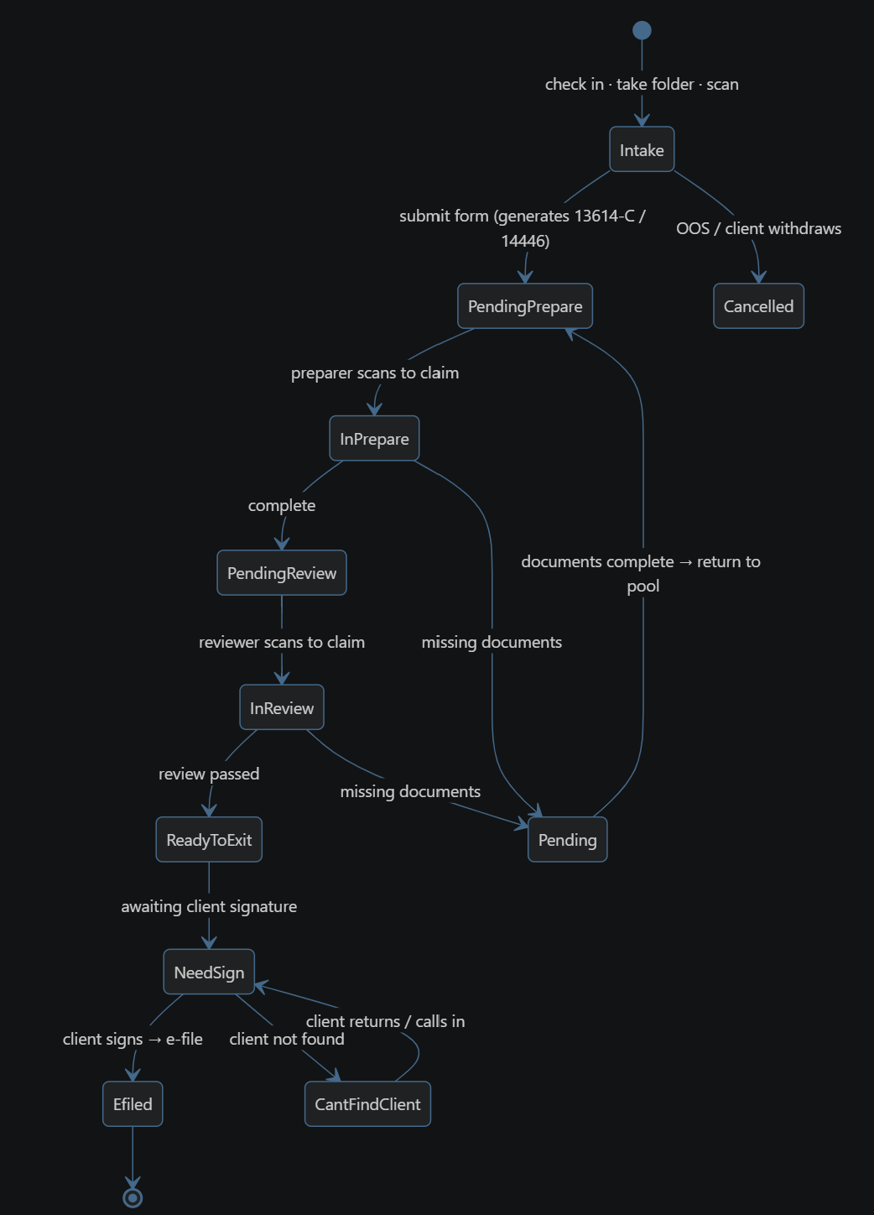
Figure 1. Case status state machine.

States
- Intake — client has checked in; documents are taken and scanned.
- PendingPrepare — intake form submitted (auto-generates Form 13614-C / 14446); case is verified and waiting in the preparer queue.
- InPrepare — a preparer has scanned the folder to claim the case and is actively working on it.
- PendingReview — preparation is complete; the case is waiting in the reviewer queue.
- InReview — a reviewer has scanned the folder to claim the case for quality review.
- Pending — on hold because documents are missing; returns to PendingPrepare once the client's documents are complete.
- ReadyToExit — quality review passed; the case is ready to exit, pending the client's signature.
- NeedSign — awaiting the client's signature before e-filing.
- CantFindClient — the client could not be reached to obtain a signature; returns to NeedSign once the client calls in or returns.
- Efiled — terminal state: the return has been signed and electronically filed.
- Cancelled — terminal state: the case was out of scope for VITA, or the client withdrew at intake.

Key Transitions
From | Trigger | To
(start) | Check in · take folder · scan | Intake
Intake | Submit form (generates 13614-C / 14446) | PendingPrepare
Intake | Out of scope, or client withdraws | Cancelled
PendingPrepare | Preparer scans to claim | InPrepare
InPrepare | Preparation complete | PendingReview
InPrepare | Missing documents | Pending
PendingReview | Reviewer scans to claim | InReview
InReview | Review passed | ReadyToExit
InReview | Missing documents | Pending
Pending | Documents complete — returns to pool | PendingPrepare
ReadyToExit | Awaiting client signature | NeedSign
NeedSign | Client signs — e-file | Efiled (end)
NeedSign | Client not found | CantFindClient
CantFindClient | Client returns / calls in | NeedSign

Every transition should be attributable to a specific staff member (intaker, preparer, reviewer, or admin) and timestamped to support the case-history / audit-trail view described in Section 8.4.

8.3 Client Portal
The client portal is the client's home view of their own case and should surface:
- Current stage of the case (e.g., waiting, verified, hold for missing documents) and, while queued, their queue position.
- Pending actions the client must take.
- Preparer contact information once a volunteer has claimed the case for preparation.
- Reviewer contact information once the case moves into quality review.
- Notifications about status changes.
- Access to the completed tax return once filing is finished.
- Actions: print the application, make corrections, or withdraw the application.
- Ability to request an appointment (future), ask questions, and view site contact information.

8.4 Volunteer Portal
- A worklist of cases, sortable by role (preparer or reviewer) and other criteria.
- For each case: who is preparing/reviewing it and their contact information.
- A case detail view showing intake form responses, uploaded documentation, and (future) an AI-generated summary.
- A case status / history tab showing key timestamps (intake completed, preparation started, client contacted, documents uploaded) and every staff member who has touched the case.
- The service method for the case: drop-off, same-day, or online.
- A volunteer profile page: preferred name, certifications earned, and contact information.
- (Future) direct messaging between volunteers and clients or other volunteers.

8.5 Admin Dashboard
- Site-wide view of volunteer workload.
- List of clients currently on hold.
- Case counts broken down by pipeline stage.
- Ability to reassign the preparer/reviewer on a case.
- Report generation.
- Ability to post reference materials for volunteers.
- Ability to issue alerts (future, see Section 7.3).

8.6 Automated Form Generation
Based on a client's intake responses, the system should auto-generate a completed draft of IRS Form 13614-C (Intake/Interview & Quality Review Sheet) and Form 14446 (Virtual VITA/TCE Taxpayer Consent), reducing duplicate manual data entry by volunteers.

9. Non-Functional Requirements
- Bilingual support — the intake form, portals, and notifications are available in both English and Chinese.
- Security — the system handles sensitive personal and tax documents and must follow standard web application security practices (authentication, authorization by role, encrypted storage/transport of documents).
- Data integrity & scalability — a relational database stores client, case, and volunteer data reliably as the site's caseload grows season over season.
- Auditability — every status change and every staff interaction with a case is logged, tied to a specific user and timestamp.
- Accessibility — the VITA program serves individuals with disabilities and limited English proficiency, so the interface should follow basic accessibility practices in addition to bilingual support.

10. Team & Responsibilities
Name | Sub-team | Responsibilities
Hailey Zheng | Frontend | UI development; intake question design
Jinyu Yang | Frontend | UI development
Manqi Lu | Frontend | UI development; English–Chinese translation
Cody Chi | Backend | Server development
Kelvin Chiu | Backend | Database design

A strict frontend/backend split is not the ideal long-term structure for the team, but it is a workable starting point for v1 and is expected to change as concrete feature ownership emerges.

11. Progress to Date & Next Steps

11.1 Completed (as of 9/9)
- Understood the current on-site workflow and service model.
- Created the GitHub repository.
- Ran a pre-survey to gather concerns from previous clients, admins, and volunteers (see Section 4); a full questionnaire was deferred due to time constraints.
- Drafted the case status state machine (Section 8.2).
- Met with the PCDC site manager to discuss promotion, testing, and requirements/expectations.
- Evaluating options for a shared coding-collaboration tool subscription.

11.2 Next Steps
- Design the database schema / class diagram.
- Build a light functional demo.
- Prepare the Milestone 1 topic presentation.

11.3 Milestone Roadmap
Milestone | Focus
Milestone 1 | Project proposal: problem, users, scope, team roles, and evidence of planning and collaboration.
Milestone 2 | To be defined as the team progresses.
Milestone 3 | To be defined as the team progresses.
Milestone 4 | To be defined as the team progresses.
Milestone 5 | To be defined as the team progresses.
Milestone 6 | To be defined as the team progresses.

12. Team Collaboration & Meeting Cadence
The team splits into a frontend group (bilingual UI first, since the client base is bilingual) and a backend group, coordinating through shared documents and regular meetings.
- Meeting 1 — 9/6, 4:00–6:00 PM, full team.
- Meeting 2 — 9/8, 10:00 AM–12:00 PM, frontend sub-team (Hailey, Manqi, Jinyu).
- Meeting 3 — 9/14, 7:00 PM—8:30 PM, full team
- Meeting 4 — 9/15, 5:00 PM—6:30 PM, M1 Speakers Cody and Hailey
- Meeting 5 — 9/16 11:00 AM - 2:00 PM M1 Speakers Cody, Hailey and Jinyu
Meeting notes and decisions are tracked via Google Calendar invites, Zoom minutes, and shared Google Docs edit history.

13. Open Questions / Items to Resolve
The following items were raised during planning and remain undecided; they are tracked here so they are not lost:
- Should the intake form support document upload directly, or is that deferred to a later step?
- Is a “Voice / info icon” needed on intake questions for additional guidance?
- Is an AI-generated case summary feasible for the volunteer portal?
- appointment scheduling?
- During tax filling season, if we are overwhelmed with the workload, priority should be given to e-filing cases instead of collecting completed docs. So we need to think about a faster method, such as creating a record directly to bypass the intake form.
- Client record generated after client submits the form, even though client is OOS
- Email verification, who claimed this case

14. Appendix: Alignment with Milestone 1 Expectations
The table below maps the questions the course uses to evaluate an M1 proposal to where this document addresses them, as a self-check before submission.
M1 Expectation | Where This Document Addresses It
Is there a proposal? | This entire document, serving as the team's Milestone 1 proposal.
Is the proposal carefully generated — many edge cases considered? | Section 8.2 (case status state machine, including the missing-documents hold loop, the client-unreachable loop, and both terminal states) and Section 3 (quantified pain points, current service models, and bottlenecks).
Are there efforts spent studying users' needs? | Section 4 (Voice of the User: direct pre-survey quotes from clients, volunteers, and site administration) and Section 3.3 (quantified pain points from the current site).
Are the team working together, as an organized group with every member contributing? | Section 10 (Team & Responsibilities) and Section 12 (meeting cadence, with dates, attendance, and a documented meeting trail).
Has the work actually been done? | Section 11.1 (Progress to Date) lists concrete completed artifacts: repo, pre-survey, state machine, PCDC site-manager meeting.
Do the team own the work, or does AI do it? | The underlying research (interviews, meeting notes, service-model details, state machine design) is the team's own; this document was assembled and formatted with AI assistance from that original material.

Meeting Notes
Meetings:

Date | Time | in-person/online | Participants | Notes | Topic
8/24 | 3:00pm - 3:30 pm | in-person | Hailey, Manqi |  | Overview
8/26 | 9:30am - 11:30am | In-person | Hailey, Kelvin |  | Overview
9/6 | 4:00pm - 6:00pm | Zoom | All |  | Overview
9/7 | 10:00am - 12:00pm | in-person | Hailey, Manqi, Jinyu |  | Overview
9/9 | 1:00pm - 1:30pm | in-person | Hailey, Prof.Mu | CSE416 VITA SMS Project Notebook | Collaboration
9/14 | 7:00pm - 9:00pm | Zoom | All |  | Planning
9/15 | 5:00pm - 6:30pm | in-person | Hailey, Cody | CSE416 VITA SMS Project Notebook | Presentation
9/16 | 10:30am - 2:00pm | in-person | Hailey, Cody, Jinyu |  | Presentation
9/21 | 12:30pm - 2:00pm | in-person | Hailey, Jinyu |  | Site Workflow  in Details
9/23 | 1:00pm - 1:30pm | in-person | Hailey, Manqi, Prof. Mu | CSE416 VITA SMS Project Notebook | Feedback
9/24 | 9:30am - 12:30pm | in-person | ALL |  | UI design
9/27 | 11:30pm - 2:30am | Zoom | ALL | CHN: CSE416 VITA SMS Project Notebook  ENG:CSE416 VITA SMS Project Notebook | UI design
9/28 | 7:00pm-8：00pm | Zoom | All | CSE416 VITA SMS Project Notebook | Planning
9/29 | 9:30am-10:30am | in-person | Hailey, Manqi |  | Mock Presentation
9/29 | 8pm-9pm | Zoom | Hailey, Manqi, Kelvin | CSE416 VITA SMS Project Notebook | Mock Presentation
9/30 | 12:30pm- | in-person | Hailey, Manqi, Kelvin, Cody | File | Presentation

0915

Key Outcomes
The team established the system name as ViTally, finalized the presentation structure for Milestone 1, and assigned primary technical roles for the project 12. They agreed to create a Figma demo to visualize the user interface and will rehearse the presentation during Cody's office hours 34.

Decisions Made
- System Name: The project will be called ViTally 1.
- Presentation Strategy:
  - For Milestone 1, the team will avoid having every member speak to prevent awkward transitions, following the professor's preference for 2-3 representatives 56.
  - Hailey will cover the "Why" (introduction and problem summary), and Cody will cover the "What" and "Who" (features, scope, and roles) 78.
- Technical Approach:
  - Use Figma for the initial demo to show the look and feel without requiring full functionality 910.
  - Implement a state machine to manage the conversion of the manual process to an online status 11.
- Feature Scope:
  - MVP: Bilingual intake forms, auto-generation of forms, database integration, and web security 11.
  - Post-MVP/Backburner: Facial recognition (too difficult to implement) and an AI-driven customer support/notification system 1213.

Role Assignments
- Front-end & UI Design: Hailey, Jinyu, and Manqi 1415.
- Back-end & Server: Cody 216.
- Database Management: Kelvin 216.
- Figma Demo: Jinyu 317.

Action Items
- Hailey: Send screen references/views to Jinyu for the Figma demo 4.
- Jinyu: Create the Figma demonstration of the website views by Wednesday 317.
- Hailey & Cody: Rehearse the Milestone 1 presentation during office hours (5:00 PM – 6:30 PM) 418.
- Team: Create a .md file for the final submission 11.

Next Steps
- Front-end Meeting: Hailey, Jinyu, and Manqi will meet to define specific feature assignments and review the state diagram 1219.
- Confirmation: Hailey will confirm with the professor whether every student must present for every milestone or if the representative approach is acceptable 20.

0927 - CHN

核心成果
本次会议围绕一个面向华人社区的免费税务申报辅助系统（PTC/VITA项目）展开，深入讨论了系统的多项核心功能设计方向，包括案例批注与可视化披露、Intake表单优化、Volunteer工作台重新设计、客户档案跨年匹配、文件管理、日程排班，以及Admin与Volunteer权限差异化展示等议题。会议明确了MVP范围，并就多个功能的实现路径达成初步共识，部分功能被推迟至后续里程碑实现。

案例批注与问题可视化功能
- 核心需求：当Preparer发现客户Intake信息中存在矛盾或不匹配时（如身份状态与工作资格不符），目前只能通过截图、电话沟通来回解决，效率极低，希望系统能提供一种可视化的批注与分享机制。 1
- 设想功能：允许Preparer在文件/表单页面内标记多个问题区域（如tag三处不匹配的字段），系统自动生成一个可分享链接，对方打开后可直接看到被标记的位置（如闪红点高亮），形成一个问题可视化界面。 1
- 典型场景：客户身份在一年内多次转变（学生签证→EAD工作许可→因父母情况变化→结婚获得新身份），导致报税身份极为复杂，过去需要画时间轴才能讲清楚，若能通过可视化链接直接展示，可大幅减少沟通成本。 23
- 现状痛点：当前方式是所有问题靠截图+电话，曾有一个复杂身份案例耗费约一个月时间反复沟通，最终靠手绘时间表才解决。 4
- 实现定位：该功能被定位为M4阶段的创新特性（老师要求提出对管理系统较新颖的功能），当前阶段暂不实现，Hailey将进一步完善需求描述。 5

Intake表单设计优化

身份与签证问题的复杂性
- Intake填写人（非专业报税员）在理解某些问题时存在认知偏差：他们被培训的是"如何帮客户填表"，而非"如何用这张表去报税"，导致填写信息与报税实际需求不符。 6
- 复杂身份客户（如无任何有效签证、通过婚姻申请过渡状态留美）往往在所有身份选项中选"No"，只在最后的备注栏写一段超长说明，信息极难被后续Reviewer快速理解。 7

老年人专项表单
- 系统目前有常规版和老年人版两套Intake问卷（共约105题，需新增一题：询问客户最佳联系时间）。 8
- 切换逻辑：用户登录开始填写时，系统询问"您是否为老年人"，根据回答切换后续问题集。 9

多语言支持
- 当前计划支持简体中文与英文，暂不支持繁体中文。 10
- 原因：PTC机构历史上由广东话使用者创立，繁体文件曾混入粤语白话文表达，导致不会粤语的员工/客户看不懂，收到差评后已逐步切换为简体中文；且粤语书面语系统（与普通话繁体中文体系不同）无人能校对。 1112
- 决策：繁体中文方案搁置，Hailey将询问机构Manager意见后再定。 10

中文措辞问题
- 部分中文问题措辞读起来"非常别扭"（如老年人版Section 6"和您同住或您出钱养的人"），但Hailey确认这种"土味"表达是刻意为之，因为目标用户群更容易理解这类直白语言。 1314
- 计划在后续里程碑通过用户测试验证措辞是否合适，当前先保留。 14

辅助提示（AI Tooltip）
- 讨论是否对部分专业词汇（如"Dependent"）添加点击解释气泡；若检测到用户频繁点击某词，可建议切换至更简单版本的表单。 15
- Hailey对此持谨慎态度，担心会增加复杂度，暂不实施。 15

客户档案与跨年信息匹配

现有匹配机制
- 每年报税案例编号从001重新计数，不跨年累计。 10
- 跨年客户匹配依据：姓名 + 电话号码（不使用SSN，因隐私政策限制）。 16
- 现有系统（Airtable）通过电话号码搜索，弹出类似名片的客户信息，再关联至当年活动（如"2026 TaxSite"）实现跨年绑定。 17

报税软件（TaxSlayer）的自动填充
- 当Volunteer在TaxSlayer中输入SSN后，系统会自动提示该客户去年有记录，可一键将历史信息（家庭成员、配偶姓名、雇主信息、公司地址等）填入当年表单，但收入金额不会自动沿用（因每年不同）。 1819
- 因此，对于情况稳定的老客户（如单身、每年只有W-2的阿姨），Volunteer实际上只需要提供当年的W-2即可完成大部分报税工作。 2021

系统内客户档案存储
- 系统内仅存储：姓名、电话号码、家庭住址（三项基本信息）。 2223
- 存储地址的原因：每年需要给回头客寄明信片（postcard）；电话号码用于后续联系和满意度调查。 23
- 不存储：W-2、1099等税务文件（法规要求报税完成后不得留存任何税务文件）。 2425
- 客户自建账号功能：讨论后认为客户每年只需使用一次，账号密码容易遗忘，建议改用**邮箱验证（Magic Link）**方式；且客户可自行登录IRS网站查询历史报税记录，无需系统重复存储。 2627
- 客户账号功能整体推迟至下一个税季（明年）实现。 26

案例（Case）管理与工作流

Add Case 流程优化
- 新增案例时，第一步选择服务方式（Drop-off / Online / Sunday等），然后可通过搜索姓名或电话号码调出已有客户档案，自动填入基本信息。 2829
- 需存储的客户基础信息（用于报告）：年龄/出生年份、家庭住址、姓名、电话号码，以及配偶和子女信息（用于机构向资助方汇报服务覆盖情况，如"费城东北区服务了多少老年人"）。 30

Edit Case 的四种触发场景
- Drop-off：最常见场景，Volunteer根据客户带来的材料逐步填写。 31
- 子女单独报税：家长误以为子女收入并入自己的税单，但只要子女有W-2或收入超过阈值（约$5,500），就需要单独开案。 3233
- 简单老客户快速处理：情况多年不变的客户（如单身、只有W-2），Volunteer可跳过大量问题，直接修改少数字段。 3435
- Self-file（客户自助报税）：系统发送链接给客户，客户自行填写，系统只需记录案例数量，无需收集详细材料。 36

材料收集与文件管理
- 建议流程：先扫描/上传所有带来的材料，系统自动识别文件类型（W-2、1099A等）并归档；再过一遍Intake表单；完成后系统对比表单需求与已上传文件，生成缺失文件清单，通知客户补充。 3738
- 优势：避免Intake时遗漏扫描（如客户有两张W-2但只扫了一张）；让客户一次性知道所有需要准备的材料，而非逐题触发。 3940
- 材料必填性：W-2和1099并非互斥，也非必填——部分客户只有养老金（1099-SSA）、只有奥巴马保险申报（1095-A）、或只有中国养老金需要申报（无需在美缴税但需申报）。因此材料均设为选填，不强制要求至少一项。 414243
- 文件管理Tab：支持跨案例搜索文件（如搜索两个案例的W-2进行对比），建议文件以案例编号为前缀组织，而非单独的全局文件库。 4445

Reassign（案例重新分配）
- 决策：移除Volunteer端的Reassign按钮，不允许Volunteer私自将案例转给他人；需要重新分配时，Volunteer在备注中说明情况，由Admin操作。 4647

权限体系与工作台设计

核心权限差异
- Admin：可查看所有案例的所有详细信息（包括客户电话、文件内容）。
- Volunteer（未认领案例）：在公共案例池（Workboard）中只能看到有限信息（不含电话号码、具体文件内容、收入金额等敏感信息），只有认领后才能看到完整信息。 4849
- 设计原因：曾发生Volunteer私下联系客户"低价抢单"的恶劣行为，限制信息可见性有助于追责（认领记录可溯源）。 48

Workboard（公共案例池）设计
- 面向Volunteer：显示两个Tab——"等待Prepare"和"等待Review"，每个Tab内只显示处于对应状态的案例及有限信息。 5051
- 面向Admin：同一Workboard但无信息过滤，可查看所有案例全部详情；另可按状态、语言、服务方式、提交时间（最旧优先）等维度筛选排序。 5253
- Volunteer认领后，可在自己的Dashboard中看到所认领案例的完整状态流转（进行中→等待Review→完成）。 54

Dashboard重新设计方向
- Volunteer Dashboard：移除或缩小"贡献图（Contribution Graph）"，保留个人案例状态追踪；新增**排班预约（Reserve Time Slot）**功能入口。 5556
- Admin Dashboard：核心区域展示所有Volunteer的当前工作负载（每人手上有多少案例），便于Admin主动分配任务；下方保留Volunteer列表和排班信息；移除"退税金额统计"功能（因无法自动从TaxSlayer获取数据，需手动导入，成本过高）。 5758

排班功能（Schedule）
- 核心价值：远程Volunteer不知道彼此何时在线，需要一种机制让大家知道谁在什么时间段可以工作。 5960
- 附加价值：许多Volunteer（CPA、EA等）参与志愿服务是为了获得继续教育学分（CPE），需要记录工作时长；排班系统可替代现有的Slack打卡方式（后者容易被遗忘）。 6162
- 交互设计：类似Uber"预约时段"或图书馆学习室预约，点击小方块选择时间段，操作简单；在Dashboard中可以看到当天哪些人已预约上线。 6364
- 放置位置：Schedule作为独立侧边栏Tab保留，Dashboard中提供快捷入口按钮。 56

通知与资源管理

通知系统
- Admin可向所有Volunteer发送通知，Volunteer必须确认已读（与普通消息区分，需单独放置，不合并进头像菜单）。 65
- 讨论将"资源（Resources）"并入通知面板，设两个子Tab："通知"和"资源"。 66

Volunteer资源库
- 每年1月7日报税季开始前，Admin会上传：培训材料、志愿者协议书、报税知识点、TaxSlayer操作指南、常用表格（如需邮寄的纸质申报表）等。 6768
- 新增系统使用说明（How-to Guide）：因曾有Volunteer错过培训后不知如何上手，需提供自助学习材料。 69
- 正式文档（Documentation）将在M5阶段完成（课程要求）。 70

Follow-up 功能
- Follow-up记录支持：Log Call、Log Message（跳转至历史短信对话）；Log Email暂无法自动跳转至历史邮件线程，只能打开新邮件并自动记录操作日志。 7172
- 部分外籍客户（英语不佳、无共同语言）更倾向于使用邮件沟通，因此Email Log功能仍有必要保留。 73
- 电话号码字段点击后应直接调起拨号，无需手动复制。 71

Review 功能与批注
- Review Tab：当Reviewer对某字段进行修改时，建议在Intake Answers对应字段旁显示修改标记（如小红点），而非单独开一个Review Tab；可通过"显示/隐藏修改"按钮切换两个图层（原始答案层 vs. 修改后图层）。 7475
- Before Tab：确认删除（无实际使用场景）。 76
- 1099-A 标记功能：Reviewer可将某项文件标记为"不需要"（Not Required），避免因缺少实际上不适用的文件而导致提交被拒。 7778

MVP范围确认
以下功能不在MVP范围内：
- 站内消息系统（Messaging System） 79
- 移动端适配（Mobile Queue） 79
- 全局文件管理Tab（Documents独立搜索） 80
- 繁体中文支持 10
- 客户自建账号系统 26
- 案例批注与可视化分享（M4实现） 5
- 退税金额统计（需手动导入数据，暂不实现） 58
以下功能在MVP范围内（需在M2/M3前完成）：
- 案例生命周期Stage更新（当前9个Stage需扩充，同步更新数据库） 81
- Workboard重新设计（含Admin/Volunteer差异化视图）
- Intake问题更新（含新增"最佳联系时间"问题） 8
- 客户端邮箱OTP登录（Magic Link） 82
- 整体样式（Styling）更新，含Logo和配色（薰衣草色） 83
- Presenter Controls（演示用快速填充）保留至M3 84

待确认事项
- 繁体中文：Hailey需向机构Manager确认是否有必要支持，以及支持形式。 10
- Admin Dashboard布局：Volunteer工作负载展示方式（折叠列表 vs. 其他形式）待进一步设计后确认。 57
- Workboard筛选维度：Admin端是否增加"由谁认领（Claim By）"筛选项，待设计稿出来后确认。 85
- Claim按钮位置：当前方案为放在案例详情页最底部，后续可能考虑在列表页直接提供快捷Claim入口（两种方案均有合理性）。 8687

行动项
- Jinyu：更新案例生命周期Stage（扩充Stage数量，同步数据库） 81
- Jinyu：重新设计Workboard（Admin全量视图 + Volunteer过滤视图，含状态/语言/服务方式/时间筛选） 5288
- Jinyu：重新设计Admin Dashboard（展示Volunteer工作负载，移除退税金额统计，添加排班入口） 57
- Jinyu：在案例详情页最底部添加Claim按钮 86
- Jinyu：整体Styling更新（颜色、Logo、字体适配） 89
- Jinyu：更新Intake问题（新增"最佳联系时间"题，共106题） 8
- Hailey：向Manager确认多语言支持策略（是否需要繁体中文） 10
- Hailey：整理近期两人会议讨论的功能清单，供次日早上与团队共同review，确认哪些进MVP 90
- Hailey：进一步完善案例批注可视化功能需求描述（M4准备） 5

0927 - ENG

Key Outcomes
This meeting focused on a free tax-filing assistance system for the Chinese community (PTC/VITA program). The discussion covered design directions for several core features: case annotation and visual issue disclosure, Intake form optimization, a redesigned Volunteer workspace, cross-year client record matching, document management, scheduling, and differentiated views for Admin vs. Volunteer permissions. The meeting defined the MVP scope and reached preliminary agreement on how to implement several features, with some deferred to later milestones.

Case Annotation & Issue Visualization
- Core need: When a Preparer finds contradictions or mismatches in a client's Intake information (e.g., immigration status inconsistent with work eligibility), the only current option is back-and-forth screenshots and phone calls, which is very inefficient. The team wants the system to provide a visual annotation and sharing mechanism.
- Proposed feature: Let the Preparer flag multiple problem areas within a document/form page (e.g., tag three mismatched fields). The system generates a shareable link; when the recipient opens it, the flagged locations are highlighted directly (e.g., flashing red dots), creating a visual issue view.
- Typical scenario: A client's status changes several times within one year (student visa → EAD work permit → change due to parents' circumstances → new status through marriage), making the filing status extremely complex. In the past, a timeline had to be drawn to explain it. A visual link would greatly reduce communication overhead.
- Current pain point: Everything is handled via screenshots + phone calls. One complex status case took about a month of repeated back-and-forth and was only resolved with a hand-drawn timeline.
- Positioning: This is framed as an M4 innovation feature (the instructor asked for a feature that is relatively novel for management systems). It will not be implemented now; Hailey will refine the requirements.

Intake Form Design Optimization

Complexity of Status & Visa Questions
- Intake fillers (not professional tax preparers) often misunderstand certain questions: they are trained on "how to help clients fill out the form," not "how the form is used to file taxes," so the information collected doesn't match what filing actually requires.
- Clients with complex status (e.g., no valid visa, remaining in the U.S. in a transitional status through a marriage-based application) often answer "No" to every status option and write a very long explanation in the final notes field, which is hard for later Reviewers to grasp quickly.

Senior-Specific Form
- The system currently has two Intake questionnaires: standard and senior versions (about 105 questions total; one question needs to be added: the client's best time to be contacted).
- Switching logic: when a user logs in and starts filling out the form, the system asks "Are you a senior?" and switches the subsequent question set based on the answer.

Multilingual Support
- Current plan: support Simplified Chinese and English; Traditional Chinese is not supported for now.
- Reason: PTC was historically founded by Cantonese speakers, and Traditional Chinese documents once mixed in written Cantonese vernacular, which staff/clients who don't speak Cantonese couldn't understand. After receiving negative reviews, the organization gradually switched to Simplified Chinese. Also, no one can proofread written Cantonese (which differs from the Mandarin-based Traditional Chinese system).
- Decision: Traditional Chinese is on hold; Hailey will ask the organization's Manager before deciding.

Chinese Wording Issues
- Some Chinese questions read very awkwardly (e.g., Section 6 of the senior version, "people who live with you or whom you financially support"), but Hailey confirmed this plain, folksy phrasing is intentional because the target users understand such direct language more easily.
- Wording will be validated through user testing in a later milestone; kept as-is for now.

AI Tooltips
- Discussed adding click-to-explain bubbles for some technical terms (e.g., "Dependent"). If the system detects a user repeatedly clicking a term, it could suggest switching to a simpler version of the form.
- Hailey is cautious, concerned it would add complexity; not implemented for now.

Client Records & Cross-Year Matching

Existing Matching Mechanism
- Case numbers restart at 001 each tax year and do not accumulate across years.
- Cross-year client matching is based on name + phone number (not SSN, due to privacy policy restrictions).
- The current system (Airtable) searches by phone number, pops up a business-card-style client record, and links it to the current year's activity (e.g., "2026 TaxSite") to connect records across years.

Auto-Fill in Tax Software (TaxSlayer)
- When a Volunteer enters an SSN in TaxSlayer, the system indicates the client has a record from last year and can carry over historical information in one click (family members, spouse name, employer info, company address, etc.), but income amounts are not carried over (since they change each year).
- So for stable returning clients (e.g., a single older woman with only a W-2 each year), the Volunteer essentially only needs the current year's W-2 to complete most of the return.

Client Record Storage in the System
- The system stores only: name, phone number, home address (three basic fields).
- Why store the address: postcards are mailed to returning clients each year; the phone number is used for follow-up contact and satisfaction surveys.
- Not stored: W-2, 1099, or other tax documents (regulations prohibit retaining any tax documents after filing is complete).
- Client self-registered accounts: after discussion, since clients only use the system once a year and easily forget passwords, the recommendation is email verification (Magic Link) instead. Clients can also log in to the IRS website to view their past filings, so the system doesn't need to store them.
- The client account feature as a whole is deferred to the next tax season (next year).

Case Management & Workflow

Add Case Flow Optimization
- When adding a new case, the first step is choosing the service type (Drop-off / Online / Sunday, etc.). The user can then search by name or phone number to pull up an existing client record and auto-fill basic info.
- Client basic info to store (for reporting): age/birth year, home address, name, phone number, plus spouse and children information (so the organization can report service coverage to funders, e.g., "how many seniors were served in Northeast Philadelphia").

Four Scenarios That Trigger Edit Case
- Drop-off: The most common scenario; the Volunteer fills things in step by step based on the materials the client brings.
- Children filing separately: Parents mistakenly think their children's income is included on their own return, but if a child has a W-2 or income above the threshold (about $5,500), a separate case must be opened.
- Quick handling for simple returning clients: For clients whose situation hasn't changed for years (e.g., single, W-2 only), the Volunteer can skip many questions and just edit a few fields.
- Self-file: The system sends the client a link to fill out on their own; the system only needs to record the case count, with no detailed materials collected.

Material Collection & Document Management
- Suggested flow: first scan/upload all materials the client brought; the system automatically identifies document types (W-2, 1099-A, etc.) and files them; then go through the Intake form; afterward, the system compares the form's requirements with the uploaded documents, generates a list of missing documents, and notifies the client to provide them.
- Benefits: avoids missed scans during Intake (e.g., the client has two W-2s but only one was scanned), and lets the client learn everything they need to prepare at once rather than being prompted question by question.
- Required vs. optional materials: W-2 and 1099 are neither mutually exclusive nor required. Some clients have only pension income (1099-SSA), only an Obamacare filing (1095-A), or only a Chinese pension to report (no U.S. tax owed, but it must be reported). Therefore, all materials are optional, with no requirement for at least one item.
- Documents tab: supports searching documents across cases (e.g., pulling up W-2s from two cases to compare). Documents should be organized with the case number as a prefix rather than in a separate global document library.

Reassign
- Decision: Remove the Reassign button from the Volunteer side. Volunteers may not transfer cases to others on their own; when reassignment is needed, the Volunteer explains the situation in the notes and the Admin handles it.

Permission System & Workspace Design

Core Permission Differences
- Admin: Can view all details of all cases (including client phone numbers and document contents).
- Volunteer (unclaimed cases): In the shared case pool (Workboard), can see only limited information (no phone numbers, document contents, income amounts, or other sensitive data). Full information is visible only after claiming the case.
- Rationale: there was a serious incident in which a Volunteer privately contacted clients to "poach cases at a lower price." Limiting visibility helps with accountability (claim records are traceable).

Workboard (Shared Case Pool) Design
- For Volunteers: Two tabs — "Awaiting Prep" and "Awaiting Review." Each tab shows only cases in that status, with limited information.
- For Admins: The same Workboard with no information filtering, showing full details for all cases. Can also filter and sort by status, language, service type, submission time (oldest first), etc.
- After claiming, Volunteers can see the full status progression of their claimed cases in their own Dashboard (In Progress → Awaiting Review → Complete).

Dashboard Redesign Direction
- Volunteer Dashboard: Remove or shrink the Contribution Graph; keep personal case status tracking; add an entry point for Reserve Time Slot scheduling.
- Admin Dashboard: The main area shows every Volunteer's current workload (how many cases each person has) so the Admin can proactively assign work. The Volunteer list and schedule info remain below. Remove the "refund amount statistics" feature (data can't be pulled automatically from TaxSlayer and would require manual import, which is too costly).

Scheduling
- Core value: remote Volunteers don't know when others are online; a mechanism is needed so everyone can see who is available during which time slots.
- Additional value: many Volunteers (CPAs, EAs, etc.) volunteer to earn continuing education credits (CPE) and need to log their hours. The scheduling system can replace the current Slack check-in method, which people easily forget.
- Interaction design: similar to Uber's "reserve a time slot" or booking a library study room — tap small blocks to select time slots, simple to use. The Dashboard shows who has reserved time to be online that day.
- Placement: Schedule stays as a standalone sidebar tab, with a shortcut button on the Dashboard.

Notifications & Resource Management

Notification System
- Admins can send notifications to all Volunteers, and Volunteers must confirm they've read them (distinct from regular messages; placed separately, not merged into the avatar menu).
- Discussed merging "Resources" into the notification panel, with two sub-tabs: "Notifications" and "Resources."

Volunteer Resource Library
- Before the tax season starts on January 7 each year, the Admin uploads: training materials, volunteer agreements, tax knowledge points, TaxSlayer operation guides, commonly used forms (e.g., paper returns that must be mailed), etc.
- Add a system How-to Guide: some Volunteers who missed training didn't know how to get started, so self-service learning materials are needed.
- Formal Documentation will be completed in M5 (course requirement).

Follow-up Feature
- Follow-up logging supports: Log Call and Log Message (jumps to the historical text conversation). Log Email can't yet jump to the historical email thread automatically; it can only open a new email and automatically record the action in the log.
- Some foreign-national clients (limited English, no shared language) prefer email, so the Email Log feature is still worth keeping.
- Clicking a phone number field should directly launch the dialer, with no manual copying.

Review Feature & Annotations
- Review tab: When a Reviewer changes a field, show a change marker (e.g., a small red dot) next to the corresponding field in Intake Answers rather than using a separate Review tab. A "Show/Hide Changes" toggle can switch between two layers (original answers vs. revised).
- Before tab: Confirmed for deletion (no real use case).
- 1099-A marking: Reviewers can mark a document as "Not Required," preventing a submission from being rejected for missing a document that doesn't actually apply.

MVP Scope Confirmed
Not in MVP:
- In-app messaging system
- Mobile adaptation (Mobile Queue)
- Global documents tab (standalone document search)
- Traditional Chinese support
- Client self-registered accounts
- Case annotation & visual sharing (implemented in M4)
- Refund amount statistics (requires manual data import; not implemented for now)
In MVP (to be completed before M2/M3):
- Case lifecycle stage updates (the current 9 stages need to be expanded, with the database updated accordingly)
- Workboard redesign (including differentiated Admin/Volunteer views)
- Intake question updates (including the new "best time to contact" question)
- Client email OTP login (Magic Link)
- Overall styling update, including logo and color scheme (lavender)
- Presenter Controls (quick-fill for demos) kept through M3

Open Items
- Traditional Chinese: Hailey to confirm with the organization's Manager whether it's needed and in what form.
- Admin Dashboard layout: How to display Volunteer workload (collapsible list vs. other formats) to be confirmed after further design.
- Workboard filters: Whether to add a "Claimed By" filter on the Admin side, to be confirmed once mockups are ready.
- Claim button placement: The current plan is the very bottom of the case detail page; a quick Claim option directly on the list page may be considered later (both approaches have merit).

Action Items
- Jinyu: Update case lifecycle stages (expand the number of stages; update the database accordingly)
- Jinyu: Redesign the Workboard (full Admin view + filtered Volunteer view, with filters for status/language/service type/time)
- Jinyu: Redesign the Admin Dashboard (show Volunteer workload, remove refund statistics, add scheduling entry point)
- Jinyu: Add a Claim button at the very bottom of the case detail page
- Jinyu: Overall styling update (colors, logo, font adjustments)
- Jinyu: Update Intake questions (add the "best time to contact" question, 106 total)
- Hailey: Confirm the multilingual support strategy with the Manager (whether Traditional Chinese is needed)
- Hailey: Compile the list of features discussed in recent one-on-one meetings for the team to review together tomorrow morning and decide what goes into the MVP
- Hailey: Further refine the requirements for the case annotation visualization feature (M4

0928

Key Outcomes
The team finalized the structure and speaker assignments for the Milestone 2 presentation, centering on three sections: UI design evolution, three core features, and a live demo. Architecture was explicitly cut from the agenda based on the professor's Piazza guidance. Presenter roles were assigned to Hailey (UI design), Manqi (three core features), and Kelvin (live demo). The team also identified the need to better demonstrate collaboration and to emphasize why the interface is friendly and intuitive for real users — a weak point flagged from Milestone 1 feedback. Rehearsal sessions were scheduled for Tuesday morning, Tuesday night on Zoom, and Wednesday morning before class.

Decisions Made
· Presentation scope: Cover only three core features, UI design evolution/comparison, and a live demo — no architecture section, as it was not requested on Piazza and teams that presented it did not receive better outcomes.
· Architecture excluded: Cody confirmed the decision after checking Piazza: "Don't do it because he didn't say to do it in the Piazza."
· Piazza guidance takes precedence over the slide deck instructions, which were noted to contradict each other; the team agreed to follow the most recent professor statement.
· Collaboration demonstration strategy: Two accepted approaches identified — (1) have all members present, or (2) explicitly describe who did what in sufficient detail (not just a one-sentence mention). Meeting minutes or abridged notes integrated into the UI design section were identified as the best vehicle for showing collaboration.
· Demo format: Kelvin will open and navigate the live site (not screenshots) to walk through all three core use cases.
· Kelvin's computer (Mac) will be used for the presentation.
· Slide selection for UI design: Hailey will select a subset of slides showing before/after comparisons and explain what changed and why, keeping her segment to approximately 1–2 minutes.
· Demo length target: Kelvin estimated at least 3 minutes for the demo; Hailey and Manqi's combined segments estimated at 4–5 minutes.
· Cloud Pro budget: The team will use the $300 course credit to cover cloud costs; Hailey submitted the reimbursement form and is awaiting funds. Jinyu had already spent approximately $150 of his own money on tokens.

Presentation Structure & Speaker Assignments

Hailey — UI Design Evolution
· Will present the UI design comparison: what changed, what was removed, what was added, and why — framed as an iterative design process.
· Will draw on WeChat/text message history with Jinyu as a record of design decisions and iterations.
· Will show select screenshots (not all 20+ views) to illustrate evolution; estimated segment length: 1–2 minutes.
· Key design rationale examples to highlight:
· Volunteer workboard only shows cases in "ready to prepare" and "ready to review" status — other statuses excluded to avoid confusing volunteers about why they cannot claim a case.
· Senior-specific intake form uses simpler, clearer language and larger fonts to serve elderly users.
· Auto-logging button for calls/texts so volunteers do not have to manually record interactions.
· Two separate intake forms (general clients vs. seniors) as evidence of user-friendly, role-appropriate design.
· Collaboration angle: abridged meeting minutes woven into the UI design narrative to show team input across iterations.

Manqi — Three Core Features
· Will present the three core use cases structured by user role:
a. Client submits intake form, retrieves case by application ID, views case status, and submits corrections.
b. Volunteer browses the case pool/workboard and claims cases; dashboard shows cases by stage (waiting for preparation, waiting for review).
c. Admin oversees all cases and volunteers; dashboard displays cases sorted by submission date (oldest unclaimed first).
· All three dashboards and views are already implemented and ready to present.
· Cody flagged that Manqi's section and Kelvin's demo may overlap; Manqi's role is to describe what exists, while Kelvin's role is to demonstrate and convince the audience of usability.

Kelvin — Live Demo
· Will navigate the live site through all three core use cases end-to-end.
· Must cover: client intake form submission → case status view → case retrieval by ID → corrections submission → volunteer workboard → case claiming → volunteer dashboard → case detail → admin dashboard.
· Key emphasis per Piazza: "Don't just show what the UI does" — actively argue that the interface is friendly and intuitive for real users.
· Will skip the login/magic link process to save time and jump directly to authenticated views.
· For the intake form, will show one representative page rather than every page to convey the concept efficiently.

System Demo Walkthrough (Jinyu's Preview)
Jinyu ran a live demo during the meeting to show the current implementation state:
· Case lifecycle: Updated from 9 stages to approximately 29 stages based on the full tax case lifecycle.
· Client flow: Client starts a new application, fills out the intake form, submits, and receives a reference ID.
· Status bug identified: After a client submits, the case status is set to "received," but the volunteer workboard filters for "ready to prepare" — causing the new case to be invisible to volunteers. The team acknowledged this as a status-matching issue to resolve.
· Volunteer/preparer flow: Volunteer claims a case, records preparation as complete, then case moves to review stage.
· Admin flow: Admin can view all cases by volunteer, see unclaimed cases sorted by submission date, and perform intake checks.
· Client progress view: Client can see their case progress update as stages advance.
· Volunteer dashboard (in progress): Shows cases classified by stage; includes a contribution summary for the tax season; masked phone numbers revealed on hover; calling numbers (3-digit sequential IDs) to be added.
· Admin dashboard: Shows cases claimed by each volunteer; allows selecting a volunteer to view their cases; unclaimed cases sorted by oldest submission date.
· Old UI still present on client screens: Jinyu flagged that the intake form UI is still on the old design and may not be updated to the new UI by Wednesday.
· Preparer dashboard: Not yet implemented at time of meeting; Jinyu committed to having the workboard, dashboard, and case detail pages done by noon Tuesday.
· Jinyu noted implementation depends on Cloud's 5-hour reset window for tokens.

Professor Feedback & Grading Criteria
· Milestone 1 feedback: The professor graded "user needs" as excellent specifically because the team had real user stories; however, the submission did not adequately explain why the system solves the problem — it described current pain points but not the value delivered after implementation.
· Milestone 2 criteria (from Piazza):
· Three core use cases
· UI design process — walk through how UI evolved, what changed and why, what was unexpected or interesting
· Live demo that convinces the audience the interface is friendly and intuitive for real users
· Collaboration requirement: Professor said he doesn't care who presents but wants to see evidence of collaboration; the team interpreted this as requiring either broad presenter participation or detailed attribution of contributions.
· Observation from other groups' presentations:
· Most groups finished in 8–9 minutes, under the time limit — interpreted as reduced effort compared to Milestone 1.
· At least one group showed no demo at all (only UI screenshots), which visibly confused the professor.
· One group received feedback that there was "no incentive to use the app."
· At least two groups received "excellent" on collaboration without explicitly discussing teamwork during the presentation.
· One group received "overall needs improvement" — considered unusual by the team.
· Takeaway: Finishing slightly under time is acceptable; going over is not; showing a live demo is essential given explicit professor guidance.

Risks & Blockers
· Old intake form UI: Client-facing intake screens still use the old UI; Jinyu uncertain whether the redesigned UI will be ready by Wednesday. The team may need to work around this during the demo.
· Status mismatch bug: Newly submitted cases (status: "received") do not appear on the volunteer workboard (filters for "ready to prepare"), which could disrupt the live demo flow if not resolved.
· Cloud token limits: Jinyu's implementation timeline depends on Cloud's reset window; estimated completion by noon Tuesday contingent on this.
· Overlap between Manqi and Kelvin segments: Risk of repetition between the "three core features" explanation and the live demo; team agreed Manqi describes what exists, Kelvin demonstrates how it works and why it's intuitive.
· Insufficient rehearsal time: Noted as a problem in Milestone 1 (rehearsed from 12:30–2 but felt it wasn't enough); team proactively scheduled earlier rehearsal windows to avoid repeating this.
· Cody availability limited: Two midterms this week; will review slides Tuesday and join rehearsal after 3:30 PM Tuesday.

Open Questions
· User testing feasibility: Cody suggested contacting the actual client organization (PTDC/ViDAP) to have real users test the interface and confirm it is intuitive, given the professor responded positively to real user stories in M1. Hailey agreed to explore this but noted the team would need to select a limited subset of views (not all 20+) for external review.
· Collaboration evidence sufficiency: The team discussed whether attending office hours regularly (and naming team members during those sessions) counts as demonstrable collaboration — no firm conclusion reached; the abridged meeting minutes approach was chosen as the primary strategy.

Action Items
· Jinyu: Complete volunteer workboard, dashboard, and case detail page implementations by noon Tuesday; also implement admin dashboard; address status-matching bug so newly submitted cases appear in the volunteer workboard.
· Hailey: Finalize and select UI design comparison slides; compile design iteration screenshots from WeChat history with Jinyu; explore contacting PTDC/ViDAP contacts for informal UI feedback if time permits.
· Hailey & Manqi: Rehearse individual segments Tuesday morning (9:30–11 AM).
· Full team (Hailey, Manqi, Kelvin): Rehearse together on Tuesday night via Zoom.
· Full team: Final rehearsal Wednesday morning before class (Kelvin available 9–11 AM and 12:30–2 PM; Manqi available 12:30–2 PM).
· Cody: Review slides and provide feedback after 3:30 PM Tuesday (post-midterm); serve as practice audience for run-through.
· Hailey: Follow up on $300 Cloud Pro reimbursement and coordinate coverage for Jinyu's ~$150 out-of-pocket token spend.
· Team (starting M3): Begin taking formal meeting minutes consistently to strengthen collaboration evidence for future milestones.

0929

Key Outcomes
The team successfully rehearsed their presentation, confirming a total duration of approximately 8 minutes and 50 seconds . They finalized the presentation flow, including the technical stack, core features, UI evolution, and a live demo, and coordinated the logistics for their in-person presentation tomorrow .

Presentation Content
· Technical Stack: Plain JS frontend with Supabase and Postgres backend, chosen to ensure consistent workflow rules for all users .
· Core Features:
· Clients: Intake form with generated application IDs for easy return, case status tracking, and direct correction submissions .
· Volunteers: A work board (case pool) for claiming cases and a personal dashboard for active work, with privacy masking for sensitive data until a case is claimed .
· Admins: High-level workflow overview, case movement tracking, and a volunteer management system to assign cases based on language and availability .
· UI Design: Evolution through five versions, moving from redundant cards to a sidebar-driven layout with case numbers, pinned cases, and a dedicated "My Case" dashboard .
· Live Demo Highlights: Features include a Chinese language toggle, a "senior version" with simpler wording, a progress tracker for the intake form, and a "your next step" guide for new volunteers .

Decisions Made
· Presentation Logistics: The team will use Kelvin's laptop for the presentation .
· Visual Aids: Hailey will spend 10–15 seconds showing the UI design process to demonstrate the team's effort to the professor .
· Scripting: The team agreed that reading from scripts during the presentation is acceptable .

Action Items
· Hailey: Reserve a study room for the team to meet before class .
· Team: Meet in person tomorrow at 12:30 PM to test the screen and projector connection .
· Manqi: Arrive between 12:30 PM and 12:45 PM (following an online class) .

UI
I used Claude with Google Stitch MCP to redesign the UI
https://stitch.withgoogle.com/docs/mcp/setup
https://github.com/davideast/stitch-mcp
Cu
– Jinyu
Sept 26

Edit:
For the latest UI screen, always check
Github `docs/design`
https://github.com/jin-yu-yang/VITA-Management-System-Demo/tree/main/docs/design
Add UI Project link:
https://stitch.withgoogle.com/projects/12293192121101638053

Client Intake
Only step 5 has a Chinese version; the rest are in English

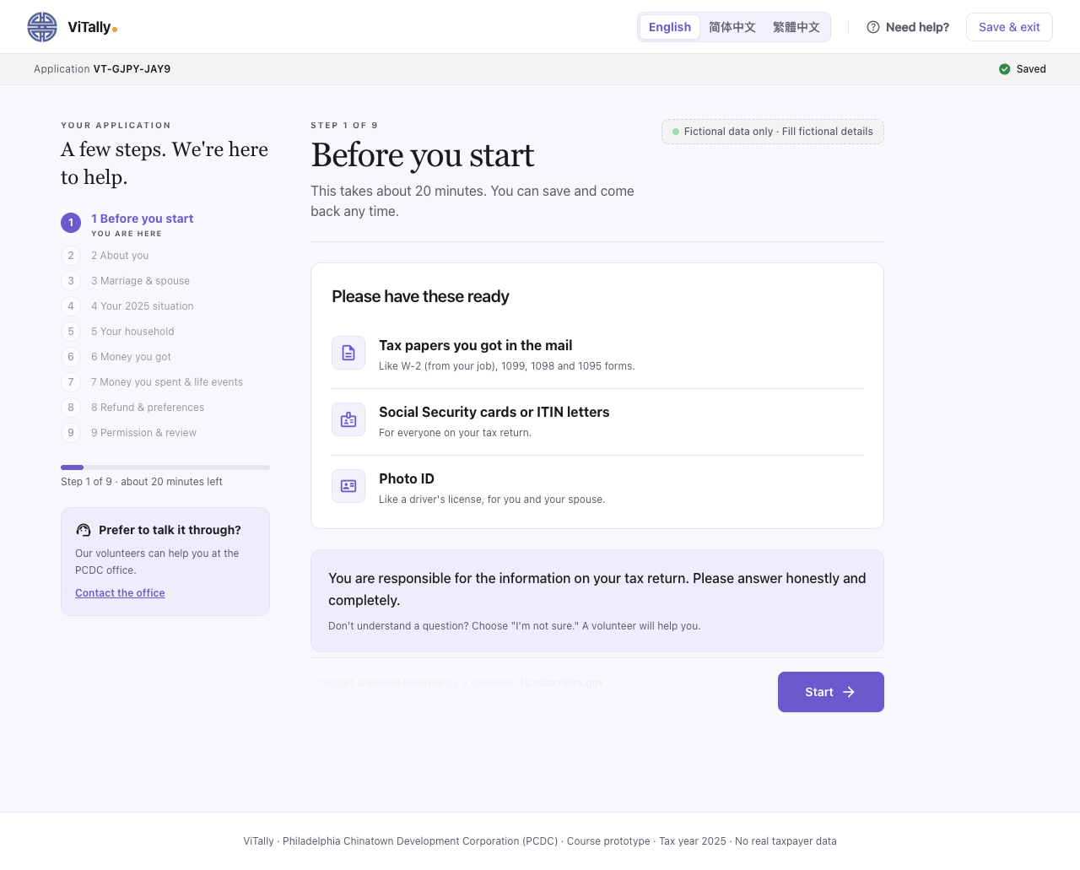
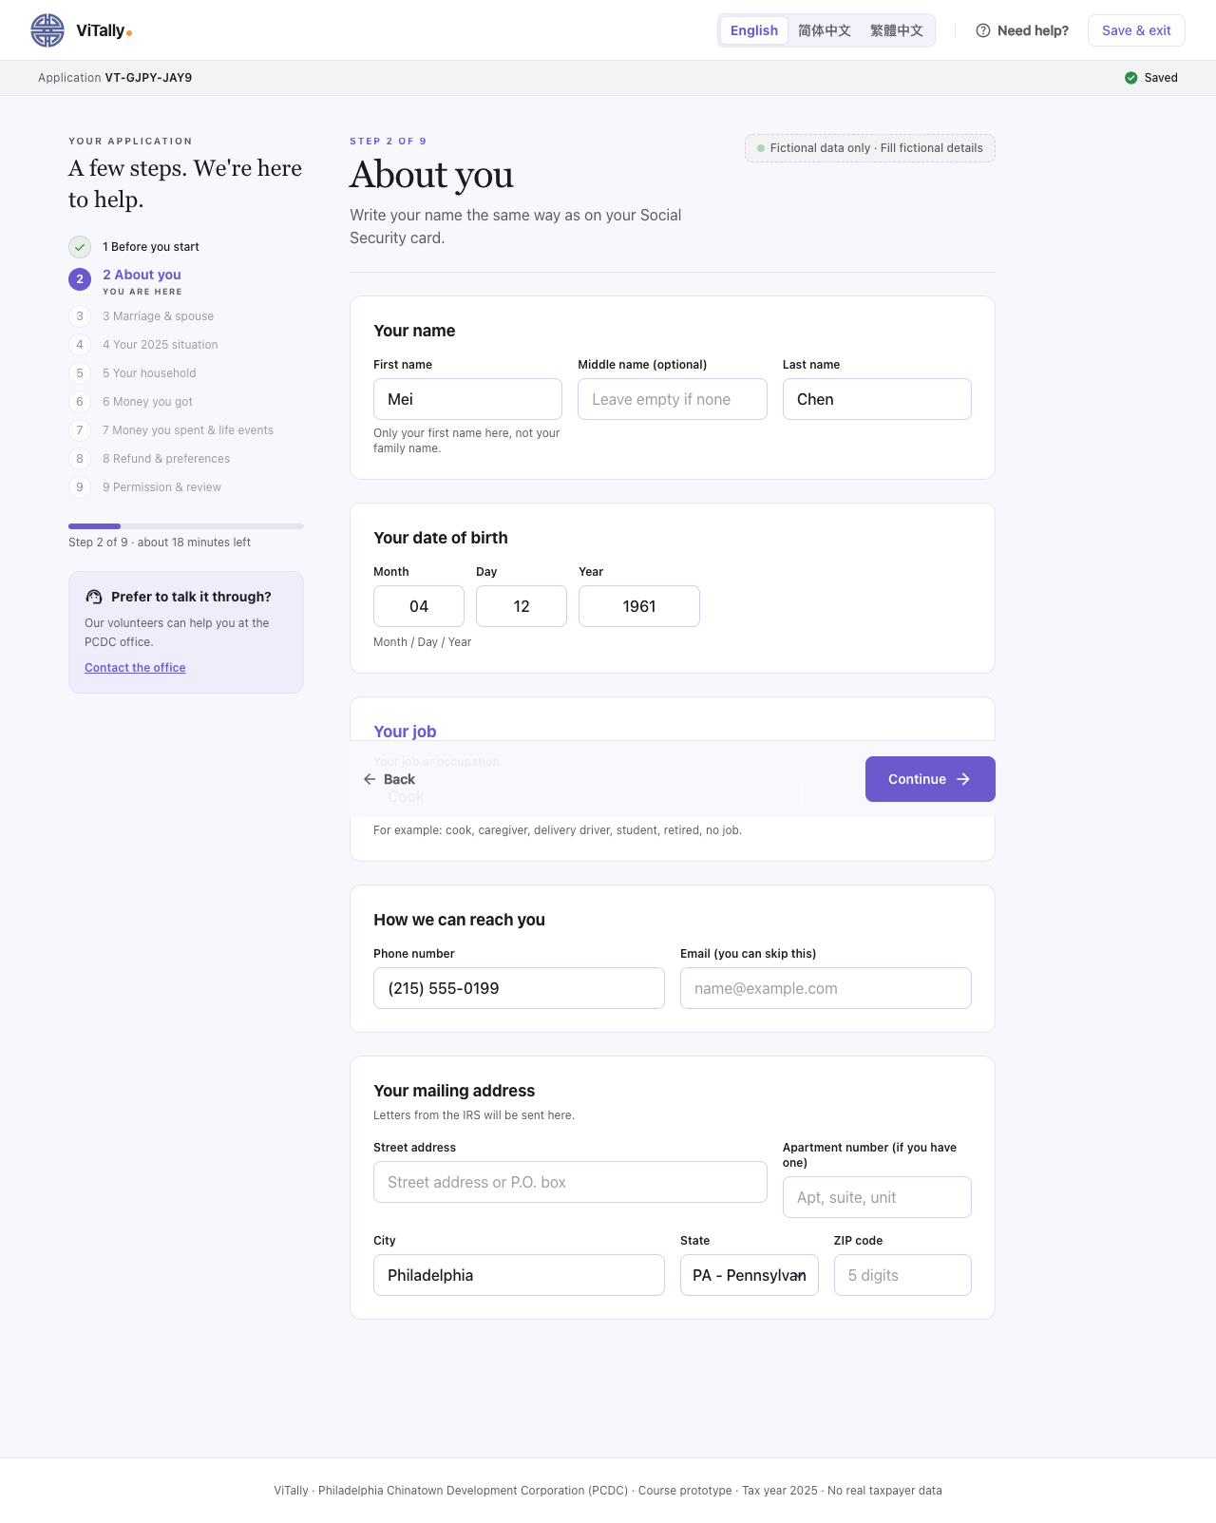
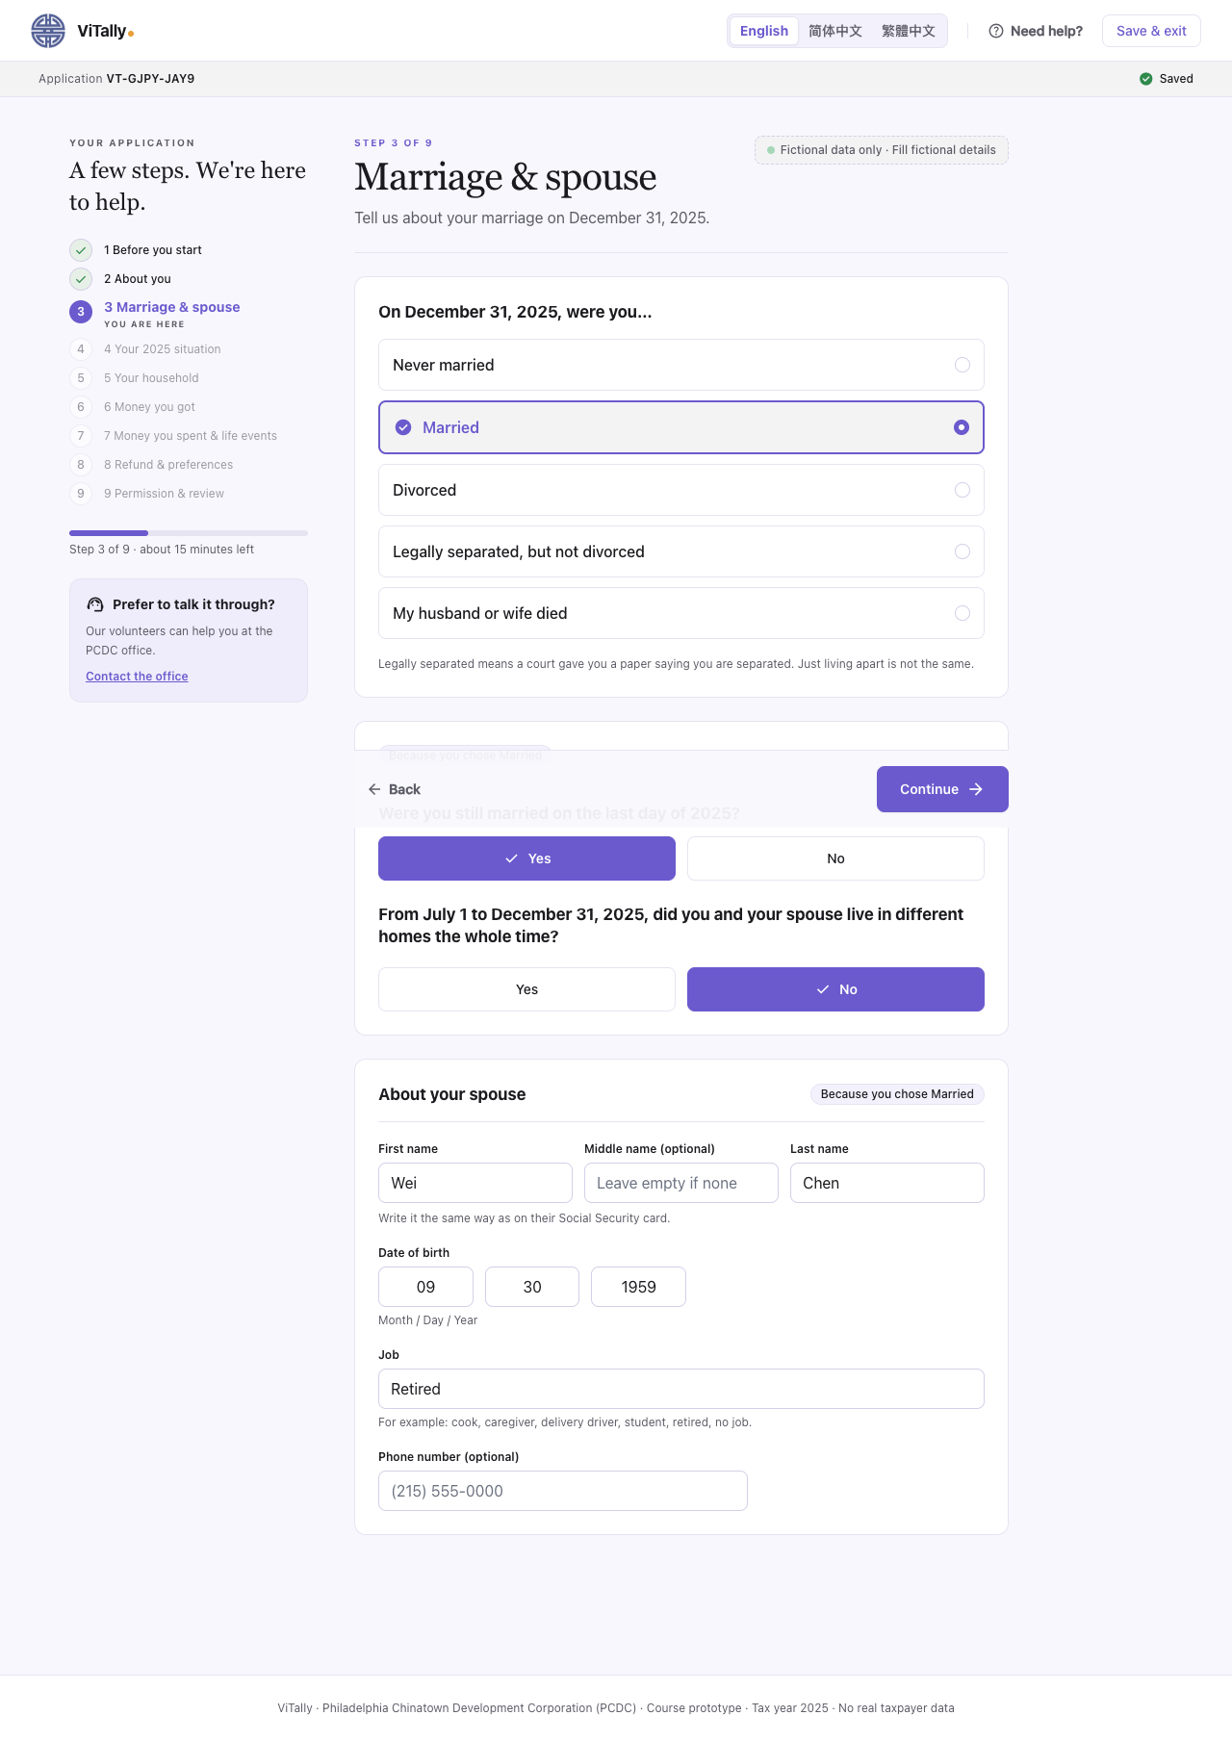
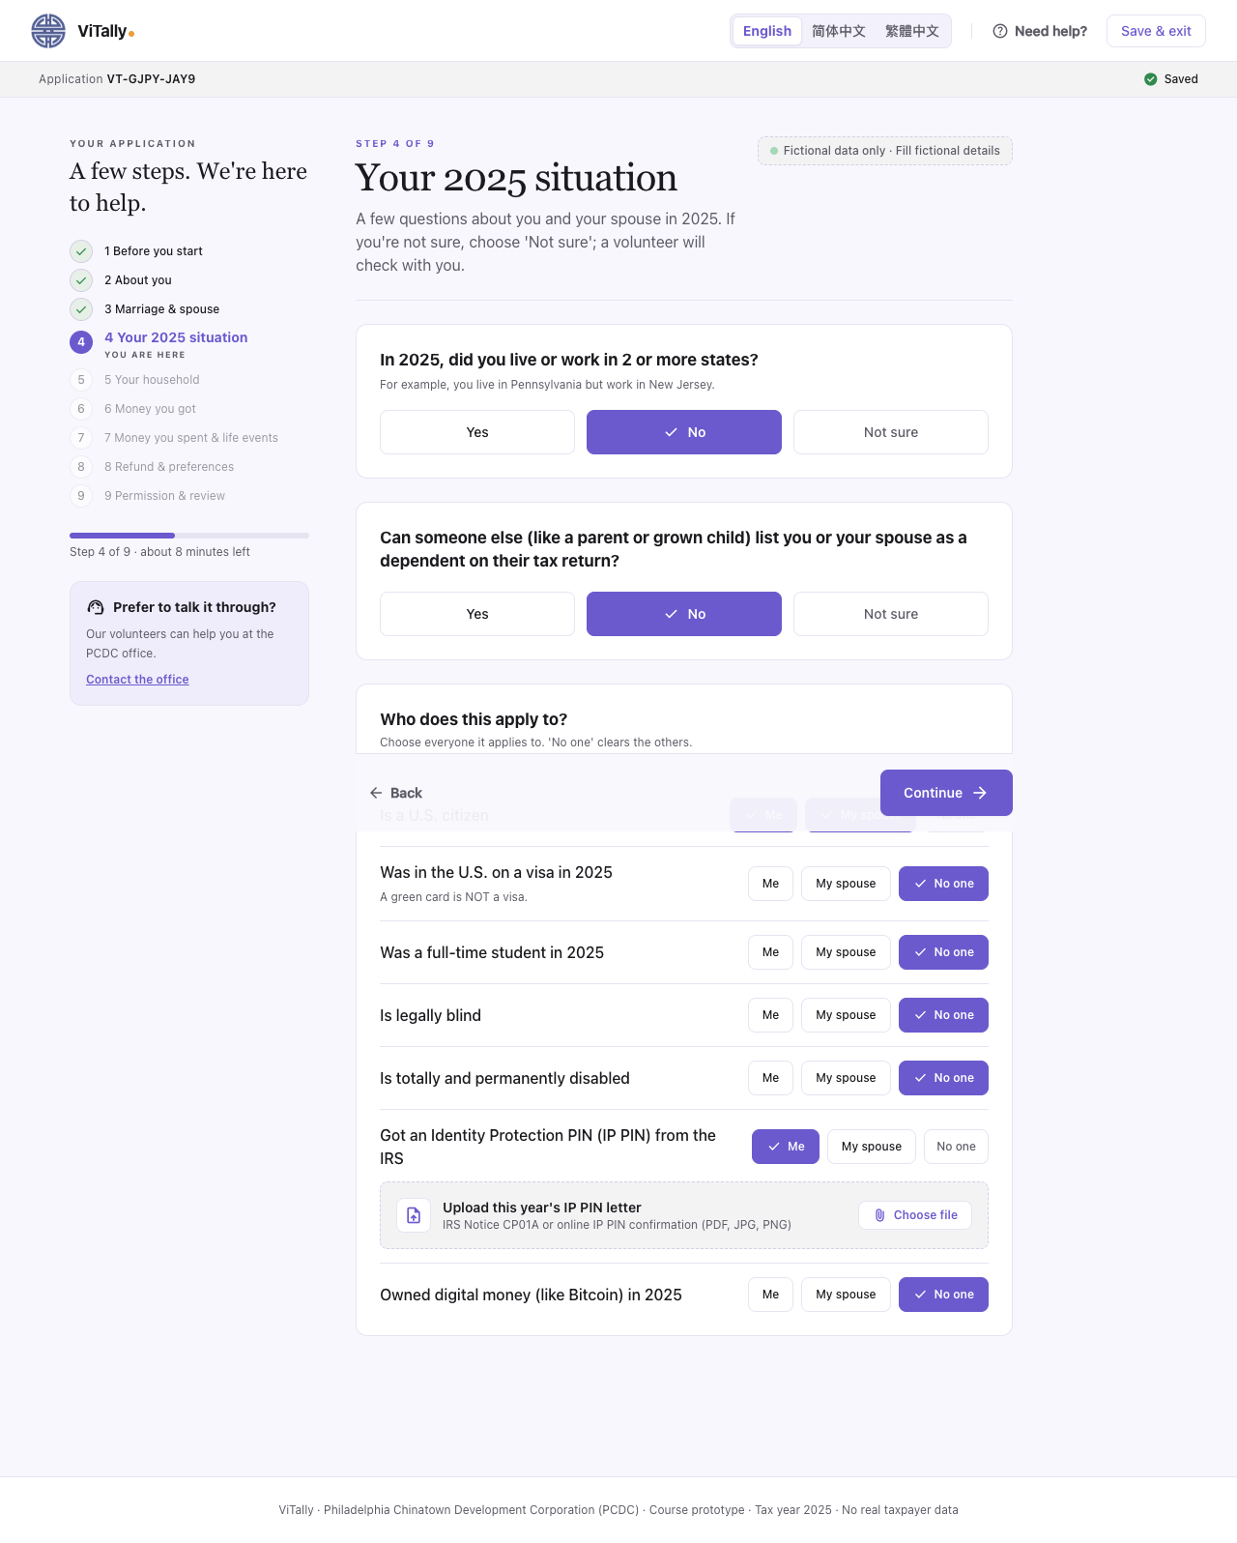
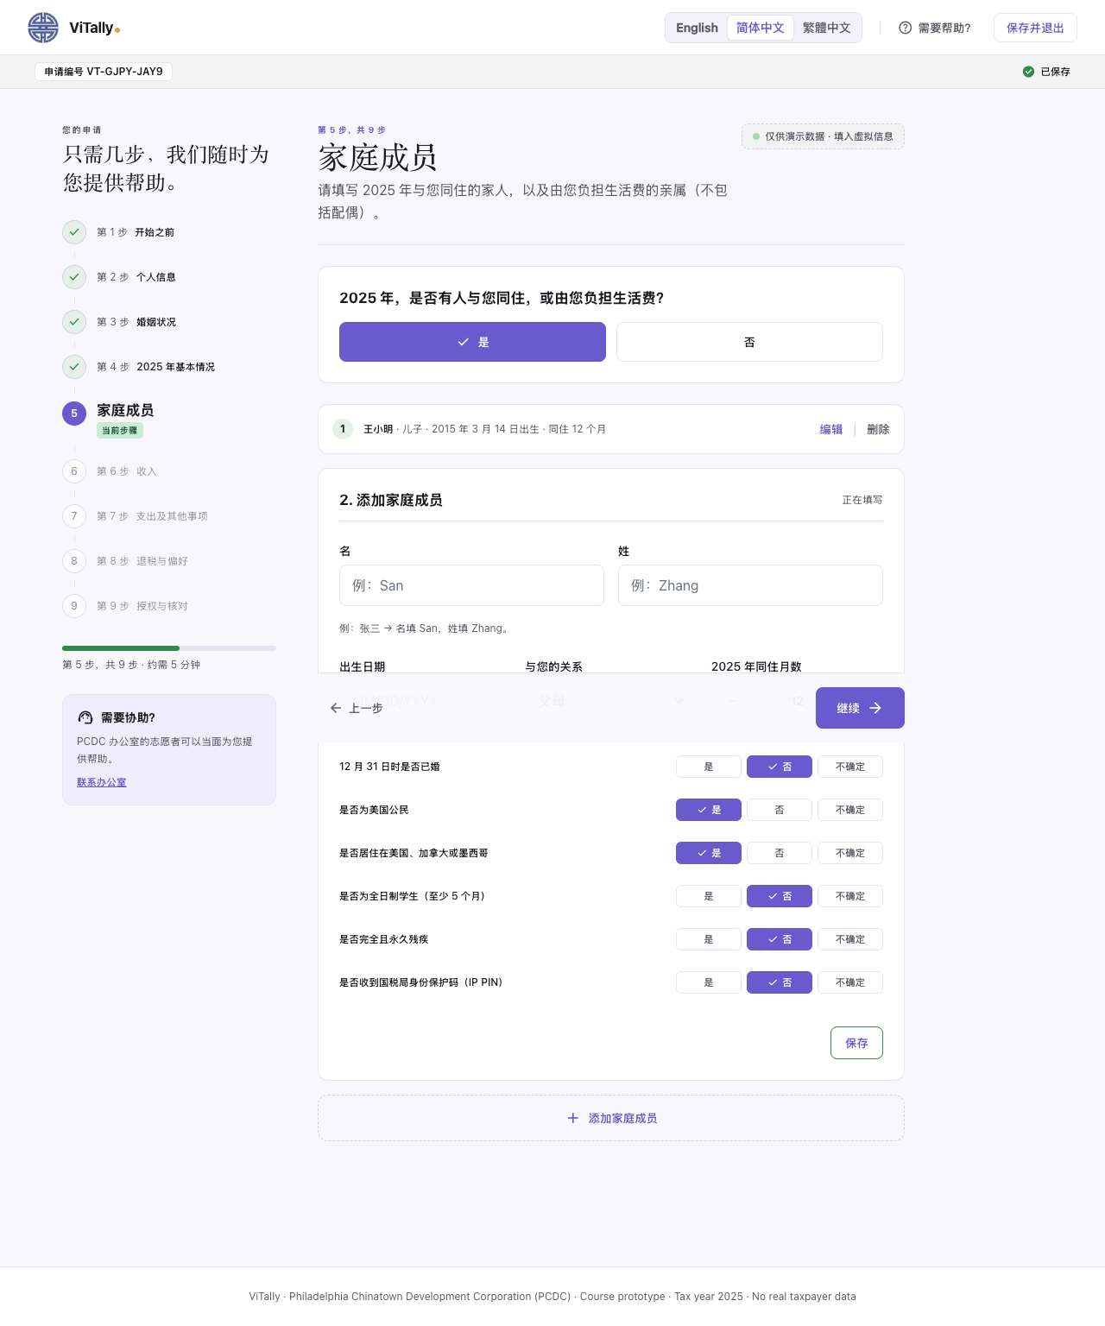
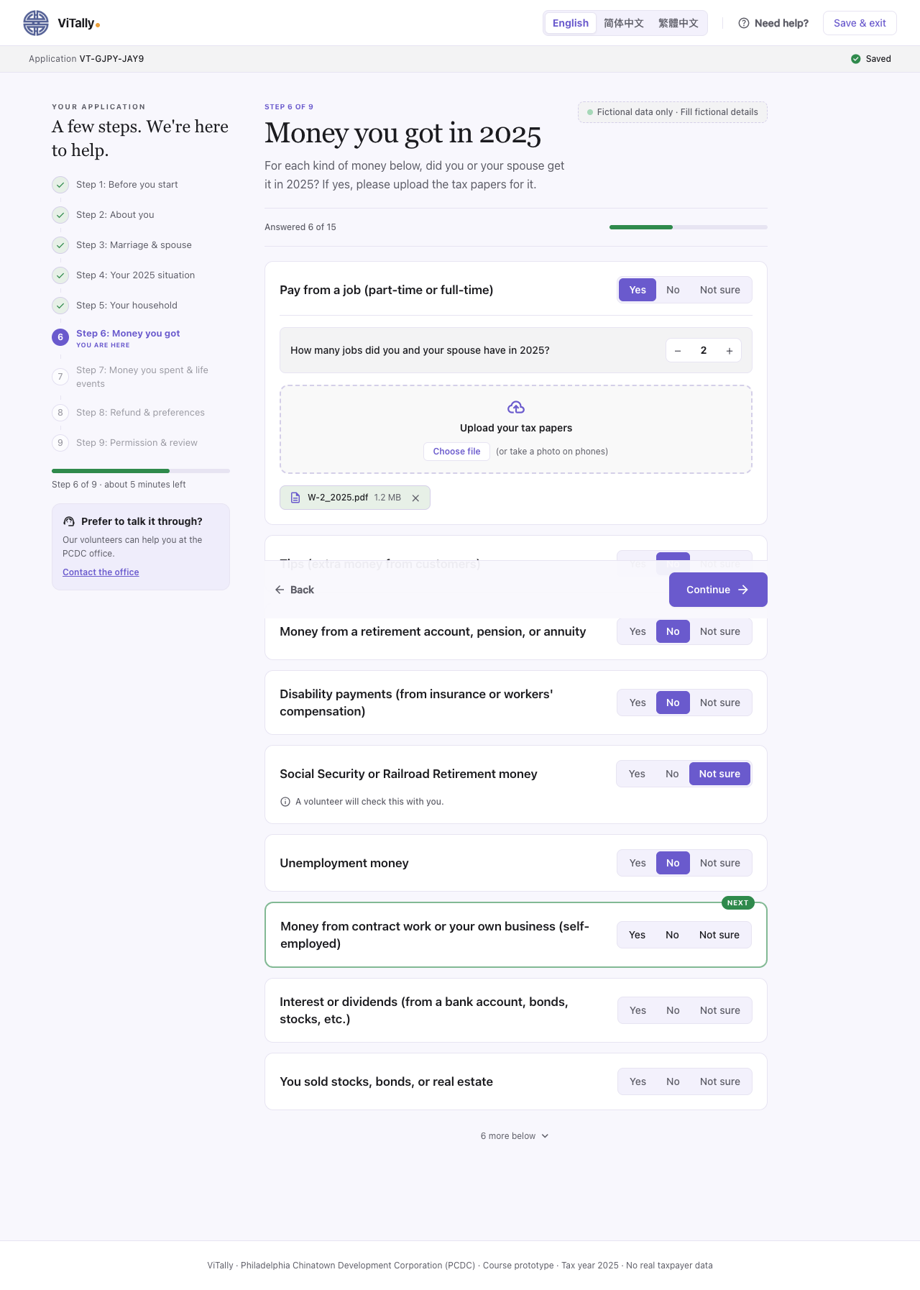
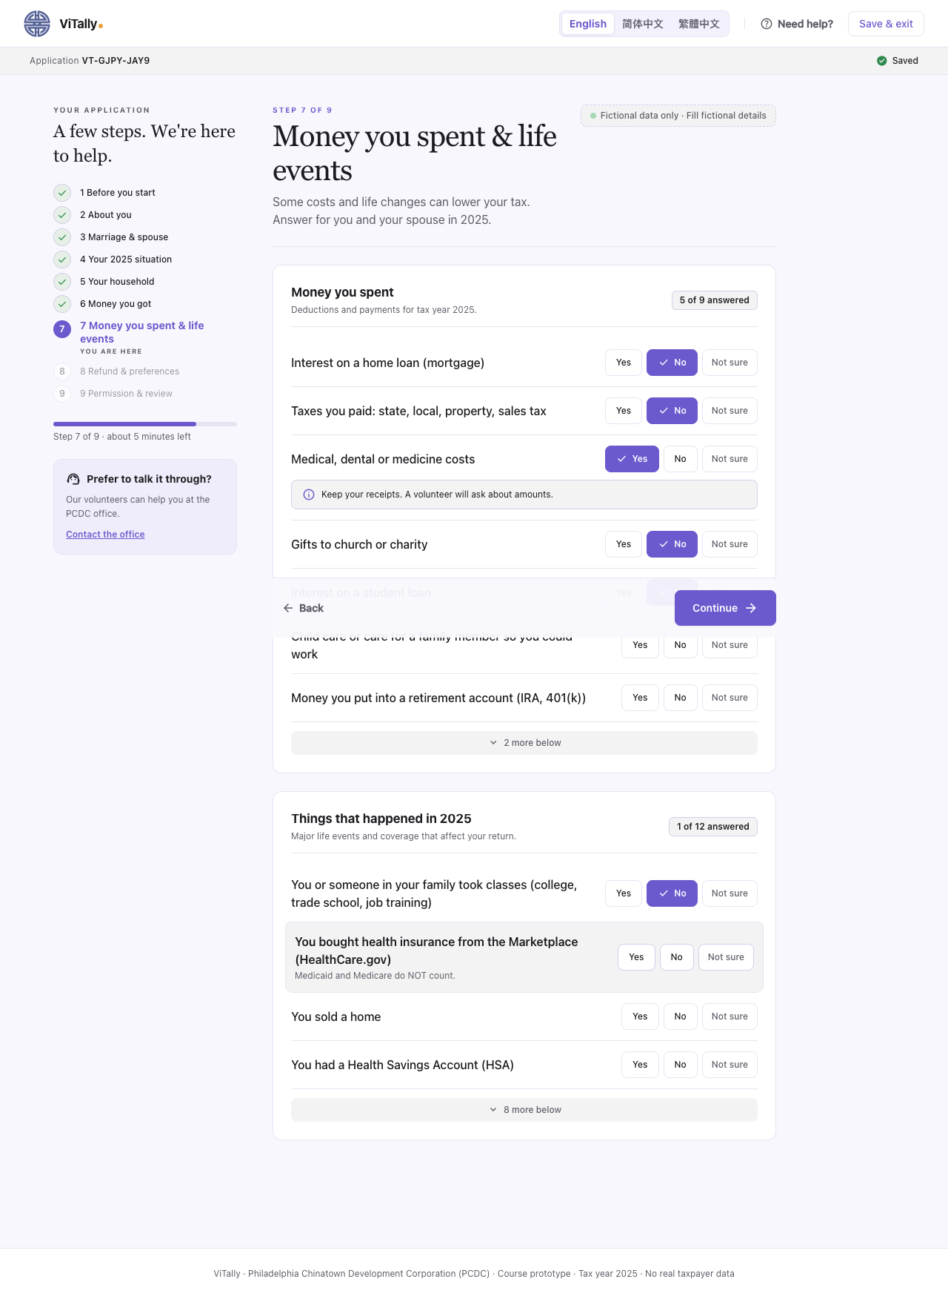
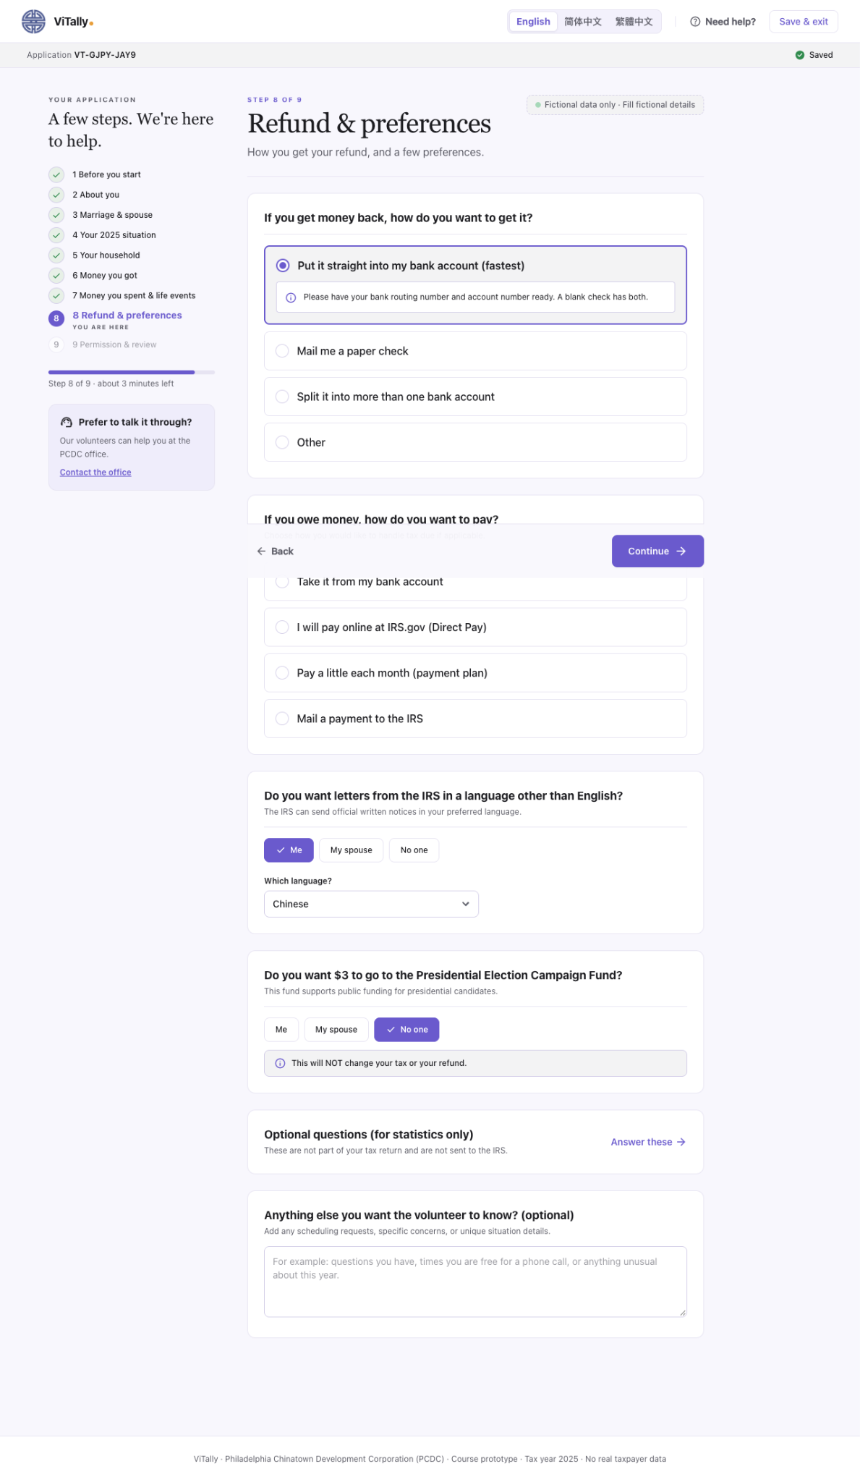
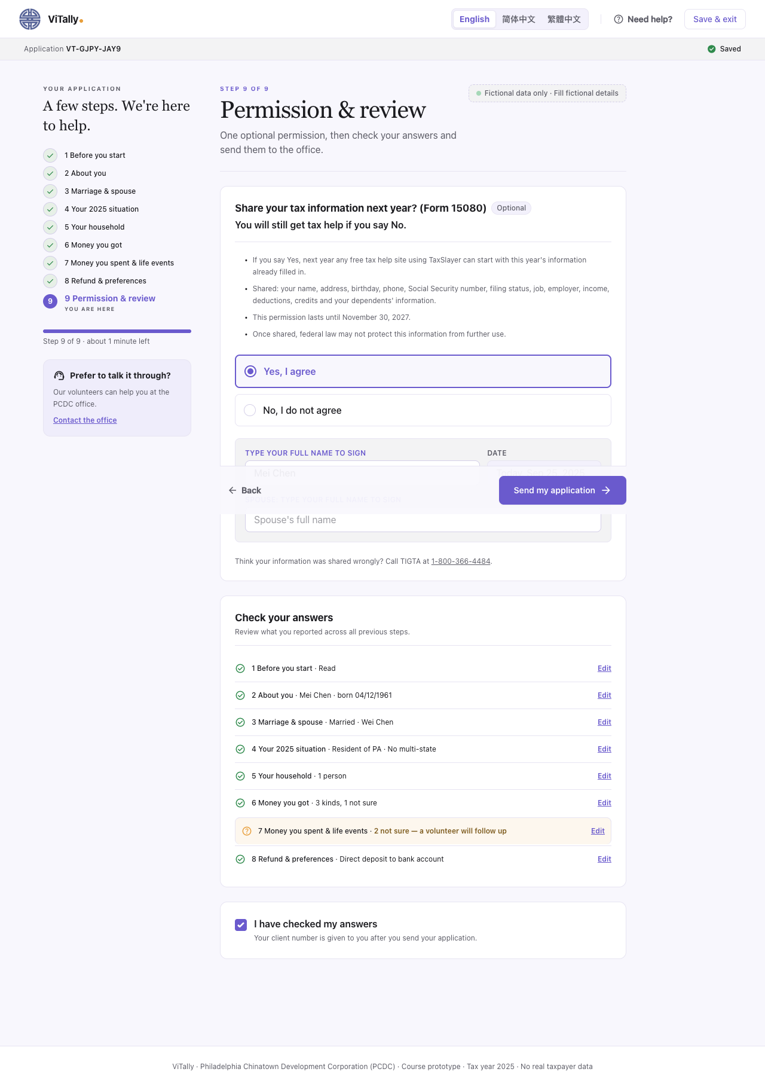

Mobile Intake
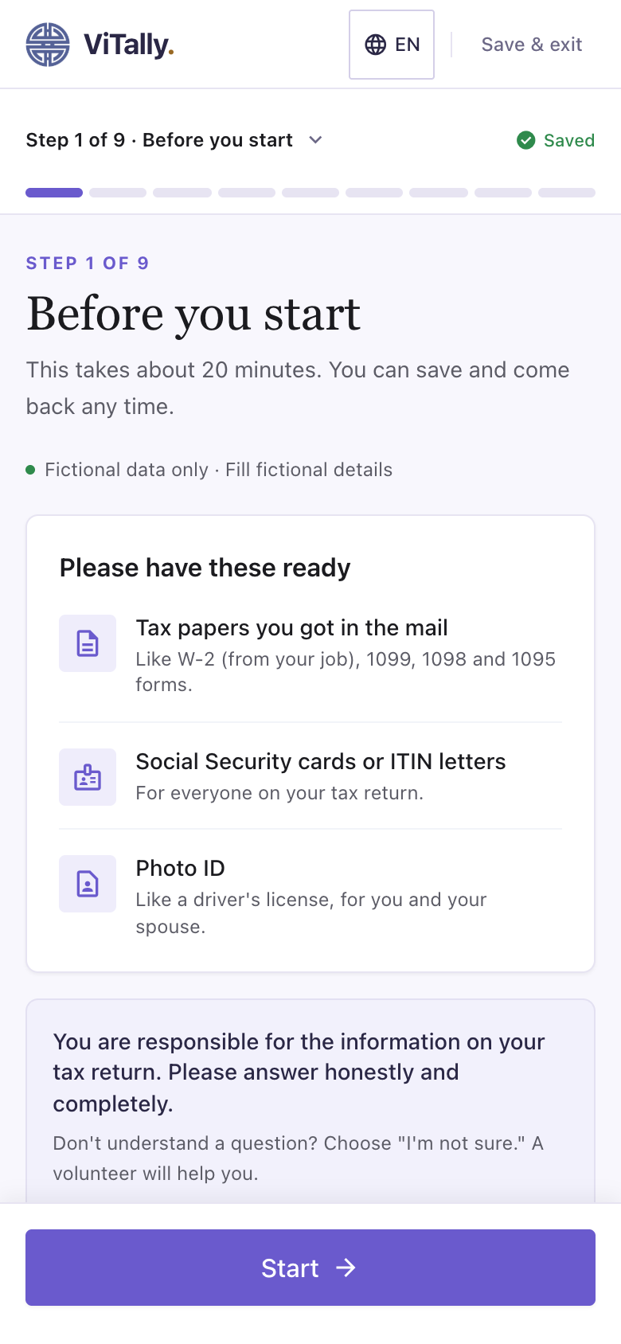
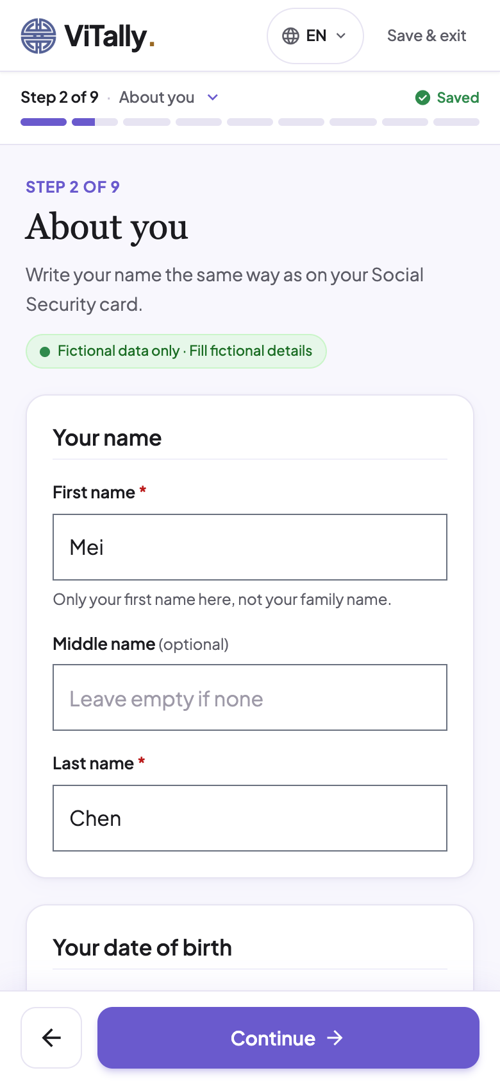
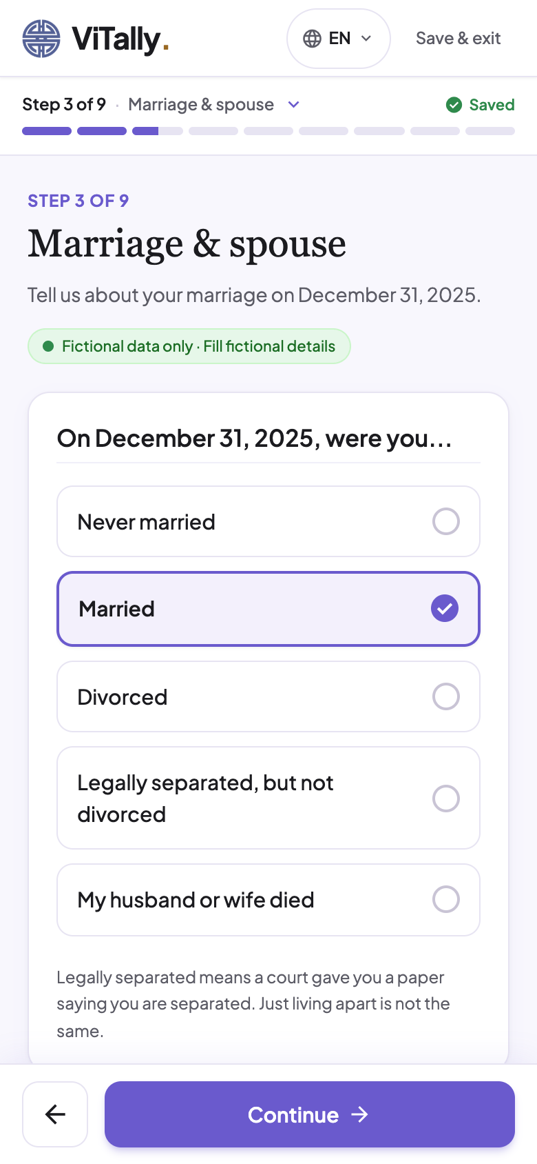
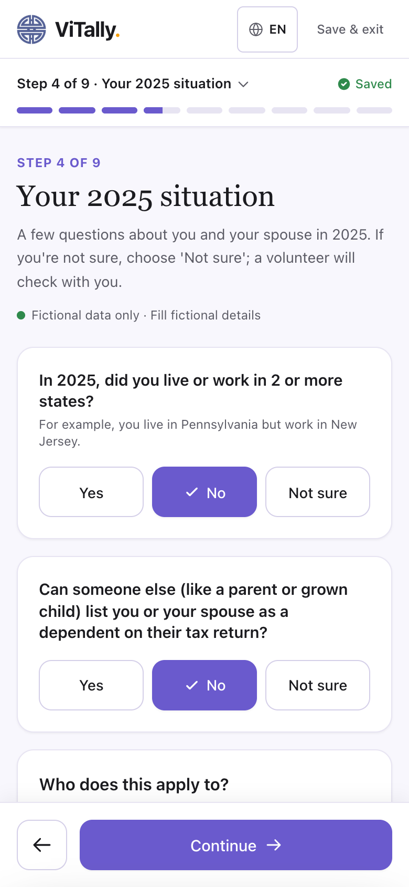
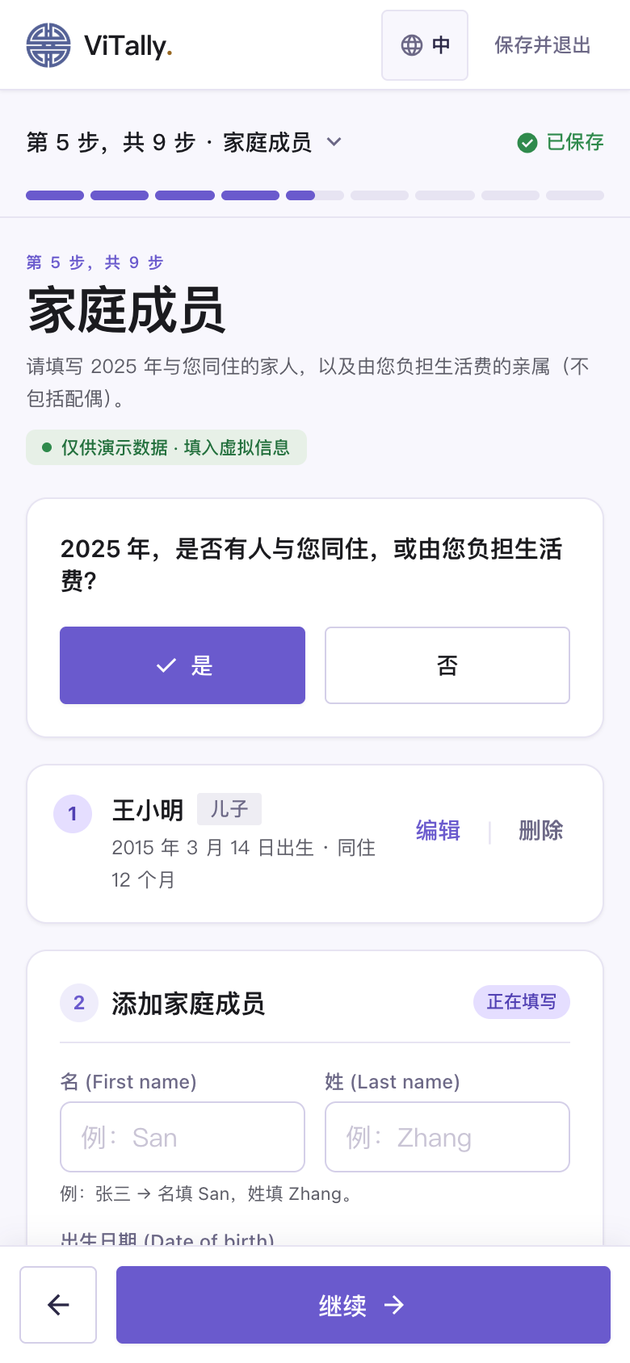

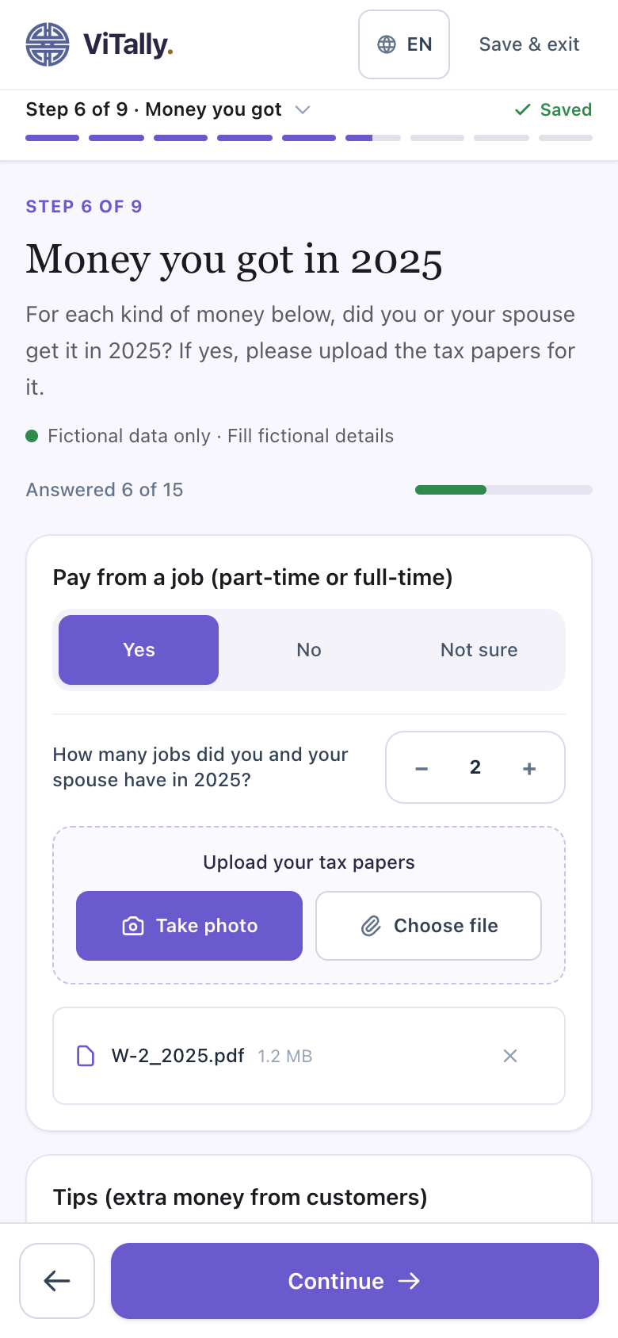
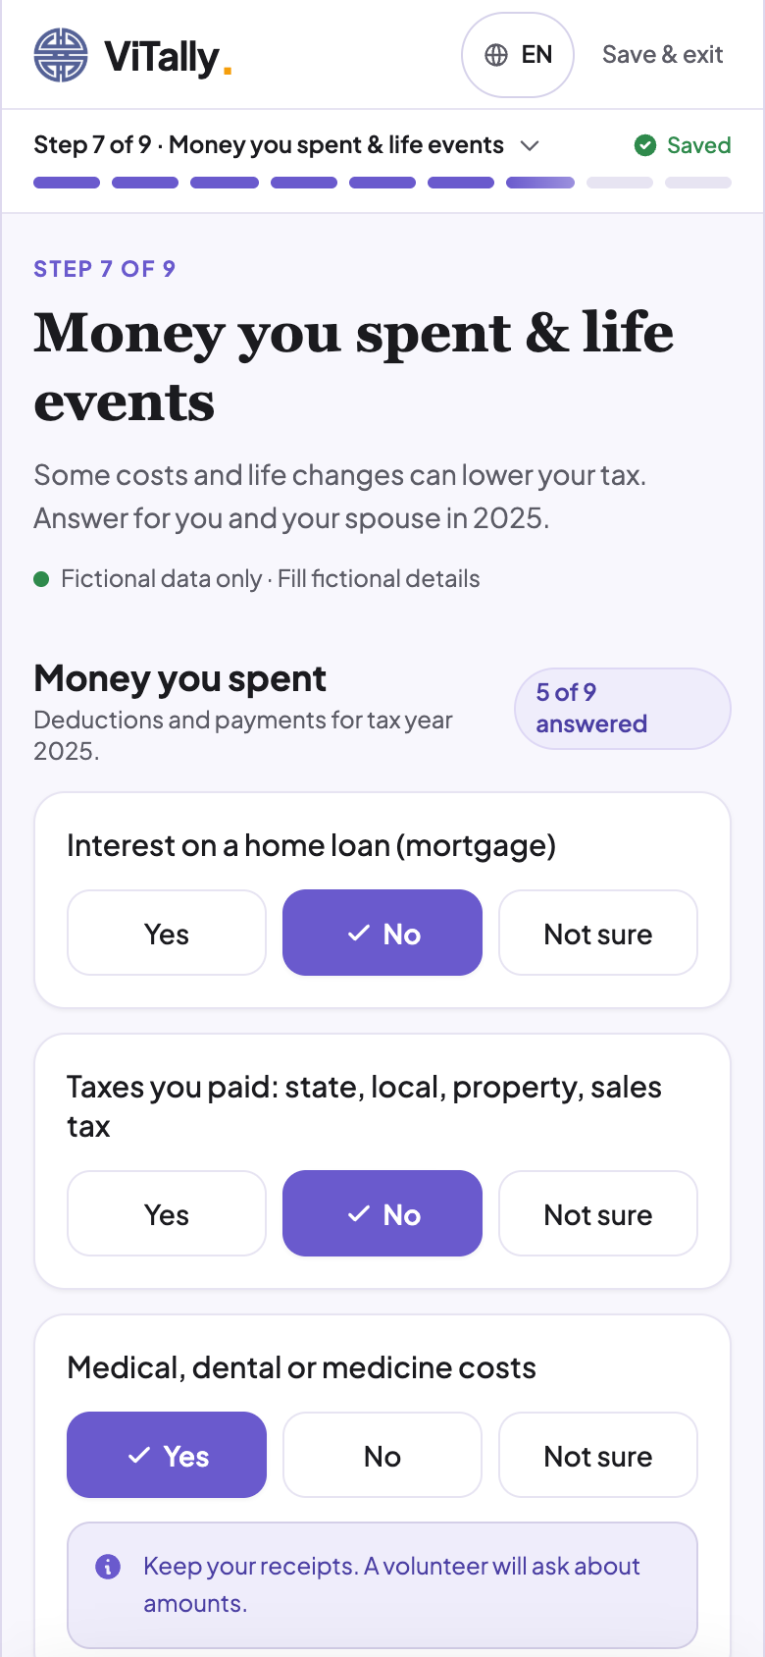
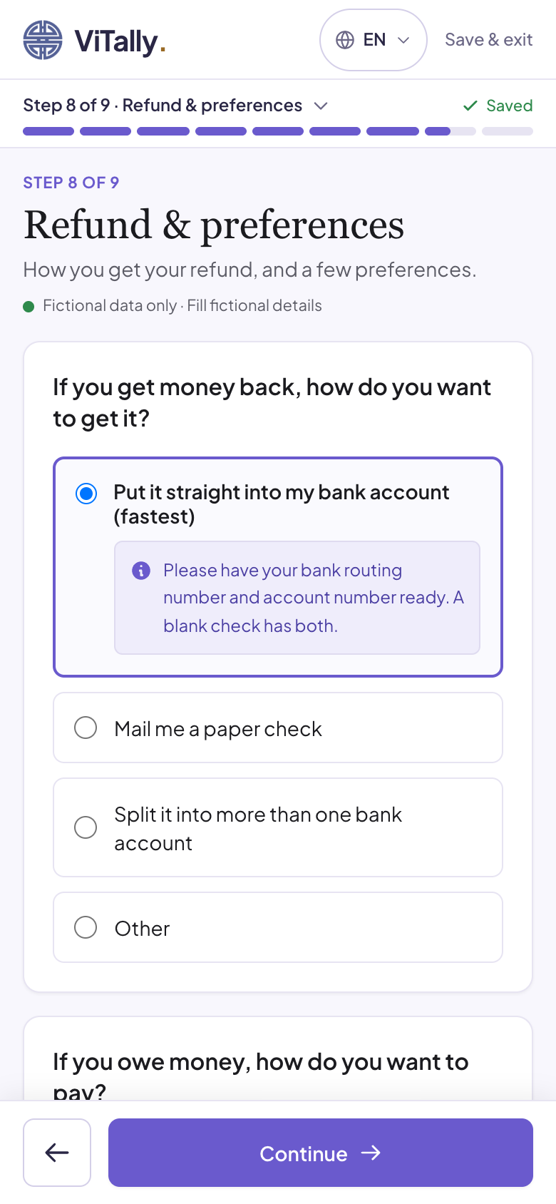
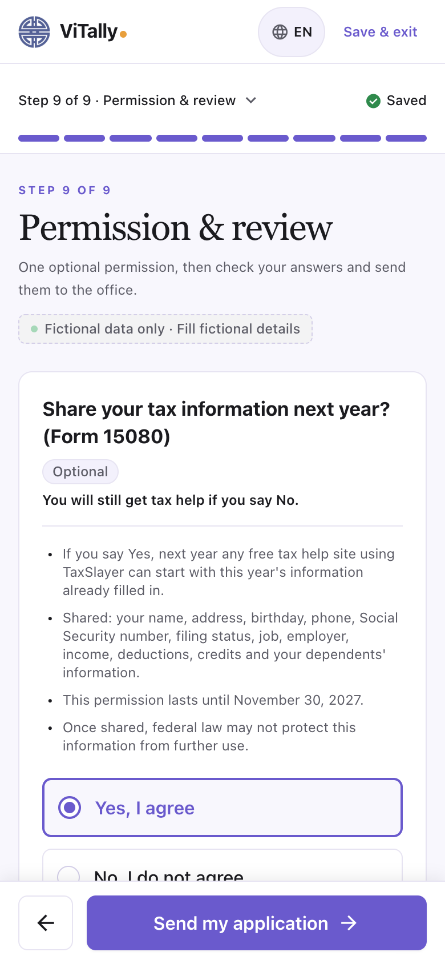
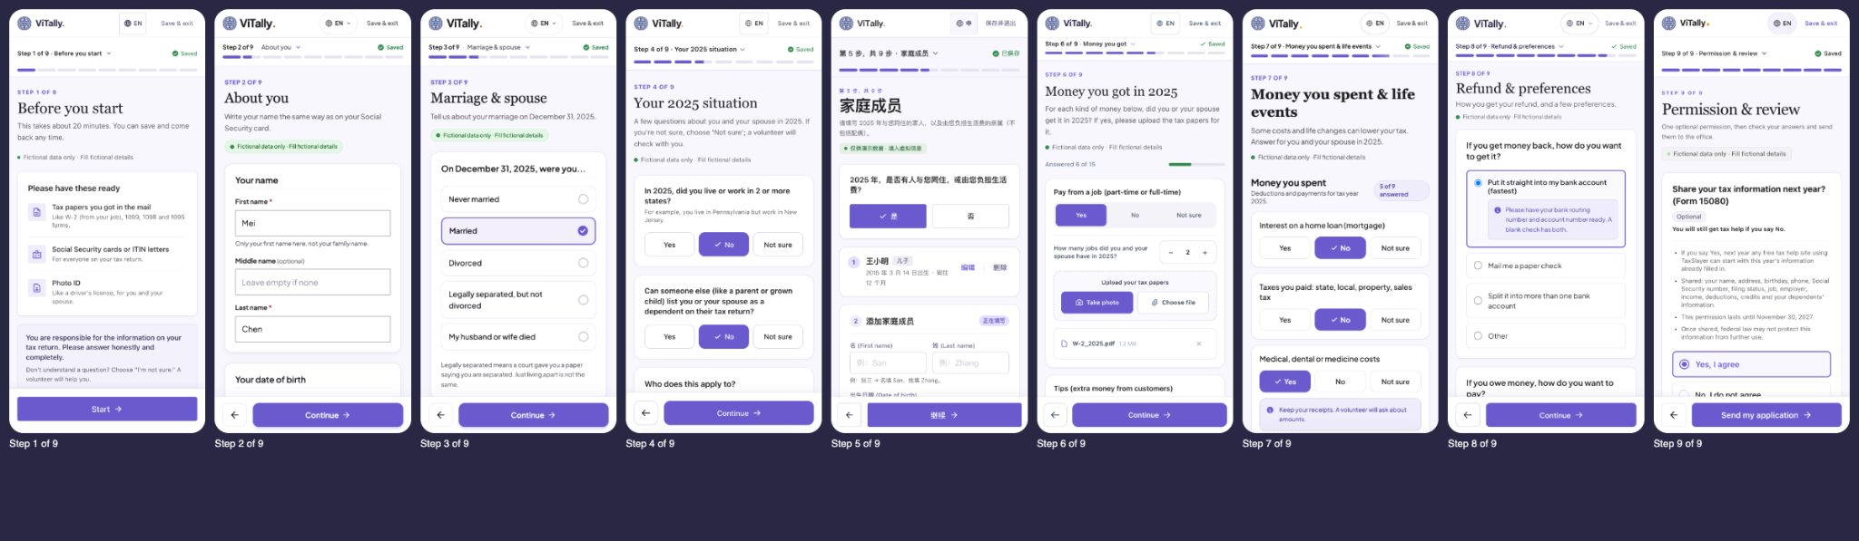

Work Board
Volunteer’s Work Board

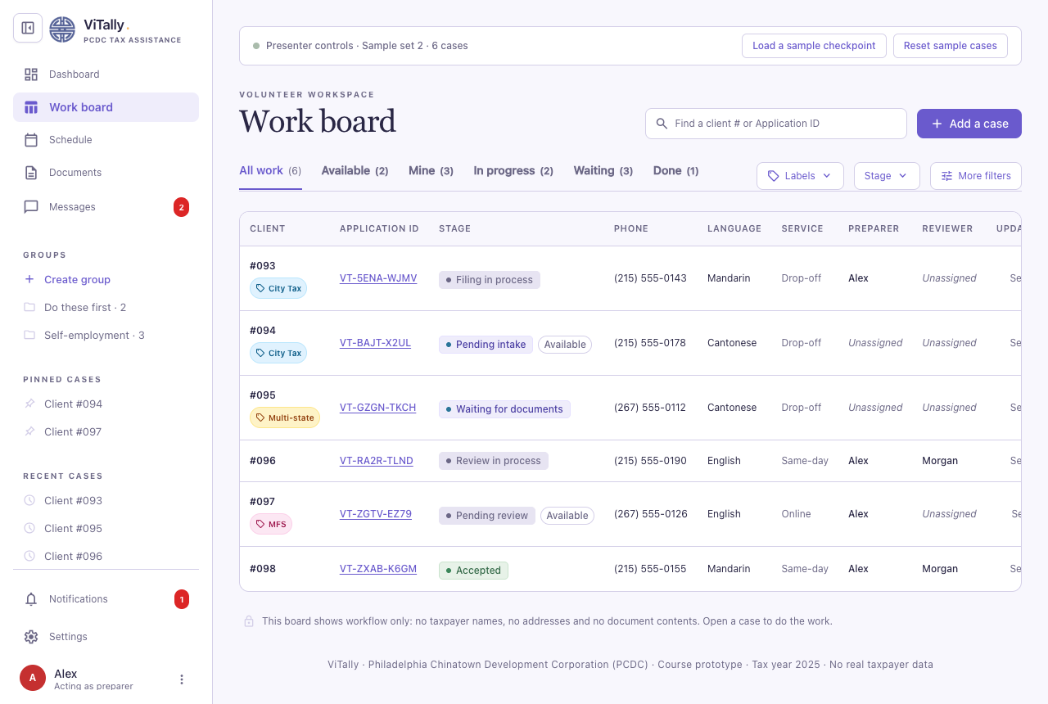

Case Detail
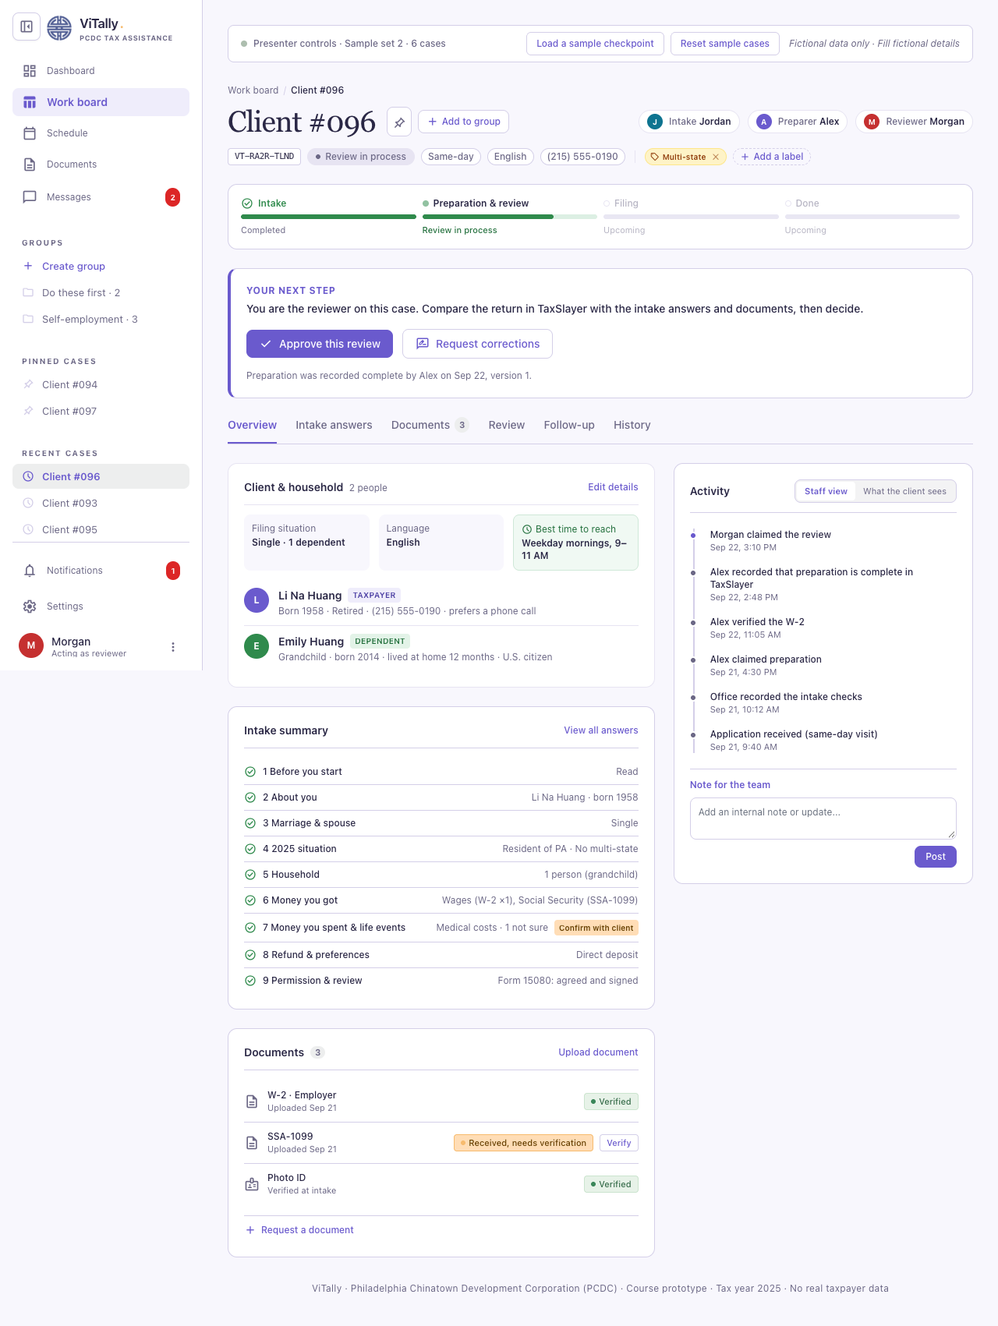

`Add a case`
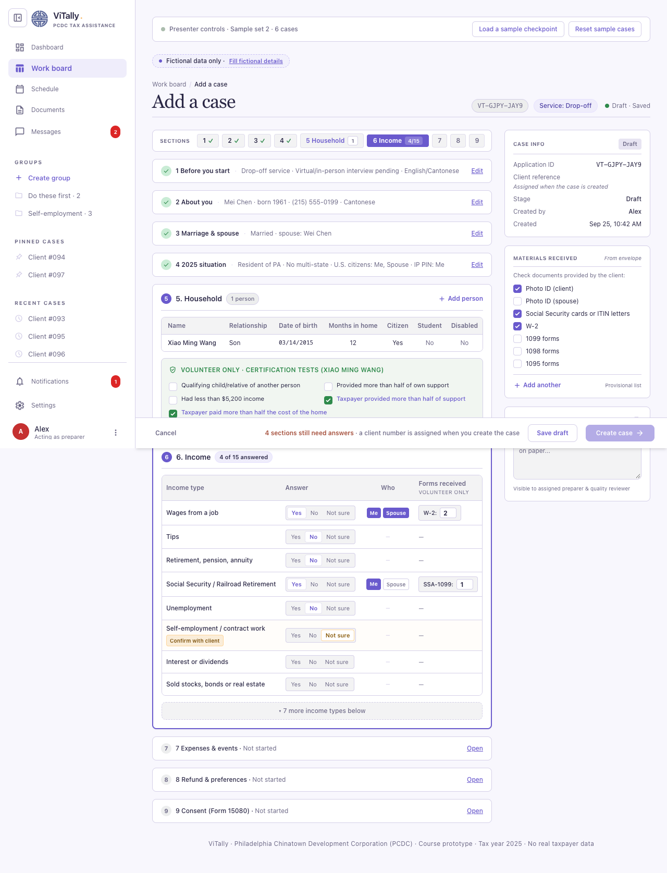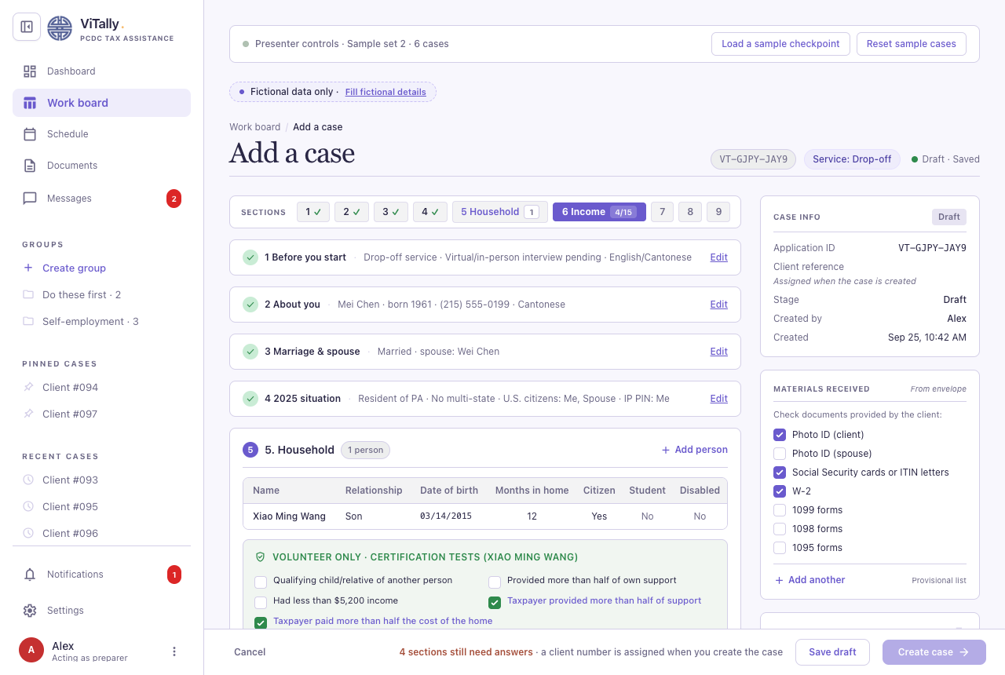

Dashboard
Volunteer Dashboard

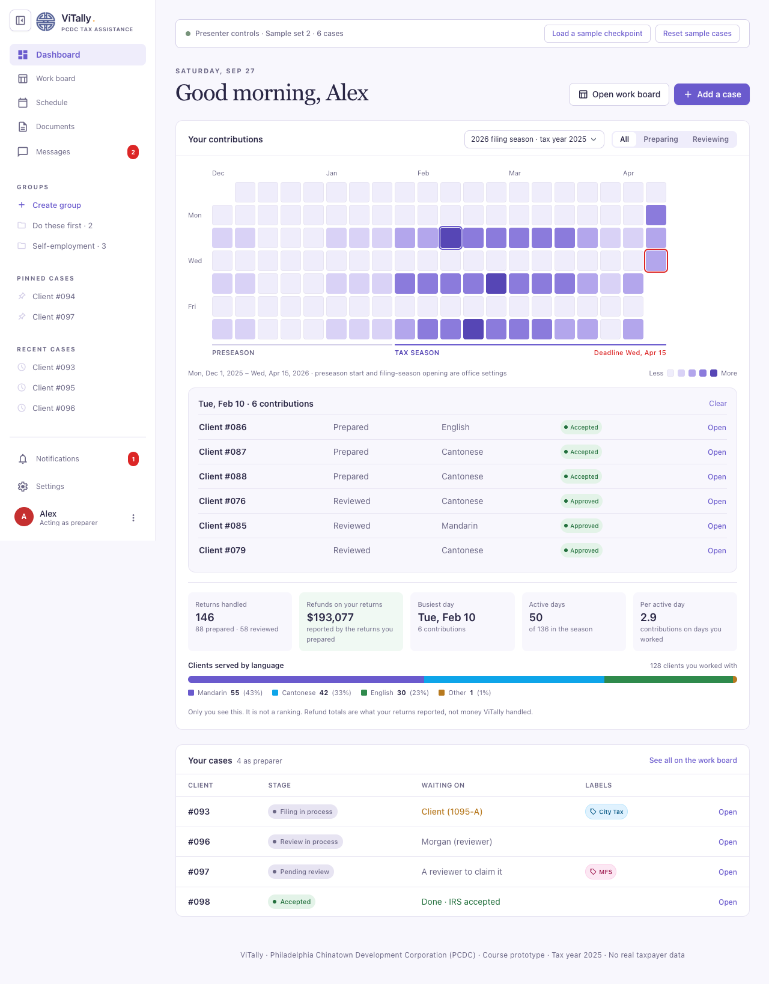
Admin Dashboard
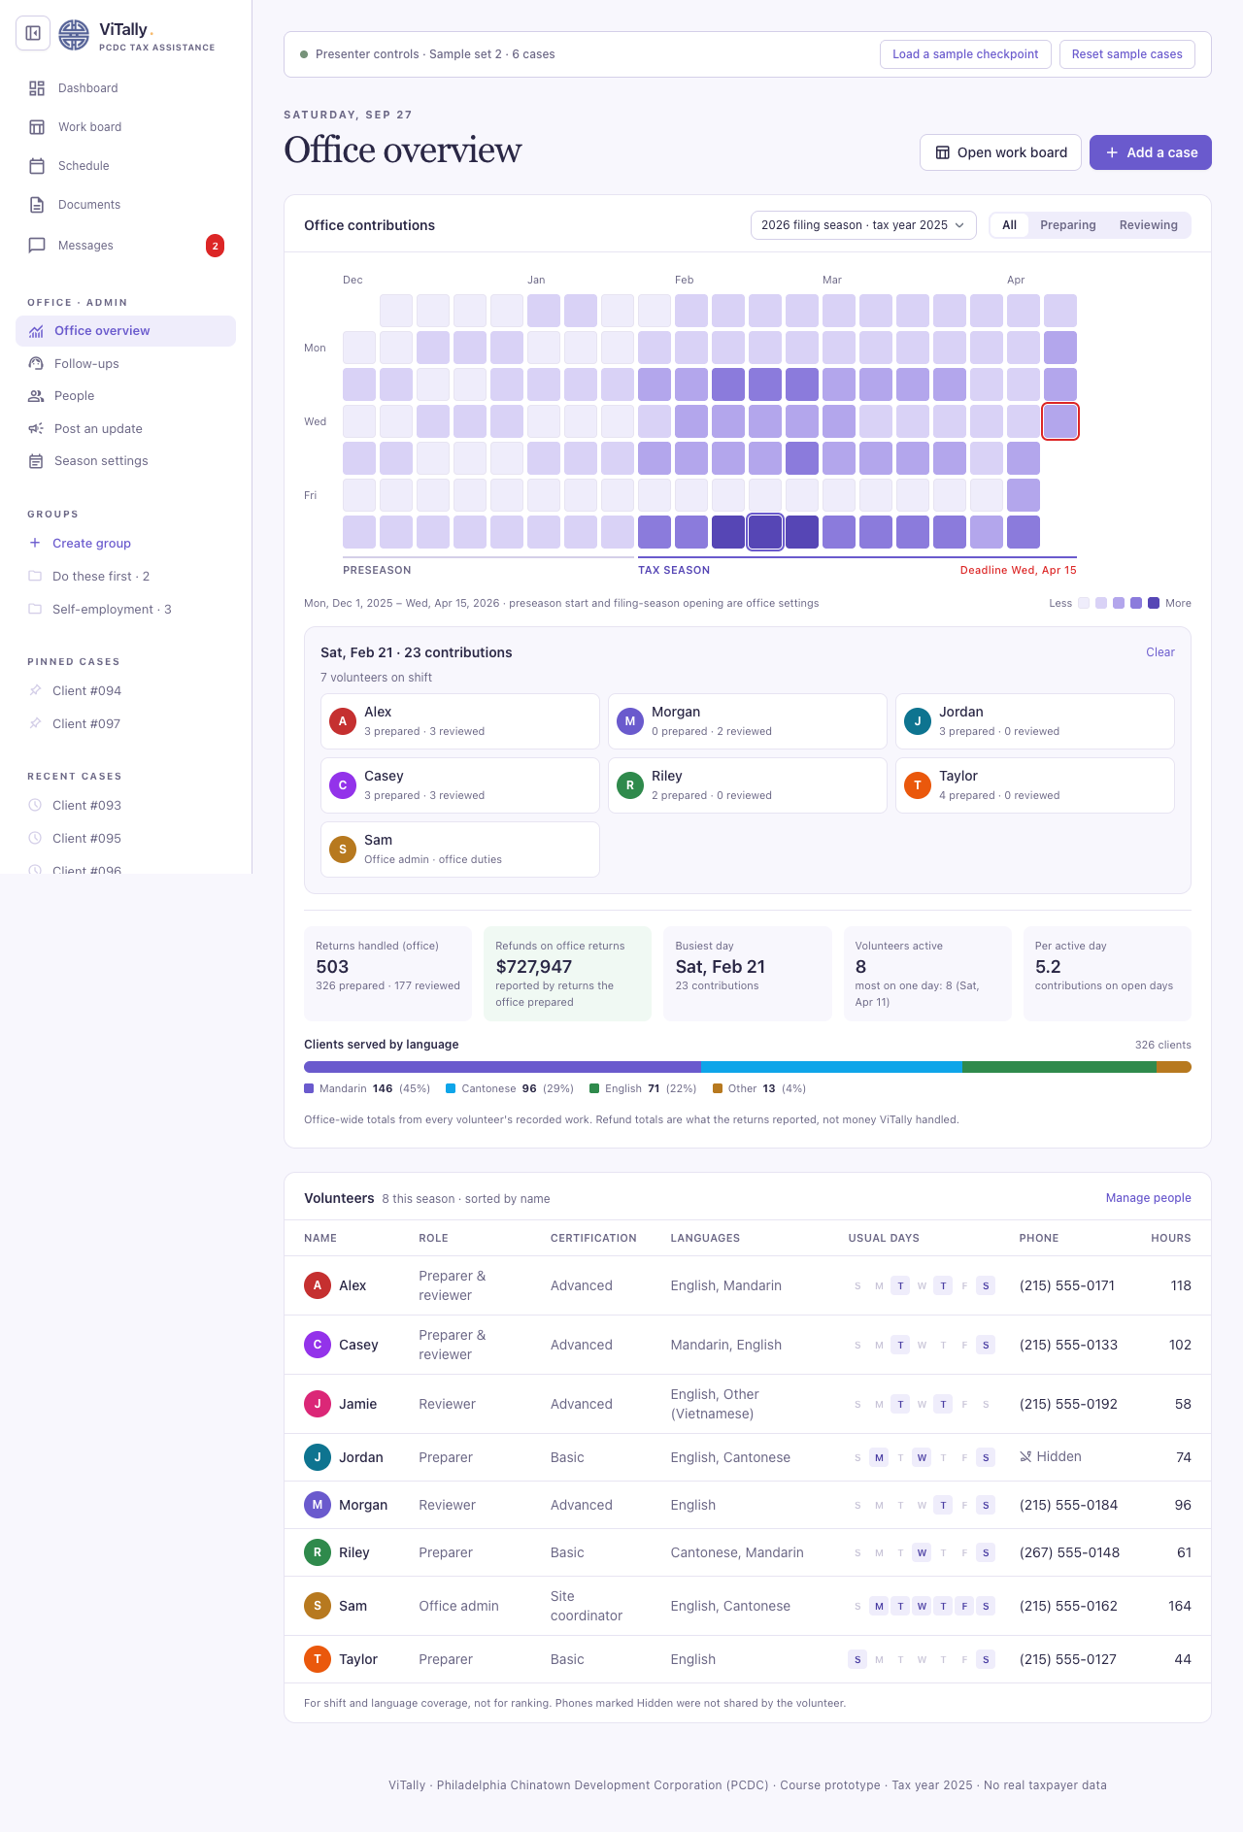

Admin Screens
Follow-up
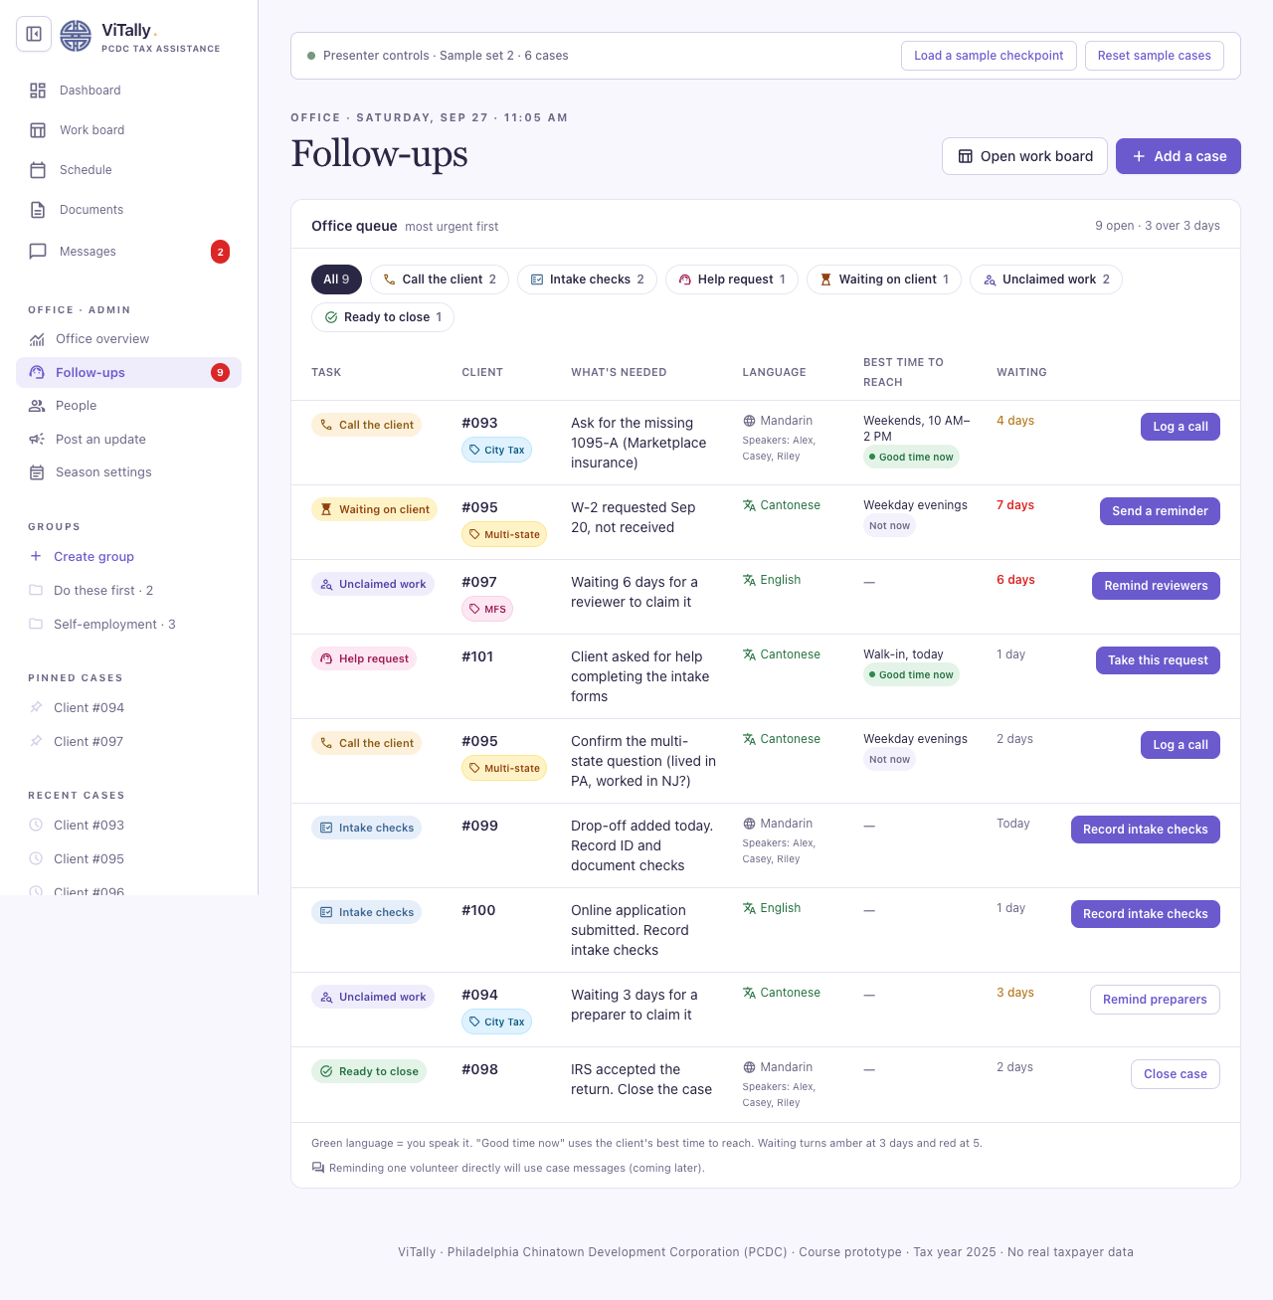
Admin - post an notification

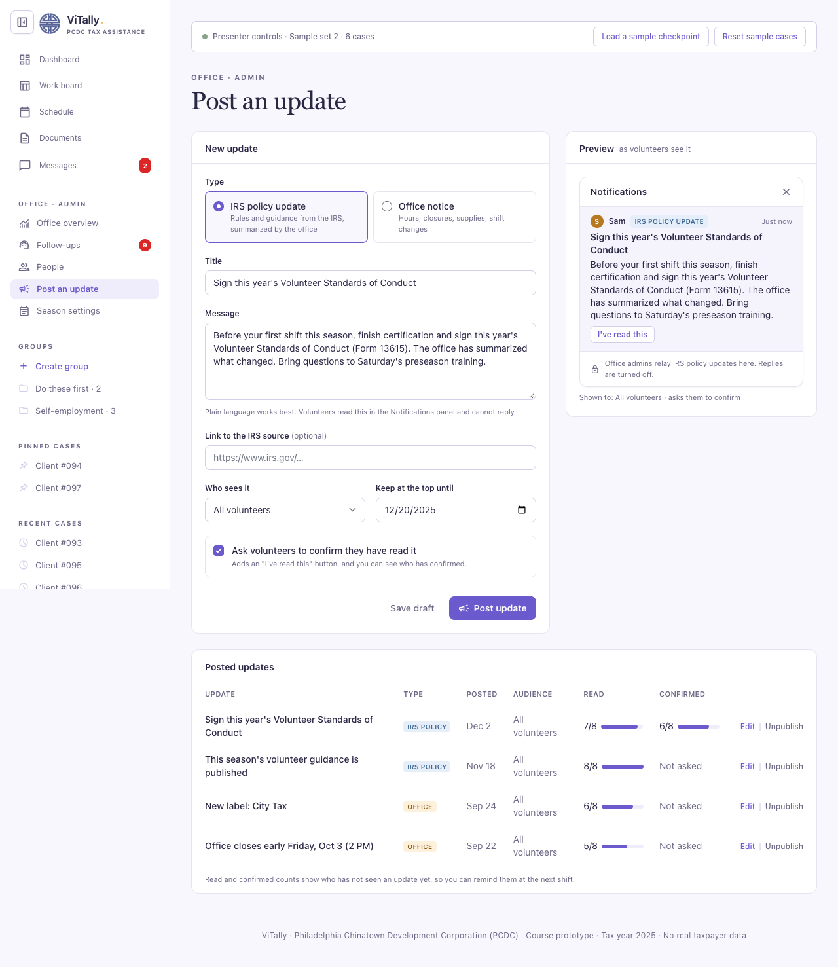

Admin - Season Setting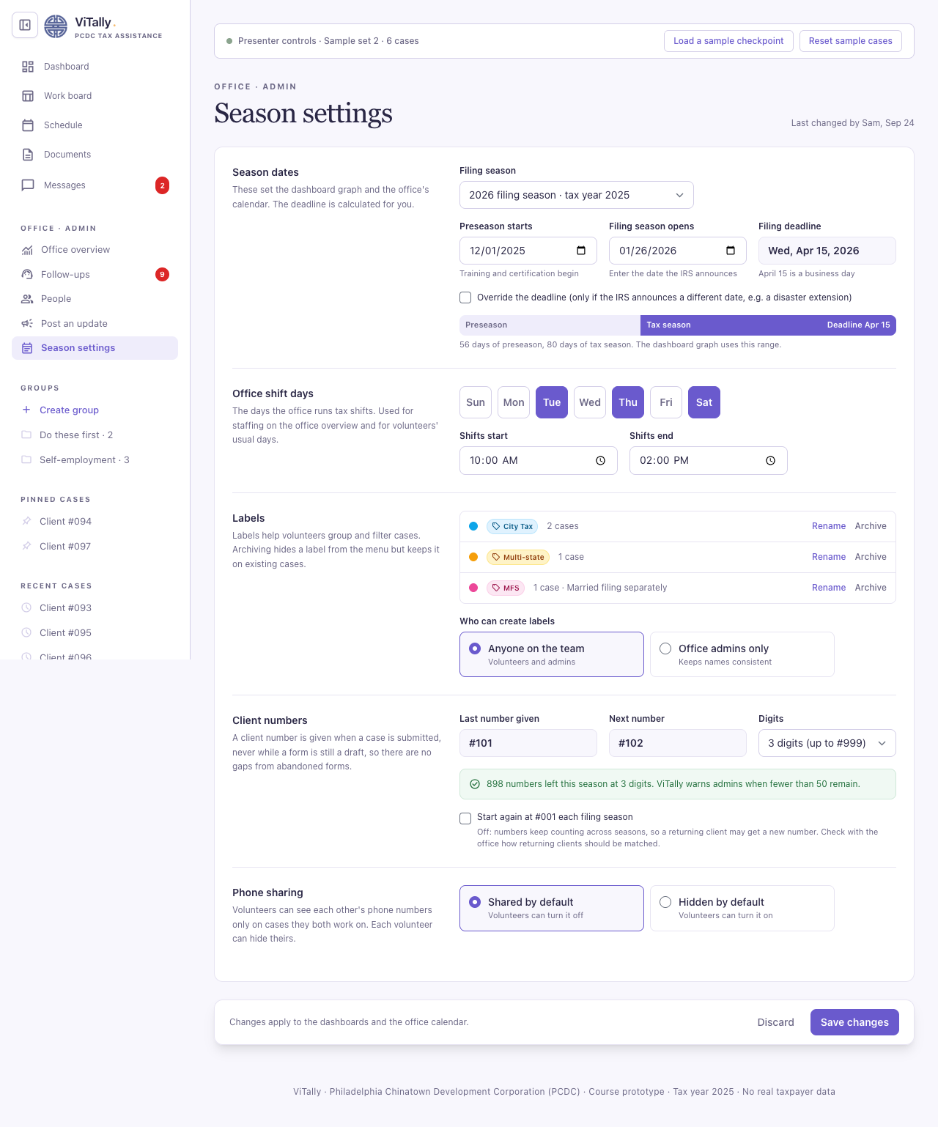
Admin - People
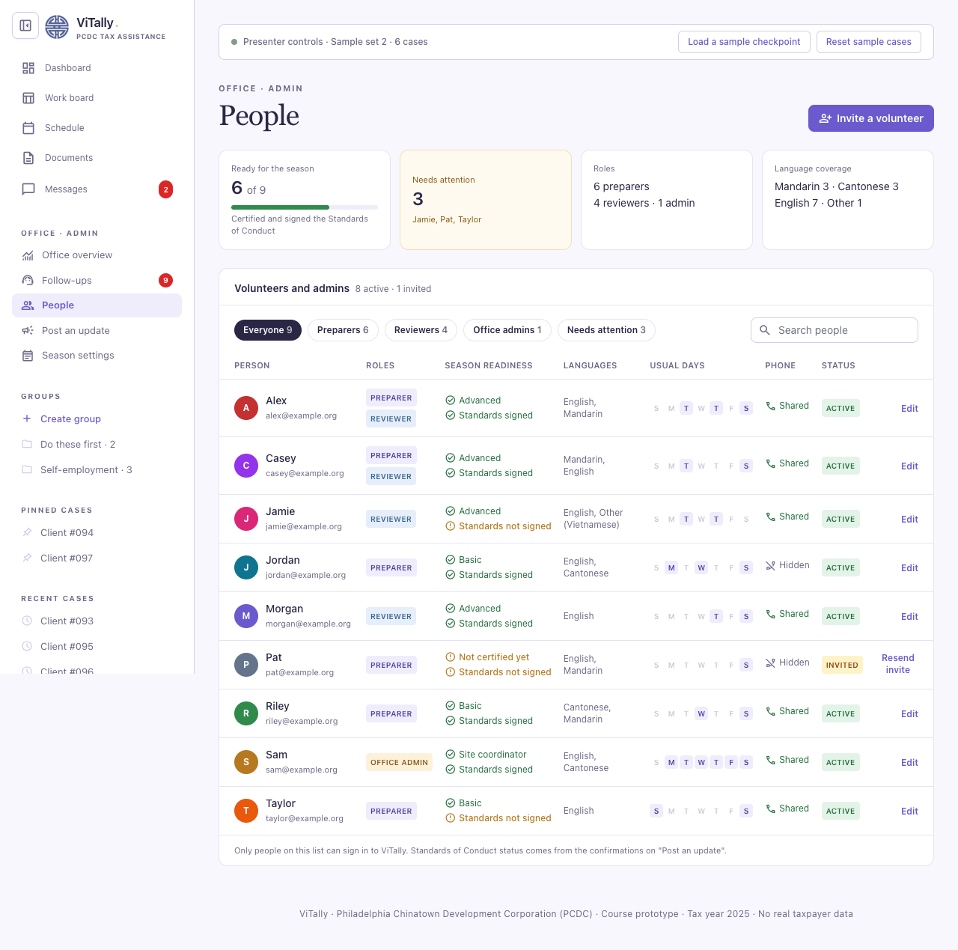
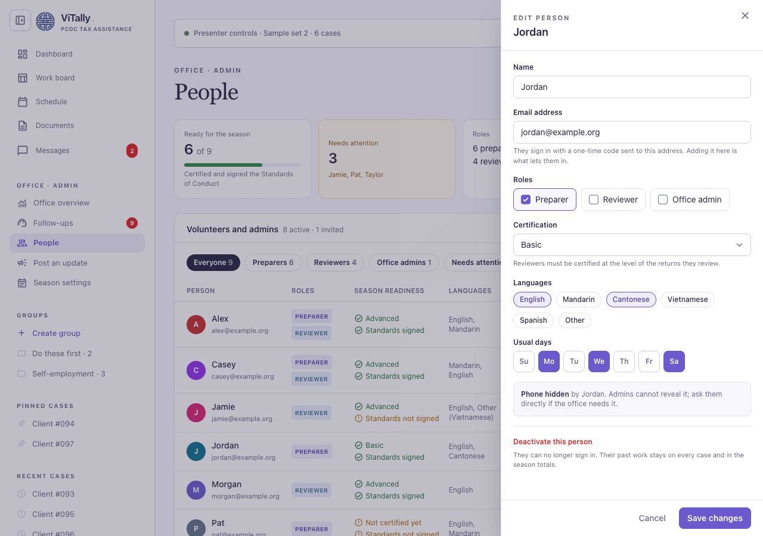

Case Tab
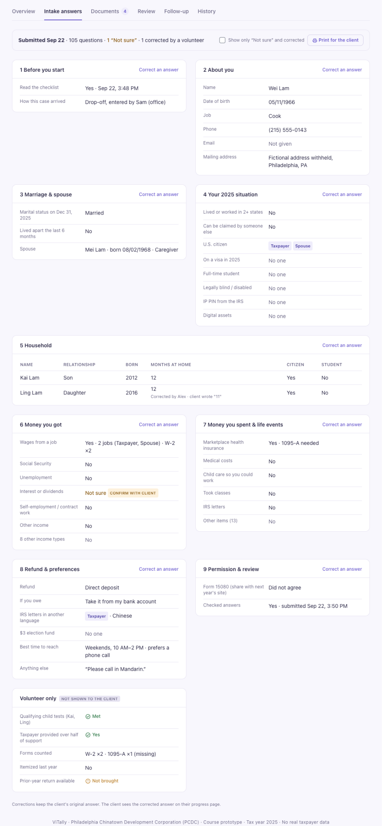
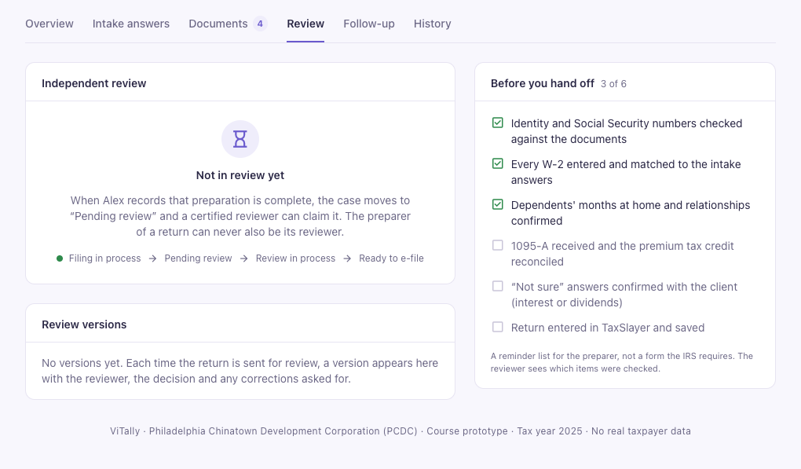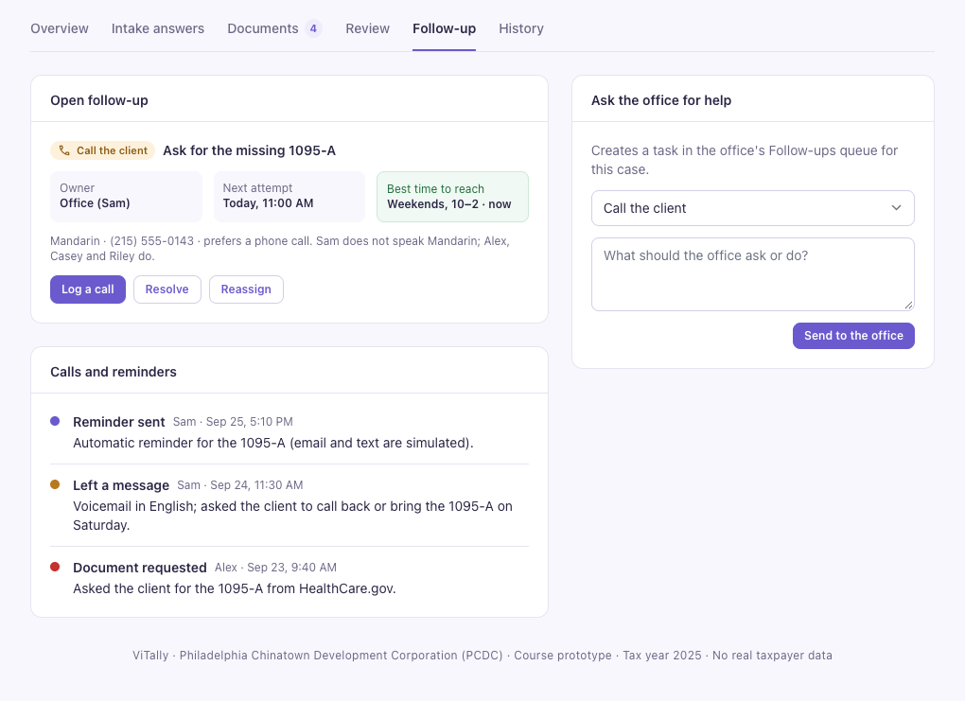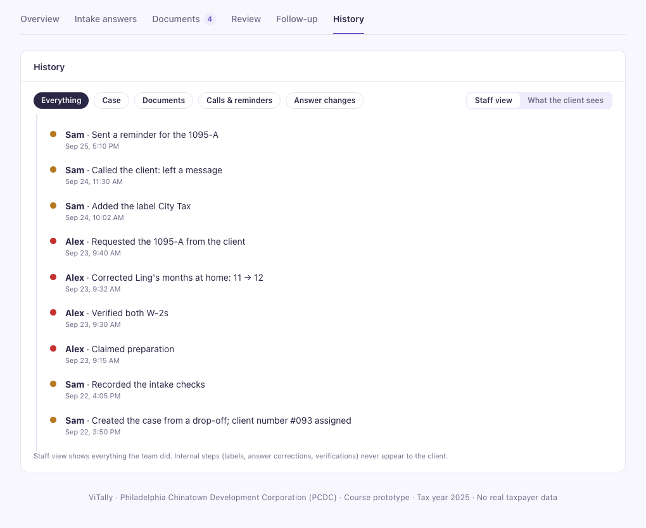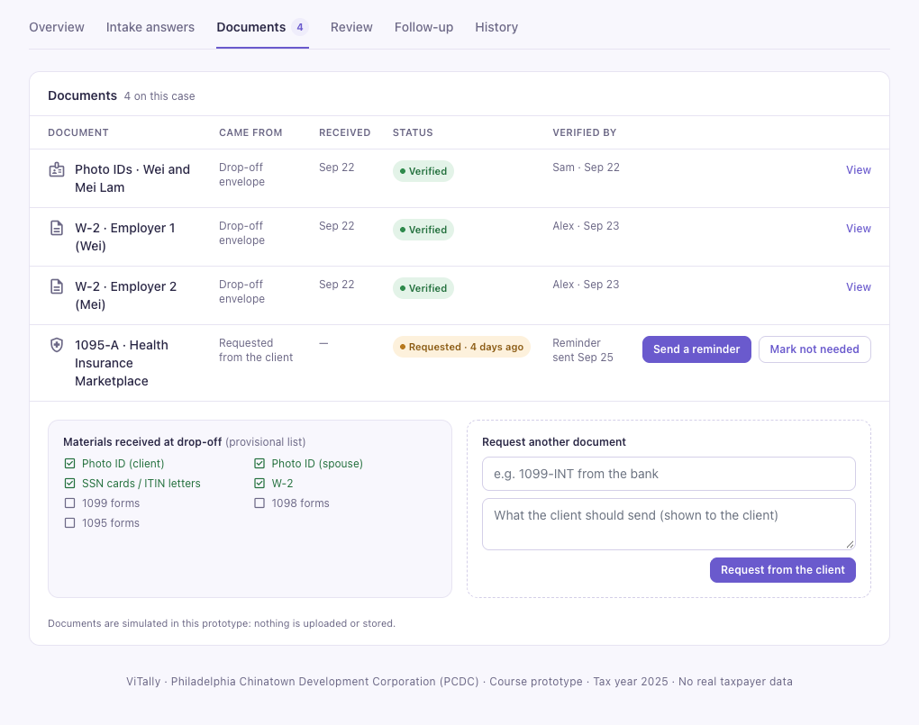

8️⃣ Milestone 1
M1 Requirement: https://drive.google.com/file/d/180XLhv0I1ZRMpDWt6RoLQEt5ur3qqz1V/view?usp=drive_link
M1 Slides: https://canva.link/zk4jfftwwu7fdzk

9/9/26 Hailey Office Hours Gain:
For M1:
- Explain what we are going to do and why we want to do it. Preferred documentation format: .md (so that we can feed it to AI directly).
- Explain how we figured out the above.
  - Explain how we conduct meetings, and provide evidence of this.
    - Show cooperation between teammates. Show that everyone contributes
      - Example: "Thanks to XXX who brought up this idea," "XXX knows something about this," "XXX searched for this."
  - Explain how we determine everyone's responsibilities
    - Red flag: dividing the team into FE and BE is not an ideal split, but we can plan to do so for now and change it later based on requirements (this will most likely change).
- No demo, slides, or visualizations are needed so far, a verbal presentation is fine. The key is to show that we've genuinely spent time thinking through what we're going to do, considering many "if-then" scenarios and edge cases. Show our thought process. Show we really think a lot before we get start to code
- Do not mention any heavy tech stack for M1, assume the audience has no technical background.
Todo:
- Github repo
- Slides - no dark bg!!!
- Team & Role(Task board)
3 roles with permissions (client, volunteer, admin)
- Client: Person submitting tax documents, check their case status
- Volunteer: Claim cases, communication, check their cases status,
- Admin: Change case preparers, check all case status, generate reports, alerts, post useful materials to volunteers
Bilingual (English and Chinese) Intake form (with document upload?), auto generation of Form 13614-C and Form 14446, database, web security, convert on-site process to online status (state machine: pending, ready for interview, hold for missing documents, etc.)

Out (for v1): Facial recognition, communication with accountants (slack for now), alert system (closed for whatever reason), scheduling (maybe), cooperation with other companies besides PCDC

Features:
- State machine
- (Future non MVP)
  - Communication with accountants
  - Alert System (things to bring, closed or not)
    - AI customer support(?)
Front-end: Hailey, Jinyu, Manqi
- Translation: Manqi
- Question Design: Hailey
- Voice/ i icon:
Back-end:
- Database: Kelvin
- Server: Cody

- What we have done so far
- Understood current site workflow/service models
- Github repo created
- pre-survey:gather concerns from previous clients, admin and volunteers. Omitted questionnaires due to time constraints.
- decided basic state diagrams,
- meet with the PCDC manager to talk about promotion and testing, gathering requirements and expectations.
- Deciding how to use the budget subscription of coding collaboration tool?
- Next step
- Creating database/ Class diagram
- Creating light demo
- Demo
- Topic presentation

Writing
9/9/26
Is there a proposal?
- Need to create repo
Is this proposal carefully generated?
- We thought about so many edge cases. Conversations with Claude, Google docs edit history
Are there efforts spent on studying the user's needs?
- Presurvey
- Excerpts from VITA’s grant proposal regarding statements about lower efficiency - did not do this as no permission anymore
- Some detailed user’s stories from admin, volunteer, and client(one for each) - Done
Are the team working together?
- We have our group divided into 2 teams as we want to complete a simple UI first, and the UI has to be bilingual due to the user graph.
- So far(9/9 2pm): 2 meeting done,
  - 1st meeting on 9/6 4pm - 6pm with all ppl attended
    - Google calendar, zoom minutes
  - 2st meeting on 9/8 10am - 12pm, Front-end team attend: Hailey, Manqi, Jinyu.
- One scheduled meeting: 9/14 7pm expects all ppl attend
- …

9/6/26
- Problem + users. Who is this for, and what hurts today?

Repeated paperwork and limited visibility into each client’s progress for VITA volunteers

Streamline the tax filing workflow to reduce manual work and errors, while using a secure, scalable database to store and manage client information efficiently.

- Why a semester. Not a weekend with ChatGPT. Several workflows, shared data, accounts.

This will require several interconnected workflows: the intake, assignment, preparation, quality review, and filing, tied together for each tax return submitted.

There will also be different user roles with different permissions, real accounts, sensitive document handling, bilingual support, and audit logging.

- Scope. What is in v1, what is explicitly out.

3 roles with permissions (client, volunteer, admin)
- Client: Person submitting tax documents, check their case status
- Volunteer: Claim cases, communication, check their cases status,
- Admin: Change case preparers, check all case status, generate reports, alerts, post useful materials to volunteers
Bilingual (English and Chinese) Intake form (with document upload?), auto generation of Form 13614-C and Form 14446, database, web security, convert on-site process to online status (state machine: pending, ready for interview, hold for missing documents, etc.)

Out (for v1): Facial recognition, communication with accountants (slack for now), alert system (closed for whatever reason), scheduling (maybe), cooperation with other companies besides PCDC

- Who does what. Names, not “we will all code.”

Frontend: Hailey, Manqi, Jinyu
Backend: Cody, Kelvin

Artifacts: written proposal, requirements, user stories (or equivalent), team roles, a rough architecture sketch(not necessarily needed)

FE-StateDiagramWritingDraft
9/8 FE team
Client只能看到自己的case，volunteers可以看到自己准备的case，admin team可以看到所有case

Welcome page
- Start an application - only for clients, no authentication required
- Retrieve an application
- Button: have acct? / create acct
- Program introduction

Create an acct page - How do volunteers & clients see different views?
- Volunteer/admin: upload volunteer agreement, government-issued ID, name, email address, mailing address, zip code, username and password -> role ( IRS SPEC / Territory Manager / SPEC OPI Volunteer / Site Coordinator / VITA Volunteer / Volunteer Instructor ) -> verify email address
- Client: intake form(application id)
  - acct generated automatically after application submitted?
- Assigned an temp username&password, client logs in to change psw -> login button -> change psw -> log in client portal
  - Contact info if help needed

Client portal
- client progress:
  - current stage – e..g, waiting; verified; hold (missing documents);
    - waiting(queue position);
      - actions: print, make corrections, withdraw
    - pending(actions you must take)
    - Volunteer claimed - preparing
      - Preparer contact info
      - Notifications
- Volunteer claimed - reviewing
  - Reviewer contact info
    - Tax Return Completed
      - Make an appointment
- Q&A
- Contact info
Volunteer Portal
- worklist: view by sorting methods/role(preparer/reviewer)
- Preparer
- Reviewer
  - Case prepared by who, contact info
Volunteer’s profile
- Preferred name,
- Certificates earned
- Contact info
- Direct Message?
Case view
- Documentations
- AI summary?
- Intake form responses?
- A tab for tracking case status
  - When intake finished, when prepared, when contacting clients, when docs uploaded
  - Any staff who touches this case(intaker/volunteer/admin)
  - Way of service - drop off/same day/onlin
admin dashboard
- volunteer work load; clients on hold; counts by stage

Presentation Flow
9/12 Manqi
Presentation Flow:

- Introducing IRS VITA Program:
  - The IRS VITA Program stands for Volunteer Income Tax Assistance. It is a community-based program supported by the IRS that trains volunteers to provide free tax preparation services to eligible taxpayers.
  - VITA volunteers usually receive tax-law training and complete the IRS certification before helping taxpayers during tax season.
  - As a VITA volunteer, you may:
    - Review tax documents such as W-2s, 1099s, etc.
    - Enter income, deductions, and tax credits into tax preparation software.
    - Check taxpayer information for accuracy.
  - The VITA program mainly serves low-to-moderate-income taxpayers, individuals with disabilities, and people with limited English proficiency.
  - VITA generally handles relatively straightforward individual tax returns, while more complicated tax situations may fall outside the program’s scope.

- Purpose of our website:
  - Potential bottlenecks:
    - The process often begins with taxpayers bringing physical documents, volunteers have to manually review and enter information, and another certified volunteer must review the return before submission.
    - Service capacity also depends heavily on the number and certification level of available volunteers, and the workflow is still labor-intensive and dependent on volunteer availability.
    - Taxpayers often have limited visibility into the status of their tax return preparation process before it is officially submitted to the IRS. They did not know whether their documents have been reviewed, whether a volunteer is preparing the return, whether something is missing, or whether the return is waiting for quality review. This creates uncertainty and requires volunteers to repeatedly contact taxpayers by phone or email.
    - Manual document intake, data entry, quality review, and limited virtual-service capacity create opportunities for improved efficiency through better automation and digital document processing.
  - What can our website do:
    - Gives taxpayers one place to upload and manage documents, check and track the real-time status of their tax return, see what actions they need to complete and show missing information, and send notifications for taxpayers to receive updates, while also helping VITA volunteers manage cases more efficiently.

- How our team work together:

Hailey Script

Slide 1 — Title
Hello, everybody. We're team ViTally. I'm Hailey, and this is Cody, and this is Jinyu. We're presenting today on behalf of our team, which also includes Kelvin, and Manqi. Our project is A VITA Site Management System.

Slide 2 — What is VITA? What is PCDC?
Let me share some quick context before the problem. So VITA, Volunteer Income Tax Assistance, is an IRS-backed program that trains volunteers to give free tax prep to the low-to-moderate-income taxpayers, people with disabilities, and people with limited English proficiency. The IRS bases a site's grant funding on the reports, so better data directly affects site’s funding.
The PCDC — the Philadelphia Chinatown Development Corporation. It is a Philadelphia-based nonprofit that has run a VITA program for over 10 years. It is also the source of our project’s problem research and workflow details

Slide 3 — Current Site Service Models
To understand why we need a brand-new system, let’s look at how PCDC currently works. There are three ways PCDC accepts cases. Same Day is the full on-site process, volunteers, admins show up on site and help with a case from collecting documents all the way through to getting the tax return done.
Drop-off means the client leaves their documents in person at the main office, and volunteers then work the case remotely while admin coordinates.
Online is fully remote — submit documents, verify your identity over Zoom, and get your completed return back by email. It's built for clients who can't make it to our site in person.
We spend 5 meetings, 10+ hours analyzing this current workflow. So what do we figure out, Cody can you share this for us?
[Pass it to Cody]
Slide 6 — What's More... (Client quotes)
Sure, so we have….
Ms. Xu, a client since 2022, told us: 'The office hotline is never reachable. I have to physically go to the office just to check my case status — and it's hard for me to walk.'
Mr. Li said everything's communicated by phone.Texts are promised but rarely come — Turns out it's not the stuff they don't care, they've just got too much on their plates.
And Ms. Liu watched another case get finished before hers with no explanation

Slide 7 — What's More... (Volunteer quotes)
Volunteers complain a lot too. Ms. Lu missed training and had no way to see which cases she could claim. And Roger, a 20-year veteran, told us simple cases sit untouched while complex ones go to newer volunteers, who just come back to him with questions anyway. He said it would be better than assigning complex cases to him directly when it is busy.

Slide 8 — What's More... (Admin quote)
And from the admin side, Eunice, a former site coordinator, told us something similar: clients are usually at work when staff try to reach them. And when staff do leave a text or voicemail by another phone system, clients often don't reply because they don't recognize them. Plus, some ppl don't know how to use Zoom, and mobility issues make identity verification even tougher.
So, how are we actually going to help, and what are we building? I'll pass it back to Cody here.

Cody Script

Slide 9 — What We Are Going to Build
Questions to answer:
Is the team working together?
Why is a semester needed?
What is in v1, what is out, what was considered? (entire slide is just this)你
Why are we doing this project?
Thank you, Hailey. These are the core features to address the main problems of centralized case tracking across the three channels and consolidated data, which is addressed by the state machine, and manual document intake and entry with the auto generated forms. All of these (gesture towards final) features we plan to implement in the future, to further improve efficiency (point towards first bullet), improve case assignment to qualified volunteers, as Hailey mentioned in her survey with Roger (point towards second bullet), and help people understand the tax return process better, with more availability (point towards the last two bullets), as mentioned in the story with Ms. Xu, Ms. Liu, and Eunice. Facial recognition, which I believe Manqi brought up in one of our meetings, would be helpful and more convenient towards senior clients, along with voice assistance (which I brought up), may be out of the scope for this class, though it would be beneficial for people like my grandma, who come from a rural area and may not know how to read Chinese that well. Having a live queue, which Hailey mentioned in her Piazza post, and scheduling, which Kelvin suggested, may be useful, but it is not something that is of high importance, relatively. Of course if we have time, we may implement any of these, as well as anything to help with the preseason, which Jinyu proposed to potentially fill out the semester in case what we have is not enough.

!!!!Transitions!!!!

Gradings
TA: zeyu.yang@stonybrook.edu
Hi team,
Here is the feedback for your project proposal VITA Site Management System.
 | Instructor | TA
Proposal Quality | Good | Good
User Needs | Excellent | Meet Expectation
Teamwork | Good | Good
Overall | Good | Good

Milestone 2
M2 Slides(switch to Adobe Express as SUNY student acct has free subscription) - done:
https://express.adobe.com/publishedV2/urn:aaid:sc:US:58ff4584-1c56-52e7-b193-8c940836f80f?promoid=Y69SGM5H&sdid=C4SZ2FYJ&mv=other
9/28
- Everyone on the team stand on the same side
.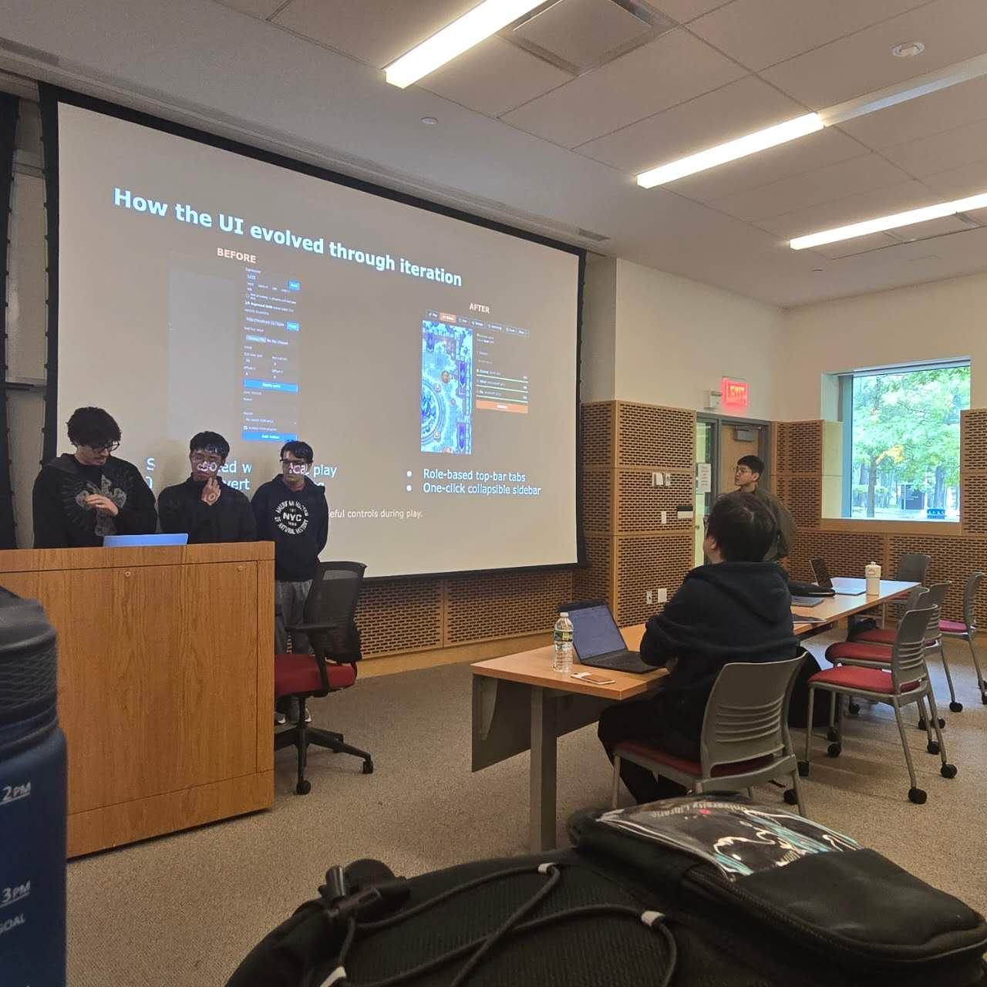
- Make it in ~9 mins
- Most of the group just start explaining tech stack right away without any introduction(to save time?)

9/23 OH Notes

M1 feedback
What didn't land
- Nobody really gets tax filing, so the problem wasn't obvious to people.
- Target users were fuzzy. People thought older adults wouldn't be able to use it. We actually have a separate channel for them, we just never said so.
- For the first ~10 min of OH, prof honestly thought the system didn't need to exist. Once I explained more, he got that it's an internal info management system for the project and said the topic's good.
- He's worried our features won't be exciting enough. Need more evidence that this thing is actually useful.
What worked
- Real user stories, the best part of our presentation.
- We have actual users. That's the project's biggest strength.
My take
Honestly we didn't do great on M1. It took us like four meetings just to figure out the workflow, what's broken, and what's actually useful. By the time we all got it, we forgot the audience didn't.

What prof said
Features
- Try AI intake notes. He thinks all intake will probably turn into AI auto note-taking eventually. Don't worry about security/privacy for now.
- Put more work/meetings/discussions into designing features. Even if the solution ends up meh, he's fine as long as he can see the effort.
Presenting
- We can let strong presenters take the lead, but presentation quality isn't in the rubric anyway.
- What he really cares about: does everyone understand the product the same way? He can tell when some members are lost, and that costs points.
- If everyone presents, he can see it directly. If not, we have to prove the others get it too, and "X did Y" doesn't count.
- He's watched undergrad talks for 20 years. Our "disasters" are normal to him. Chill about delivery, focus on content.
- Don't do “written presentation”. Practice a lot and keep revising. He can tell when a talk's been reworked.
Splitting work
- We tried FE/BE and by-feature. Neither felt right. Still no idea what "right" is.
- He didn't have a recommendation, but said just caring enough to debate this puts us ahead of a lot of teams. Lots of teams split work badly and probably won't fix it.
- He wants us to show that effort in the presentation.
- Fun fact: he expects about half the teams to start slacking off as the semester goes on.

For M2
- Make target users + positioning super clear (mention the older-adult channel!)
- Give enough tax background that outsiders get the pain point
- Keep leaning on real user stories
- Spend real time on features, maybe add AI intake notes, and bring evidence
- Get everyone on the same page, ideally everyone presents
- Talk about how we figured out splitting work
- Practice, revise, repeat
Also: prof wants this class to train us to think like PMs.
9/28
Team and member introduction
Briefly introduce the stack/architecture in some sentences(1-2 slides)
(Minimal Prototype) Three core features(as they are all case-based) - slides + oral
- Client submits intake form and then see the case status, client retrieve cases by application id. Clients can submit corrections.
- Volunteer look though the case pool and claim cases, then go to their dashboard to work on the cases
- The case pool only shows “ready to prepare” and “ready to review” cases
- The case detail only shows the necessary information for determining the certificate level. Privacy info like contact info and uploaded docs would only be available until the case is claimed.
- Admin looks at the case pool to determine the case progress. Admin then looks at admin’s dashboard to see which volunteer is available to take the case then assign it to someone.
UI design process. - static pages, before and after comparison
Live demo shows these 3 features.

- Architecture diagram (clients, APIs, data, jobs)
- Tech stack and a one-sentence rationale
- Repo with a CI skeleton (lint / test / build)
- Design doc connected to the requirements
- Three core use cases and why they matter
- UI design process and iteration
- Live demo of the three use cases through the actual UI

Preparation/todo
M2 — DESIGN AND SETUP: TODO
Repo: https://github.com/jin-yu-yang/VITA-Management-System-Demo

**BELOW ARE ALL AI GENERATED, REFERENCE, NO USE**
ALREADY COVERED before 9/16
[x] Repo exists, public, MIT licensed, 23 commits
[x] Clone-and-run works with no dependency install (npm start -> 127.0.0.1:4173)
[x] Unit test suite (npm test)
[x] .env.admin.example / .env.test.example + .gitignore in place
[x] Running prototype: intake, save/return, preparation claims, document requests
[x] Supabase migrations, workspace setup, ownership rules, isolated DB tests

1. ARCHITECTURE DIAGRAM
[x] Create docs/architecture.md
[x] Draw the system as it actually is, not as idealized: browser (client view /
volunteer view / presenter switch) -> Supabase (Postgres + Auth + row-level
security); server.mjs labeled as a local static server, not production
architecture
[ ] Show the four layers the rubric asks for: clients, APIs, data, jobs
[x] Draw not-yet-built pieces as dashed boxes marked "planned": email delivery,
file storage, admin/reviewer screens, PDF form generation (13614-C / 14446)
[ ] Label arrows with protocol and direction, not bare lines
[ ] Export to PNG/SVG and embed in both docs/architecture.md and the design doc

2. STACK AND RATIONALE
[ ] Add a "Stack" section to README with one sentence per choice:
- Vanilla JS, no framework, no bundler: clone and run with zero setup, so
reviewers and PCDC staff need nothing installed
- Supabase: Postgres, Auth, and row-level security in one service; RLS maps
directly to the role-based visibility in spec section 6
- Node 24 + built-in node --test: no extra test framework to install
- Plain server.mjs static server: local demo only, deliberately not a
production API
[ ] State trade-offs honestly (no framework means more manual DOM work as the
UI grows)

3. CI SKELETON
[ ] Add .github/workflows/ci.yml with three jobs named lint / test / build
[ ] lint: node --check across all .mjs / .js
[ ] test: npm ci + npm test (unit suite only)
[ ] build: boot the server and curl it as a smoke check
[ ] Keep test:database and test:browser OUT of CI (need Supabase credentials /
Chrome); document them as local-only in README
[ ] Open a PR, confirm all three jobs go green
[ ] Screenshot the green checks for the design doc
[ ] Optional: add a CI status badge to README

4. PROTOTYPE
[ ] Re-verify a clean clone runs on a teammate's machine who has never run it
(fresh git clone, Node 24, npm start)
[ ] Confirm README's run instructions match reality step for step
[ ] Keep the "fictional data only" warning prominent: no real PCDC client
information anywhere in the repo
[ ] Record a 30-60s screen capture of the end-to-end flow as a fallback artifact
for the presentation

5. DESIGN DOC CONNECTING TO REQUIREMENTS
[ ] Write docs/design.md (or extend the existing spec)
[ ] Include: architecture diagram, stack table, CI screenshot, prototype link/GIF
[ ] Add a requirement traceability table mapping M1 spec sections to
implementation:

M1 section | Component | Status
------------------------|-------------------------------|---------
8.1 Accounts & auth | Supabase Auth | partial
8.2 Case state machine | workflow contracts in src/ | partial
8.3 Client portal | client view | done
8.4 Volunteer portal | volunteer view, claims | done
8.5 Admin dashboard | -- | planned
8.6 Form generation | -- | planned
9 Auditability | Supabase ownership rules | partial
9 Bilingual support | -- | planned

[ ] Fill in the Milestone 2 row of the roadmap table in the M1 spec (11.3) --
it currently says "To be defined"

TEAM AND PROCESS
[ ] Make contributions visible: every member opens at least one PR, or use
co-authored commits -- right now the history reads as one person
[ ] Decide whether to move the repo to a team org before M2 submission
[ ] Fix the repo description: it currently says "Pre-Milestone 3"
[ ] Add an "AI assistance" section to README, consistent with M1 spec section 14
-- the docs/superpowers/ directory makes AI tooling visible, so document it
rather than leave it unexplained
[ ] Log M2 meetings (date, attendance, decisions) to continue the section 12
meeting trail

SUGGESTED OWNERS
Cody - CI workflow, architecture diagram
Kelvin - Supabase/schema portion of the diagram, traceability table (data rows)
Jinyu - repo hygiene, PR flow, description fix, clean-clone verification
Hailey - design doc assembly, screenshots, demo recording
Manqi - README stack section, AI-assistance section, wording pass

DEFINITION OF DONE
Someone outside the team can clone the repo, run it in under two minutes, see a
green CI run on a PR, and read one document that shows which M1 requirement each
part of the system serves.

Features Brainstorming
Federal tax return form - 1040
PA tax return form - PA40
Philadelphia - NPT/BIRT/EET/SIT, depends on income resource

9/21
Even though it is OOS, we still want the client know it after clicking the btn as we would like to know how many ppl OOS and some basic info of them
Need extra tips for hold cases?
OCR?

9/24
- Dynamic year，without hard coding
- Q5.4 choose citizenship status (green card)
- Q9.12 - done

UI:
- Theme color: blue
- Senior intake form has larger font, can also have a slider for manually adjusting the font size
- Corresponding missing docs’s intake form field
- Dashboard for ready to exit
- Document view archive
- Message dm to client
- Create group
- Recent cases / Pinned cases

New feature - QR code:
Same-day:
- Clients should be able to scan a QR code on a cover sheet; then a client number and application number should be auto-generated for the client. A generated client number is succeeding the previous one (#98, #99, etc.)
Drop-off
- Volunteers should be able to start a new case and fill in the intake form on the work board based on the drop-off materials. Similarly, a succeeding client number and a random application number would be generated.

🤯 UI design questions
Questions for Hailey:

Updated: Sept 25 - Jinyu

Take a look at the lifecycle stage diagram I made:
EDIT: pushed to the main branch
https://github.com/jin-yu-yang/VITA-Management-System-Demo/blob/main/docs/media/return-lifecycle.svg
Can `withdrawn` happen from any stage (just like dismissed)?
- HZ: Yes, all boxes in this pic can lead to “dismiss” and “withdrawn” except “accepted”
I bet `Ready to exit` is confusing to many; perhaps rename it to something like `Ready to sign`?
- HZ: I'd prefer we keep "Ready to Exit." PCDC has used this status for more than ten years, and it was originally established by highly respected leaders and accountants, so I don't think we should change an established naming convention. No one complains on this so far. Also, exiting a case doesn't only mean it's waiting for a signature. It can also mean the volunteers have finished all their work and we now need the client to confirm or decide whether they want to proceed. There are many complicated situations that you may not be aware of, and honestly, I may not know all of them either. What I can say is that "Ready to Exit" is clear enough for volunteers who are familiar with the tax side of the case.
- HZ: I understand your concern that clients might find this confusing. To address that, we could keep these short case statuses internal and show clients a clearer, more descriptive message about their case's current status.
Do we want to add this svg to the M2 documentation?
- HZ: Need to be discussed by all
Do we expect the system to identify `Duplicate` cases once it receives a client's application? If so, the `Duplicate` stages should happen from `Request sent`.
- HZ: To prevent duplicate cases from being entered into our database, we could set certain key fields in the intake form as unique identifiers. For example, if an SSN/ITIN that already exists in the system is entered, the form would show an alert. Another option is that when a first and last name matching an existing record is entered, the system could display a pop-up saying, "An existing application was found for this name. Would you like to open it?" and then ask for the application ID. I think this is worth discussing with the whole team.
—

Are the systems supposed to automatically classify cases as `drop-off`, `same-day`, or `online`
- HZ: Need to be discussed by all

—-
Per our chat, we want a feature to show each client’s best contact time in the household panel. So we will need a best-contact-time question to support it.
e.g.,
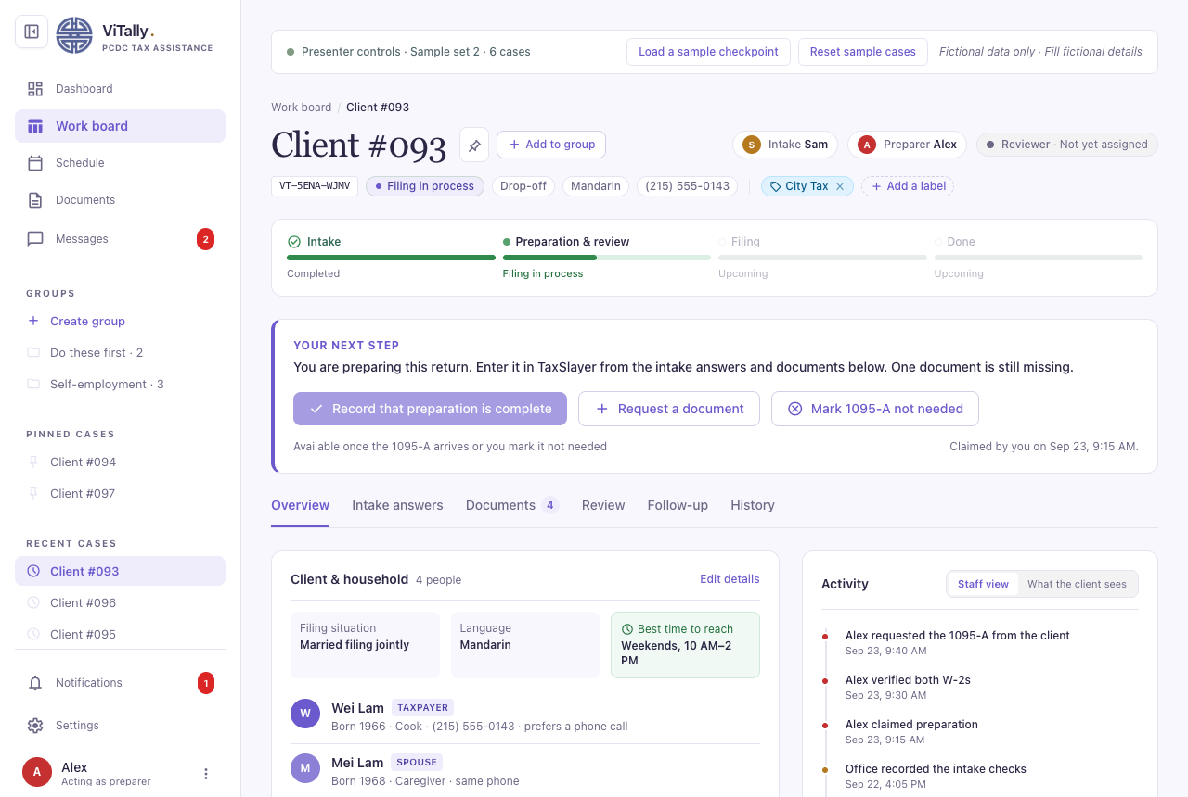

—-
Do we need a mobile view of the client intake for M3/M4?
- HZ: Good to have it. Depending on the rubrics for M3/M4, which most likely be posted right before M3/m4 so we can't make a decision now.
Meeting notes - Sept 27 Night:
`Adopt the ~20-stage lifecycle now, or keep the 9 stages and only restyle?`
We'll adopt it soon. See docs/media/return-lifecycle.svg for all stages.
`Client numbers: assigned on submit (agreed). Restart at #001 each season, or keep counting? How are returning clients matched?`
Assigned on submit; Restart at #001 each season; How are returning clients matched? We can't save client's documents according to VITA's policy. But we can save their name, phone number, date of birth, address, family number info. So we need a new feature: once the volunteer click `add a case` they should be able to search client's name/phone number from last years' cases, and fill in the matched results.
`Replace the 17-key intake with the 105-question drafts, and when? Which draft (general or senior) is the product wording? Traditional Chinese: translate, or fall back to Simplified?`
We will do it soon. Simply add a `are you senior?/would you like to fill in the senior intake` question and a brief `page text` that explains the senior version has shorter descriptions and easier-to-understand wordings. Then they will be given senior's intake questions if answered yes.
`Real document uploads, or keep simulated documents for the MVP?`
keep simulated documents for now
`Show client phone numbers on the work board (and reword the privacy note), or only inside a case?`
number masking; If the Client's phone number is ` (555) 555-1234`, show ` (•••) -•••-1234` only.
Admins may view all details of all the cases (including documents).
Volunteer can access all details of their claimed cases; they may also view the intake answers of available cases; they cannot view the unmasked phone number or uploaded documents from the available cases.
Based on this update, we need to redesign: Admin's dashboard, Admin's work board, Volunteer's dashboard, and Admin's work board.
- Admin's dashboard: Add a stat panel shows how many cases has not been taken and for how long (like for a week), sorted by submission date or languages; Add a management panel: click any volunteer -> see their cases; (admins usually do not do tax prep like a volunteer, so no personal contribution graph)
- Admin's work board: A case pool with all cases -- masked phone number; needed to hang over on it to view the number. They may filter by: phrases, stages, languages, service type (drop-off, online, or same-day), location (Main office / crane center / others), or claimed by whom: prepared/reviewed by whom
- Volunteer's dashboard: Add a chart to view all your claimed cases; they may filter cases by phrases (aka status, e.g., available, waiting for preparation, Waiting for review, done, ...) Keep the contribution graph, but it's less important; so put the graph at the bottom of the page
- Volunteer's work board: 3 tabs (3 phrases) only: Available, Waiting for preparation, Waiting for review.
`Which new features are MVP? Labels, groups, pinned cases, notifications and posting, teammate contact card with phone sharing, dashboards, admin People, Season settings, Schedule, Documents, Messages`
MVP:
Stages 9 -> ~20
Client number
Intake questions
groups and pinned cases
notifications and posting
teammate contact card with phone sharing
admin's People and Season settings
Styling
Work board
Add a case
Dashboard
Email OTP (magic link)
...
out:
SMS
Messaging system
Schedule
Documents
Mobile view
`Case-based messaging: build it later (as designed) and keep phone contact meanwhile?`
It's not in mvp
`Contribution graph data: may we derive it from existing case events (completion = preparing; approve or corrections = reviewing)? Drop "refunds", or add a refund field?`
Drop refunds, we cannot get refunds without getting data from taxslayer pro weekly report, which could make things harder for admins.
`Best time to reach, the materials checklist, certification levels and usual days are new fields. Who owns them (intake, volunteer, admin)?`
self explanatory;
Needed to add the best-time-to-reach question. Either intake/volunteers/admin can edit it.
The materials checklist (add if any is missed):
id, ssn/itin, greencard, birth certificate, W2, 1099NEC, 1099MISC, 1099INT, 1098T, 1095A, prior year tax return/1040; volunteer/admin can edit it
certification levels: Needed to discuss with my group
usual days: we'll build a schedule system (schedule tab) - volunteers can add their "office hours", e.g.,`7pm - 10pm, Sept 29`, which means they would work on the tax prep from 7pm to 10pm, on Sept 29. The current design is fine - you can only edit your own `usual days`, you cannot change others.
`Presenter controls stay in the product UI (they're demo-only today)?`
keep the presenter control. And we will implement this soon.
`Serif font: keep Georgia (no download, what the designs show) or switch to Noto Serif (better Chinese pairing)?`
Yes
`Scope of mobile: client intake only for the MVP?`
Not in MVP
Additional info:
email:
vita@chinatown-pcdc.org
phone number:
2159226156
A couple of update:
For designs/case-tabs.html, remove the Review tab, which is not needed;

Hailey Script M2
Page 1 · Cover
Hi everyone, we're ViTally.
Page 2 · Tech Stack & CI
Our stack is a plain JS front end, and Supabase, with Postgres as the back end. The reason why we choose this is that all workflow rules live in the database, so every user gets the same checks.
Page 3 · Architecture
Here's how it fits together. The browser app talks to Supabase for sign-in, reads, and actions, and gets live updates back. All the rules live in Postgres: it decides what each user can see and whether each action is allowed.
Our 3 core features are built based on them and I’ll pass to Manqi for more information.
(Pages 4–6: Manqi)
Page 7 · UI Design Evolution (~10s)
Thanks Manqi.
The first version of the UI was generated by Claude. We then connected Claude to Google Stitch through MCP to redesign it. Our guiding question was always: what does the user actually need? Let me show you with our work board, which went through five versions.
[V1]
The first version had everything, but the filter panel and the small stat cards in the middle were redundant. k.
[V2]
In V2, we added a sidebar so volunteers can quickly get back to their recent cases, and tabs to group cases by stage.
[V3]
In V3, we added case numbers. Clients get an Application ID when they start the intake, but once they submit, a short case number is much easier to remember. We also added pinned cases, and groups for keeping similar cases together.
[V4]
In V4, we moved every case a volunteer has claimed to their own dashboard so you see the “my case” btn just disappeared.
[V5]
So in our current version, the board only shows cases waiting for preparation or waiting for review, because those are the only cases that need a "claim." We also mask phone numbers. Before claiming, volunteers see only what they need to judge the case level, like the types of income. Phone numbers, addresses and documents only open on their dashboard after they claim the case.
[Argument]
We had a lot of interesting debates. For example, where should the Claim button go? I wanted it at the bottom of the case page, so volunteers read the whole case before claiming it. Cody wanted it right on the work board, so a volunteer could claim a whole family's four cases in a row. At the end we actually just keep both as both make sense. I was thinking as an admin, and he was thinking about volunteer convenience. We had many debates like this, and we realized we can't really settle them internally. Only testing with real users will probably tell us which works better.

Manqi Script M2

Slide 4 — Client
So now I’ll go over the three core features of our system.
For the client, we wanted to keep everything pretty simple. A client starts by filling out an intake form, and they’ll receive a generated application ID. They can use that ID to come back at any time. Once they hit submit, they can check the case status. If something is wrong or needs to be updated, they can submit a correction directly through the system. This way, clients don’t have to wonder who they should contact or what’s happening with their case — they can just come back and check it themselves.

Slide 5 — Volunteer
Then on the volunteer side, we have the work board and dashboard. You can think of the work board as a case pool. Volunteers can come in, see which cases are ready to be worked on, and claim a case that they’re able to handle. Once they claim one, that case moves to their dashboard and they can start working on it. We also wanted to be careful about privacy here. Before a volunteer claims a case, we only show them the information they actually need to decide if they can handle it. Things like the client’s contact information and uploaded documents stay hidden until that case is actually claimed.

Slide 6 — Admin
And finally, for admins, they get more of a big-picture view of the entire workflow. They can see how cases are moving through the system, check which volunteers are currently available, and assign cases when needed. This is especially important when a case has been waiting or needs attention, because the admin can quickly connect it with an available volunteer instead of having to manage everything separately. This helps make sure cases don’t just get stuck in the process.”

Conclusion → Hailey
So together, these three views create one connected workflow: clients can easily submit and track their cases, volunteers can securely find and complete their work, and admins can make sure the overall process keeps moving smoothly. And now that you all have seen what our three core features are, the next question is probably: what does all this actually look like for users? So I’ll pass it over to Hailey to talk about our UI.

Milestone 3

Milestone 4

Milestone 5

Milestone 6

