Washington International

Mission University

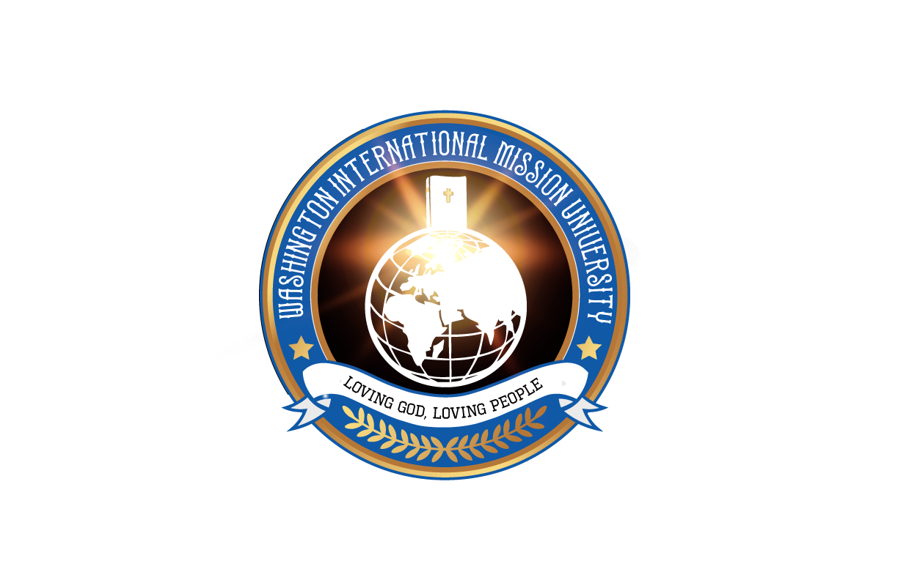

**2020 Catalog**

**WIMU**

**32008 32nd Ave S**

**Federal Way, WA 98003**

**U.S.A.**

*www.WIMU.com*

*This catalog is certified to be true and correct in content and policy as of the date of publication.*

**Table of Contents**

**Message from the President…….3**

**Our Passione ……………………….4**

**Religious Exemption Statement & Accreditation……………………5**

**Statement of Purpose..……………6**

**Location………………………………9**

**Student Life…………………………10**

**Attendance Policies……………….11**

**Academic Policies………………… 12**

**Class Schedules…………………….13**

**Earning Credits………………………15**

**General Information ……………16**

*Financial Information*

*Scholarships*

*Tuition refund policy*

*Transferring Out*

**Admission and Application…..18**

Application Process**….…….……..**18

*Certificate of Ministry*

*Bachelor of Ministry*

*Master of Ministry & Master of*

*Divinity*

*Doctor of Ministry*

**Program Descriptions…………..20**

**Outline of Programs……………..21**

*Certificate of Ministry*

*Bachelor of Ministry*

*Master of Ministry*

*Master of Divinity*

*Doctor of Ministry*

**Course Descriptions……………26**

*Theology…………………………26*

*Bible………………………………29*

*Practical Ministry……………… 33*

*Personal Growth………………..39*

*Internship………………………..41*

**Board of Directors…………………42**

**Instructor…………………………….44**

*Tuition*

*New Student*

*Returning Student*

*Late Fee*

*Withdrawal*

**Message from the President**



Dear Students who want to pursue truth and excellence:

There are so many universities and colleges all around the globe. However, this Washington International Mission University has been established to be the beacon of truth for this dark world.

So many religions and their leaders have come and gone like a flood. The extreme selfishness and lost morality overflows the empty bowl of reality. And yet, here is the educational goal for our University: only contending for the truth and finding visionaries who are willing to sacrifice and willing to chase the shadow away and recover the society that has long lost moral value and truthfulness.

You, the beloved prospective student:

Washington International Mission University (WIMU) has great plans with a solid educational ideology to suit your needs for a firm faith so that we may be the stepping stone to your promising time and eternity.

We have a vision based on the Word of God: “Your beginning will seem humble, so prosperous will your future be.” (Job 8:7)

If you are willing to set out to invest your valuable time, talent, and treasure at our University, we would partner with you to be the bearers of the Light and Truth of the World.

May we challenge you with an invitation from God’s promise for better scholarship and more mature faith in the Lord?

Dr. Richard H. Kong

President

**Our Passion**

Our primary passion at Washington International Mission University is to build you up in your faith and to equip you for ministry to others. We desire to present every man complete in Christ (Colossians 1:28). We are training activators who are launching globally, each one transforming others with revelation and wisdom. Computers, communication technology, and methods are dynamic. Therefore, we will train you to become His Light in this changing world with the unchanging Word of God, imparting Jesus’ gifts, as we build churches in a global community together.

You will find that Washington International Mission University is a great environment to seek God, discover your own gifts, form your core values, and identify & activate the desires He built in you.

**Emphasis on Internship**

With all of the programs we offer, there is a strong emphasis on internship. This is your opportunity for hands-on experience – you learn best by doing. We help give you that opportunity in a wide variety of ministries, both urban and multi-cultural. You will also get a chance to be involved in a broad spectrum of activities within those ministries.

**Please, ask God if this is for you!**

Do you have a hunger for abiding presence of God? Is the cry of your heart to see God’s Kingdom come, on earth as it is in Heaven? I would encourage you to pray, asking Jesus if International Bible College and University is the next step for you! We will be happy to welcome you to the family!

**Religious Exemption Statement**

The Washington Student Achievement Council has determined that Washington International Mission University qualifies for religious exempt status from the Degree-Granting Institutions Act for the following programs: Bachelor of Ministry (BM), Master of Ministry (MM), Master of Divinity (MDiv), and Doctor of Ministry (DMin). The Council makes no evaluation of the administration, faculty, business practices, financial condition or quality of the offerings by this institution. Any person desiring information about the requirements of the act or the applicability of those requirements to the institution may contact the Council at P.O. Box 43430, Olympia, WA 98504-3430 or by email at degreeauthorization@wsac.wa.gov.

**Accreditation**

Washington International Mission University (WIMU) is not accredited. To be officially recognized as an “accredited” college by government definition, a school must be evaluated and approved as such by an accrediting agency that is recognized by the U.S. Department of Education.

Although Washington International Mission University is not an accredited college by this standard, this does not reflect on the academic quality of our classes and programs. Because of the strong academic foundation, quality of instructors, and deep internship experience gained while at IBC&U, we are recognized by many churches and certain denominations as a qualified training school, and we are considered as substantial and often sufficient in providing training for those in pursuit of obtaining Ministerial Credentials within their organization. Each church and organization has their own standards for licensing, and we strongly encourage you contact them to discover their prerequisites prior to applying with us.

Our position with the State of Washington is that we are registered as a “RELIGIOUS EXEMPT” College. This allows us the flexibility to teach on a broad variety of Christian and Christian Ministry related topics that many other schools cannot offer. In addition, we also do not have the requirement of offering typical “General Education” courses that are usually necessary to receive that level of academic accreditation.

**Transferability of Credit**

Because we are not accredited, it should be noted that students desiring to transfer credits to another institution should contact the admissions department of the other schools before enrolling in any courses with Washington International Mission University in order to verify transferability of academic credit. Some colleges will favorably consider transferability of credits on a case by case situation, and the decision belongs solely to the receiving institution.

**Statement of Objective**

We exist for training in Christian academics, life skills, and ministry skills for the objective of sending people globally to make disciples of all nations.

**What is our goal?**

To raise up a Kingdom people – a generation of men and women that will go throughout the world making disciples of the nations, baptizing in the name of Father, Son, and Holy Spirit. And to teach the new disciples (Matthew 28:19).

**How is this done?**

We are a school of the supernatural. We value an atmosphere of faith – a spiritual greenhouse where the life and the fruit of God’s Spirit is evident. You will capture this value through practical “worshiping” ministry experience; through seasoned teachers who impart their gifts, wisdom and passions; and through discipleship under qualified mentors.

You will be expanded in three primary areas:

1. Ministry Skills
2. Life-Skills
3. Word of Knowledge from God Skills

You will gain lasting relationships with fellow students, mentors, teachers and pastors, helping you build a network from which you can launch a fruitful ministry.

**Our Basic Core Values**

These are the four common threads you will discover running throughout our programs:

1. Worshiping God
2. Equipping with the Word of God
3. Knowing and Using Your Gifts
4. Discipling Others

**What We Believe**

*We are an interdenominational college designed to train men and women who desire to expand the Kingdom of God globally. There are pastors and mentors from many and various churches and different denominational affiliations and traditions. However, there are some vital common doctrines uniting us. Here they are:*

**We believe…**

* There is only one true God who is the eternal King, Creator and Redeemer of all that is. He is perfectly holy, just, loving and truthful. He has revealed Himself to be eternally self-existent – one being in three persons: God the Father, God the Son, who is Jesus the Christ, and God the Holy Spirit.
* The Bible is the inspired and only infallible and authoritative Word of God.
* Humankind was created in the image of God to know and enjoy Him, yet we willfully rejected the Lordship and glory of God for which we were intended. Because of this, sickness, death, and judgment entered the world and now creation experiences the effects and consequences of sin.
* The Lord Jesus Christ, the one and only Son of God, was born of the virgin Mary, who was conceived by the Holy Spirit, and is God's Anointed One, empowered by the Holy Spirit to inaugurate God's Kingdom on earth. He was crucified for our sins, died, was buried, resurrected and ascended into heaven, and is now alive today in the presence of God the Father and in His people. He is "truly God" and "truly man."
* The victorious redemptive work of Christ on the cross provides freedom from the power of the enemy: sin, lies, sickness and torment.
* We are saved by God's grace, through faith, in the person and work of Jesus Christ. Anyone can be restored to fellowship with God through repenting, believing and receiving Jesus as their Savior and Lord. The Holy Spirit convicts, regenerates, justifies, and adopts us as we enter the Kingdom of God as His sons and daughters.
* In the sanctifying power of the Holy Spirit who dwells within us, we are enabled to live holy and minister super-naturally. The baptism of the Holy Spirit, according to Acts 1:4-8 and 2:4, is poured out on believers that they might have power to be witnesses.

**What We Believe**

* The Church consists of all who put their faith in Jesus Christ, and are born again. Jesus gave His church the ordinances of Baptism and Communion. The Church exists to expand the Kingdom of Jesus Christ; to undo the works of the enemy; to equip saints for ministry; to preach and witness the good news of God's love; to disciple the nations, baptizing and teaching them to love and obey God.
* The Church eagerly waits for the glorious and visible return of our Lord Jesus Christ. Heaven and hell are real places. There will be a resurrection of the saved and the lost – one to everlasting life and the other to everlasting judgement.

**Location**

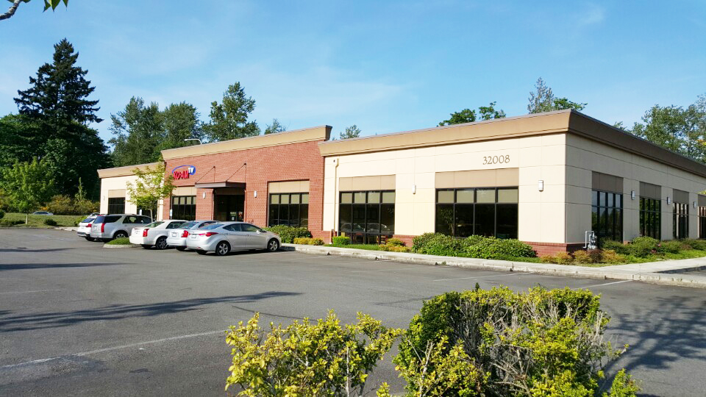

Washington International Mission University – Federal Way, Washington

Our campus is located at 32008 32nd Ave S, Federal Way, WA 98001 U.S.A. The building is located in one of the nation’s most culturally diverse areas. Just 20 minutes from campus, and accessible by freeway, are Sea-Tac Airport, Seattle Downtown, professional sports arenas, and innumerable other recreational opportunities.

Geographically, Seattle is the nearest major U.S. city from Asia. Due to its location, foreign students have the opportunity to visit numerous worldwide, well-known businesses, such as Microsoft, Boeing, Starbucks, Costco, and Amazon.

**Student Life**

As believers, we are a new creation and we have been saved from death to life, transformed from being a sinner to a saint through the work of Jesus Christ. Because of this, it is a core value of Washington International Mission University that students walk in integrity and godly righteousness. We also use this principle as the base foundation of the administration and guidelines for the college.

It is our belief that all Christians are called to a high standard of living. Students are expected to display honor and love, and resist picking up offenses, settling all relational conflicts Biblically and quickly.

***1 Peter 2:9***

*“But you are a chosen race, a royal priesthood, a holy nation, a people for his own possession, that you may proclaim the excellences of him who called you out of darkness into his marvelous light.”*

***Ephesians 5:1-2***

*“Be imitators of God, therefore, as dearly loved children and live a life of love, just as* Christ loved us and gave himself up for us as a fragrant offering and sacrifice to God.

We believe that students will not only grow academically and in their spiritual gifts, but they will also be challenged to mature and grow in character into the full measure of the stature of Jesus Christ.

**Discipline**

The nature of our Christian beliefs at Washington International Mission University requires a high level of godliness and self-management in the students’ lives. It is expected that students will uphold a Christ-like character, which includes meekness, truthfulness, peace, and love with no judgement, embracing a multi-cultural attitude. A situation or circumstance involving students walking outside of this framework will be dealt with in a healthy, firm, and appropriate manner. This will first be done on a one-on-one confrontation, providing an opportunity for resolution and repentance. After the first warning, if the action continues, the school staff will meet with the student to discuss appropriate disciplinary actions. The goal of discipline at our school is reconciliation and to allow opportunity for the students grow and mature.

**Attendance Policies**

**Attendance**

Attendance is taken for all classes, chapels and intensives.

**Certificate Program Attendance Policy:**

3 Absences – Student receives warning from administration

4+ Absences – Student must complete supplemental homework from instructor

5+ Absences – Student eligible for termination from IBC&U

**Bachelor, Master, Doctorate Program Attendance Policy (per course):**

2 absences – Student receives warning from administration

3+ absences – Student eligible for termination from IBC&U

**Academic Policies**

Grades will be monitored by each instructor and the administration. The grading scale is determined by the instructor. Students continuously at a C average will receive an academic warning from the administration and will be put on academic probation.

**4.0 – 2.4 GPA (A – C+ average)**  Passing

**2.3 – 1.4 GPA (C – D+ average)** Warning and academic probation

**1.3 or Lower GPA (D or lower)** Termination of enrollment

**Grading Scale**

A 94 – 100% 4 grade points

A - 90 – 93% 3.7 grade points

B+ 87 – 89% 3.5 grade points

B 83 – 86% 3.3 grade points

B - 80 – 82% 3.0 grade points

C+ 77 – 79% 2.7 grade points

C 73 – 76% 2.3 grade points

C - 70 – 72% 2.0 grade points

D+ 67 – 69% 1.7 grade points

D 60 – 66% 1.3 grade points

F less than 60 0.0 grade points

**Grade Point Averages**

A Grade Point Average (GPA) is calculated for each student by multiplying the number of credits for each course taken times the grade points for the assigned grade (see above). The total grade points are then divided by the number of total credits. Courses having a pass fail grade do not have grade points counted towards the student’s GPA.

**Class Schedules**

*Note: Course schedules listed below are subject to change. Check registration information for exact times and dates for each course including seminars and intensives.*

**Classes**

Most class offerings are 4 credit classes taken once a week per class. The schedule for each class varies for each quarter and may be offered in the morning, afternoon, or evening. If the student takes online courses, the required number of hours online is the same as the in-class participating hours.

**Seminars**

Seminars are typically 2 credits for two days of intensive learning. The schedule for the seminars is as follows:

**Friday:** 7:00pm-9:00pm

**Saturday:** 9:00am-12:00pm

1:00pm-5:00pm

7:00pm-9:00pm

**Intensives**

Intensives are 4 credits with book reading and paper writing. The schedule for intensives is as follows:

**Friday:** 6:00pm-9:00pm

**Monday/Tuesday/Saturday:**  9:00am-5:00pm

**Course Loads**

A full time student takes 12 credits per quarter in the Master of Ministry and Master of Divinity program. All students in the Certificate of Ministry and Bachelor of Ministry programs must take 16 credits to be considered full-time. To be a full time student in Doctor of Ministry it takes 16 credits per year. Any less is considered a part-time student.

**Clock Hour Calculations**

Washington International Mission University has adopted the standard credit hour calculation for the quarter system. A quarter unit is equivalent to 50 minutes of classroom time per week over a ten weeks quarter.

**Academic Advisement**

At the time of initial enrollment, and during enrollment for every subsequent quarter, students will fill out a registration form. This form must be reviewed and signed by the school staff before the student can complete registration for that quarter. This is to ensure that program requirements are being followed and the needs of the student are being met.

**Class Schedules**

**Internship Courses**

These courses are pass/fail which is decided by attendance and performance reviews made by internship mentors and school staff.

**Transfer of Credits**

WIMU will allow transfer of some college level credits. Students who wish to transfer credits will need to have official sealed transcripts sent to the office for review. Credits will be considered for transfer from a recognized educational institution of higher learning provided the student has received a 2.0 or better grade on courses.

Credits that relate specifically to our academic classes will be accepted on a case by case basis upon review of institution catalogue and courses from the other school.

Some credits are available for life-experiences. Each is considered on a case by case basis.

Due to the nature of the internship program, internship credits must be earned from an approved IBC&U program. In most cases, internship credits will not transfer.

**Earning Credit**

**Academic Classes**

These are the core of our programs and courses offered at the school. The normal class load is to take four 4 credit classes per quarter for bachelor programs. Master program students generally take three 4 credit classes per quarter. As described in the class schedule section, academic classes are held at various times during the week and, occasionally, weekend seminars and multi-day intensives will be offered (see previous section in Catalog for schedule).

**Internship Program**

The internship program is a core piece of WIMU. Placement into various departments is handled on a case by case basis after meeting and reviewing with school staff. Students are placed under an internship mentor who has an established relationship with the school. During the quarter, the mentor will turn in a “review slip” relating to the student and his/her performance, attendance, and activities. Periodically, during the quarter, the student will meet with school staff to review how the student is doing in the area he/she is involved in.

A normal load for the internship program is one, 4 credit course for every quarter. Each student will be required to serve a minimum of 4 hours per week to receive a passing grade for the course. During the senior year of our bachelor’s program, the internship requirements are increased while the academic course load is decreased (see section on programs offered).

**General Information**

**Financial Information**

Application Fee: $50

Foreign Student Processing Fee: $100

Certificate of Ministry: $132/credit

Bachelor of Ministry: $132/credit

Master of Ministry and Master of Divinity: $165/credit

Doctor of Ministry $200

Official Transcript: $15

**Tuition Payment**

Washington International Mission University accepts cash, personal checks from a U.S. bank, money orders, and international wire transfers. Credit and debit cards are accepted when payment is given in person. Credit and debit cards are not accepted over the phone or online for security reasons. Please request additional information from the office for international wire transfers.

**New Students**

Tuition payment is required on Orientation Day before the start of the quarter.

**Returning Students**

Tuition payment is due on Registration Day for the upcoming quarter.

**Late Fee**

A fee of $200 will be added to the cost of tuition if payment is not received on the due date. Students are not permitted to attend class until tuition payment is completed.

**Withdrawal**

Students withdrawing from the school must complete a withdrawal form. Until this withdrawal form has been completed and submitted, students will continue to be financially responsible for ongoing tuition.

**General Information**

Students withdrawing from a class must submit an official withdrawal form prior to four weeks before the last day of class. If a course is dropped in the last 4 weeks of the quarter, they will receive a failing grade.

**Scholarships**

Washington International Mission University awards scholarships of 20% to 50% off tuition costs to ministers, pastors and missionaries. Scholarships are offered after each applicant is reviewed by school staff. If a student is interested in receiving a ministerial tuition discount, he/she must contact the school office prior to the time of registration.

**Tuition Refund Policy**

Students who withdraw from one, or all, of their courses receive the stated tuition refund percentage below. This refund will be based on the date the official withdrawal form is returned to and approved by the administration. Only tuition is refundable. Fees are non-refundable.

Time of withdrawal Percentage Refunded

During Open Registration 100%

First week of quarter 80%

Second week of quarter 60%

Third week of quarter 40%

Fourth week of quarter 20%

After fourth week 0%

**Transferring Out**

Students transferring out from the WIMU to another school must complete the transfer process no later than the first day of the subsequent quarter. Students may not transfer out after the first day of the quarter.

**Admission and Application**

**Application Process**

A genuine “born again” experience is required for admission to Washington International Mission University in the bachelor, master and doctor level programs. Prospective students must also be in agreement with our beliefs listed above under “What We Believe”.

Applicants must have a diploma from a recognized high school (with a 2.0 average GPA) or qualifying GED (General Education Diploma) for bachelor degree, bachelor degree for master’s degree and master’s degree for doctor degree.

**Certificate of Ministry (CM)**

To begin application process, turn in application form with the application fee and all other necessary documentation.

**Bachelor of Ministry (BM)**

To begin application process, turn in application form with the application fee and all other necessary documentation including:

* Completed and signed Application for Admission
* One completed pastoral reference form
* One professional reference form (personal or other professional)
* Transcripts or official records that show student meets the above admission requirements

**Master of Ministry (MM) & Master of Divinity (MDiv)**

To begin the application process, turn in the application form with the application fee and all other necessary documentation including:

* Completed and signed Application for Admission
* One completed pastoral reference form
* One professional reference form
* One personal reference form
* Transcripts or official records that show student meets the above admission requirements
* Completed essay on the essay question listed on application, written or typed in English on a separate paper – must include applicant’s full name on top

**Doctor of Ministry (DMin)**

To begin application process, turn in the application form with the application fee and all other necessary documentation including:

Admission Requirements

* A Master of Divinity or its equivalent, or a Master of Arts of a theological nature of at least 72 quarter units (48 semester units) from a religious institution
* A ministerial leadership position – the DMin program is designed for ministry leaders to continue to learn and grow without having to leave their ministry context
* A minimum of three years ministerial leadership experience after receiving the M.Div. or M.A. degree
* A grade point average of 3.0 or higher (3.0 on 4.0 scale)
* One course in biblical language NT Greek or OT Hebrew (This requirement may be met through a course in the DMin program)

Application Requirements

* Completed and signed Application for Admission
* One completed pastoral reference form
* One professional reference form
* One personal reference form
* Transcripts or official records that show student meets the above admission requirements
* Completed essay on the essay question listed on application, written or typed in English on a separate paper – must include applicant’s full name on top
* Doctor of Ministry applicants are required to submit a resume/record of at least 3 years of full-time ministry experience

**Program Descriptions**

**Course Codes** Courses at Washington International Mission University are broken up into 6 main categories with a specified amount of credits required in each category (see below):

**TH** – Theology: courses dealing with specific theological issues (i.e. Survey of Theology)

**BI** – Bible: courses dealing with specific books of the bible, or sections of scripture (i.e. Gospel of John)

**PM** – Practical Ministry: courses dealing with some of the more detailed specifics of ministry, main focus of these classes is dealing with others (i.e. Bondage Breaking)

**PG** – Personal Growth: courses dealing with personal issues, main focus of these classes is dealing with self (i.e. Bible Study Methods; Knowing My Gifts)

**IN** – Internship Courses: when enrolled in an internship course, the focus is learning by doing, “hands on” ministry (e.g. involvement with Worship Team; Healing Rooms; Bible Study; Youth Group; Missions Team)

**Outline of Programs**

**Programs**

Washington International Mission University offers the following programs:

* Certificate of Ministry (CM, one year bible study program)
* Bachelor of Ministry (BM, four year program)
* Master of Ministry (MM, two years program)
* Master of Divinity (MDiv, three years program)
* Doctor of Ministry (DMin, minimum 3 years)

Details of each program are outlined below:

**Certificate of Ministry (CM, 1 year)**

**Program Objective**: The Certificate of Ministry program is preparatory in nature. Credits are not transferable into upper degree programs.

*CM program takes each quarter 16 credits as below and each student must take 2 Bible electives, 1 PM or PG elective, and 1 PM or TH elective course per quarter.

BI 8 2 Bible Electives

PM/PG 4 1 PM or PG Elective

PM/TH 4 1 PM or TH Elective

____________________________________________________

**Total: 16 Credits * 3 Quarters = 48 Credits (Certificate achieved)**

**Bachelors of Ministry (BM, 4 years)**

**Program Objective**: This program is designed to produce Christian ministers who can effectively lead church and its community.

**Year One Course Requirements:**

PM 112 4 Foundations for Discovery*

PM 115 4 The Christian Life *

4 Kingdom Living/Equipped for Leadership (Spring)*

PM 4 Seminar/Conference

BI 4 one book of Bible

PG/PM 12 Credits

IN 12 Internship Credits: 4 Credits each quarter

____________________________________________________

**Total: 48 Credits**

**Outline of Programs**

**Year Two Course Requirements:**

TH 8 Survey of Theology

History of Pentecostal Movements

BI 12 Acts, Survey of the NT

PG 4 Church Leadership

PM 8 Electives

IN 16 Internship Credits

____________________________________________________

**Total: 48 Credits**

**Year Three Course Requirements:**

TH 8 Electives

BI 8 Electives

PM 4 Electives

IN 28 Internship 10 credits per quarter

____________________________________________________

**Total: 48 Credits**

**Year Four Course Requirements:**

TH 4 Electives

BI 8 Electives

PM 8 Electives

IN 28 Electives

____________________________________________________

**Total: 48 Credits**

**Graduate Total: 192 Credits (Bachelors of Ministry achieved)**

* Required Classes

**Outline of Programs**

**Masters of Ministry (MM, 2 years)**

**Program Objective**: This program is designed for the people who want to serve church and its members as advanced program. Typically, it takes 2 years of full time study after any bachelor program.

**Required Core Courses:**

TH 501 4 Survey of Theology

TH 502 4 History of Pentecostal Movement

BI 501 4 New Testament Survey

PM 502 4 Bondage Breaking

TH 580 4 Systemic Theology

**Your choice of concentration (52 Credits):**

Global Leadership Concentration:

*Take leadership classes from PM 501, PM 504, PM 519, PM 520, PM 521, PM 522, PM 523, PM 524, PM 570, PM 571.

*3 PG Elective courses

Christian Worship and Music Concentration:

*Take classes from PM 509, PM 515, PM 516, PM 519, PM 520, PM 521, PM 522, PM 531 (I, II, III)

*3 PG Elective courses

Christian Counseling Concentration:

*Take leadership classes from PM 521, PM 526, PM 527, PM 528, PM 529, PM 530, PM 541, PM 542, PM 543, PM 544.

*3 PG Elective courses

____________________________________________________

**Total: 72 Credits** (Masters of Ministry achieved)

**Master of Divinity (MDiv,3 Years)**

**Program Objective:** This program is designed to produce church ministers who lead church members, church activities, preaching and worship. As an advanced program, typically it takes 3 years of full time study after any bachelor program.

**Required Core Courses: 108**

**Outline of Programs**

BI 410 4 Greek I

BI 412 4 GreekII

BI 414 4 Hebrew I

BI 416 4 Hebrew II

**Your Choice of Concentration (68 credits):**

Global Leadership Concentration:

*Take leadership classes from PM 501, PM 504, PM 519, PM 520, PM 521, PM 522, PM 523, PM 524, PM 570, PM 571.

*3 BI Elective courses

*3 TH Elective courses

*3 PM Elective courses

*4 PG Elective courses

Christian Worship and Music Concentration:

*Take classes from PM 509, PM 515, PM 516, PM 519, PM 520, PM 521, PM 522, PM 531 (I, II, III)

*3 BI Elective courses

*3 TH Elective courses

*3 PM Elective courses

*4 PG Elective courses

Christian Counseling Concentration:

*Take leadership classes from PM 521, PM 526, PM 527, PM 528, PM 529, PM 530, PM 541, PM 542, PM 543, PM 544.

*3 BI Elective courses

*3 TH Elective courses

*3 PM Elective courses

*4 PG Elective courses

**Outline of Programs**

**Doctor of Ministry (DMin, required minimum 3 years)**

**Program Objective:** This program is designed for those who ministered for more than 3 years as a full time pastoral experience or four years of part time pastoral experience. As a professional degree program, this program can’t finish within 3 years and must finish within 10 years.

**Required Core Courses:**

TH 16 2 Theology Elective (800 course level above)

BI 16 2 Bible Elective (700 course level above)

PM 8 1 Practical Ministry Elective (from PM 874 or PM 876)

PM 711 2 Research Workshop

PM 720 6 Doctor’s Thesis

____________________________________________________

**Total: 48 Credits** (Doctor of Ministry achieved)

**Course Descriptions**

* *0-100 level: Certificate and Bachelor degree courses.*
* *500 level and 600 level: Master degree courses. Master degree course requires at least 1500 pages reading or 30 hours practicum during each quarter.*
* *All courses which are 600 and under 600 level are 4 credits except some classes marked on specific credits and course description.*
* *700 level and 800 level: Doctor Degree course required at least 3000 pages reading.*
* *All 700 and 800 levels are 8 credits.*

**THEOLOGY (TH, 4-8 credits)**

**Course Descriptions**

**TH 101 (501) Survey of Theology**

This course provides an overview of the major biblical doctrines including Bibliology, Theology Proper, Anthropology, Hamartiology, Soteriology, Christology, Pneumatology, Ecclesiology, Angelology, and Eschatology.

**TH 102 (502) Church History (Theology through the Ages)**

This course is a study of development of theology through the eras of the church. It will examine the different beliefs of the Christian church from the time of Christ until now.

**TH 103 (503) History of Pentecostal Movements**

This course is a study of the history of Pentecostalism, including study of major revivals, key times, and people in the history of Pentecostalism.

**TH 104 (504) Attributes of God**

This will be a study of the many facets of God. Does God know everything? Is He everywhere? Is He loving or judging? How do we reconcile the God of the Old and New Testaments? This class will go in depth to study the emotions and character of God in a search to answer some of these questions.

**TH 105 (505) Worship through the Bible**

This is a study of the history and theology of worship, including the topics of the tabernacle of David, prophetic instrumentation, banners, flags, dancing, and houses of prayer.

**TH 106 (506) The Kingdom of God**

What did Jesus have to say about the Kingdom? It was his main message. He preached: “The Kingdom of God is at Hand”. In this class, we will study what the Kingdom of God is, and its applications for today.

**TH 107 (507) Bibliology**

The study of the Bible, in this course you will learn about the interpretation of the theology of written scriptures, including what the Bible says about itself. This is a “How to Study the Bible” course.

**TH 505 Backgrounds of Contemporary Theology**

A selected study of major theologians who continue to influence contemporary Christianity.

**TH 108 (508) Christ and Church**

In this course students learn about the Church, the Body of Christ, as the manifestation of Jesus on the earth. It will examine the relationship between Jesus and the Church and how it is an expression of Christ through which his works are now evidenced.

**TH 506 Major Christian Doctrines**

This course is an introduction to prominent doctrinal topics of Christian theology.

**TH 508 History of Western Thought**

A survey of Western philosophical thought with the purpose of introducing students of theology to philosophical ideas which have had a significant influence on the development of Christian theology. Students may complete an examination in lieu of the course requirement, or the course may be taken concurrently with other required courses.

**TH 530 Modern and Contemporary Christian Thought**

A study of thought from Enlightenment trends to contemporary theological and philosophical developments. The latter subject includes nineteenth century liberalism, twentieth century new-orthodoxy, existentialism, and post-existential trends such as secular, liberation, and hope theologies. Attention is also given to recent philosophical movements such as logical positivism, linguistic analysis and process though. The course stresses the history of major ideas, the system of formative scholars, and the conservative alternative.

**TH 555 Philosophical Theology**

This course employs philosophical methodology to examine the problems of the nature, limits and validity of religious knowledge, the meaning of religious languages, and the origin and nature of evil.

**TH 180(580) Systematic Theology**

This course is an examination of man as sinner, Christology and the atonement, salvation, eschatology and the church.

**TH 612 (812) Biblical Theology**

A study of the nature, history and current trends in Biblical theology. Each semester, there will be a special focus given to specific areas in Old Testament Biblical Theology or New Testament Biblical Theology.

**TH 642 (842) Process Theology**

This course is an examination of the theological movement based on the process philosophy of Alfred North Whitehead and Charles Hartshorne.

**TH 660 (860) Study in Asian Religious And Philosophical Thoughts**

This course is a thematic approach to the study of Asian religious and philosophical thoughts. Major themes of Buddhism, Confucianism, and Taoism are identified and explored both historically and diachronically (both within their individual contexts and in their mutual interactions with one another).

**TH 665 (865) Theology of Christian Spirituality**

An exploration of historical and contemporary currents in Christian spirituality**.** Particular attention is given to changes in the theology and practice of spirituality during the 20th century within Protestantism and Roman Catholicism. Students have opportunities to do analytic and theory-building work.

**TH 670 (870) The Cultural Context of Theology And Ministry**

This course is a study of the impact of culture on the development of theology and the practice of ministry.

**BIBLE (BI, 4-8credits)**

**Course Descriptions**

**BI 101 (501) Epistles to the Corinthians**

This course will teach Paul’s letters to the Corinthians and will include major topics such as communion, use of spiritual gifts in the church, and love.

**BI 102 (502) Gospel of John**

This will be an in-depth study into the unique view of Jesus’ ministry from the Gospel of John.

**BI 103 (503) Old Testament Survey**

All books of the Old Testament will be surveyed covering topics such as major people, places and events all through the Old Testament.

**BI 104 (504) New Testament Survey**

All books of the New Testament will be surveyed covering all topics such as major people, places and events all through the New Testament.

**BI 105 (505) Epistles to the Church (Gal-Thess)**

These epistles give us detailed information about the actual conditions within the church at Corinth. Not even the apostolic churches were perfect! This course will include studies in pastoral problems, and application of Christian principles which bring about resolution.

**BI 106 (506) The Book of Acts of the Apostles**

This is a study of the birth of the church and the Acts of the Apostles which continue today. This study will look at the new church and its relationship to the Holy Spirit to discover how we should relate to Him today.

**BI 107 (507) Pentateuch**

This course will study the first 5 books of the OT and study topics including: creation, the exodus, and the law. With an emphasis on how these books point to the coming Messiah, Jesus Christ.

**BI 108 (508) Minor Prophets**

This course will cover the books Hosea-Malachi focusing on finding out what these books say within their own historical context and how these prophecies paved the way for the Messiah.

**BI 109 (509) Pastoral Epistles (Timothy/Titus)**

Written to church leaders, these epistles teach us how to oversee the church. In this course we will study the Pastoral Epistles to not only find insight for pastors, but leadership principles critical for the home, the workplace, and anywhere you may find yourself responsible for leading and caring for other people.

**BI 110 (510) Eschatology (Revelation/Daniel)**

The books of Revelation and Daniel will be studied in terms of prophecy and the application of prophecy to current events. This course will include discussion on the last days.

**BI 111 (511) Poetry Books**

This course is designed to learn the five poetry books: Job, Psalms, Proverbs, Ecclesiastes, and Song of Songs. This course will give students the whole structure of the five books and their major contents. In studying the heart of the Bible, students can learn the mind of God.

**BI 112 (512) Gospel - The Living Life of Christ**

This course is to teach the four books of the Gospel: Matthew, Mark, Luke and John. This main focus is Jesus’ ministry through these four books.

**BI 410 Greek I**

A study of phonology, morphology, and grammar of New Testament Greek with an emphasis placed on vocabulary development. Covers reading, writing, verb conjugation, and other parts of speech. It also introduces Greek customs, culture, and politics of the inter-testaments period.

**BI 412 Greek II**

Greek II is a continuation of Greek I. This course emphasizes nouns, verbs, infinitives, adjectives, and pronouns. Voice, extension and tense are also covered.

**BI 414 Hebrew I**

Fundamentals of biblical Hebrew with a focus on pronunciation, vocabulary, and the basic grammar in the usage of the Hebrew language. Hebrew I is to be used for translation and written exercises. Selected readings in biblical texts will be covered.

**BI 416 Hebrew II**

BS 416 is a continuation of BS 414. It provided further study of Hebrew grammar with emphasis on morphology, phonology, syntax, vocabulary, and the understanding of the abbreviations and marks in the Hebrew Bible. Selected passages will be read from the Old Testament.

**BI 505 Basic Aspects of the Hebrew Bible**

An introduction to the content of Hebrew Bible Literature, and to the methods for its interpretation.

**BI 507 Basis Aspects of the Study of the New Testament**

An introduction to the history and literature of the Christian movement in the first and second centuries, with particular focus on the New Testament. This course is a prerequisite to all other courses in New Testament. Students may proceed to advanced New Testament courses by passing a prescribed examination lieu of taking the course.

**BI508 Basic Aspects of the Study of the Old Testament**

A survey of the history and literature of the Old Testament, with special attention paid to significant events (e.g., creation, the Exodus from Egypt), outstanding persons (e.g., Moses), and dominant theological motifs (e.g., redemption). An emphasis will be made on certain books which advance and develop one’s grasp of the holistic message of Scripture.

**BI 523 Old Testament Backgrounds**

An exploration of Egyptian, Babylonian, Assyrian, and Persian backgrounds of the Old Testament, designed to provide the student with an understanding of the Old Testament world.

**BI 530 Moral Issues in the Old Testament**

An examination of the moral values that govern human behavior in the Old Testament. Special attention will be devoted to the relationship between moral behavior and its theological foundations.

**BI 533 Old Testament Ethics**

This course is designed to acquaint students with the ethical teachings of the Old Testament, and to probe the relevance of Old Testament ethics for a contemporary personal and social ethic.

**BI 537 the Old Testament in Global Perspective**

Learn how the Old Testament has been used and interpreted in Africa, Asia and Latin America and explore the important relationship between biblical interpretation and one’s socio-cultural context.

**BI 540 Old Testament Interpretations**

General introduction and hermeneutics: historical, cultural, and religious background; the language and translation of the New Testament; textual criticism; the theological *Raison d’etre* of the New Testament; The New Testament books as canon; the principles and practice of New Testament exegesis.

**BI 543 New Testament Backgrounds**

A study of the Greek, Roman and Jewish backgrounds of the New Testament is made in order to give the New Testament student an understanding of the world of Jesus and the Early Church. Extensive readings in representative texts from the New Testament period, including the Dead Sea Scrolls.

**BI 558 New Testament Ethics**

This course is designed to acquaint students with the ethical teachings of the New Testament, and to probe the relevance of New Testament ethics for a contemporary personal and social ethic.

**BI 560 New Testament Theology**

A study of the history and methods of biblical theology and examination of the major themes of the principal New Testament writers in the light of their historical backgrounds.

**BI 585 Exegesis of the New Testament**

A study of various tools of New Testament investigation and the praxis of interpretation of selected texts.

**BI 608 The Church in the New Testament**

An examination of New Testament sources dealing with the early Church in its various communities, including its social composition, rituals, customs of worship, and organization. Important documents concerning the Church from other early Christian literature are also examined.

**BI 620 Eschatology and the New Testament**

A study of various eschatologists of the New Testament and the early Christian movement from their beginnings in the ancient Near East into the second century. Course includes a survey of early Christian views of the Combat of God and the Devil, life after death, the judgment, heaven and hell, and the Eschaton both personal and cosmic.

**BI 640 Acts, Canonical and Apocryphal**

The study of the so-called Apocryphal Acts of Apostles, especially The Acts of Paul, The Acts of Peter, The Acts of John, The Acts of Andrew, and The Acts of Thomas. Topics treated include the religious orientation of each of the Acts, the relationships among those Acts and the New Testament, the role of apostolic memory in the early church, the depictions of women in these texts, and the value of the Apocryphal Acts for understanding the diversity of the early church.

**BI 710 Special Study: Old and/or New Testament**

Individual study projects involving library research in the field of the Old and/or New Testament.

**BI 712 Old Testament Survey**

All books of the Old Testament will be surveyed, covering topics such as major people, places, and events all through the Old Testament.

**BI 714 New Testament Survey**

All books of the New Testament will be surveyed, covering all topics such as major people, places, and events all through the New Testament.

**PRACTICAL MINISTRY (PM, 4-8 credits)**

**Course Descriptions**

**PM 001, 002, 003, 004, 005, 006 Chapel I, II, III, IV, V, VI**

Attendance at and participation in quarterly chapels are an essential part of a student’s studies. Fellowship with God and others through chapel is an integral part of every program. (No credit)

**PM 010, 011, 012 Bible Reading 1, 2, 3**

This course explores scripture through biblical stories and teachings in the Old Testament and New Testament. It is designed to develop a deeper understanding of scripture and how it applies to one’s personal life as well as in a ministry setting.

**PM 020, 021, 022 Listening to God and to Others 1, 2, 3**

This three sequential courses offer about listening skills. When God is speaking to you by prophecy or preacher’s teaching, you have to have full understanding.

**PM 030, 031, 032 Speaking Cross-Culturally 1, 2, 3**

You will be equipped with speaking skills with these courses. Students are required to speak 5 minutes sermon and testimony after each course.

**PM 040, 041, 042 Writing a Life Journal 1, 2, 3**

This course is designed to write correct journal. As a Christian, writing journal according to biblical teaching is critical. Student will learn from very basic writing style and more advanced writing. Eventual goal is to write daily life journal.

**PM 050, 051, 052 Principles of Communication 1, 2, 3**

This course is to teach Biblical grammar in English for adult. This class will teach basic concept to understand Biblical English.

**PM 060, 061, 062 Community Service 1, 2, 3**

As people of God, loving people is core teaching of Jesus. Students will visit homeless facility, nursing home, and other non-profit organization in this activity. Students are required to report before class after serving neighbors with writing and speaking.

**PM 070, 071, 072 Literary Terminology 1, 2, 3**

These series of classes are to practice terminology for biblical study and missionary work..

**PM 101 (501) Healing**

This course will study the topic of physical healing. In this class, you will learn what the bible says about healing, along with practical advice and opportunities to minister right in class.

**PM 102 (502) Bondage Breaking**

This course will study bondage breaking, including topics such as generational sins, soul ties, covenants, and much more.

**PM 103 (503) Cleansing the Land**

This is a course on praying for cities and regions, and breaking curses off of the land. You will learn about the dynamics of praying intentionally and specifically for a city or region, spiritual mapping, and seeing the fruit of this ministry.

**PM 104 (504) Role of the Leader (Prophet, Priest and King)**

The three main areas of Christian leadership are the roles of prophet, priest, and king. This course will study the purpose and actions involved as you walk out these three main roles in your life.

**PM 105 (505) Hermeneutics**

The study of interpreting the Bible: We will study, historical, contextual, allegorical, and topical aspects. As well as learning some tools for understanding the original languages of the Bible.

**PM 106 (506) Spiritual Gifts and Ministries**

Learn how to identify, operate, and grow in the gifts; including study of the gifts to the church, gifts of the Holy Spirit, and the grace gifts that God has built into us.

**PM 107 (507) Preaching (Homiletics)**

Whether it’s in front of a church or a small group, this class will teach you the practicality of preaching with clarity and impact. Study tools for preparing sermons will be taught.

**PM 108 (508) Coaching and Mentoring Disciples**

All ministry flows out of relationships. This class will impart practical tools for coaching others in their life and growth in Jesus.

**PM 109 (509) The Foundation of Worship**

This course will study the role of worship in our daily lives. What does worship mean? What does it look like? There will be an emphasis on prophetic worship through instrumentation, song, dance, flagging, and the arts.

**PM 110 (510) Church Administration**

In this class, we will study some of the roles of vision casting, financial administration, volunteerism, conflict resolution, group dynamics, and communication. We will also study the eight essential measurements for a healthy church.

**PM 111 (511) Building Ministries that Multiply**

This class instructs in creating models that multiply, and will investigate church planting models and identify stages of maturity in a ministry or church. This class is essential for those desiring to plant churches.

**PM 112 (512) Foundations for Discovery**

This course provides an introduction to Christian Growth and discipleship. It enables the learner to understand the basic issues of spiritual growth, the church and mission, and releasing gifts for ministry.

**PM 113 (513) Disciplines of the disciple**

This course focuses on the more advanced preparation, biblical study, prayer, and development of Christian Character.

**PM 114 (514) Bible Basics**

This course provides effective and relevant introduction to the Old and New Testaments. The last three lessons focus on putting the Christian faith into practice.

**PM 115 (515) The Christian Life**

This course builds a strong and relevant foundation for a healthy family life and church life.

**PM 116 (516) Kingdom Living**

This course provides detailed training for Christian living and ministry, focusing on a more Pentecostal approach to spiritual warfare and ministry.

**PM 117 (517) Equipped for Leadership**

This course provides a thorough and practical approach to the call to ministry, mentoring, and church administration.

**PM 118 (518) Seminar: Prophecy**

This course is designed to know God’s revelation through prophecy. Students will learn the way of God’s revelation and will have practical time with guest speakers or prophets.

**PM 119 (519) A Biblical Theology of Worship**

This course will explore the concept and practice of worship in the Old and New Testaments. Students will be taught a biblical theology of worship that takes into account the variety of biblical materials related to worship. This course serves as a foundation for present and future ministry.

*6 credit hours*  
This course will explore the concept and practice of worship in the Old and New Testaments. Students will be taught a biblical theology of worship that takes into account the variety of biblical materials related to worship. This course serves as a foundation for present and future ministry.

**PM 120 (520) The History of Christian Worship**

This course is an overview of the history of Christian worship, its theology and rituals from the early church to today. Special attention is paid to the rites of the first four Christian centuries and the theology of worship inspired by their development. Events and cultures engendering subsequent ecclesial groups and forms of worship are also explored.

*6 credit hours*  
This course is an overview of the history of Christian worship, its theology and rituals from the early church to today. Special attention is paid to the rites of the first four Christian centuries and the theology of worship inspired by their development. Events and cultures engendering subsequent ecclesial groups and forms of worship are also explored.

**PM 121 (521) Spirituality in a Postmodern World**

This course will focus on the shift from modernity, with its emphasis on reason and logic, to postmodernity and its attraction to the spiritual and symbolic. Course material examines cultural trends in theology, philosophy and epistemology. The centerpiece of the course is a close-up look at the emerging postmodern world through the lenses of thought, art, architecture and society.

**PM 122 (522) Cross-Cultural Perspectives in Christian Worship**

This course explores the impact of globalization on Christian worship in the 21st century. Students will examine a wide variety of contemporary cultural expressions of worship, and seek to understand how these expressions reveal the triune God. Students will also reflect on how understanding these expressions might enable deeper engagement with the triune God in the student’s own worship setting.*6 credit hours*  
This course explores the impact of globalization on Christian worship in the 21st century. Students will examine a wide variety of contemporary cultural expressions of worship, and seek to understand how these expressions reveal the triune God. Students will also reflect on how understanding these expressions might enable deeper engagement with the triune God in the student’s own worship setting.

Dr. Doris Borchert, professor emeritus, will continue with the students currently under her tutelage in the Internship phase of their degree program.

**PM 132 (532) Mentoring Skills for Leaders**

This course provides mentoring skills in local church settings. Learn how to be a good mentor and how you can be a good model as a leader.

**PM 123 (523) Leadership Ethics in the Old Testament**

This course focuses on developing a leader’s ethical standards in modern life based on Old Testament examples like Moses, Abraham, Joshua, and David.

**PM 124 (524) The Personal Life of the Leader**

The life of a leader is very influential not only the church, but also at home and in the community. This course will teach on the best model of leadership.

**PM 125 (525) Psychology of Religion**

This course is an overview of major theories, issues, data, and research methodologies of the psychology of religion, with an emphasis on contemporary trends including cognitive and evolutionary approaches. It is highly recommended as part of the integration curriculum, especially for those who plan on undergraduate teaching careers.

**PM 126 (526) Training Lay Counselors in local church**

This course will provide an overview of a biblical approach to lay Christian counseling, and will cover a model developed by the course instructor for training and using lay Christian counselors in the church. Other lay training models and programs in Christian counseling, and relevant literature on lay pastoral care in general, will also be briefly reviewed.

**PM 127 (527) Biblical Counseling**

This course will provide an overview of a biblical approach to Christian counseling, and will search the biblical model developed by the course in Old and New Testaments, training and using Christian counselors in the church.

**PM 128 (528), 129 (529), 130 (530) Practicum Faculty Consultation I, II, III**

This course is the final in the Clinical Foundations I, II and III sequence. This experiential course will equip students with theoretical concepts and practical core methods for practicing therapy with couples and parent-child dyads based on Christian teaching. The focus of this course will be in the application of theory to case conceptualization and therapeutic practice using Structural Family Therapy and Solution Focused Therapy theories and techniques. Under the direction of seasoned therapist, and through the medium of a specially equipped observation room with a one-way mirror, students will practice various assessment and family therapy techniques by participating as therapists in simulated marital and/or parent-child therapy sessions.

**PM 131 (531) Practice of Worship Leading I, II, III**

This class is a sequential series designed to help develop worship leading skills through training in instruments, power point, and song leading in various styles.

**PM 141 (541) Spiritual Transformation Course 1: Foundations**

This course is to build the basics foundation of biblical truths through the study of the following: the Trinity, being born again, baptisms, enlarging your spirit, elementary doctrines, principle of giving and forgiveness.

**PM 142 (542) Spiritual Transformation Course 2: Hearing God**

The second course in this series will help students discover the various ways God communicates with his children. Students will learn how to apply the exercises in hearing God individually and in a group setting.

**PM 143 (543) Spiritual Transformation Course 3: Knowing My Design Gift**

Why do you do the things you do? The third course in this series will help students understand the seven Design Gifts from Romans 12. This study greatly affects the way in which we look at people, relationships, leadership and ministry.

**PM 144 (544) Spiritual Transformation Course 4: Bondage Breaking**

This course is designed to give students practical spiritual tools to understand and overcome negative soul ties, generational sins, ungodly covenants, and more. This is a life changing class giving students resources and understanding directly applicable to their ministries.

**PM 160 Spanish for Missions**

This course is an excellent resource for those looking to minister to Spanish Speakers in their community or abroad vocabulary focuses on family, the Bible, Christian expressions, everyday communication and witnessing.

**PM 170 (570) Church Management and Leadership**

This course is designed to teach students management and leadership in the church or nonprofit sector. This course will cover the spirit of Jesus’ servant-hood and leadership in church.

.

**PM 171 (571) The Voluntary Nonprofit Sector and Public Policy**

This class is designed to teach students a basic understanding of public policy pertaining to the voluntary nonprofit sector. This class will largely focus on policies pertaining to work and volunteering in a church or ministry related environment.

**PM 172 (572) Financial Management of Religious Organizations**

This course will cover financial management of the church organization. Because finances are a challenging and crucial part of the church, students will gain tools and learn techniques for budgeting, planning, analyzing, and controlling the financial performance of a church or non-profit organization.

**PM 173 (573) Human Resources Management in Church Related Sectors**

This class is about how to hire people in the Church. The class will focus on biblical teaching about people, work, and hiring.

**PM 711 Research Workshop (2)**

An introduction to research workshop, including research mission, collection of data, data analysis, and interpretation of data.

**PM 720 Doctor’s Thesis (6)**

This course is required class for doctoral student. Each student need to write and report the study of a well-defined problem that both emerges from and carries forward some existing body of knowledge or theory.

**PM 870 Church Management and Leadership**

This course is to understand about Church or nonprofit sector’s management and leadership. This course will cover the spirit of Jesus’ servant-hood and leadership in church

**PM 872 A Biblical Theology of Worship**

This course will explore the concept and practice of worship in the Old and New Testaments. Students will be taught a biblical theology of worship that takes into account the variety of biblical materials related to worship. This course serves as a foundation for present and future ministry.

**PM 874 Expository Preaching**

This course is designed to make progress in preaching skills based on scripture analysis.

**PM 876 Evangelistic Preaching**

This class is to develop powerful preaching in mission field or local setting for evangelistic emphasis.

**PERSONAL GROWTH (PG, 4 credits)**

**Course Descriptions**

**PG 101 (501) Bible Study Methods**

Have you ever stared at your Bible puzzled and confused? This class will give you keys on how to unlock the scriptures and develop a great love for the Word of God. Attention will be given to modern computer software programs as well as traditional books and tools.

**PG 102 (502) Walking in Righteousness**

As a believer you are now prone to righteousness, this means you are a new creation and the fruit of the Spirit is flowing through you, this class will equip you with some practical tools to walk in spirit led, self-control and become the “Royal Priesthood” you are called to be in the Bible.

**PG 103 (503) Christian Marriage and Family**

This course will study the topic of family life from a biblical worldview. Learn how to raise Godly children in a loving, Godly home.

**PG 104 (504) Money Management**

A basic skill in life is money management, this course will help guide you through basic money and finance skills in personal life, and ministry. You will learn what a non-profit is, and what that means, alongside with resources for those in full time ministry and personal accounting skills.

**PG 105 (505) Knowing My Design Gift**

Knowing God’s design is very critical as minister or lay person. This course will give instruction on how to recognize each person’s gift(s) based on Biblical teaching. There will be time for practical application for each person in the middle of the session.

**PG 106 (506), 107 (507), 108 (508) Musical Instrument I, II, III**

This course is a musical instrument sequence in the first year as basic and intermediate level training. This class is designed to teach how to lead worship during Sunday service or other meetings.

**PG 115 (515), 116 (516), 117 (517) Musical Instrument IV,V,VI**

This course is a continued musical instrument sequence in the second year. This class is designed for the advanced student who already leads worship.

**PG 112 (512), 113 (513), 114 (515) Vocal Training I, II, III**

This course is a vocal sequence designed to train students on how to lead worship. This sequence develops students from beginner to intermediate and advanced levels.

**PG 115 (515), 116 (516), 117 (517) Internship I, II, III**

This course is a sequential internship in the first year program. Each student will be paired with one mentor who is an expert in a specific area. Students will meet four times with this mentor during each quarter with the student: 1) First two hour meeting is for setting goals for the quarter; 2-4) The second, third and fourth meeting exist to monitor the progress of the student and his plan, grade homework, and make course corrections. Each 6 credit internship class requires a minimum of 6 hours each week of leading a portion of a ministry in a supervised setting, or observing their mentor in action.

**PG 118 (518), 119 (519), 210 (520) Internship IV, V, VI**

This course continues the internship in sequence in the second year program.

**PG 142 Spiritual Transformation Course 2: Hearing God**

See PM 142 for course description.

**PG 211 (521), 212 (522), 213 (523), 214 (524), 215 (525), 216 (526) Independent Study I, II, III, IV, V, VI**

This course is designed for students to independently study and research varying situations and subjects relating to their course of study.

**PG 217 (527) Deep Calls to Deep**

This course teaches on listening to the voice of God. The first half focuses on biblical teaching about God’s heart; the second half focuses on the practical application of this in individual and group settings.

**PG 218 (528) Holy Spirit Encounter**

Learn how to identify, operate, and grow in the gifts. This course includes study of the gifts to the church, gifts of the Holy Spirit, and the grace gifts that God has built into us. This class is designed as a weekend conference and two days class with teachings and discussions.

**INTERNSHIP (IN, 4 credits)**

**Course Descriptions**

**IN 101, 102, 103, 104, 105, 106, 107, 108, 109, 110, 111, 112, 113, 114, 115, 116, 117, 118, 119, 120, 121, 122, 123 Internship**

This courses’ focus is learning by doing, “hands on” ministry. The examples are involvement with Worship Team; Healing Rooms; Bible Study; Youth Group; Missionary Team. But it is possible to train in so many areas in the church and community as a future minister. If you have specific areas to work with, you have to ask to the school administer to have permit.

**Board of Directors**

**Yong Seok Han** **/Chairman**

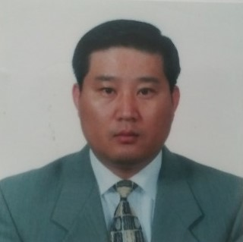

Chairman, Syung Man Rhee, 1st President of Korea Memorial Association

Sr, Pastor, Calvary Bible Presbyterian Church

Honor Doctor, Christian Education, Puritan Reformed University

**Chong Cheh Ko/Treasure**

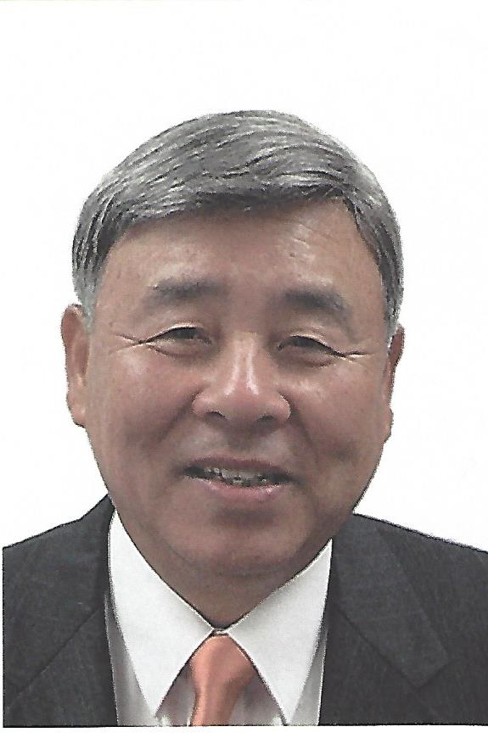

KOAM-TV, WA, CEO

General Manager, Secretary General Worldwide

Korean Christian

Korean Embassy in Vietnam, Staff

Republic of Korea Forces in Vietnam Radio Station, PD

BA, Yonsei University

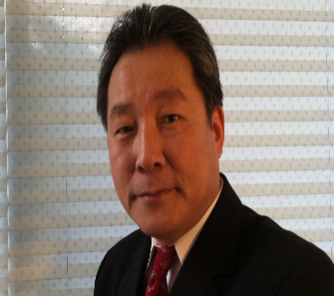**Rev., Richard H Kong,**.**/ Secretary**

Senior Pastor, Faith Church

Pusan National University, BM & MM

University of Washing, WA, studied for DMA

Robert Webber Institute for Worship Study, FL,

Advanced Graduate Worship Studies

Fuller Theological Seminary, CA, MA and DMin

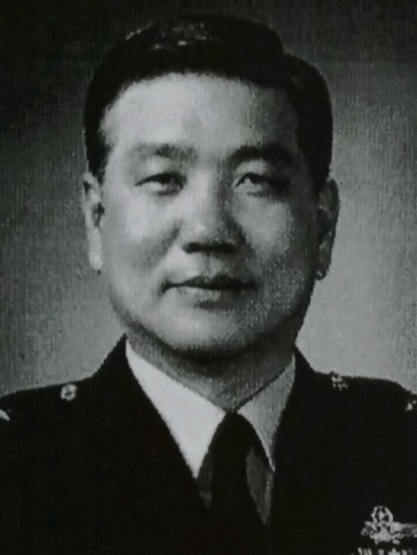

**Sung Chu Hahn/Board Member**

Air Force Academy, Republic of Korea, BA

U. S. Naval Academy, Computer Science, MA

Retired Major General

Choong NamUniversity, studied for Doctorate for Military Science

**Sun Kyu Whang, /Board Member**



Founder, Good Shepard Mission

Fuller Theological Seminary, D.Miss.

Washington Baptist Theological Seminary, MDiv

**Staff Directory**



**Rev. Dr. Richard H. Kong, President**

*DMin, Studied DWS and DMA*

Pastor Rick loves to learn other languages and cultures. He has a passion for worshiping God, teaching people, raising leaders of nations, and planting churches. He earned a Bachelor’s and Master's degree in Music, and he studied for his doctorate study at the University of Washington. After receiving the M.Div. degree in Washington, he continued his studies and received the degree of Advanced Graduate Worship Studies at Robert Webber Institute for Worship Study in Florida, an M.A. Theology Degree, and the Doctor of Ministry from Fuller Theological Seminary. Pastor Kong has ministered by teaching public schools and colleges in Korean and U.S. A. for more than 20 years. Also he founded Federal Way Youth Symphony Orchestra 15 years’ ago to train young people with musical service. Rick now serves also as the Sr. Pastor of Faith Church in Federal Way, WA.

**Instructors**



**Rev. Dr. Yong Seok Han**

D,ed. Honorary

Pastor Han has ministered as a chaplain at Korean Army and Korean church in Washington. He is serving as a Chairman, Syung Man Rhee, 1st President of Korea Memorial Association. As a former senior pastor of Calvary Bible Presbyterian Church, pastor Han is now looking for to train future international leaders here in WA. His Honor Doctor received from Christian Education, Puritan Reformed University.

**Sung Chu Hahn,** M.A.Science



Retired Major Hahn served his life as defend South Korea as a pilot, military leader, and writer for military strategy and Christianity. When he was serving Air Force of South Korea, he was well known military strategy with Carl von Clausewitz(1780-1831)’s Center of Gravity. He also wrote books for Christian, Emmanuel vs Antichrist (2010), Distortion of Theology for 2000 years (2011), Why Christian Cannot Trust Theology? (2012), Forgotten Bethany Lesson of Jesus Christ (2013).



**Sun Kyu Whang,** DMin.

Dr. Whang has served His church as a pastor and missionary. After retired a church which was planted by him, he began Good Shepard Mission for the world and he is supporting missionaries around of the world now. His book, One and One Mission, became his foundation to make disciples in the world.

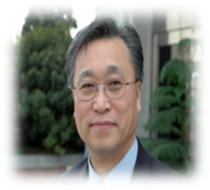**Rev. Dr. Ezra HS Kyung**

Th.D., Ph.D.

Ezra has trained students, teachers, pastors, and missionaries for more than 20 years internationally. He founded International Bible College and University 23 years ago in S. Korea and Israel to train people who want to be witnesses of God. Captured by a vision to disciple all nations, his mission was not only to teach people, but also to build bible learning centers around world. Ezra has coached and assisted in 26 new church plants, emphasizing multi-cultural church starts. Ezra speaks internationally at churches, conferences, and colleges, on the power of the Holy Spirit, ministering gentle encouragement with a prophetic wind that ignites fires and builds faith.

**Rev. Terry Tarsiuk**



*M.A. Theology and Ministry*

Pastor Terry Tarsiuk Terry has been in full-time church ministry for over 35 years. He has served at the Christian Faith Center as a pastor and teacher for 32 years in Bible Training schools, and he is currently with Vision College and Northwest University in Kirkland, WA. He earned a Master of Arts Degree in Theology and Ministry from Fuller Theological Seminary. Terry's consuming passion is to create the atmosphere of Heaven on earth through teaching others to live by the principles of God's Kingdom.

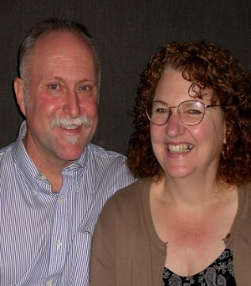**Rev. Mike Banks**

*B.A. Communication and Sociology*

Mike graduated from the University of Washington in 1976 with degrees in Communication and Sociology. He has just retired from the U.S. District Court after working 30 years as a Probation Officer. He has been a Foursquare Pastor for eight years and is currently an assistant pastor at Horizon Church. Mike and his wife, Mary, live in Ballard and have two adult sons.

**Dr. Shirl DeBay**

*B.A., M.A., Ph.D.*

Dr. Shirl DeBay has been a missionary in Japan and China, a Christian counselor, and an instructor at many different colleges. She has received several degrees including a Missions Diploma from Northwest University, a B.A. in Psychology from Seattle Pacific University, and a Masters and a Doctorate in Christian Counseling from Triune Biblical University. She was a Missionary in Japan for 11 years, Missionary in China for 10 years, Professor and Dean of Women at Eugene Bible College, Professor and Dean of Women at Beacon College and Seminary, Professor at Hong Kong Bible College, Professor at Seattle Bible College, and a Marriage and Family Counselor in private practice for 35 years.

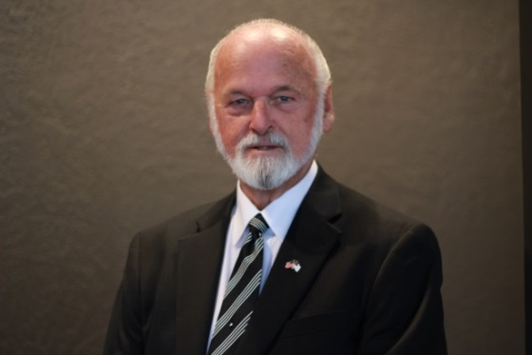

**Rev. Jack DeBay**

*B.A., M.Th.*

Beside his years of pastoring, Jack has a B.A. in Education from Florida Southern College and a Masters in Theology from Beacon College & Seminary, he was a Professor at Eugene Bible College, Professor at Hong Kong Bible College, Professor at Seattle Bible College, and he was a Missionary in China for 10 years. Jack’s grasp of the Word, coupled with his life experiences, brings solid depth to understanding God’s Word.

**Rev. Paul Kim**

*M.Div., D.Min.*

Paul has been in ministry after graduating from the General Assembly Theological Seminary in Seoul, Korea, receiving a M.Div. in 1968. When he completed his B.A. at Korea University, he knew that God wanted him for ministry, and he responded His calling. After 6 years of ministering in Korea, he came to Tacoma and founded the Tacoma Reformed Christian Church in 1977. Paul has recently retired. He loves teaching people, not only locally, but also internationally. His teaching continues as he has finished his Doctorate at Faith Theological Seminary in Philadelphia, PA.

**Rev. Dr. Rick Kong**

*MM, MA, M.Div, DMin, Studied for Doctor of Worship and DMA*

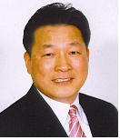

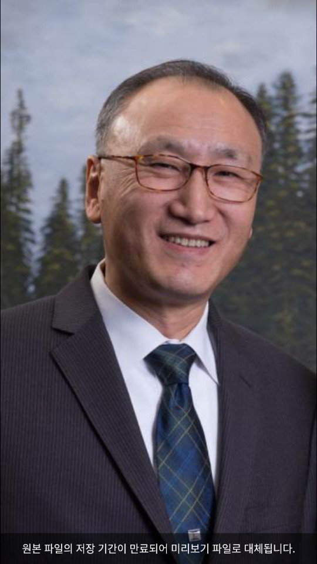

**Choon Won Chang**

BA, MDiv, MBA, DBA

Jong-Ang University, BA

California State Polytechnic University, MBA

Pacific States University, DBA

Reformed Presbyterian Seminary, M.Div

Westminster Theological Seminary, MA

Fuller Theological Seminary, Studies for DMin

Global Assistant Partners (GAP), Co-representative

International Assembly of New Life Mission Church, International Chairman

Joy Mission, Chairman

Sr. Pastor, New life Church, Chicago