HRMS

Prerequisite
For the HRMS Portal to run smoothly, we must ensure that few configurations are configured prior to any action on the site.

- EMAIL-SETTINGS: under the server administration we must set up the configurations for mailing as following image suggests:
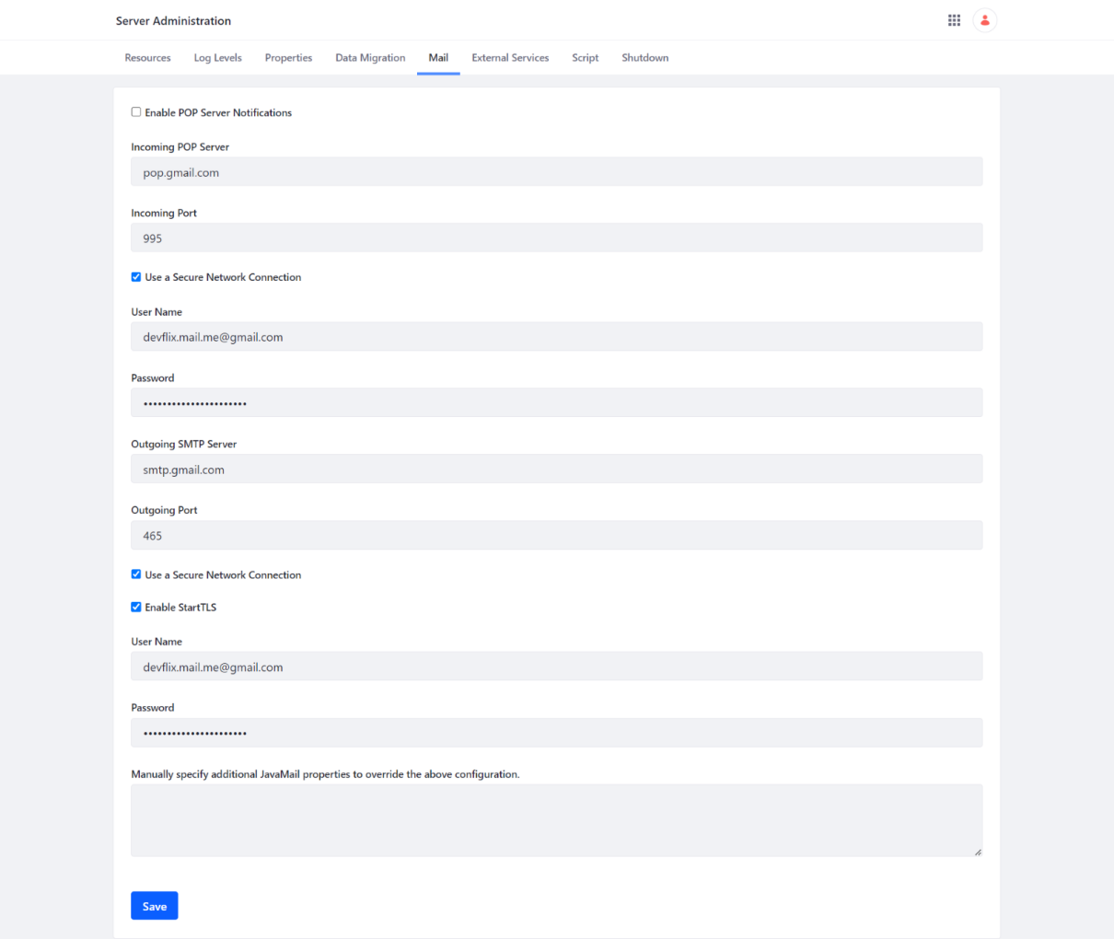

Scheduler:
Job Scheduler for HRMS plays a very vital role, it has monthly, daily and yearly scheduler.
Daily scheduler :
- Appraisal Form Pending reminder: The appraisal forms not filled and have a deadline of 1 day from the scheduler run will be notified to HR on the mail.
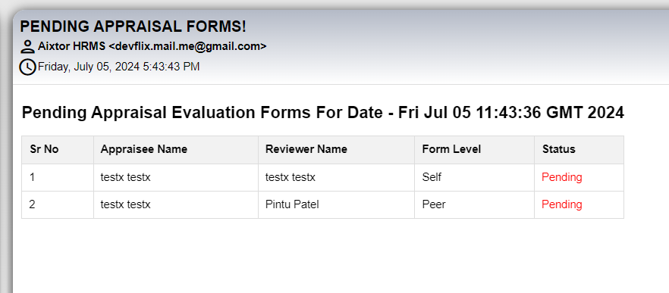
- Pip Meeting notifiaction that the employee’s pip meeting is approcahing.

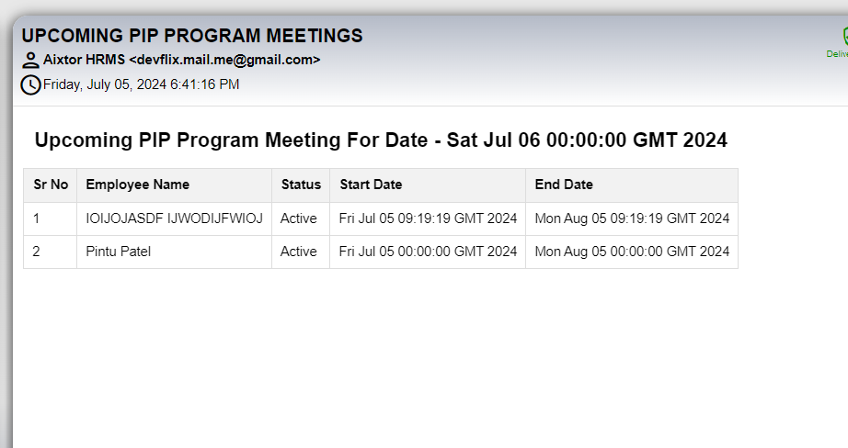
- Employee Whose birthday is there they also informed by notification and Mail to HR:
Configurations-Notification:- Under 9 Dots > System settings > catagory.HRMS > Notification Template Configurations. > Birthday Wish
Placeholder: Refer Excel sheet for the placeholders.
Configurations-Mail:- Under 9 Dots > System settings > catagory.HRMS > Mail Template Configurations. > Daily Scheduler Birthday
Placeholder: Refer Excel sheet for the placeholders.
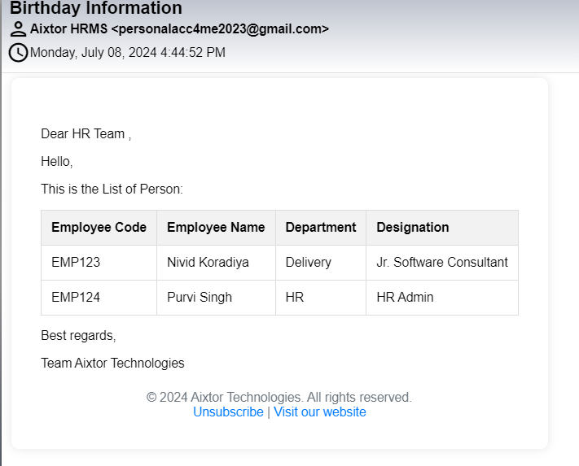
- Employee Whose Work Anniversary is there they also informed by notification and Mail to HR:
Configurations-Notification:- Under 9 Dots > System settings > catagory.HRMS > Notification Template Configurations. > Anniversary Wish
Placeholder: Refer Excel sheet for the placeholders.
Configurations-Mail:- Under 9 Dots > System settings > catagory.HRMS > Mail Template Configurations. > Daily Scheduler Anniversary
Placeholder: Refer Excel sheet for the placeholders.
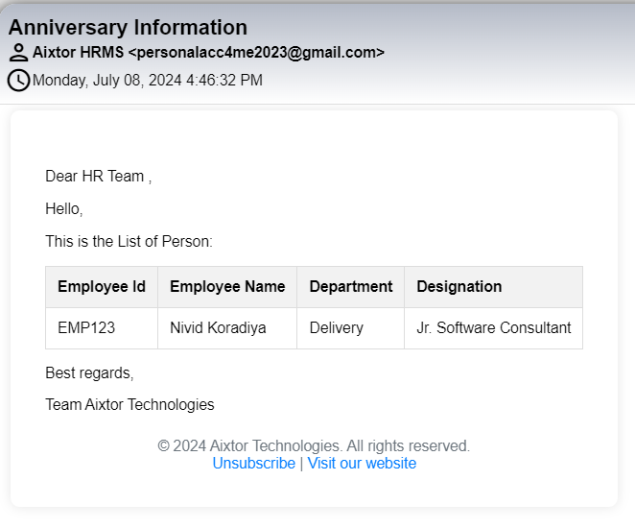

Monthly Scheduler:
- Employee whose appraisal last year in the same month as the scheduler running will be added to the appraisal process, Also the HR will get mail and notification
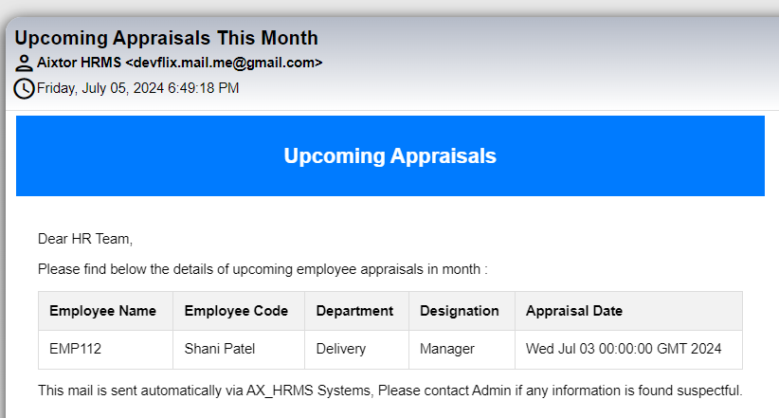
- Configurations-Notification:- Under 9 Dots > System settings > catagory.HRMS > Notification Template Configurations. > Appraisal Reminder to HR Notification (Employee)
- Placeholder: Refer Excel sheet for the placeholders.

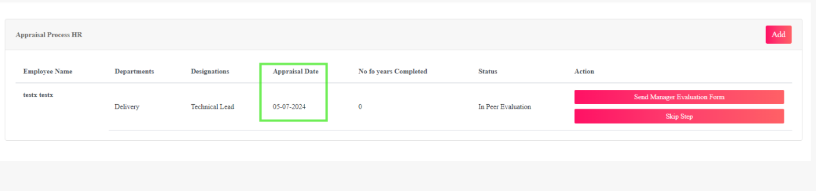

Master Module:
Master module has a very significant role to play in all the various modules in this project. As it contains basic details of every entity that could be consumed in some way by the project modules. Let’s discuss the modules one by one in detail:

Appraisal Status Master:

Functionalities:
Appraisal status master stores the status of an appraisal process. The main functionality of this portlet includes – deleting the status, adding the status, editing the status.

Page Name & Links:
The page where the portlet is placed is named Appraisal Status Master.
Link - http://localhost:8080/group/hrms/appraisalstatusmaster

Functionality Flow:
The flow starts by navigating to the link mentioned in the above section, that will present you the below screen:
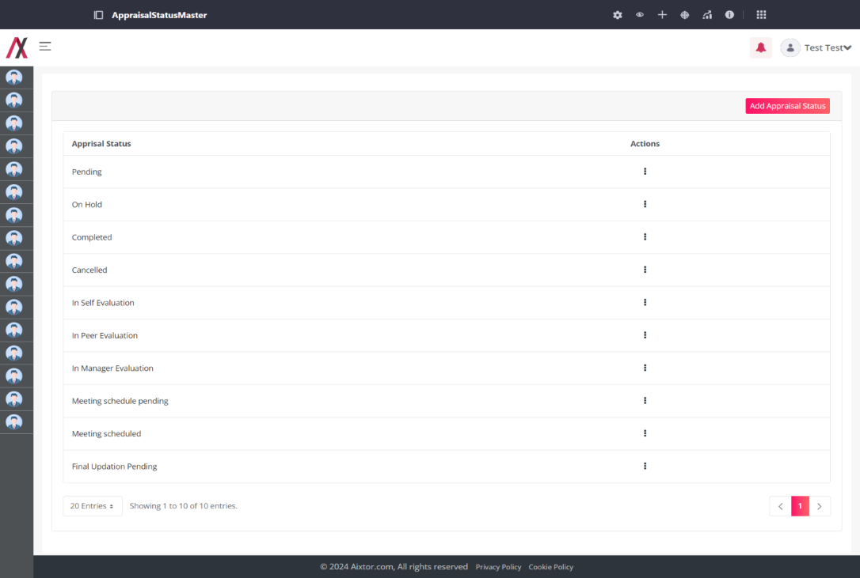
This screen has the list of all the appraisal status master available with that there is also an Add Appraisal Status button that will lead you to another screen to add the appraisal status:
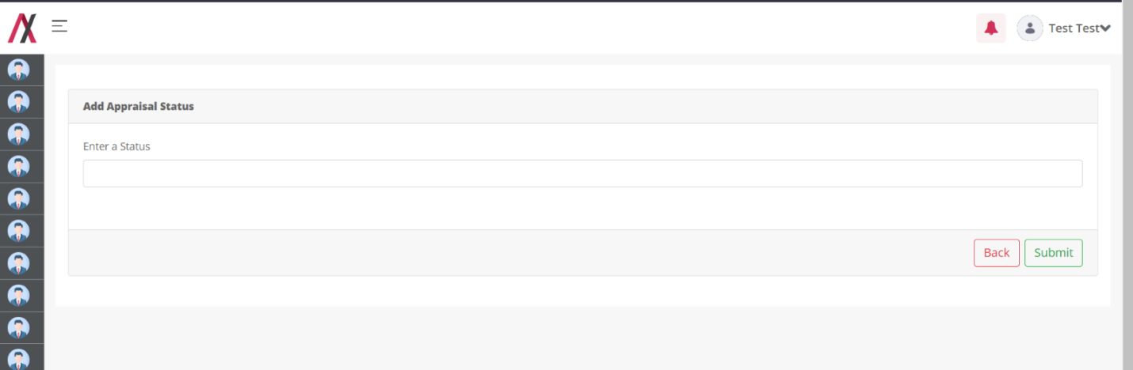
Here you can add the name of appraisal status that you want to add into your system. There are two buttons available on the screen, one to go back to the listing page and another to add the status. This field will only accept alphabetical value only and will consider “Apple” and “apple” as same.
If you add a status that already exist in the system you will be encountered with the error as below:
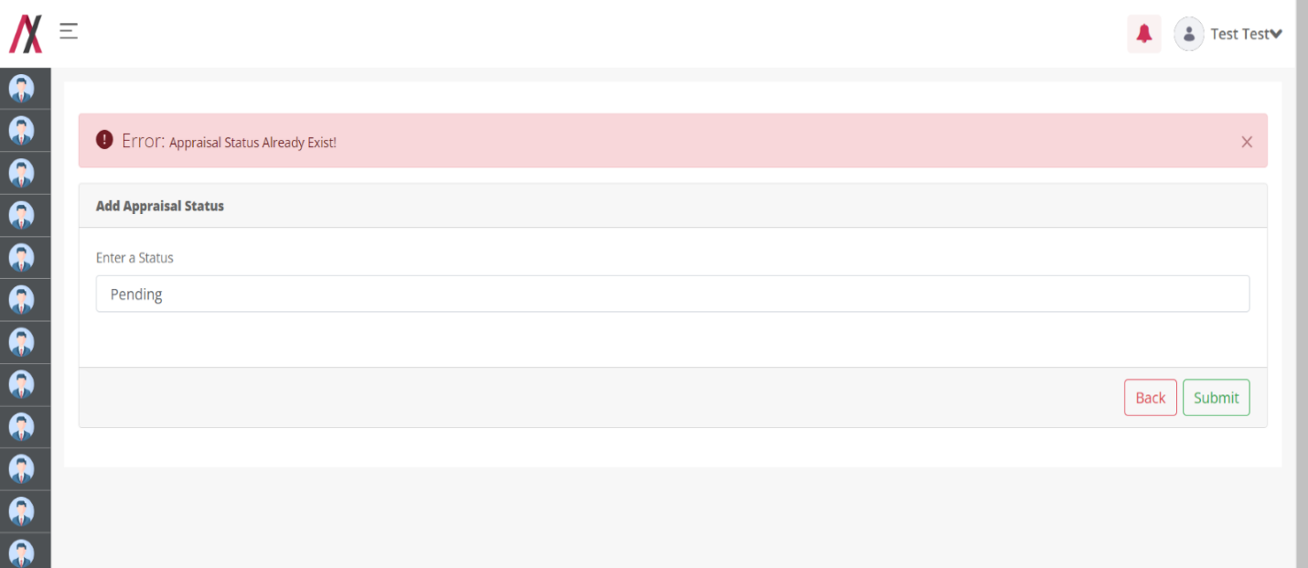

But, if you add the correct status you will be greeted with the success message as below:
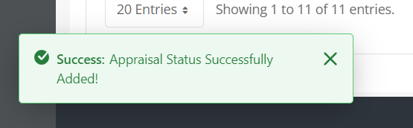
And after adding the status we are redirected back to the list page.
On clicking the 3-dot available in the action column you will be allowed to navigate to view, edit and delete functions
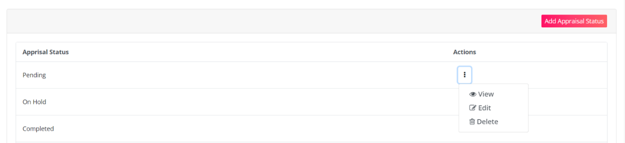
By clicking the View button, you are redirected to the following screen where you can see the details about a specific entry of appraisal status as shown in image below:
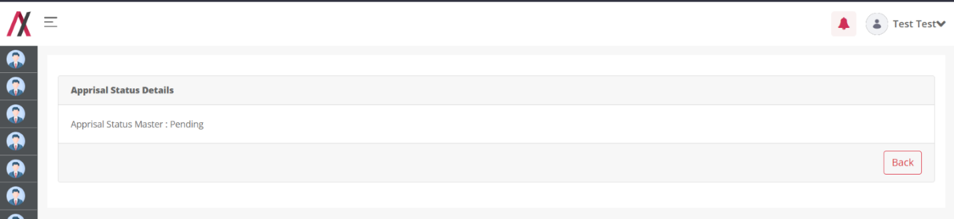
By clicking on the edit button you will be taken to the editing screen, here you can edit the appraisal status. There are two buttons available on the screen, one to go back to the listing page and another to add the status. This field will only accept alphabetical value only and will consider “Apple” and “apple” as same. The editing screen is shown in image below:

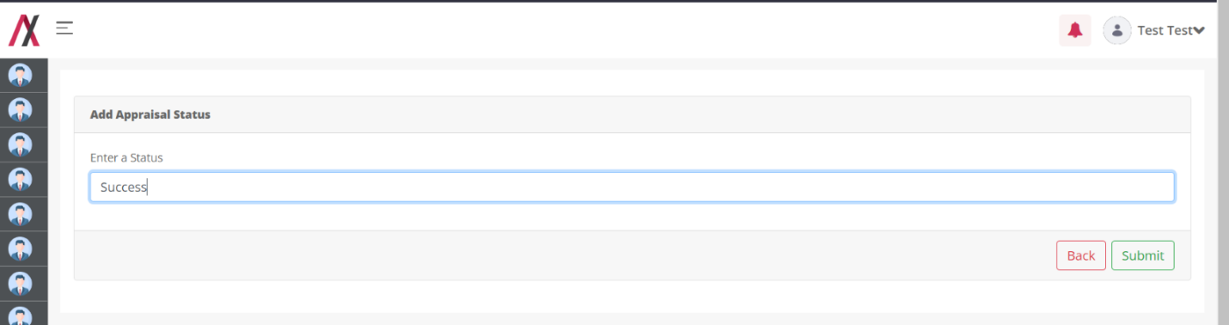
On clicking the submit button we will be greeted with the message.
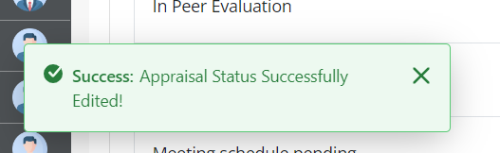

Department Master:

Functionality:
Department master stores all department names that will be co-related to the employee while on-boarding and other processes where it could be consumed.
You can add, edit and delete the department details using this portlet.

Page Name & Links:
The page where the portlet is placed is named Department Master.
Link - http://localhost:8080/group/hrms/departmentmaster

Functionality Flow:
The flow starts by navigating to the link mentioned in the above section, that will present you the below screen:
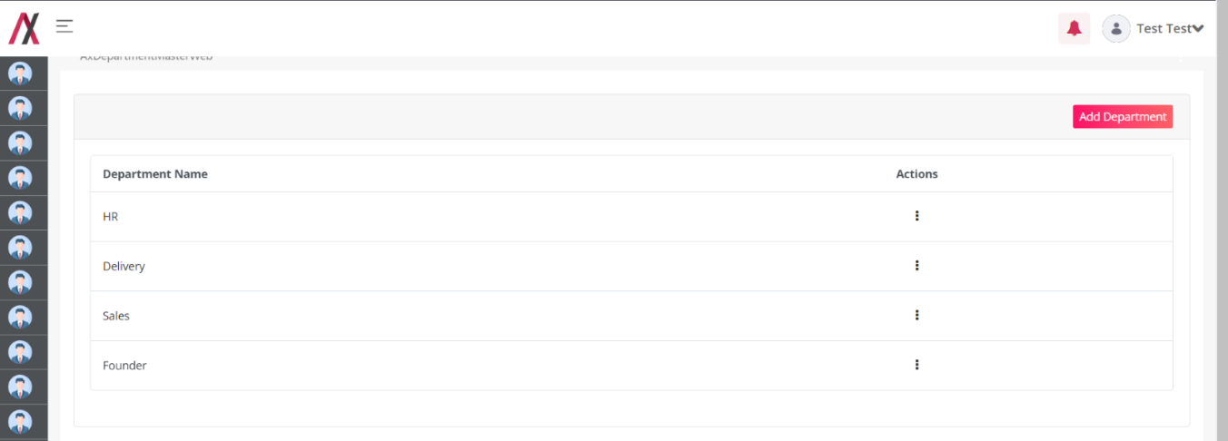

On this screen you’ll see all the departments listed that are preset in the system currently. Including the button on the top-right corner to add the departments.
By clicking on the add button you will be taken to the adding screen, here you can add the department. There are two buttons available on the screen, one to go back to the listing page and another to add the department. This field will only accept alphabetical value only and will consider “Apple” and “apple” as same. The editing screen is shown in image below:

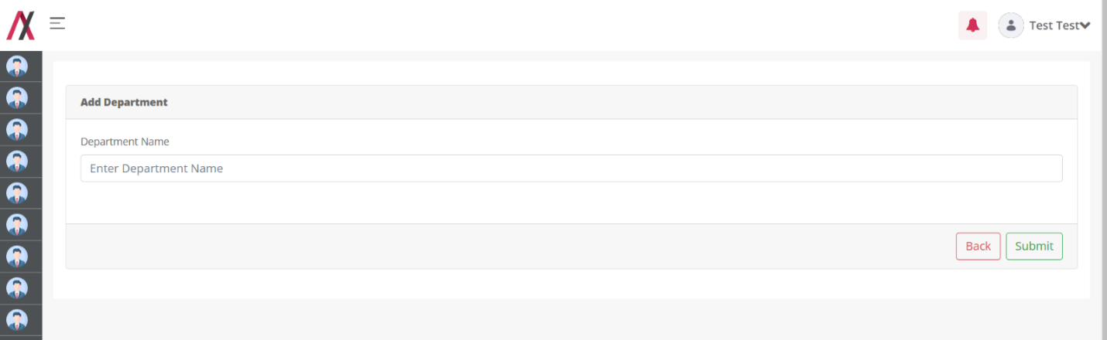
If you add a department that already exist in the system you will be encountered with the error as below:

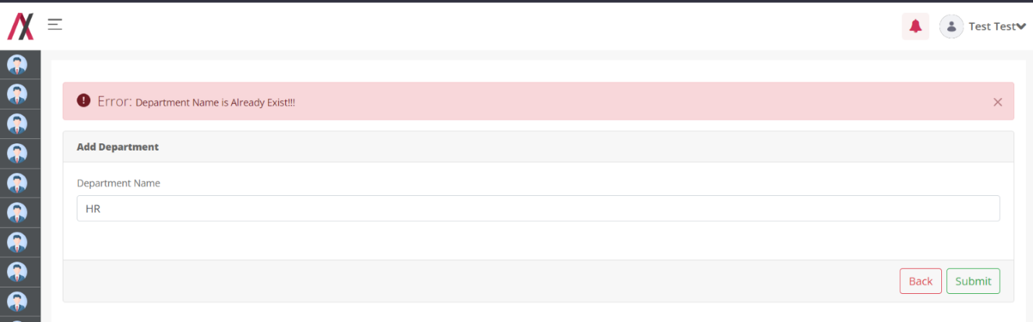
Once you add a correct department name and press submit you will be greeted with the success message:
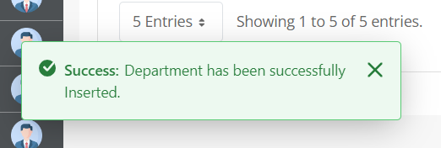
Note : on adding a new department a new Role will be created in the Liferay's system named same as the department!

After adding the department to the master data, you’ll be redirected to the list page :
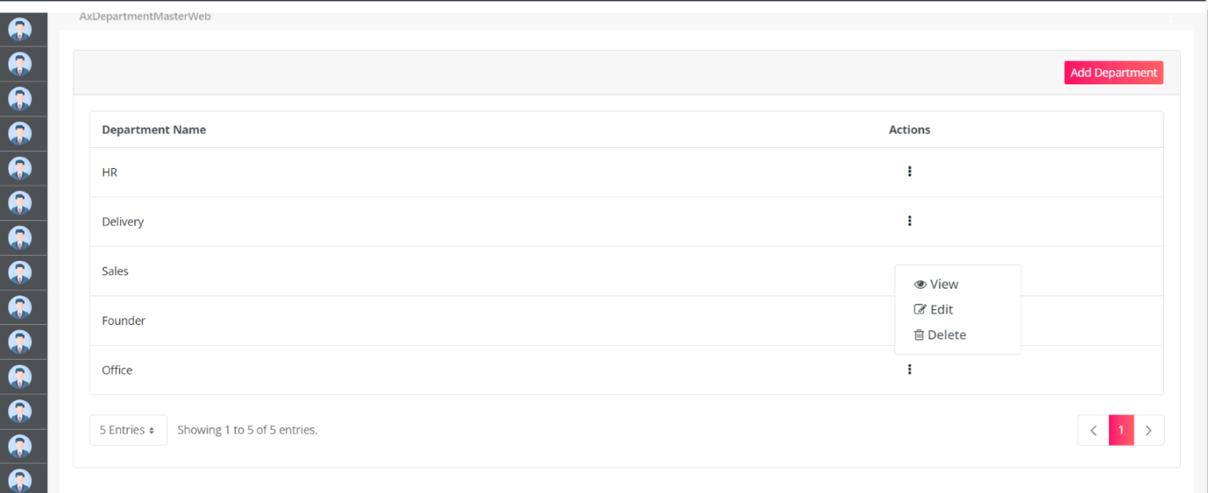
Here on the 3-dots you can find the actions you could perform on the department data – like edit, view and delete.
On clicking on the edit data, you will be redirected to the editing panel that will look like following form, filled with the data including the department name pre-filled:
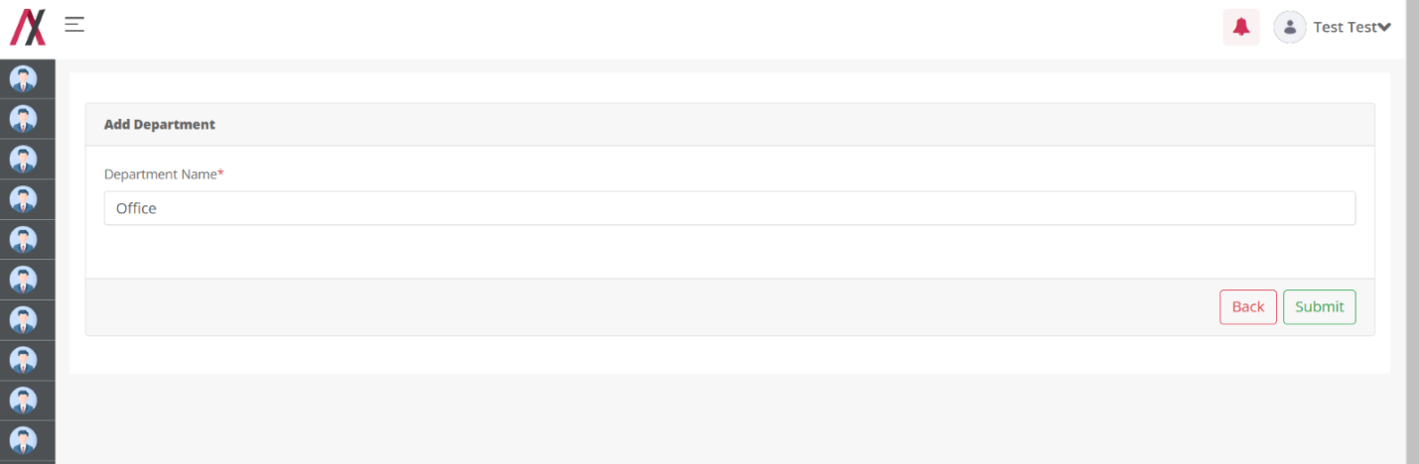
After editing the data, you will be greeted with the success message or an error if you end up adding a department name already available in the list.
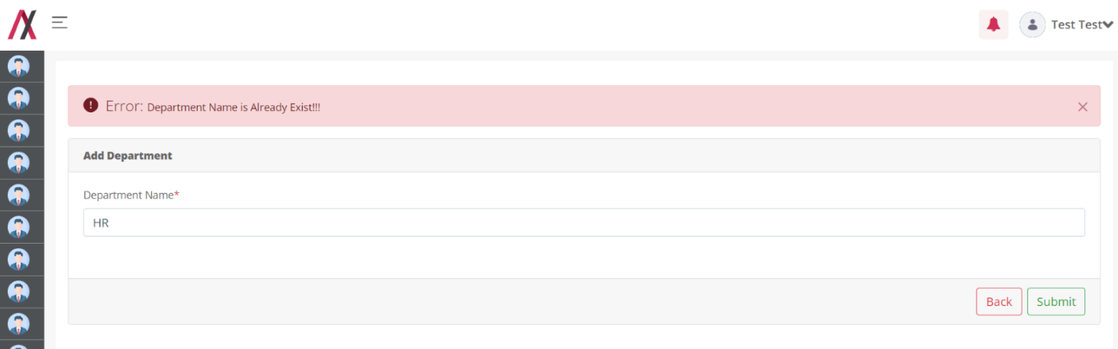
On success the following message appears:
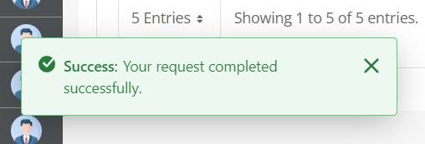

On delete from the list page actions, you will see the following message:
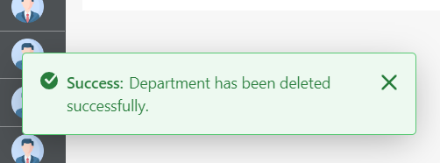

Designation Master:

Functionality:
Designation master stores all designation names that will be co-related to the employee while on-boarding and other processes where it could be consumed.
You can add, edit and delete the designation details using this portlet.

Page Name & Links:
The page where the portlet is placed is named Designation Master.
Link - http://localhost:8080/group/hrms/designationmaster

Functionality Flow:
The flow starts by navigating to the link mentioned in the above section, that will present you the below screen:
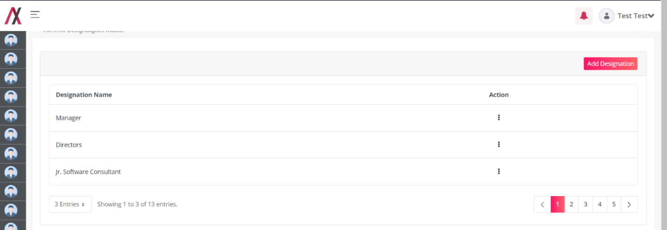

On this screen you’ll see all the designations listed that are preset in the system currently. Including the button on the top-right corner to add the designations.
By clicking on the add button you will be taken to the adding screen, here you can add the designation. There are two buttons available on the screen, one to go back to the listing page and another to add the designation. This field will only accept alphabetical value only and will consider “Apple” and “apple” as same. The editing screen is shown in image below:

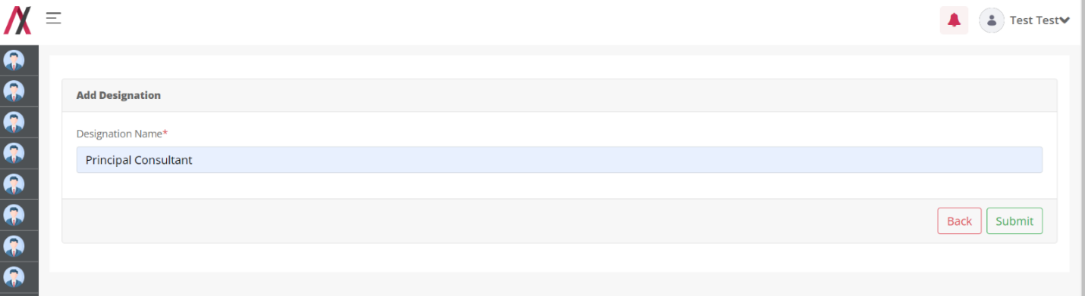
If you add a department that already exist in the system you will be encountered with the error as below:

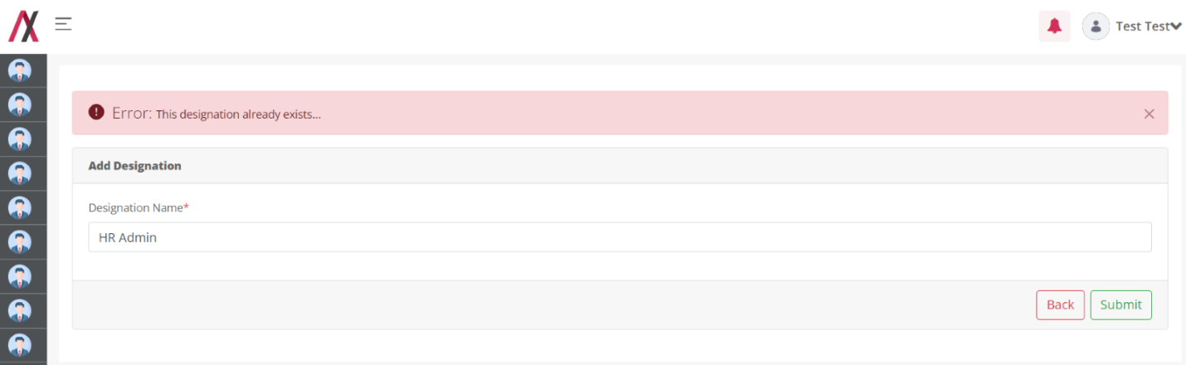
Once you add a correct designation name and press submit you will be greeted with the success message:
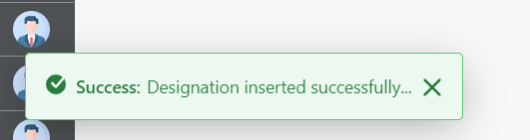
Note : on adding a new designation a new Role will be created in the Liferay's system named same as the designation!

After adding the designation to the master data, you’ll be redirected to the list page:
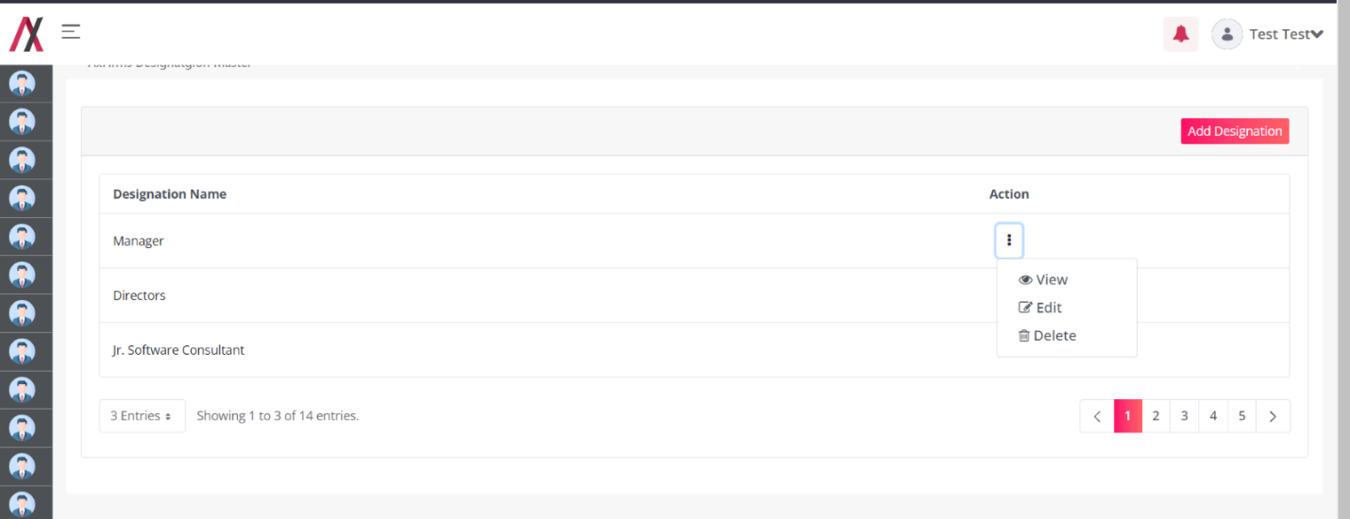
Here on the 3-dots you can find the actions you could perform on the designation data – like edit, view and delete.
On clicking on the edit data, you will be redirected to the editing panel that will look like following form, filled with the data including the designation name pre-filled:
Unable to load the picture

After editing the data, you will be greeted with the success message or an error if you end up adding a designation name already available in the list.
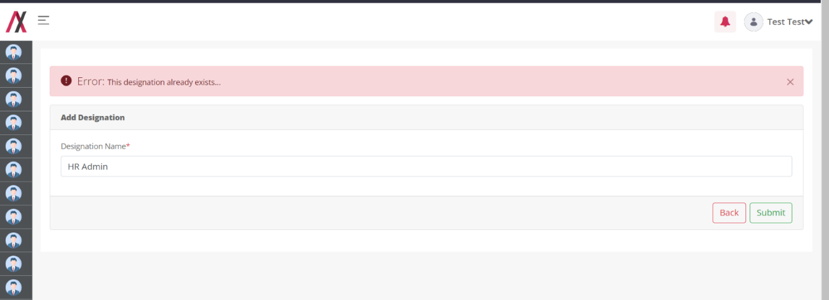
On success the following message appears:
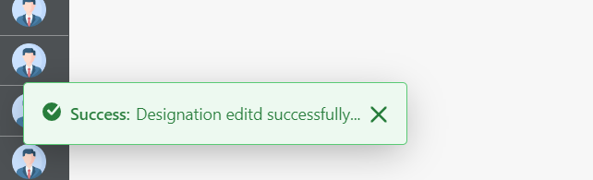

On delete from the list page actions, you will see the following message:
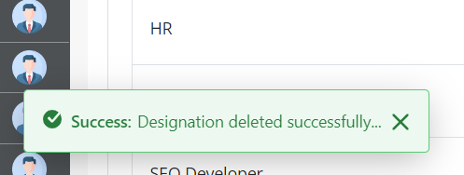

Leave Policy Master:

Functionality:
Leave Policy Master Stores all leave policy for the employees; based on this data, the leaves will be credited into the employee's account. It gives you full flexibility to make the changes into a leave policy as you require it to change it.
You can add, edit and delete the leave policy details using this portlet.

Page Name & Links:
The page where the portlet is placed is named Leave Policy Master.
Link - http://localhost:8080/group/hrms/leavepolicymaster

Functionality Flow:
On visiting the page of this page, we have the list of all the leave policies already added to the system.
Once you go on the page you get a list containing a table with various columns. As shown below:
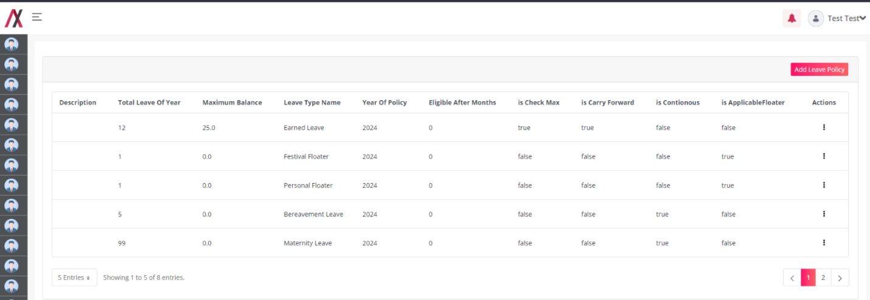
On the right corner you must find the add button that will take you to the form to add the leave policy. On clicking you will see the following form:
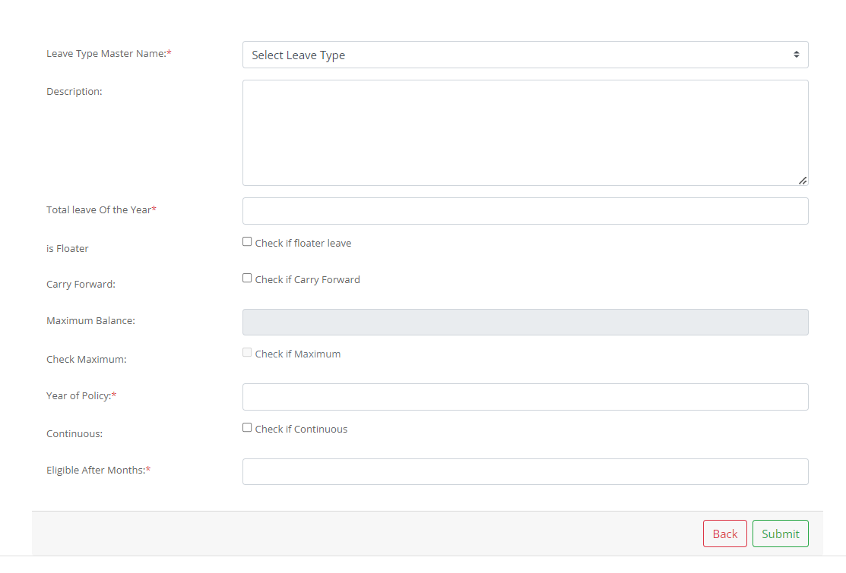In this form you will find following fields:
- Leave type master: This will have the dropdown of all the types of leaves available in the master data of Leave type.
- Description: You can add a short description for each leave policy you are adding.
- Total Leave of the year: that implies to a text box where you must fill the total no of leaves that specific leave type will be credited to the users/ employees.
- Is Floater: This check box indicates if the leave type is a floater or not. That means the leave needed to be taken fully, no partial leaves will be allowed to be taken.
- Carry Forward: This allows us to specify if the leave type is a carryforward type or not, that means after the specific year will these leave vanish or will continue to add on the next year’s balance.
- Maximum Balance: If the leave policy is carrying forward type, then how much balance can be carry forwarded at the same time.
- Check if Maximum: This check box allows you to check if there is any maximum limit over the storage of this type of leave.
- Check if continuous: This checkbox is to be checked in case the type of leave must be taken in one go! That is to be taken consecutively.
- Eligible after months: This field must be filled with the no. Of months after which the leave type will be activated for the employee.

After filling in all such data, the submit button must be pressed to save the leave policy.
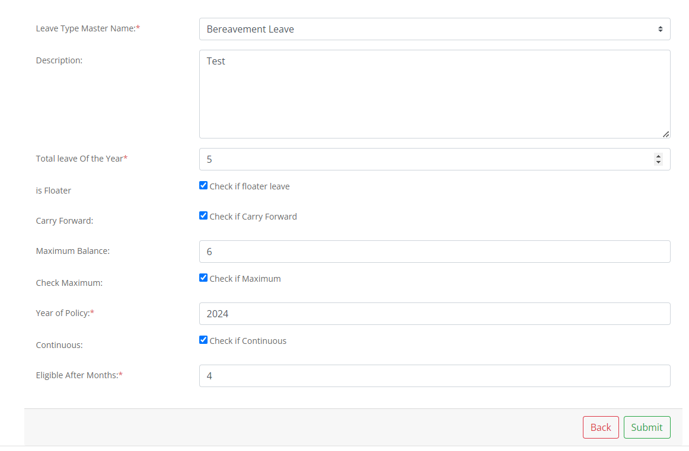
Now we can press the Submit button and our leave policy will be saved with following message:
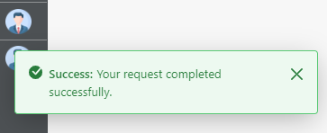

And then you will be redirected to the leave policy list page, where you will find 3-dots associated with every leave policy that has the actions for that entry.
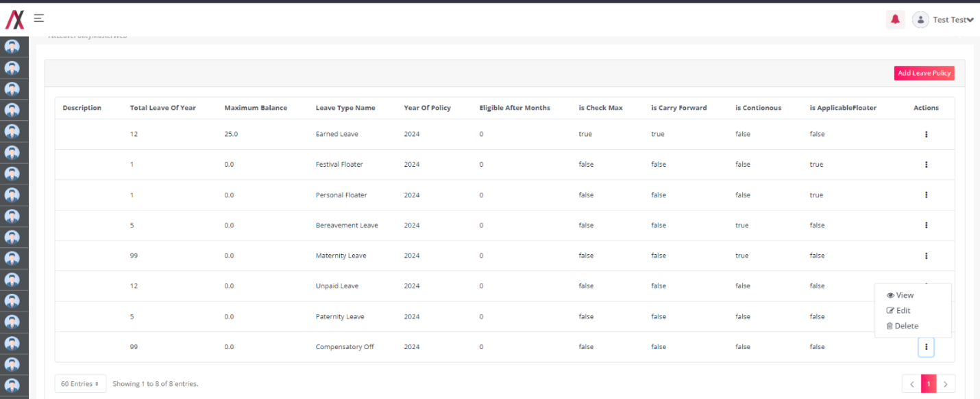
On the action dropdown you will have actions like – View, Edit and Delete.
When you click the view button, you will have a detailed view of that leave policy entry. The view is showing in the image below:
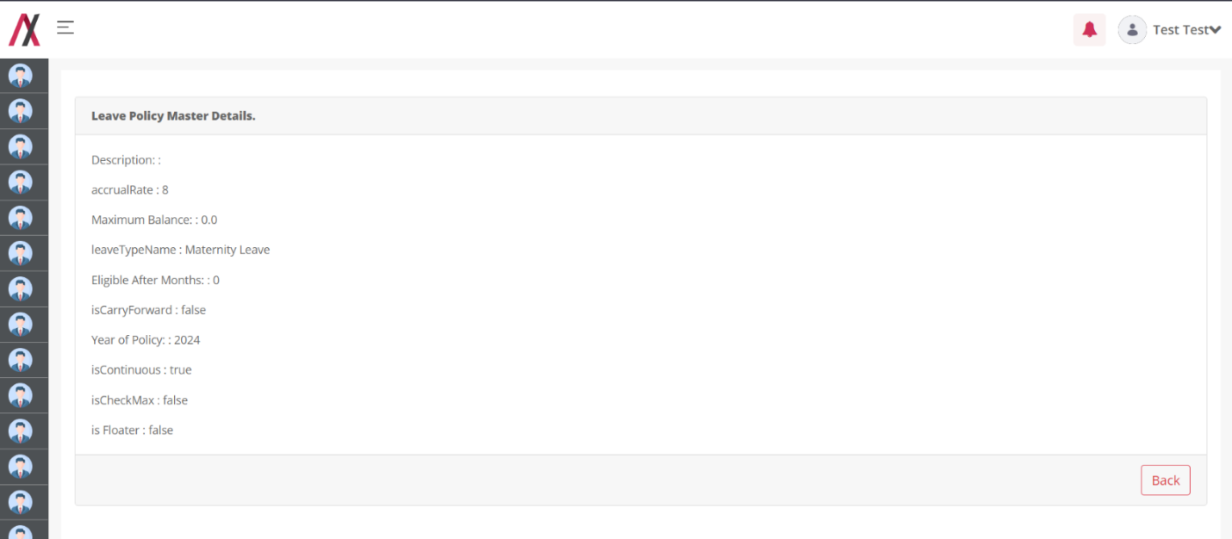
On pressing the delete button,
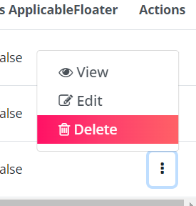
You will be prompted to warn you to delete the leave policy entry. If you press okay, the leave policy will be deleted, with the message as below:
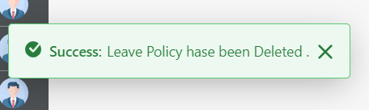
On pressing the edit button you will be taken to the editing page,
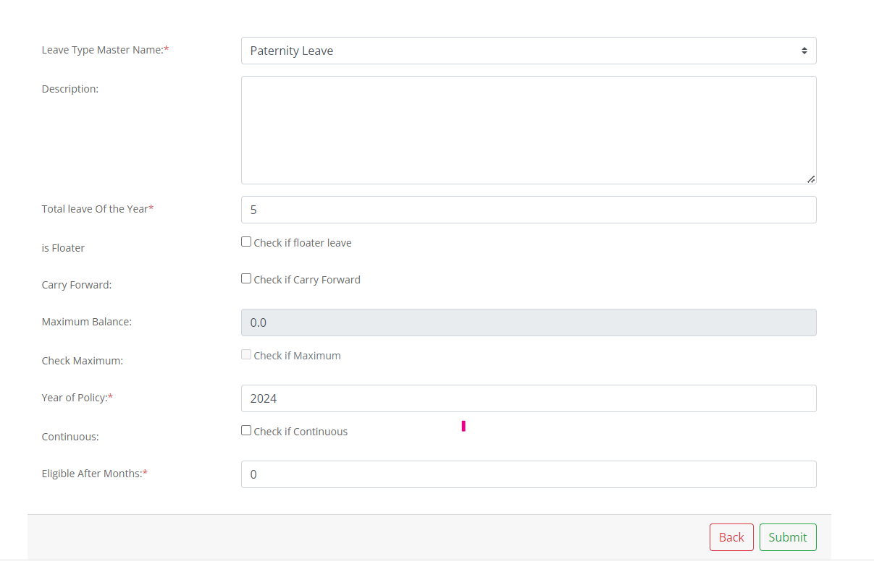
Here on the editing page, you will find various fields that you can customize as your leave policy allows.
In this form you will find following fields:
- Leave type master: This will have the dropdown of all the types of leaves available in the master data of Leave type.
- Description: You can add a short description for each leave policy you are adding.
- Total Leave of the year: that implies to a text box where you must fill the total no of leaves that specific leave type will be credited to the users/ employees.
- Is Floater: This check box indicates if the leave type is a floater or not. That means the leave needed to be taken fully, no partial leaves will be allowed to be taken.
- Carry Forward: This allows us to specify if the leave type is a carryforward type or not, that means after the specific year will these leave vanish or will continue to add on the next year’s balance.
- Maximum Balance: If the leave policy is carrying forward type, then how much balance can be carry forwarded at the same time.
- Check if Maximum: This check box allows you to check if there is any maximum limit over the storage of this type of leave.
- Check if continuous: This checkbox is to be checked in case the type of leave must be taken in one go! That is to be taken consecutively.
- Eligible after months: This field must be filled with the no. Of months after which the leave type will be activated for the employee.

After filling in all such data, the submit button must be pressed to save the edited leave policy. You will be greeted with the following message:
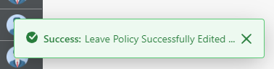
And you will be returned to the listing page.

Document Type Master:

Functionality:
Document Type Master stores information about different type of document .

Page Name & Links:
The page where the portlet is placed is named Document Type Master.
Link -http://localhost:8080/group/hrms/documenttypemaster

Functionality Flows:
The flow starts by navigating to the link mentioned in the above section, that will present you the below screen :
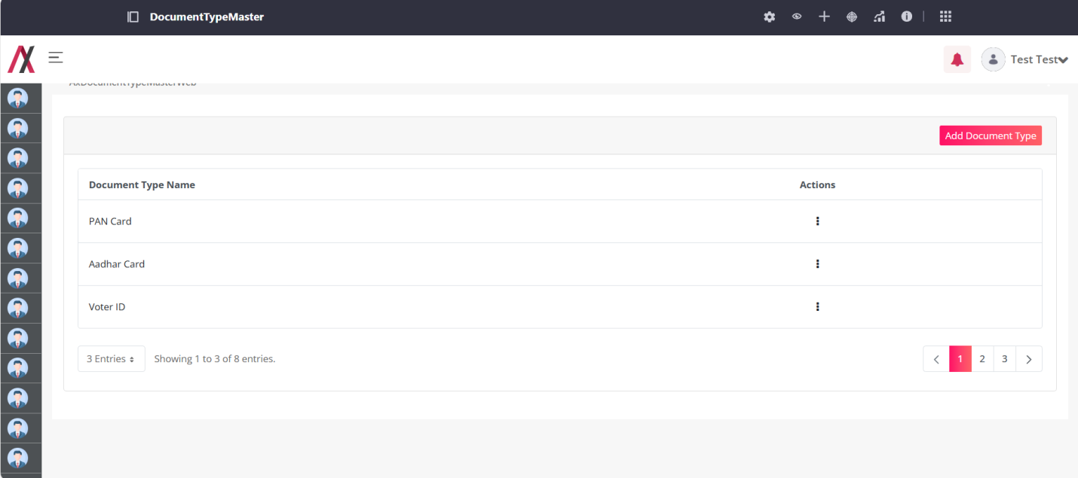
This screen has the list of all the document type master available with that there is also an Add Document Type button that will lead you to another screen to add the document type :
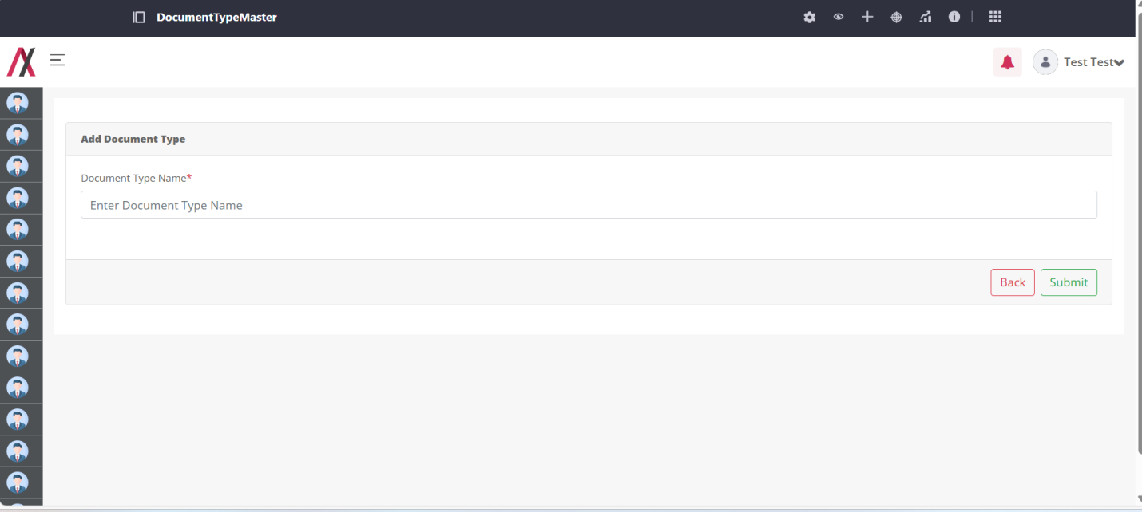
Here you can add the name of document type that you want to add into your system. There are two buttons available on the screen, one to go back to the listing page and another to submit the document type. This field will accept alphabetical value and numerical only and will consider “Apple1” and “apple1” as same.
Ex. Pancard123 is accept. But 123Pancard is not accept.
If you add a document type that already exist in the system you will be encountered with the error as below:
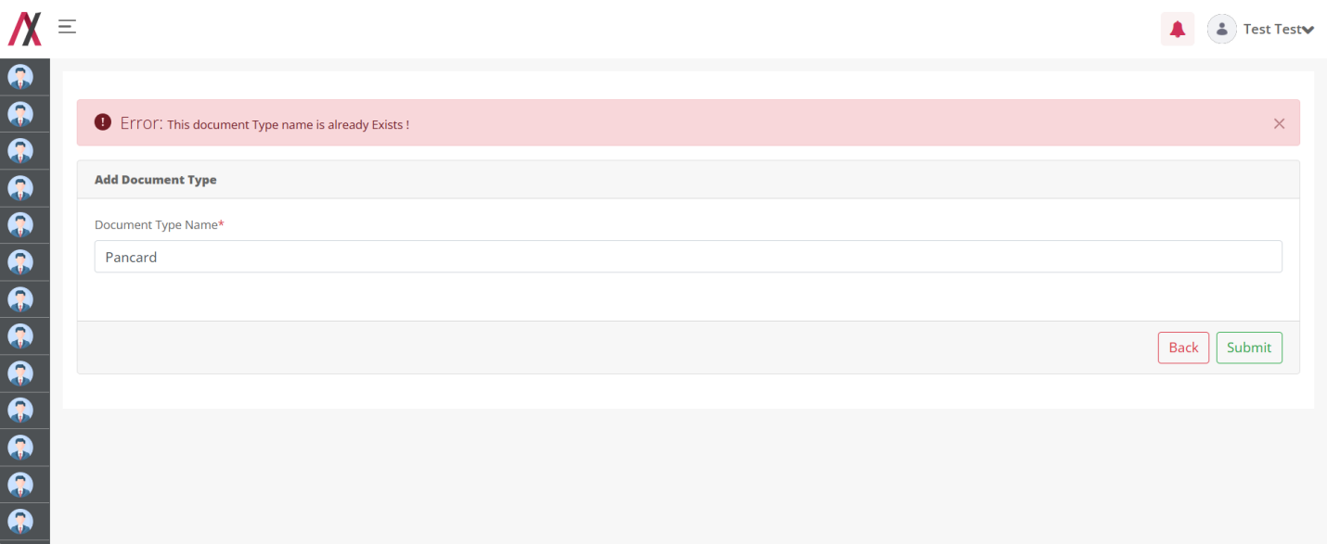
But, if you add the correct document type you will be greeted with the success message as below:
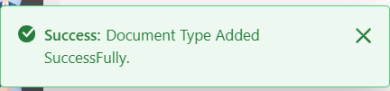
And after adding the document type we are redirected back to the list page.
On clicking the 3-dot available in the action column you will be allowed to navigate to view, edit and delete functions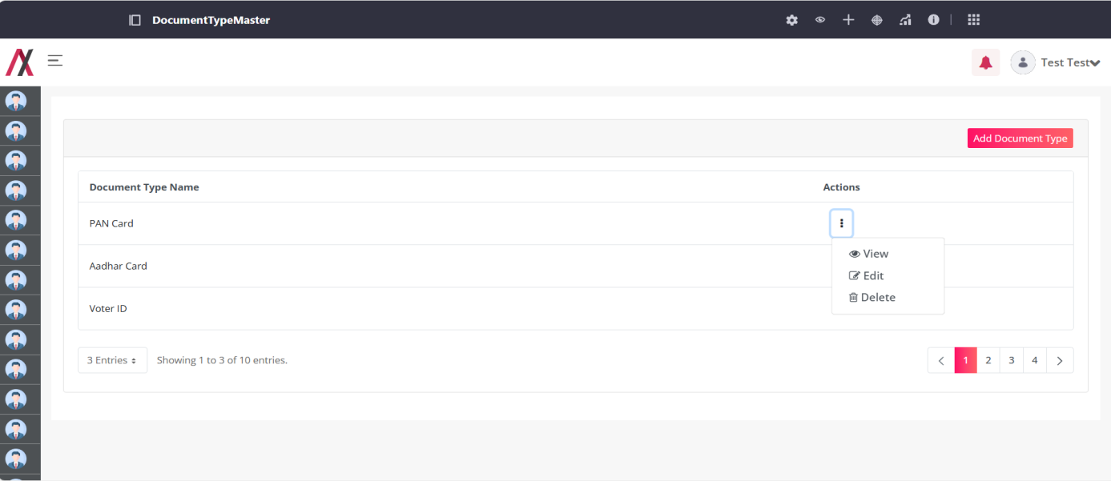
By clicking the View button, you are redirected to the following screen where you can see the details about a specific entry of document type as shown in image below:
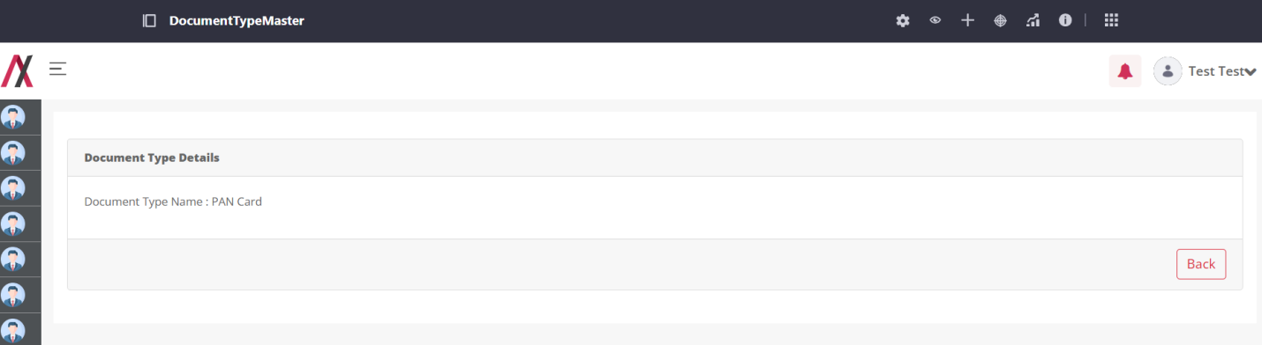
By clicking on the edit button you will be taken to the editing screen, here you can edit the document type. There are two buttons available on the screen, one to go back to the listing page and another to add the document type. This field will accept alphabetical value and Numerical only and will consider “Apple1” and “apple1” as same. The editing screen is shown in image below:
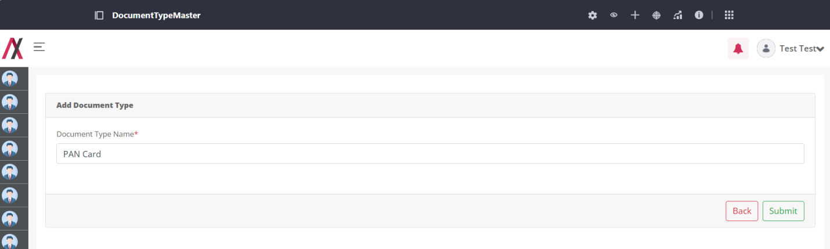
On clicking the submit button we will be greeted with the message.
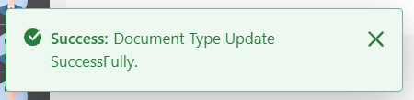

On clicking the Delete button, open alert box like this,
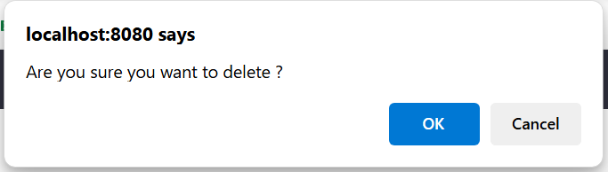
If you click ok button then delete that Document type, and you will be greeted with the success message as below:
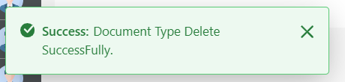

Education Level Master

Functionality:
Education level Master stores information about different level of education.

Page Name & Links:
The page where the portlet is placed is named Education Level Master.
Link - http://localhost:8080/group/hrms/educationlevelmaster

Functionality Flows:
The flow starts by navigating to the link mentioned in the above section, that will present you the below screen :

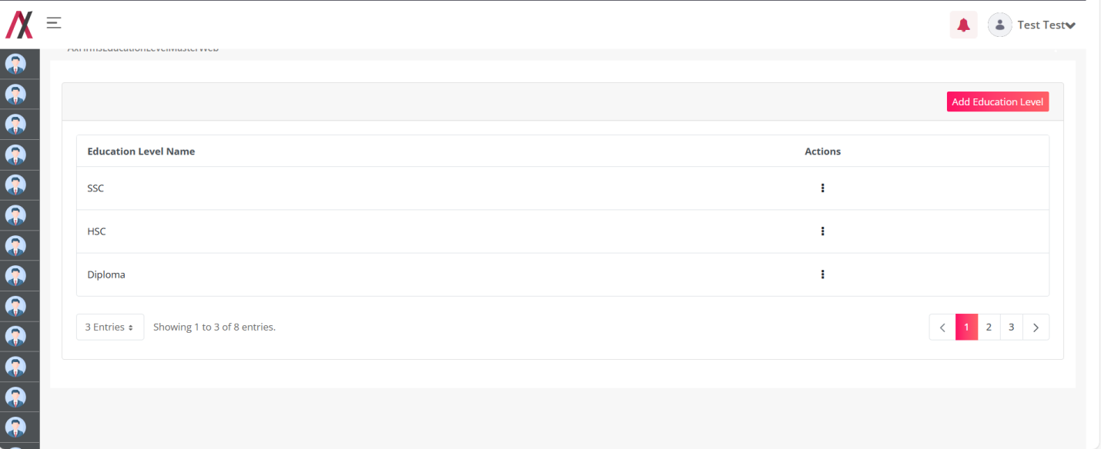
This screen has the list of all the education level master available with that there is also an Add Education Level button that will lead you to another screen to add education level :
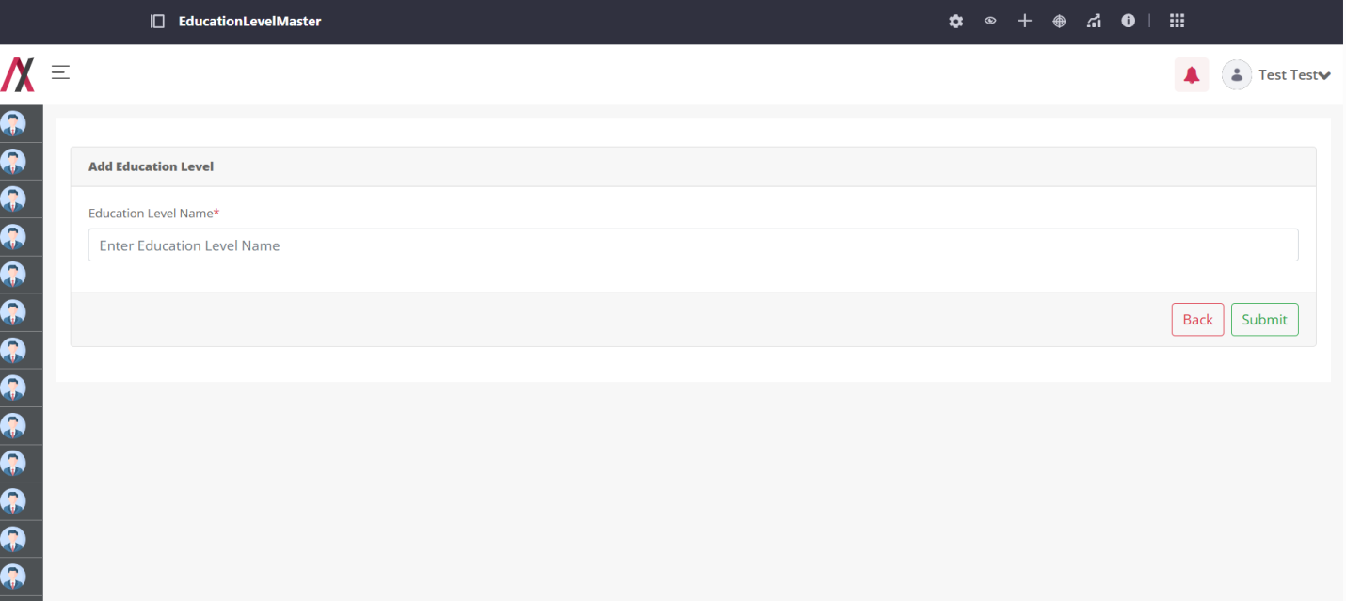
Here you can add the name of education level that you want to add into your system. There are two buttons available on the screen, one to go back to the listing page and another to submit the education level. This field will accept alphabetical value only and will consider “Apple” and “apple” as same.
If you add a education level that already exist in the system you will be encountered with the error as below:
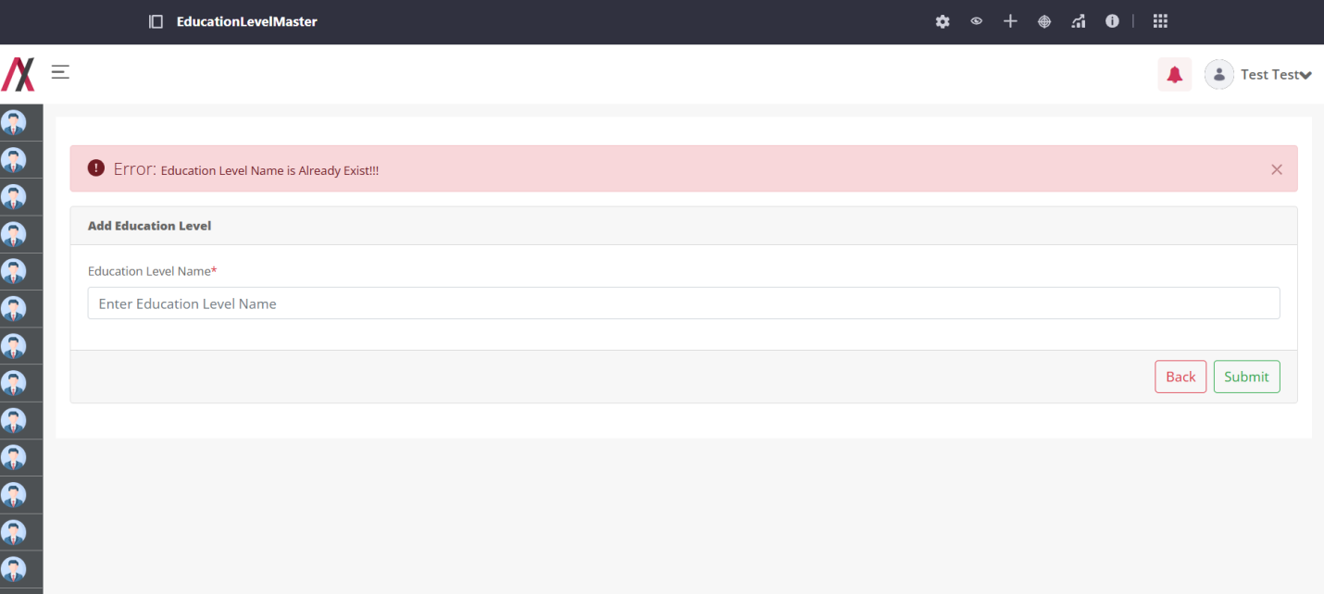
But, if you add the correct education level you will be greeted with the success message as below:
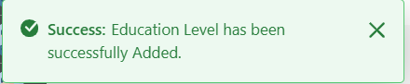
And after adding the education level we are redirected back to the list page.

On clicking the 3-dot available in the action column you will be allowed to navigate to view, edit and delete functions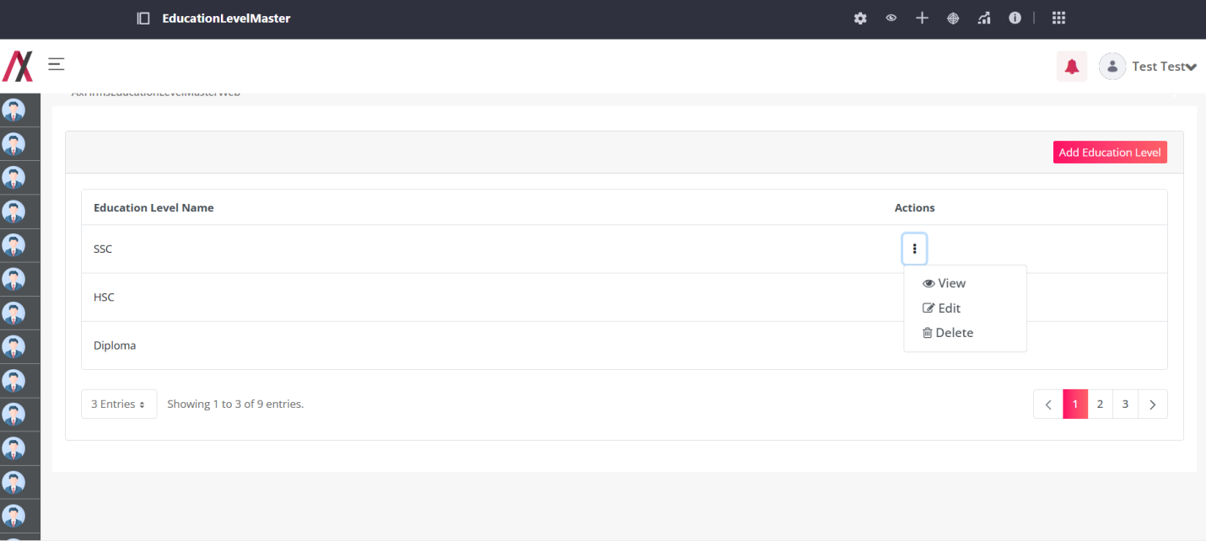
By clicking the View button, you are redirected to the following screen where you can see the details about a specific entry of education level as shown in image below:
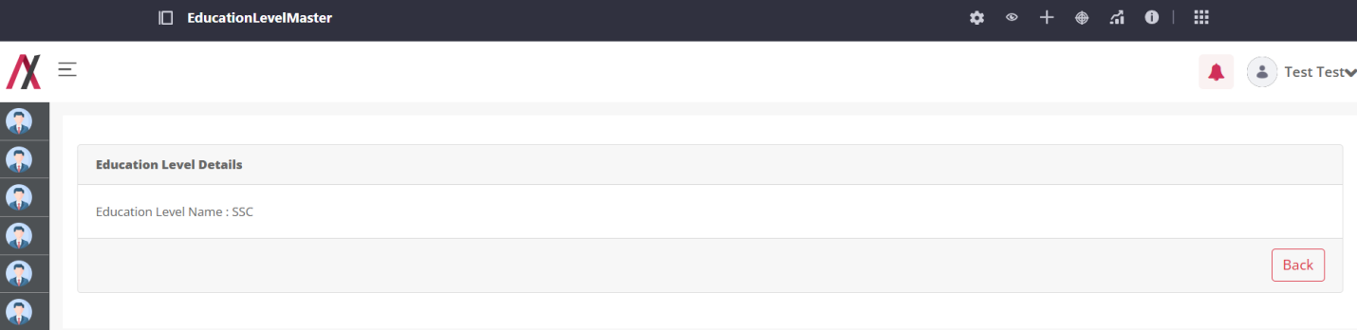
By clicking on the edit button you will be taken to the editing screen, here you can edit the education level. There are two buttons available on the screen, one to go back to the listing page and another to add the level. This field will only accept alphabetical value only and will consider “Apple” and “apple” as same. The editing screen is shown in image below:
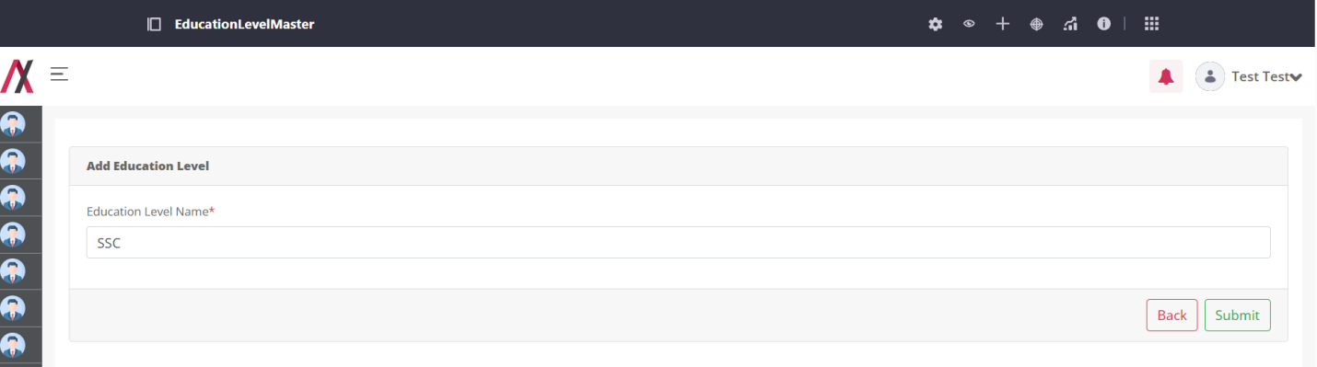
On clicking the submit button we will be greeted with the message.
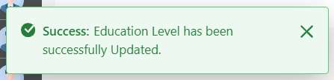

By clicking the Delete button, open alert box like this,
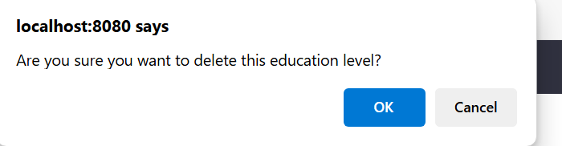
If you click ok button then delete that Document type, and you will be greeted with the success message as below:

Template Level Master:

Functionality:
Template Level Master stores information about different Level of Template of Appraisal.

Page Name & Links:
The page where the portlet is placed is named Template Level Master.
Link - http://localhost:8080/group/hrms/templatelevelmaster

Functionality Flows:
The flow starts by navigating to the link mentioned in the above section, that will present you the below screen :
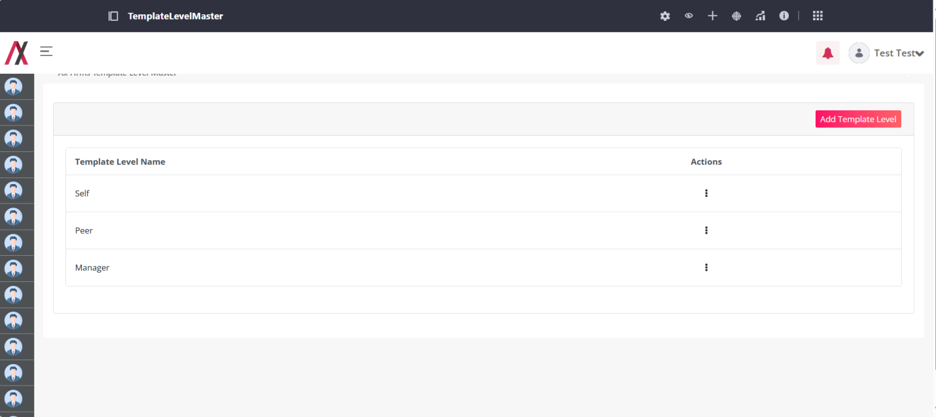
This screen has the list of all the template level master available with that there is also an Add Template Level button that will lead you to another screen to add the template level :
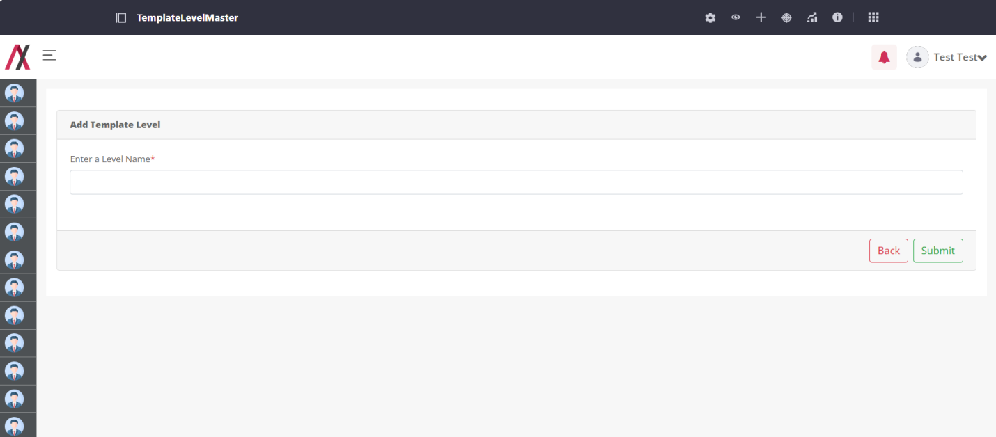
Here you can add the name of template level that you want to add into your system. There are two buttons available on the screen, one to go back to the listing page and another to submit the template level. This field will accept alphabetical value only and will consider “Apple” and “apple” as same.
If you add a template level that already exist in the system you will be encountered with the error as below:
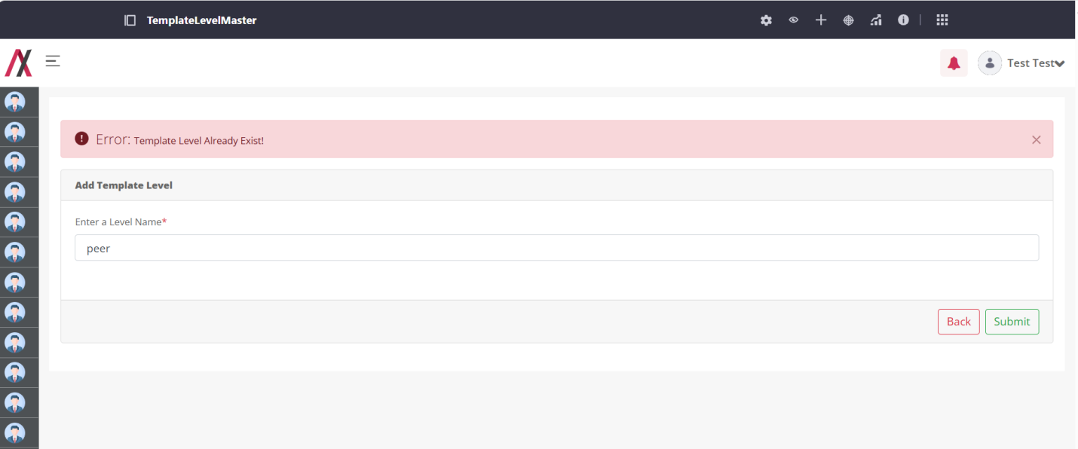
But, if you add the correct template level you will be greeted with the success message as below:
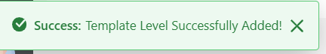
And after adding the template level we are redirected back to the list page.
On clicking the 3-dot available in the action column you will be allowed to navigate to view, edit and delete functions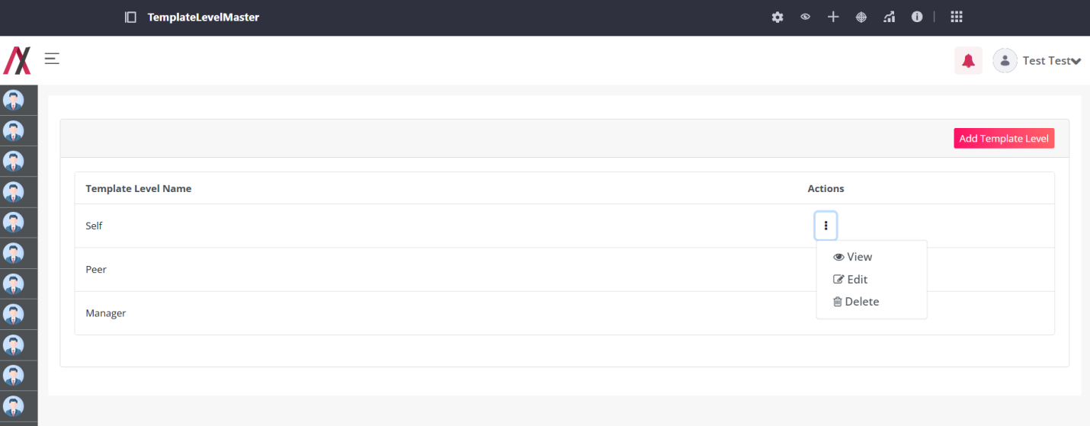
By clicking the View button, you are redirected to the following screen where you can see the details about a specific entry of template level as shown in image below:
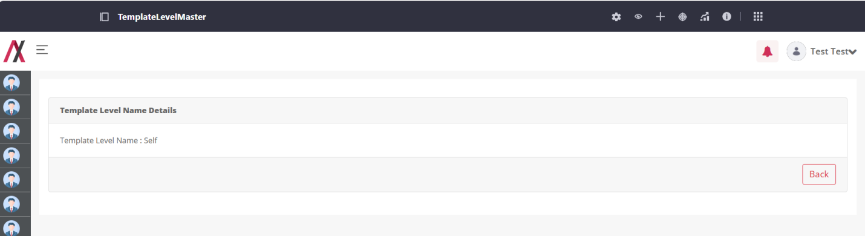
By clicking on the edit button you will be taken to the editing screen, here you can edit the template level. There are two buttons available on the screen, one to go back to the listing page and another to add the level. This field will accept alphabetical value only and will consider “Apple” and “apple” as same. The editing screen is shown in image below:
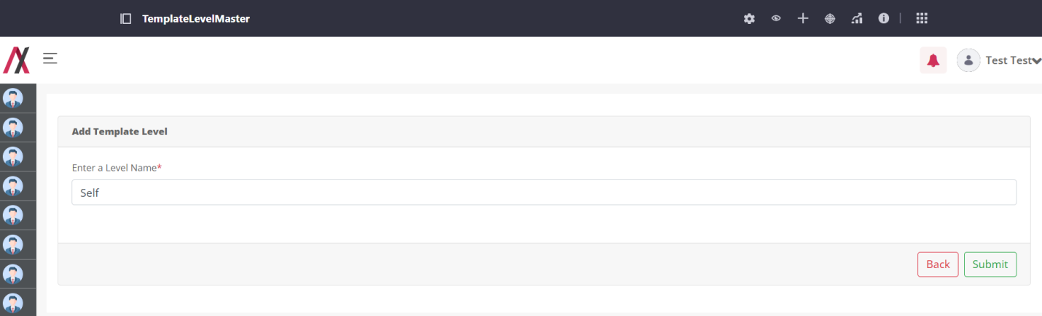
On clicking the submit button we will be greeted with the message.
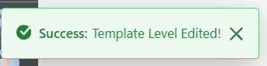

On clicking the Delete button, open alert box like this,

If you click ok button then delete that Template level, and you will be greeted with the success message as below:
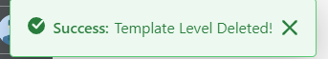

Probation Status Master:

Functionality:
Probation Status Master stores information about different status of Probation.

Page Name & Links:
The page where the portlet is placed is named Probation Status Master.
Link - http://localhost:8080/group/hrms/probationstatusmaster

Functionality Flows:
The flow starts by navigating to the link mentioned in the above section, that will present you the below screen :
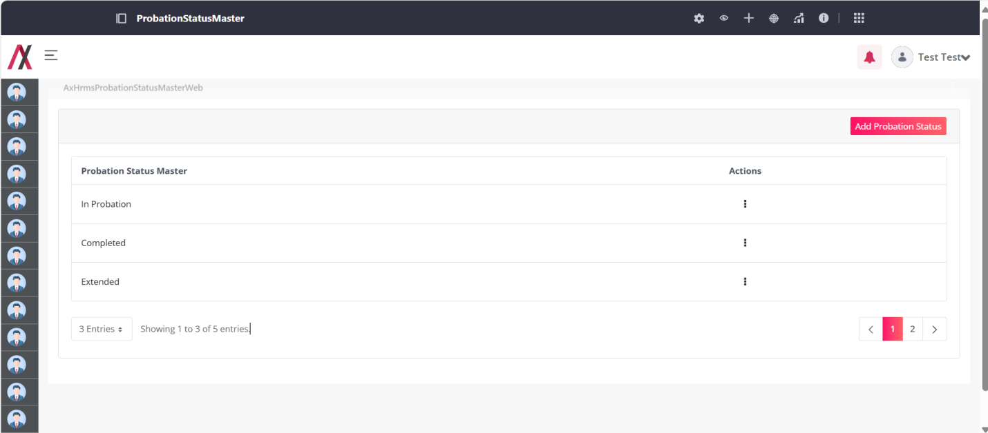
This screen has the list of all the Probation Status master available with that there is also an Add Probation Status button that will lead you to another screen to add the Probation Status :
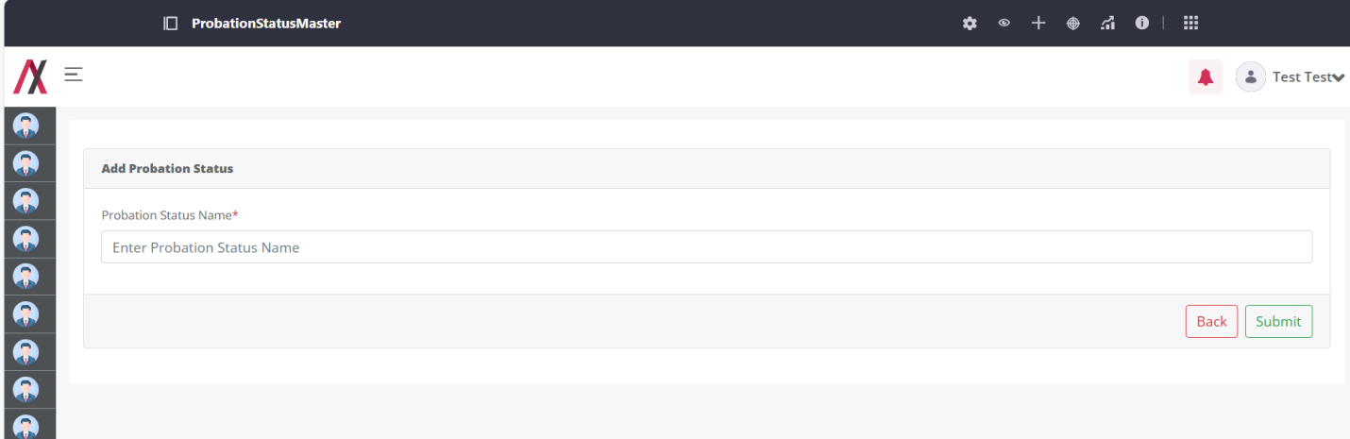
Here you can add the name of Probation Status that you want to add into your system. There are two buttons available on the screen, one to go back to the listing page and another to submit the probation status. This field will accept alphabetical value only and will consider “Apple” and “apple” as same.
If you add a Probation Status that already exist in the system you will be encountered with the error as below:
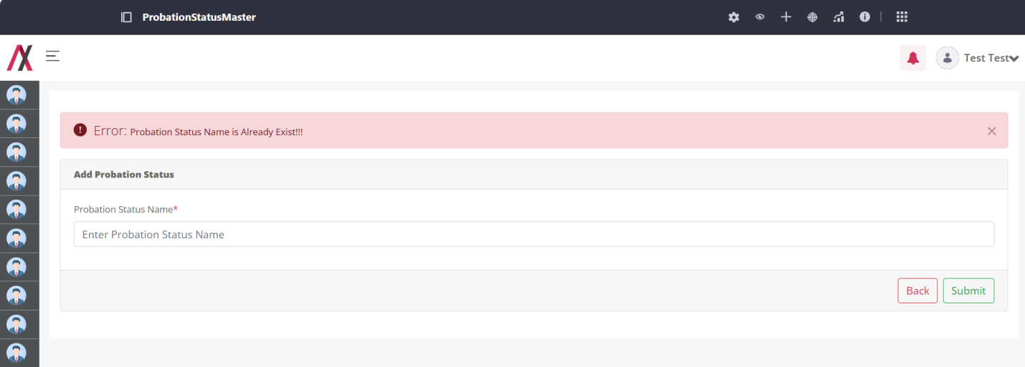
But, if you add the correct Probation Status you will be greeted with the success message as below:
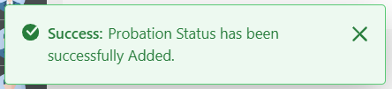
And after adding the Probation Status we are redirected back to the list page.
On clicking the 3-dot available in the action column you will be allowed to navigate to view, edit and delete functions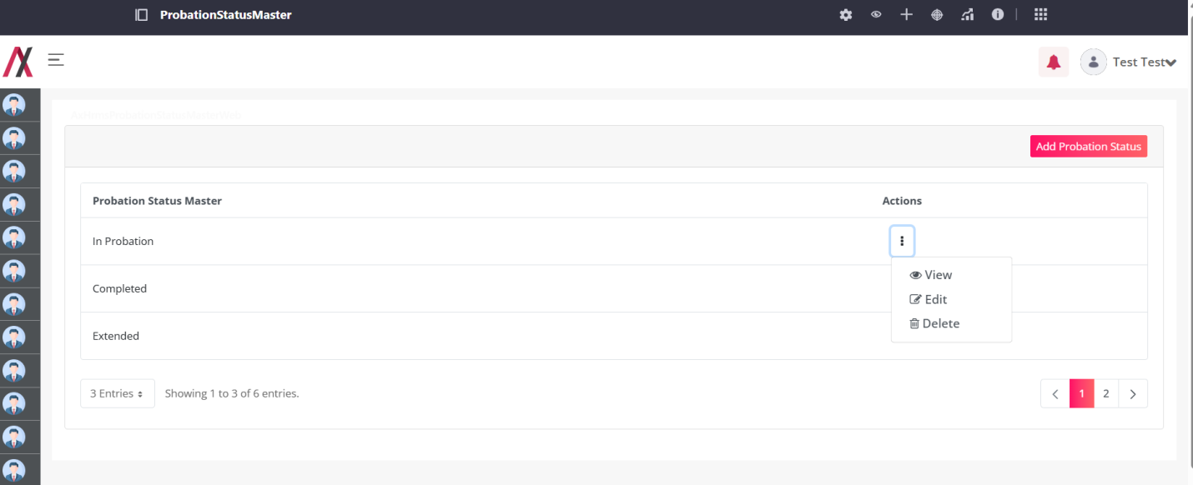
By clicking the View button, you are redirected to the following screen where you can see the details about a specific entry of probation status as shown in image below:
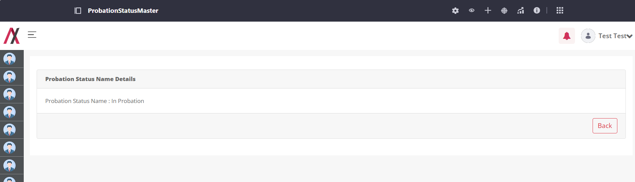
By clicking on the edit button you will be taken to the editing screen, here you can edit the probation status. There are two buttons available on the screen, one to go back to the listing page and another to add the status. This field will accept alphabetical value only and will consider “Apple” and “apple” as same. The editing screen is shown in image below:
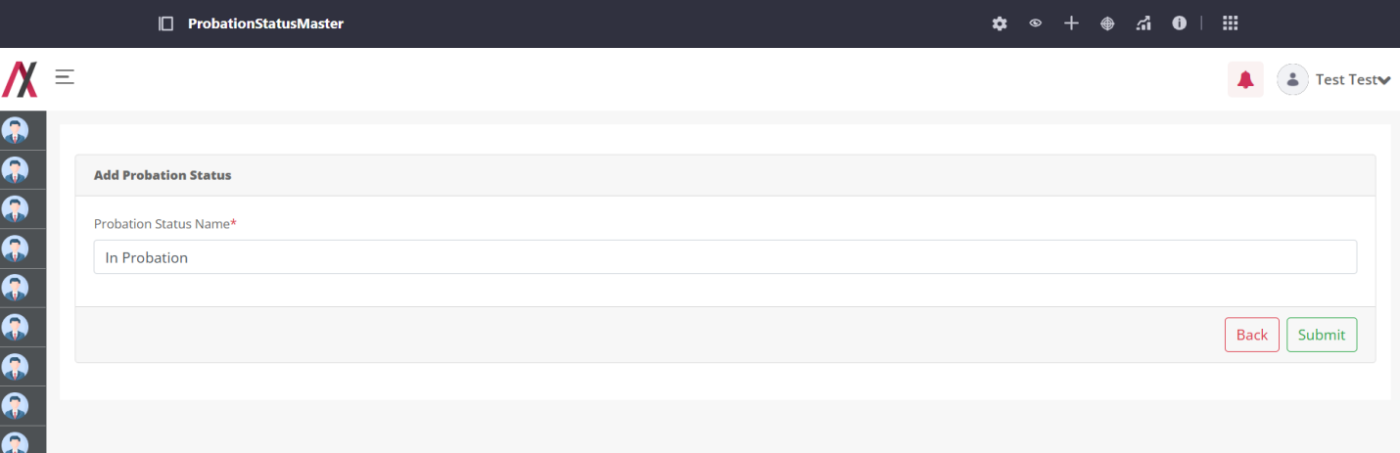
On clicking the submit button we will be greeted with the message.
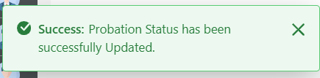

On clicking the Delete button, open alert box like this,

If you click ok button then delete that Probation Status, and you will be greeted with the success message as below:
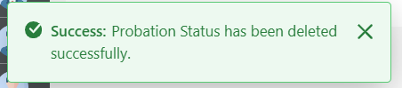

Wish Type Master:

Functionality:
Wish Type Master stores information about different types of Wishes.

Page Name & Links:
The page where the portlet is placed is named Wish Type Master.
Link - http://localhost:8080/group/hrms/wishtypemaster

Functionality Flows:
The flow starts by navigating to the link mentioned in the above section, that will present you the below screen :
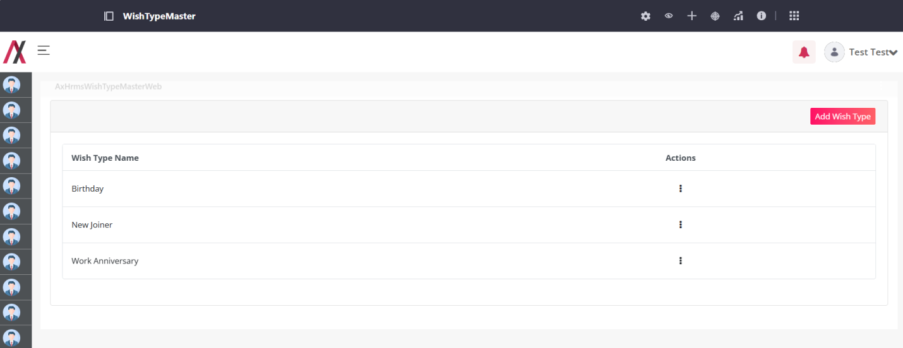
This screen has the list of all the Wish Type master available with that there is also an Add Wish Type button that will lead you to another screen to add the Wish Type :
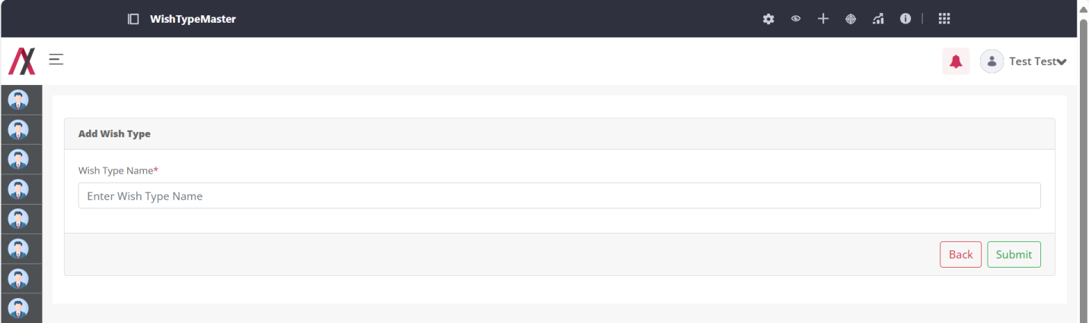
Here you can add the name of Wish Type that you want to add into your system. There are two buttons available on the screen, one to go back to the listing page and another to submit the Wish Type. This field will accept alphabetical value only and will consider “Apple” and “apple” as same.
If you add a Wish Type that already exist in the system you will be encountered with the error as below:
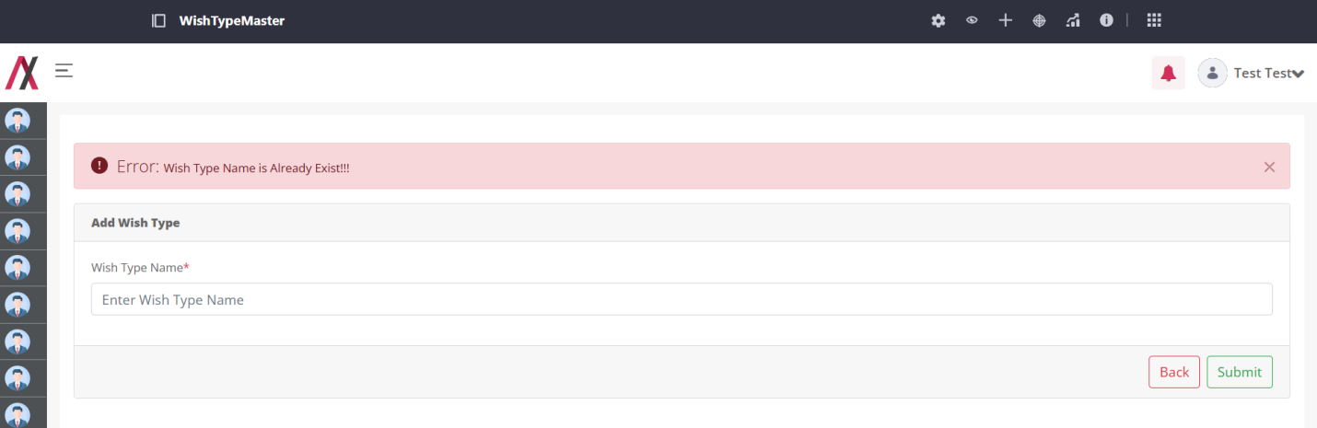
But, if you add the correct Wish Type you will be greeted with the success message as below:
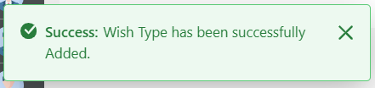
And after adding the Wish Type we are redirected back to the list page.
On clicking the 3-dot available in the action column you will be allowed to navigate to view, edit and delete functions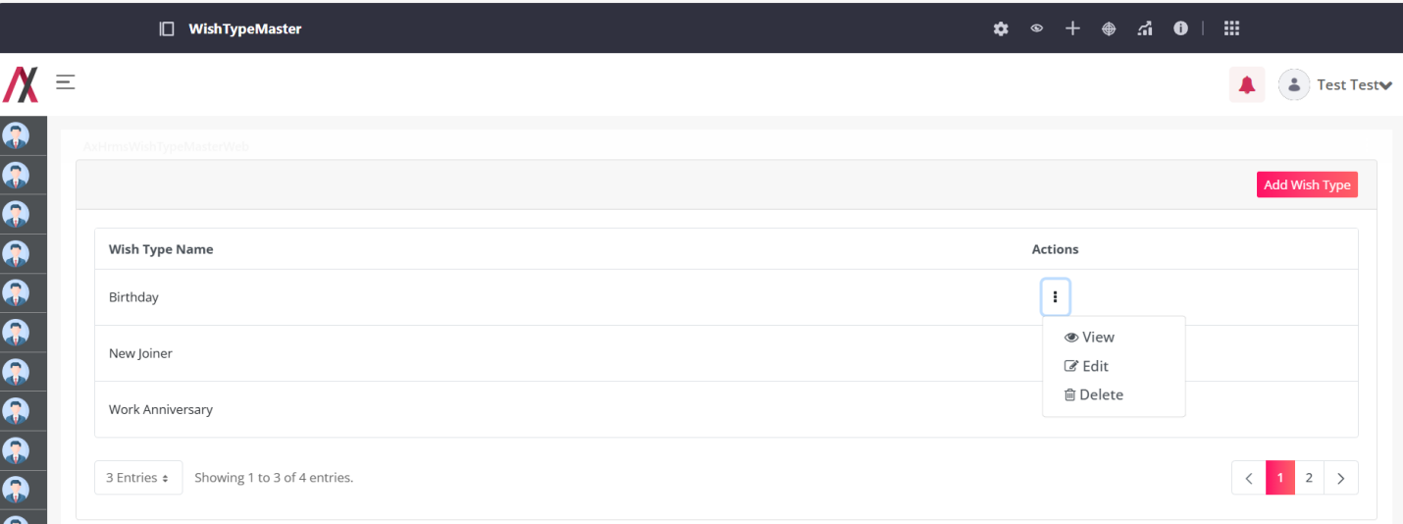
By clicking the View button, you are redirected to the following screen where you can see the details about a specific entry of Wish Type as shown in image below:
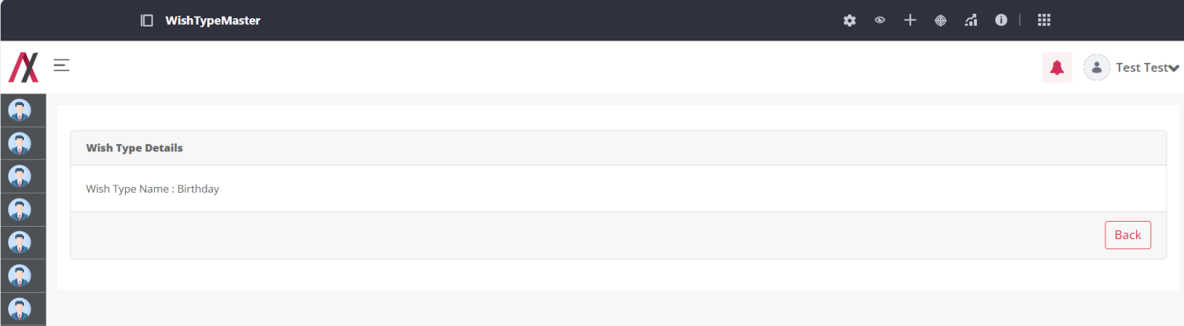
By clicking on the edit button you will be taken to the editing screen, here you can edit the Wish Type. There are two buttons available on the screen, one to go back to the listing page and another to add the Wish Type. This field will accept alphabetical value only and will consider “Apple” and “apple” as same. The editing screen is shown in image below:
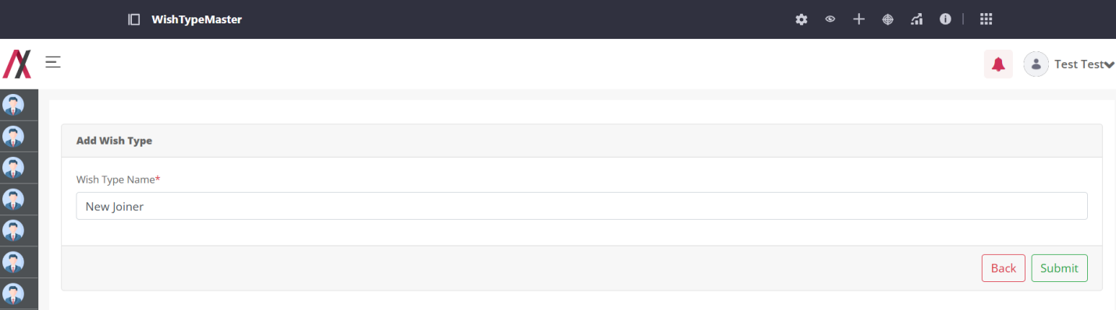
On clicking the submit button we will be greeted with the message.
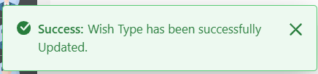

On clicking the Delete button, open alert box like this,

If you click ok button then delete that Wish Type, and you will be greeted with the success message as below:
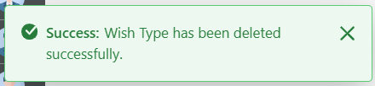

Priority Master:

Functionality:
Priority Master stores information about different Priorities for Tasks.

Page Name & Links:
The page where the portlet is placed is named Priority Master.
Link - http://localhost:8080/group/hrms/prioritymaster

Functionality Flows:
The flow starts by navigating to the link mentioned in the above section, that will present you the below screen :
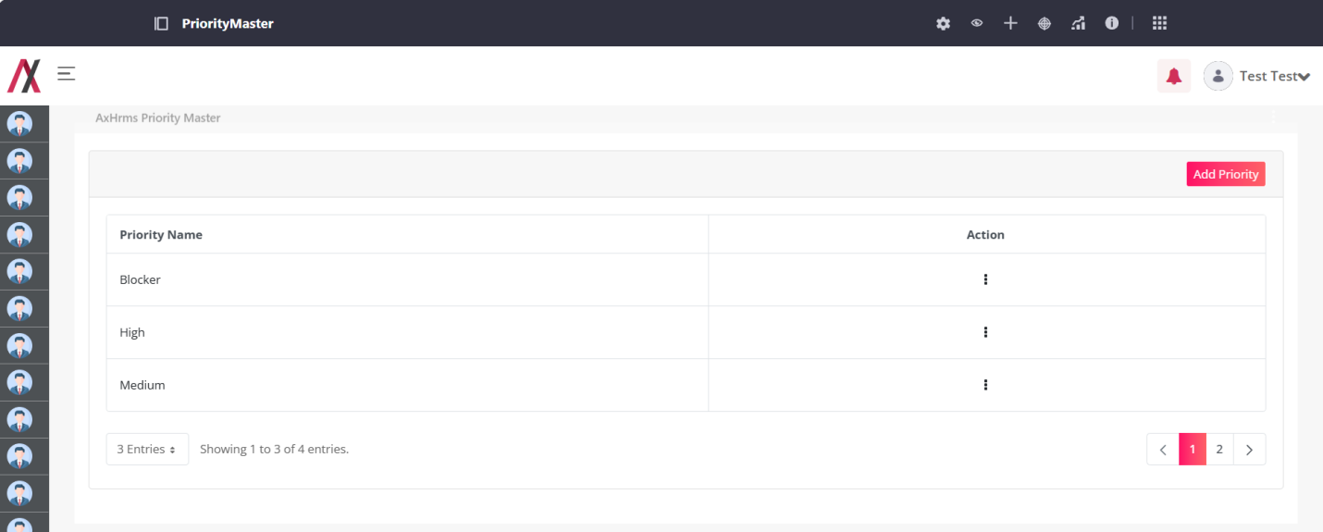
This screen has the list of all the Priority master available with that there is also an Add Priority button that will lead you to another screen to add the Priority :
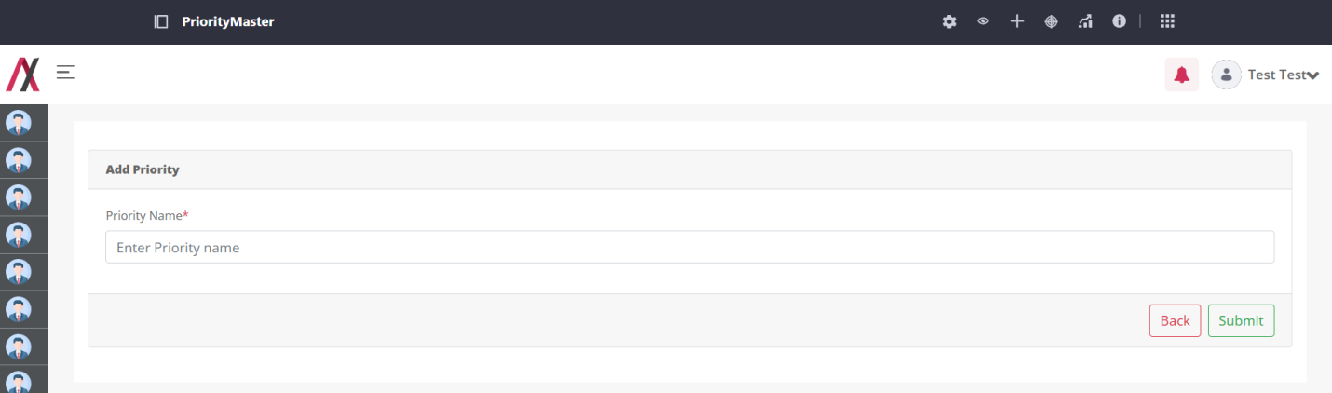
Here you can add the name of Priority that you want to add into your system. There are two buttons available on the screen, one to go back to the listing page and another to submit the Priority. This field will accept alphabetical value only and will consider “Apple” and “apple” as same.
If you add a Priority that already exist in the system you will be encountered with the error as below:
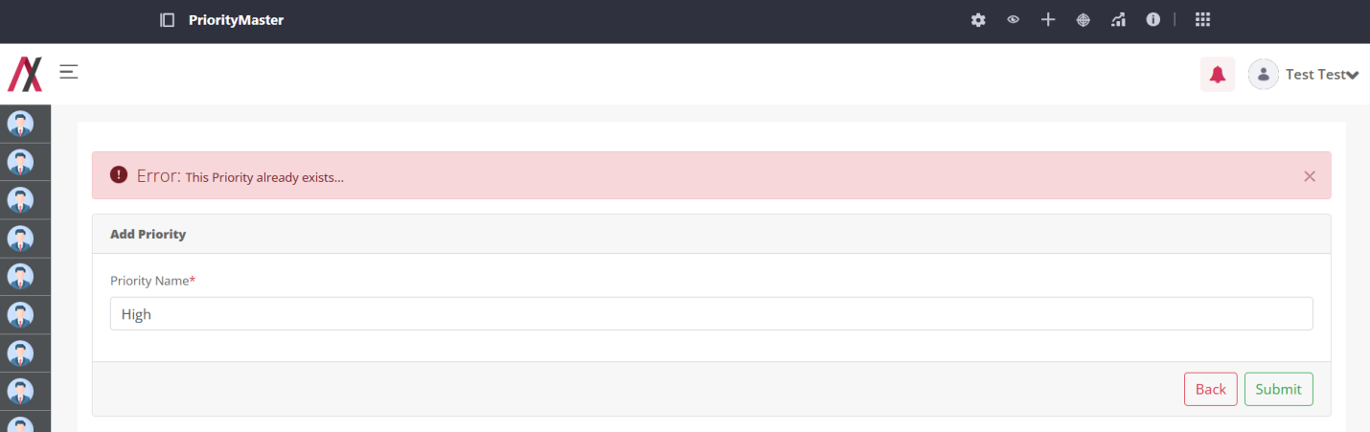
But, if you add the correct Priority you will be greeted with the success message as below:
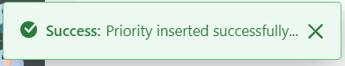
And after adding the Priority we are redirected back to the list page.
On clicking the 3-dot available in the action column you will be allowed to navigate to view, edit and delete functions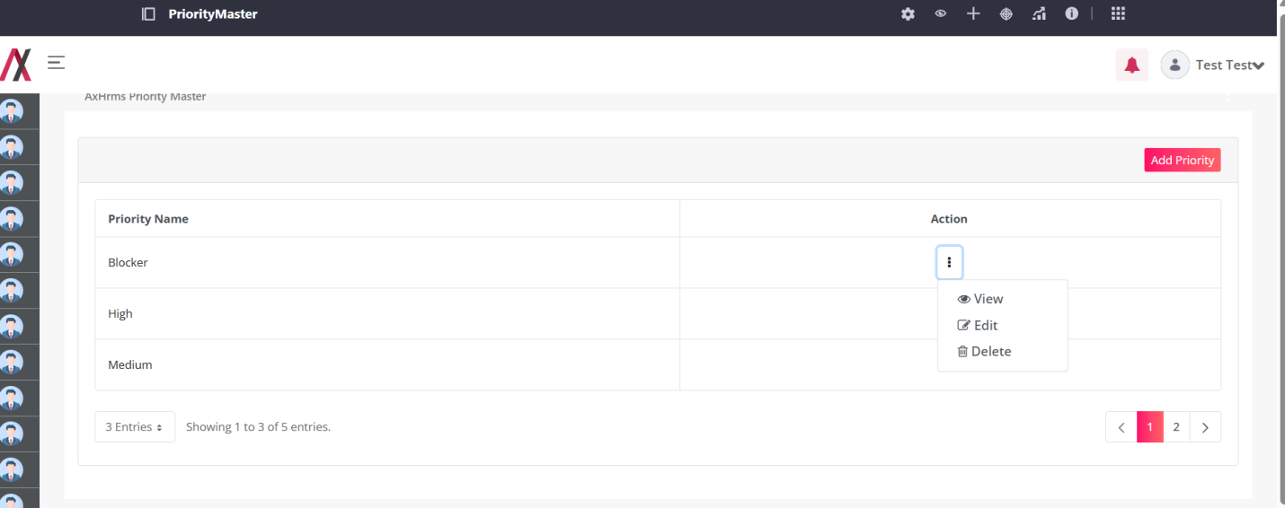
By clicking the View button, you are redirected to the following screen where you can see the details about a specific entry of Priority as shown in image below:
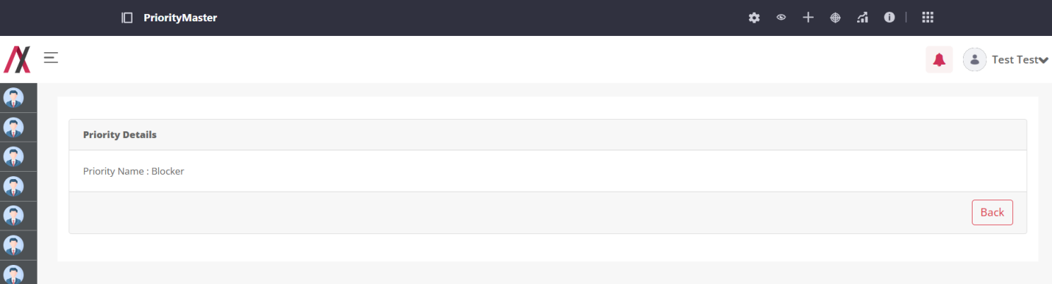
By clicking on the edit button you will be taken to the editing screen, here you can edit the Priority. There are two buttons available on the screen, one to go back to the listing page and another to add the Priority. This field will accept alphabetical value only and will consider “Apple” and “apple” as same. The editing screen is shown in image below:
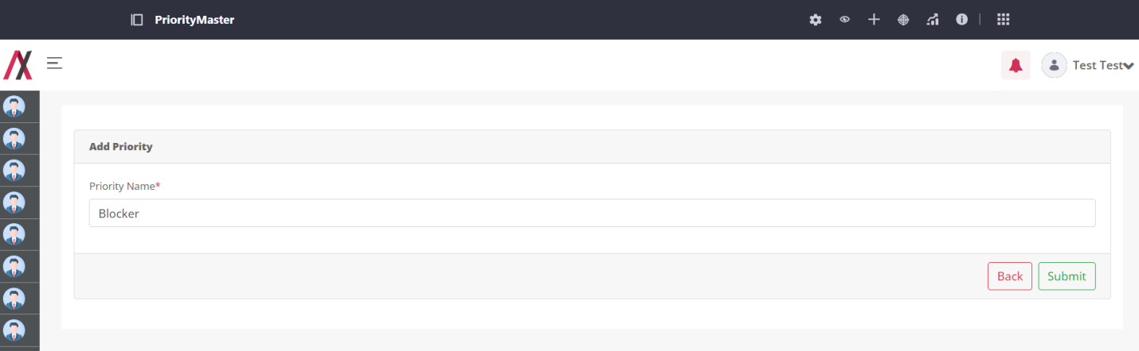
On clicking the submit button we will be greeted with the message.
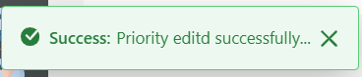

On clicking the Delete button, open alert box like this,

If you click ok button then delete that Priority, and you will be greeted with the success message as below:
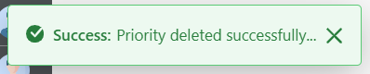

Leave Compensatory Status Master:

Functionality:
Leave compensatory Status Master stores information about different Status of Leave.

Page Name & Links:
The page where the portlet is placed is named Leave Compensatory Status Master.
Link - http://localhost:8080/group/hrms/leavecompensantorymaster

Functionality Flows:
The flow starts by navigating to the link mentioned in the above section, that will present you the below screen :
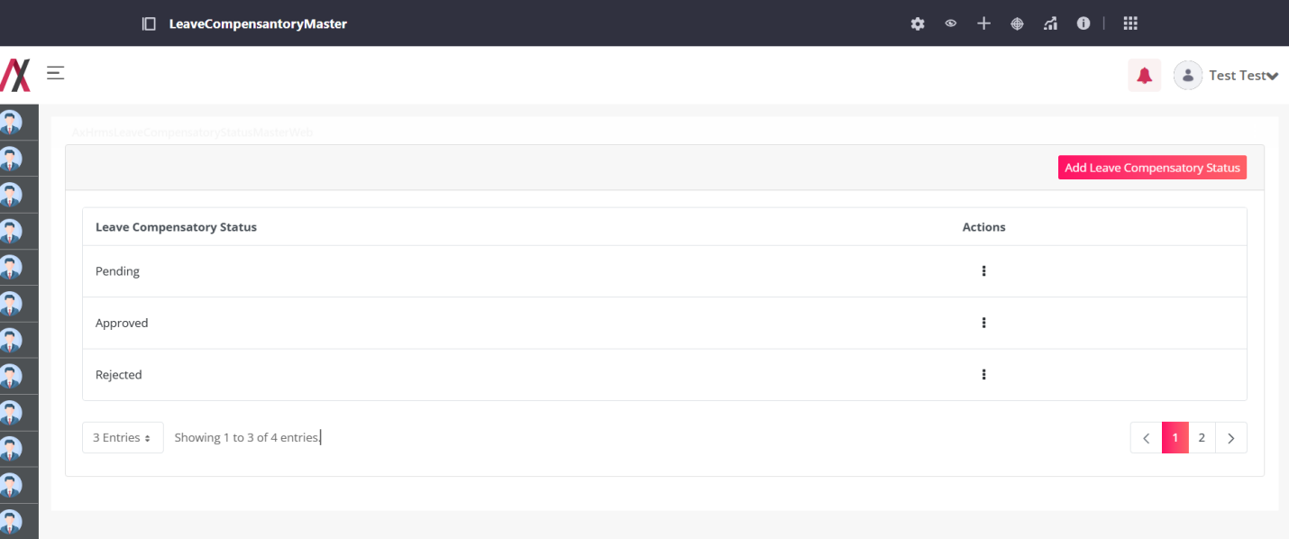
This screen has the list of all the Leave compensatory Status master available with that there is also an Add Leave Compensatory Status button that will lead you to another screen to add the Leave Compensatory Status:
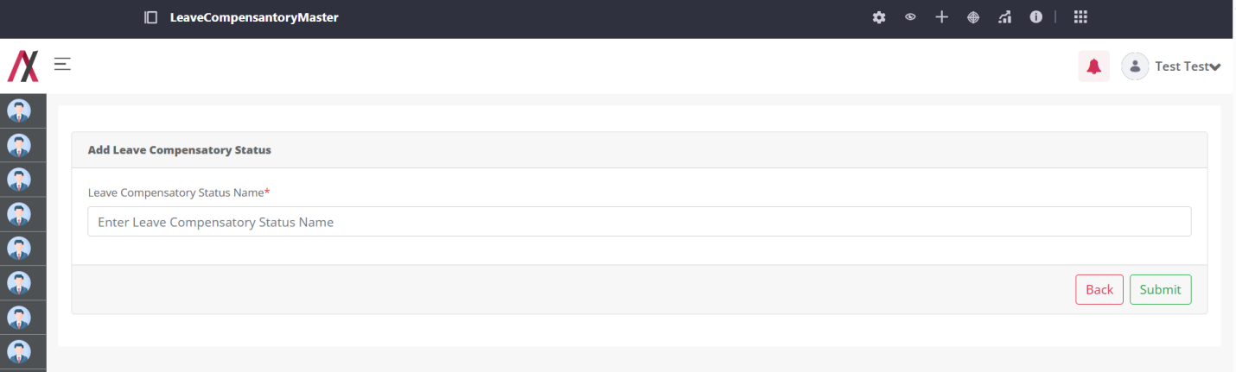
Here you can add the name of Leave Compensatory Status that you want to add into your system. There are two buttons available on the screen, one to go back to the listing page and another to submit the Leave Compensatory Status. This field will accept alphabetical value only and will consider “Apple” and “apple” as same.
If you add a Leave Compensatory Status that already exist in the system you will be encountered with the error as below:
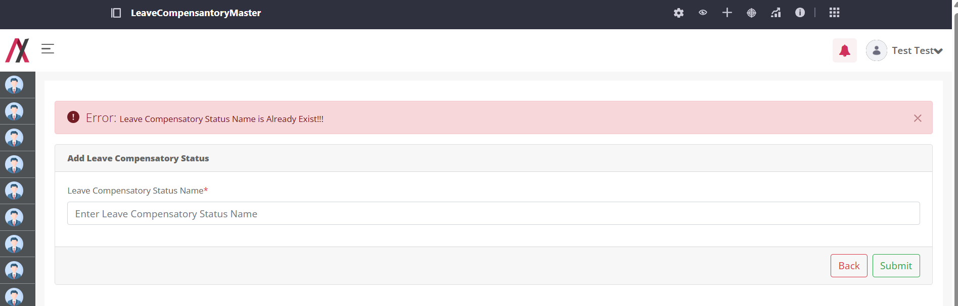
But, if you add the correct Leave Compensatory Status you will be greeted with the success message as below:
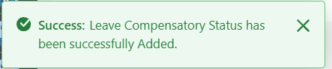
And after adding the Leave Compensatory Status we are redirected back to the list page.
On clicking the 3-dot available in the action column you will be allowed to navigate to view, edit and delete functions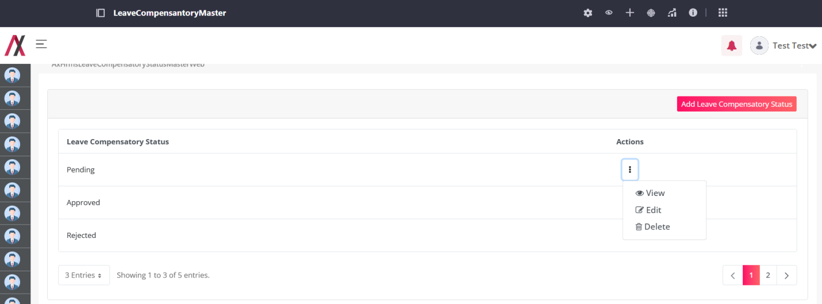
By clicking the View button, you are redirected to the following screen where you can see the details about a specific entry of Leave Compensatory Status as shown in image below:
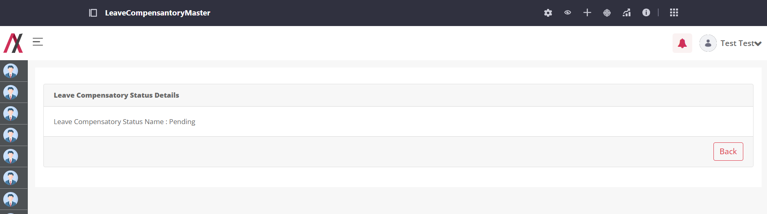
By clicking on the edit button you will be taken to the editing screen, here you can edit the Leave Compensatory Status. There are two buttons available on the screen, one to go back to the listing page and another to add the Leave Compensatory Status. This field will accept alphabetical value only and will consider “Apple” and “apple” as same. The editing screen is shown in image below:
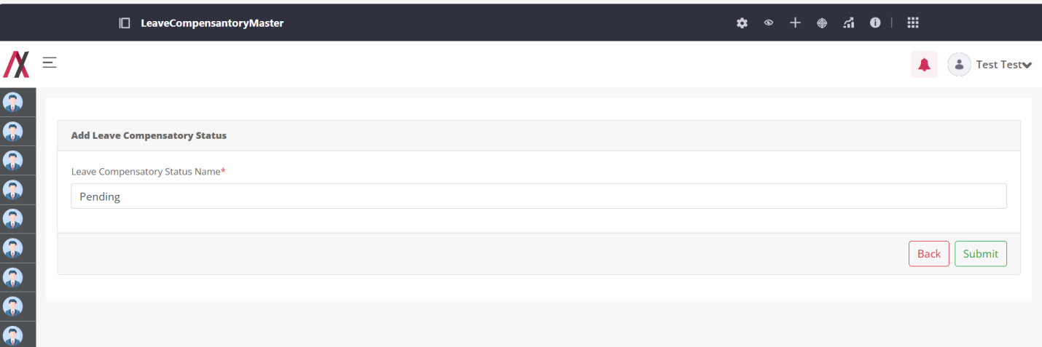
On clicking the submit button we will be greeted with the message.
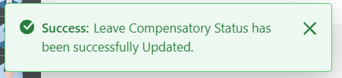

On clicking the Delete button, open alert box like this,

If you click ok button then delete that Leave Compensatory Status, and you will be greeted with the success message as below:
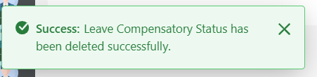

Policy Type Master:

Functionality:
Policy Type Master stores information about different Type of Policy.

Page Name & Links:
The page where the portlet is placed is named Policy Type Master.
Link - http://localhost:8080/group/hrms/policytypemaster

Functionality Flows:
The flow starts by navigating to the link mentioned in the above section, that will present you the below screen :
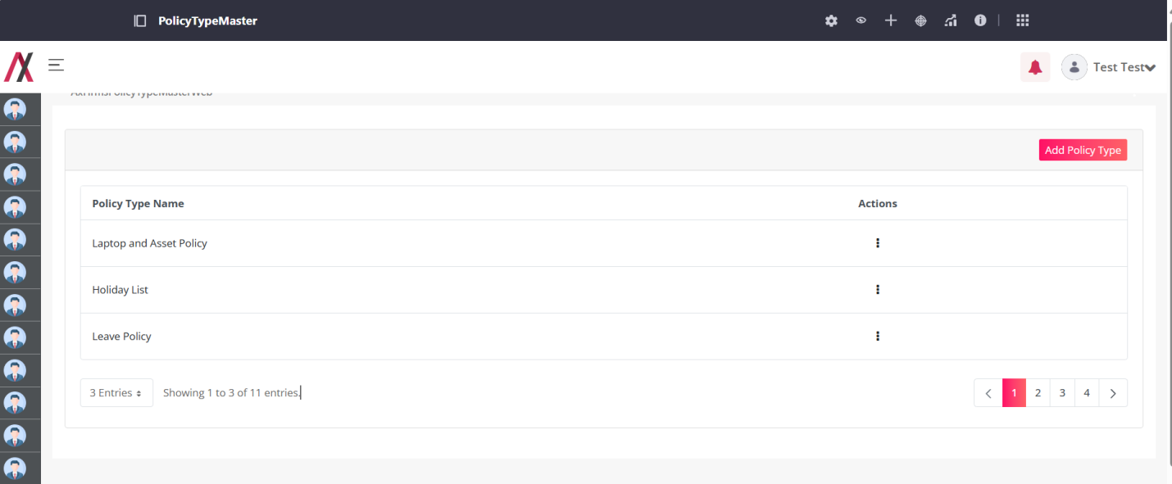
This screen has the list of all the Policy Type master available with that there is also an Add Policy Type button that will lead you to another screen to add the Policy Type:
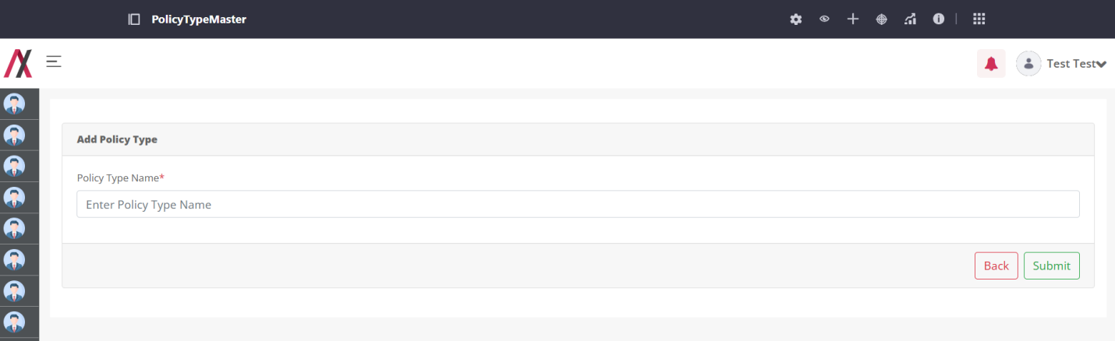
Here you can add the name of Policy Type that you want to add into your system. There are two buttons available on the screen, one to go back to the listing page and another to submit the Policy Type. This field will accept alphabetical value only and will consider “Apple” and “apple” as same.
If you add a Policy Type that already exist in the system you will be encountered with the error as below:
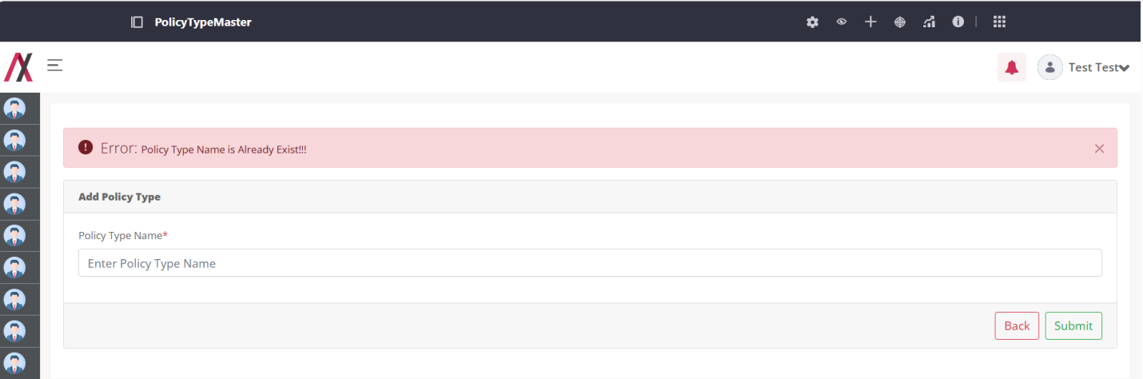
But, if you add the correct Policy Type you will be greeted with the success message as below:
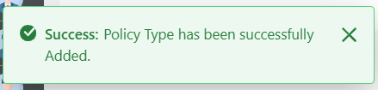
And after adding the Policy Type we are redirected back to the list page.
On clicking the 3-dot available in the action column you will be allowed to navigate to view, edit and delete functions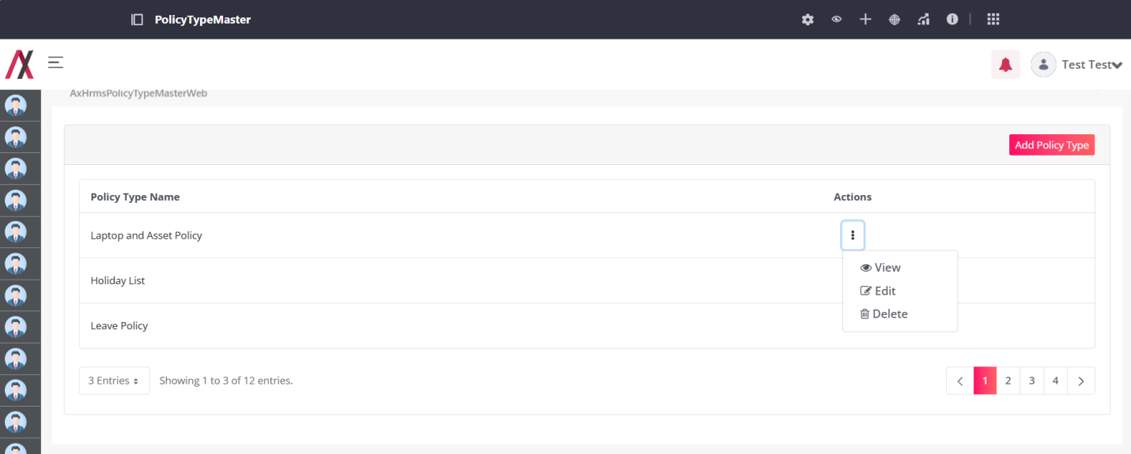
By clicking the View button, you are redirected to the following screen where you can see the details about a specific entry of Policy Type as shown in image below:
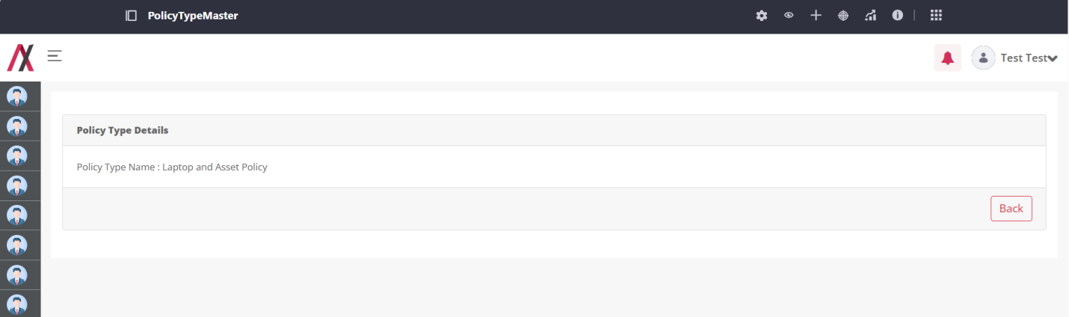
By clicking on the edit button you will be taken to the editing screen, here you can edit the Policy Type. There are two buttons available on the screen, one to go back to the listing page and another to add the Policy Type. This field will accept alphabetical value only and will consider “Apple” and “apple” as same. The editing screen is shown in image below:
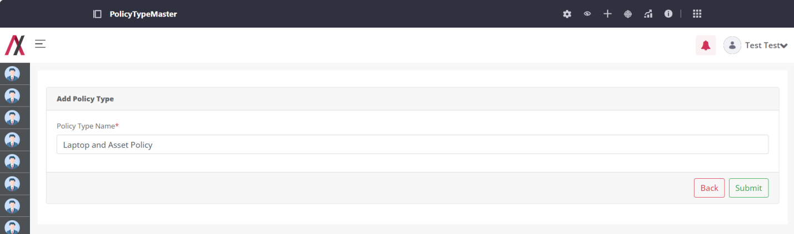
On clicking the submit button we will be greeted with the message.
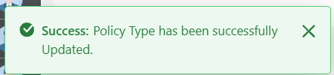

On clicking the Delete button, open alert box like this,

If you click ok button then delete that Policy Type, and you will be greeted with the success message as below:
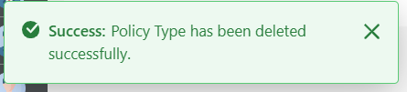

Project Task Status Master:

Functionality:
Project Task Status Master stores information about status which is applicable for Project or Task.

Page Name & Links:
The page where the portlet is placed is named Project Task Status Master.
Link - http://localhost:8080/group/hrms/projecttaskstatusmaster

Functionality Flows:
The flow starts by navigating to the link mentioned in the above section, that will present you the below screen :
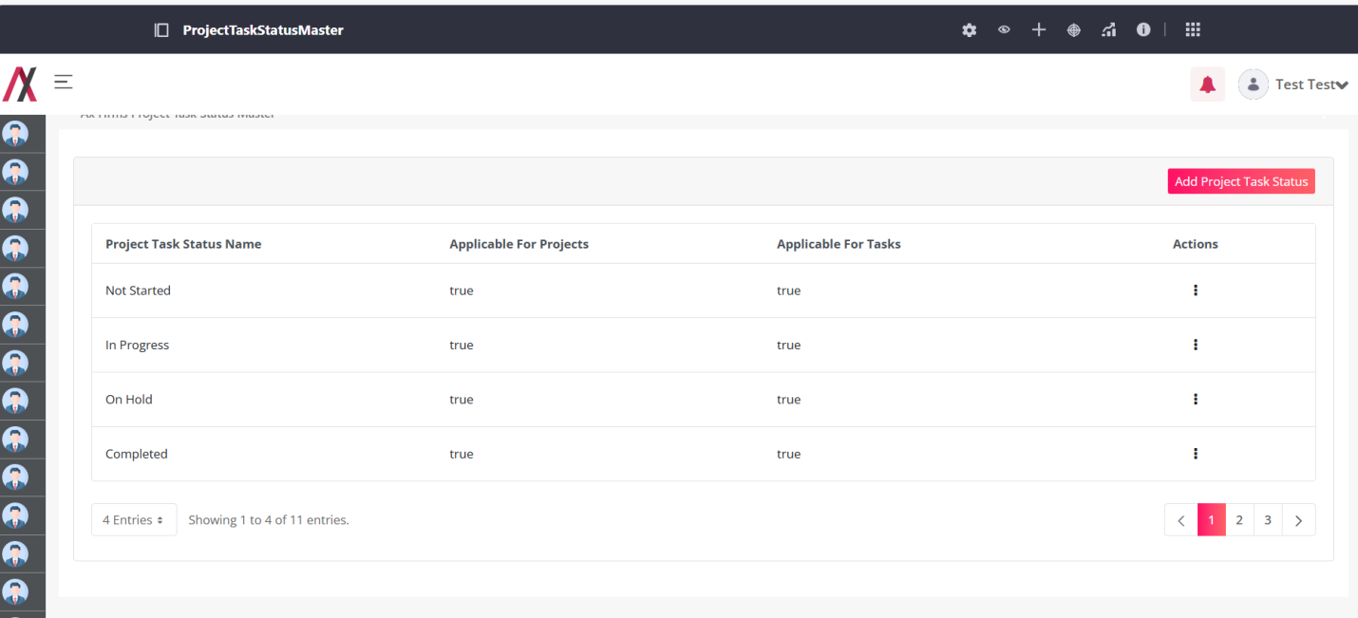
This screen has the list of all the Project Task Status master available with that there is also an Add Project Task Status button that will lead you to another screen to add the Project Task Status:
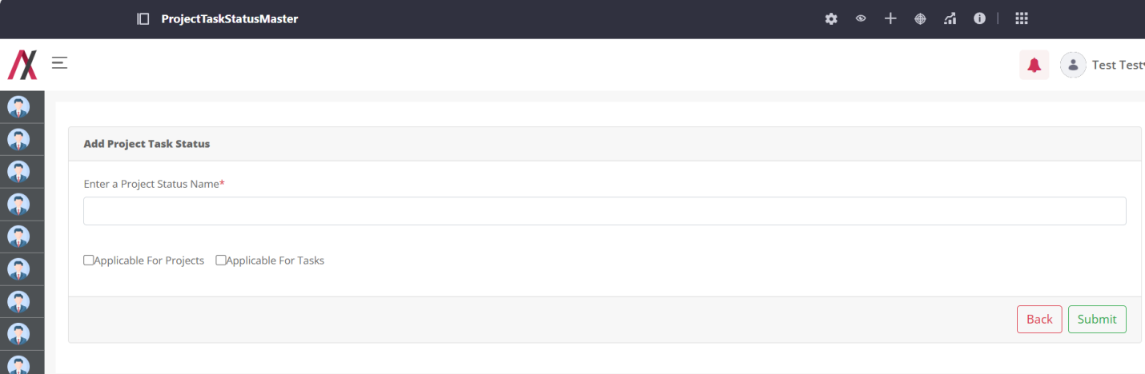In this form you will find following fields:
1.Project Task Status: Here you can add the status of the project and task.
2.Applicable for Projects: Check this box if this status applies to projects.
3.Applicable for Tasks: Check this box if this status applies to tasks.

Here you can add the name of Project Task Status that you want to add into your system. There are two buttons available on the screen, one to go back to the listing page and another to submit the Project Task Status. This field will accept alphabetical value only and will consider “Apple” and “apple” as same.
If you add a Project Task Status that already exist in the system you will be encountered with the error as below:
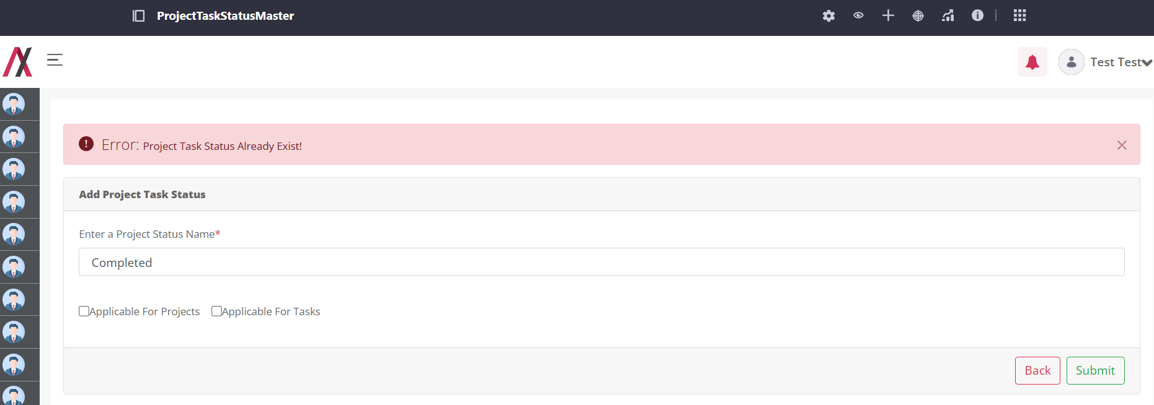
But, if you add the correct Project Task Status you will be greeted with the success message as below:
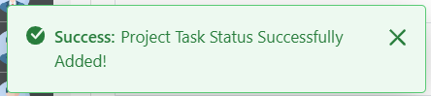
And after adding the Project Task Status we are redirected back to the list page.
On clicking the 3-dot available in the action column you will be allowed to navigate to view, edit and delete functions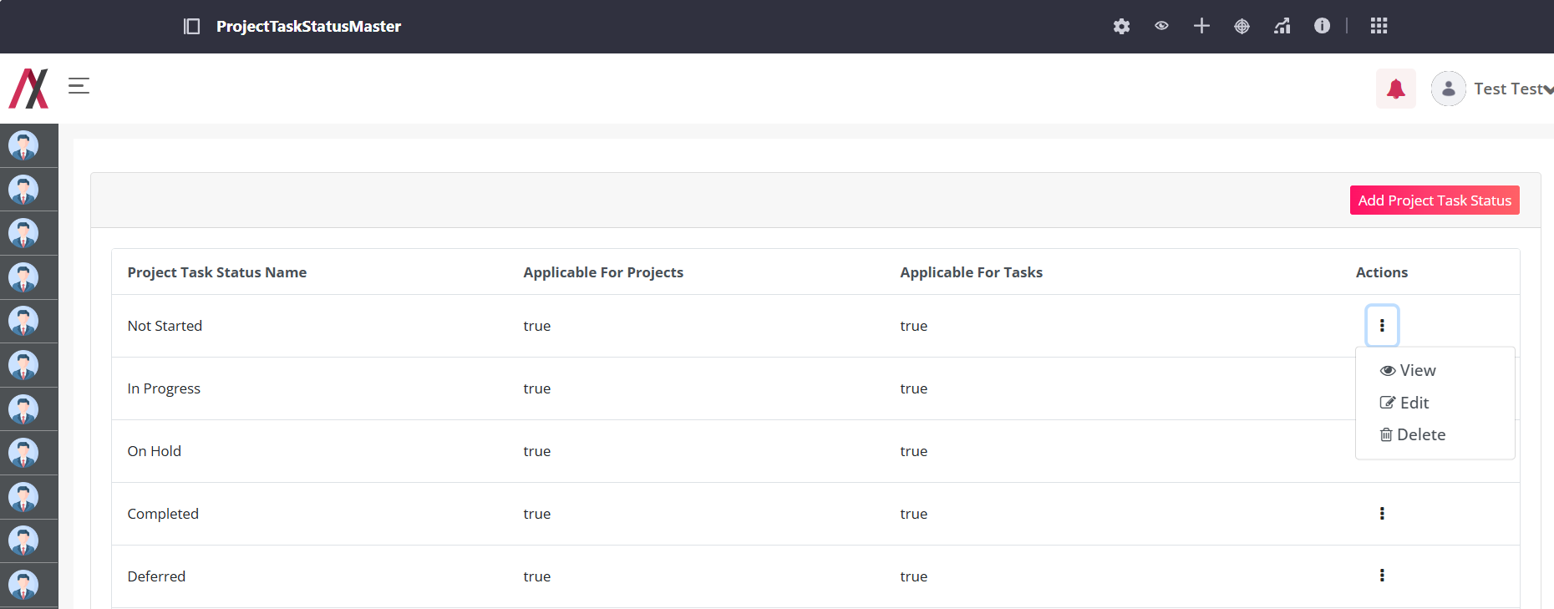
By clicking the View button, you are redirected to the following screen where you can see the details about a specific entry of Project Task Status as shown in image below:
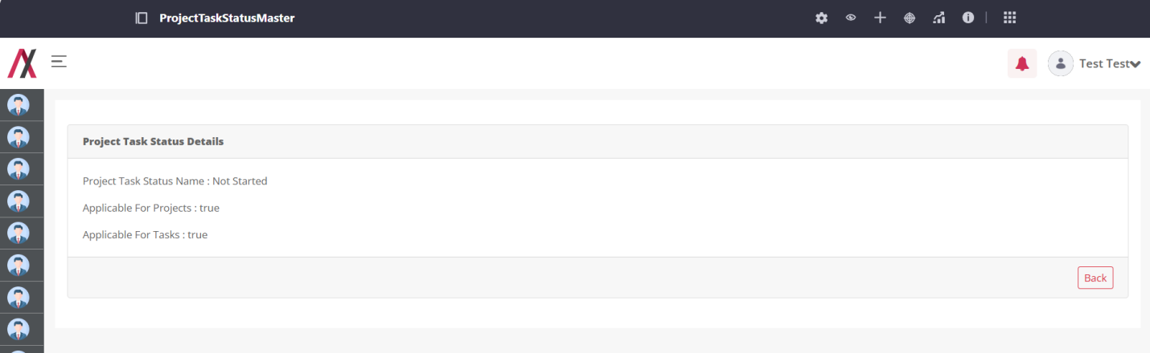
By clicking on the edit button you will be taken to the editing screen, here you can edit the Project Task Status. There are two buttons available on the screen, one to go back to the listing page and another to add the Project Task Status. This field will accept alphabetical value only and will consider “Apple” and “apple” as same. The editing screen is shown in image below:
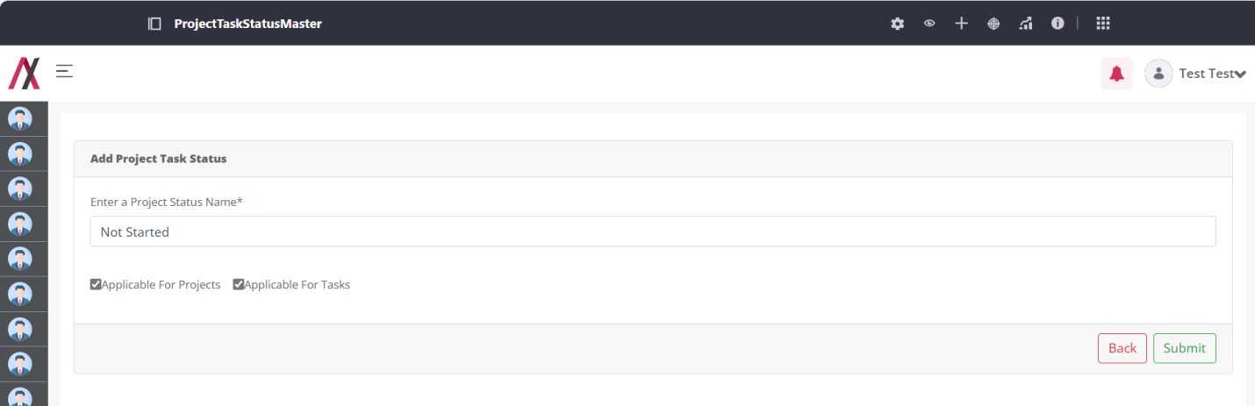
On clicking the submit button we will be greeted with the message.
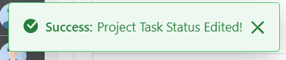

When you click the Delete button:
If you confirm by clicking OK, the Project Task Status will be deleted, and you will receive the following success message: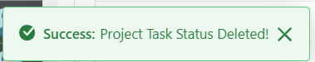

Leave Type Master:

Functionality:
Leave Type Master stores information about different types of Leaves which is applicable for Employee.

Page Name & Links:
The page where the portlet is placed is named Leave Type Master.
Link - http://localhost:8080/group/hrms/leavetypemaster

Functionality Flows:
The flow starts by navigating to the link mentioned in the above section, that will present you the below screen :
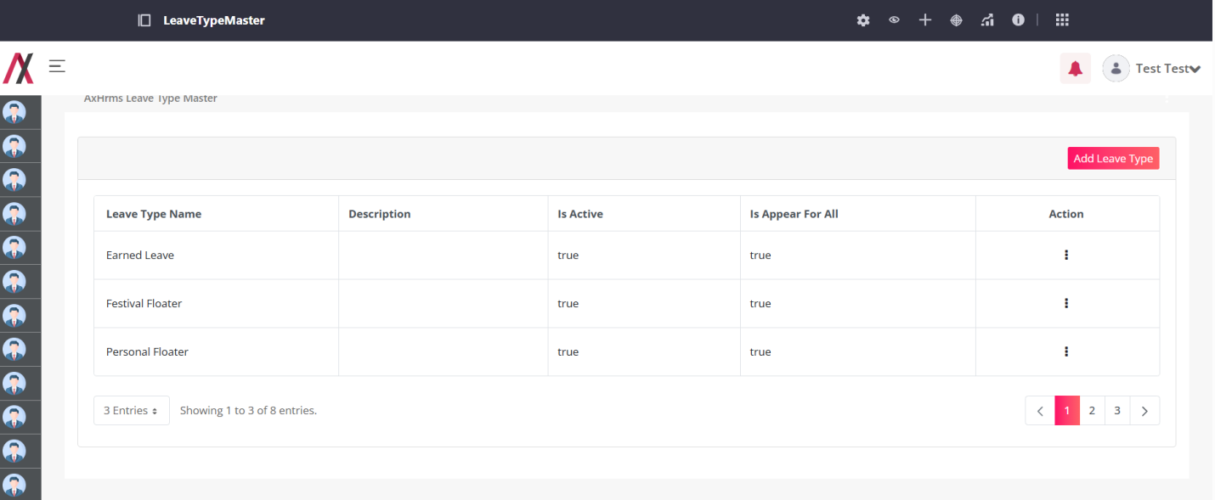
This screen has the list of all the Leave Type available with that there is also an Add Leave Type button that will lead you to another screen to add the Leave Type:
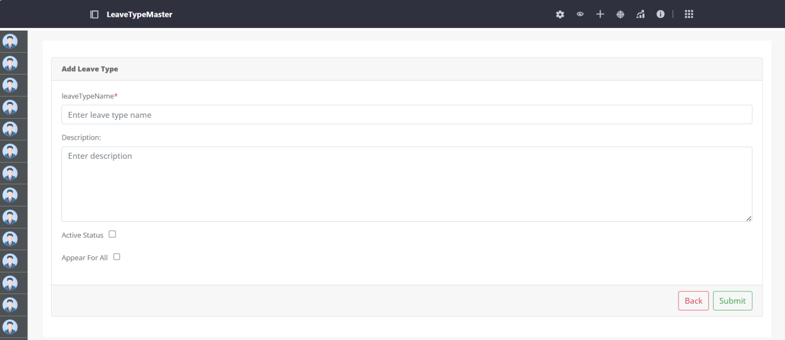In this form you will find following fields:
1.Leave Type Name: Here you can add the different types of leave.
2.Description: You can add a short description for each leave type you are adding.
3.Applicable for All : Check this box if this leave type applies to all Employee.
4.Active Status : Check this box if this leave type is active.

Here you can add the name of Leave Type that you want to add into your system. There are two buttons available on the screen, one to go back to the listing page and another to submit the Leave Type. This field will accept alphabetical value only and will consider “Apple” and “apple” as same.
If you add a Leave Type that already exist in the system you will be encountered with the error as below:
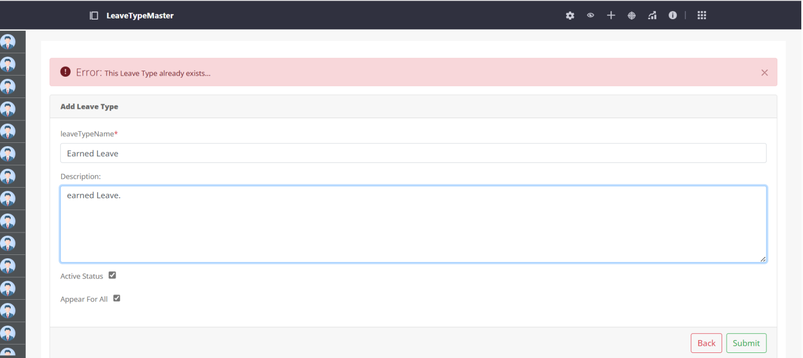
But, if you add the correct Leave Type you will be greeted with the success message as below:
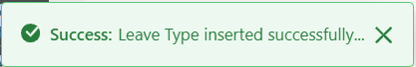
And after adding the Leave Type we are redirected back to the list page.
On clicking the 3-dot available in the action column you will be allowed to navigate to view, edit and delete functions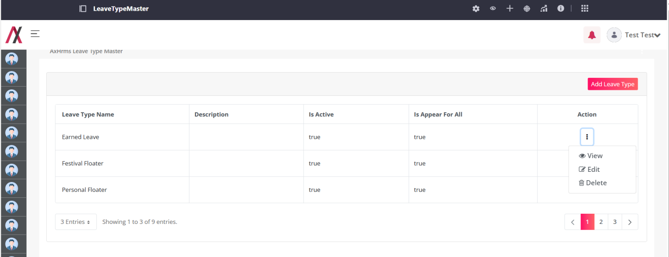
By clicking the View button, you are redirected to the following screen where you can see the details about a specific entry of Leave Type as shown in image below:
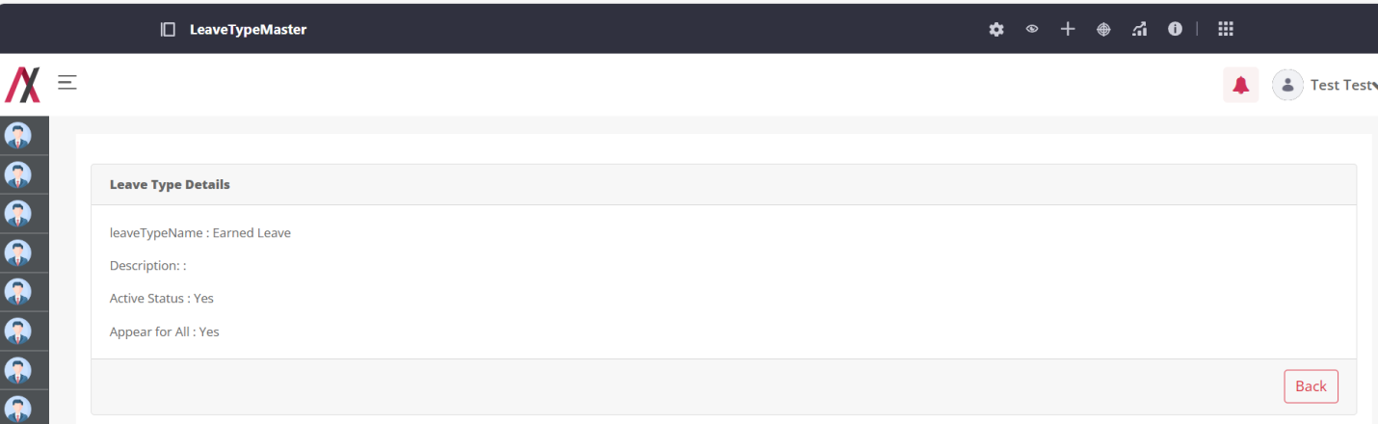
By clicking on the Edit button you will be taken to the editing screen, here you can edit the Leave Type. There are two buttons available on the screen, one to go back to the listing page and another to add the Leave Type. This field will accept alphabetical value only and will consider “Apple” and “apple” as same. The editing screen is shown in image below:
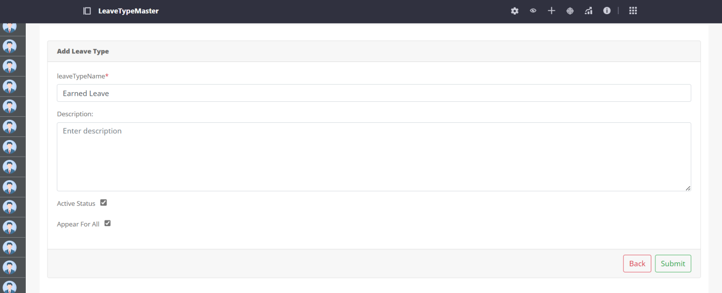
On clicking the submit button we will be greeted with the message.
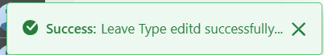

When you click the Delete button:
If you confirm by clicking OK, the Leave Type will be deleted, and you will receive the following success message:
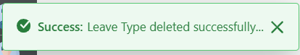

Employee On Boarding:

Functionality:
Employee on boarding module is the starting point of adding the employee and total employee management. You can add, update and offboard the employee in this module.
Here in the on boarding module there are 2 parts i.e. 2 pages involved. One page is for the HR related activities, and another is for the Employee related activities.

Page Name & Links:
The page where the HR portlet is placed is named “Employee On Boarding HR”
Link - http://localhost:8080/group/hrms/employee-onboarding-hr

The page where the Employee portlet is placed is named “Employee On Boarding Employee”
Link - http://localhost:8080/group/hrms/employee-on-boarding

Functionality Flow (HR):
The flow starts by navigating to the link mentioned in the above section for HR Portlet, that will present you the below screen:
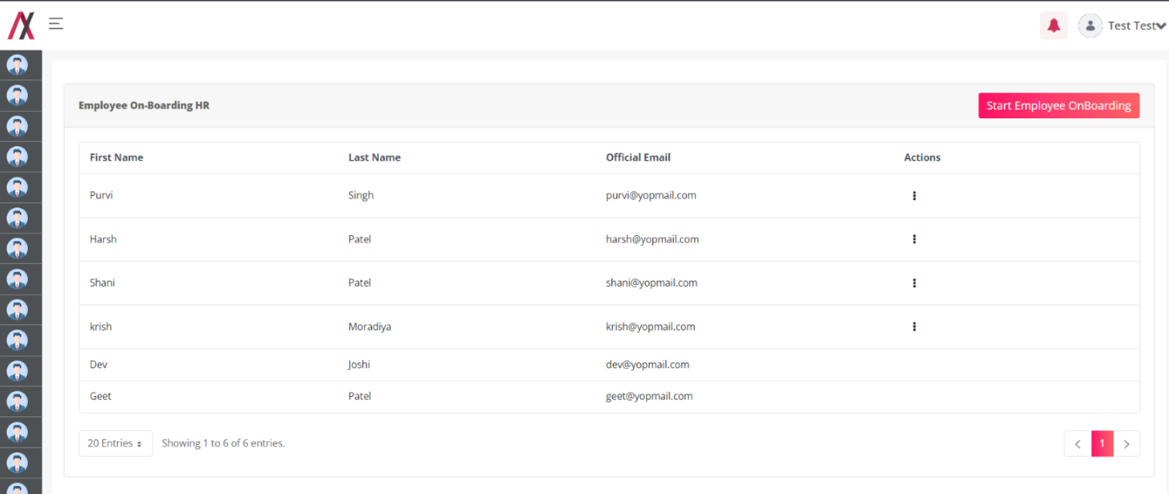
Here on this screen, you will find the employees list that are currently onboarded on your system.
On top right corner you will find the "Start Employee On Boarding” button, on clicking that button you will be presented with the onboarding form as following screen:
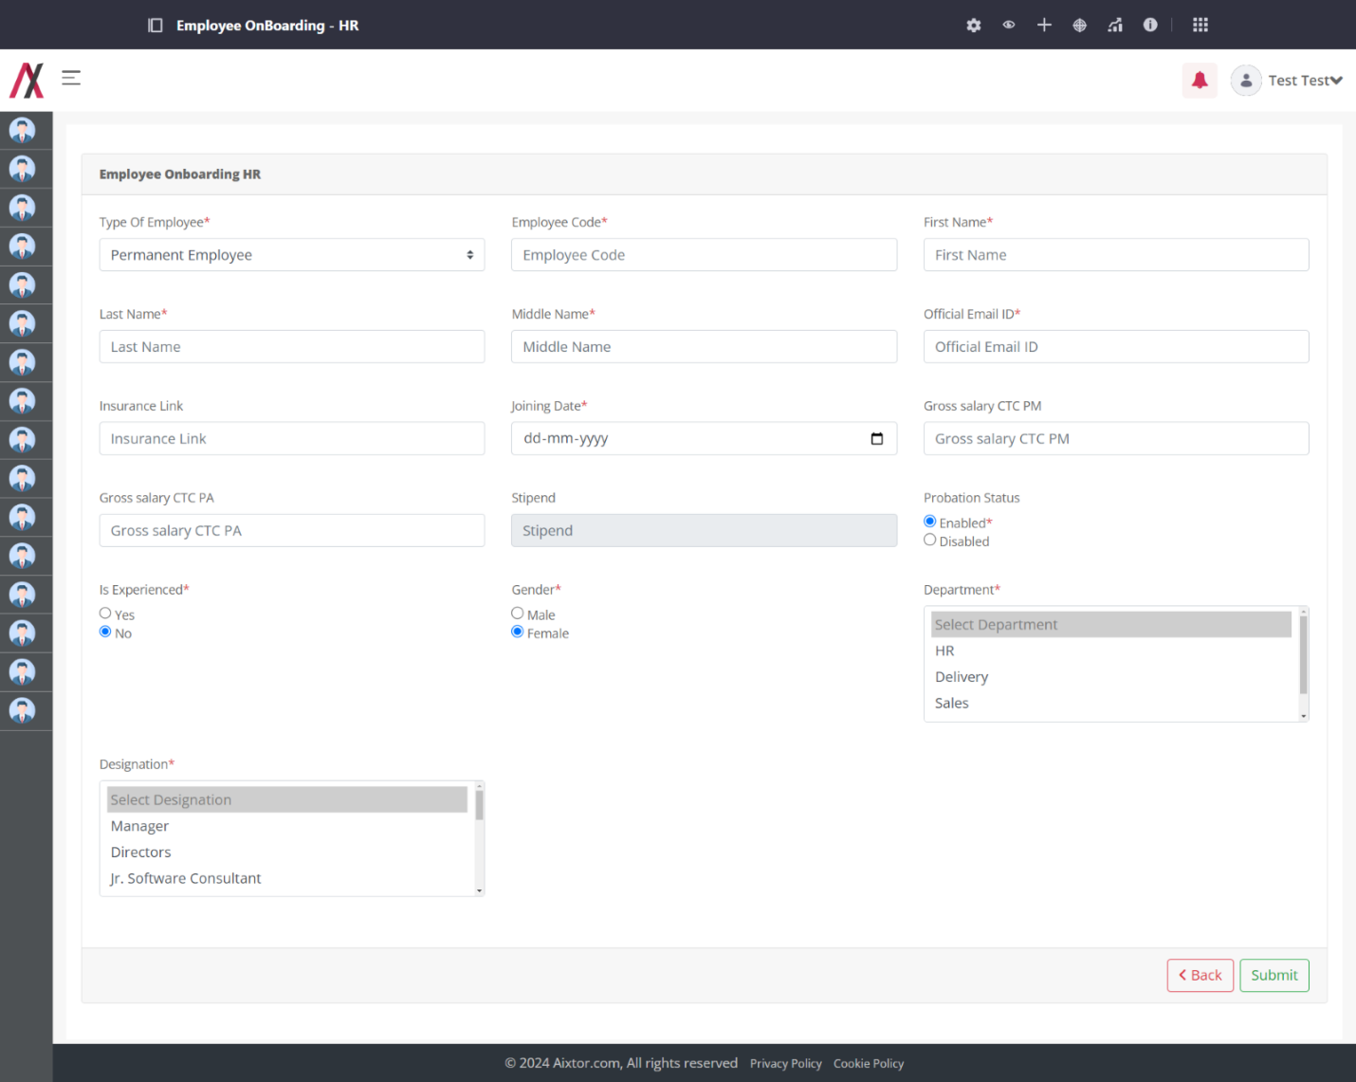
On this form you have various fields that you need to fill to onboard an employee from HR side, these are the details that are required to be fille by HR only. The fields and the corresponding outcomes are as below:
- Type Of Employee: Currently there are 4 types of employee added to the system as below :
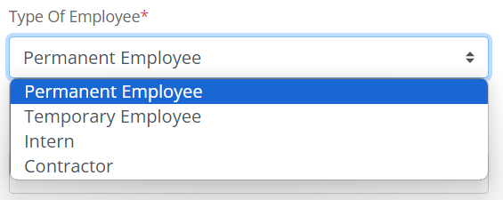

- Employee Code: This is the employee code that must be unique in nature and HR must fill it in manually for their future reference.
- First Name: It is the First Name of the employee. [Only characters no space]
- Last Name: It is the Last Name of the employee. [Only characters no space]
- Middle Name: It must be filled with the employee's middle name. [Only characters no space]
- Official Email: This field is specially kept for adding the official email where all the official communication must be done. [Only Mail format string]
- Insurance Link: This filed is only for the Permanent and Temporary Employee and will be disabled for the Intern and Contractor.
- Joining Date: Here, the employee's joining date must be filled. [ISO Type Date.]
- Gross CTC PM: This field must be filled with the gross salary per month. This filled will be disabled for the Intern (Type of Employee). [Only Decimal]
- Gross CTC PA: This field must be filled with the gross salary per annum. This filled will be disabled for the Intern (Type of Employee). [Only Decimal]
- Stipend: This filled is only available for Intern (Type of Employee) and will be filled with the stipend for the intern. [Only decimal]
- Probation Status: This filed is only available for Permanent and Temporary type of employees. If you have selected yes, then the employee will be on probation as soon as you onboard them and vice versa.
- Is Experienced: This field is for the employee experienced or not.
- Gender: This field is for filling in the gender of the employee, you may select the radio buttons accordingly.
- Department: This is the multi select box where all the departments are listed (fetched from the department master module), you may select one or more, according to the selection of the departments the entries will be created, and the employee will be assigned to such roles.
- Designation: This is the single selection for the designation where you must select the designation for the employee, and accordingly the roles will be allocated to the employee.

After filling in all the data to the form, you must press submit to onboard the employee form HR side.
Once you press the submit, the employee’s user will be created in the system and the roles according to the designation and department will be assigned to the user.
The screen name will be according to the name: firstname.lastname or firstname.middlename.lastname (in case the firstname.lastname already exists).
Then the user will receive a mail on their official email id you just entered, the mail will contain the login credentials, the insurance link (If applicable), and a link to employee on boarding employee where they will add the further details.
On submission you will be presented with the message:
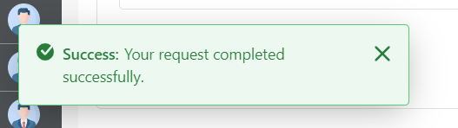

The mail received on the employee’s official Mail:
Configurations-Mail:- Under 9 Dots > System settings > catagory.HRMS > Mail Template Configurations. > Permanent Employee OnBoarding Mail (BODY).
Placeholder: Refer Excel sheet for the placeholders.

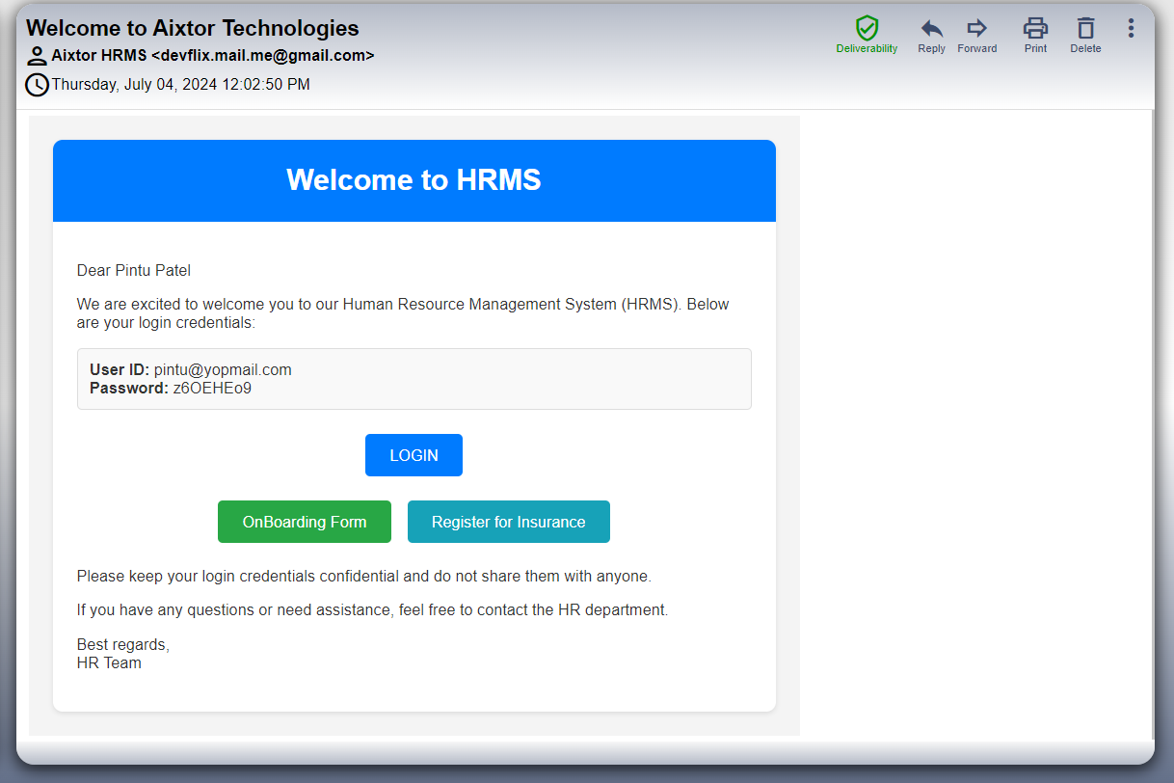

You will be then redirected to the employee Listing page.
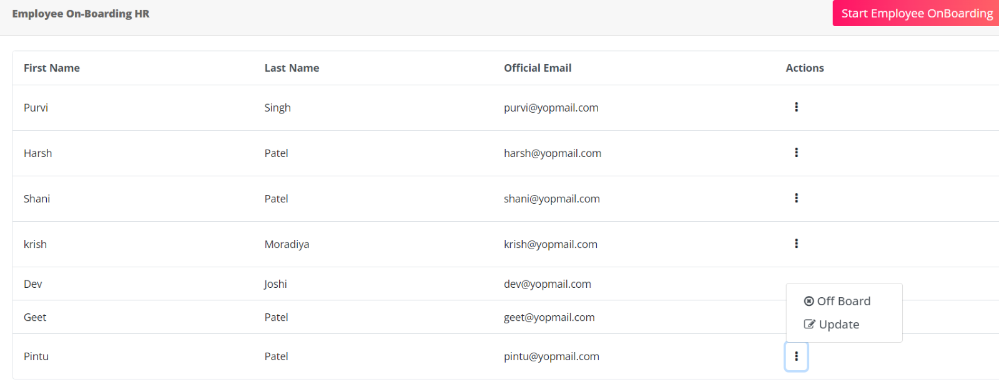
On the listing page there’s a 3-dot menu for the actions that can be performed upon the employee. On this action menu you will have 2 options, one to update the employee and one to offboard that employee.
On clicking the update employee, you will have a combined form, that will include the employee onboarding employee form and the HR form we just filled to onboard the employee. Where you can edit every field that employee or you have filled in the past.
These are the images for the 7 Tab form:
Note: These all 7 tab form’s field’s description are given on the HR and Employee on boarding form details.
Basic Details:
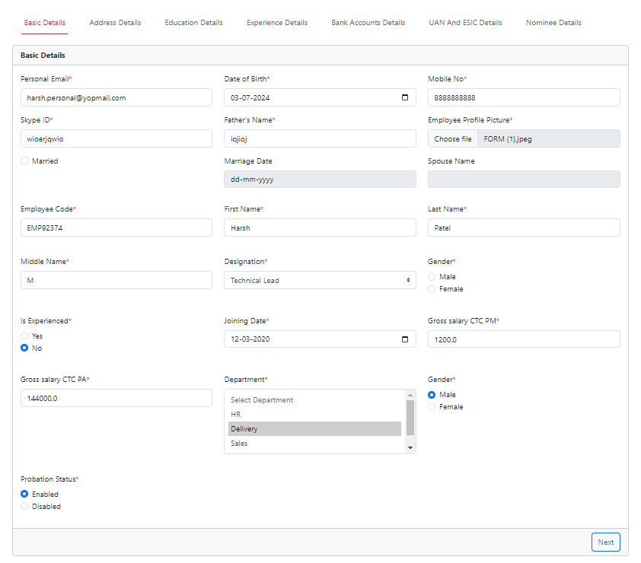

Address tab:
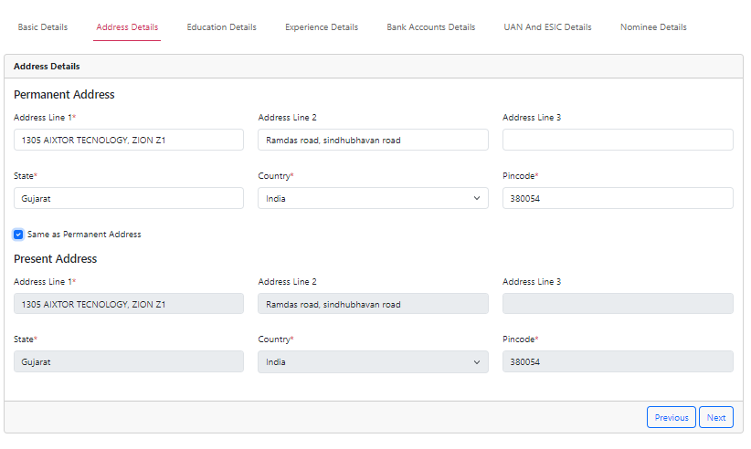
Education Data tab:
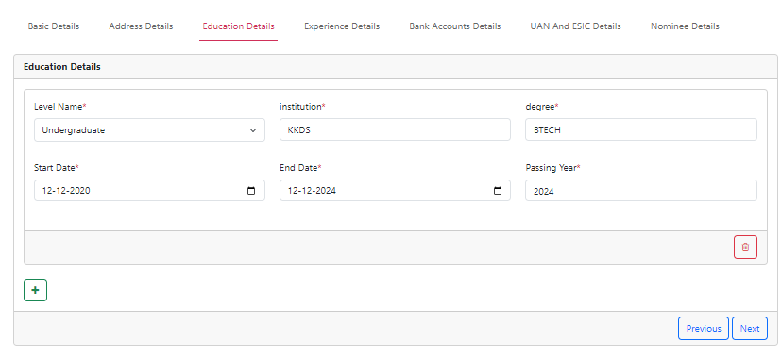

Experience details:
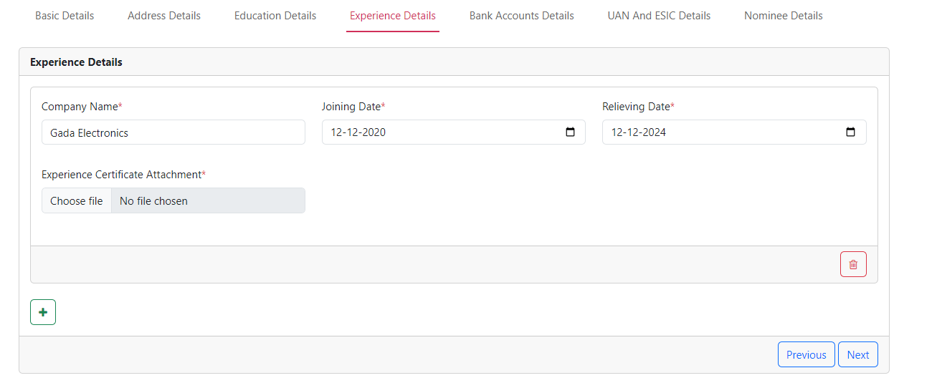
Bank Account details:
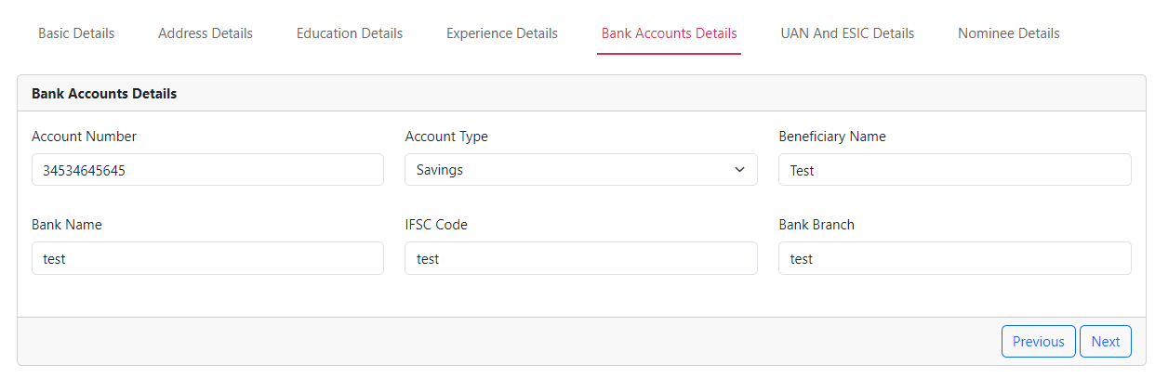
UAN and ESIC Details:
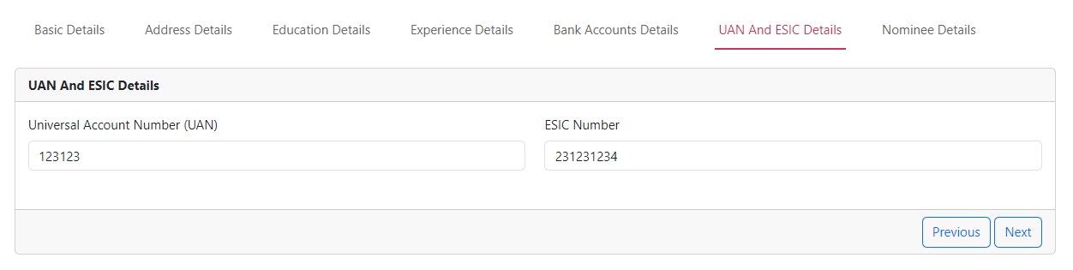

Nominee Details:
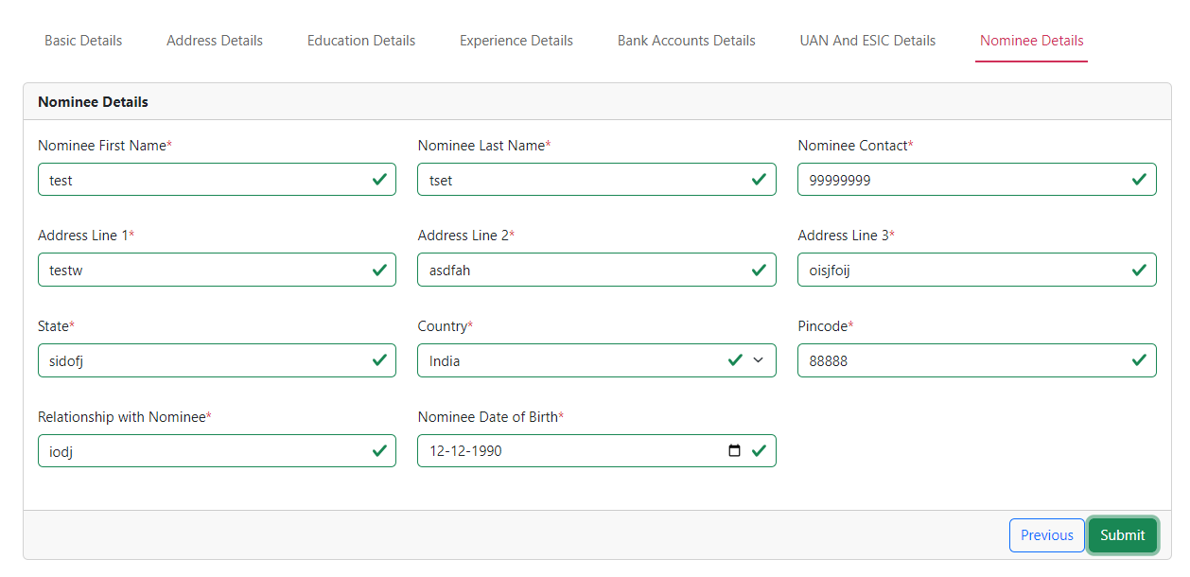
On submit the data will be successfully saved and on pressing back you will be taken back to the employee Listing.

On Pressing the Off-Board employee Action, you are taken to the offboarding view,
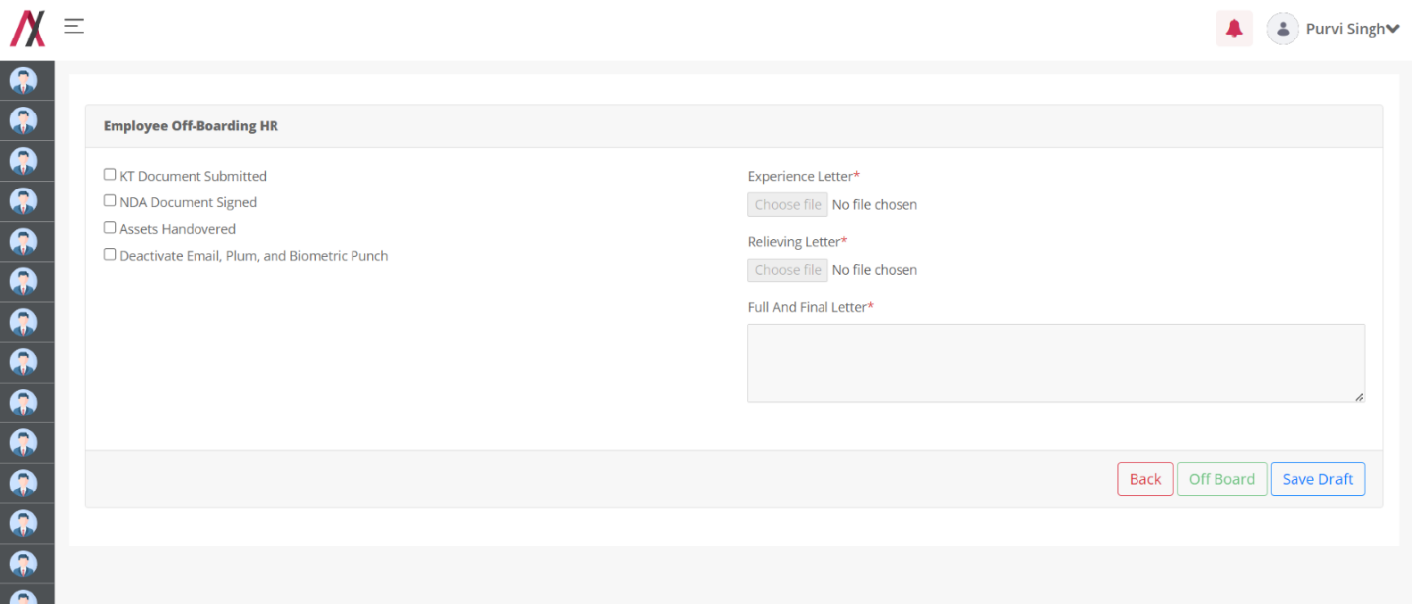
Here you have the form where you have functionality to partially fill the form and save the draft.
You may notice that the fields on the right side and the off-board button are disabled because once the left side fields are fully filled then and only then the right fields are enabled and after filling the form to its entirety the off-board button gets enabled.

On saving the draft, you will see the following message on the screen:
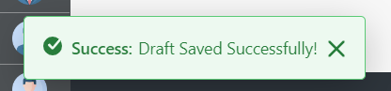
And once you upload all the file and fill all the fields, the offboard button gets enabled.
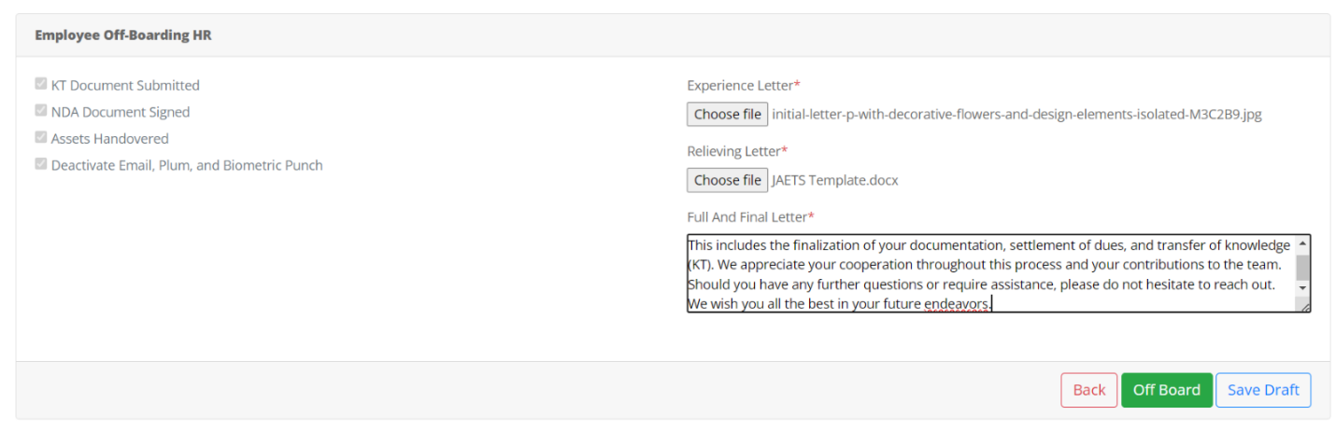
On clickng the off-board button you will see the following message:
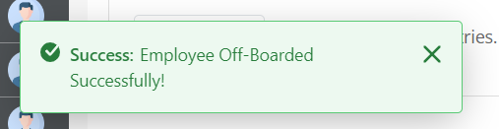
As soon the offboarding completed the employee will receive its full and final mail on the personal mail that has been configured on the employee onboarding that will contain the relieving letter and the experience letter as an attachment, the mail thing can be seen in the following image:
Configurations-Mail:- Under 9 Dots > System settings > catagory.HRMS > Mail Template Configurations. > Permanent Employee OnBoarding Mail (BODY).
Placeholder: Refer Excel sheet for the placeholders.
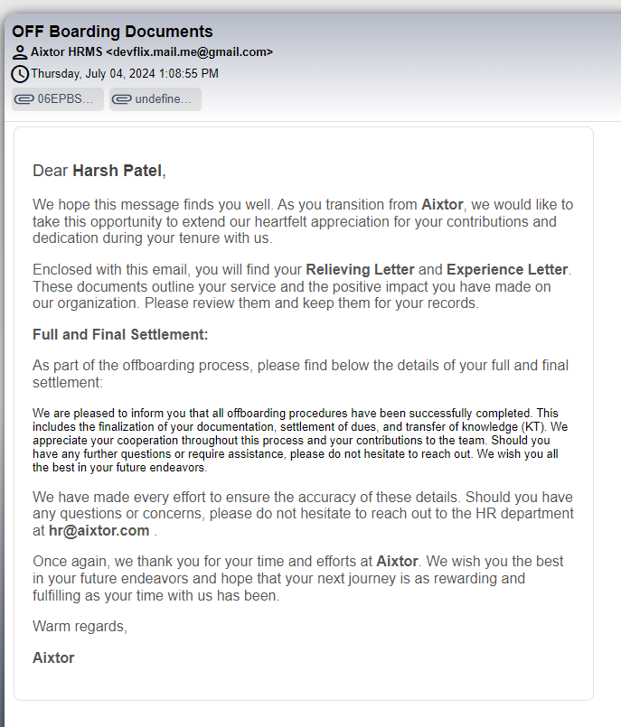

Functionality Flow (Employee):
Once the employee recieves the onboarding mail with the credentails the employee needs to login using the temporary credentails recieved on the mail address.
The following are the visual steps of the signing in for the first time:
Configurations-Mail:- Under 9 Dots > System settings > catagory.HRMS > Mail Template Configurations. > Permanent Employee OnBoarding Mail (BODY).
Placeholder: Refer Excel sheet for the placeholders.

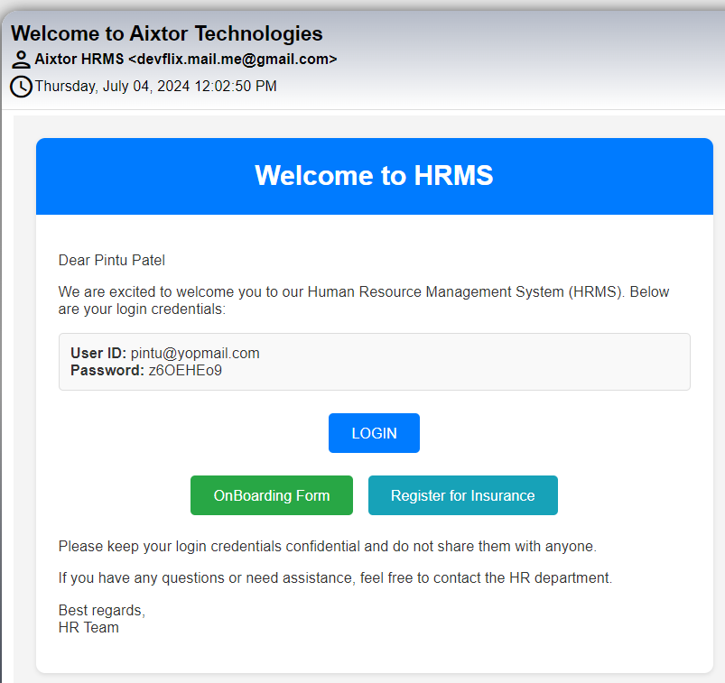This is the employee’s mail
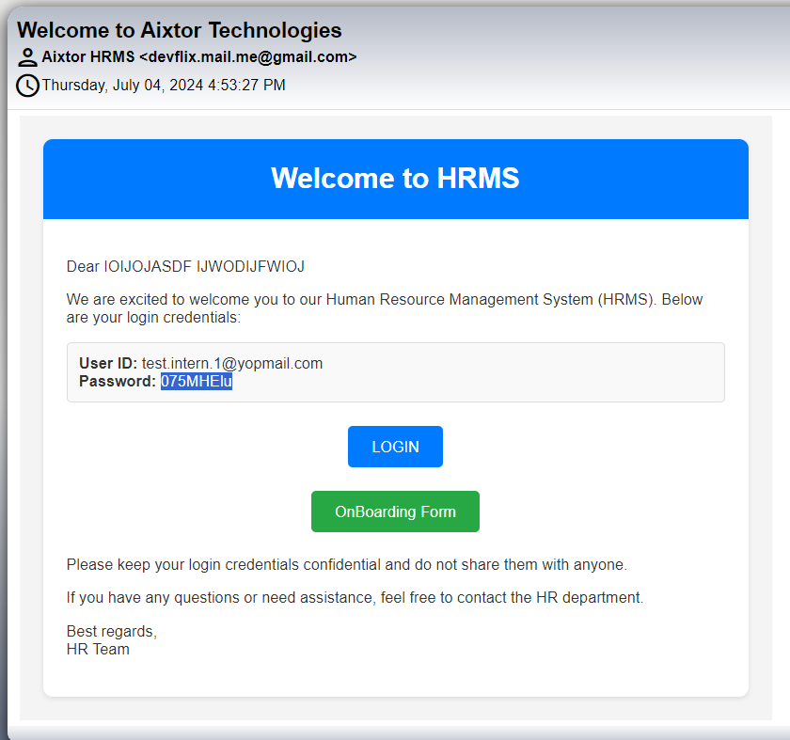This is the intern’s mail
On clicking the login link, you will be taken to the login page of the Liferay, and employee must enter the id and password received in their mail.
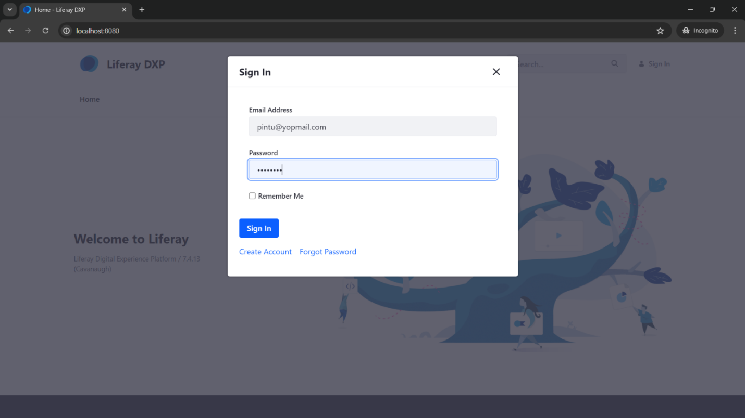
Once logged in the user has to agree the terms and conditions and set new password,
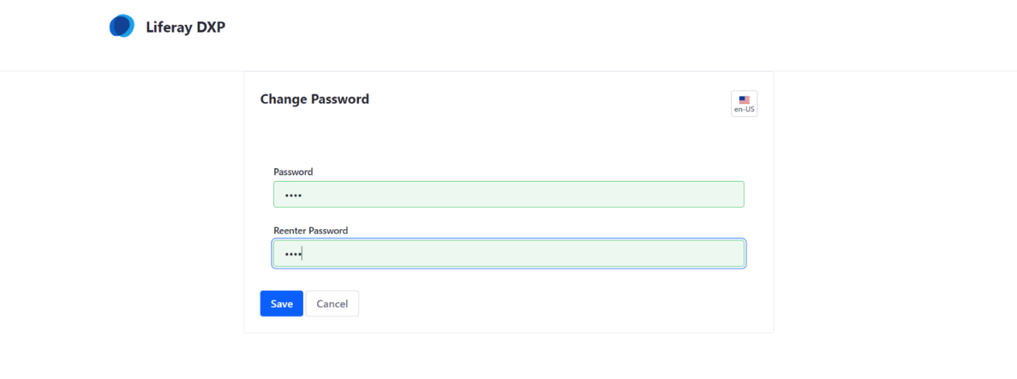
After logging in, the user must click the onboarding link on the mail to initiate the employe side onboarding!
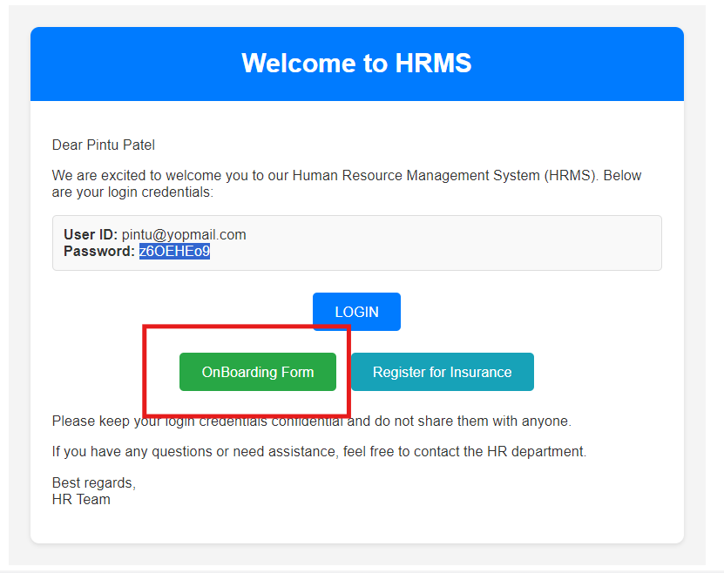
Once the user clicks on the onboarding form button, the employee is redirected to the employee On-Boarding form shown as below:

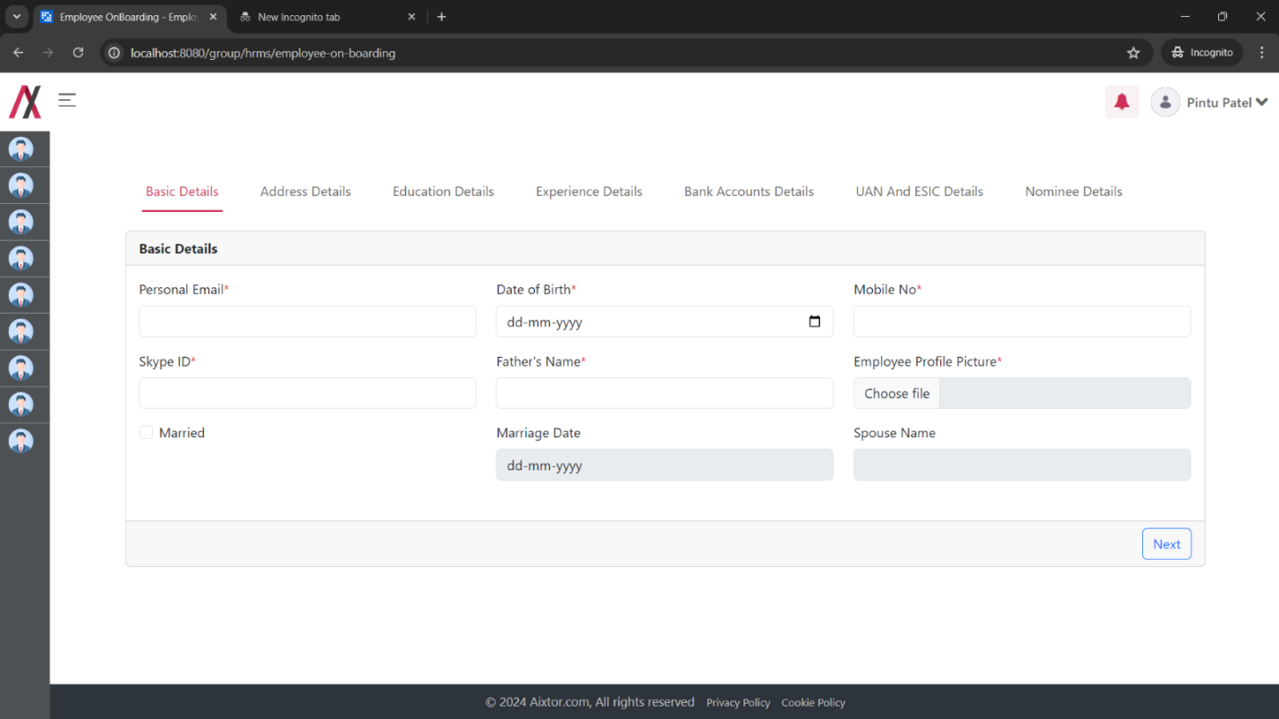
As you can see there are 7 tabs in the form, each form tab has one type of the details,
- Basic Details:
  - Personal Email: Employee’s personal email where the offboarding process data is sent! [email format required]
  - Date of birth: it is the employee’s date of birth. [date format required]
  - Mobile no: mobile no of the employee [number format required]
  - Skype Id: for the formal communication for the office, skype id of employee
  - Father’s name: The employee must fill in it. [character only required]
  - Employee Profile Picture: It is the profile picture of the user that will be displayed on the profile page.
  - Married checkbox: this checkbox is used to mark that employee is married or not married. Once the employee checks the box the marriage date and spouse name get enabled till then it stays disabled.

The 2nd tab is for the address details:
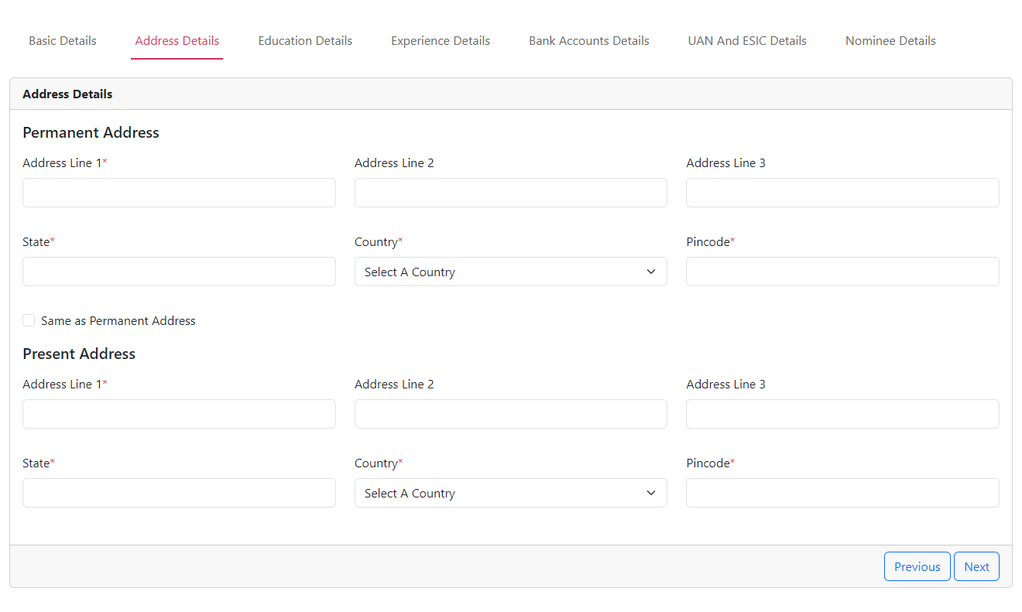
- Address Details:
  - Permanent Address
  - Address Line 1: Enter the first line of your permanent address (e.g., street number and name).
  - Address Line 2: Enter the second line of your permanent address (e.g., apartment number). This field is optional.
  - Address Line 3: Enter the third line of your permanent address (e.g., floor number). This field is optional.
  - State: Enter the state or province where you live.
  - Country: Select the country where you live from the dropdown menu.
  - Pincode: Enter the postal code for your permanent address. This field may be called "ZIP code" in some countries.
  - Same as Permanent Address: This checkbox allows you to copy your permanent address information to your present address.
  - Present Address
  - Address Line 1: Enter the first line of your present address (e.g., street number and name).
  - Address Line 2: Enter the second line of your present address (e.g., apartment number). This field is optional.
  - Address Line 3: Enter the third line of your present address (e.g., floor number). This field is optional.
  - State: Enter the state or province where you live.
  - Country: Select the country where you live from the dropdown menu.
  - Pincode: Enter the postal code for your present address. This field may be called "ZIP code" in some countries.

Once the employee fills all the address information and presses next, the address details are saved, and the next tab is visible for education details:

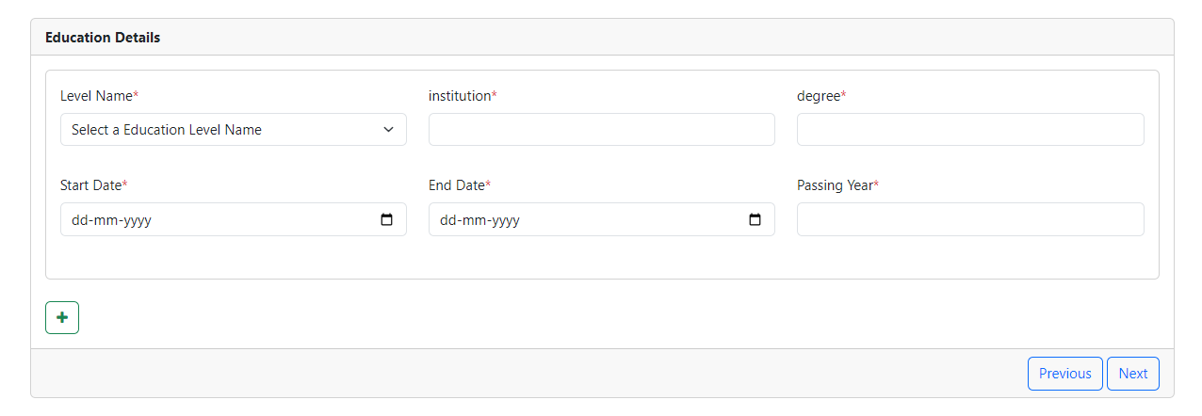In here this is a multiple education filling form that means the”+” button act as multiple education filler. On clicking the”+” button the form replicated itself as shown below:

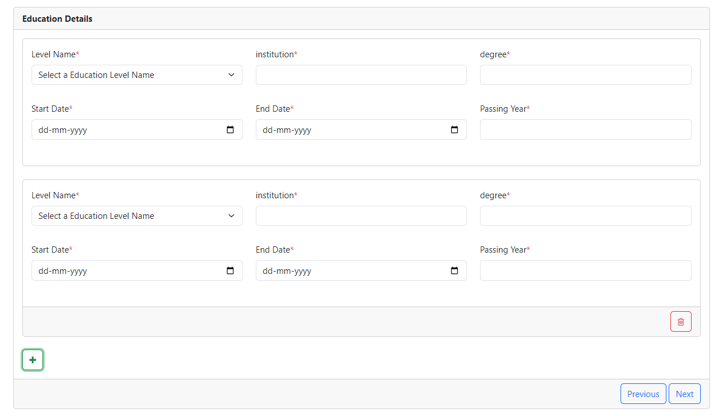
The intern’s and Contractors view is as following:
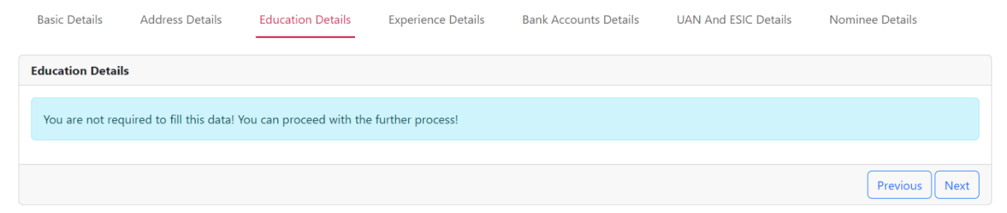
The fields of the form are as below:
- Level Name: This field is a dropdown menu. It likely contains a list of possible options that are fetched from the education level master table. You would select the option that corresponds to the educational level you want to add.
- Institution: This field is where you enter the name of the educational institution you attended (e.g., school name, university name).
- Degree: This field is where you enter the degree or diploma you earned (e.g., "Bachelor of Arts in English", "GED").
- Start Date: This field is where you enter the date you started your education at this institution (dd-mm-yyyy).
- End Date: This field is where you enter the date you graduated or finished your program at this institution (dd-mm-yyyy).
- Passing Year: You would enter the year in which you graduated or finished your program at this institution.

Once the employee fills all the education information and presses next, the address details are saved, and the next tab is visible for Experience details:
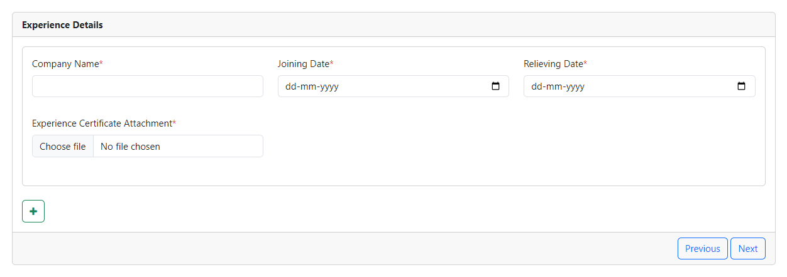
In here this is a multiple experience filling form that means the” +” button act as multiple experience filler. On clicking the” +” button the form replicated itself as shown below:
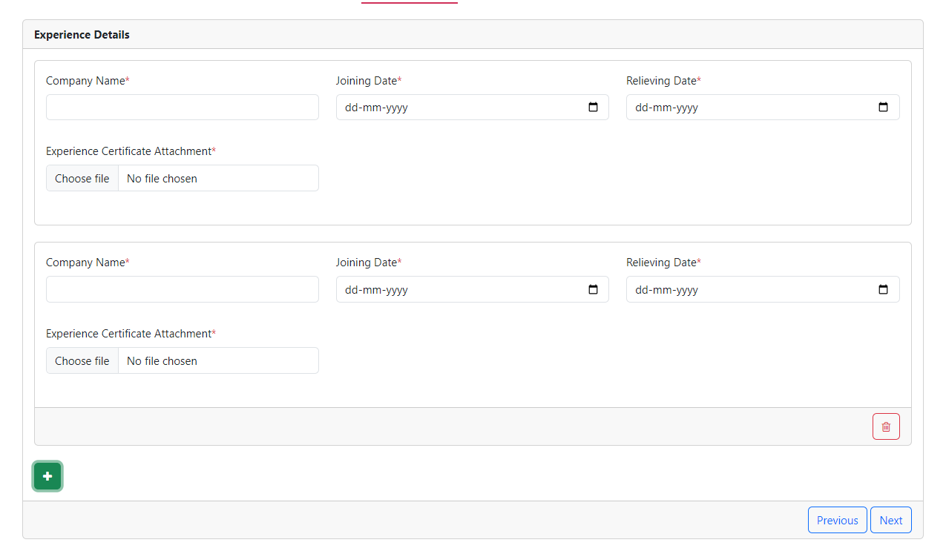
If the employee’s type is Intern or the contractor, the view for the intern is different as shown in the below figure:
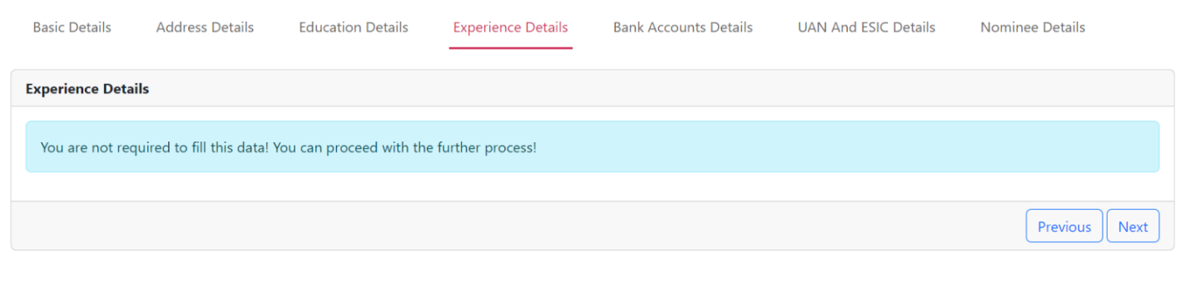
The fields of the form are as below:
- Company Name (required): This field is where you enter the name of the company you worked for.
- Joining Date (required): This field is where you enter the date you started working at the company in dd-mm-yyyy format.
- Relieving Date (required): This field is where you enter the date you stopped working at the company in dd-mm-yyyy format.
- Experience Certificate Attachment: This section allows you to upload a scanned copy of your experience certificate by clicking "Choose File".

On clicking the Next button, the expericence details are saved in the Database and we are sent to the next tab to enter the bank account details:
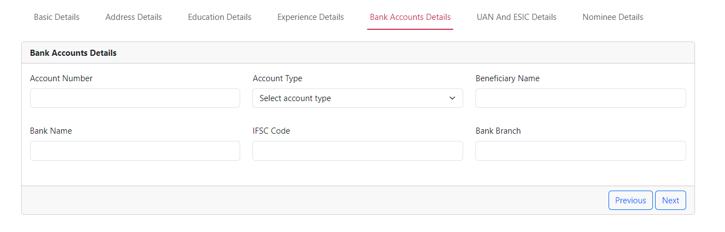
The bank for has following fields (These fields are not required):
- Account Number: This field lets you enter your bank account number. This is a unique identifier for your bank account and may include a combination of letters and numbers.
- Account Type: This field lets you enter the type of bank account you hold. In India, common account types include savings accounts, current accounts, recurring deposit accounts, etc.
- Beneficiary Name: This field may not be applicable according to the Indian banking system. It might be a placeholder for entering beneficiary information if this form is used for setting up a money transfer.
- Bank Name: This field lets you enter the name of the bank you hold the account with.
- IFSC Code: This field let you enter the 11-digit Indian Financial System Code (IFSC) for the branch where your account is held. You'll use this code when making electronic fund transfers.
- Bank Branch: This field lets you enter the name of the bank branch where your account is held.

On clikcing the next button your bank details are stored within the system and you are displayed the UAN ESIC form:
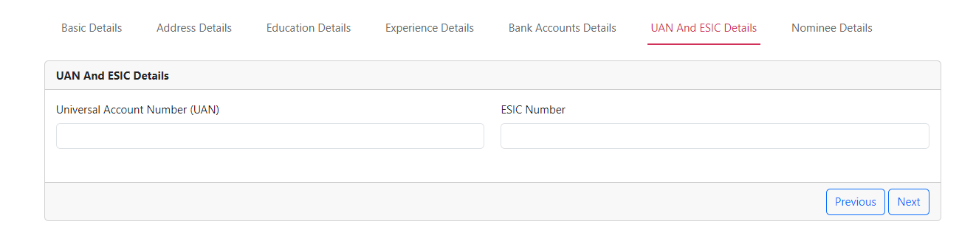
There are 2 fields:
- UAN – Universal Account Number must be entered by the user to work with an organization as a permanent employee.
- ESIC Number is the number to be entered by the user.

On clicking the next button your UAN/ESIC Details are saved to the Database and then you are presented with the nominee filling form where the employee has to fill their nominee's name and other important details:
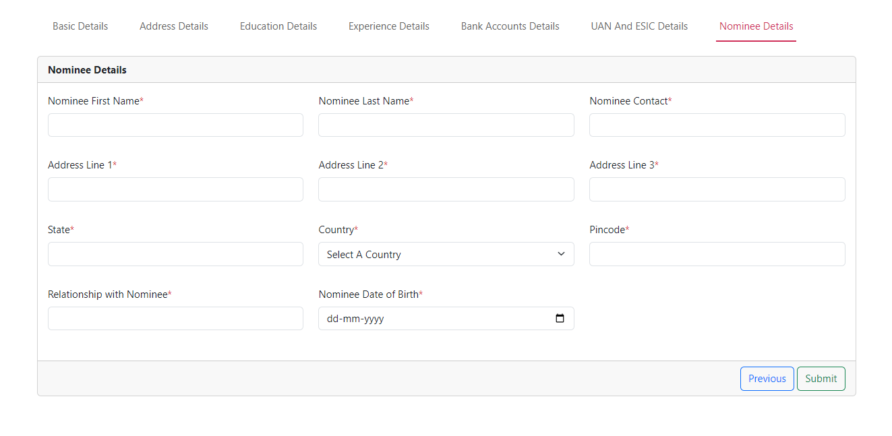
- Nominee First Name: Enter the first name of the person you are designating as the nominee for your bank account.
- Nominee Last Name: Enter the last name of the nominee for your bank account. An asterisk indicates this field is required.
- Nominee Contact: Enter the phone number or contact information for the nominee.
- Address Line 1: Enter the first line of the nominee's address. An asterisk indicates this field is required.
- Address Line 2: Enter the second line of the nominee's address. An asterisk indicates this field is required.
- Address Line 3: Enter the third line of the nominee's address (optional).
- State: Enter the state or province where the nominee lives. An asterisk indicates this field is required.
- Country: Select the country where the nominee lives from the dropdown menu. An asterisk indicates this field is required.
- Pin code: Enter the postal code for the nominee's address. This field may be called "ZIP code" in some countries. An asterisk indicates this field is required.
- Relationship with Nominee: Enter your relationship to the nominee from the dropdown menu. An asterisk indicates this field is required.
- Nominee Date of Birth: Enter the date of birth of the nominee in the format dd-mm-yyyy. An asterisk indicates this field is required.

On clicking the final “Submit” button the employe onboarding details are shared to the HR for verification via mail and the employee are displayed with the following screen:
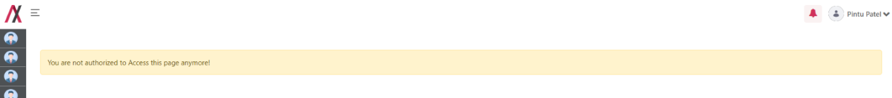
The mail to HR looks like the image below:
Configurations-Mail:- Under 9 Dots > System settings > catagory.HRMS > Mail Template Configurations. > Verify OnBoarding Details HR MAIL (BODY)

Placeholder: Refer Excel sheet for the placeholders.

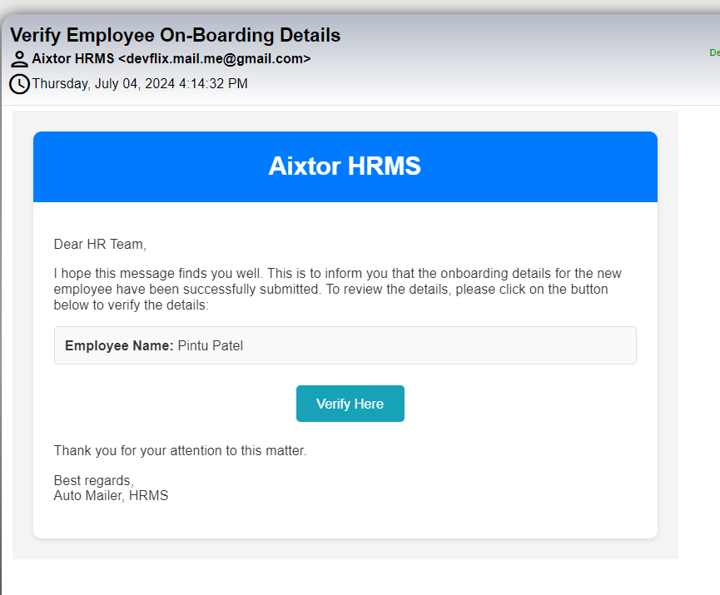
This mail is sent to all HR admins such that they can review the employee details.
On clicking the Verify here button a verification panel opens for the HR admin. The image of verification panel is given below:

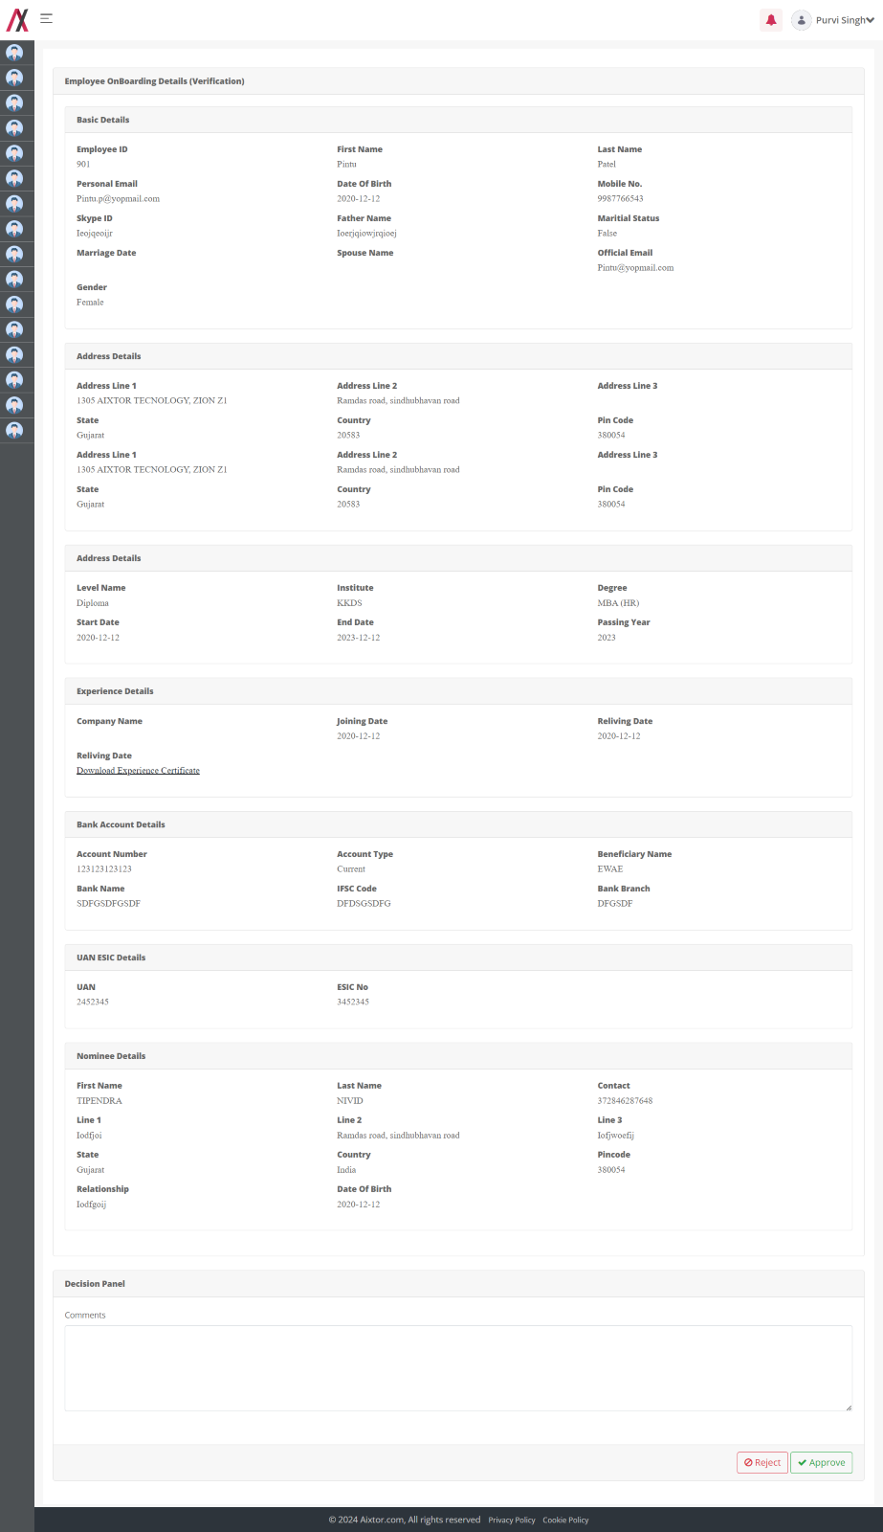
If the HR Adds comments and rejects the application of employee verification, a mail is triggered to the employee back with the comments.
The snap of the mail is below:
Configurations-Mail:- Under 9 Dots > System settings > catagory.HRMS > Mail Template Configurations. > Re-Upload OnBoarding Details Employee MAIL (BODY)
Placeholder: Refer Excel sheet for the placeholders.

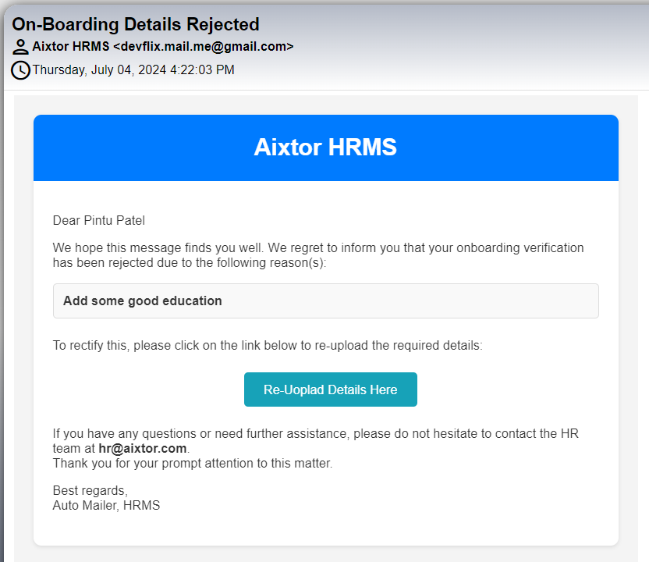
On clicking on the button in mail, the employee is taken to the employee on boarding again to refill the information. And the cycle continues,

If the HR approves the approval request leave balance will be added to that employee, then the mail is triggered to employee, like in the below image:
Configurations-Mail: - Under 9 Dots > System settings > catagory.HRMS > Mail Template Configurations. > Employee OnBoarding Details Successfully Verified Employee MAIL (BODY)

Placeholder: Refer Excel sheet for the placeholders.

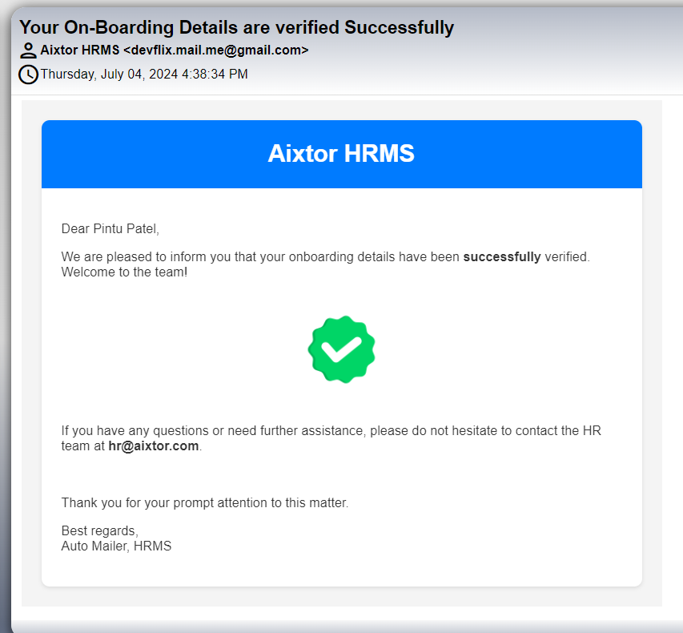

Project:

Functionality:
Project Module is stores all information about the project which is created by Manager.

Page Name & Links:
The page where the portlet is placed is named Project
Link - http://localhost:8080/group/hrms/project

Functionality Flows:
The flow starts by navigating to the link mentioned in the above section, that will present you the below screen :
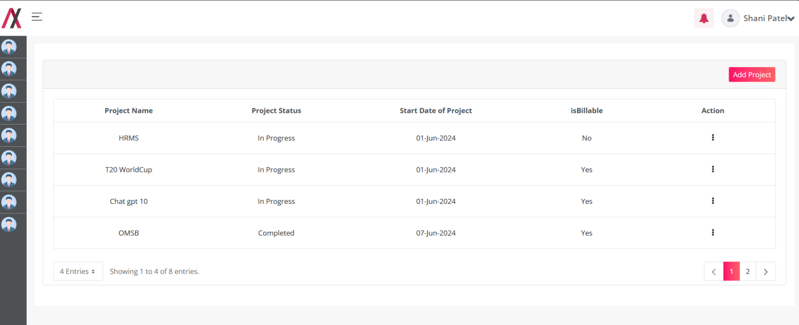
This screen lists all projects created by or assigned to the logged-in user. Employees with a Manager can access an Add Project button to create new Projects. Employees without a Manager role do not see this button. However, HR Admins have visibility of all projects within the HRMS System. Clicking the Add Project button navigates to another screen for creating a new project.
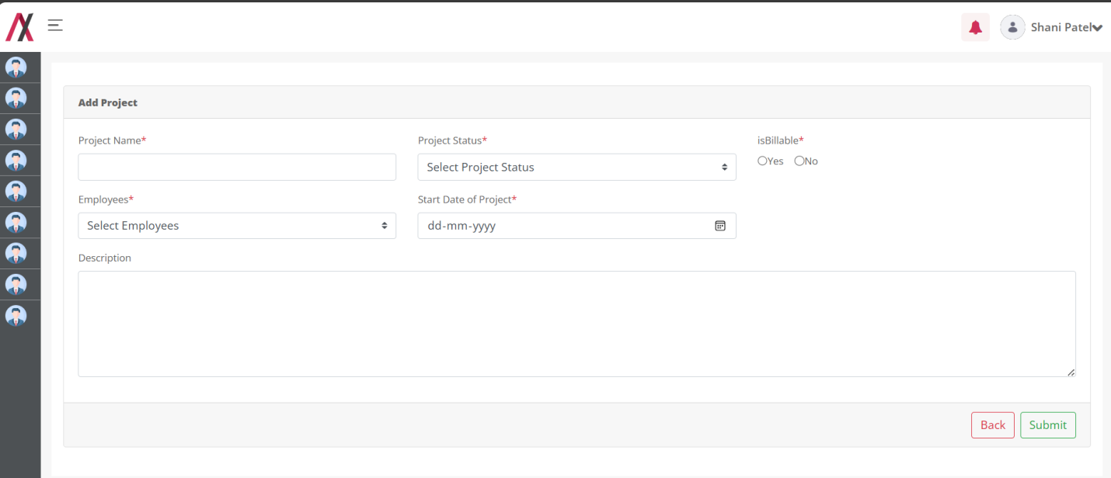In this form you will find following fields:
1.Project Name: Here you can add the name of the Project.
2.Description: You can add a short description about project.
3.Project Status : This will have the dropdown of all the status available in the master data of Project Task Status Master.
4.IsBillable : Check this box if this project is billable.
5.Employees: This will have the multiple selection dropdown of all the Employee which is not terminated.
6.Start Date of Project: Select the start date of Project.

Here you can add the name of Project that you want to add into your system. There are two buttons available on the screen, one to go back to the listing page and another to submit the Project .
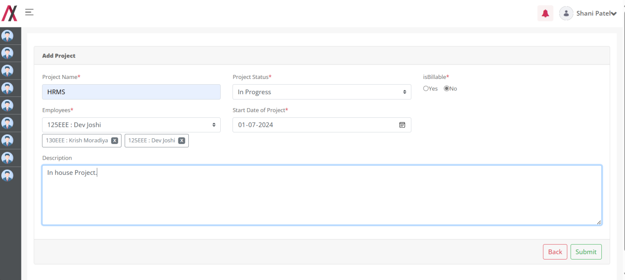

you add the Project you will be greeted with the success message as below:
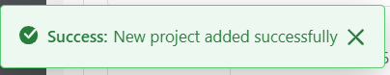

After successfully adding a project, the manager receives a notification about the newly added project.
Configurations-Notification:- Under 9 Dots > System settings > catagory.HRMS > Notification Template Configurations. > Project (Manager AddProject)
Placeholder: Refer Excel sheet for the placeholders.


After being assigned to a new project, employees also receive a notification,
Configurations-Notification:- Under 9 Dots > System settings > catagory.HRMS > Notification Template Configurations. > Project (Employee Assigne)
Placeholder: Refer Excel sheet for the placeholders.
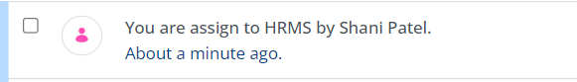
And also receive mail,

Configurations-Mail:- Under 9 Dots > System settings > catagory.HRMS > Mail Template Configurations. > Project Assignement for Employee.

Placeholder: Refer Excel sheet for the placeholders.

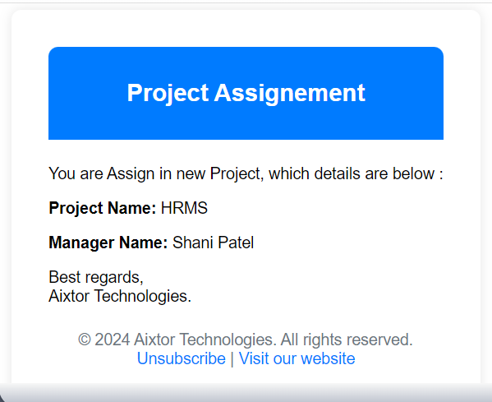

And after adding the Project we are redirected back to the list page.
Clicking the three-dot icon in the action column allows managers to access view, edit, and delete functions. For non-manager role Employee, only the view button is available,

For Manager:
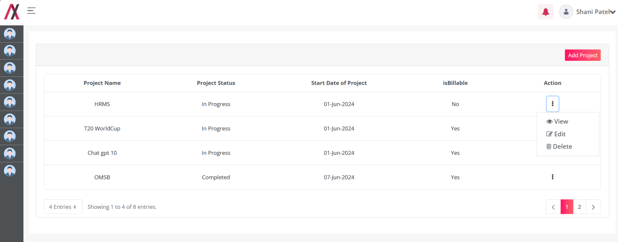
By clicking the View button, you are redirected to the following screen where you can see the details about a specific entry of Project as shown in image below:
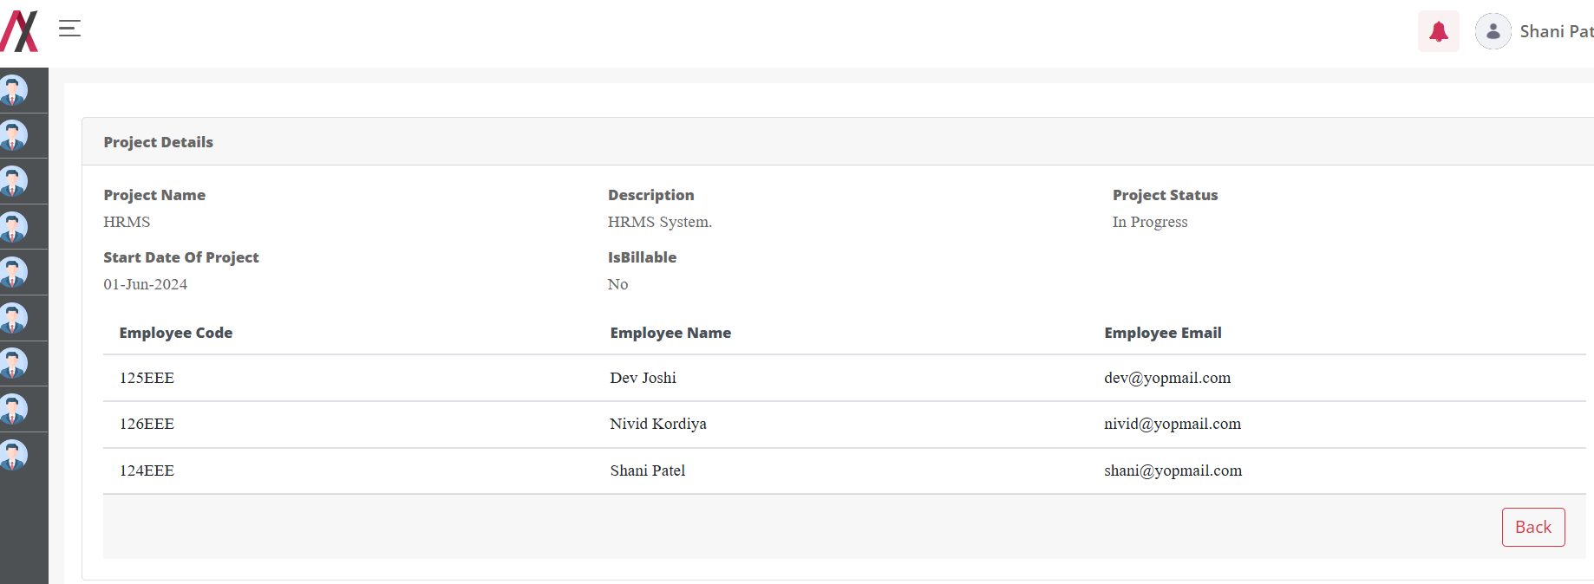
By clicking on the Edit button you will be taken to the editing screen, here you can edit the Project. There are two buttons available on the screen, one to go back to the listing page and another to add the Project. The editing screen is shown in image below:
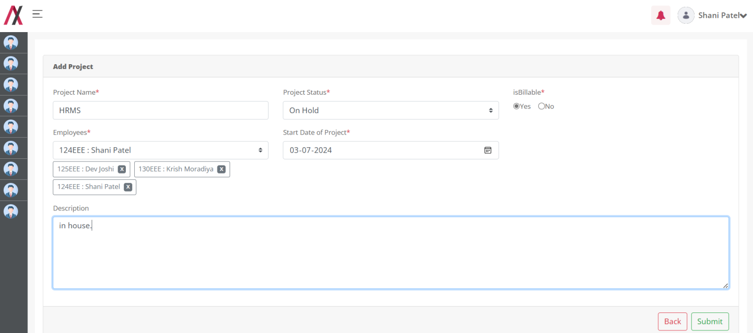
If during the editing process of a project, a manager updates the list of employees (for example, by removing someone), that employee will receive a notification and email informing them of their removal from the project.
Configurations-Notification:- Under 9 Dots > System settings > catagory.HRMS > Notification Template Configurations. > Project (Employee Remove)

Placeholder: Refer Excel sheet for the placeholders.

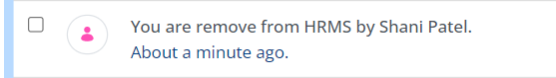

Configurations-Mail:- Under 9 Dots > System settings > catagory.HRMS > Mail Template Configurations. > Project Removal for Employee.
Placeholder: Refer Excel sheet for the placeholders.

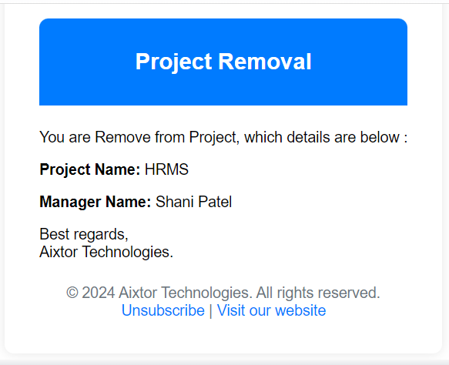
On clicking the submit button we will be greeted with the message.
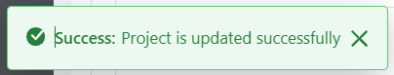

When you click the Delete button:
If you confirm by clicking OK, the Project will be deleted, and you will receive the following success message:
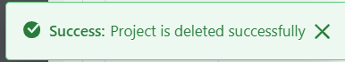

For Employee:
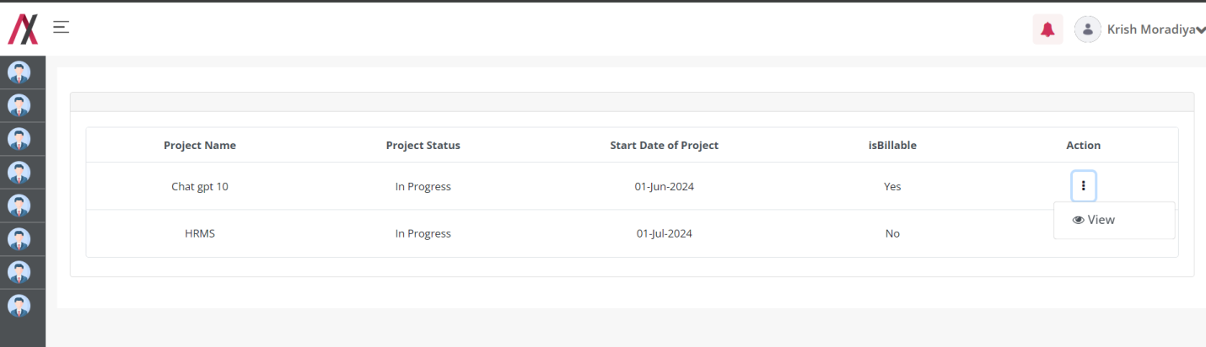

Task:

Functionality:
Task Module is stores all information about the Task of Project which is created by Manager.

Page Name & Links:
The page where the portlet is placed is named Task
Link - http://localhost:8080/group/hrms/task

Functionality Flows:
The flow starts by navigating to the link mentioned in the above section, that will present you the below screen :
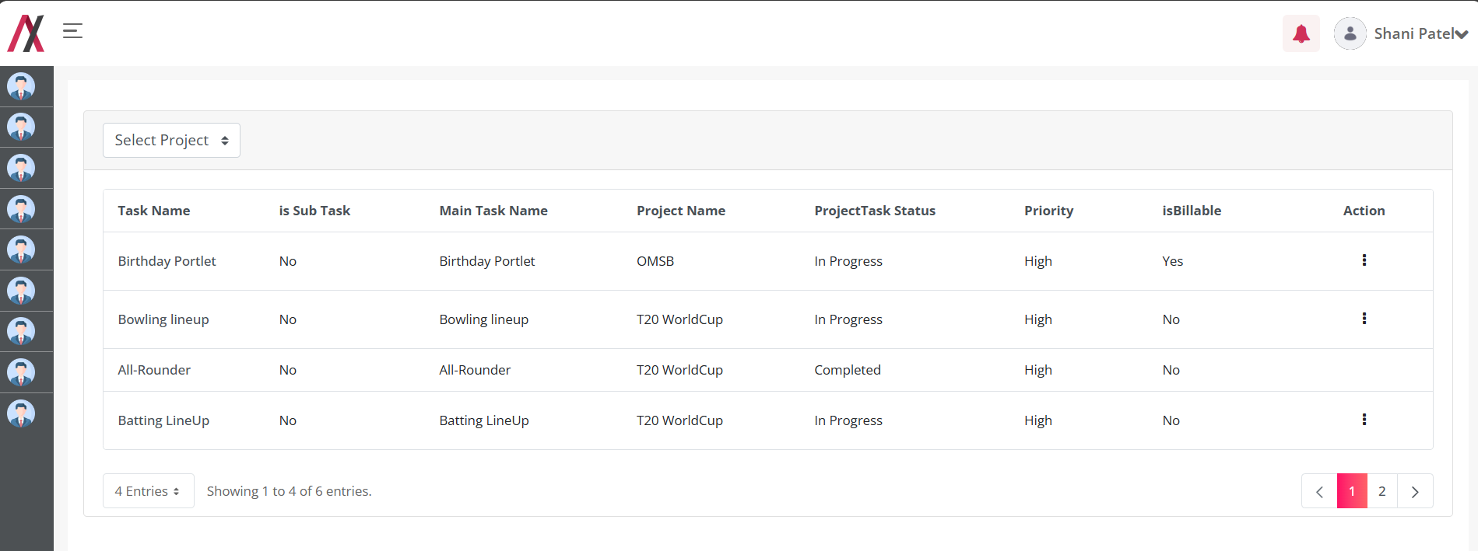
This screen lists all tasks of the project created by or assigned to the logged-in user. Managers can select a project from the dropdown list and access an Add Task button to create new tasks. Employees without a Manager role do not have access to this button.
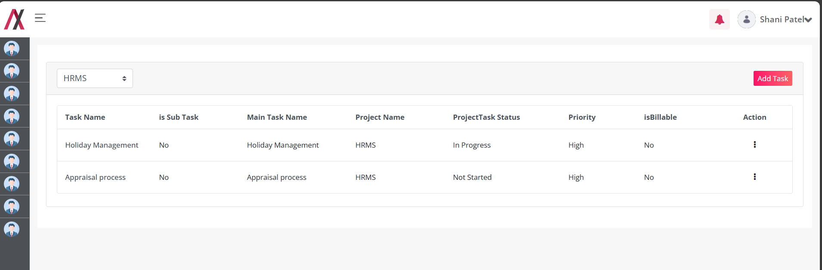

Clicking the Add Task button navigates to another screen for creating a new task.
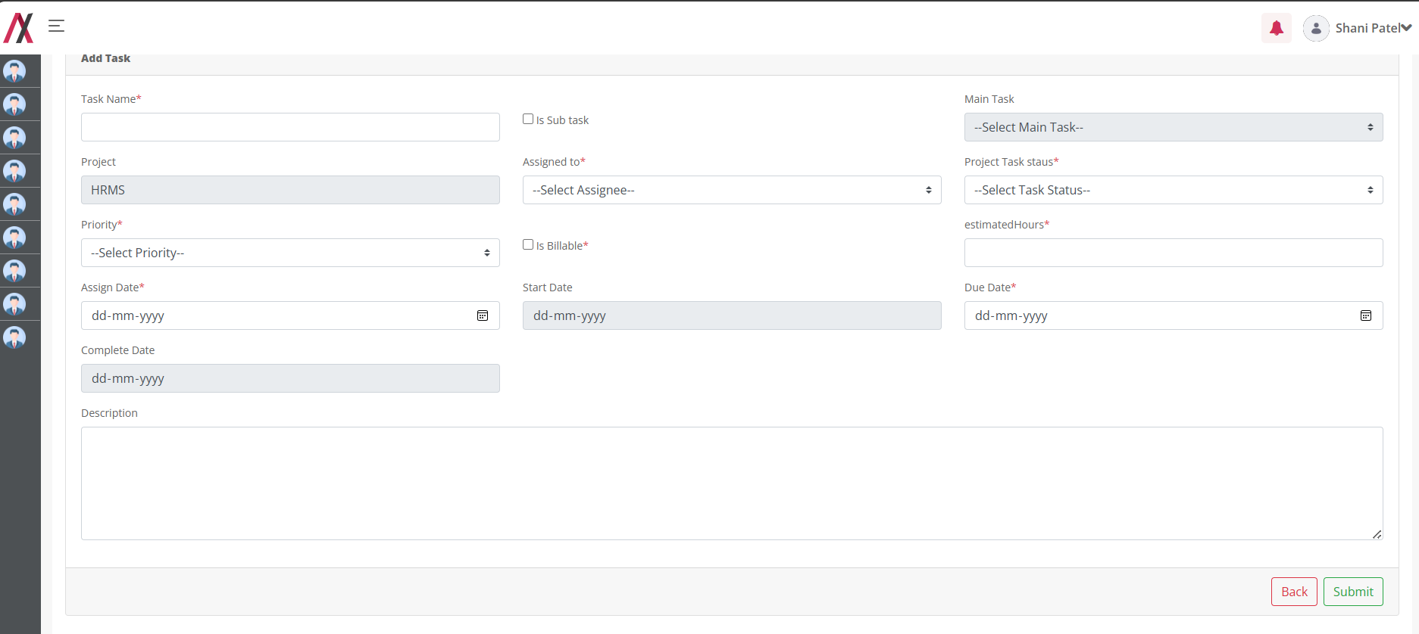In this form you will find following fields:
1.Task Name: Here you can add the name of the Task.
2.Description: You can add a short description about task.
3.Project Task Status : This will have the dropdown of all the status available in the master data of Project Task Status Master.
4.IsBillable : Check this box if this task is billable.
5.Assigned To: This will have the dropdown of all the Employee which is assign in Project of this Task.
6.Is Sub Task : Check this box if this Task is Sub task of another Task of this Project.
7.Main Task: This will have dropdown list of all the task of this project. If Manager check is sub task then this field is available for select the main task of this task.
8.Project: This Field is auto filled by Project name which is selected by the manager.
9.Priority: This will have dropdown of the priority available in the Master data of Priority Master .
10.Estimated Hours: Managers can add the estimated hours required to complete this task.
11.Assign Date: Managers can select the date on which they assign the task to the employee.
12.Due Date: Managers can select the date by which this task must be completed.
13.Start Date: Only the task assignee has access to this field. They can select the actual start date of this task.
14.Complete Date: Only the task assignee has access to this field. They can select the actual completion date of this task.

Here Manager can add the Task that you want to add into your system. There are two buttons available on the screen, one to go back to the listing page and another to submit the Task.
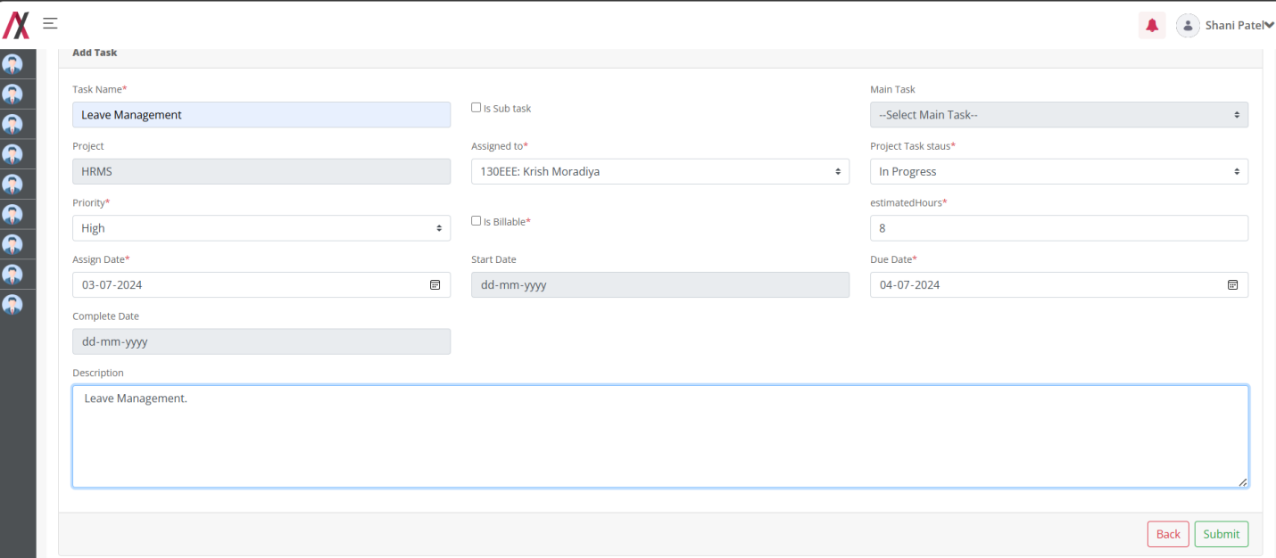

you add the Task you will be greeted with the success message as below:
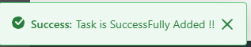

After successfully adding a Task, the manager receives a notification about the newly added task.
Configurations-Notification:- Under 9 Dots > System settings > catagory.HRMS > Notification Template Configurations. > Task (Manager AddTask)
Placeholder: Refer Excel sheet for the placeholders.

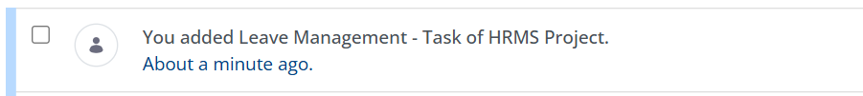
After being assigned to a new task, employees also receive a notification,
Configurations-Notification:- Under 9 Dots > System settings > catagory.HRMS > Notification Template Configurations. > Task (Employee Assigne)

Placeholder: Refer Excel sheet for the placeholders.

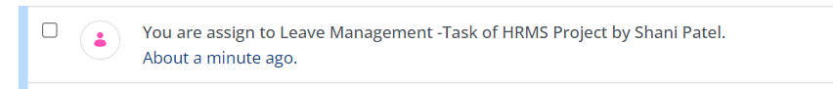
And also receive mail,

Configurations-Mail:- Under 9 Dots > System settings > catagory.HRMS > Mail Template Configurations. > Task Assignement for Employee
Placeholder: Refer Excel sheet for the placeholders.

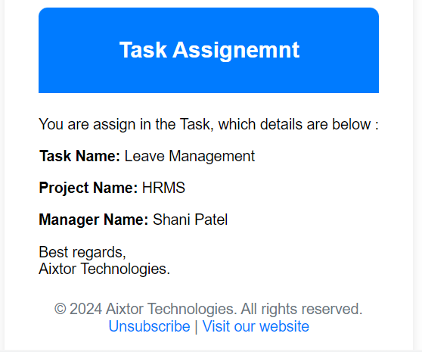

And after adding the Task we are redirected back to the list page.
Clicking the three-dot icon in the action column allows managers to access edit, and delete functions. For non-manager role Employee, the edit and addLogTime button is available,

For Manager:
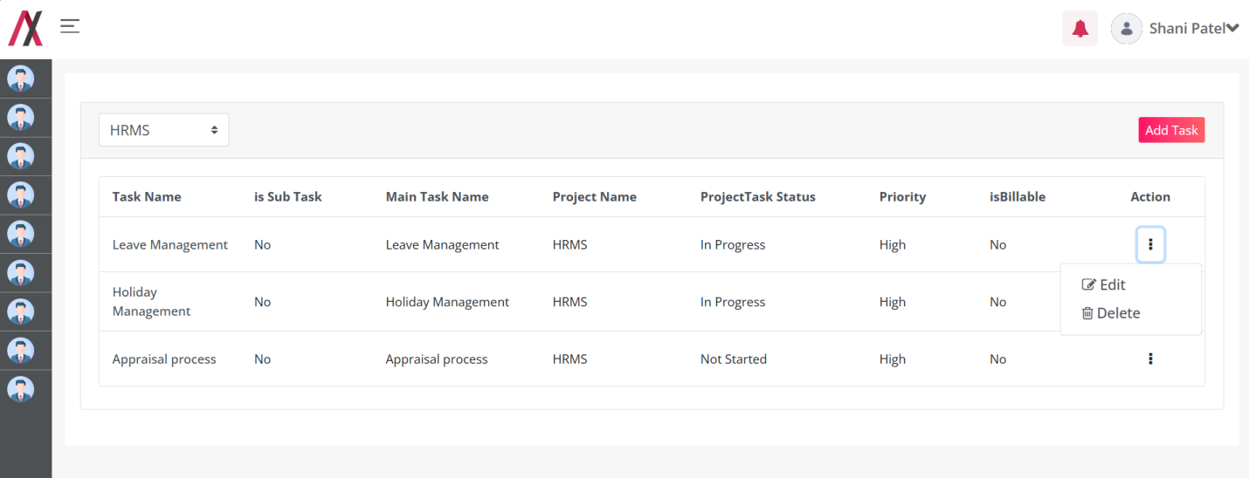
By clicking the Task Name of every Task, you are redirected to the following screen where you can see the details about a specific entry of Task as shown in image below:
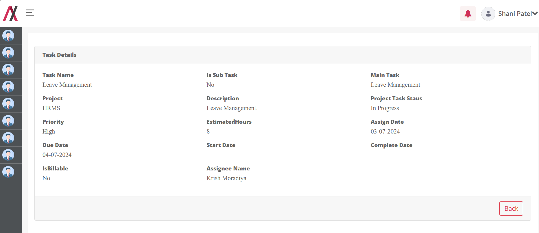
By clicking on the Edit button you will be taken to the editing screen, here you can edit the Task. There are two buttons available on the screen, one to go back to the listing page and another to add the Task. The editing screen is shown in image below:
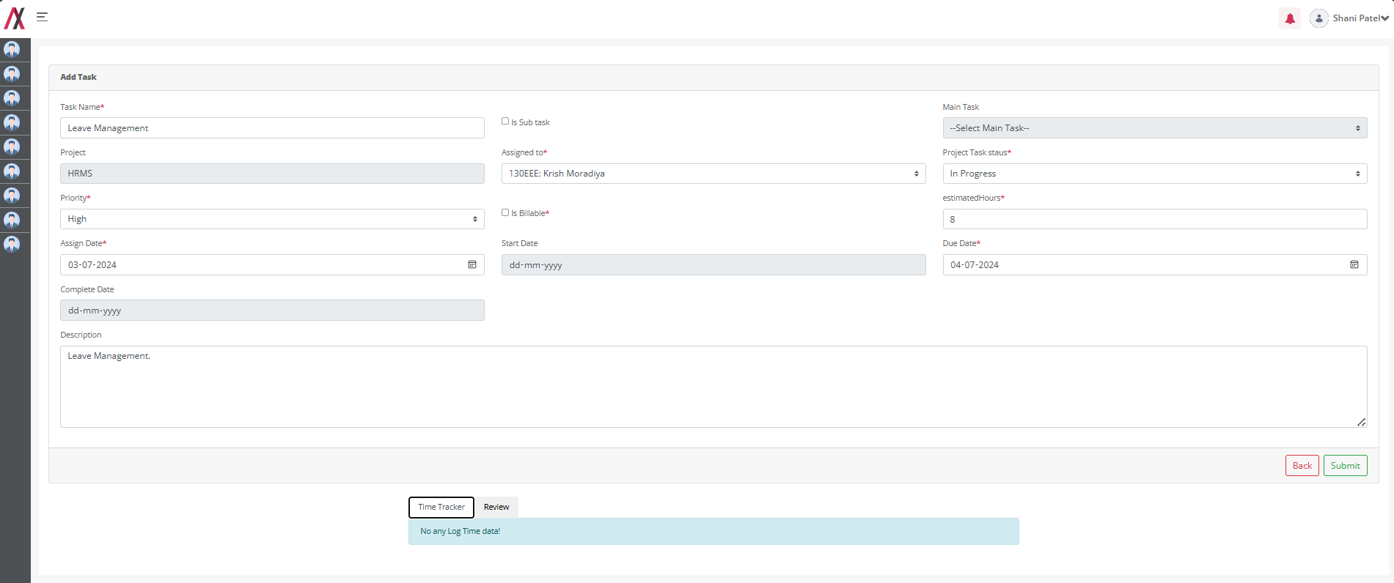
If during the editing process of a task, a manager updates assigned to (for example, by removing employee and add new assignee), that old employee will receive a notification and email informing them of their removal from the task, and new employee receive a notification and email same as adding task process.
Configurations-Notification:- Under 9 Dots > System settings > catagory.HRMS > Notification Template Configurations. > Task (Employee Remove)

Placeholder: Refer Excel sheet for the placeholders.

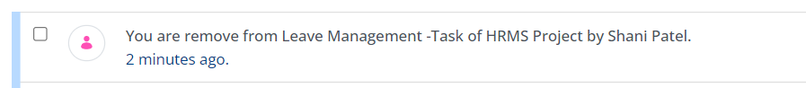

Configurations-Mail:- Under 9 Dots > System settings > catagory.HRMS > Mail Template Configurations. > Task Removal for Employee.
Placeholder: Refer Excel sheet for the placeholders.

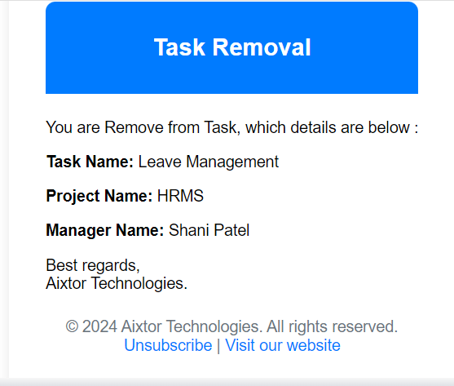
On clicking the submit button we will be greeted with the message.
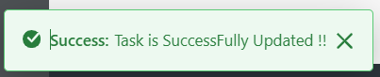

When you click the Delete button:
If you confirm by clicking OK, the Project will be deleted, and you will receive the following success message:
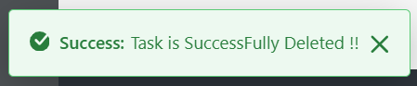

For Employee:
Employees can only see 3-dot icon buttons for tasks assigned to them. Tasks not assigned to them can only be viewed by clicking on the task name. Clicking the three-dot icon in the action column allows access edit, and addLogTime functions.
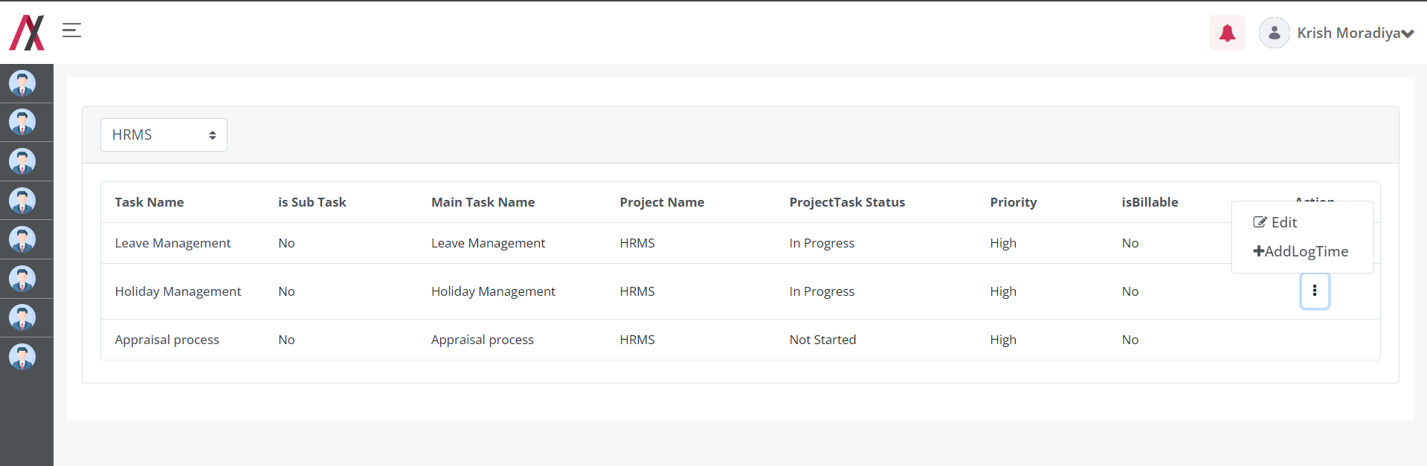
By clicking on the Edit button you will be taken to the editing screen, here Employee can edit only Start Date and Complete Date of the Task. There are two buttons available on the screen, one to go back to the listing page and another to edit the Task. The editing screen is shown in image below:

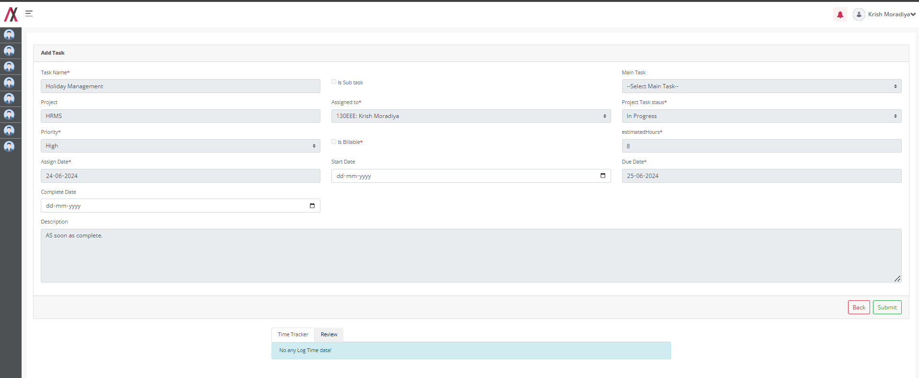

By clicking on the addLog button, Employee can add the LogTime of that Task.

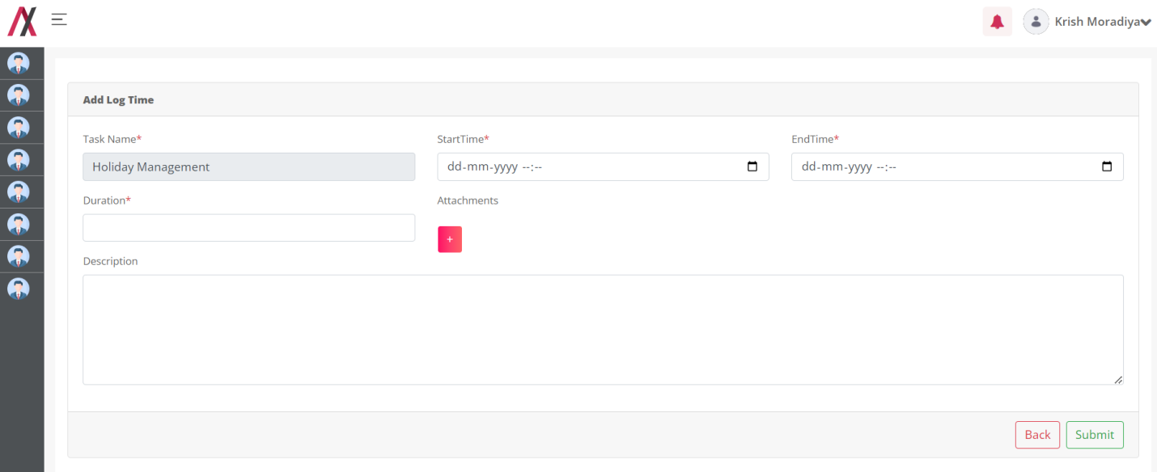
In this form you will find following fields:
1.Task Name: This field is automatically filled with the Task Name.
2.Start Time: Employee can select start time of that task.
3.End Time: Employee can select end Time of that task.
4.Duration: Employee can add working time hours of between start time and end time.
5.Description: If employees want to add information about the work they have done during that time, they can include it.
6.Attachments: If an employee wants to add documents related to their work, they can upload documents. Employee can also upload multiple documents.

Here Employee can add the log time that they want to add into your system. There are two buttons available on the screen, one to go back to the listing page and another to submit the Log time.
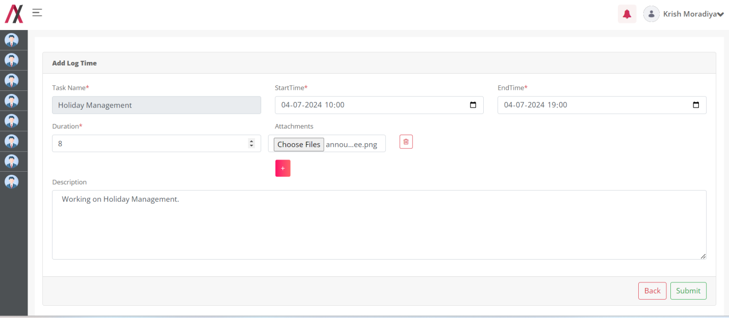

you add the Task you will be greeted with the success message as below :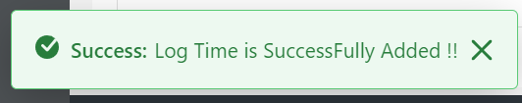
After adding log time it is visible in the TimeTracker Tab in the edit Page of that Task.

Time Tracker:
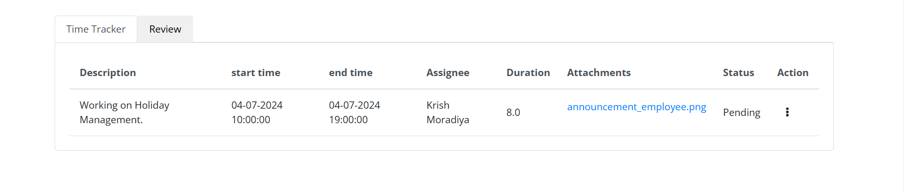 Manager and Employee both are able to see the list of logtime of that task.
Clicking the three-dot icon in the action column allows managers to access Approve and Reject functions. For non-manager role Employee, the edit and delete button is available,
For Manager ,
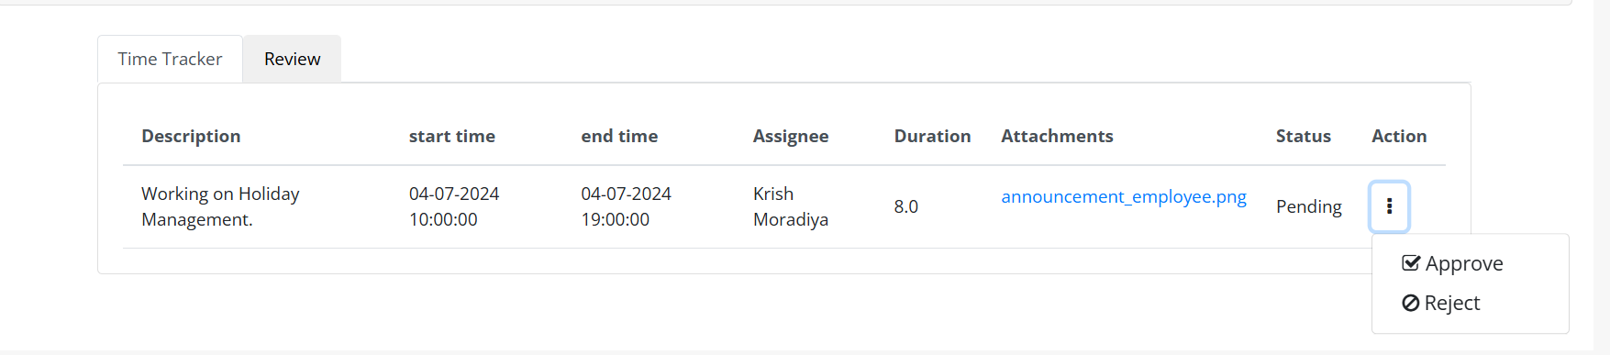
If Manager Reject the logTime then status is change from Pending to Rejected,also approve and reject button is disable .If status is not Pending then that button is disable. 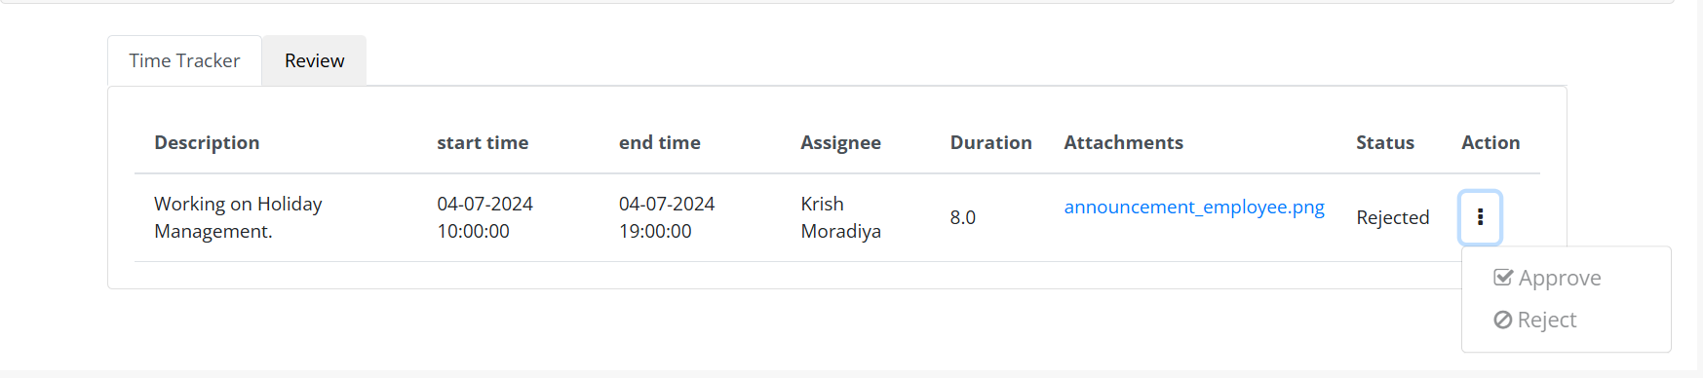
after rejecting log time you will be greeted with the success message as below :
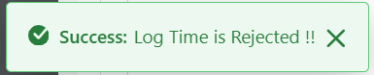
And that task of assignee also receive notification of reject logTime.
Configurations-Notification:- Under 9 Dots > System settings > catagory.HRMS > Notification Template Configurations. > Log Time(Reject)
Placeholder: Refer Excel sheet for the placeholders.

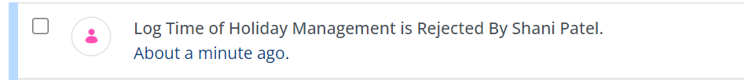
If Manager Approve the logTime then status is change from Pending to Approved ,also approve and reject button is disable .If status is not Pending then that button is disable. 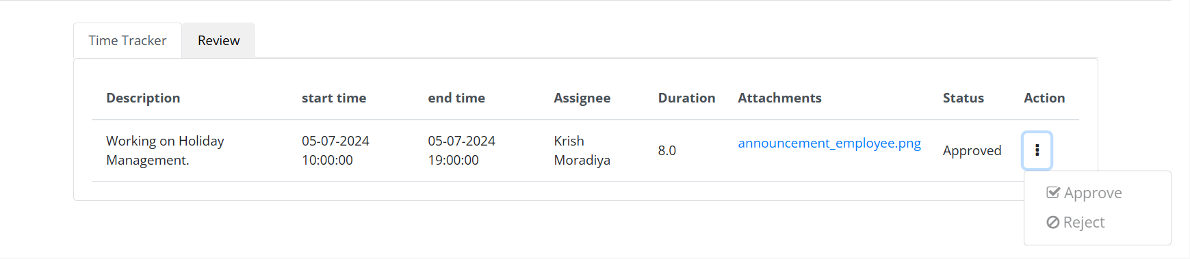after approving log time you will be greeted with the success message as below :

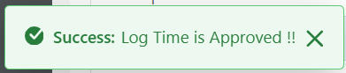
And that task of assignee also receive notification of approved logTime.
Configurations-Notification:- Under 9 Dots > System settings > catagory.HRMS > Notification Template Configurations. > Log Time(Approve)
Placeholder: Refer Excel sheet for the placeholders.

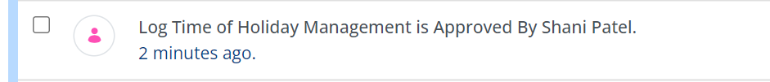

For Employee,
the edit and delete button is available,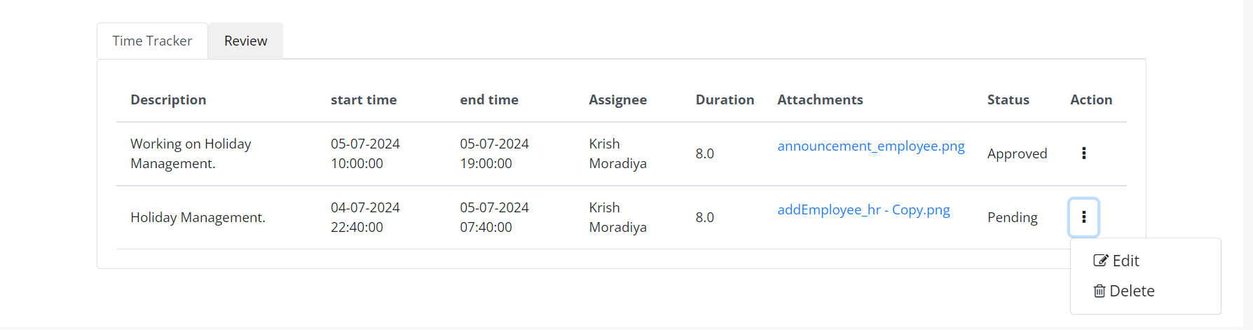
By clicking on the Edit button you will be taken to the editing screen, here Employee can edit the Log Time. There are two buttons available on the screen, one to go back to the listing page and another to edit the Task. The editing screen is shown in image below:

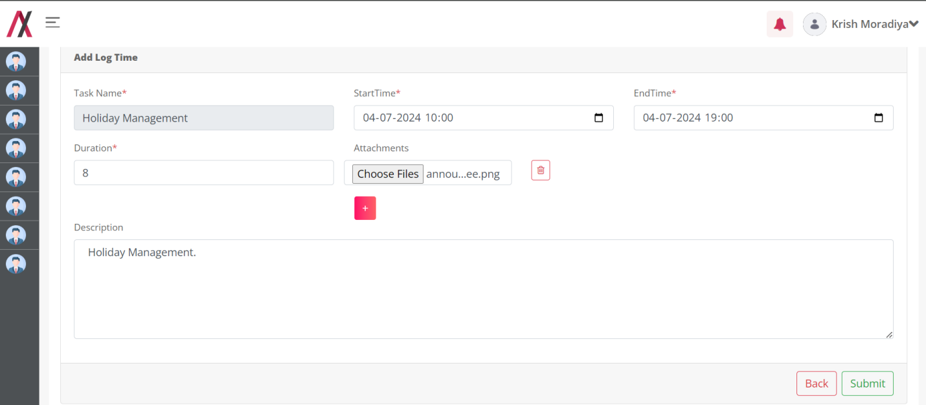

On clicking the submit button we will be greeted with the message.
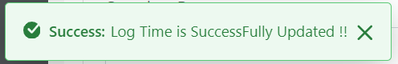

When you click the Delete button:
If you confirm by clicking OK, the Project will be deleted, and you will receive the following success message:
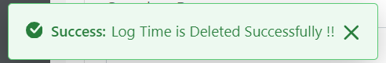
Second Tab in the edit Task page is the Review.
Review:
If Manager or Employee wants to add some comments related to this Task then they can add the review on this page,
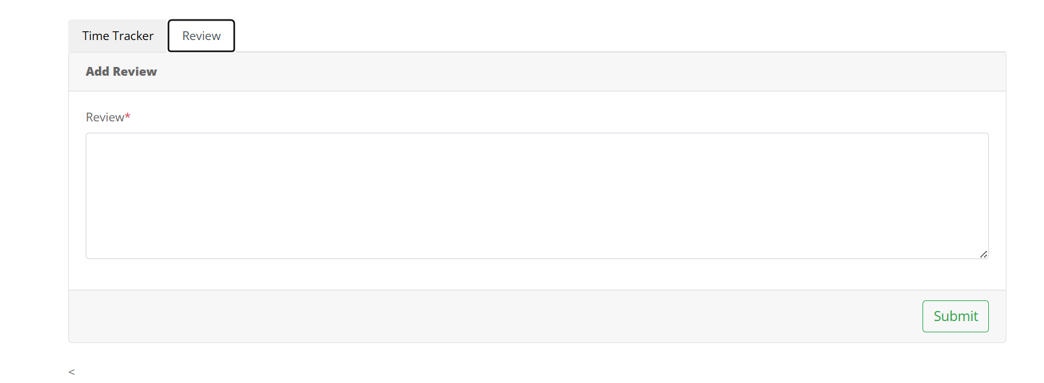Add some review in this form,
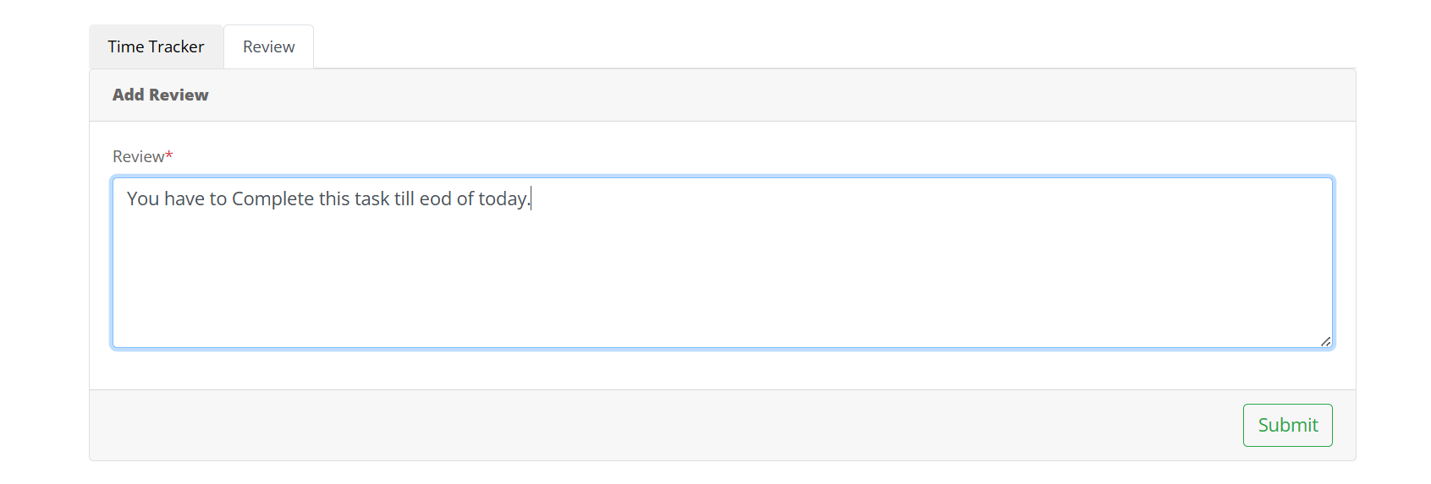
After submit , you will receive success message,
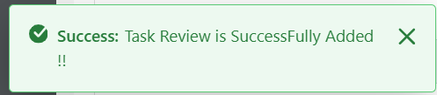
Manager of that Task and Assignee both are receive same notification of adding review.

Configurations-Notification:- Under 9 Dots > System settings > catagory.HRMS > Notification Template Configurations. > Review.
Placeholder: Refer Excel sheet for the placeholders.

After adding the review Manager and Employee can see the review at page of Review:
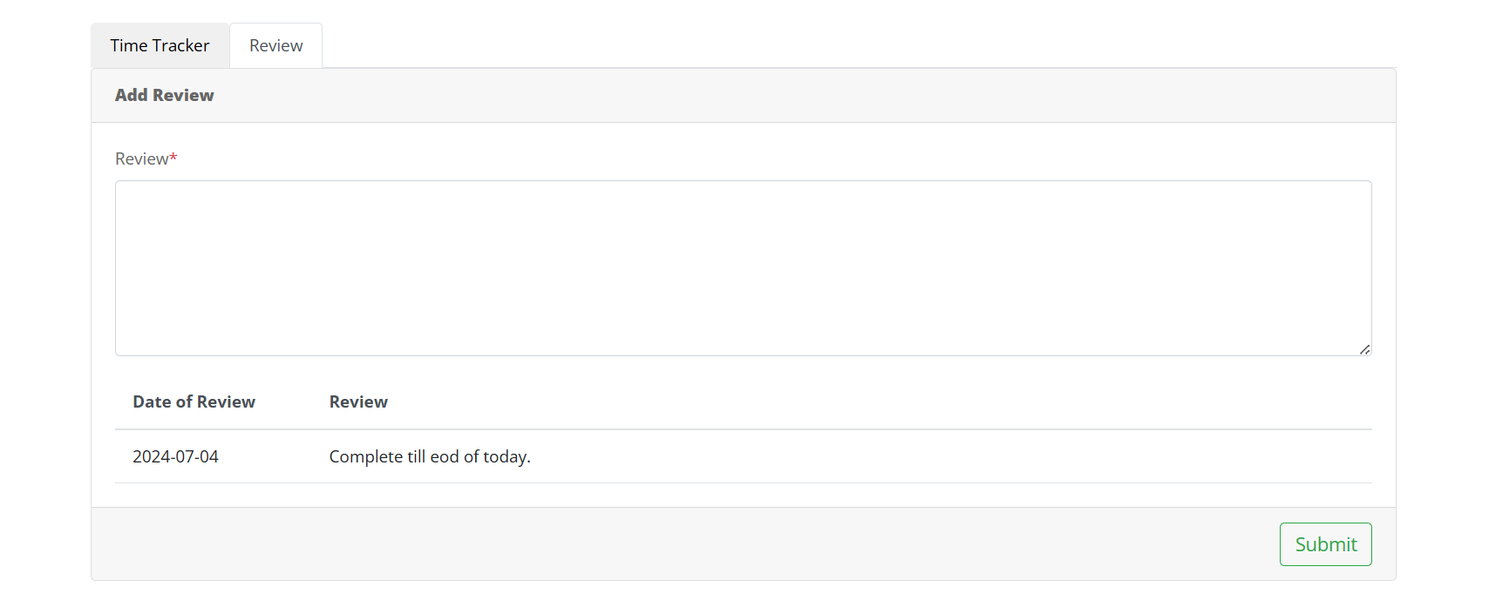
And the view page of that task.

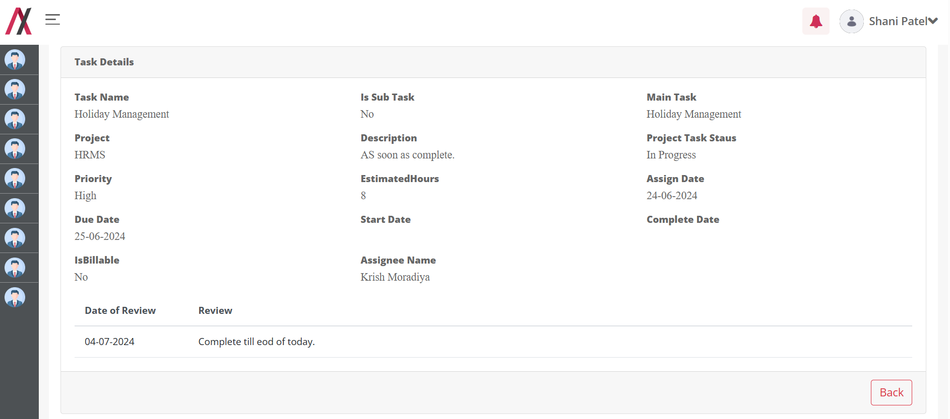

Employee Directory:

Functionality:
Employee directory Module is Show information about all the Employee which is part of organizations.

Page Name & Links:
The page where the portlet is placed is named Employee Directory
Link - http://localhost:8080/group/hrms/employee-directory

Functionality Flows:
The flow starts by navigating to the link mentioned in the above section, that will present you the below screen :
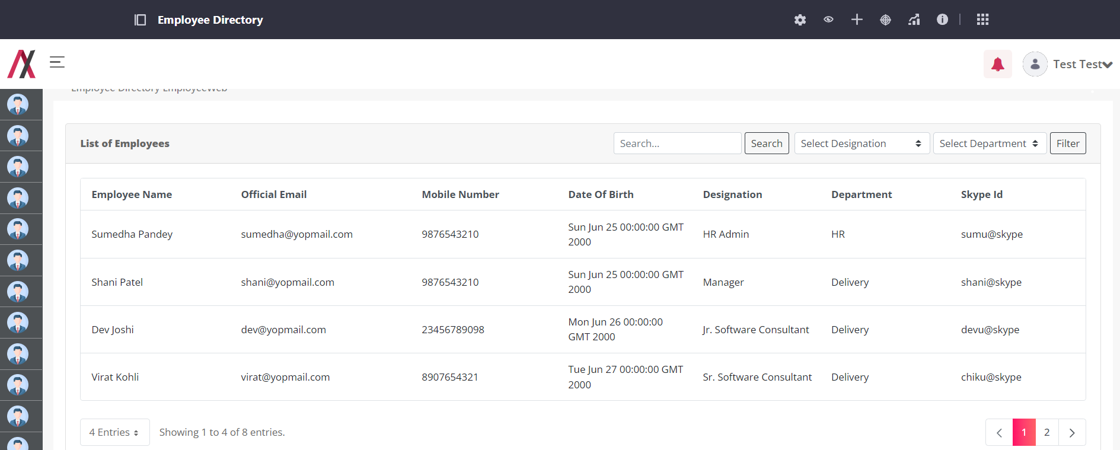

Any employee can find information about another employee using this page. They can search using keywords related to the person's data, and the search will fetch a list of all employees whose data matches the search keyword.
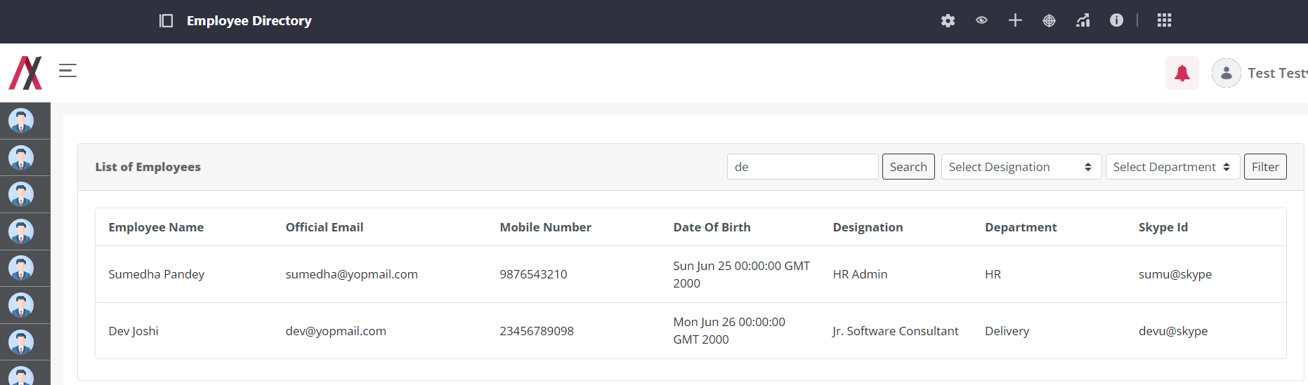

If any employee wants to search for employee data based on department and designation selection, they can do so by selecting the department or designation and clicking on the filter button. The search will fetch data for employees whose department or designation matches the selected criteria.
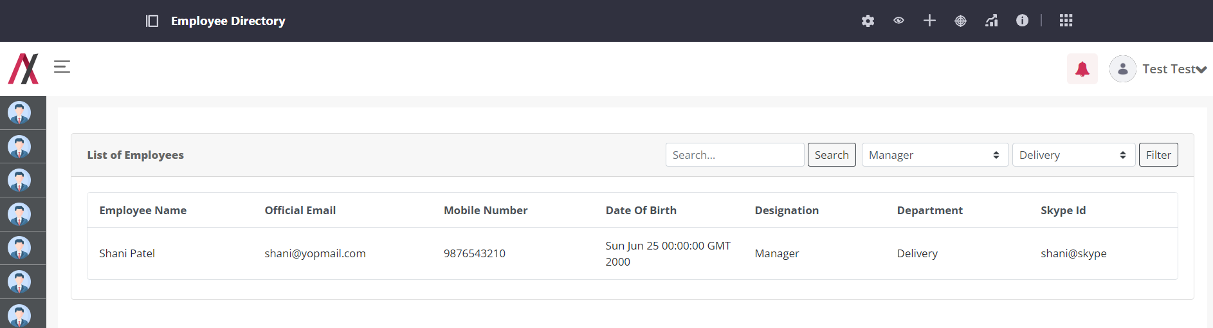

Leave Request:

Functionality:
The Leave Request Module is used by employees to request leave based on their allowable allowances.

Page Name & Links:
The page where the portlet is placed is named Leave Request.
Link - http://localhost:8080/group/hrms/leave-request

Functionality Flows:
The flow starts by navigating to the link mentioned in the above section, that will present you the below screen :
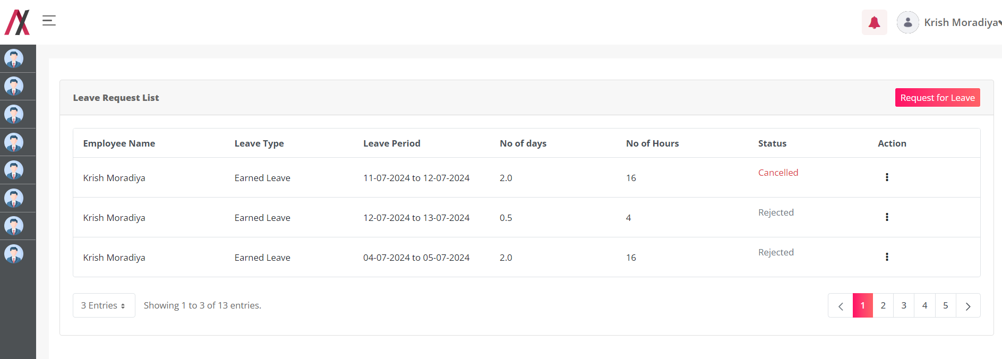
On this page, logged-in users can view a list of all leave requests they have applied for. If an employee is in probation, an intern, or a contractor, they cannot apply for leave. In such cases, the Request for Leave button will be disabled for them.
Clicking the Request for Leave button navigates to another screen for apply Leave.

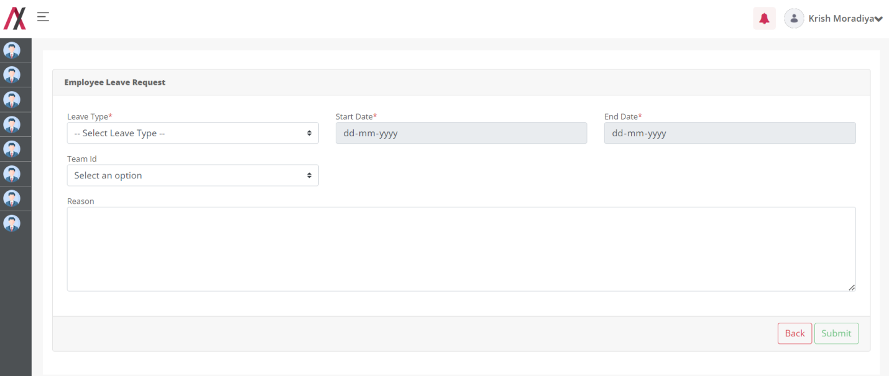
In this form you will find following fields:
1.Leave Type: This will have the dropdown of all the type of Leave available in the master data of Leave Type.
2.Start Date: Employee can select the start date of the Leave.
3.End Date: Employee can select the End Date of the Leave.
4.Team Id: This will have the dropdown of all the Employee which is active in the organization. If Employee wants to inform about their leave to their teammates then they can select by this drop down.
5.Reason: Employee can add reason of taking leave.

Based on the select leave type , start date and end date form show different other field,
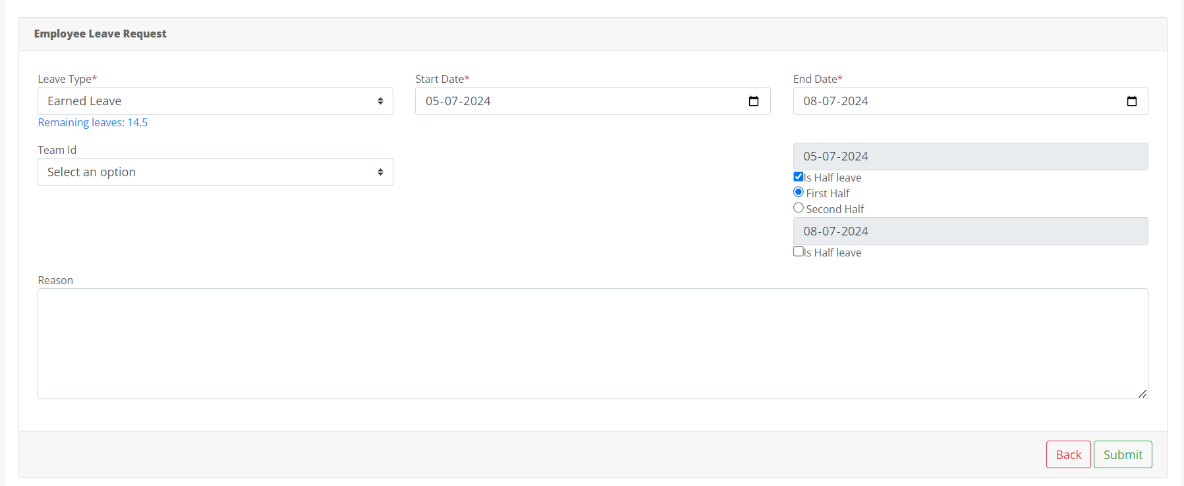
In the above image, if an employee selects Earned Leave as the leave type, the remaining leave of that type is displayed in the form.
After selecting the start date and end date, an additional field appears:
6.Is Half Leave: If the employee wants to take half-day leave, they can check this checkbox.
7.First Half: This is also a checkbox. After selecting Is Half Leave, the employee can indicate whether they want to take leave in the first half or the second half of the day.
If an employee selects Festival Floater as the leave type,
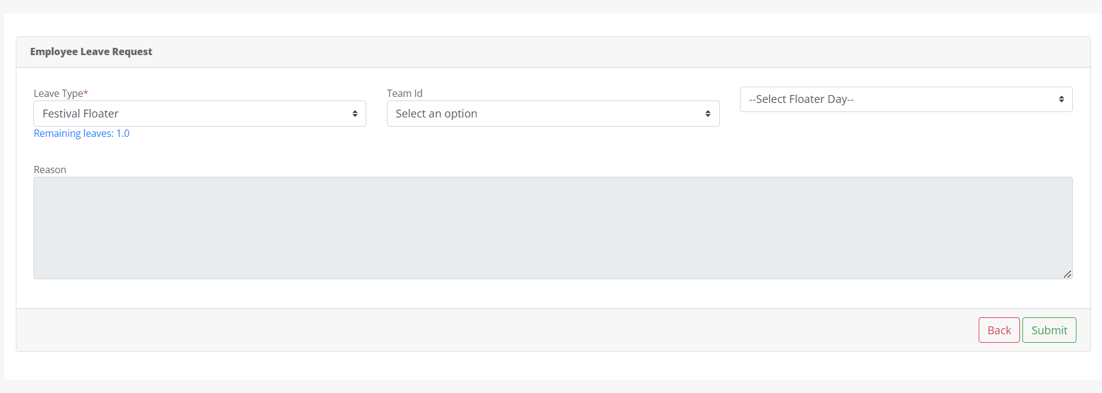
In this type No any start date or End date is needed. This functionality works based on leave type.
In the above page, the Reason field is disabled because no reason is needed for a floater holiday.
There are no Start Date and End Date fields in this form because the holiday has its own designated date.
Additionally, an additional field Select Floater Day appears, allowing the employee to choose the specific floater holiday

8.Select Floater Day: This field includes a dropdown menu listing all floater holidays Holiday list. When HR Admin fills out the holiday details and selects a holiday as a floater, it will appear in this dropdown box.
If employee Select Bereavement Leave,
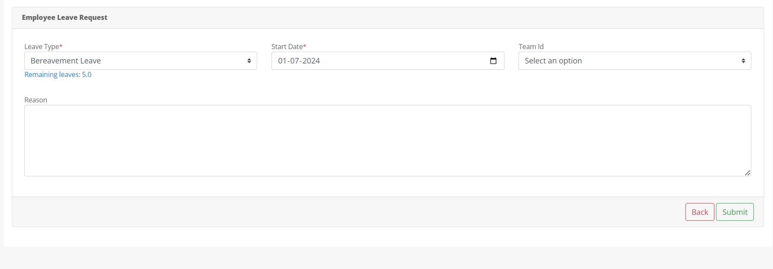
In this type of leave End date is not appear because this leave is continuous,
So based on Leave Type this functionality is working.
Which Leave is Continuous or not that are decided by HR Admin in the Leave Type Master.
If any Leave has not sufficient Balance then it show the warning message and employee can’t apply leave,
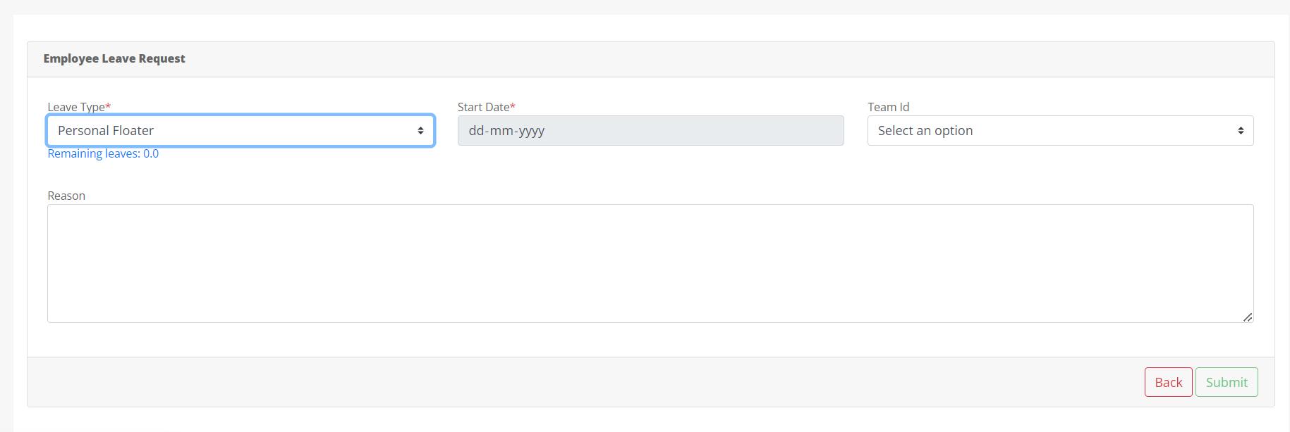
In above , Employee select the Personal Floater as leave type but remaining balance is 0 so they can’t apply for leave and submit button also disabled.
And get Warning Message ,
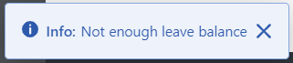
But if they have Leave Balance then they can apply for leave. After filling form , by clicking Submit button they can apply for leave.
They will get success message,
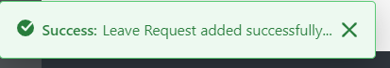
After Submitting form they navigate to the list page of leave ,
By clicking 3- dot icon in Action Column they see only button based on leave status,if status is Pending then it show Cancel and View Button but if status is not Pending then it show only View Button.
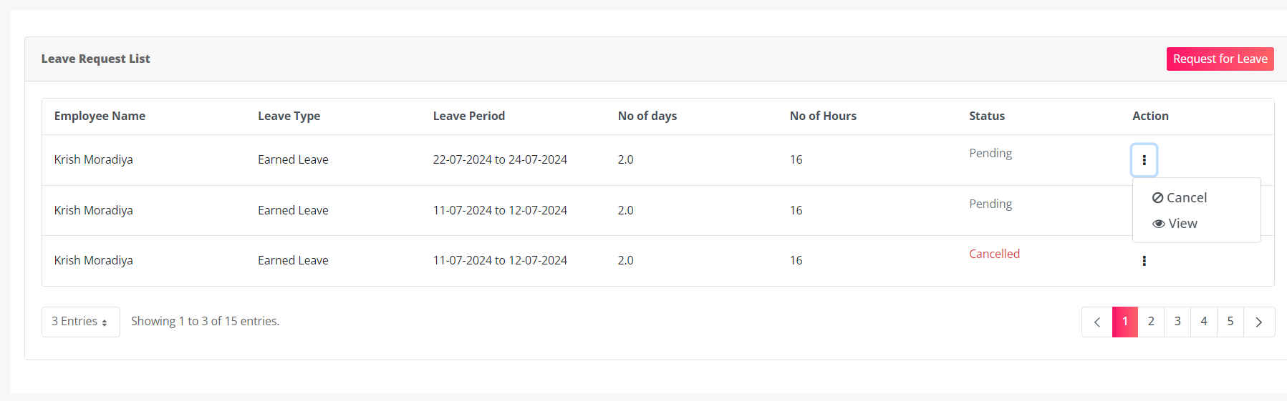
By Clicking Cancel button leave cancelled and status is change from Pending to Cancelled.
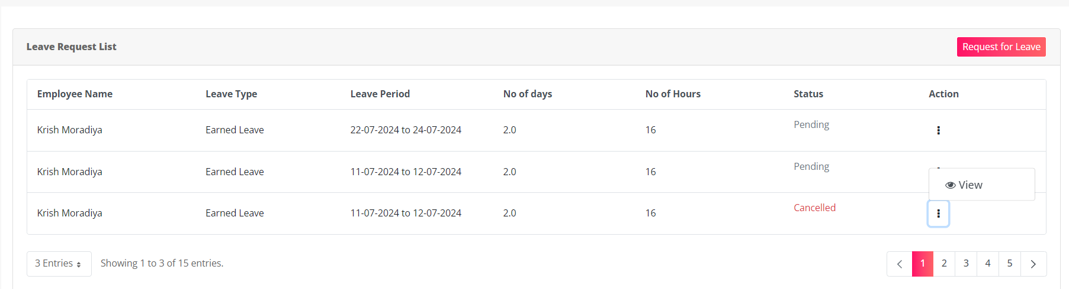 In Above Image you can see that, if status is cancelled then it show only View button option.
By Clicking View button they redirect to the view page of Leave,
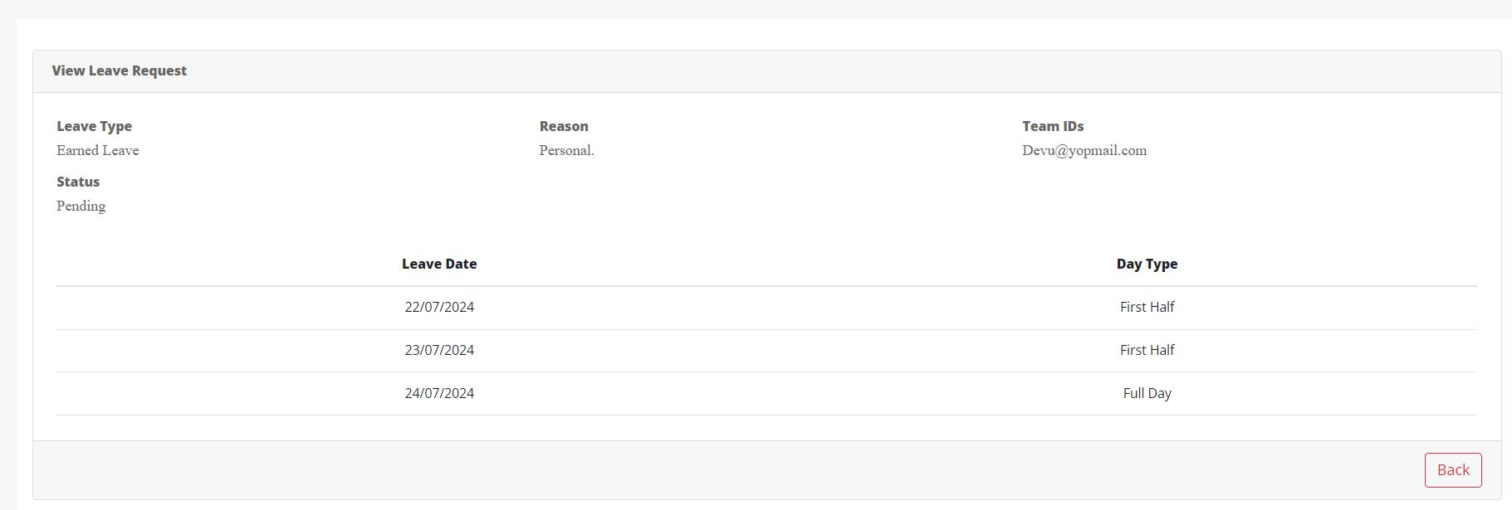

Leave Management:

Functionality:
The Leave Management Module facilitates HR in granting leave to employees.

Page Name & Links:
The page where the portlet is placed is named Leave Management.
Link - http://localhost:8080/group/hrms/leave-management

Functionality Flows:
The flow starts by navigating to the link mentioned in the above section, that will present you the below screen :
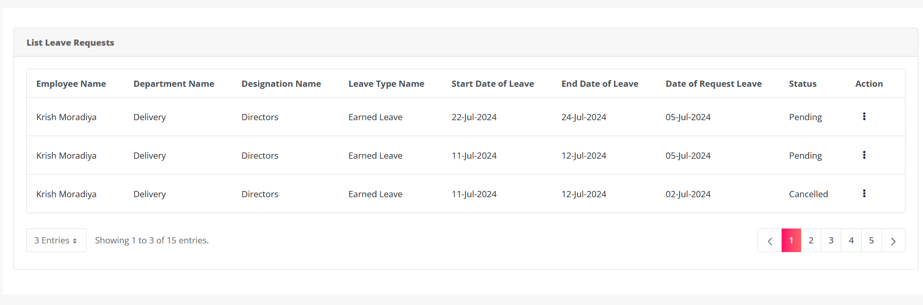
On this page, HR can view a list of all leave requests of all employee.
Clicking the 3-dot icon button in action column it show Approve, Reject, Cancel and View Button.

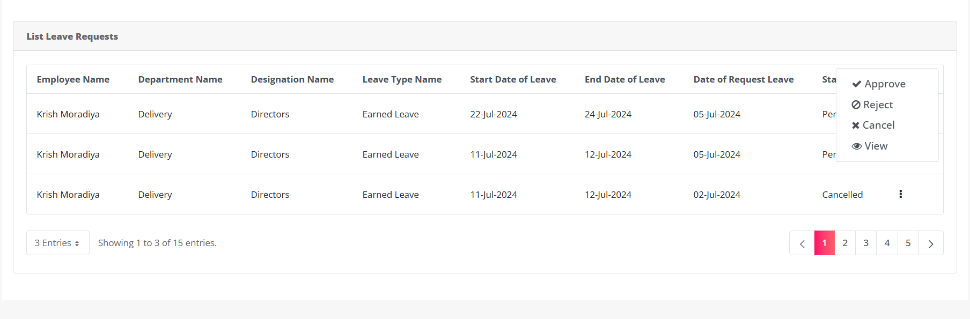
By clicking Approve button HR is approved the leave.
Get success message,
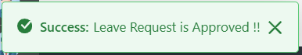
And employees receive a notification and email upon approval of their leave,
Configurations-Notification:- Under 9 Dots > System settings > catagory.HRMS > Notification Template Configurations. > Leave Approved Notification to Employee (Employee)
Placeholder: Refer Excel sheet for the placeholders.

Configurations-Mail:- Under 9 Dots > System settings > catagory.HRMS > Mail Template Configurations. > Leave Approve Mail to Employee
Placeholder: Refer Excel sheet for the placeholders.

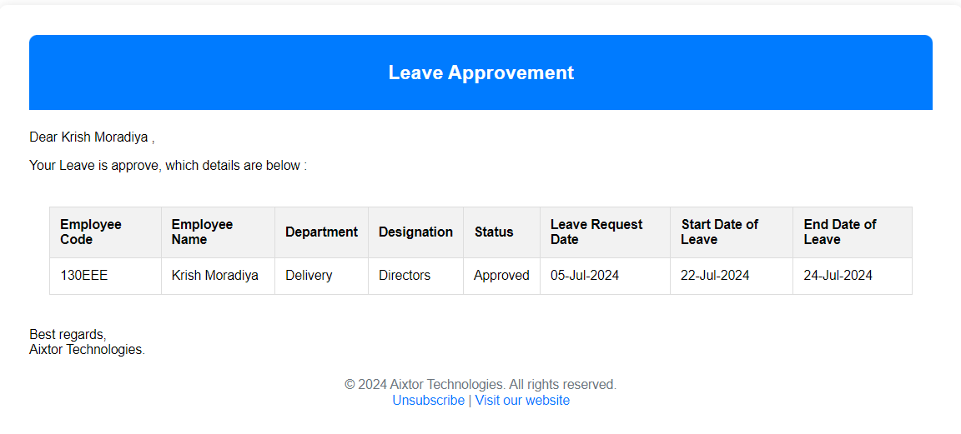
Additionally, team members of the employee selected in the leave request also receive an email informing them that the leave request has been approved.
Configurations-Mail:- Under 9 Dots > System settings > catagory.HRMS > Mail Template Configurations. > Leave Approved Notification to Employee
Placeholder: Refer Excel sheet for the placeholders.

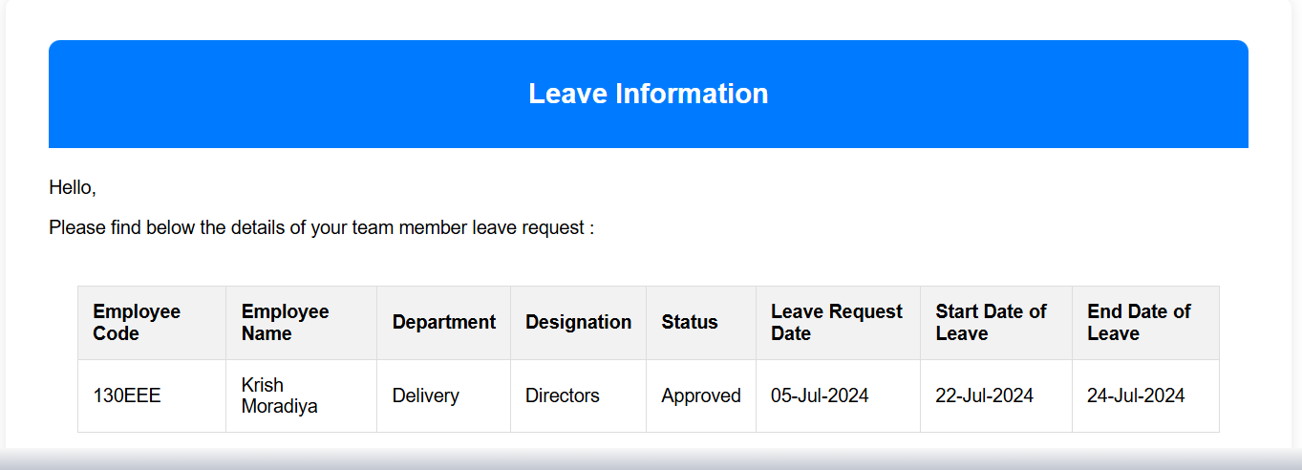

If HR Reject the leave then status is change from Pending to Rejected .
Get success message,
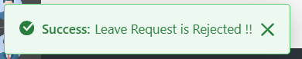
Employee receive the notification and email of rejection of leave request.
Configurations-Notification:- Under 9 Dots > System settings > catagory.HRMS > Notification Template Configurations. > Leave Rejected Notification to Employee
Placeholder: Refer Excel sheet for the placeholders.

Configurations-Mail:- Under 9 Dots > System settings > catagory.HRMS > Mail Template Configurations. > Leave Reject Mail to Employee
Placeholder: Refer Excel sheet for the placeholders.

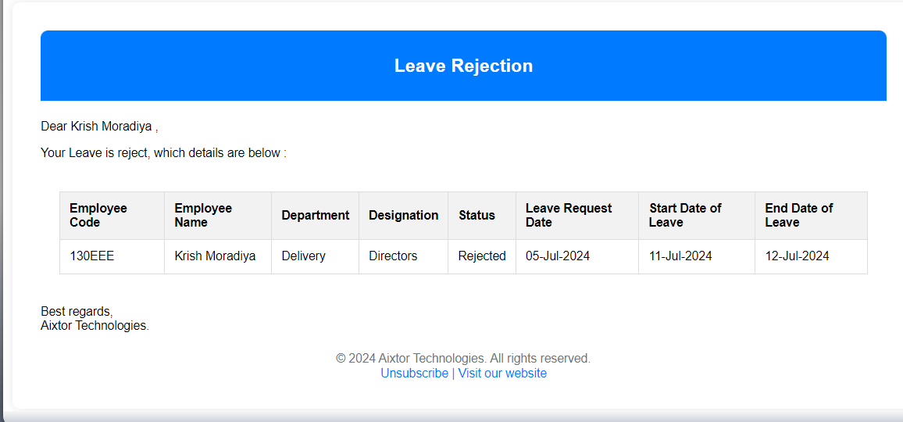
If HR Cancelled the leave request then status is change from Pending to Cancelled .
Get success message,
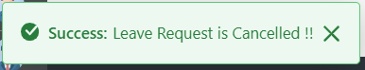
Employee receive notification and email of Cancellation of leave,
Configurations-Notification:- Under 9 Dots > System settings > catagory.HRMS > Notification Template Configurations. > Leave Cancelled Notification to Employee
Placeholder: Refer Excel sheet for the placeholders.

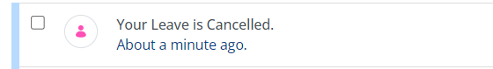
Configurations-Mail:- Under 9 Dots > System settings > catagory.HRMS > Mail Template Configurations. > Leave Cancel Mail to Employee
Placeholder: Refer Excel sheet for the placeholders.

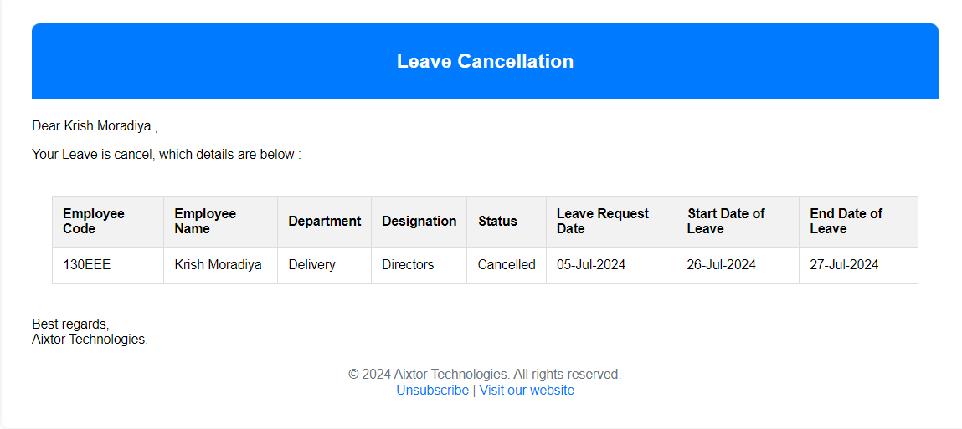
After Approving or Rejecting the leave request HR can also Cancel the leave of that Employee.
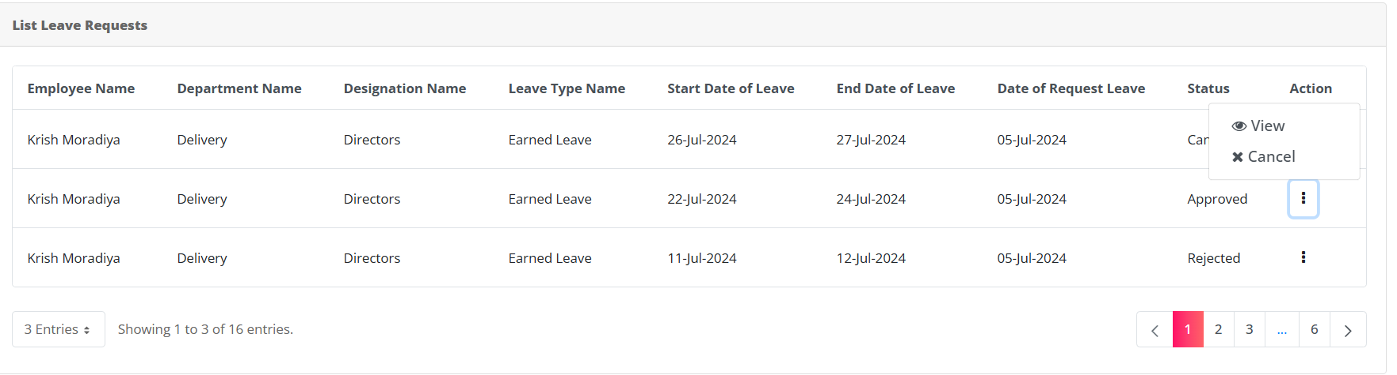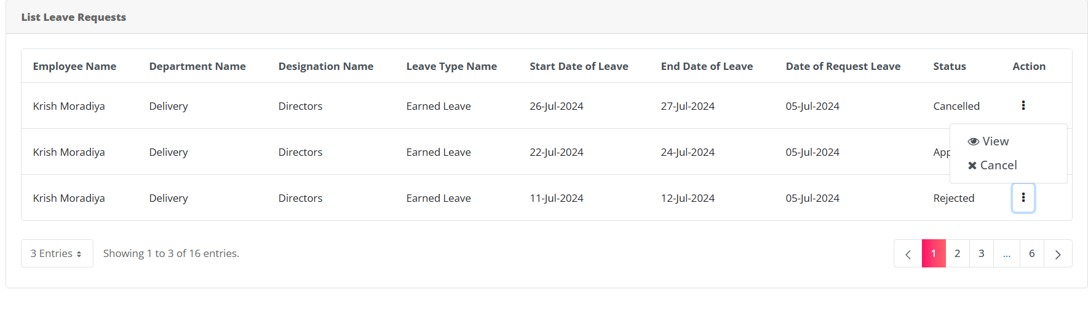
After Cancelling the leave HR can’t approve or reject that.

By clicking the View Button HR see the details of the leave request of that employee,
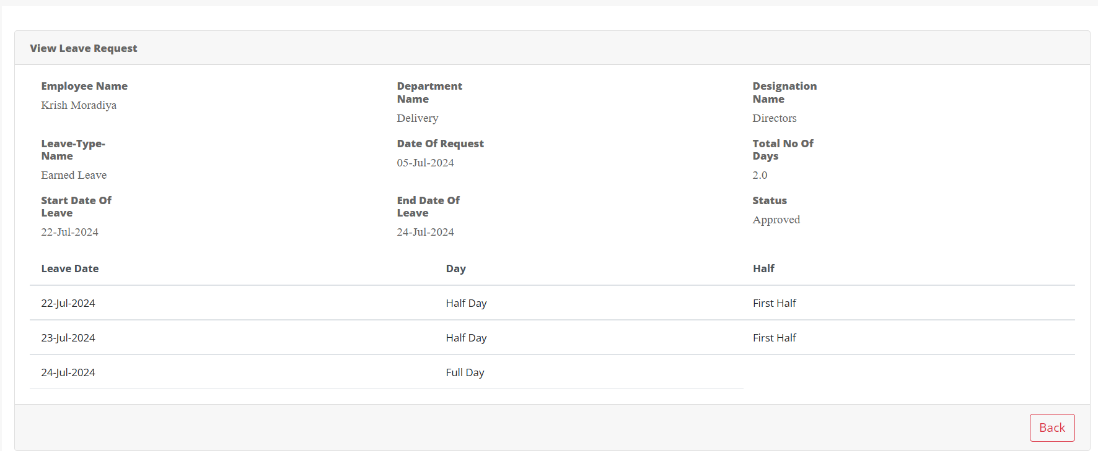

Policy Process Management:

Functionality:
Policy Process Management allows HR Admin to add organizational policies. Access to this page is restricted to HR Admin.

Page Name & Links:
The page where the portlet is placed is named Policy Process Management.
Link - http://localhost:8080/group/hrms/policy-process-management

Functionality Flows:
The flow starts by navigating to the link mentioned in the above section, that will present you the below screen :
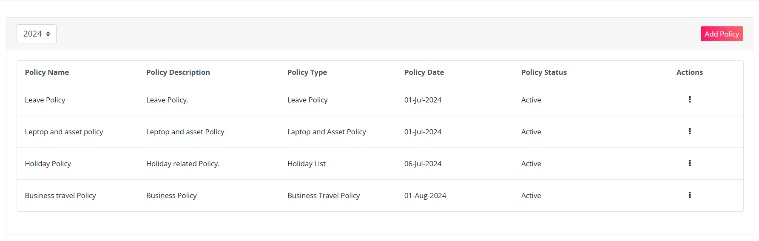
This screen displays a list of all available policies, accompanied by an Add Policy button. Clicking this button leads to another screen where HR can add policies for the current year, the previous two years, and the upcoming year.
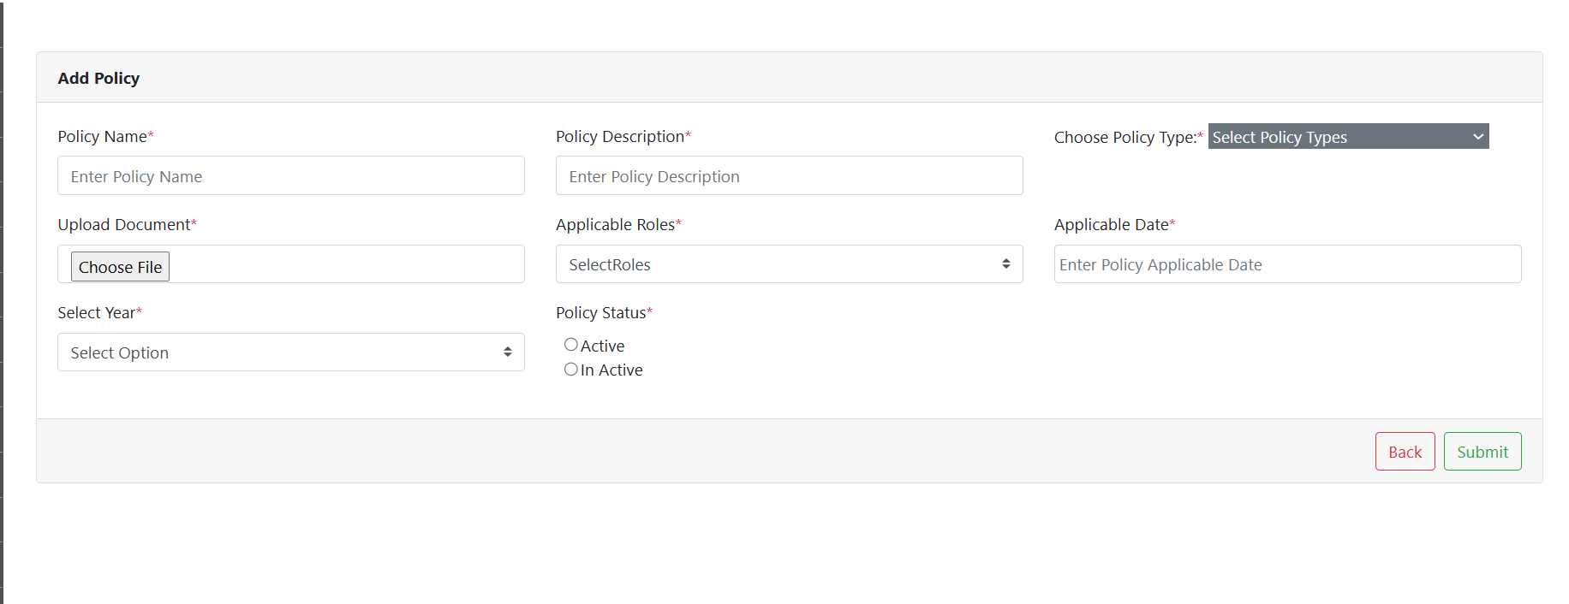
In this form you will find following fields:
1.Policy Name: Here you can add the name of the Policy.
2.Policy Description: You can add a short description for each policy you are adding.
3.Choose Policy Type: This include dropdown of Policy type which available data in Policy Type Master.
4.Upload Document : HR Can Upload the document of the policy.
5.Applicable Roles: This includes a dropdown menu listing all roles available within the organization. HR can select the roles to which they want to apply this policy.
6.Select Year: This includes a dropdown menu listing the years for which HR can add policies.
7.Applicable dates: Select the date to apply this policy in the organization.
8.Policy status: This is a radio button. Select Active if HR wants to activate this policy; otherwise, select Inactive.

Here you can add policy that you want to add into your system. There are two buttons available on the screen, one to go back to the listing page and another to submit the Policy.
If you add a Policy that already exist in the system you will be encountered with the error as below:
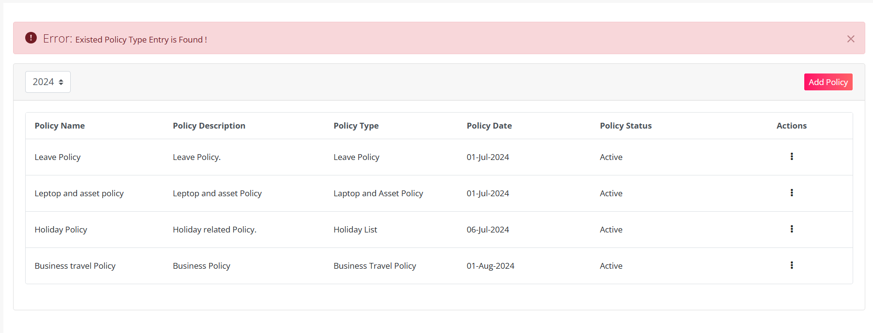
But, if you add the correct Policy you will be greeted with the success message as below:
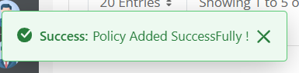
And after adding the Policy we are redirected back to the list page.
In the top left corner, there is a dropdown menu for selecting the year. HR can use this dropdown to view the list of policies for different years.
On clicking the 3-dot available in the action column you will be allowed to navigate to edit and delete functions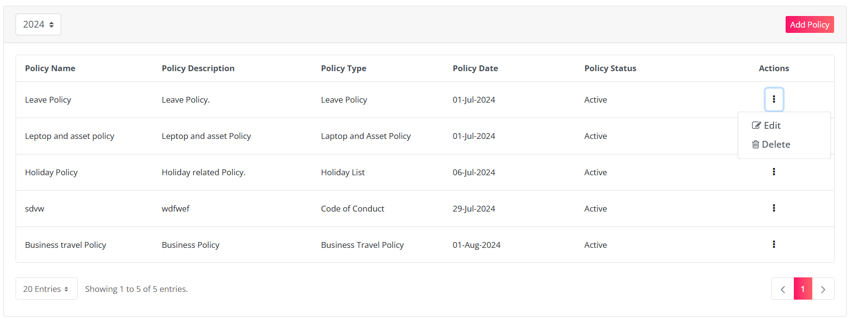
By clicking on the Edit button you will be taken to the editing screen, here you can edit the Policy. There are two buttons available on the screen, one to go back to the listing page and another to Submit. The editing screen is shown in image below:
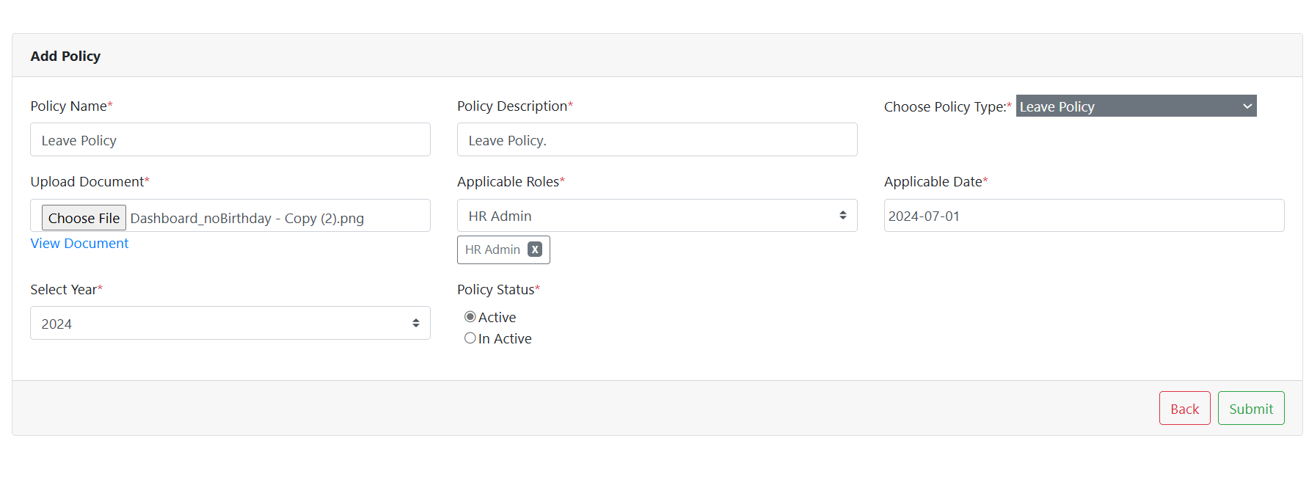
On clicking the submit button we will be greeted with the message.
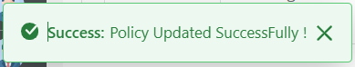

When you click the Delete button:
If you confirm by clicking OK, the Leave Type will be deleted, and you will receive the following success message:
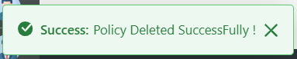

Policy Process:

Functionality:
The Policy Process module is used to display all organizational policies to employees, as added by HR Admin.

Page Name & Links:
The page where the portlet is placed is named Policy Process .
Link - http://localhost:8080/group/hrms/policy-process

Functionality Flows:
The flow starts by navigating to the link mentioned in the above section, that will present you the below screen :
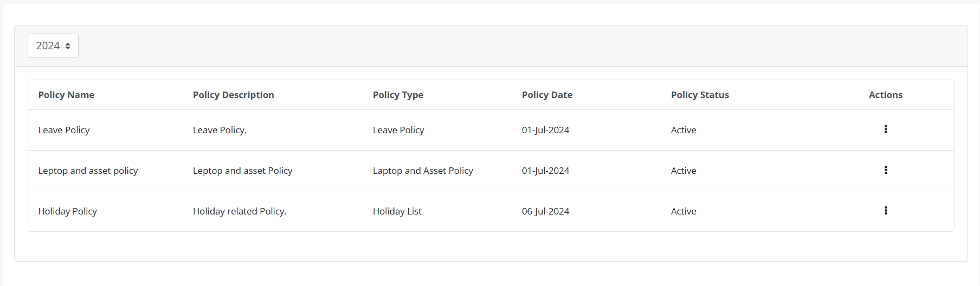
On this Page HR can see the different year policies.
In the top left corner, there is a dropdown menu for selecting the year. HR can use this dropdown to view the list of policies for different years.
For Employee,
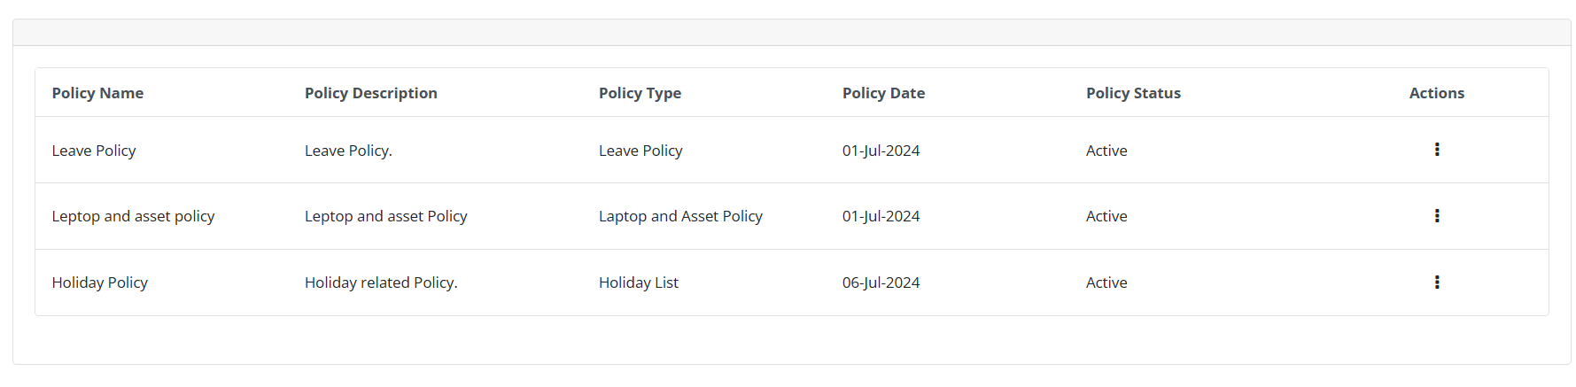
Employee can see only current year Policy.
On clicking the 3-dot available in the action column Employee will be allowed to navigate to download functions
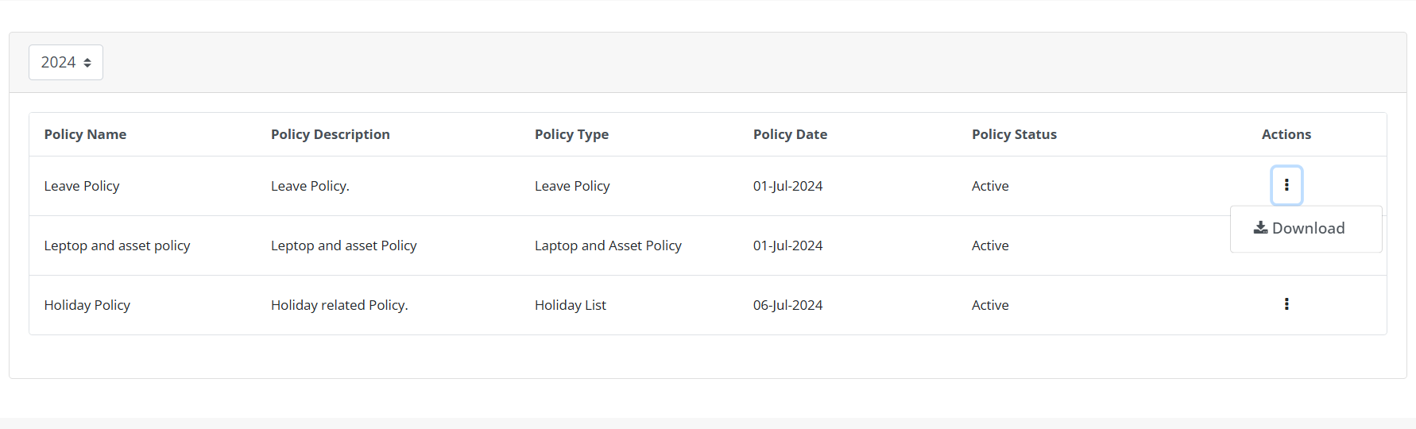
By clicking the download button employee can download that Policy in their Local device.

Leave Balance History:

Functionality:
The Leave Balance History is used to display the leave balances of a employee to HR Admin based on the selected year and Employee.

Page Name & Links:
The page where the portlet is placed is named Leave Balance History.
Link - http://localhost:8080/group/hrms/leave-balance-history

Functionality Flows:
The flow starts by navigating to the link mentioned in the above section, that will present you the below screen :
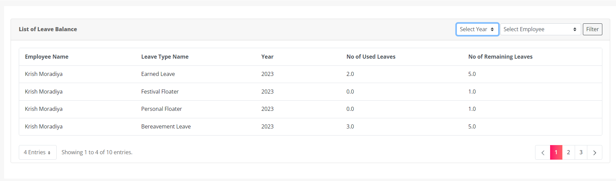
HR can see the Leave Balance Data of Past year of the Employee.
In the top right corner, there are two dropdown menus: one for selecting the year and the other for selecting the employee. After selecting the year and employee, the list will be fetched based on the selection.
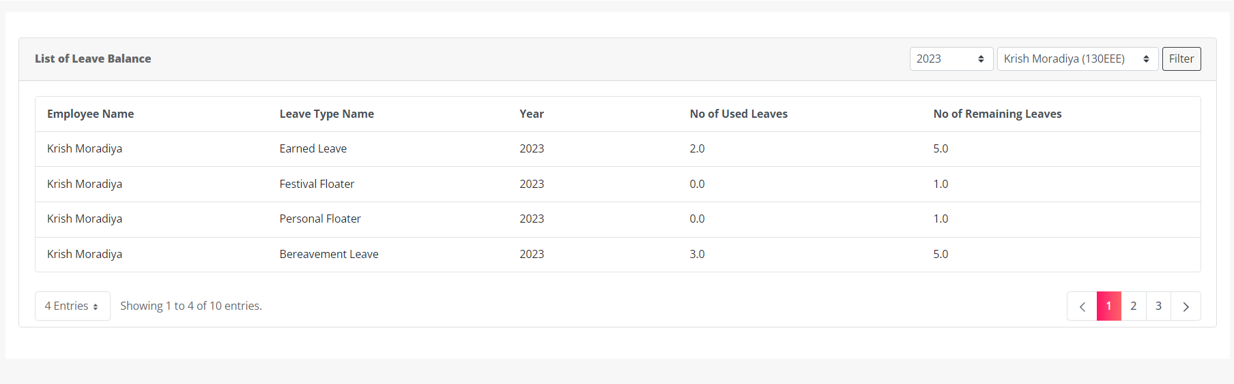

Holiday:

Functionality:
The Holiday module is used to display the holidays to employees.

Page Name & Links:
The page where the portlet is placed is named Holiday.
Link - http://localhost:8080/group/hrms/holiday

Functionality Flows:
The flow starts by navigating to the link mentioned in the above section, that will present you the below screen :
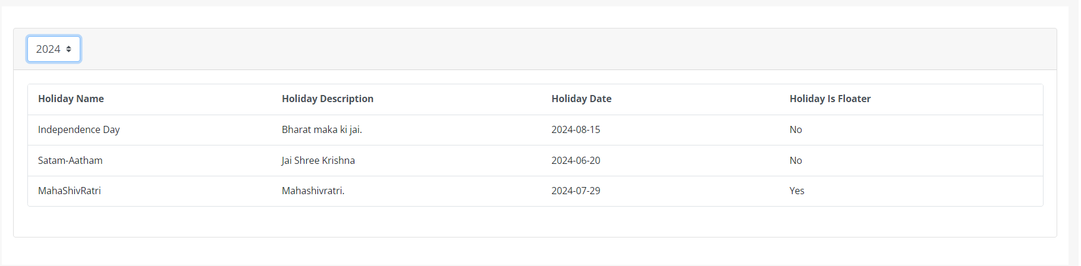In the top left corner, there are one dropdown menu for selecting the year. After selecting the year, the holiday will be show based on the year.

Leave Report:

Functionality:
It is used for logged-in users to view their leave data for the current year.

Page Name & Links:
The page where the portlet is placed is named Dashboard.
Link - http://localhost:8080/group/hrms/dashboard

Functionality Flows:
The flow starts by navigating to the link mentioned in the above section, that will present you the below screen :
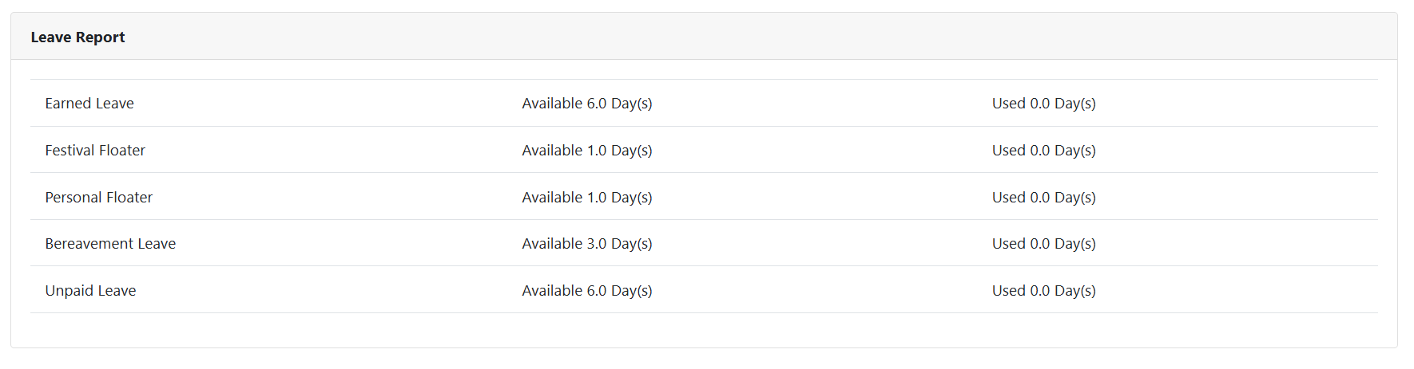

Upcoming Holidays:

Functionality:
It is used for to view upcoming holiday of current year..

Page Name & Links:
The page where the portlet is placed is named Dashboard.
Link - http://localhost:8080/group/hrms/dashboard

Functionality Flows:
The flow starts by navigating to the link mentioned in the above section, that will present you the below screen :
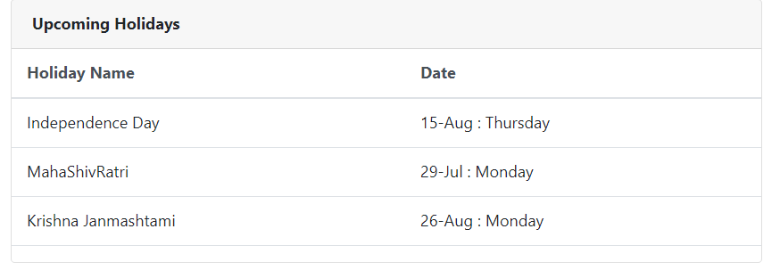

New Joiner:

Functionality:
It is used to display new joiners of the organization. This data is fetched by the Daily Scheduler

Page Name & Links:
The page where the portlet is placed is named Dashboard.
Link - http://localhost:8080/group/hrms/dashboard

Functionality Flows:
The flow starts by navigating to the link mentioned in the above section, that will present you the below screen :
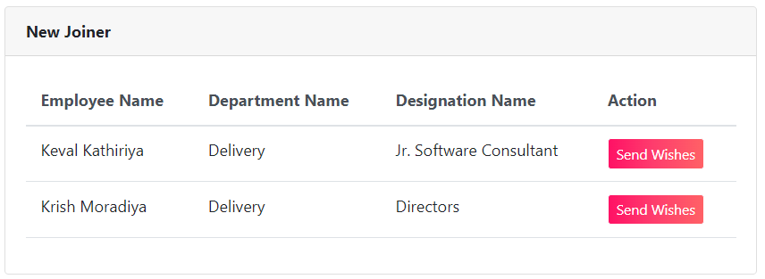
There is an action button labeled Send Wishes. When any logged-in user clicks on this button, a popup box opens allowing them to send wishes to the new employee.
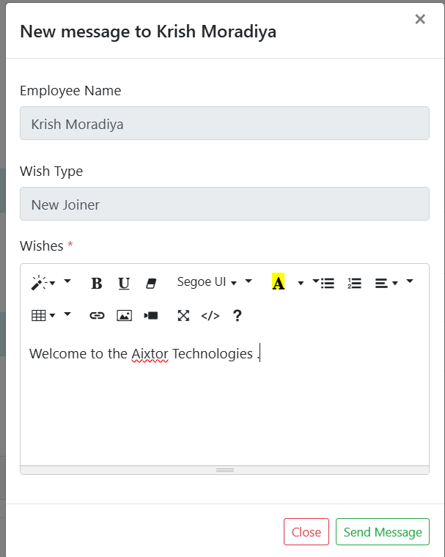
After filling the wishes click on the send message.
Also get the success message,
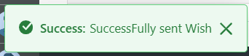
This wishes is sending via mail to the new employee.
Configurations-Mail:- Under 9 Dots > System settings > catagory.HRMS > Mail Template Configurations. > New Joinee Wish
Placeholder: Refer Excel sheet for the placeholders.

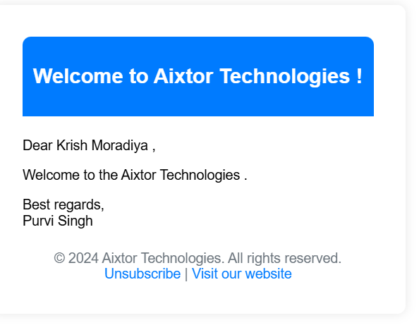

Anniversary:

Functionality:
It is used to display work anniversaries of employees in the organization daily

Page Name & Links:
The page where the portlet is placed is named Dashboard.
Link - http://localhost:8080/group/hrms/dashboard

Functionality Flows:
The flow starts by navigating to the link mentioned in the above section, that will present you the below screen :
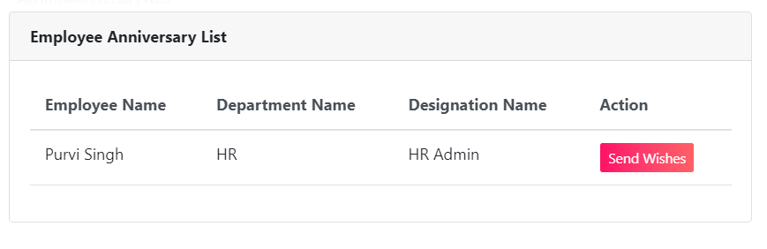
There is an action button labeled Send Wishes. When any logged-in user clicks on this button, a popup box opens allowing them to send wishes to the new employee.
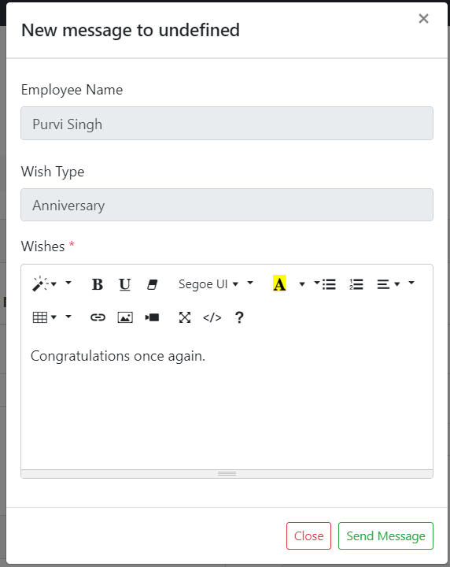
After filling the wishes click on the send message.
Also get the success message,

This wishes is sending via mail to the new employee.
Configurations-Mail:- Under 9 Dots > System settings > catagory.HRMS > Mail Template Configurations. > Anniversary Wish
Placeholder: Refer Excel sheet for the placeholders.



Birthday:

Functionality:
It is used to display birthday employees in the organization daily.

Page Name & Links:
The page where the portlet is placed is named Dashboard.
Link - http://localhost:8080/group/hrms/dashboard

Functionality Flows:
The flow starts by navigating to the link mentioned in the above section, that will present you the below screen :
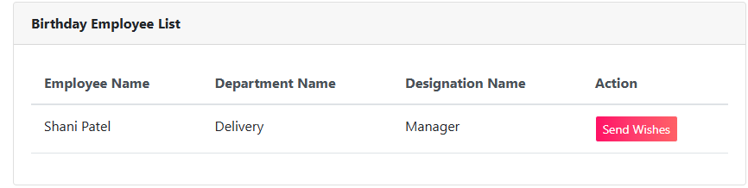
There is an action button labeled Send Wishes. When any logged-in user clicks on this button, a popup box opens allowing them to send wishes to the new employee.
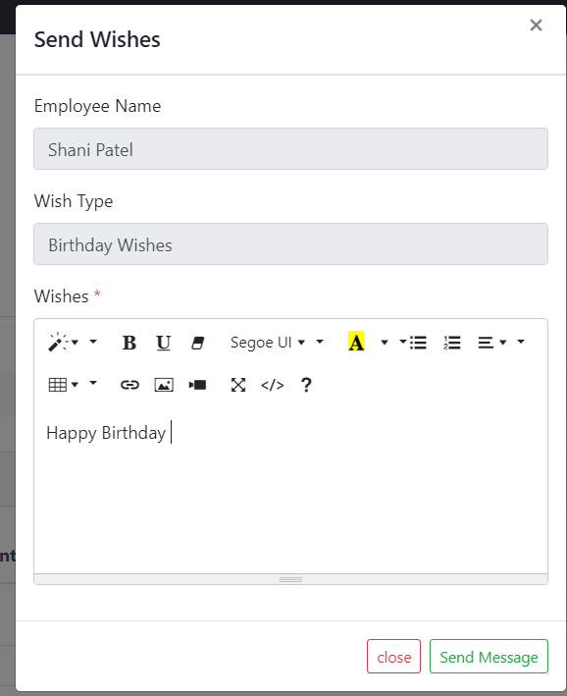
After filling the wishes click on the send message.
Also get the success message,
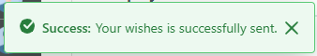
This wishes is sending via mail to the new employee.
Configurations-Mail:- Under 9 Dots > System settings > catagory.HRMS > Mail Template Configurations. > Birthday Wish
Placeholder: Refer Excel sheet for the placeholders.

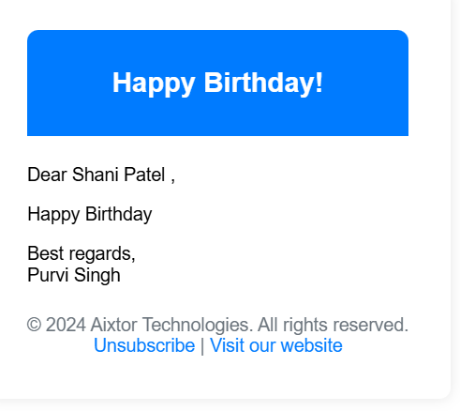

Holiday Management:

Functionality:
Holiday Management allows HR Admin to add holiday. Access to this page is restricted to HR Admin.

Page Name & Links:
The page where the portlet is placed is named Holiday Management.
Link - http://localhost:8080/group/hrms/holiday-management

Functionality Flows:
The flow starts by navigating to the link mentioned in the above section, that will present you the below screen :
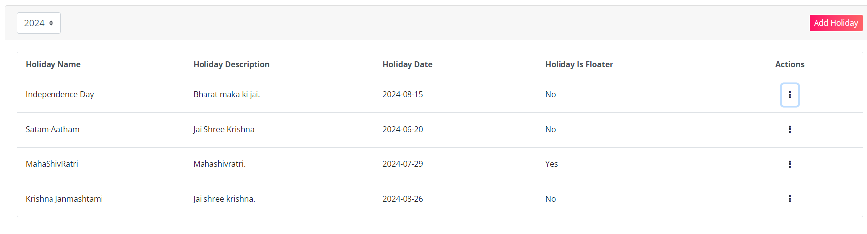
This screen displays a list of all available holiday, accompanied by an Add Holiday button. Clicking this button leads to another screen where HR can add holiday for the current year, the previous two years, and the upcoming year.
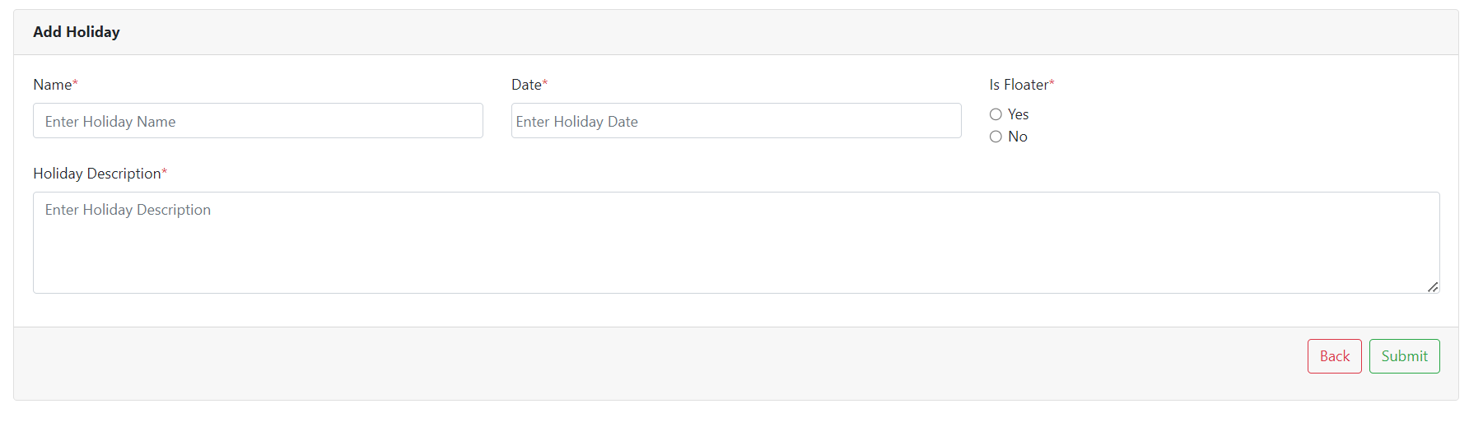
In this form you will find following fields:
1.Name: Here you can add the name of the Holiday.
2.Holiday Description: You can add a short description for each Holiday you are adding.
3.Date: Select the date of this Holiday.
4.Is Floater: This is a radio button. Select 'Yes' if HR wants to designate this holiday as a floater; otherwise, select No.

Here you can add Holiday that you want to add into your system. There are two buttons available on the screen, one to go back to the listing page and another to submit the Holiday.
If you add a Holiday that already exist in the system you will be encountered with the error as below:
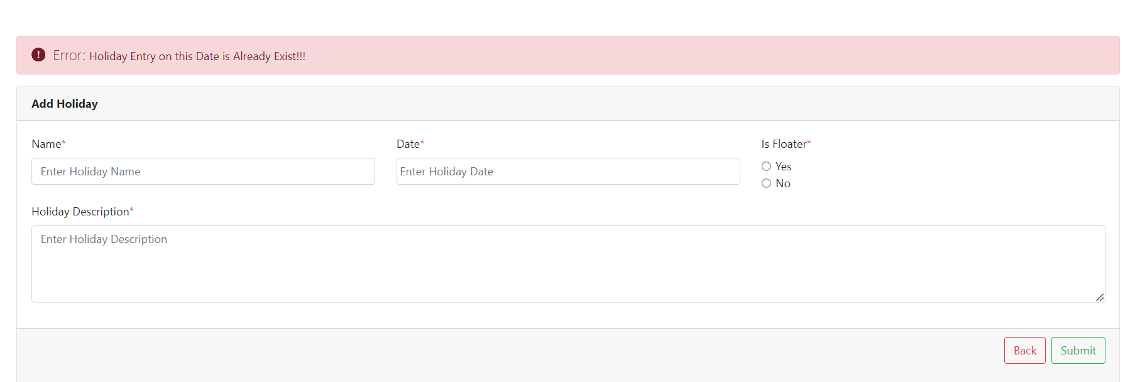
But, if you add the correct Holiday you will be greeted with the success message as below:
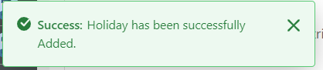
And after adding the Holiday we are redirected back to the list page.
In the top left corner, there is a dropdown menu for selecting the year. HR can use this dropdown to view the list of holiday for different years.
On clicking the 3-dot available in the action column you will be allowed to navigate to edit and delete functions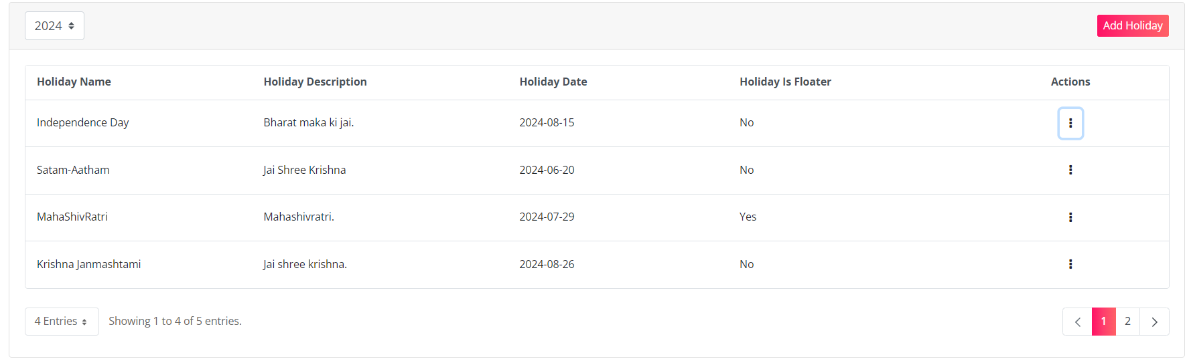
By clicking on the Edit button you will be taken to the editing screen, here you can edit the Holiday. There are two buttons available on the screen, one to go back to the listing page and another to Submit. The editing screen is shown in image below:
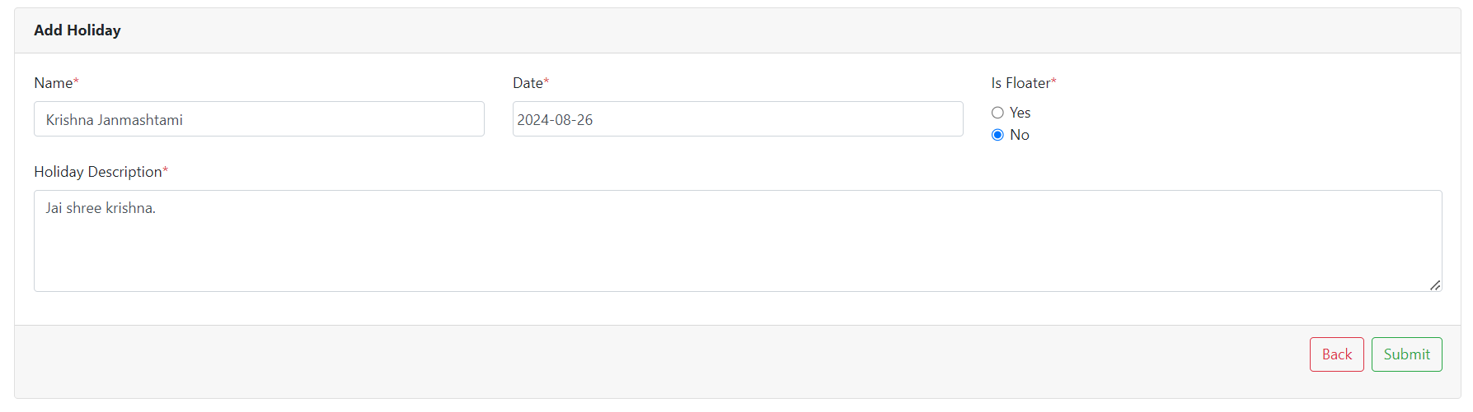
On clicking the submit button we will be greeted with the message.
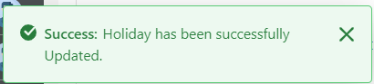

When you click the Delete button:
If you confirm by clicking OK, the Leave Type will be deleted, and you will receive the following success message:
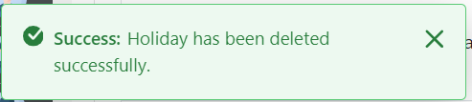

Appraisal Process Management:

Functionality:
Appraisal Process management is the module for appraisal process of the company’s employee. The appraisal process has multiple steps involved into the process, that includes the SELF, Peer, Manager evaluation and then the managerial meeting with the employee and then CTC and designation updating.

Page Name & Links:
The page where the HR portlet is placed is named “Appraisal Process Management”
Link - http://localhost:8080/group/hrms/appraisal-process-hr

Functionality Flow (HR):
The flow starts by navigating to the page / link given above, as you open the page you will see the page having a list of the appraisals for multiple employees.
Navigation to the page is also possible by the portlet on the dashboard named Appraisal Process reminder and a button on right corner will lead you to the process page:
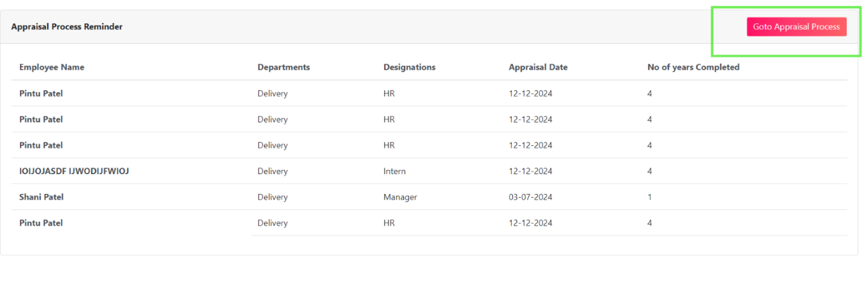
The appraisals you see on the list are added by the Monthly Scheduler, depending upon the date of last appraisal.
Also, if you want to manually add the employee for the appraisal process, it is possible.
Here is the image of appraisal process management list view:
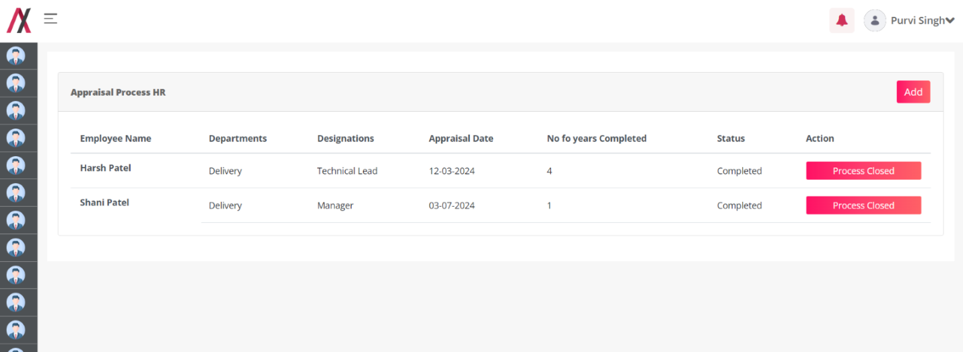
Using the “ADD” button on the top right side you can manually add the employee for appraisal, as you click on the add button you will see a pop up to select the employee to manually add them to appraisal process.
This is how you can add them:
Click Add Button:
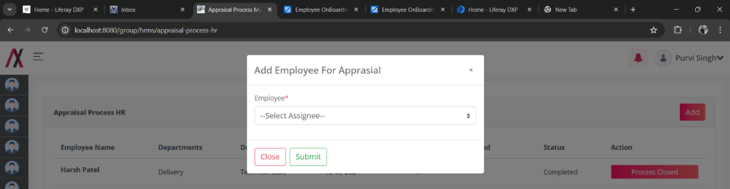
Now select the employee using the dropdown menu:
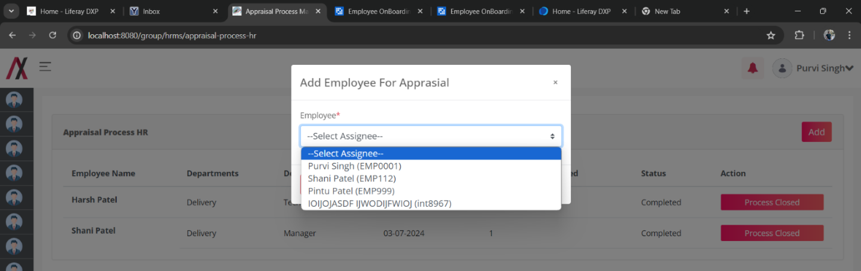
And then press the “Submit” button, you will see this messge:
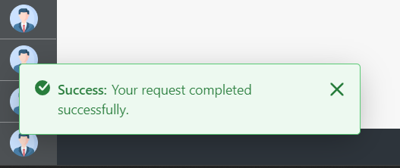
And the employee will be added to the appraisal process, and visible on the list as below:
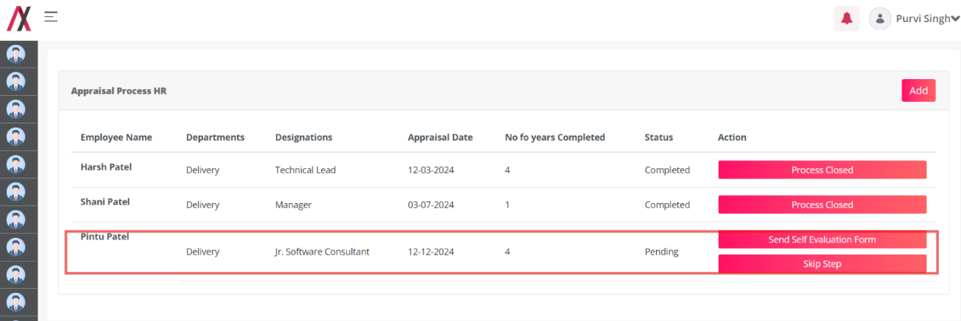
As you add the employee its appraisal process starts instantly. As discussed, there are 3 steps of evaluation forms, then a meeting and then final update of the CTC and designation.
Here you have the option to send the evaluation form or skip the step. We’ll walk forward by clicking the send self-evaluation form and the popup will open which will allow the HR Admin to select the date of submission.
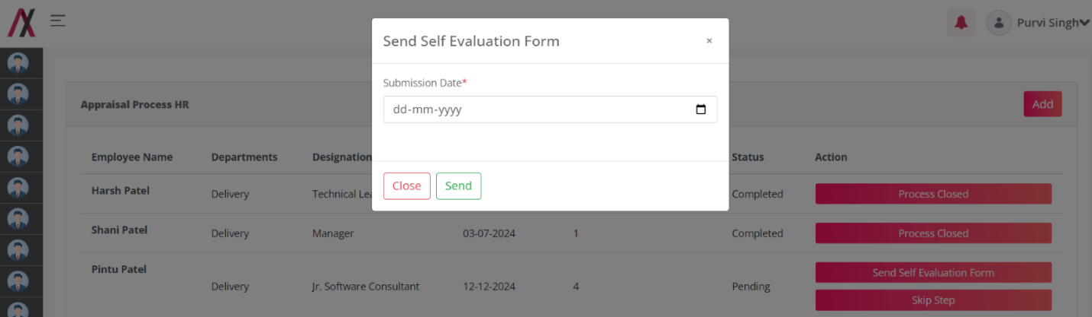
In case the appraisal form template for that year is not available then the folloeing warning pops:
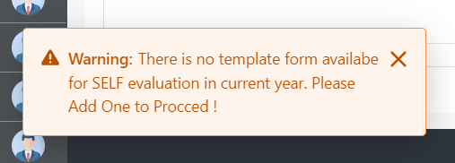
Note: you cannot fill in the date before today and post this month. That means the date must fall this month and not before today!
Once you select the submission date and submit the form, the following message appears:
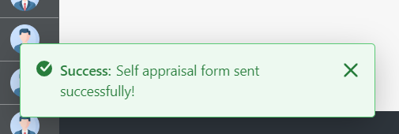
As soon as the HR sends the evaluation form to employee, they will receive the following mail with the link to submit the form:
Configurations-Mail:- Under 9 Dots > System settings > catagory.HRMS > Mail Template Configurations. > Self Evaluation Form Mail.
Placeholder: Refer Excel sheet for the placeholders.

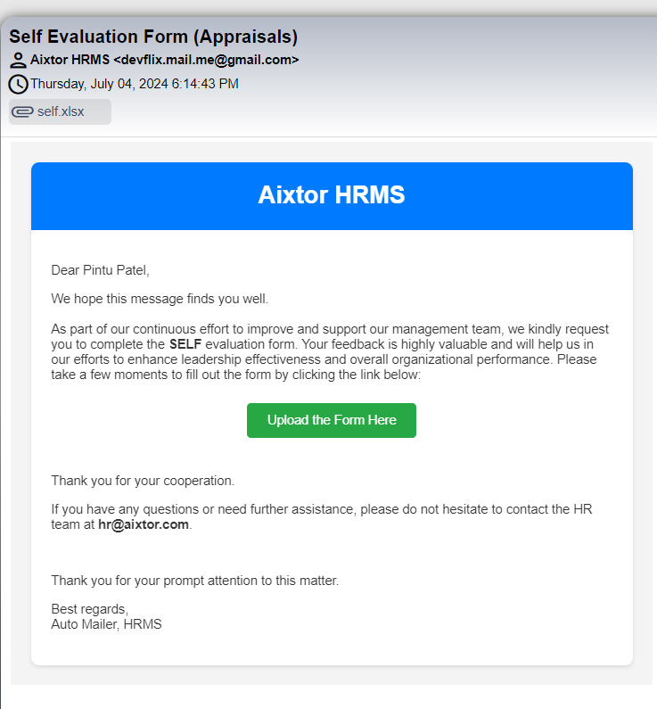

Once the employee opens the link he gets form to submit the evaluation form:
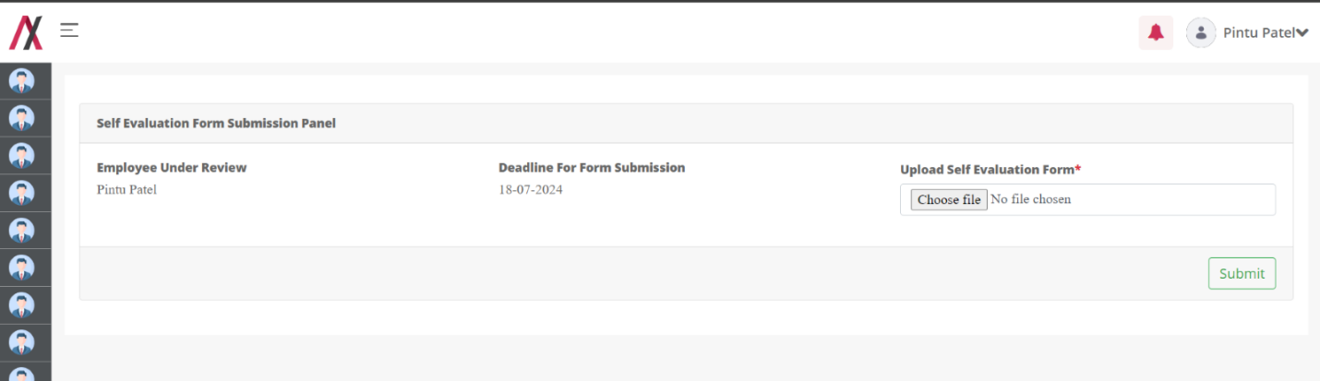
As employee uploads the self evaluation form and submits he gets the following messgae:
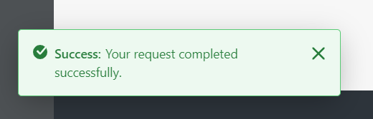
On the other hand HR Admins recieve an e-mail having the information about the submission of the form. With the filled form attached:
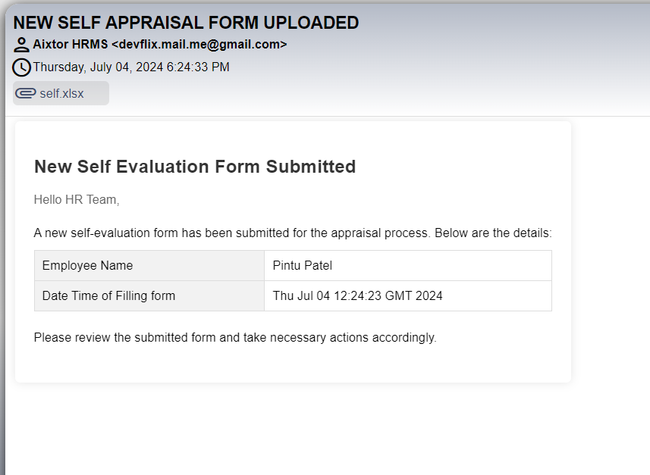

Now the action changes to “Send Peer Evaluation form”. As shown in the image below:
Here also you can skip this step and jump on to the Manager evaluation step, or else you must select the send peer Evaluation form button and again a popup will open prompting you to enter a submission date and the peers for the employee to send the evaluation form.
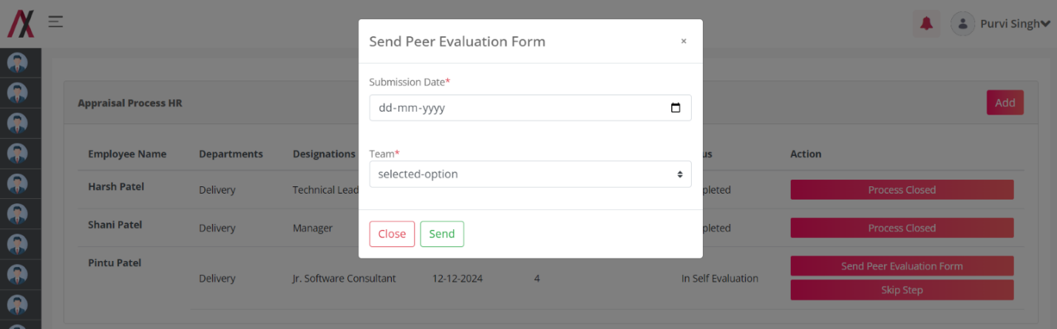
Once you select the peers and the date, you must submit the form and you will see this greeting:
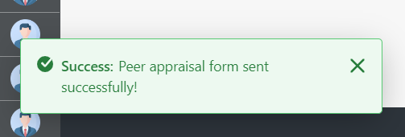

The peers will receive the following mail in their mailbox with the link to upload the evaluation form:

Configurations-Mail:- Under 9 Dots > System settings > catagory.HRMS > Mail Template Configurations. > Peer Evaluation Form Mail.
Placeholder: Refer Excel sheet for the placeholders.

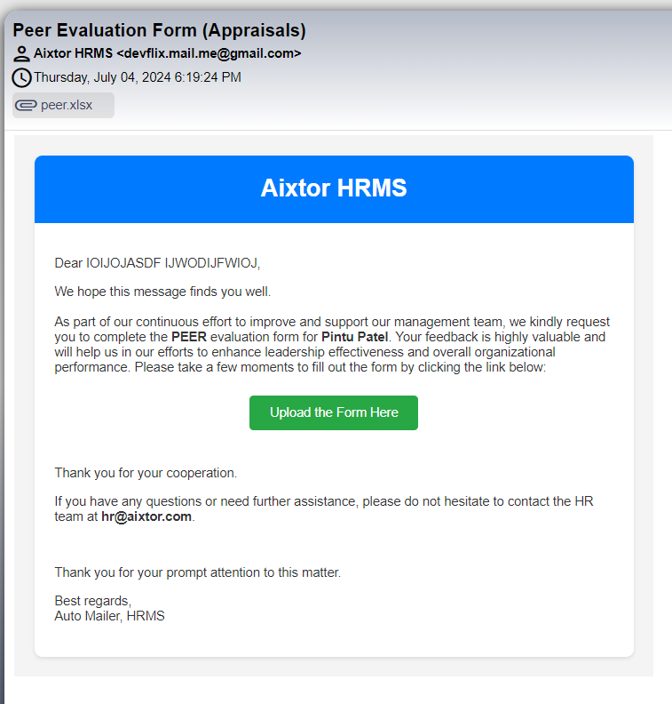

Once the user clicks on the upload form here button the employee will be taken to the form to upload evaluation form.

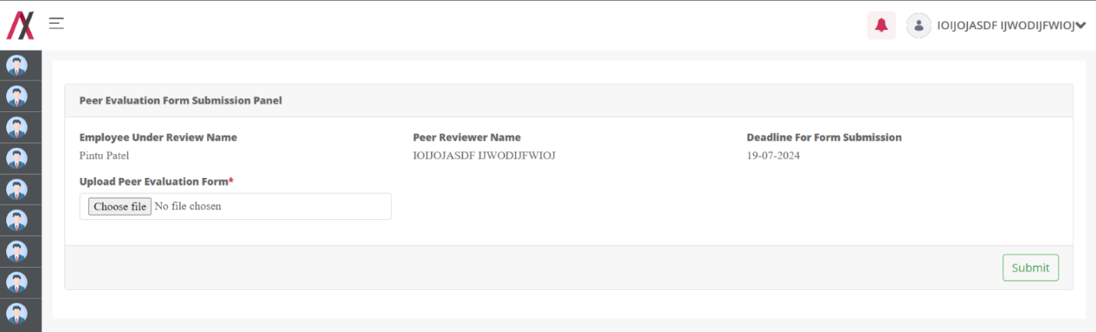
Once the employee uplaods the form and submits the form.the success message is shown:
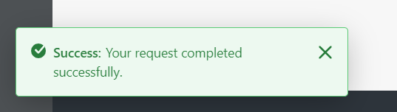

The HR Admin will recieve the notificaion on the mail with the attached form that peer-employee uploaded:
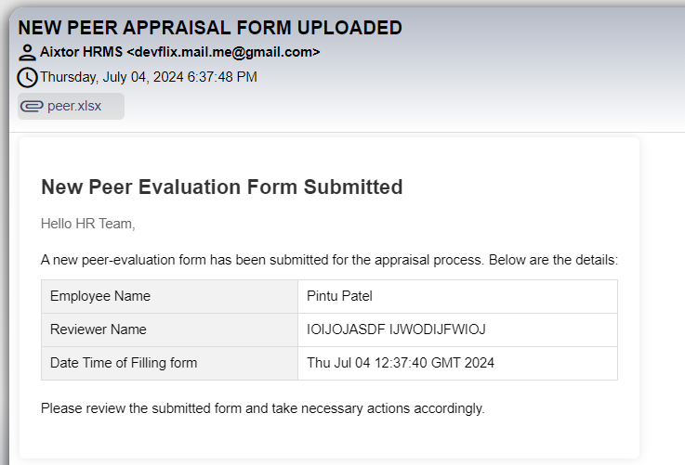

Now the process moves forward to the manager evaluation:
Here also you can skip this step and jump on to the Meeting step, or else you must select the send manager Evaluation form button and again a popup will open prompting you to enter a submission date and the managers for the employee to send the evaluation form.
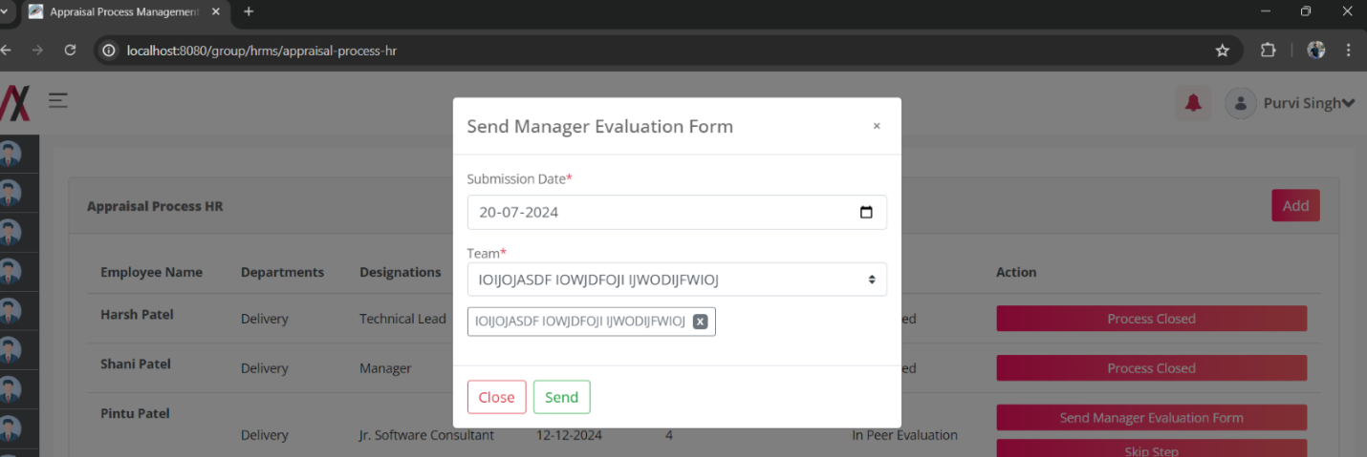
Once you send the form, the selected managers will receive a mail attached to the appraisal form template. And you will see the following messgae:
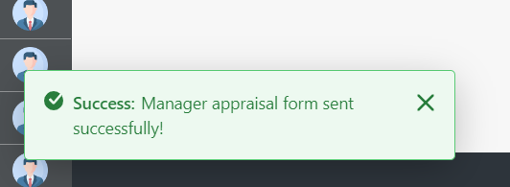

Mail to the managers will look like this;

Configurations-Mail:- Under 9 Dots > System settings > catagory.HRMS > Mail Template Configurations. > Manager Evaluation Form Mail
Placeholder: Refer Excel sheet for the placeholders.

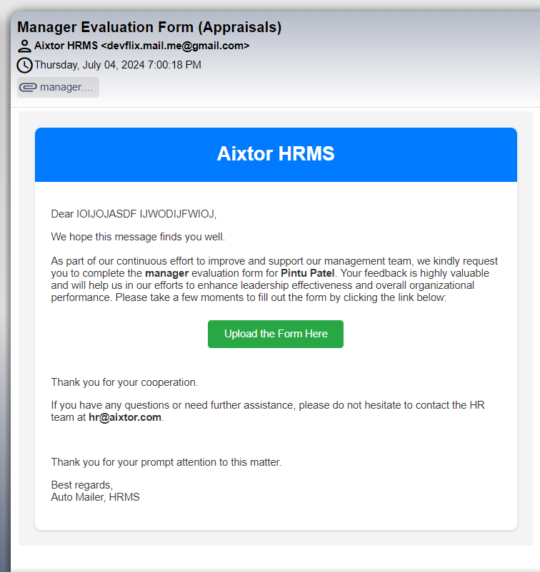

Once the manager gets the form and the link to upload, he can click the form link to upload the document :
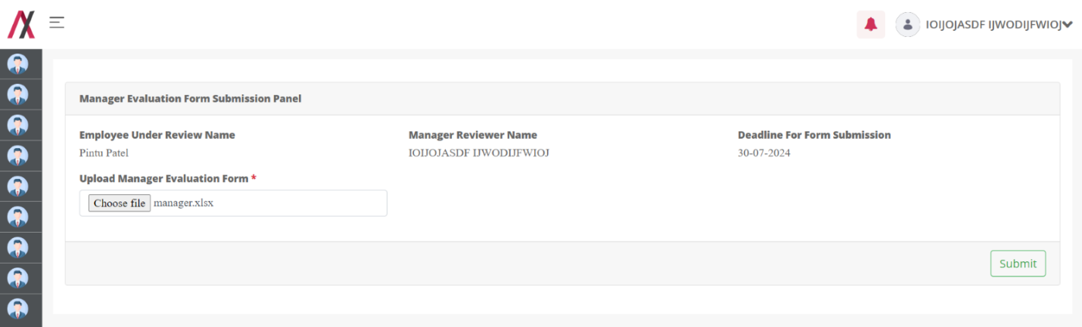
Once manager uploads the filled form and submits the form he sees the following message:
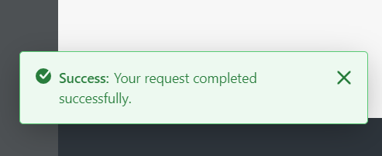

Also, once the manager forms are sent the HR Admin can move further the process, by scheduling the meeting by clicking the button as shown here:
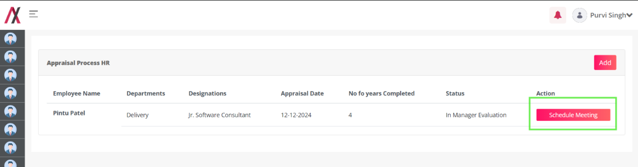
Once you press the button the pop up opens to select the meeting date, time and the attendees:
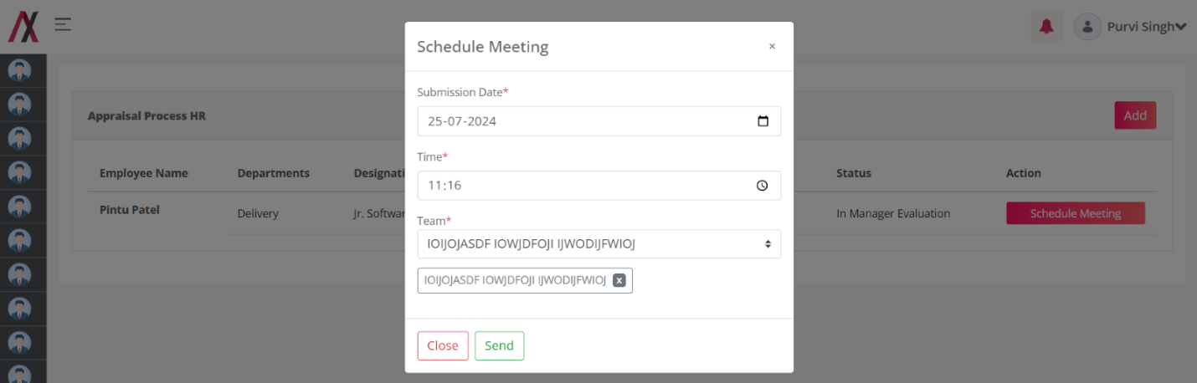
Once you select the attendees press send and the message pop up:
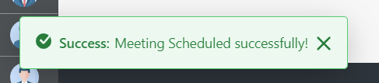

And the attendees get the following mail for the schedule of meeting:
Configurations-Mail:- Under 9 Dots > System settings > catagory.HRMS > Mail Template Configurations. > Appraisal Meeting
Placeholder: Refer Excel sheet for the placeholders.

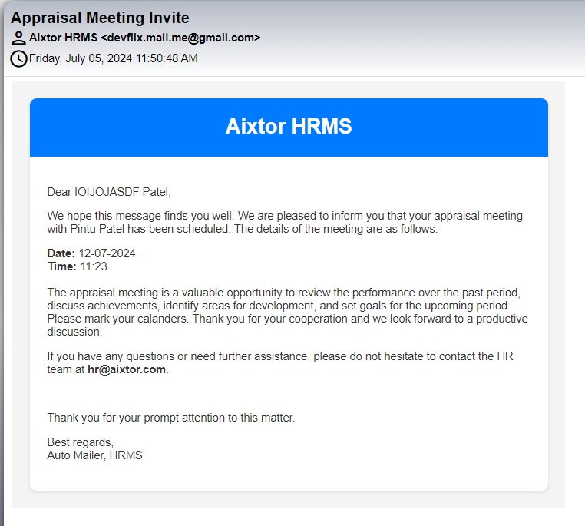

Also, the HR Can change the meeting time, date and the attendees:
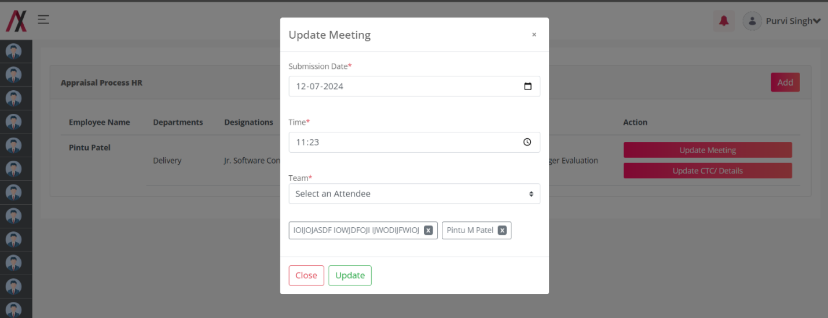
Once the meeting is updated the following message pops:
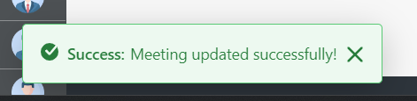
If HR removes some person and update the time, then the updated person gets the new meeting scheduled and the existing person get updated mail and the removed person get the removed mail.
Updated mail:

Configurations-Mail:- Under 9 Dots > System settings > catagory.HRMS > Mail Template Configurations. > Appraisal Meeting Updated
Placeholder: Refer Excel sheet for the placeholders.

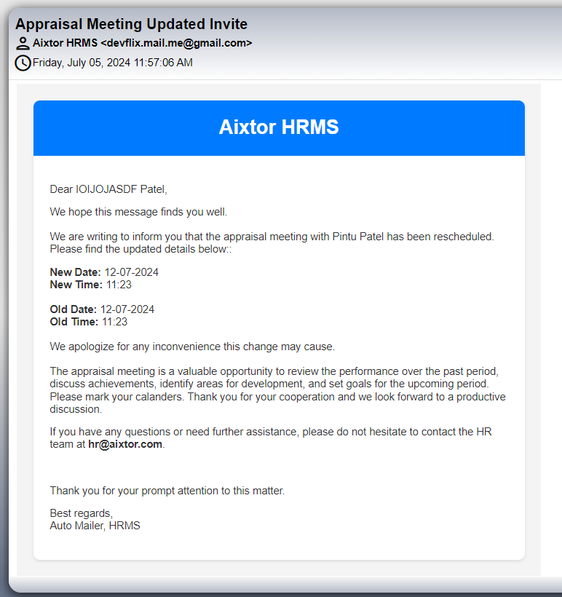

Removed mail:
Configurations-Mail:- Under 9 Dots > System settings > catagory.HRMS > Mail Template Configurations. > Appraisal Meeting Invitation Cancellation
Placeholder: Refer Excel sheet for the placeholders.

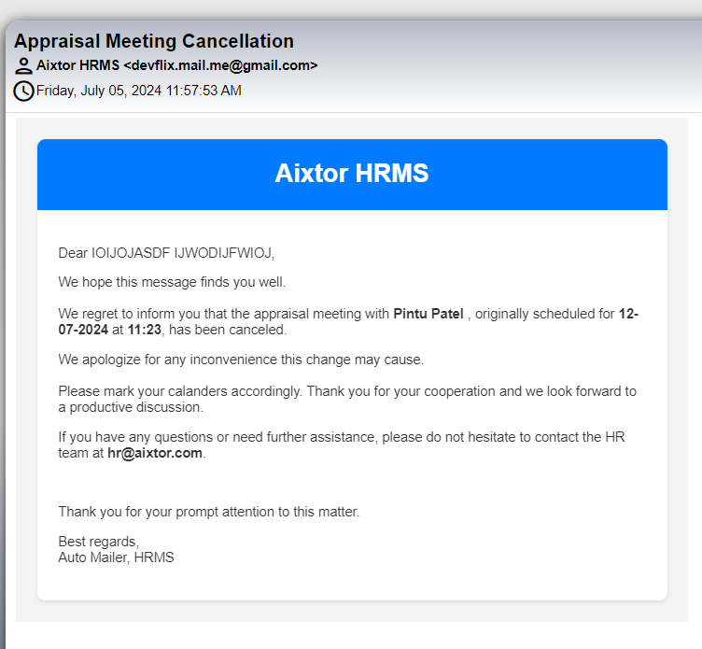

Once the meeting completed the HR can update the ctc :
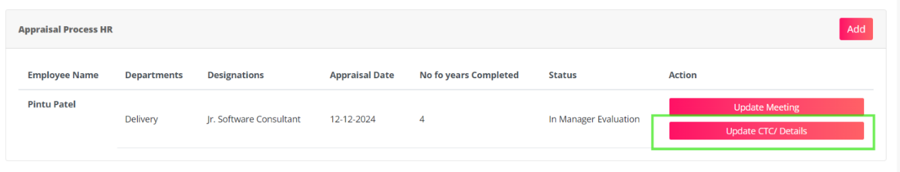
On clicking the update CTC button the popup comes to update the following details:

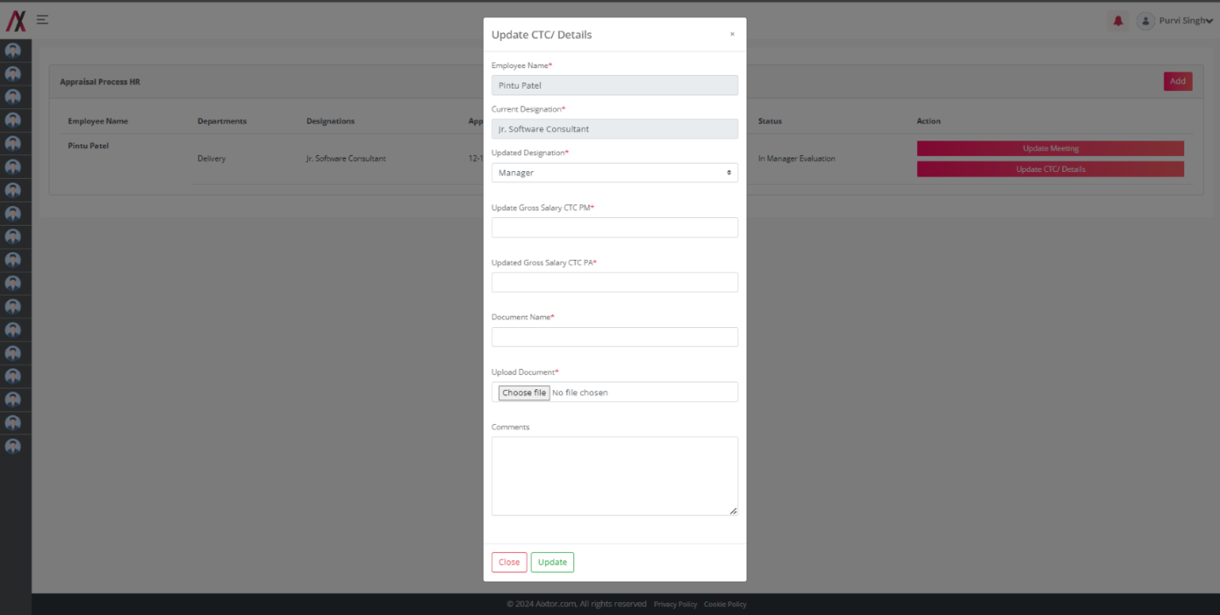
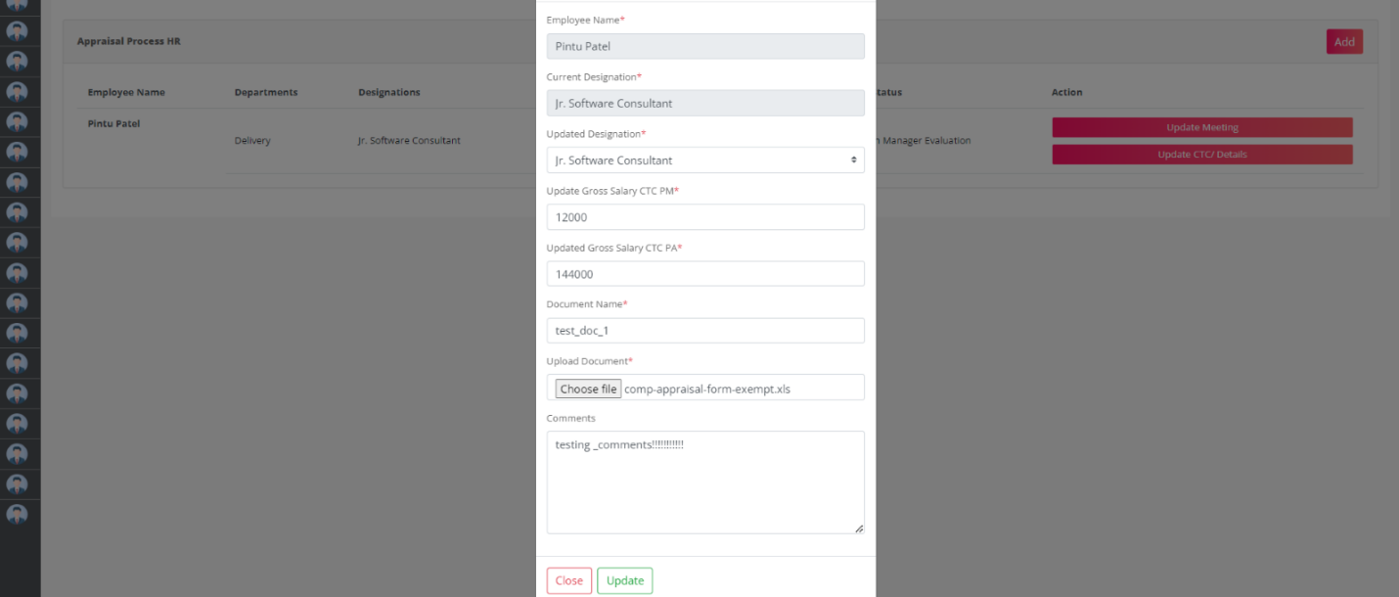
Employee name and current designation are the disabled fields.
Next fields are UPDATED CTC PA and PM that has to be filled using decimal numbers.
Then the document name that you need to rename the file and send to employee.
and the appraisal document/ letter, then the comments for the employee.
Once the form is submitted, following message pops:
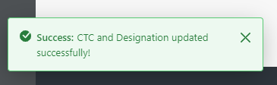

And the employee gets the following mail:
Configurations-Mail:- Under 9 Dots > System settings > catagory.HRMS > Mail Template Configurations. > Appraisal Meeting Invitation Cancellation
Placeholder: Refer Excel sheet for the placeholders.

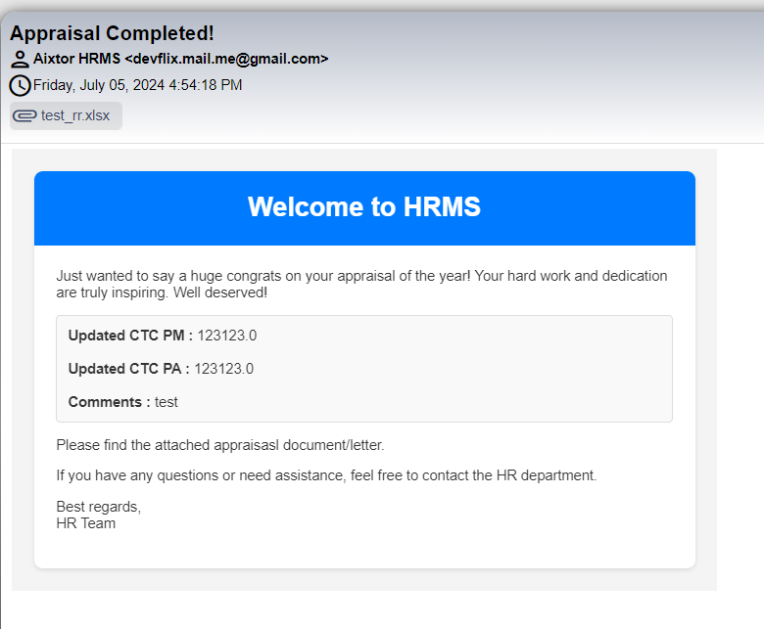

Appraisal Form Templates:

Functionality:
Appraisal form template is the module where the HR Admin can add the appraisal form templates for a particular year. These appraisal form templates are sent to the employees under appraisal process.

Page Name & Links:
The page where the portlet is placed is named Appraisal Form Templates.
Link - http://localhost:8080/group/hrms/appraisal-form-template

Functionality Flow:
On visiting the page of this page, we have the list of all the appraisal form templates already added to the data base.
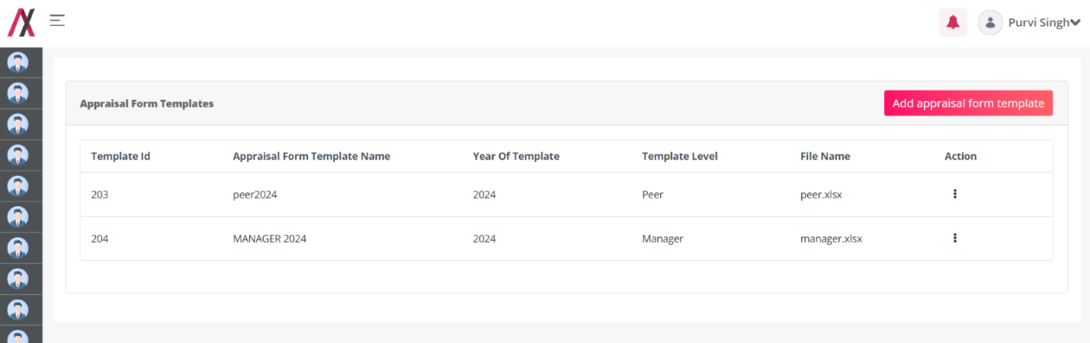
To add a new appraisal form template the button on the top right has to be clicked taking you to new form:
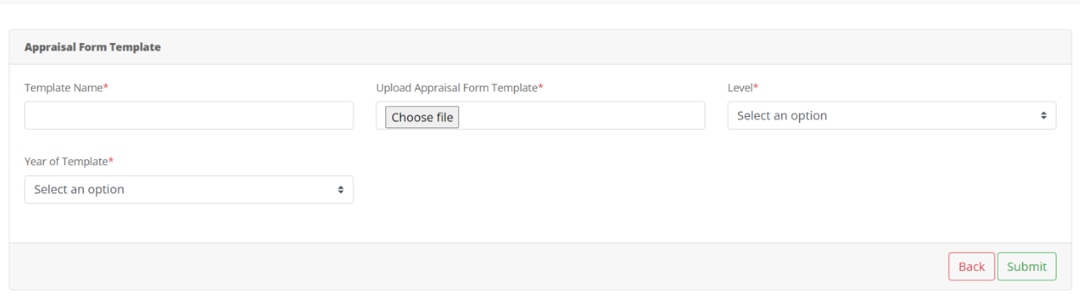
- Template Name: This field allows you to enter a name for the appraisal template you are uploading.
- Upload Appraisal Form Template: This button triggers a file selection dialog box where you can choose the appraisal template file to upload.
- Select an option: This dropdown menu lets you choose the level or category for the appraisal template. The specific options available will depend on your organization's appraisal template hierarchy. [Pre filled from the template level master.]
- Year of Template: This dropdown menu allows you to select the year for which the appraisal template is applicable.
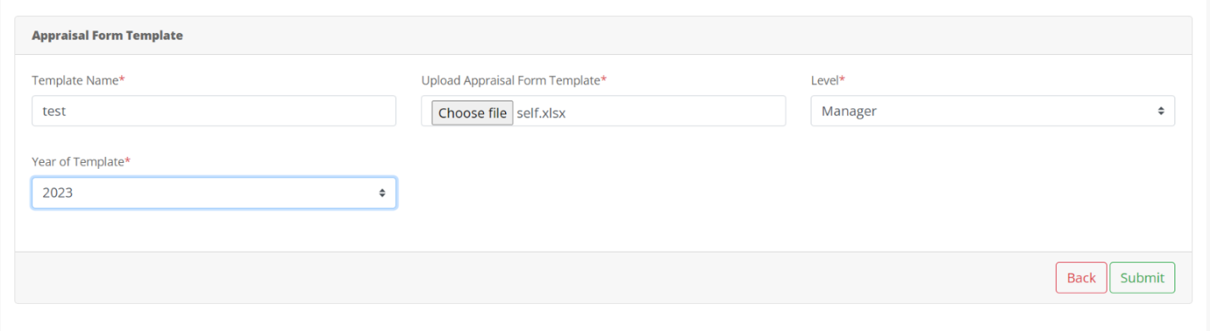
Once you fill and submit the following message appears:
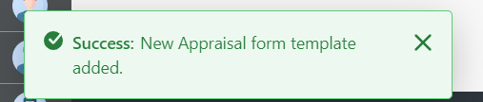

And you are taken back to listing page, here on the 3-dot menu you will find edit,delete and view buttons:
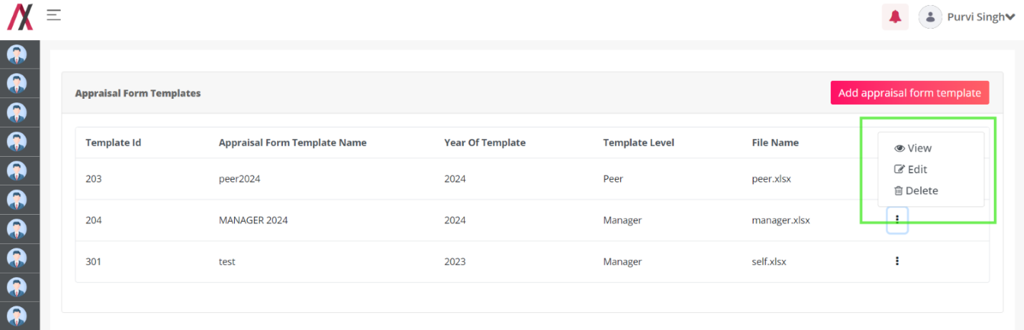
On clicking the view button, the following view opens:
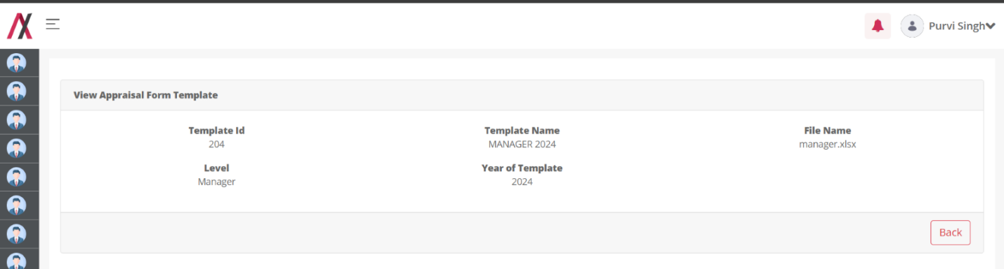

On the edit button you are allowed to edit the specific template details:
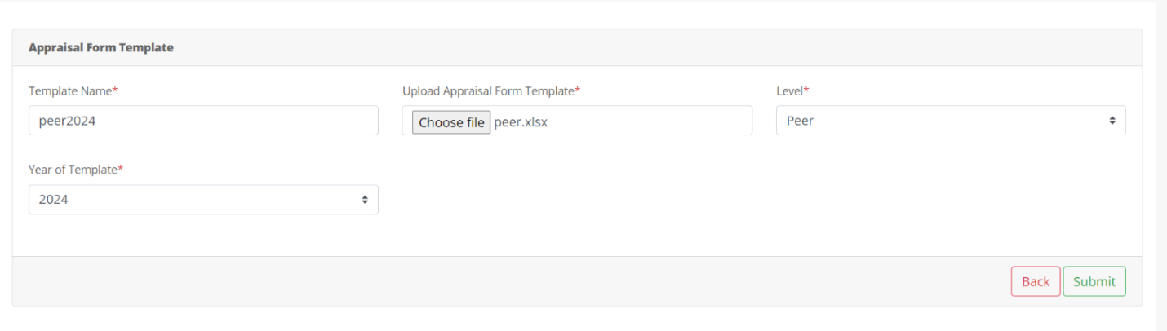

On submit the followinf message appears:

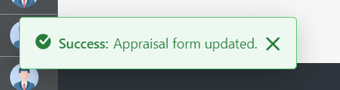

On delete action the following message appears;

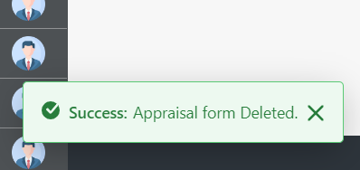

These appraisal form templates are required to send the appraisal form to the self, managers and peers.

Leave Balance Management (HR):

Functionality:
Leave Balance Management is the module where the HR Admin can change the Leave balance for a specific employee.

Page Name & Links:
The page where the portlet is placed is named Leave Balance.
Link - http://localhost:8080/group/hrms/leave-balance

Functionality Flow:
On visiting the page of this page, we have the dropdown of employees that HR can use to select an employee to edit their leave balance.

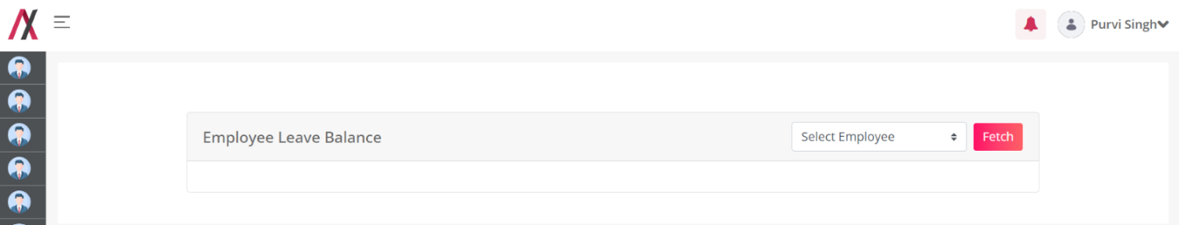
On clicking the drop down and selecting the employee press fetch to get all the leave balances of the employee.:
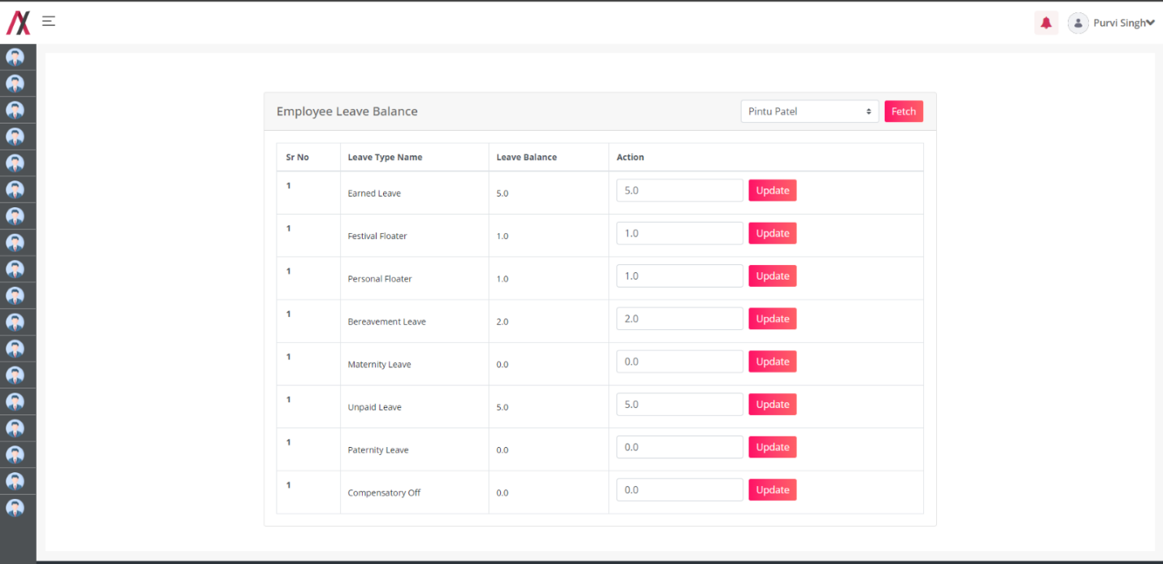
Now to update a specific type of leave change the value in action box and then press update :
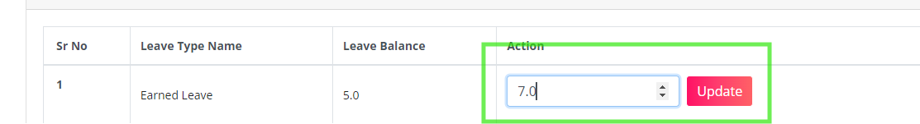
Once you press update the following message pops
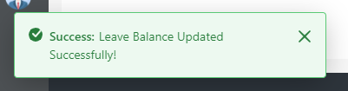
And the leave balance gets updated:

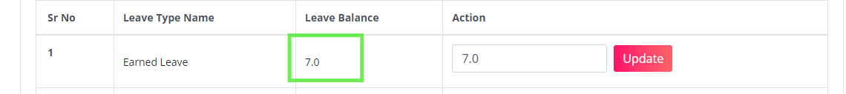

Compensatory Management :

Functionality(Manager):
Compensatory management for manager is the module where the manager can approve or reject the comp off request made by the employees.

Functionality(Employee):
Compensatory Management for the Employees is a module where the employees can easily make the request and add the information about it, that request will be requested to the manager to approve.

Page Name & Links:
The page where the employee portlet is placed is named Compensatory Employee
Link - http://localhost:8080/group/hrms/compensatory-employee

The page where the manager portlet is placed is named Compensatory Manager
Link - http://localhost:8080/group/hrms/compensatory-manager

Functionality Flow :
On visiting this page, we have the list of all the past compensation requested.
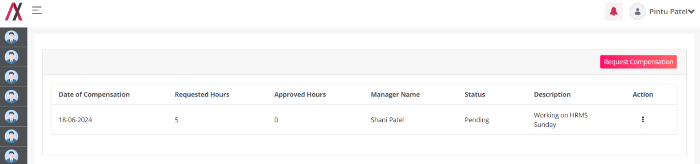
On clicking the request button on top right you will see a popup to fill in the information for the comp off:
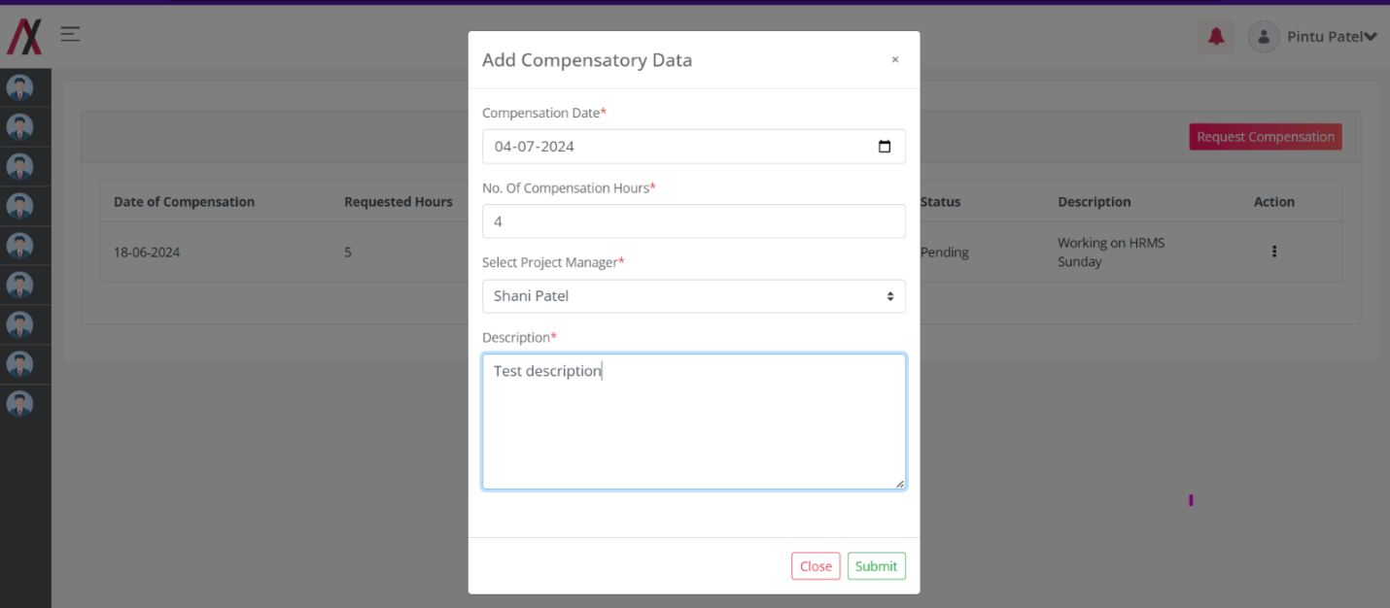

Once you submit the form you’ll see the following message:

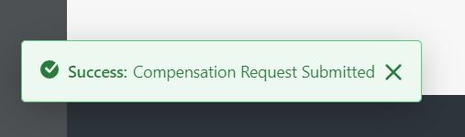

And the status of that reques is set to pending:
In case the employee wants to delete the request , click on 3-dot and press delete:
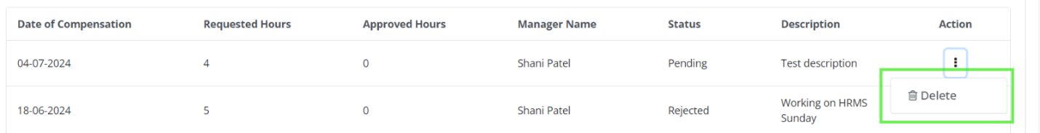
And the following message appears:
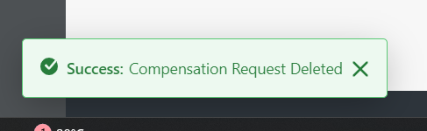
On the manager end the manager can see the list of compensation requests:
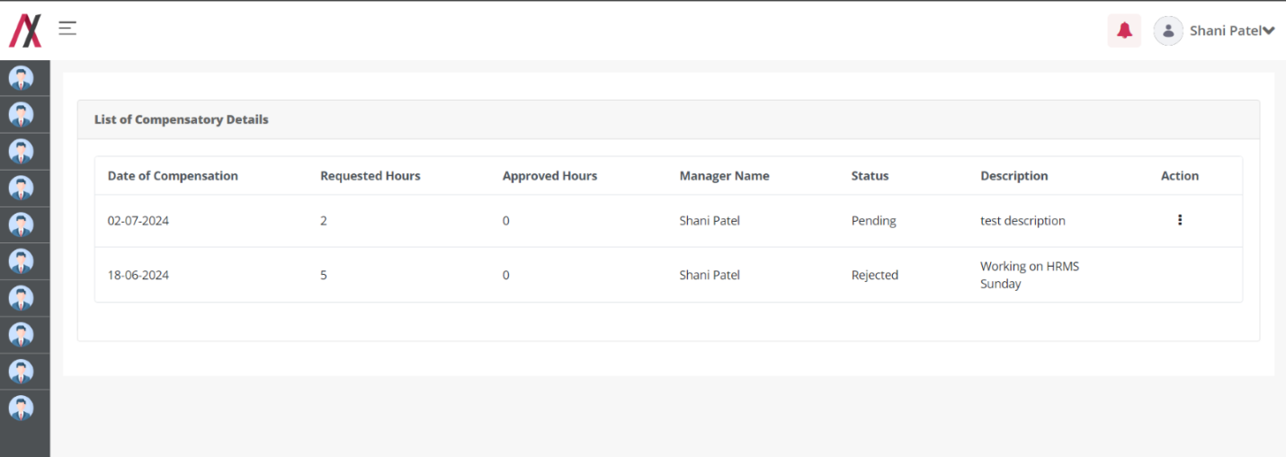
To approve or reject the manager has to click the 3-dot revealing the following menu:
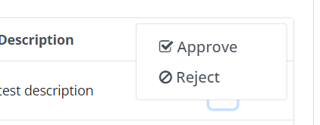
If the manager clicks reject, following message pops:
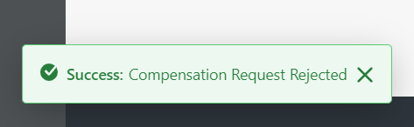

If the manager clicks the approve, he gets to fill the custom hours to approve:

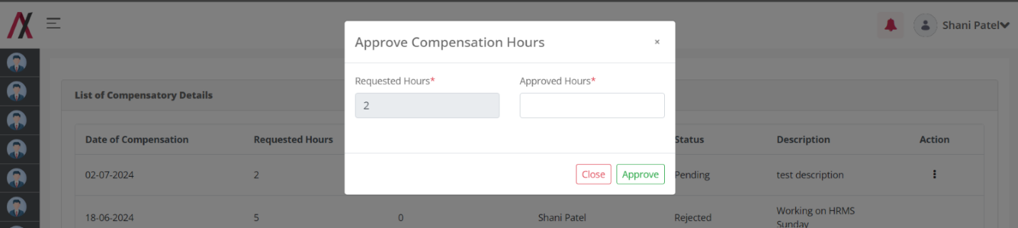
Once the manager fills in the hours and press approve, message appears:
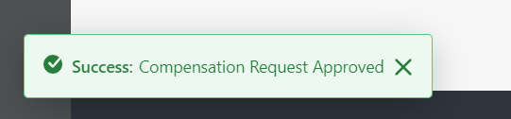

And the employee can see that their request has been approved,
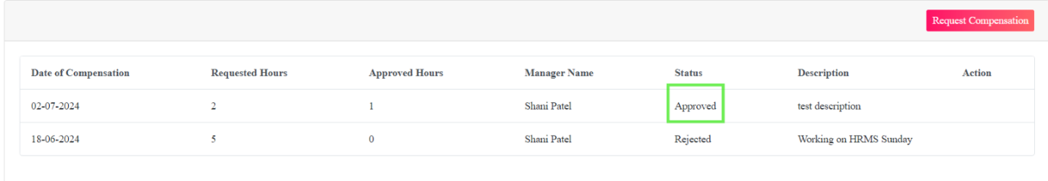

Performance Improvement Program (PIP):

Functionality:
PIP module is for the HR Admin using that the PIP can be managed with ease. In here the HR Admin can add the employee to the PIP program.

Page Name & Links:
The page where the portlet is placed is named PIP Program.
Link - http://localhost:8080/group/hrms/pip-program

Functionality Flow:
On visiting the page of this page, we have the list of all the PIP employees already added to the database.

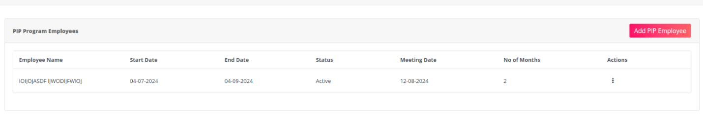
To add a employee to the pip program, press the add button on top right that will open the form.
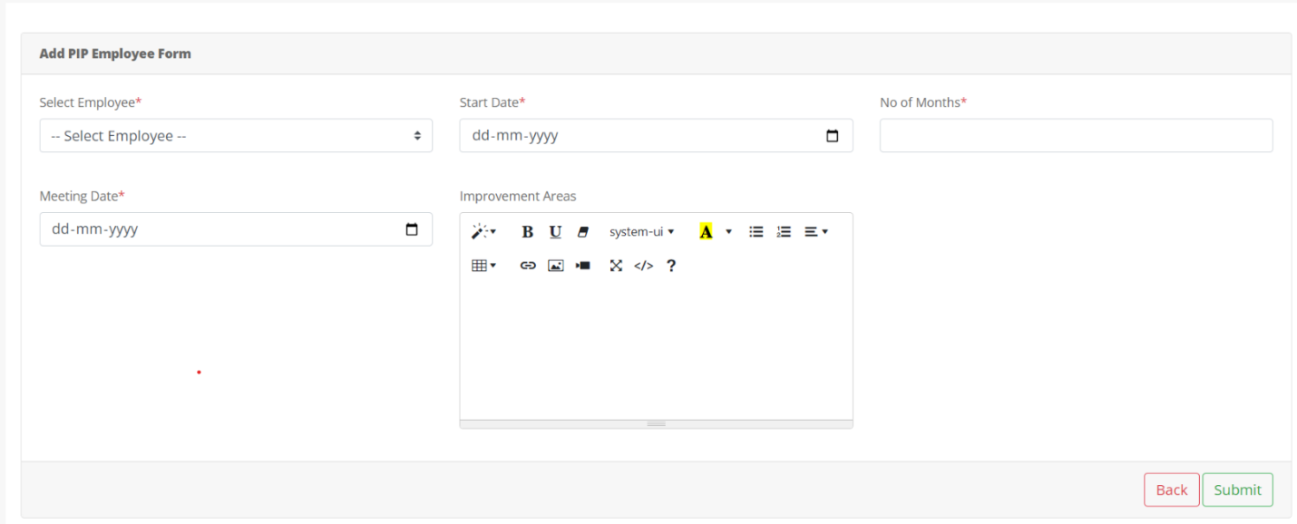
- Select Employee:* This is a mandatory drop-down menu containing a list of employees you can select from.
- Start Date: * This is a mandatory field where you can enter the start date of the PIP (Performance Improvement Plan) in a dd-mm-yyyy format.
- No. of Months: This field allows you to enter the number of months the PIP will be in effect.
- Meeting Date (dd-mm-yyyy): This is a mandatory field where you can enter the date of the PIP meeting in dd-mm-yyyy format.
- Improvement Areas: This section allows you to enter a description of the areas where improvement is needed. There might be a free text box where you can type this information.
Once you fill the form and submit, following message appears:
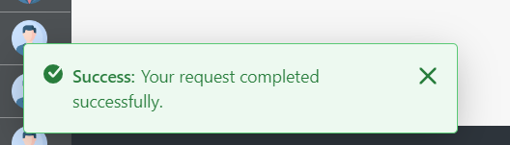

On the other side, employee will receive the following mail:
Configurations-Mail:- Under 9 Dots > System settings > catagory.HRMS > Mail Template Configurations. > PIP Program Mail
Placeholder: Refer Excel sheet for the placeholders.

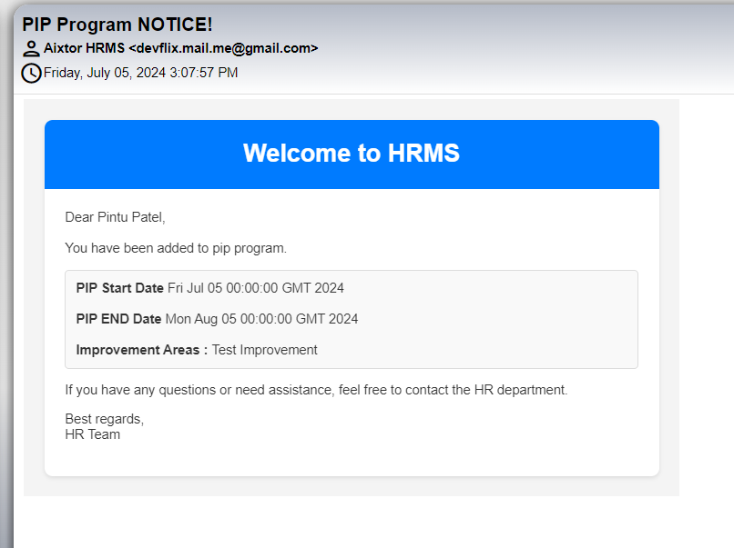
After this the HR Acdmin will be redirected to the list screen:
Here you have 3-dot with 4 options:
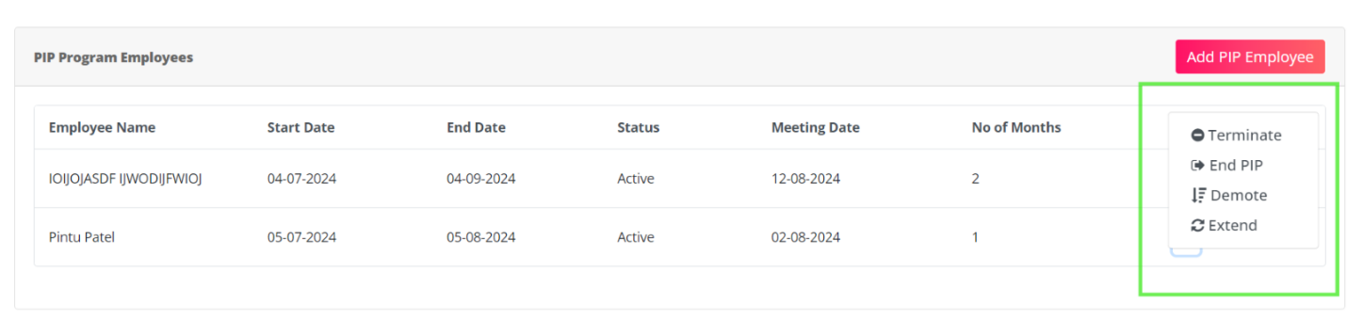
END PIP: If the HR Admin press end pip the employee will come out of pip without any change.
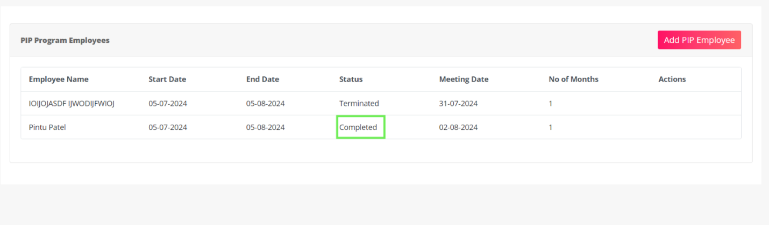
Demote : If the HR Press this button then the demote form opens:
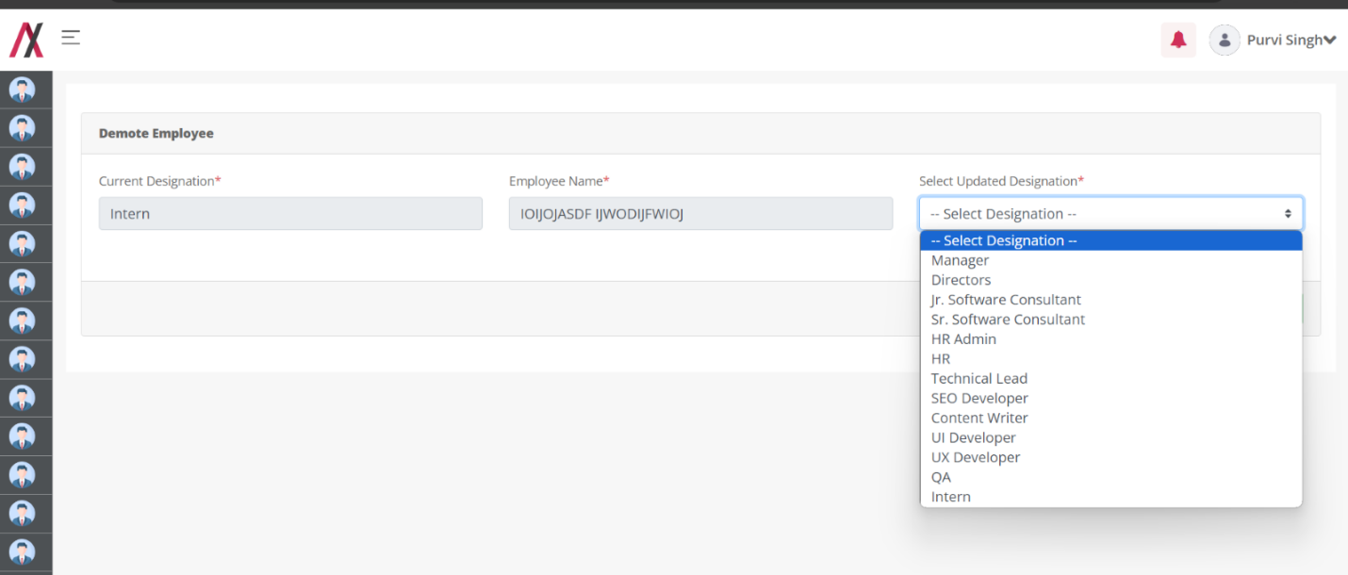
On this panel, the HR must select the employee's demoted position.
Extend: if the HR extends the pip program. The following form opens and as HR fills the form the number of months gets extended for the PIP program.
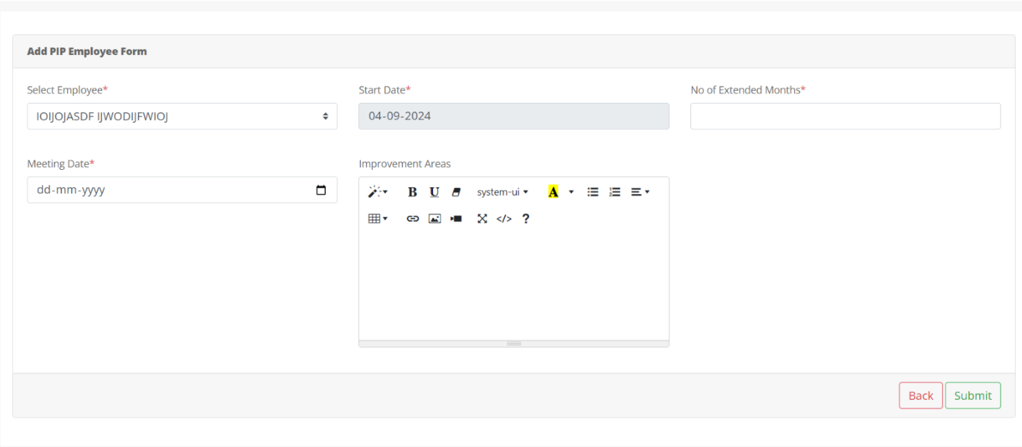
- Select Employee:* Pre filled
- Start Date: Pre filled
- No. of Months: This field allows you to enter the number of months the PIP will be in effect.
- Meeting Date (dd-mm-yyyy): This is a mandatory field where you can enter the date of the PIP meeting in dd-mm-yyyy format.
- Improvement Areas: This section allows you to enter a description of the areas where improvement is needed. There might be a free text box where you can type this information.
Once extended the status changes to extended:
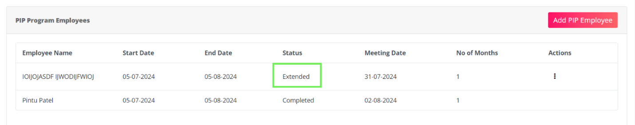
Terminated: If HR terminates the employee, the employee will lose access to the HRMS immediately.
