**ReactJs**

**MODULE: 9 ReactJs Intro**

1. **What is React Js?  
   A:** React is a JavaScript library created by Facebook.

React is a User Interface (UI) library.

React is a tool for building UI components.

According React, sometimes referred to as a frontend JavaScript framework, is a JavaScript library created by Facebook.

React is used to build single-page applications.

React allows us to create reusable UI components.

1. **What is NPM in React Js?  
   A:** NPM is short for node package manager, an online directory that contains the various already registered open-source packages. NPM modules consume the various functions as a third-party package when installed into an app using the NPM command npm install .
2. **What is Role of Node Js in react Js?  
   A:** NodeJS is a framework of JavaScript which is mainly used for working with the backend of our application or building the backend using JavaScript, whereas ReactJS is a JavaScript front-end library. It is mainly used for building the user interface or the frontend of our application.
3. **What is CLI command In React Js?  
   A:** CLI is a text-based program that enables users to instruct computers with text commands. It is used for running programs, managing computer files, and also interacting with computers. CLI accepts text inputs as commands and runs these commands to execute specific tasks.
4. **What is Components in React Js?  
   A:** Components are independent and reusable bits of code. They serve the same purpose as JavaScript functions, but work in isolation and return HTML. Components come in two types, Class components and Function components, in this tutorial we will concentrate on Function components. function components can be written using much less code & also easier to understand.
5. **What is Header and Content Components in React Js?  
   A:** A header is a section at the top of a page that displays site name and navigation. React is the most popular frontend library for developing component-driven user interfaces. It's used for developing single page, mobile, and server-rendered applications.

Components are independent and reusable bits of code. They serve the same purpose as JavaScript functions, but work in isolation and return HTML. Components come in two types, Class components and Function components, in this tutorial we will concentrate on Function components.

1. **How to install React Js on Windows, Linux Operating System? How to Install NPM and How to check version of NPM?  
   A:   
   Step 1: node.js & npm Install  
   Step 2: Open command prompt to check whether it is completely installed or not type the command** –>  
   cmd : node -v

cmd: npm –v

**Step 3: Now in the terminal run the below command:**npm install -g create-react-app

It will globally install react app for you. To check everything went well run the command

create-react-app –version

**Step 4: Move inside the same folder using the below command:**cd newfolder (your folder name)

**Step 5: Now Create a new folder where you want to make your react app using the below command:**create-react-app reactfirst

**Step 6: Use the terminal and move inside your app name folder.Use command    
cd reactapp (your app name)**

**Step 7: To start your app run the below command:**npm start

Once you run the above command a new tab will open in your browser showing React logo as shown below :

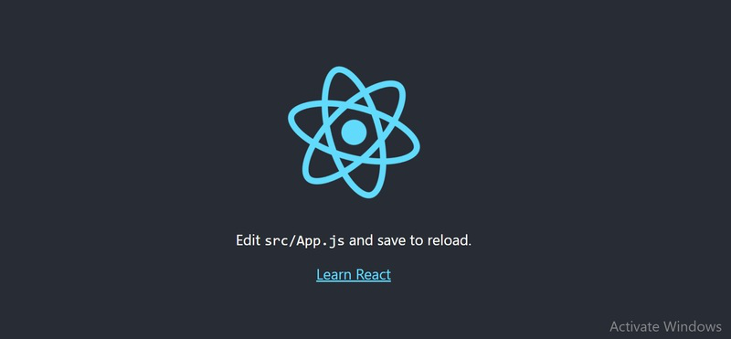

1. **How to check version of React Js?A:** The package.json contains metadata about our project. It is created by default when we create our React project. We can create a react app using the command mentioned below:

npx create-react-app name_of_the_app

The package.json file contains a lot of information in the name/value pairs in JSON format. We can easily check our React version under the list of dependencies as shown in the image given below.

The package.json file contains a lot of information in the name/value pairs in JSON format. We can easily check our React version under the list of dependencies as shown in the image given below.

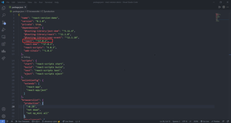

We can easily check the React version by using the command mentioned below on our command line.

npm view react version

1. **How to change in components of React Js?**

**A:** setState() setState() enqueues changes to the component state and tells React that this component and its children need to be re-rendered with the updated state. This is the primary method you use to update the user interface in response to event handlers and server responses.

1. **How to Create a List View in React Js?  
   A:**   
   **Input:**

**ChekBoxList.jsx**

import React from 'react'

function ChekboxList() {

    return (

      <div className='bg-primary'>

         {/* chekbox start function */}

        <div className="col-md-12 mt-5 offset-4 bg-primary">

        <h1>The "React way" to Reander a list</h1>

        </div>

        <div className="col-md-3 mt-5 offset-4">

          <div className="input-group">

            <div className="input-group-text">

              <input className="form-check-input mt-0" type="checkbox" defaultValue aria-label="Checkbox for following text input" />

            </div>

            <input type="text" className="form-control" aria-label="Text input with checkbox" />

          </div>

        </div>

        <div className="col-md-3 mt-5 offset-4">

          <div className="input-group">

            <div className="input-group-text">

              <input className="form-check-input mt-0" type="checkbox" defaultValue aria-label="Checkbox for following text input" />

            </div>

            <input type="text" className="form-control" aria-label="Text input with checkbox" />

          </div>

        </div>

        <div className="col-md-3 mt-5 offset-4">

          <div className="input-group">

            <div className="input-group-text">

              <input className="form-check-input mt-0" type="checkbox" defaultValue aria-label="Checkbox for following text input" />

            </div>

            <input type="text" className="form-control" aria-label="Text input with checkbox" />

          </div>

        </div>

        <div className="col-md-3 mt-5 offset-4">

          <div className="input-group">

            <div className="input-group-text">

              <input className="form-check-input mt-0" type="checkbox" defaultValue aria-label="Checkbox for following text input" />

            </div>

            <input type="text" className="form-control" aria-label="Text input with checkbox" />

            {/* chekbox end function */}

          </div>

        </div>

      </div>

    )

  }

  export default ChekboxList

**App.js**

import React from 'react'

import Task from './Task_increment-decrement/Task'

function App() {

  return (

    <div>

      <Task/>

    </div>

  )

}

export default App

**Output:**

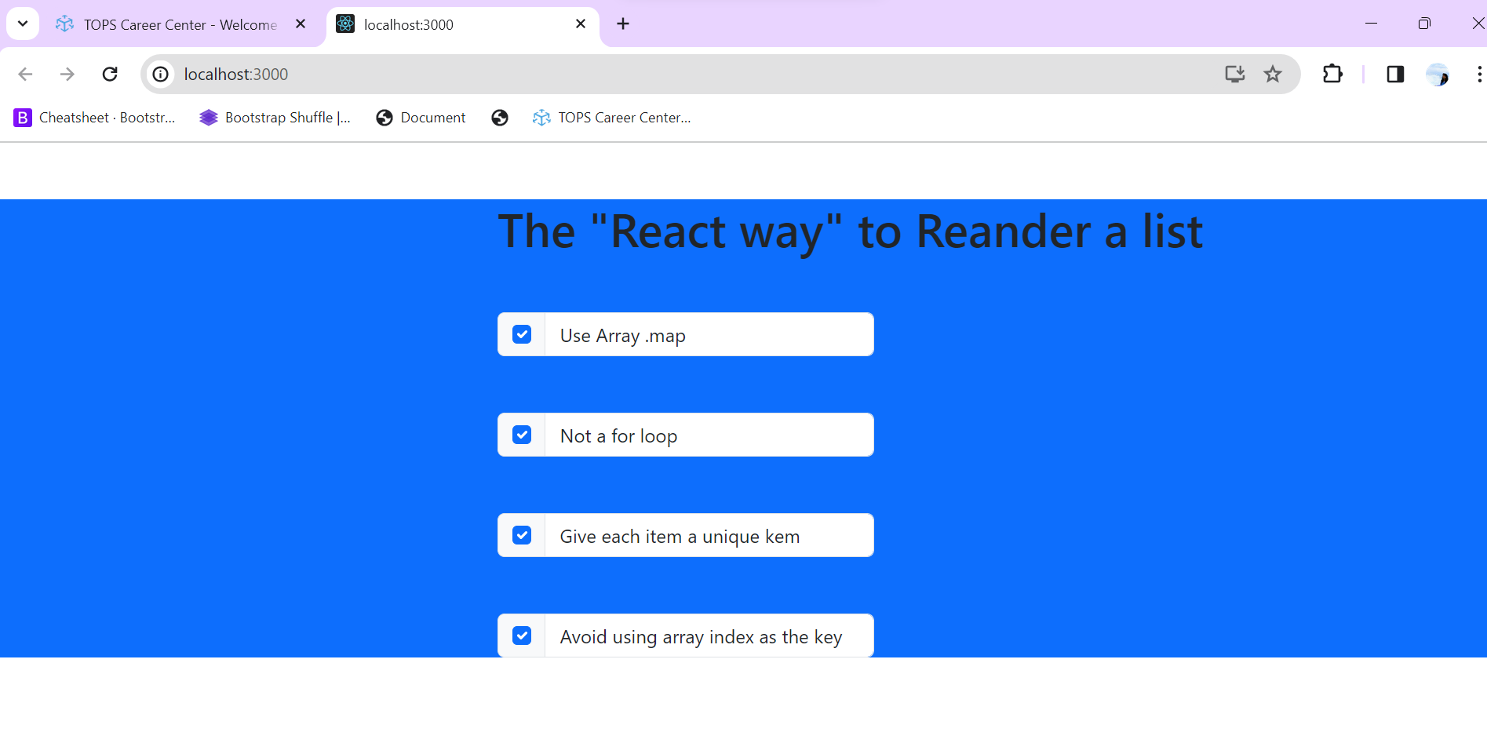

1. **Create Increment decrement state change by button click?**

**Ans: Input**

**Task.jsx**

import React, {useState} from "react";

function Task() {

  //Increment decrement function

  const [count, setCount] = useState(0);

  return (

    <>

   <div className="container my-5">

    <div className="card text-center my-5">

      <div className="card-body">

          <h1>Counter app</h1>

          <div className="my-5">

            <h2 className="my-5">{count}</h2>

            {/* button start */}

            <button className="btn btn-success mx-3" onClick={() => setCount(count + 1)}>Increment</button>

            <button className="btn btn-danger mx-3" onClick={() => setCount(count - 1)} disabled={count === 0}>Decrement</button>

            <button className="btn btn-secondary mx-3" onClick={() => setCount(0)} disabled={count === 0}>Reset</button>

            {/* button end */}

          </div>

      </div>

    </div>

   </div>

   </>

  );

}

export default Task;

**App.js**

import React from 'react'

import ChekboxList from './Checkbox/ChekBoxList'

function App() {

  return (

    <div>

      <ChekboxList/>

    </div>

  )

}

export default App

**Output:**

