**Documentation**

**Note:** Code and document are created based on my understanding.

1. Fetch data in a JSON format.

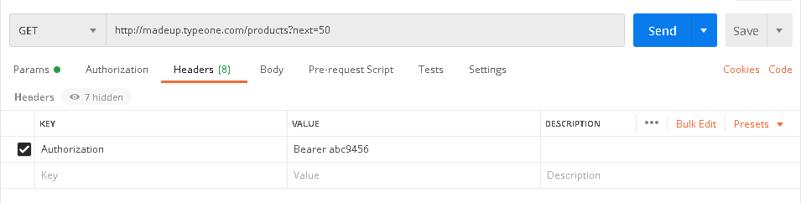

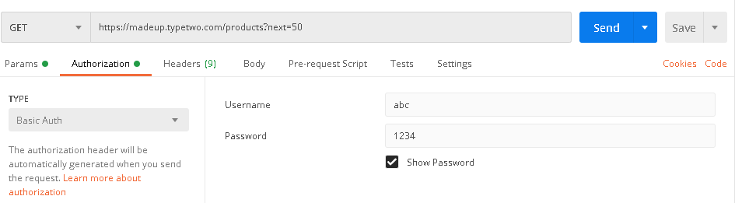

1. Here we can take mongo db as a database as we have to process JSON format data.
2. We can take two collection, one for parent and second one for children. It will merge using sku value. For Example,

Parent collection:

|  |  |  |  |
| --- | --- | --- | --- |
| SKU | Name | Description | LinkPoints |
| Prod_1 | Prod 1 | Product No 1 | [      {          "name": "Prod 1",          "child_skus": [              {                  "SKU": "Child_1"              },              {                  "SKU": "Child_2"              }          ]      }  ] |
| Prod_2 | Prod 2 | Product No 2 | [      {          "name": "Prod 2",          "child_skus": [              {                  "SKU": "Child_3"              },              {                  "SKU": "Child_4"              }          ]      }  ] |

Children Collection:

|  |  |  |  |
| --- | --- | --- | --- |
| SKU | Name | Description | Link |
| Child_1 | Child 1 | Product No 11 | {      "name": "Child 1",      "value": "green",      "parentSku": "Prod_1"  } |
| Child_2 | Child 2 | Product No 21 | {      "name": "Child 2",      "value": "green",      "parentSku": "Prod_1"  } |

So, here we can assume that Prod_1 have two child inside children collection.

1. The final structure in above step needs to be uploaded to target endpoint “products”. Post request. Type JSON Example (<https://madeup.typeboss.com/products>)

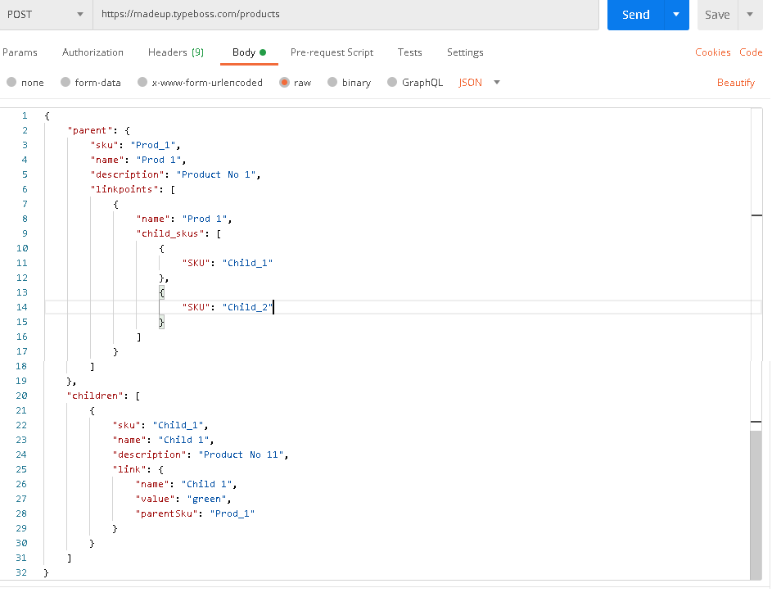

1. Fetch inventory data in a JSON format.

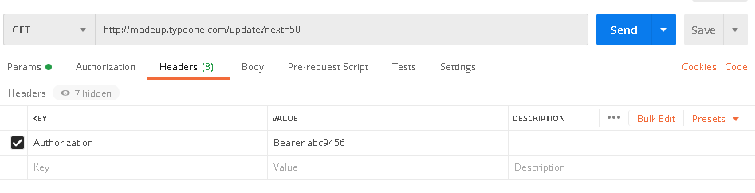

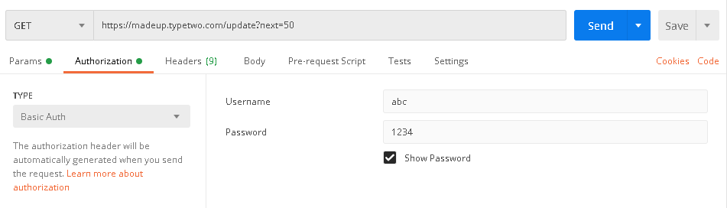

In 5(c), Found object from array which name is “default “as source for inventory.

In 5(d), which object have isManaged is true, qty taken as same from the same object else take value from setting collection which is consider as a default value.

1. Take mongo db as a database.

|  |  |  |  |
| --- | --- | --- | --- |
| sku | price | extended_field | custom_field |
| Inv_1 | $38.00 | {      "stock_update": {          "qty": "3"      }  } | {      "attribute_code": "status",      "attribute_value": "number"  } |

1. Create a structure as mentioned in given document.
2. The final structure needs to be uploaded to endpoint “product_update” in destination. Post request. Type JSON. <https://madeup.typeboss.com/product_update>

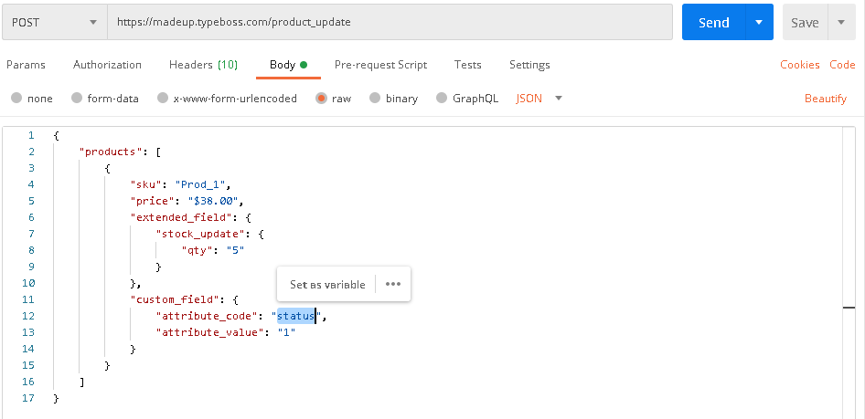

1. So we can set cron job in AWS Lambda for parallel processing or use elastic beanstalk service.