Create table product :
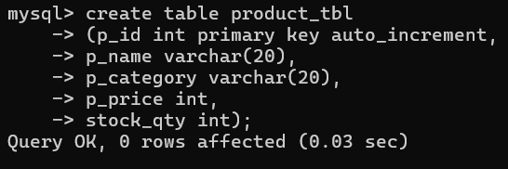
Create table customer :
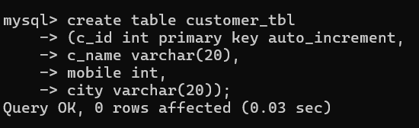
Insert values in product table:
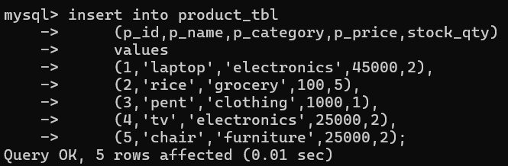
Insert values in customer table:
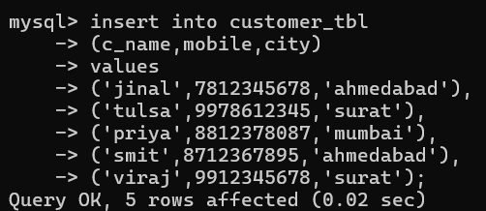
Queries:
- Show all products:
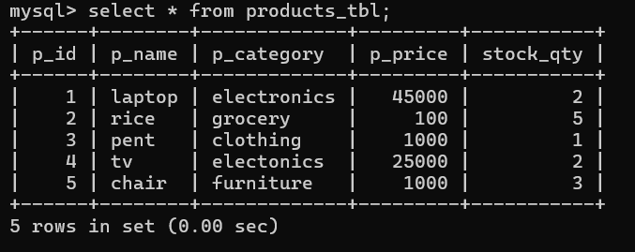
- Show all customers:
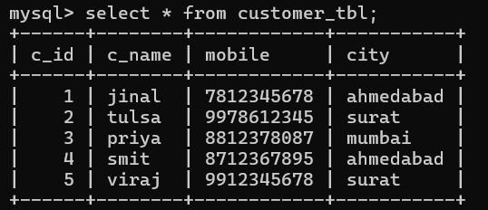
- Show products only from category “Electronics”:
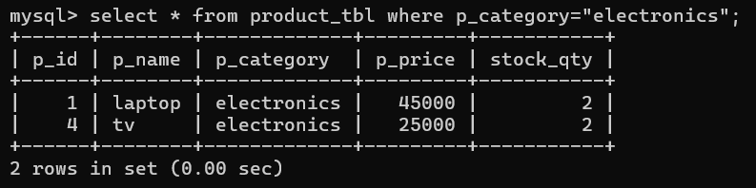

- Show customers from a specific city:
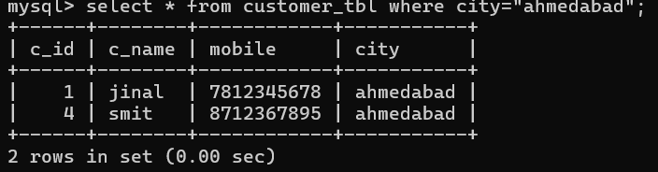

- Show products whose price is greater than 500:
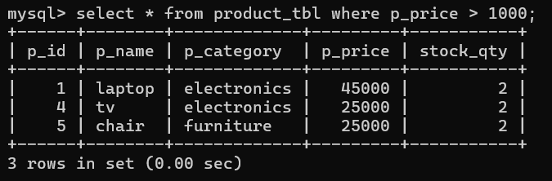

- Show products whose stock is less than 10:
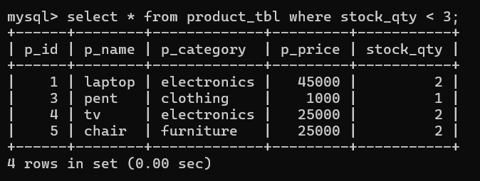

Update:
- Change price of any one product:
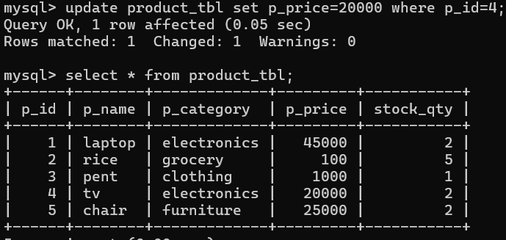

- Change stock of any product:
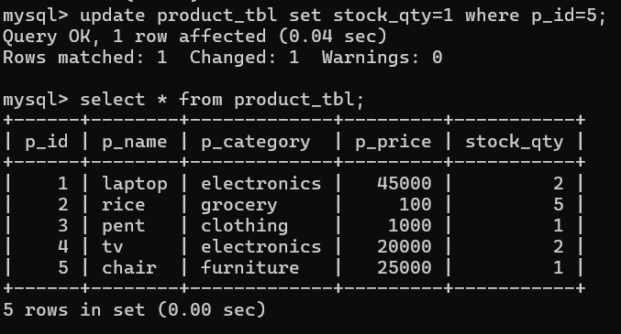

- Update customer city:
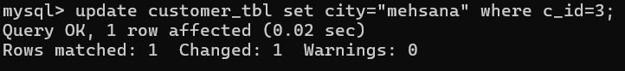
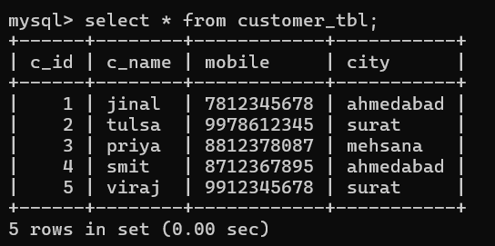
- Update customer mobile number:
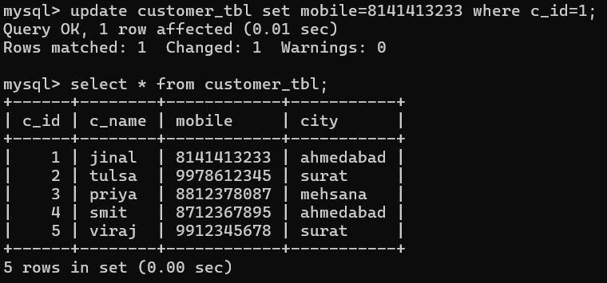
Delete queries :-
1. One product:
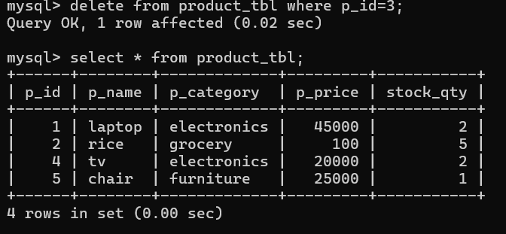
2. One customer :
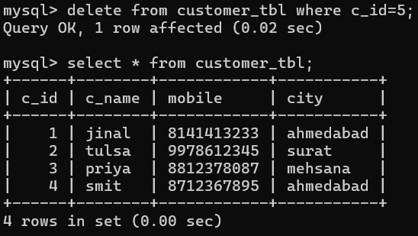
3. Delete all products from a specific category (example: Grocery):
