Session 4 -locaters Made Easy[No code]
1. Open Flipkart.com in Chrome, right-click on the search box, and use Inspect Element to find and write down its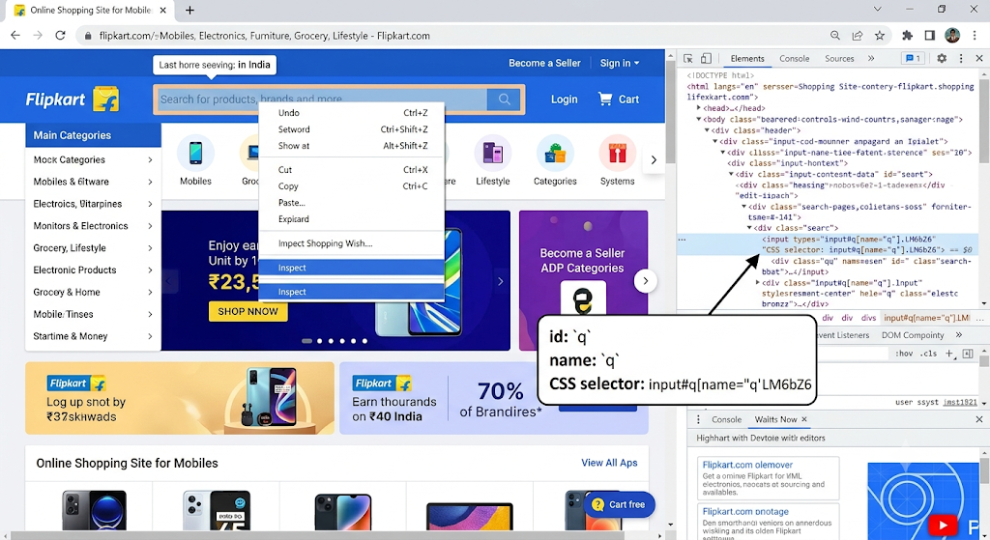 2.
On the Zomato homepage, use Chrome DevTools to extract the XPath for the 'Log in' link and explain whether this locator is likely to be stable or fragile.<br><br><em><strong>Hint:</strong> Consider if the XPath depends on position or text that might change.</em>
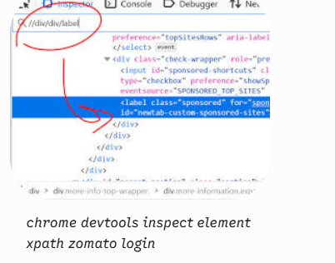racted XPaths for Zomato 'Log in' Link
- Relative XPath (Text-based): //a[text()='Log in'] or //a[contains(text(),'Log in')]
- Absolute XPath (DOM Position): /html/body/div[1]/header/div/ul/li[3]/a (or /html/body/div[1]/div/div[2]/header/nav/ul/li[3]/a)
Stability Evaluation: Fragile
Both types of XPaths extracted for this element are inherently fragile and prone to breaking during automated test execution:
- Text-based XPath (//a[text()='Log in']): This locator breaks if Zomato updates UI copy (e.g., changing "Log in" to "Sign In", "Login", or localized translations like "Entrar"). Additionally, if an icon or extra <span> tag is added inside the link, exact text() matching fails.
- Absolute/Positional XPath (/html/body/div/...): This is extremely
- fragile because any change to surrounding parent elements, layout updates, or dynamic wrapper <div> tags added by framework bundles immediately invalidates the strict DOM hierarchy.
Better Alternative: Target a dedicated attribute, such as a[aria-label="Log in"] or a[data-testid="login-link"], which remains invariant even across UI redesigns.
To see how to write resilient XPaths and select stable locators step-by-step using DevTools, this tutorial on Zomato Clone Building provides visual context on structural web element positioning.
3.
Choose any visible button on the BookMyShow homepage and use Chrome DevTools to extract both its CSS selector and XPath. Paste both locators and briefly describe which one you think is more reliable for automation.
Button Chosen: "Sign in" (top right corner of the BookMyShow homepage)

Locator Type | Locator String
CSS Selector | button[data-testid="header-sign-in-btn"] (or div.sc-1v2v2v-0 > button depending on dynamic class hashing)
XPath | //button[text()='Sign in'] (or relative path: //div[@id='super-container']//button[contains(.,'Sign in')])
Which Locator is More Reliable for Automation?

The CSS Selector (specifically targeting an explicit attribute like data-testid or a stable id/name) is significantly more reliable.

- Maintainability & Stability: CSS selectors referencing data attributes or IDs don't break when UI copy changes or when site localized text updates. XPaths relying on exact visible text (text()='Sign in') break immediately if the label changes to "Login", "Sign In", or is translated into another language.

- Performance: CSS selectors execute faster natively across all modern web browsers compared to XPaths, which require the browser's engine to parse the full XML/DOM tree structure.

4.
Using Selenium IDE, record a simple test on Myntra.com that clicks the 'Men' menu link. After recording, view the test step and note which locator type Selenium IDE picked for the 'Men' link (id, name, linkText, CSS, or XPath).

When recording the click action on the 'Men' header link on Myntra.com using Selenium IDE, the tool captures multiple locator strategies and automatically designates one as the primary target.

1. Primary Recorded Locator Type
- Locator Strategy Picked: linkText (rendered in Selenium IDE as linkText=MEN or link=MEN).

- Recorded Target: linkText=MEN

Why Selenium IDE prioritizes this:
For standard HTML anchor (<a>) tags containing plain text, Selenium IDE defaults to linkText because it directly matches the user-visible hyperlink text without relying on underlying HTML dynamic class names.

2. Alternative Recorded Locators (Fallback Targets)
If you click on the Target dropdown in Selenium IDE for that recorded step, you will see the full list of secondary fallback locators generated during the recording:

- CSS Selector: css=.desktop-navLink:nth-child(1) > .desktop-main (or css=a[data-group="men"])

- XPath (Relative): xpath=//header[@id='desktop-header-cnt']//a[contains(text(),'Men')]

- XPath (Position/Index): xpath=//div[1]/nav/div/div[1]/a

5.
Pick a product listing element (like a product card) on Amazon.in and suggest a custom CSS selector that would remain stable even if the site's layout changes slightly. Justify your selector choice.<br><br><em><strong>Hint:</strong> Avoid selectors based only on index or class names that look auto-generated.

Custom CSS Selector for an Amazon Product Card
Selector:

CSS
div[data-component-type="s-search-result"][data-asin]:not([data-asin=""])
(Alternative variant targeting a specific product component within the card, e.g., the title link):

CSS
div[data-component-type="s-search-result"] h2 a

Justification of Choice
- Reliance on Stable data-* Attributes:
Amazon's core search engine layout heavily utilizes internal data attributes like data-component-type="s-search-result" to define search results structural components. Unlike layout CSS classes (which frequently change during A/B testing or site updates), these data attributes remain consistent across deployments.

- Avoiding Dynamic, Obfuscated Classes:
Selectors built on CSS utility classes like .s-result-item.s-asin.sg-col-4-of-12 or auto-generated hashes are prone to breaking whenever Amazon changes grid column structures, padding rules, or responsive breakpoints.

- Domain-Specific Unique Identifiers (data-asin):
Every real product listed on Amazon is assigned a unique 10-character ASIN (Amazon Standard Identification Number). Amazon attaches this to product card containers via the data-asin HTML attribute. Filtering for div[data-asin]:not([data-asin=""]) guarantees that you are selecting actual product listings while excluding promotional ad banners, carousel wrappers, or empty container placeholders.

- Structure-Independent:
This selector does not rely on rigid positional relationships like :nth-child() or absolute parent-child paths (e.g., div > div > div > div), ensuring the automation test will not break if Amazon inserts or removes wrapper elements.

