**STYLE GUIDE FOR FITFLEX APP**

1. **Consistent Layout**: In the application all the pages should be consistent with the page layout size, header and footer locations, image placing and font size and style.
2. **Grid Set Up**: A competent layout has a solid structure behind it with fully responsive and reliable grid, properly aligning the contents. The grid should contain certain mandatory aspects like container, units, number of rows and columns, and margins. In this app, pages such as home page, recipe page considers a grid layout with two columns mandatory. Each grid should contain a minimum width of 98-102px and height of 95-100px. Every grid should maintain a padding of 2 px across left, right, top and bottom. The corner edges should maintain a radius of 12 px.

For Example:

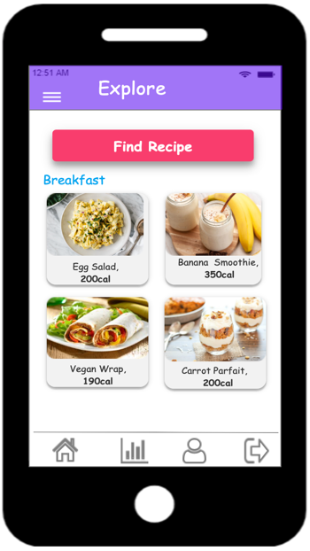

98-102 px

95-100 px

1. **UI components**- All the UI components such as buttons, navigation, notifications, form elements and icons create consistency and depicts a better overall look. Each one of them has its own personality, its own set of rules and properties that can interact individually as well as together, as a part of an evolving system.

* Buttons: Here buttons are of type contained buttons and buttons should contain height in the range of 30-35px an width in the range of 115-125px. All the buttons should have a shadow effect and a border of thickness 1, the text in the button should maintain the font type, all these features provide good look and feel of the application.

**Usage**

On Hover

#u8 .text {

1. position: absolute;
2. align-self: center;
3. padding: 3px 16px 2px 17px;
4. box-sizing: border-box;
5. width: 100%;

}

Link Buttons

Shadow effect

* **Form Elements**: Group labels with their inputs, bring to light basic helper text wherever possible, use one column in your form, include all possible feedback like active, valid, warning, error and so on. Error messages should pop up as soon as user enters incorrect input and the color of the error should be of same color.

For Example:

1. **Color Palette**:

1. **Typography:**

FONT TYPE: This is Comic Sans MS