Analysing U.K. Police Bias

*Abstract*— The aim of this project is to review U.K. Police information, which is freely available on their website [1], in order to determine if the U.K. police is biassed toward women, minorities, or other groups. From February 2020 to February 2021, we gathered road data as well as halt and look data. We use this information to dissect it to determine if there is bias based on race or gender within the police system. Within the presentation, we also look at how the widespread has affected the wrongdoing rates in the United Kingdom.

# INTRODUCTION

Each legal system in the United Kingdom, including England, Wales, and Northern Ireland, has its own law enforcement. [2] Some recent cases [3], [4], [5] have indicated that the UK police discriminate against people based on their skin colour. In this investigation, we want to see if this is true. We simply want to know if the pandemic has had any effect on crime and policing...

## A. Pandemic effect on crimes

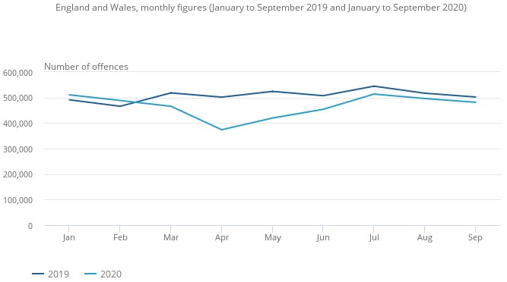 Take a look at the information on the UK Police website.. [6]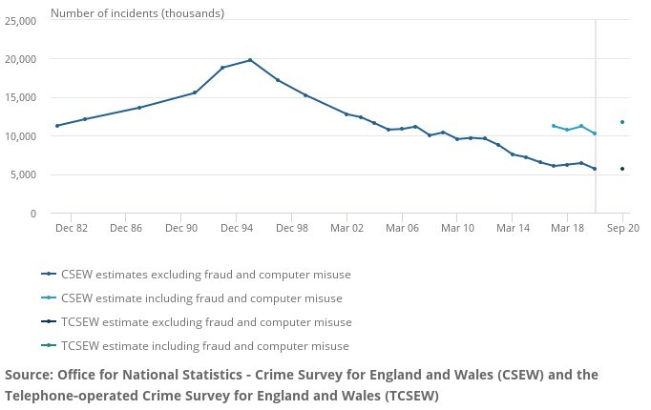

Fig. 1: From July to September 2020, police recorded crime levels that were equivalent to those seen prior to the Coronavirus pandemic.

The number of crimes reported to the police is depicted in Figure 1. This may be due to the pandemic and the subsequent lockdowns. The number of offences is steadily decreasing. This can be seen in the graph, which shows that the number of crimes registered in the year ending September 2020 fluctuates.

To continue measuring crime during the pandemic, a telephone version of CSEW (TCSEW) was created, as shown in Figure 2, which depicts total crime figures for England and Wales as reported by the face-to-face Crime Survey (CSEW). CSEW had to be suspended in March 2020 due to COVID-19, so the graph shows TCSEW data from March 2020 onwards. Since the mid-1990s, crime estimates have been poor, as seen in the graph.

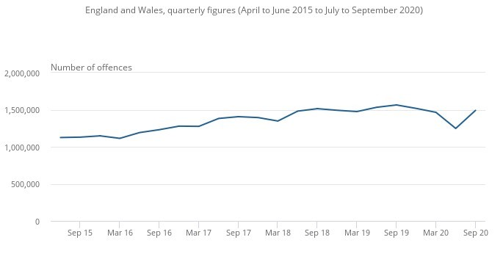

Fig. 2: CSEW crime estimates from December 1981 to March 2020, and TCSEW crime estimates from September 2020 to September 2020

April-June 2020, followed by July-September 2020. This may be due to the easing of lockout, but the number of offences in July-September 2020 is still smaller than in July-September 2019. This plot is depicted in Figure 3.

Fig. 3 Plot of crimes reported by police from July to September 2020 compare with September 2019

## Figure 3 shows that the number of reported offences between April and September 2020 remained lower than the number between April and September 2019. Nonetheless, when the lockout restrictions were lifted, the disparity began to fade.

## B. Ethnicity in case of Stop and search

When an individual is stopped and searched, they are asked to identify themselves. These figures are focused on ethnicity information [7]. Table 4 reveals that people who identify as BAME account for a higher proportion of all stops in the MPS sector when opposed to powers in the rest of England and Wales.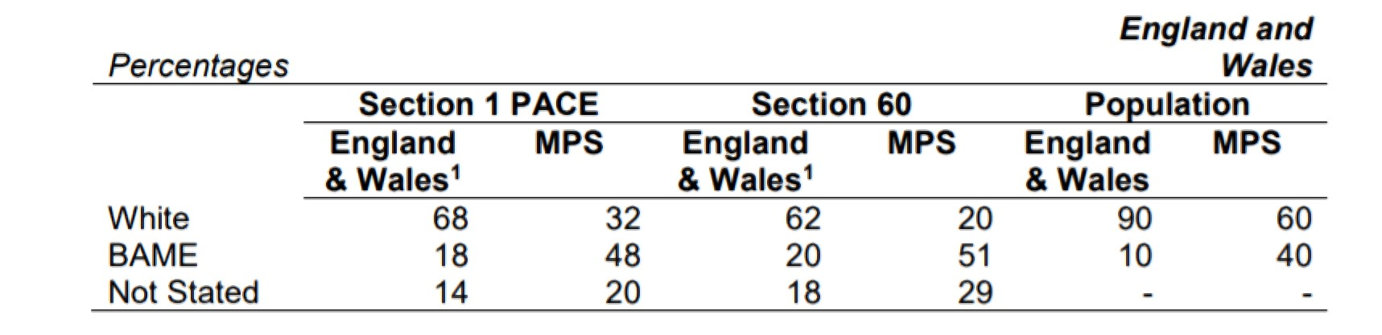

Fig. 4: Stop and scan proportions by ethnicity in England and Wales, as well as the MPS market, for the fiscal year ending March 2020.

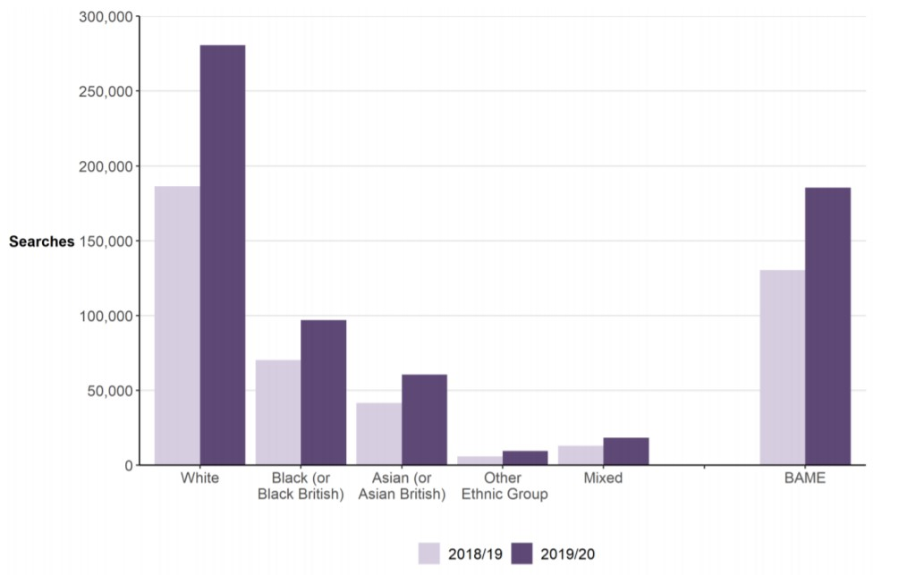

Fig. 5: Plot of ethnicity-based shifts in stop and search in England and Wales..

As seen in Figure 5, the use of stop and search has risen across all ethnic groups in the last year. When it comes to numbers, white people have seen the greatest increase in any ethnic group. This is a serious problem since, if true, the policing algorithm would need to be changed. [8]

# LITERATURE REVIEW

According to the article [8,] in the United Kingdom, Black and Asian citizens are more likely than White people to be arrested and searched. The findings show that most police officers perform disproportionate searches of minorities, but they also argue that this is because minority neighborhoods are over-patrolled. The author [9] also investigates the impact of a one-day training curriculum on police ethnic/racial discrimination during stop and search operations. The programme, they say, would help officers improve their competence and skills while also mitigating bias. The authors of [10] provide a number of policy-based recommendations for reducing police bias. Developers of algorithmic policing technologies have also called for the use of algorithmic policing methods in news reports, such as [11].

# METHODOLOGY

## We downloaded data for Halt, Look, and Path from January 2019 to February 2021. In each organiser, the records are organised in month-by-month packets, with separate records for various regions, as well as halt and look and road information. We started by merging the records to build a Pandas information outline with all of the details, which we could then pause and examine.

## Bias analysis on the basis of gender - Stop and Search

Following entries are present in the dataset like the facts about the person's gender, the person's ethnicity, as determined by himself. The ethnicity of the person identified by the police officer or the type of quest, such as an individual or vehicle search or both a person and a vehicle search. Figure 6 depicts the distribution of the count or number of stops and searches after grouping the data by type of search and year. Figure 7 depicts the same distribution as a Kernel density estimate (KDE) map.

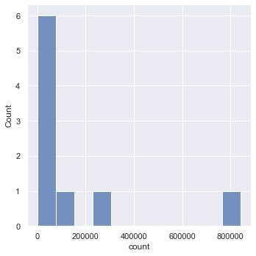

Fig. 6: Box plot Distribution of search by type and year

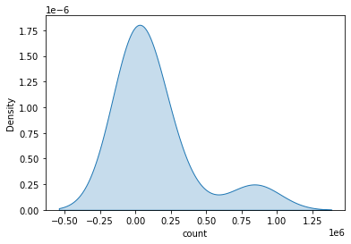

Fig. 7: Gaussian Distribution of search w.r.t to type and year

To better understand the details, box plots are used. As a result, we divide the data into three categories: type, year, and gender. Figures 8 and 9 depict boxplots based on sex and year, respectively. Figure 8 depicts a boxplot with type and gender, while Figure 9 depicts a boxplot with year and gender. We can see that the majority of the people being searched are men.

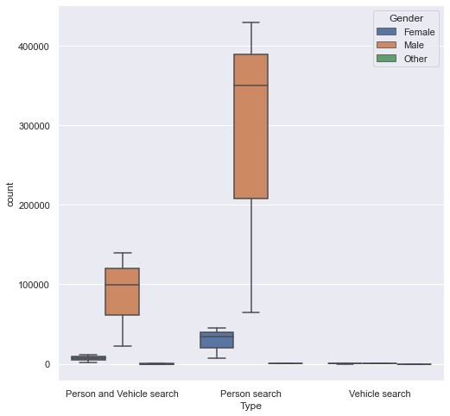

Fig. 8: Boxplot – type and gender

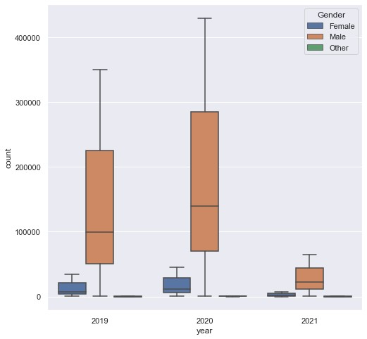

Fig. 9: Boxplot - year and gender

## B. Bias analysis on the basis of ethnicity - Stop and Search

After that, we combined the 2021 and previous happiness data and went through some of the previous research again. Box plots of the number of stops by form are shown in Figures 10 and 11, with hues indicating self-defined and officer-defined ethnicity, respectively.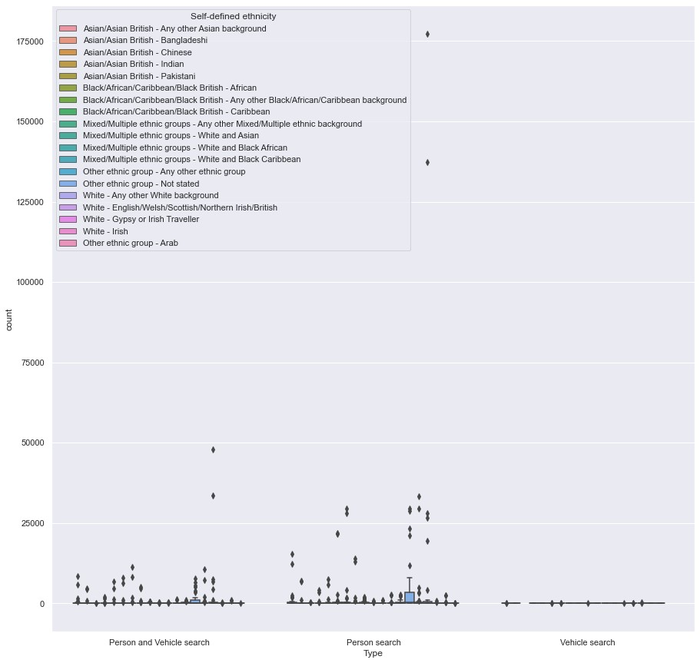

Fig. 10: Boxplot - type and Person ethnicity

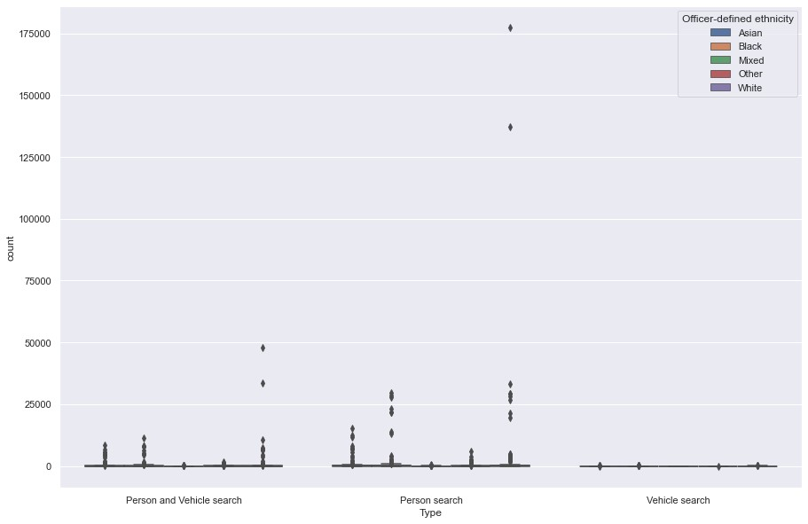

Fig. 11: Boxplot by type and Officer-defined ethnicity

Figures 12 and 13 show a box plot of the number of stops made each year by ethnicity as specified by the officer and the resident. Figures 14 and 15 display the same kind of boxplot with type, with the exception that we have reduced the number of stop and search points and re-boxplot it to make it easier to understand and imagine. Figures 16 and 17 display the boxplot for the year of self-defined ethnicity and officer-defined ethnicity, respectively, with a small number of stops and searches. These box plots show that white people are being stopped less often.

.

# RESULTS

We may assume that there is some gender imbalance since we were able to see it using box plots with gender. 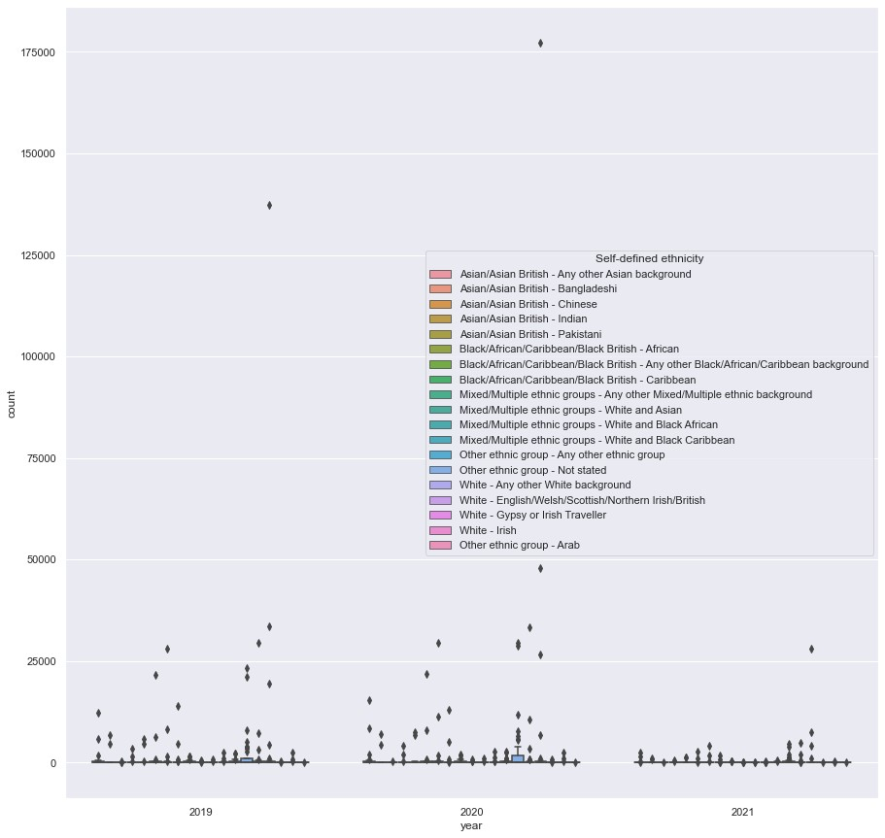

Fig. 12: Boxplot - by year with ethnicity as described by the Person

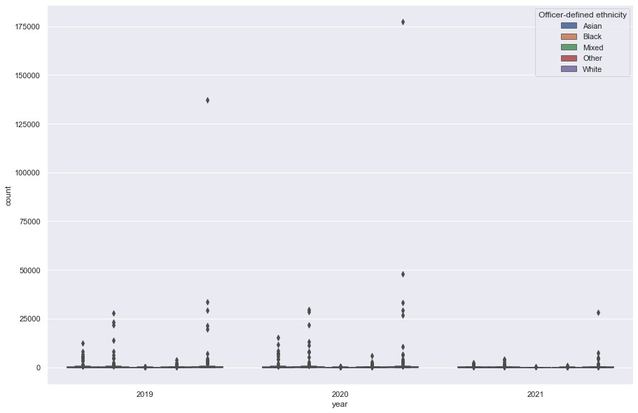

Fig. 13: Boxplot - by year with Officer-defined ethnicity

Males are prevented in disproportionately large numbers. However, we might need more information, such as the gender distribution of people in cars, before we can be certain. We also agree that there is an ethnic difference, with white people being stopped less often.

# DISCUSSION

Sex, as well as ethnicity, can play a role in stop-and-frisk situations, according to our current research.

# CONCLUSION

Finally, we'd like to state that we were able to provide some useful insights into the analysis of whether or not the UK Police are biassed using the given data set. We acknowledge that discrimination based on gender and ethnicity exists.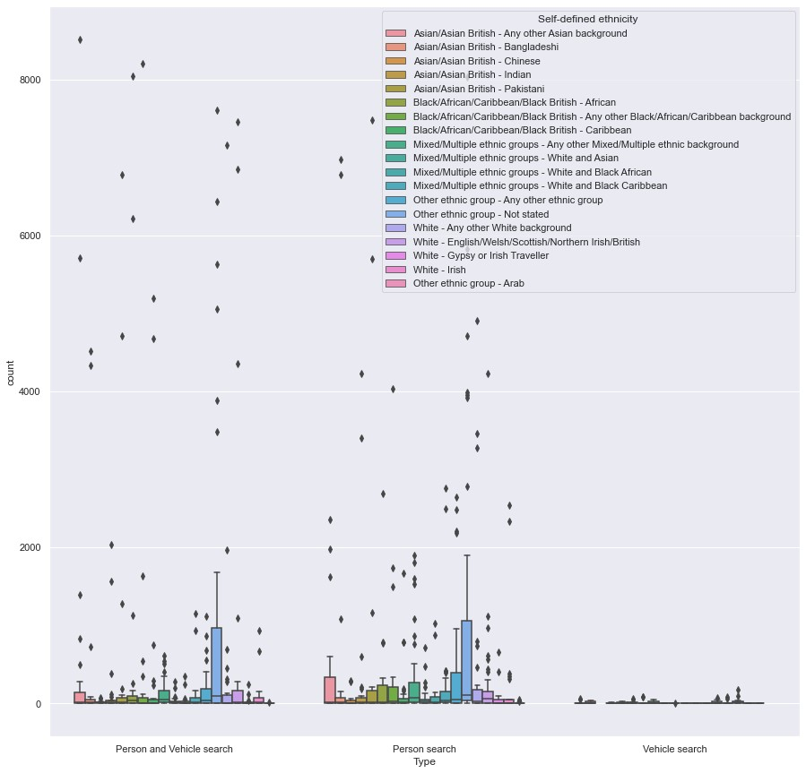

Fig. 14: Boxplot - by type ethnicity as described by the Person

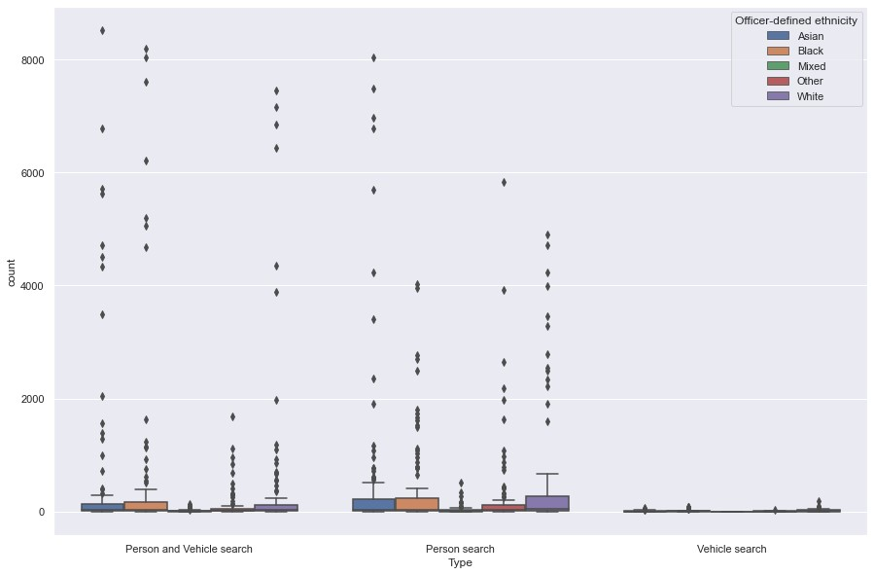

Fig. 15: Boxplot - by type and ethnicity as described by the officer

# REFERENCES

1. U.K. Police. U.K. Police Data. [Online]. Available: https://data.police.uk/data/
2. Wikipedia. Law enforcement in the United Kingdom. [Online]. Available:

https://en.wikipedia.org/wiki/Law enforcement in the United Kingdom

1. The Guardian. 65% of minority ethnic Britons say police are biased against them. [Online].

Available: https://www.theguardian.com/uk-news/2020/aug/20/65-ofminority-ethnic-britons-say-police-are-biased-against-them

1. The Week. Black Lives Matter protests: do UK police have a race problem? [Online]. Available: https://www.theweek.co.uk/107163/dobritish-police-have-a-race-problem-black-lives-matter-protests
2. The Guardian. Black people nine times more likely to face stop and search than white people. [Online]. Available: https://www.theguardian.com/uk-news/2020/oct/27/black-peoplenine-times-more-likely-to-face-stop-and-search-than-white-people
3. U.K. Police. U.K. Police Statistical Data. [Online]. Available: https://data.police.uk/data/statistical-data/
4. ——. Police powers and procedures, England and Wales, year ending 31 March 2020 second edition. [Online].

Available: https://www.gov.uk/government/statistics/police-powers-andprocedures-england-and-wales-year-ending-31-march-2020

1. L. Vomfell and N. Stewart, “Officer bias, over-patrolling and ethnic disparities in stop and search,” *Nature Human Behaviour*, 01 2021.
2. J. Miller, P. Quinton, B. Alexandrou, and D. Packham, “Can police training reduce ethnic/racial disparities in stop and search?

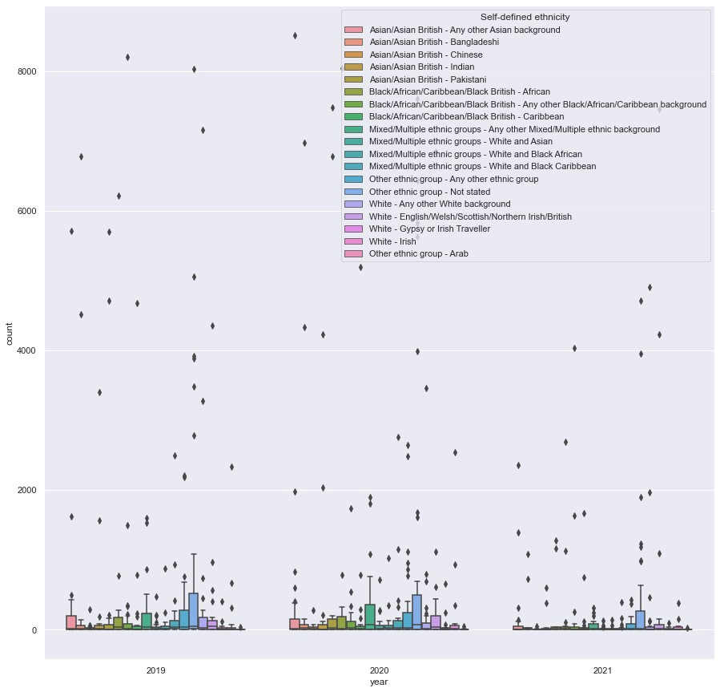

Fig. 16: Boxplot - by year with ethnicity as described by the person

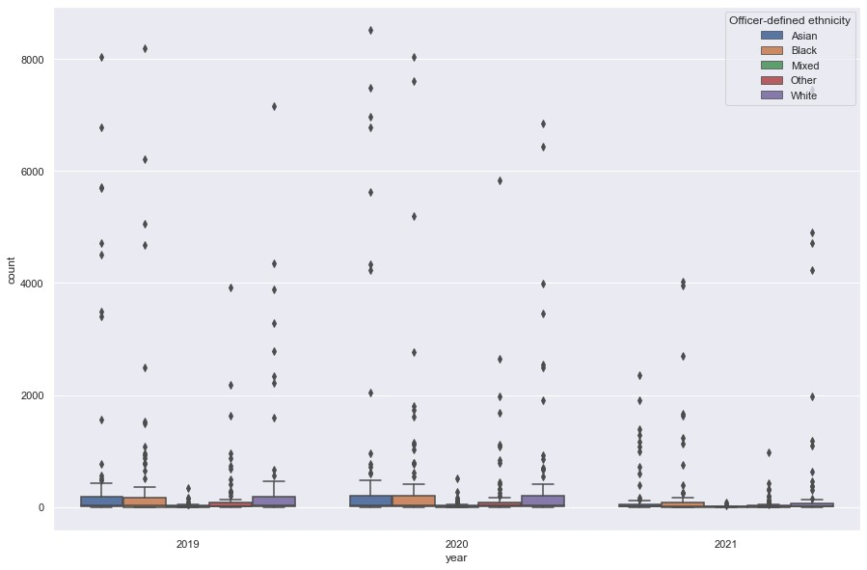

Fig. 17: Boxplot - by year with ethnicity as described by the officer

evidence from a multisite uk trial,” *Criminology & Public Policy*, vol. 19, no. 4, pp. 1259–1287, 2020. [Online]. Available: https://onlinelibrary.wiley.com/doi/abs/10.1111/1745-9133.12524

1. R. G. Dunham and N. Petersen, “Making black lives matter,” *Criminology & Public Policy*, vol. 16, no. 1, pp. 341–348, 2017. [Online]. Available: https://onlinelibrary.wiley.com/doi/abs/10.1111/17459133.12284
2. Prospect. The dangerous rise of policing by algorithm.

[Online]. Available: https://www.prospectmagazine.co.uk/science-andtechnology/the-dangerous-rise-of-policing-by-algorithm