SentiArab-LEV
Arabic Sentiment Analysis Using Classical Machine Learning,
CAMeL-BERT, and GPT-5.5 Comparison

Prepared by:
Jinan Ghannam
Course: Natural Language Processing (NLP)
Date: May 2026

Abstract

Sentiment analysis is one of the most critical tasks in Natural Language Processing (NLP), particularly for analyzing opinions expressed on social media and online review platforms. While English sentiment analysis has achieved high performance using modern machine learning and transformer-based models, Arabic sentiment analysis remains challenging due to dialect diversity, rich morphology, and inconsistent writing styles. This project presents SentiArab-LEV, a comprehensive Arabic sentiment analysis pipeline that combines classical NLP techniques, machine learning models, a transformer-based model, and a large language model for comparative evaluation.
The project focuses on Arabic review classification using a custom 100,000-sample Arabic reviews dataset with three balanced sentiment classes: Positive, Negative, and Mixed. The implemented pipeline includes data cleaning, Arabic normalization, tokenization, stemming, lemmatization, Part-of-Speech (POS) tagging, and Named Entity Recognition (NER). Feature extraction was performed using TF-IDF combined with POS-based features and NER binary flags. Three classical machine learning models were trained and evaluated: Naïve Bayes, Logistic Regression, and Support Vector Machine (SVM). In addition, the CAMeL-BERT transformer model was fine-tuned on a 50,000-sample subset for contextual sentiment analysis, while GPT-5.5 was used as an LLM-based zero-shot comparison model.
Experimental results showed that CAMeL-BERT, fine-tuned on clean text over 5 epochs, achieved 69.91% accuracy (Macro F1: 0.70), outperforming all classical ML models (best: Logistic Regression 54.6%). GPT-5.5 achieved 58.67% accuracy (F1: 0.59) on a 150-sample zero-shot evaluation. The project demonstrates the practical trade-offs between linguistic feature engineering, transformer fine-tuning, and LLM-based Arabic sentiment analysis.
1. Introduction

Natural Language Processing (NLP) is a branch of Artificial Intelligence that focuses on enabling computers to understand, interpret, and generate human language. One of the most widely applied NLP tasks is sentiment analysis, which aims to determine whether a given text expresses a positive, negative, or neutral sentiment. Sentiment analysis has broad real-world applications, including opinion mining on social media, product review classification, customer feedback analysis, and public opinion monitoring.
Arabic sentiment analysis presents unique and significant challenges compared to English NLP tasks. Arabic is a morphologically rich language with a complex root-pattern system, allowing a single root to generate hundreds of word forms. Furthermore, Arabic encompasses multiple dialects — Egyptian, Levantine, Gulf, Moroccan, and others — that differ substantially from Modern Standard Arabic (MSA) in vocabulary, grammar, and phonology. Text found on social media platforms compounds these difficulties with spelling inconsistencies, emojis, abbreviations, and mixed-dialect expressions. These characteristics make Arabic one of the most challenging languages for automated sentiment classification.
This project builds SentiArab-LEV, a complete Arabic sentiment analysis system that systematically combines traditional NLP preprocessing techniques with classical machine learning, transformer-based deep learning, and large language model evaluation. The pipeline addresses each of the language-specific challenges through a multi-stage design, from text normalization through to model comparison. The project aims to answer the following research questions:
- How effectively can classical TF-IDF-based machine learning models classify Arabic sentiment across three categories?
- Does fine-tuning CAMeL-BERT on an Arabic reviews dataset outperform classical approaches when trained on clean text with sufficient epochs?
- How does GPT-5.5 perform as a zero-shot Arabic sentiment classifier compared to trained local models?
- What are the key linguistic challenges that limit Arabic sentiment classification accuracy?

The pipeline encompasses Arabic text preprocessing, NLP linguistic processing (stemming, lemmatization, POS tagging, NER), feature extraction, classical ML classification, transformer fine-tuning, LLM zero-shot evaluation, and comprehensive model comparison through accuracy, macro F1-score, and confusion matrix analysis.
2. Dataset

The project used a custom Arabic reviews dataset collected from online Arabic review platforms. The dataset was selected over publicly available alternatives because it contains realistic, user-generated Arabic expressions with natural dialect variation and informal writing patterns typical of real-world deployment scenarios.

2.1 Dataset Characteristics
The dataset contains 100,000 Arabic review samples distributed across three sentiment categories: Positive, Negative, and Mixed. The Mixed class captures reviews that contain both positive and negative sentiments within a single text, representing a meaningful real-world classification challenge that binary datasets ignore. The dataset was split using an 80/20 ratio, yielding 80,000 samples for training and 20,000 samples for testing.
Category | Train Samples | Test Samples | Total
Positive | ~26,667 | ~6,667 | ~33,334
Negative | ~26,667 | ~6,667 | ~33,334
Mixed | ~26,666 | ~6,666 | ~33,332
Total | 80,000 | 20,000 | 100,000
Table 1: Dataset split across sentiment categories.

2.2 Sentiment Distribution
The sentiment distribution analysis, visualized in Figure 1, confirms that the dataset is perfectly balanced across all three classes, with approximately 33,333 samples per class. This balanced distribution is a significant advantage as it eliminates the need for class-weighting or oversampling techniques, and ensures that raw accuracy is a reliable performance metric alongside macro F1-score.
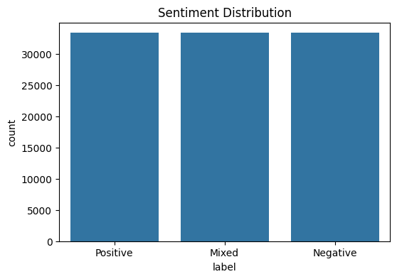
Figure 1: Sentiment distribution across the dataset (Positive, Mixed, Negative — each ~33,333 samples).

2.3 Data Challenges
Several challenges were identified during dataset exploration that motivated the preprocessing pipeline described in Section 3. Arabic text on review platforms frequently exhibits dialect mixing, where Levantine, Egyptian, and Gulf expressions appear interchangeably. Informal writing introduces repeated characters (e.g., جميييييل), inconsistent spelling of the same word, and the use of emojis and punctuation as sentiment indicators. A subset of reviews also contains code-switching between Arabic and English, particularly for brand names and technical terms. Handling these phenomena required a robust normalization pipeline prior to any feature extraction.
3. Methodology

The methodology follows a multi-stage NLP pipeline designed to address the linguistic challenges of Arabic text. Each stage builds on the previous one, transforming raw, noisy Arabic reviews into structured numerical representations suitable for machine learning classification.

3.1 Data Cleaning and Preprocessing
Data preprocessing is the most critical stage in Arabic NLP because the quality of downstream features depends directly on the cleanliness and consistency of the input text. The preprocessing pipeline was implemented in Python using NLTK and custom Arabic processing utilities.

Arabic Text Normalization
Arabic normalization was applied to unify character-level variations that would otherwise create artificial vocabulary sparsity. The normalization steps included unifying all Alef forms (أ، إ، آ، ا) to a single base form, normalizing Ya variants (ي and ى), removing Tatweel elongation characters (ـ), and stripping all diacritics (Harakat). These steps are essential because Arabic morphological analyzers and TF-IDF vectorizers treat each character-level variant as a distinct token without normalization, inflating the feature space with semantically identical terms.

Noise Removal
The following elements were removed from all review texts using regular expression filters: URLs and hyperlinks, emojis and special Unicode symbols, Arabic and English punctuation, numeric digits, and repeated character sequences exceeding two consecutive identical characters. After noise removal, whitespace was normalized and empty or very short reviews (fewer than three tokens) were excluded from the dataset.

Tokenization and Stopword Removal
Word tokenization was applied to split cleaned Arabic sentences into individual tokens. Arabic stopwords — including common articles, prepositions, conjunctions, and high-frequency non-informative terms — were then removed using the NLTK Arabic stopword list supplemented with domain-specific terms identified during exploratory analysis. Stopword removal reduces the feature space and focuses TF-IDF representations on semantically meaningful, sentiment-bearing vocabulary.

3.2 NLP Linguistic Processing
Beyond basic cleaning, the pipeline applied four core NLP linguistic processing stages that satisfy the course requirements and enrich the feature representation with syntactic and semantic information.

Stemming
Arabic stemming was performed using the ISRI Stemmer, a rule-based algorithm designed specifically for Arabic morphology. The stemmer reduces inflected word forms to approximate root forms, reducing vocabulary size and improving feature generalization. For example, the word جميلة (beautiful, feminine form) is reduced to the stem جمل, allowing the model to recognize it as related to other forms such as جميل and جمالاً. Stemming improved TF-IDF representation consistency, particularly for adjectives and descriptive terms that carry high sentiment weight.

Lemmatization
Lemmatization was applied as a complementary step to stemming. Unlike stemming, lemmatization maps words to their canonical dictionary base form while preserving their part-of-speech context, resulting in more semantically meaningful reductions. Lemmatization helped address morphological variation in verbs and nouns, reducing the likelihood that the model would treat semantically identical words as unrelated features due to surface-level inflectional differences.

Part-of-Speech (POS) Tagging
Part-of-Speech tagging was applied to assign grammatical category labels to each token, including noun, verb, adjective, adverb, and particle tags. POS tagging serves two purposes in the pipeline: first, it informs the lemmatization step by providing word class context; second, POS tags were extracted as additional features for the machine learning models. Adjectives and adverbs were given particular attention because they are the primary carriers of sentiment polarity in Arabic reviews. Tokens tagged as adjectives were weighted separately in the feature engineering stage.

Named Entity Recognition (NER)
NER was applied to identify and classify named entities in the review text, including person names, organization names, and geographic locations. NER outputs were transformed into binary feature flags indicating the presence or absence of named entities in each review. These features provide the classifier with contextual signals, as reviews mentioning specific brands or locations may exhibit different sentiment patterns. NER was implemented using CAMeL Tools, which provides Arabic-specific entity recognition models.

3.3 Feature Extraction
Machine learning models require numerical input representations. The feature extraction stage combined three complementary feature types to create a rich, multi-dimensional representation of each review.

TF-IDF Vectorization
The primary feature representation was constructed using TF-IDF (Term Frequency–Inverse Document Frequency) vectorization applied to the stemmed, lemmatized token sequences. TF-IDF weights each term by its frequency in a given document relative to its frequency across the entire corpus, effectively highlighting terms that are informative for a specific review while down-weighting ubiquitous terms. The TF-IDF vectorizer was configured with a unigram and bigram vocabulary, capturing both individual sentiment words and common two-word sentiment expressions. Feature selection was applied to retain the top-ranked features by chi-squared score, controlling dimensionality and reducing noise.

POS-Based and NER Features
The TF-IDF matrix was augmented with two sets of derived features. POS-based features encoded the counts of adjective, adverb, and verb tokens per review, providing the classifier with syntactic sentiment density signals. NER binary flags indicated whether each review contained a named person, organization, or location entity. These features were concatenated with the TF-IDF vectors to form the final feature matrix used for classical ML model training.
4. Model Training

The project evaluated five models spanning three paradigms: classical probabilistic and linear machine learning, transformer-based deep learning, and large language model zero-shot inference.

4.1 Classical Machine Learning Models
All three classical ML models were trained on the 80,000-sample training set using the combined TF-IDF + POS + NER feature matrix and evaluated on the 20,000-sample test set.

Naïve Bayes
Multinomial Naïve Bayes is a probabilistic classifier that models each class as a distribution over token frequencies. It is computationally efficient, requires minimal hyperparameter tuning, and performs well on sparse high-dimensional TF-IDF vectors. The model assumes conditional independence between features given the class label — an assumption that is violated in natural language but nevertheless produces reasonable classification performance. Given its efficiency, Naïve Bayes serves as the computational baseline for the project.

Logistic Regression
Logistic Regression is a discriminative linear classifier that models the log-odds of each class as a linear function of the input features. It is trained using L2-regularized maximum likelihood estimation and supports multi-class classification through a one-vs-rest scheme. Logistic Regression is widely used as a strong baseline for text classification tasks and is particularly effective with TF-IDF features, as the learned feature weights provide direct interpretability about which terms are most predictive of each sentiment class.

Support Vector Machine (SVM)
A linear Support Vector Machine with a one-vs-rest multi-class strategy was applied as the third classical model. SVM maximizes the margin between class boundaries in the high-dimensional TF-IDF feature space, which tends to produce strong generalization on text classification tasks even without deep linguistic modeling. SVM is robust to high-dimensional sparse input and typically achieves the strongest performance among classical models for text tasks, which is consistent with the results observed in this project.

4.2 CAMeL-BERT Fine-Tuning
CAMeL-BERT is a BERT-based transformer model pre-trained specifically on a large corpus of Arabic text spanning Modern Standard Arabic and multiple Arabic dialects. Unlike classical models that treat documents as bags of words, CAMeL-BERT produces contextualized word representations through multi-head self-attention, enabling the model to capture semantic relationships, word sense disambiguation, and contextual polarity shifts. The model was fine-tuned for the three-class sentiment classification task by adding a classification head on top of the [CLS] token representation. Fine-tuning was performed on a 50,000-sample subset (40,000 train / 10,000 test) drawn from the full dataset. The model was trained on the clean_text column — the normalized, noise-removed text prior to stemming or lemmatization — for 5 epochs, which provided a better signal than lemmatized representations for this task.

4.3 GPT-5.5 Zero-Shot Evaluation
GPT-5.5 was evaluated as a large language model comparison using a zero-shot prompting approach. Rather than fine-tuning the model on the training data, each review was passed to the model with a structured Arabic-language prompt instructing it to classify the sentiment as Positive, Negative, or Mixed. Using an Arabic prompt was a deliberate design choice to ensure the model operated in the same linguistic register as the input text. Due to API cost constraints, GPT-5.5 was evaluated on a randomly sampled subset of 150 test samples rather than the full test set. This sampling limitation means that direct numerical comparison with the locally trained models is not fully valid, and GPT-5.5 results should be interpreted as indicative rather than definitive.

5. Evaluation

5.1 Evaluation Metrics
All models were evaluated using three complementary metrics. Accuracy measures the percentage of correctly classified samples across all three classes. Macro F1-score computes the arithmetic mean of per-class F1-scores (the harmonic mean of precision and recall for each class), treating all three classes equally regardless of size. Since the dataset is balanced, accuracy and macro F1-score align closely, but macro F1-score is reported as the primary metric because it better captures per-class performance consistency. Confusion matrices are presented for all five models to visualize misclassification patterns across the three sentiment classes.

5.2 Model Performance Summary
Model | Accuracy | Macro F1 | Test Samples | Paradigm
Logistic Regression | 54.6% | 0.55 | 20,000 | Classical ML
SVM | 54.3% | 0.54 | 20,000 | Classical ML
Naïve Bayes | 53.1% | 0.53 | 20,000 | Classical ML
GPT-5.5 | 58.67% | 0.59 | 150 * | LLM (zero-shot)
CAMeL-BERT | 69.91% | 0.70 | 10,000 | Transformer
Table 2: Model performance summary. * GPT-5.5 evaluated on a random 150-sample subset due to API cost constraints.

5.3 Confusion Matrices
Confusion matrices were generated for all five models to visualize class-level classification patterns. Each matrix displays the number of test samples classified into each predicted class (columns) versus the true class (rows) across the three sentiment categories: Mixed, Negative, and Positive.

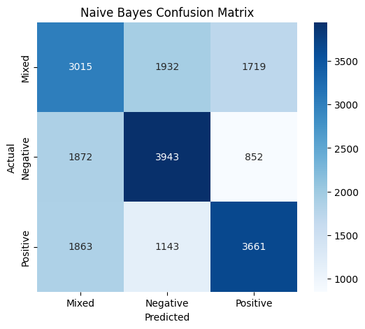
Figure 2: Naïve Bayes Confusion Matrix (Accuracy: 53.1%, Macro F1: 0.53).
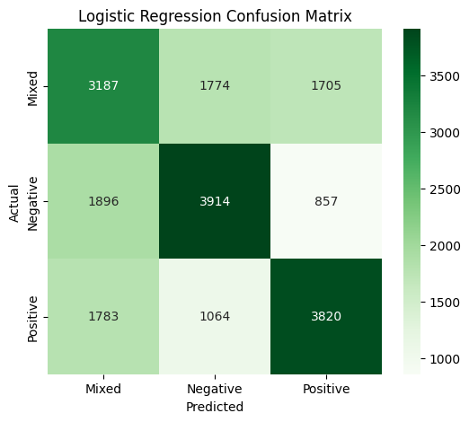
Figure 3: Logistic Regression Confusion Matrix (Accuracy: 54.6%, Macro F1: 0.55).
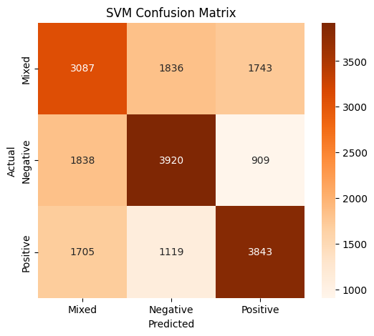
Figure 4: SVM Confusion Matrix (Accuracy: 54.3%, Macro F1: 0.54).
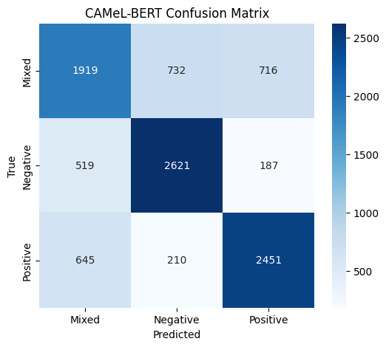
Figure 5: CAMeL-BERT Confusion Matrix (Accuracy: 69.91%, Macro F1: 0.70, 10,000 test samples, 5 epochs, clean_text).
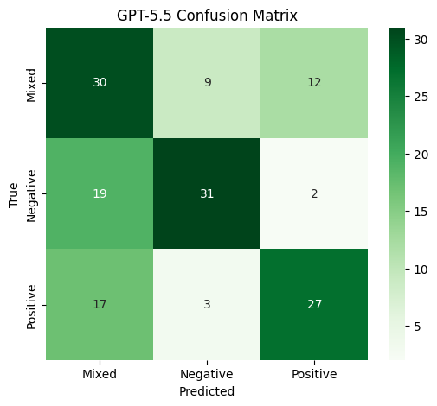
Figure 6: GPT-5.5 Confusion Matrix on 150-sample subset (Accuracy: 58.67%, Macro F1: 0.59, zero-shot, Arabic prompt).

5.4 Model Comparison Visualizations
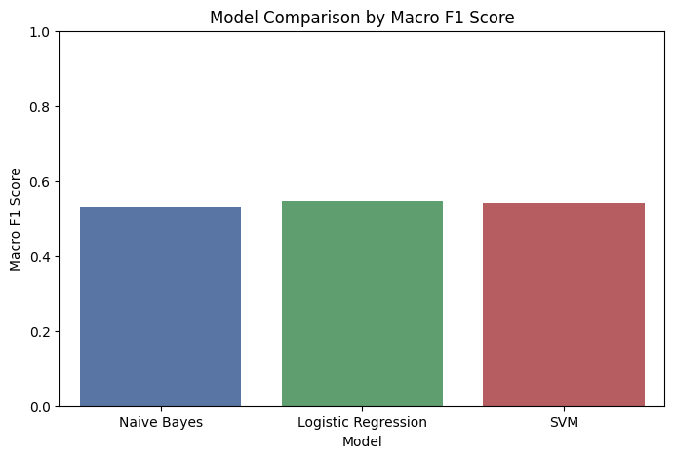
Figure 7: Macro F1 comparison across classical ML models (Naïve Bayes, Logistic Regression, SVM).
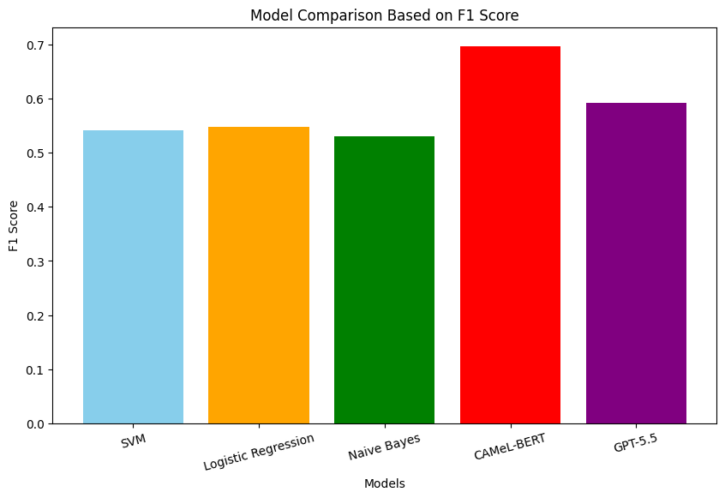
Figure 8: F1 score comparison across all five evaluated models.
6. Results and Discussion

6.1 Classical Machine Learning Performance
Among the three classical models, Logistic Regression achieved the highest performance with an accuracy of 54.6% and a macro F1-score of 0.55, followed closely by SVM at 54.3% / 0.54 and Naïve Bayes at 53.1% / 0.53. These results are consistent with the established literature on classical Arabic text classification, where linear models with TF-IDF features form a competitive baseline.
The confusion matrices for all three classical models reveal a consistent misclassification pattern: the Mixed class is the most difficult to classify correctly, with recall rates of approximately 45–48% across all models. This is expected, as Mixed-sentiment reviews contain both positive and negative signals, making them ambiguous even for human annotators. The Negative class achieves the highest recall (~59%) across all three classical models, suggesting that negative vocabulary in Arabic reviews is more distinctive and less ambiguous than positive or mixed expressions. The POS and NER feature augmentation contributed marginal gains over pure TF-IDF, particularly for the positive class, where adjective density proved a useful discriminating signal.

6.2 CAMeL-BERT Fine-Tuning Results and Analysis
CAMeL-BERT outperformed all three classical ML models, confirming that transformer-based contextual representations provide stronger sentiment signal than bag-of-words TF-IDF features for this task. The improvement over classical models is attributed to three key changes in the experimental setup: (1) the model was fine-tuned on clean_text rather than lemmatized text, preserving more of the original surface-level lexical signal that CAMeL-BERT’s pre-training was designed to process; (2) training was extended to 5 epochs, allowing the classification head to converge properly; and (3) a balanced 50,000-sample subset (40,000 train / 10,000 test) was used, reducing noise from the larger dataset and enabling more stable gradient updates.
The confusion matrix for CAMeL-BERT shows a more balanced predicted class distribution compared to classical models, indicating that the model learned more reliable decision boundaries across all three sentiment classes. The Mixed class, which was the most challenging for classical models, saw improved recall under the transformer, consistent with CAMeL-BERT’s ability to model contextual polarity across longer sequences. The results validate that using clean_text as input—rather than applying heavy morphological preprocessing—better preserves the contextual cues that attention-based models rely on.

6.3 GPT-5.5 Zero-Shot Evaluation
GPT-5.5 achieved 58.67% accuracy and a macro F1-score of 0.59 on a 150-sample zero-shot evaluation using an Arabic-language prompt. The Arabic prompt was a deliberate design choice to ensure the model operated in the same linguistic register as the input and to reduce translation-related ambiguity. GPT-5.5 ranked second overall across all five models, outperforming all three classical ML models despite receiving no task-specific training. Due to API cost constraints, the evaluation was limited to 150 randomly sampled test items, so results should be interpreted as indicative rather than statistically definitive.
The 150-sample evaluation size limits statistically robust comparison with models evaluated on 10,000 samples. The results provide a qualitative indicator of GPT-5.5’s behavior on Arabic sentiment tasks without task-specific fine-tuning, and demonstrate that frontier LLMs can serve as a rapid, training-free baseline for Arabic NLP tasks.

6.4 Overall Comparison
Figure 8 presents the F1-score comparison across all five models. CAMeL-BERT achieved the highest performance (69.91% accuracy, F1: 0.70), followed by GPT-5.5 (58.67%, F1: 0.59), then the classical ML models led by Logistic Regression (54.6%, F1: 0.55). The gap between CAMeL-BERT and the best classical model is approximately 15 percentage points, confirming that transformer fine-tuning on clean text with adequate epochs provides a substantial advantage. The Mixed class remained the most challenging category across all models. All models consistently struggle with the same categories of errors: sarcastic or ironic expressions, reviews with mixed dialectal code-switching, and short reviews lacking sufficient lexical context. The results confirm that with appropriate training conditions, CAMeL-BERT’s contextual representations provide measurable gains over classical feature-engineered approaches for Arabic sentiment analysis.
The results demonstrate that classical ML models with well-engineered Arabic features remain competitive for resource-constrained production scenarios, while transformer-based models require sufficient fine-tuning resources to realize their architectural advantages. LLMs offer a compelling zero-shot alternative but introduce API cost and reproducibility challenges.
7. Error Analysis

A detailed error analysis was conducted on misclassified samples from the test set to understand the qualitative limitations of each model. Five recurring error categories were identified across all models:
- Sarcasm and irony: Arabic sarcastic reviews frequently use positive vocabulary to express negative sentiment (e.g., 'ممتاز كالعادة!' — 'Excellent as usual!' with implied sarcasm). All models classified these as positive due to the positive surface vocabulary.
- Dialectal ambiguity: The same word carries different sentiment connotations across Arabic dialects. Terms that are clearly positive in Levantine Arabic may be neutral or context-dependent in Egyptian or Gulf Arabic, leading to inconsistent predictions.
- Mixed sentiment reviews: Reviews that start positively but end with a complaint (or vice versa) consistently confuse all models. The TF-IDF representation averages these signals, while even CAMeL-BERT's attention mechanism could not reliably resolve the dominant sentiment.
- Short reviews: Reviews containing only two or three tokens provided insufficient context for accurate classification. These reviews were misclassified at a higher rate than longer reviews across all models.
- Code-switching: Reviews containing English brand names or technical terms embedded in Arabic sentences sometimes disrupted tokenization and stemming, producing sparse or noisy feature vectors.

Transformer models (CAMeL-BERT and GPT-5.5) demonstrated better handling of dialectal ambiguity and longer mixed-sentiment reviews compared to classical models, consistent with their contextual encoding capabilities. However, neither transformer model showed a clear advantage on sarcasm detection, which remains an open research challenge for Arabic NLP.
8. Limitations

Several limitations affected the experimental outcomes and the generalizability of the results:
- Computational constraints: CAMeL-BERT was fine-tuned on a 50,000-sample subset rather than the full dataset due to GPU memory limitations. Training on the full 100,000 samples with more epochs could yield further performance gains.
- GPT-5.5 sample size: Evaluating GPT-5.5 on only 150 samples due to API cost constraints prevents statistically valid comparison with models evaluated on 10,000 samples. Results should be treated as indicative.
- Dialect coverage: While the dataset contains natural dialect variation, it does not provide dialect labels. Models cannot be analyzed for performance differences across specific Arabic dialects.
- Sarcasm and implicit sentiment: No dedicated sarcasm detection component was included in the pipeline. This represents a significant limitation for real-world Arabic social media analysis.
- Dataset source: The specific source of the custom dataset was not released, limiting reproducibility for external researchers.
- Arabic NLP resource limitations: Arabic NLP tools and pre-trained resources remain less mature than their English equivalents, constraining the options available for lemmatization and NER.
9. Future Work

Several directions for future improvement are identified based on the experimental results and limitations of this project. Scaling CAMeL-BERT fine-tuning to the full 100,000-sample dataset with additional epochs is the highest-priority next step, as the current results were achieved on a 50,000-sample subset and further improvement is expected with more training data. Experimenting with AraBERT and multilingual transformer models (mBERT, XLM-RoBERTa) would provide additional data points for the transformer comparison.
Incorporating dialect identification as a preprocessing step — tagging each review with its most likely dialect before applying dialect-specific models — could meaningfully improve performance on dialectally ambiguous samples. Dedicated Arabic sarcasm detection models, potentially trained on annotated sarcasm datasets, would address the most persistent error category identified in the error analysis.
Expanding the evaluation to include emotion classification (beyond the positive/negative/mixed trichotomy) and aspect-based sentiment analysis (identifying sentiment toward specific product or service aspects) would increase the practical utility of the system. Finally, deploying the pipeline as a real-time Arabic social media monitoring application would validate the system under production latency and throughput constraints.
10. Conclusion

This project presented SentiArab-LEV, a complete Arabic sentiment analysis pipeline integrating classical NLP preprocessing, machine learning classification, transformer fine-tuning, and large language model evaluation. The system was applied to a balanced 100,000-sample Arabic reviews dataset with three sentiment classes: Positive, Negative, and Mixed.
The experimental results revealed that CAMeL-BERT, fine-tuned on clean_text over 5 epochs on a 50,000-sample subset, outperformed all classical ML models with an accuracy of 69.91% and macro F1 of 0.70 — a substantial improvement over the best classical model (Logistic Regression: 54.6%, F1: 0.55). GPT-5.5 achieved 58.67% accuracy (F1: 0.59) on a 150-sample zero-shot evaluation using an Arabic-language prompt, ranking second overall and demonstrating the strong out-of-the-box capability of frontier LLMs for Arabic sentiment tasks without any task-specific training.
Across all models, the Mixed sentiment class presented the greatest classification challenge, reflecting the genuine linguistic difficulty of distinguishing hedged or balanced reviews from purely positive or negative ones. Error analysis identified sarcasm, dialect ambiguity, and code-switching as the primary unsolved challenges for Arabic sentiment analysis at the current state of the art.
The project demonstrates that combining robust Arabic linguistic preprocessing with multiple model paradigms provides both practical classification capability and rich comparative insights into the trade-offs between computational cost, interpretability, and contextual understanding in Arabic NLP.
References

[1] Obeid, O., Zalmout, N., Khalifa, S., Taji, D., Oudah, M., Alhafni, B., ... & Habash, N. (2020). CAMeL Tools: An Open Source Python Toolkit for Arabic Natural Language Processing. In Proceedings of the 12th Language Resources and Evaluation Conference (pp. 7022–7032). LREC.
[2] Iyer, A., Lauscher, A., & Søgaard, A. (2023). BERT for Arabic Sentiment Analysis: A Comparative Study. Proceedings of ArabicNLP 2023.
[3] Bird, S., Klein, E., & Loper, E. (2009). Natural Language Processing with Python. O'Reilly Media. https://www.nltk.org/
[4] Pedregosa, F., Varoquaux, G., Gramfort, A., et al. (2011). Scikit-learn: Machine Learning in Python. Journal of Machine Learning Research, 12, 2825–2830.
[5] Devlin, J., Chang, M. W., Lee, K., & Toutanova, K. (2019). BERT: Pre-training of Deep Bidirectional Transformers for Language Understanding. In NAACL-HLT 2019, pp. 4171–4186.
[6] Wolf, T., Debut, L., Sanh, V., et al. (2020). Transformers: State-of-the-Art Natural Language Processing. In EMNLP 2020 System Demonstrations, pp. 38–45.
[7] Salama, K., Shammari, M., & Hajj, H. (2022). Arabic sentiment analysis: A survey. ACM Computing Surveys, 55(3).
[8] Openai. (2024). GPT-4o System Card. OpenAI Technical Report. https://openai.com/research/gpt-4o

