**Assignment / Group Project**

**IT1090-ISDM**  **Semester II, 2020**



**BSc (Hons) in Information Technology**

Topic : Online Auction System

Group no : MLB_PG.WE.02_02

Campus : Malabe

Submission Date: 21/10/2020

Group Details:

|  |  |  |
| --- | --- | --- |
|  | **Student Registration Number** | **Student Name** |
| **1** | IT20062392 | Withana.W.D.T.S.J |
| **2** | IT20020958 | Mayadunne.J.N.A |
| **3** | IT20028046 | Gunathilaka.S.B.M.B.S.A |
| **4** | IT20065294 | Prasadi.W.V.C |
| **5** | IT20063832 | Wellalage.P.M |

(01)

**Quick auction system**

 Quick auction system is an online auction system. When considering this system, User provides details such as name, country, address, email, contact number etc. User also have the ability to edit his/ her own account which is also meant to be the user profile. User can contact the system owner for further information. Only a registered user can sell and buy items. A single seller can sell more than one item while a particular buyer can place bids on one or more items, Seller can add or remove items while the Admin has the authority to add new users or remove the existing users in this auction system.

When the Sellers add items to this Auction system, those items should consist an item name and an item ID since it would be an easy task for the Buyers to place their bids. Sellers are providing a particular time period for the bidding process, so that the buyers can only place their bids within the given time period. At the end of this assigned period, the seller's gets the chance to select the highest bidder who have won the particular auction. The selected buyer gets three options to select his/her mode of payment. Here the buyer has the ability to make his/her payment via PayPal, credit card or by a debit card. When it is confirmed that the buyer has made the payment, the seller delivers the item to the buyer. The Admin of this auction system is authorized to generate three types of reports namely Daily reports, monthly reports and sales reports these includes the overall behaviour of the auction system to make decisions. The users who have registered can leave a feedback. As a result of this the Admin can intervein in the problems of the users and solve them in an efficient and effective way.

(02)

* **Draft Requirements Analysis document**
* There are five main entities in this system. The main entities are as follows,
* **System**
* **Admin**
* **Seller**
* **Buyer**
* **Item**
* **Category**
* There are two uses in this system
* **Buyer**
* **seller**
* This system allows the buyers to bid in an auction according to their desire.
* Sellers can add on many items as they wish to sell.
* There is no assigned limit for the buyers in the bidding process.
* The admin manages the sellers and buyers accounts.
* The system has the ability to retrieve feedback from the sellers and the buyers and the system checks user (seller, buyer) feedbacks and gets adjusted according to their requirements.
* System ID, information, address, contact number and email are attributes of the system.
* Sellers and buyers are allowed to give their feedback to the system.
* Country, username, password, e-mail, First Name, Last Name, SID and Contact Number are the attributes of the seller entity.
* Username, password, e-mail, First Name, Last Name, BID, address and Contact Number are the attributes of the buyer entity.
* Buyers and sellers are allowed to present their problems to their problems to their admin and seek solutions to those problems.
* AID, Full Name, username, E-mail, password are the attributes of the Admin Entity.
* Sellers Allow listing (add) of items for bidding.
* Starting price, IID, Item Name, Start Time, End Time, Description, Item Photo are the attributes of the Item Entity and item can classify items to categories. CID and Name is the category attributes.
* When the buyer buys the item buyer allowed to provide his/her bank Account No and the method of payment.
* Different types of software, methods and technologies have to be used in designing this system (ER diagram, Database, MySQL etc.)
* **The ER Diagram**

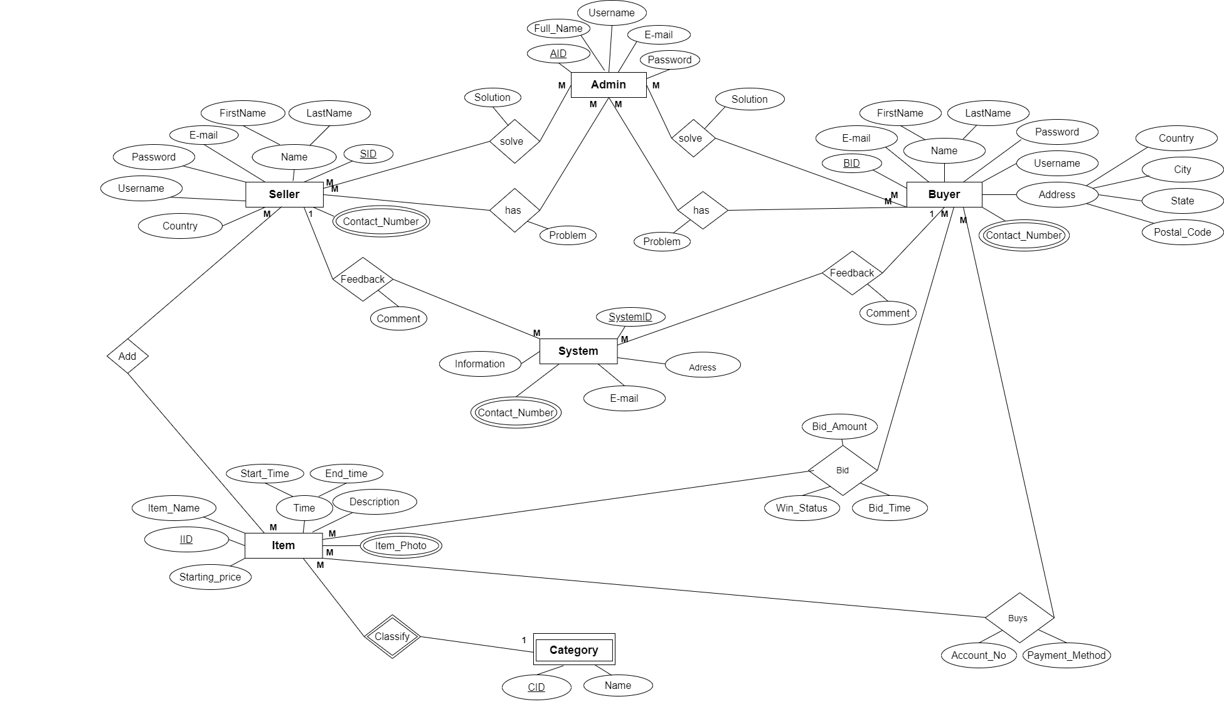

* **Schema of the Database**

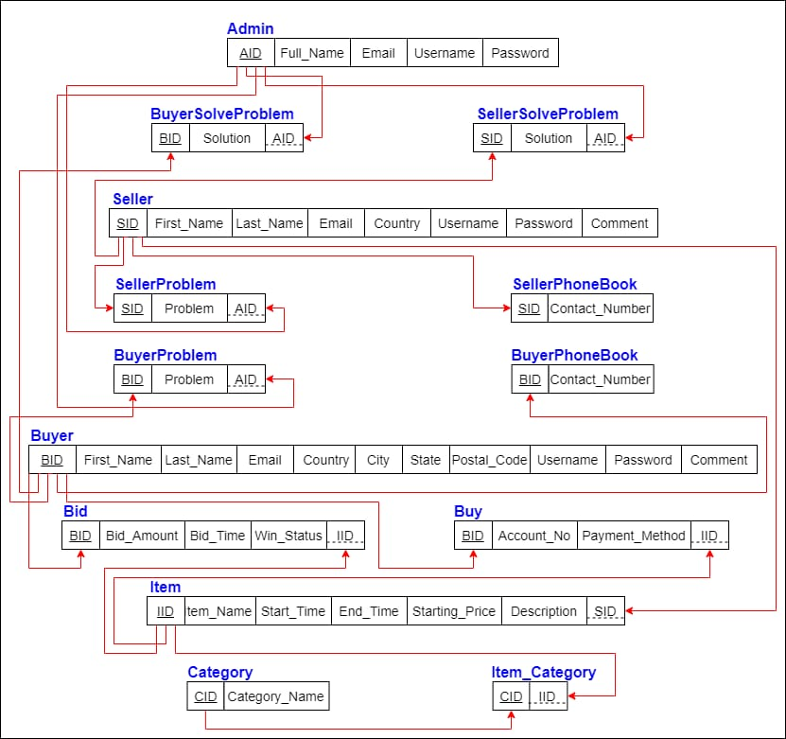

* **Special performance**

**Response time**

It is guaranteed that the performances shall not be fallen though the user logins and interactions increases up to 100 000. Comparatively it will generate a response time about 0.05 seconds for a light load and will generate a response time about 0.5 seconds for a heavy load.

**Workload**

It is estimated that the system enables 35 000 users to get interacted with the system on regular days while the system supports to a maximum of 10 000 users on a busy day. Here a maximum time of 30 seconds will be allocated as the think time between all the pages.

**Scalability**

It is guaranteed that this particular online auction system is available with a capability of providing access to 100,000 users at the same moment by the time this system is implemented in an appropriate operational domain.

**Platform**

The platform used to implement this auction system is Microsoft SQL. The reason to choose this platform is that it being a relational database management system which is also considered to be a free platform.

* **Security requirement analysis**
* It is Mandatory to use a strong password for this database. This ensures the security of users
* This database is constantly updated, there for, new technology can be added to the data base and the security will be enhanced by repeated testing and improves.
* Updates a backup of the database.
* Manage database access tightly and by properly updating, maintaining the access methods to be followed when entering the database, unauthorized access can minimize possible damages to the database.
* Encrypt sensitive data.
* Maintain strong privacy settings.
* And this system has security control to secure from attacks.