Environment-wide association study on body mass index of 12-18 year-old, US NHANES 2003-2004 and 2013-2014

Water and Health Laboratory - Cyprus University of Technology

# Dataset 2003-2004 (discovery)

## Correlations between predictor variables

Correlation plot of prediction variables in 2003-2004 dataset and table with the correlation coefficients

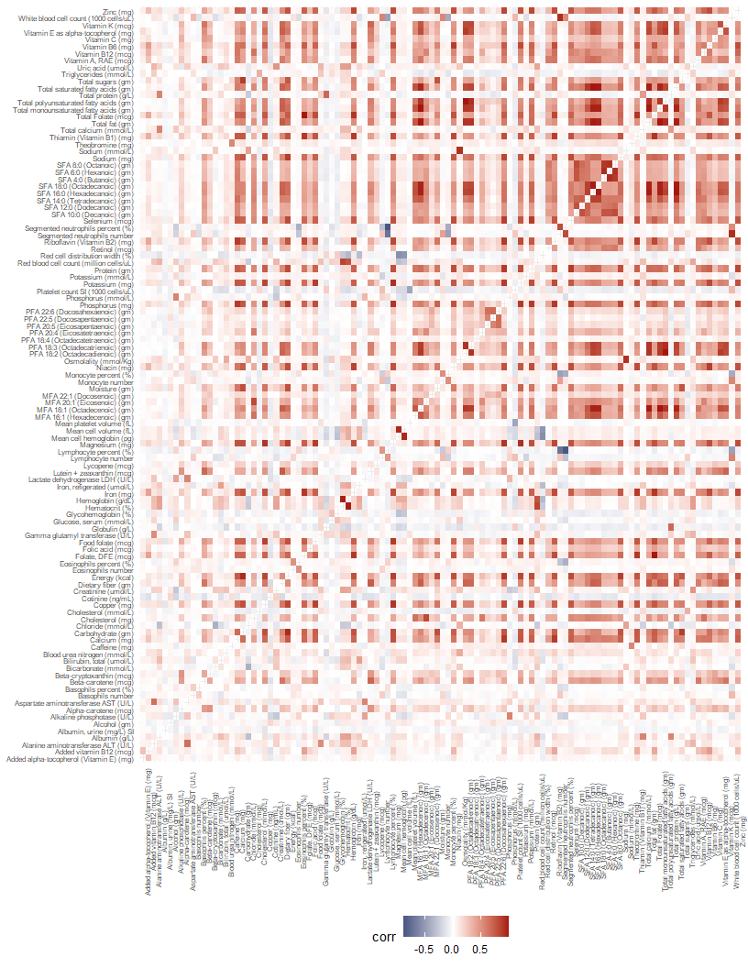

## [1] "The complete table with all the correlation coefficients can be found in the folder: CorrCoeffiencents_results in csv format (file name:correlation03_all.csv)."

## Univariable analysis: 2003-2004 dataset

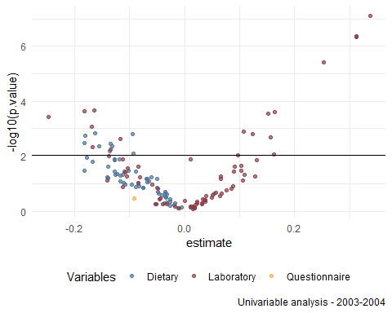

Univariate regression results - FDR - BH method <0.05

* Total number of regressions: 139
* P-value<=0.05: 54

| summary | Section | estimate | std.error | statistic | p.value | fdr |
| --- | --- | --- | --- | --- | --- | --- |
| Alanine aminotransferase ALT (U/L) | Laboratory | 0.337 | 0.033 | 10.163 | 0.000 | 0.000 |
| Gamma glutamyl transferase (U/L) | Laboratory | 0.312 | 0.035 | 8.833 | 0.000 | 0.000 |
| Uric acid (umol/L) | Laboratory | 0.312 | 0.036 | 8.792 | 0.000 | 0.000 |
| Triglycerides (mmol/L) | Laboratory | 0.252 | 0.035 | 7.301 | 0.000 | 0.000 |
| Mean cell hemoglobin (pg) | Laboratory | -0.165 | 0.033 | -4.950 | 0.000 | 0.005 |
| Mean cell volume (fL) | Laboratory | -0.182 | 0.037 | -4.898 | 0.000 | 0.005 |
| Platelet count SI (1000 cells/uL) | Laboratory | 0.163 | 0.033 | 4.880 | 0.000 | 0.005 |
| White blood cell count (1000 cells/uL) | Laboratory | 0.153 | 0.032 | 4.783 | 0.000 | 0.005 |
| Albumin (g/L) | Laboratory | -0.248 | 0.053 | -4.665 | 0.000 | 0.006 |
| Bilirubin, total (umol/L) | Laboratory | -0.170 | 0.040 | -4.216 | 0.001 | 0.012 |
| Lymphocyte number | Laboratory | 0.107 | 0.027 | 3.998 | 0.001 | 0.016 |
| Riboflavin (Vitamin B2) (mg) | Dietary | -0.163 | 0.041 | -3.948 | 0.001 | 0.016 |
| Red blood cell count (million cells/uL) | Laboratory | 0.124 | 0.031 | 3.928 | 0.002 | 0.016 |
| Retinol (mcg) | Dietary | -0.095 | 0.024 | -3.913 | 0.002 | 0.016 |
| Folate, DFE (mcg) | Dietary | -0.181 | 0.047 | -3.828 | 0.002 | 0.017 |
| Segmented neutrophils number | Laboratory | 0.157 | 0.042 | 3.765 | 0.002 | 0.018 |
| Sodium (mmol/L) | Laboratory | -0.117 | 0.032 | -3.709 | 0.002 | 0.019 |
| Total Folate (mcg) | Dietary | -0.182 | 0.051 | -3.538 | 0.003 | 0.025 |
| Total sugars (gm) | Dietary | -0.135 | 0.038 | -3.500 | 0.004 | 0.026 |
| Vitamin B6 (mg) | Dietary | -0.132 | 0.039 | -3.397 | 0.004 | 0.030 |
| Iron (mg) | Dietary | -0.156 | 0.046 | -3.383 | 0.004 | 0.030 |
| Bicarbonate (mmol/L) | Laboratory | -0.168 | 0.050 | -3.350 | 0.005 | 0.030 |
| Iron, refigerated (umol/L) | Laboratory | -0.134 | 0.041 | -3.257 | 0.006 | 0.035 |
| Thiamin (Vitamin B1) (mg) | Dietary | -0.136 | 0.043 | -3.200 | 0.006 | 0.037 |
| Lutein + zeaxanthin (mcg) | Dietary | -0.094 | 0.030 | -3.077 | 0.008 | 0.045 |
| Lactate dehydrogenase LDH (U/L) | Laboratory | 0.163 | 0.053 | 3.059 | 0.009 | 0.045 |
| Cholesterol (mmol/L) | Laboratory | 0.097 | 0.032 | 3.008 | 0.009 | 0.048 |

## Multivariable analysis: 2003-2004 dataset

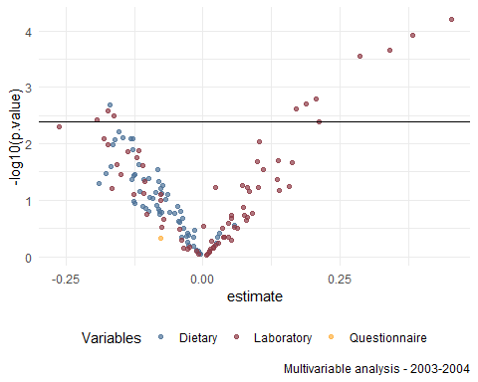

Multivariable regression results - FDR - BH method <0.05

* Total number of regressions: 139
* P-value<=0.05: 45

| summary | Section | estimate | std.error | statistic | p.value | fdr |
| --- | --- | --- | --- | --- | --- | --- |
| Uric acid (umol/L) | Laboratory | 0.452 | 0.046 | 9.895 | 0.000 | 0.008 |
| Alanine aminotransferase ALT (U/L) | Laboratory | 0.383 | 0.044 | 8.779 | 0.000 | 0.008 |
| Gamma glutamyl transferase (U/L) | Laboratory | 0.341 | 0.043 | 7.886 | 0.000 | 0.010 |
| Triglycerides (mmol/L) | Laboratory | 0.285 | 0.038 | 7.560 | 0.000 | 0.010 |
| Red blood cell count (million cells/uL) | Laboratory | 0.207 | 0.038 | 5.435 | 0.002 | 0.040 |
| White blood cell count (1000 cells/uL) | Laboratory | 0.188 | 0.036 | 5.228 | 0.002 | 0.040 |
| Riboflavin (Vitamin B2) (mg) | Dietary | -0.170 | 0.033 | -5.179 | 0.002 | 0.040 |
| Platelet count SI (1000 cells/uL) | Laboratory | 0.170 | 0.034 | 5.010 | 0.002 | 0.040 |
| Mean cell volume (fL) | Laboratory | -0.174 | 0.035 | -4.943 | 0.003 | 0.040 |
| Mean cell hemoglobin (pg) | Laboratory | -0.163 | 0.034 | -4.731 | 0.003 | 0.045 |
| Phosphorus (mmol/L) | Laboratory | -0.193 | 0.042 | -4.585 | 0.004 | 0.047 |
| Segmented neutrophils number | Laboratory | 0.211 | 0.047 | 4.497 | 0.004 | 0.048 |

### Plots of the predicted values per sex for the significant predictors (FDR<0.05)

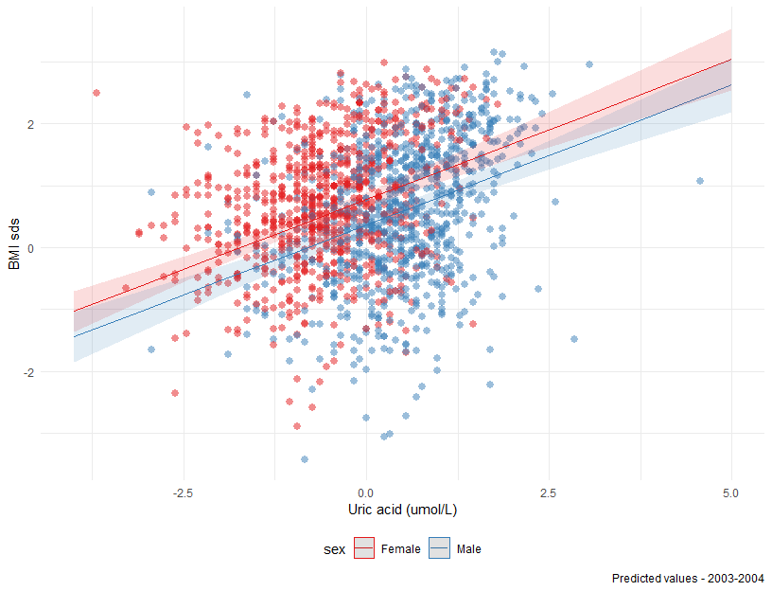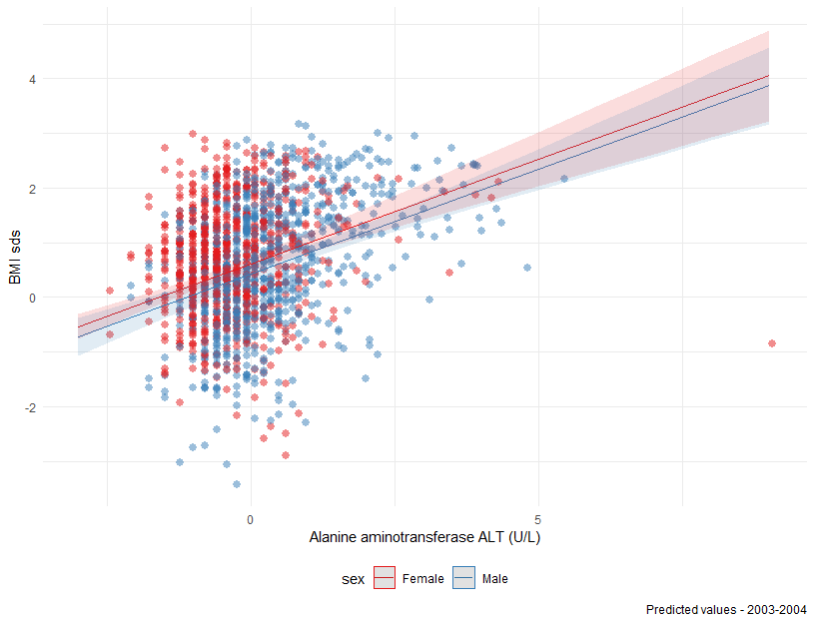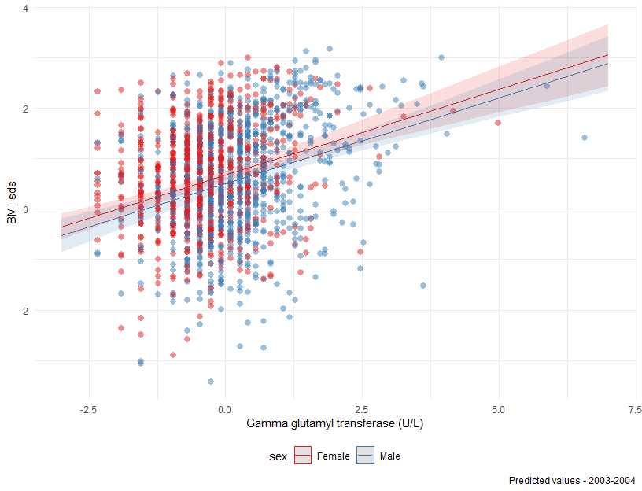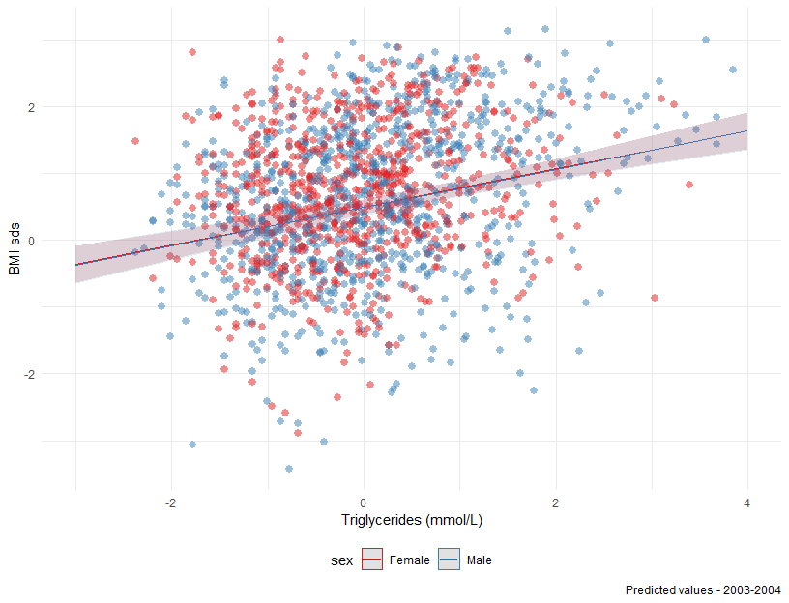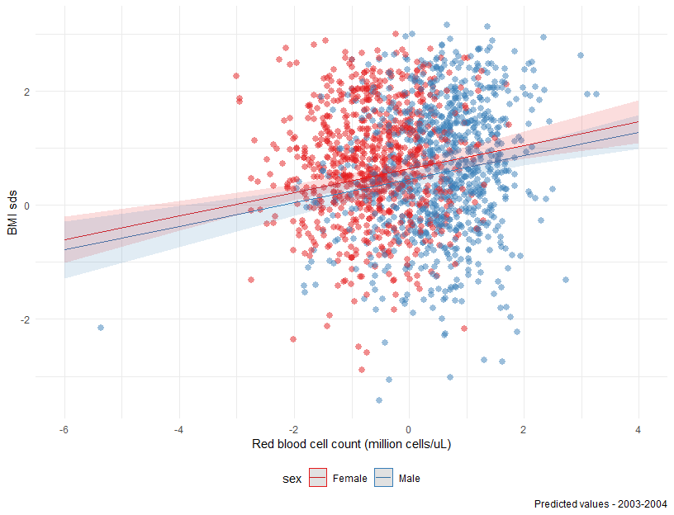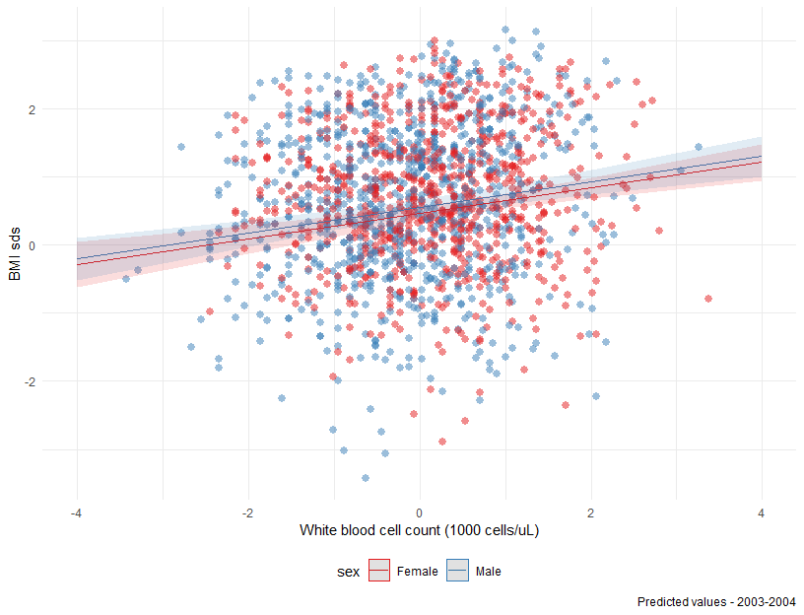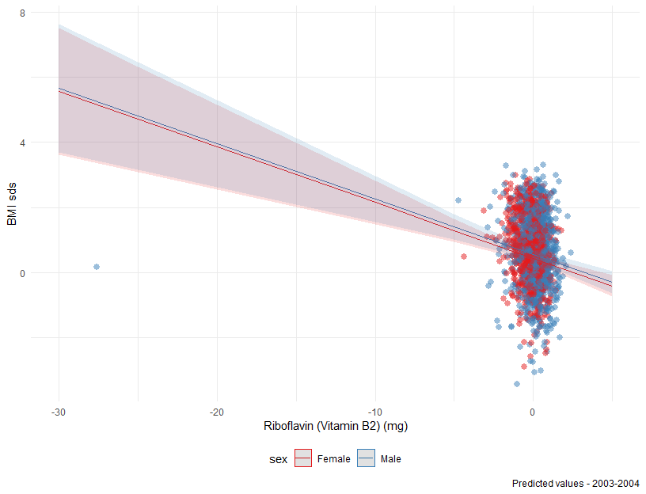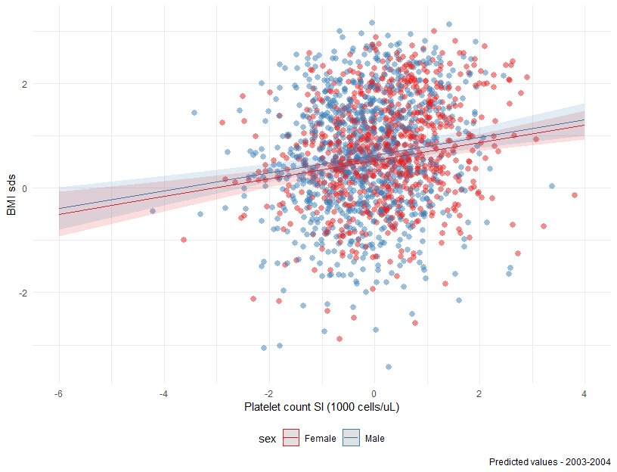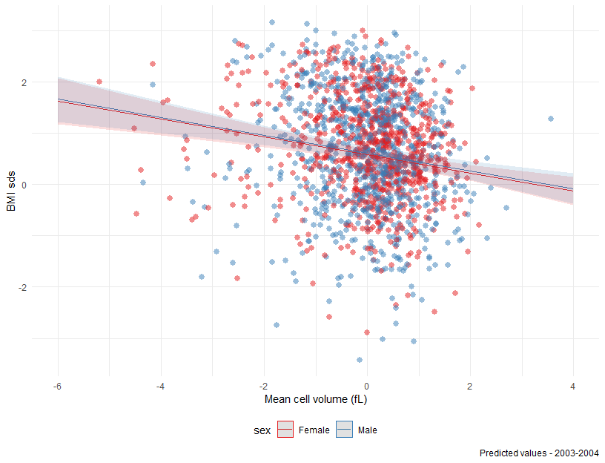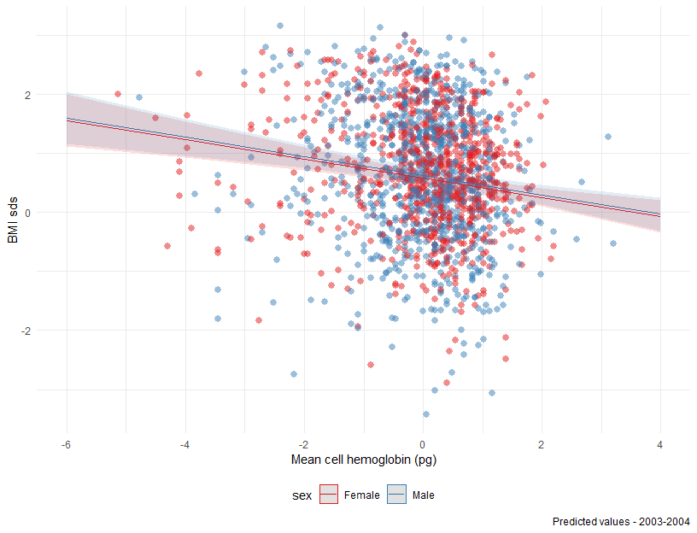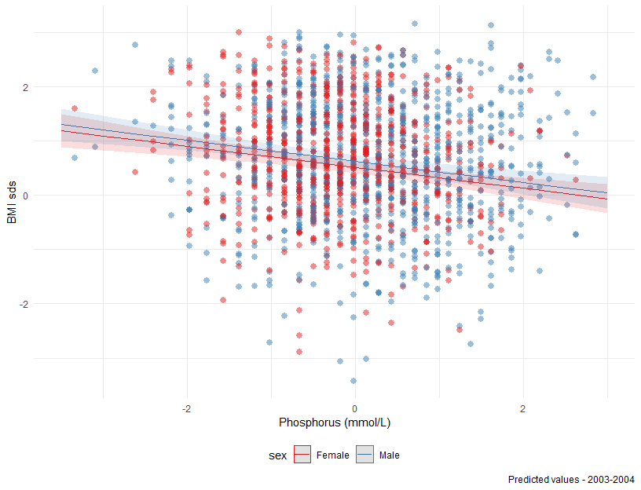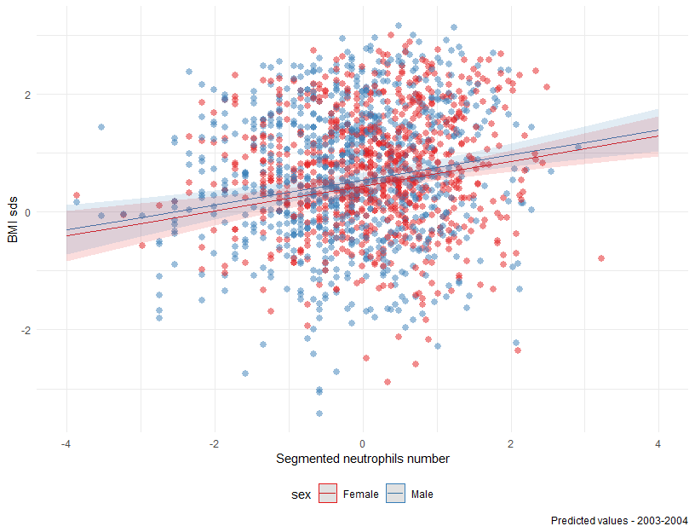

# Dataset 2013-2014 (replication)

## Correlations between predictor variables

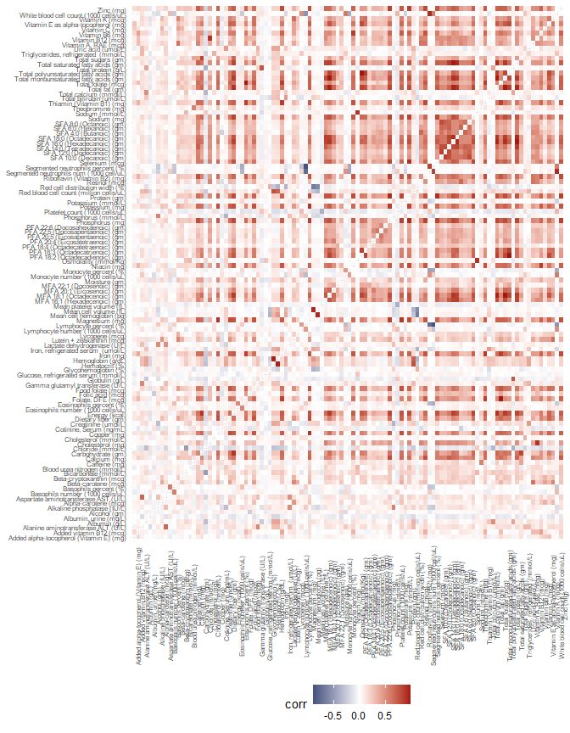

Correlation plot of prediction variables in 2013-2014 dataset

## [1] "The complete table with all the correlation coefficients can be found in the folder: CorrCoeffiencents_results in csv format (file name:correlation13_all.csv)."

# Univariable regressions: dataset 2013-2014

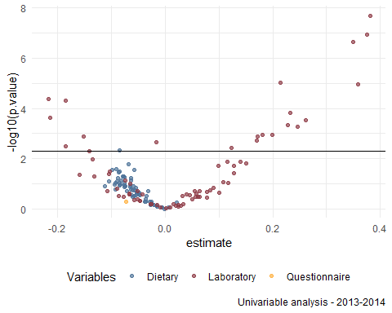

Univariate regression results - FDR - BH method <0.05

* Total number of regressions: 139
* P-value<=0.05: 39

| summary | Section | estimate | std.error | statistic | p.value | fdr |
| --- | --- | --- | --- | --- | --- | --- |
| Gamma glutamyl transferase (U/L) | Laboratory | 0.381 | 0.034 | 11.306 | 0.000 | 0.000 |
| Alanine aminotransferase ALT (U/L) | Laboratory | 0.375 | 0.038 | 9.814 | 0.000 | 0.000 |
| Triglycerides, refrigerated (mmol/L) | Laboratory | 0.350 | 0.038 | 9.283 | 0.000 | 0.000 |
| Monocyte number (1000 cells/uL) | Laboratory | 0.215 | 0.032 | 6.730 | 0.000 | 0.000 |
| Uric acid (umol/L) | Laboratory | 0.358 | 0.054 | 6.631 | 0.000 | 0.000 |
| Mean cell volume (fL) | Laboratory | -0.217 | 0.037 | -5.850 | 0.000 | 0.001 |
| Mean cell hemoglobin (pg) | Laboratory | -0.185 | 0.032 | -5.746 | 0.000 | 0.001 |
| 2-Hydroxynaphthalene (ng/L) | Laboratory | 0.233 | 0.045 | 5.129 | 0.000 | 0.003 |
| Albumin (g/L) | Laboratory | -0.214 | 0.044 | -4.899 | 0.000 | 0.004 |
| White blood cell count (1000 cells/uL) | Laboratory | 0.262 | 0.055 | 4.769 | 0.000 | 0.004 |
| Platelet count (1000 cells/uL) | Laboratory | 0.228 | 0.050 | 4.558 | 0.000 | 0.006 |
| Segmented neutrophils num (1000 cell/uL) | Laboratory | 0.246 | 0.055 | 4.482 | 0.001 | 0.006 |
| Red cell distribution width (%) | Laboratory | 0.200 | 0.049 | 4.088 | 0.001 | 0.011 |
| Lactate dehydrogenase (U/L) | Laboratory | 0.180 | 0.044 | 4.079 | 0.001 | 0.011 |
| 1-Hydroxyphenanthrene (ng/L) | Laboratory | 0.173 | 0.043 | 4.011 | 0.001 | 0.011 |
| Total bilirubin (umol/L) | Laboratory | -0.151 | 0.038 | -4.010 | 0.001 | 0.011 |
| Lymphocyte number (1000 cells/uL) | Laboratory | 0.170 | 0.044 | 3.822 | 0.002 | 0.015 |
| Perfluorobutane sulfonic acid (ug/L) | Laboratory | -0.016 | 0.004 | -3.741 | 0.002 | 0.017 |
| Perfluorodecanoic acid (ug/L) | Laboratory | -0.185 | 0.052 | -3.551 | 0.003 | 0.023 |
| Globulin (g/L) | Laboratory | 0.123 | 0.035 | 3.461 | 0.004 | 0.027 |
| Total sugars (gm) | Dietary | -0.085 | 0.025 | -3.366 | 0.005 | 0.031 |
| Iron, refrigerated serum (umol/L) | Laboratory | -0.141 | 0.042 | -3.316 | 0.005 | 0.032 |

# Multivariable regressions: dataset 2013-2014

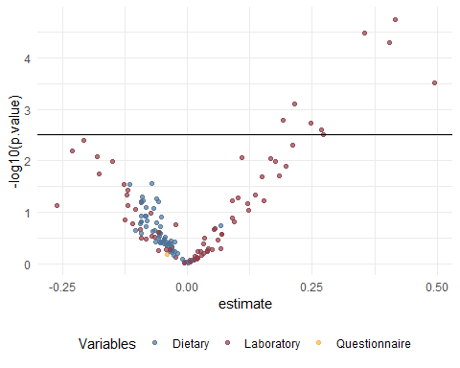

Multivariable regression results - FDR - BH method <0.05

* Total number of regressions: 139
* P-value<=0.05: 27

| summary | Section | estimate | std.error | statistic | p.value | fdr |
| --- | --- | --- | --- | --- | --- | --- |
| Gamma glutamyl transferase (U/L) | Laboratory | 0.416 | 0.034 | 12.328 | 0.000 | 0.002 |
| Triglycerides, refrigerated (mmol/L) | Laboratory | 0.355 | 0.032 | 11.099 | 0.000 | 0.002 |
| Alanine aminotransferase ALT (U/L) | Laboratory | 0.405 | 0.039 | 10.269 | 0.000 | 0.002 |
| Uric acid (umol/L) | Laboratory | 0.494 | 0.066 | 7.432 | 0.000 | 0.011 |
| Monocyte number (1000 cells/uL) | Laboratory | 0.215 | 0.034 | 6.267 | 0.001 | 0.021 |
| Lactate dehydrogenase (U/L) | Laboratory | 0.191 | 0.035 | 5.451 | 0.002 | 0.036 |
| 2-Hydroxynaphthalene (ng/L) | Laboratory | 0.247 | 0.047 | 5.303 | 0.002 | 0.036 |
| White blood cell count (1000 cells/uL) | Laboratory | 0.269 | 0.054 | 4.992 | 0.002 | 0.043 |
| Segmented neutrophils num (1000 cell/uL) | Laboratory | 0.273 | 0.057 | 4.790 | 0.003 | 0.047 |

## Plots of the predicted values per sex for the significant predictors (FDR<0.05)

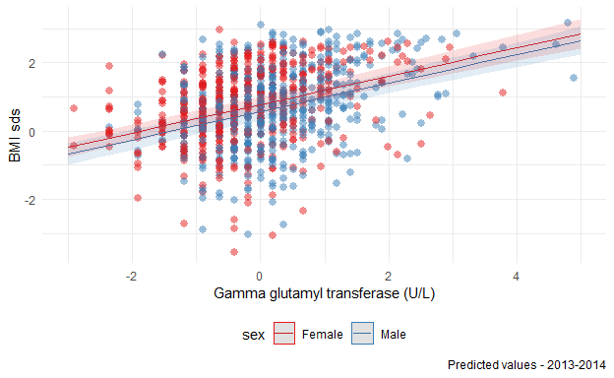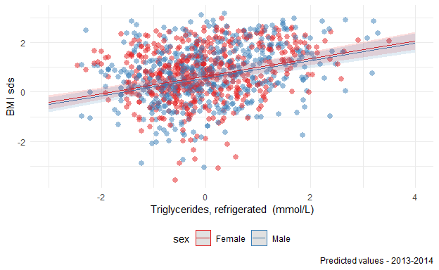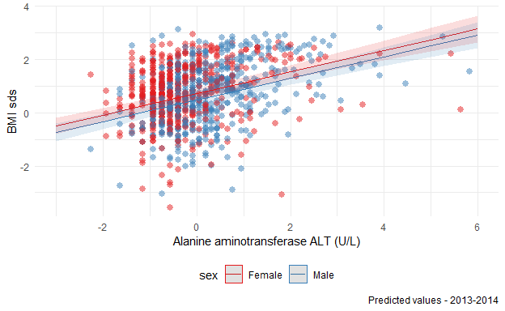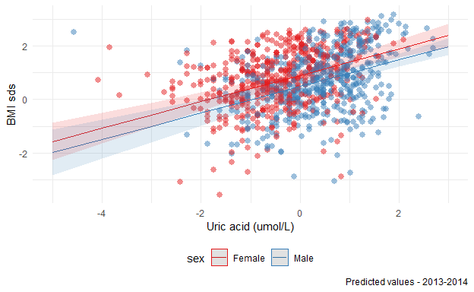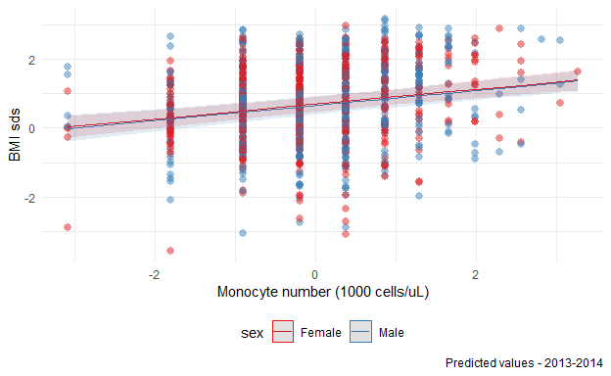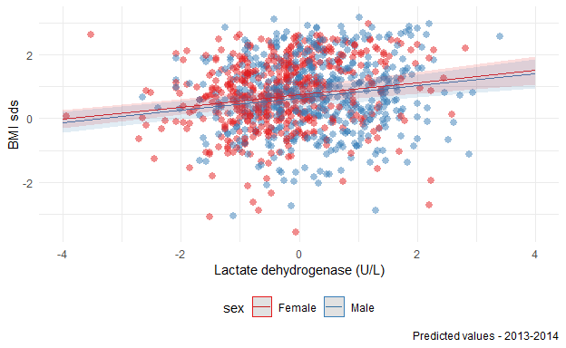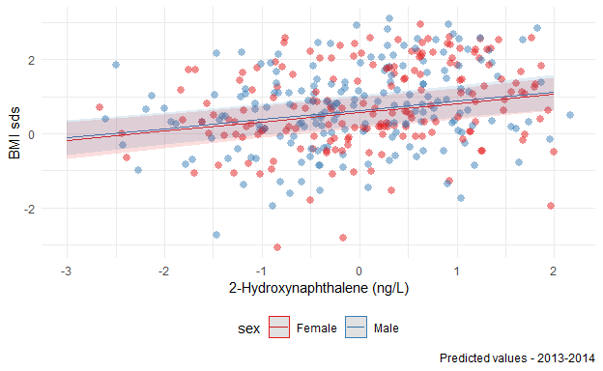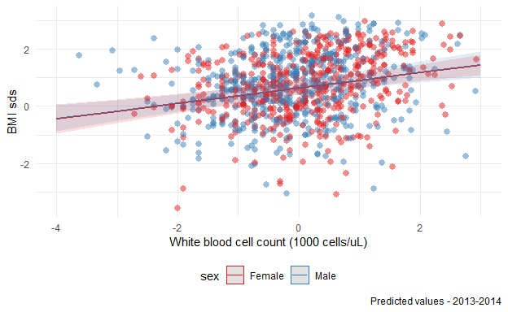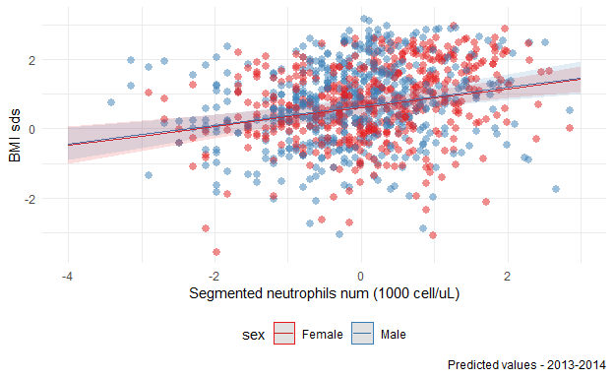

# Variables significant in both datasets

|  |  |  |  |
| --- | --- | --- | --- |
| variable | var_name | summary | Section |
| lbdneno_tr | lbdneno | Segmented neutrophils num (1000 cell/uL) | Laboratory |
| lbdstrsi_tr | lbdstrsi | Triglycerides, refrigerated (mmol/L) | Laboratory |
| lbdsuasi_tr | lbdsuasi | Uric acid (umol/L) | Laboratory |
| lbxsatsi_tr | lbxsatsi | Alanine aminotransferase ALT (U/L) | Laboratory |
| lbxsgtsi_tr | lbxsgtsi | Gamma glutamyl transferase (U/L) | Laboratory |
| lbxwbcsi_tr | lbxwbcsi | White blood cell count (1000 cells/uL) | Laboratory |

# Exporing interactions between sex and the other ExWAS predictors (in the discovery and replication datasets)

Model details – survey 2003-2004 using the interaction term

| term | estimate | std.error | statistic | p.value | var_name | summary | var_name_tr |
| --- | --- | --- | --- | --- | --- | --- | --- |
| (Intercept) | 2.003249817 | 0.32635996 | 6.13816055 | 0.001666922 | lbdsuasi | Uric acid (umol/L) | lbdsuasi_tr |
| ridageyr | -0.080868242 | 0.01879729 | -4.30212129 | 0.007699935 | lbdsuasi | Uric acid (umol/L) | lbdsuasi_tr |
| sexMale | -0.424079686 | 0.08074994 | -5.25176486 | 0.003321377 | lbdsuasi | Uric acid (umol/L) | lbdsuasi_tr |
| indfmpir | -0.030891799 | 0.01756162 | -1.75905175 | 0.138892916 | lbdsuasi | Uric acid (umol/L) | lbdsuasi_tr |
| ethnicityNon-Hispanic Black | 0.265620000 | 0.07608179 | 3.49124283 | 0.017447207 | lbdsuasi | Uric acid (umol/L) | lbdsuasi_tr |
| ethnicityNon-Hispanic White | -0.036369666 | 0.07531496 | -0.48290094 | 0.649567462 | lbdsuasi | Uric acid (umol/L) | lbdsuasi_tr |
| ethnicityOther | -0.418636723 | 0.14810345 | -2.82665070 | 0.036819421 | lbdsuasi | Uric acid (umol/L) | lbdsuasi_tr |
| ethnicityOther Hispanic | -0.005917176 | 0.17858328 | -0.03313398 | 0.974849758 | lbdsuasi | Uric acid (umol/L) | lbdsuasi_tr |
| smoker_homeYes | 0.114635745 | 0.08446868 | 1.35713898 | 0.232784380 | lbdsuasi | Uric acid (umol/L) | lbdsuasi_tr |
| lbdsuasi_tr | 0.326631286 | 0.06301433 | 5.18344490 | 0.003515197 | lbdsuasi | Uric acid (umol/L) | lbdsuasi_tr |
| sexMale:lbdsuasi_tr | 0.245442176 | 0.07507045 | 3.26949126 | 0.022211059 | lbdsuasi | Uric acid (umol/L) | lbdsuasi_tr |
| (Intercept) | 1.285747470 | 0.36789216 | 3.49490317 | 0.017378959 | lbxsatsi | Alanine aminotransferase ALT (U/L) | lbxsatsi_tr |
| ridageyr | -0.046120214 | 0.02113733 | -2.18193240 | 0.080915538 | lbxsatsi | Alanine aminotransferase ALT (U/L) | lbxsatsi_tr |
| sexMale | -0.176620074 | 0.09652662 | -1.82975502 | 0.126807622 | lbxsatsi | Alanine aminotransferase ALT (U/L) | lbxsatsi_tr |
| indfmpir | -0.007339266 | 0.02245073 | -0.32690539 | 0.756981066 | lbxsatsi | Alanine aminotransferase ALT (U/L) | lbxsatsi_tr |
| ethnicityNon-Hispanic Black | 0.320276175 | 0.07594002 | 4.21748891 | 0.008347917 | lbxsatsi | Alanine aminotransferase ALT (U/L) | lbxsatsi_tr |
| ethnicityNon-Hispanic White | 0.001641021 | 0.08398905 | 0.01953851 | 0.985167238 | lbxsatsi | Alanine aminotransferase ALT (U/L) | lbxsatsi_tr |
| ethnicityOther | -0.225889973 | 0.13532718 | -1.66921360 | 0.155944968 | lbxsatsi | Alanine aminotransferase ALT (U/L) | lbxsatsi_tr |
| ethnicityOther Hispanic | -0.033510916 | 0.19958113 | -0.16790624 | 0.873237286 | lbxsatsi | Alanine aminotransferase ALT (U/L) | lbxsatsi_tr |
| smoker_homeYes | 0.147779007 | 0.07781163 | 1.89918921 | 0.115983921 | lbxsatsi | Alanine aminotransferase ALT (U/L) | lbxsatsi_tr |
| lbxsatsi_tr | 0.228944994 | 0.08206318 | 2.78986245 | 0.038451128 | lbxsatsi | Alanine aminotransferase ALT (U/L) | lbxsatsi_tr |
| sexMale:lbxsatsi_tr | 0.248081562 | 0.08617333 | 2.87886709 | 0.034633881 | lbxsatsi | Alanine aminotransferase ALT (U/L) | lbxsatsi_tr |

Model details – survey 2013-2014 using the interaction term

| term | estimate | std.error | statistic | p.value | var_name | summary | var_name_tr |
| --- | --- | --- | --- | --- | --- | --- | --- |
| (Intercept) | 1.24026347 | 0.33634868 | 3.6874338 | 0.0141834409 | lbxsatsi | Alanine aminotransferase ALT (U/L) | lbxsatsi_tr |
| ridageyr | -0.02221117 | 0.02325016 | -0.9553127 | 0.3832920197 | lbxsatsi | Alanine aminotransferase ALT (U/L) | lbxsatsi_tr |
| sexMale | -0.23972323 | 0.09584091 | -2.5012619 | 0.0544060591 | lbxsatsi | Alanine aminotransferase ALT (U/L) | lbxsatsi_tr |
| indfmpir | -0.07843586 | 0.02096822 | -3.7407014 | 0.0134218203 | lbxsatsi | Alanine aminotransferase ALT (U/L) | lbxsatsi_tr |
| ethnicityNon-Hispanic Black | 0.20617984 | 0.11417247 | 1.8058630 | 0.1307668843 | lbxsatsi | Alanine aminotransferase ALT (U/L) | lbxsatsi_tr |
| ethnicityNon-Hispanic White | 0.03140817 | 0.10621281 | 0.2957098 | 0.7793388354 | lbxsatsi | Alanine aminotransferase ALT (U/L) | lbxsatsi_tr |
| ethnicityOther | -0.13124126 | 0.17701203 | -0.7414257 | 0.4917684841 | lbxsatsi | Alanine aminotransferase ALT (U/L) | lbxsatsi_tr |
| ethnicityOther Hispanic | 0.12980702 | 0.17131745 | 0.7576987 | 0.4827924157 | lbxsatsi | Alanine aminotransferase ALT (U/L) | lbxsatsi_tr |
| smoker_homeYes | 0.23949004 | 0.06013027 | 3.9828529 | 0.0105008634 | lbxsatsi | Alanine aminotransferase ALT (U/L) | lbxsatsi_tr |
| lbxsatsi_tr | 0.30089299 | 0.04142584 | 7.2634127 | 0.0007730575 | lbxsatsi | Alanine aminotransferase ALT (U/L) | lbxsatsi_tr |
| sexMale:lbxsatsi_tr | 0.18483910 | 0.06183100 | 2.9894243 | 0.0304675097 | lbxsatsi | Alanine aminotransferase ALT (U/L) | lbxsatsi_tr |

### Focus on uric acid (dataset 2003-2004) and alanine aminotransferase (datasets 2003-2004 and 2013-2014)

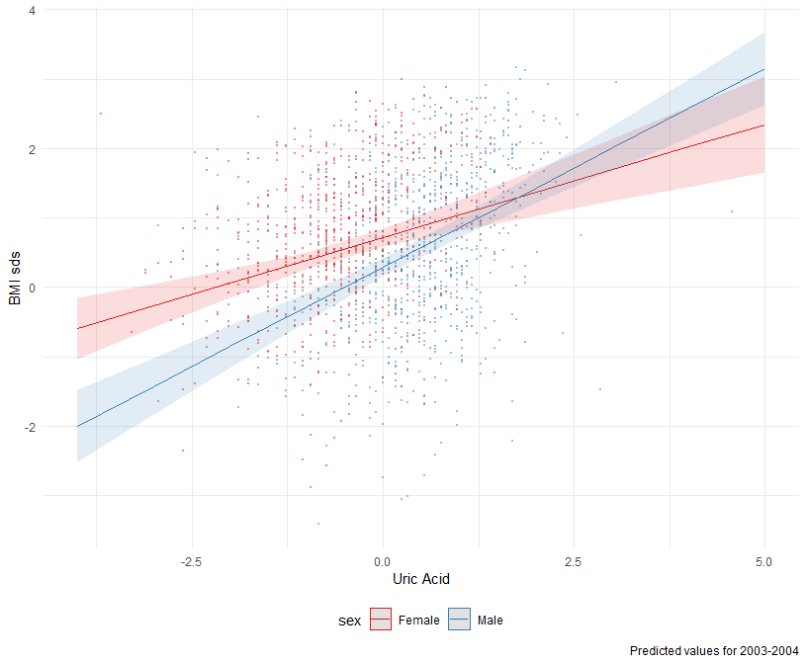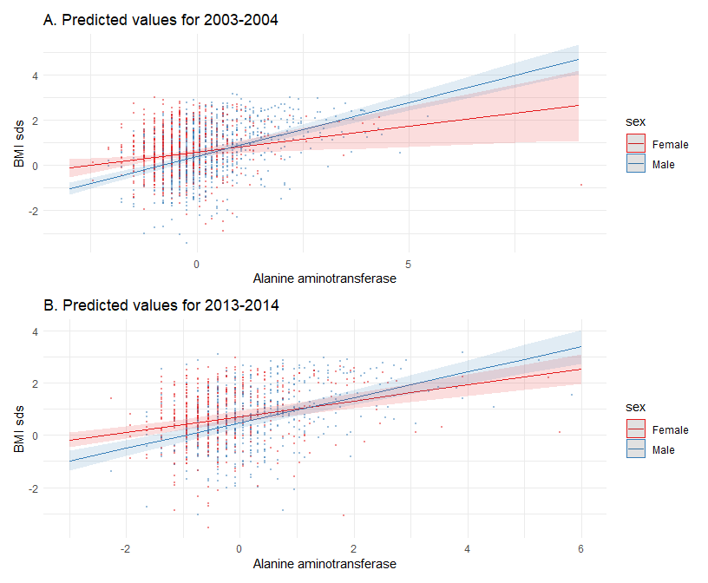

|  |  |  |  |  |
| --- | --- | --- | --- | --- |
| term | estimate | std.error | statistic | p.value |
| (Intercept) | 2.0032498 | 0.3263600 | 6.1381606 | 0.0016669 |
| ridageyr | -0.0808682 | 0.0187973 | -4.3021213 | 0.0076999 |
| sexMale | -0.4240797 | 0.0807499 | -5.2517649 | 0.0033214 |
| indfmpir | -0.0308918 | 0.0175616 | -1.7590518 | 0.1388929 |
| ethnicityNon-Hispanic Black | 0.2656200 | 0.0760818 | 3.4912428 | 0.0174472 |
| ethnicityNon-Hispanic White | -0.0363697 | 0.0753150 | -0.4829009 | 0.6495675 |
| ethnicityOther | -0.4186367 | 0.1481035 | -2.8266507 | 0.0368194 |
| ethnicityOther Hispanic | -0.0059172 | 0.1785833 | -0.0331340 | 0.9748498 |
| smoker_homeYes | 0.1146357 | 0.0844687 | 1.3571390 | 0.2327844 |
| lbdsuasi_tr | 0.3266313 | 0.0630143 | 5.1834449 | 0.0035152 |
| sexMale:lbdsuasi_tr | 0.2454422 | 0.0750704 | 3.2694913 | 0.0222111 |

|  |  |  |  |  |
| --- | --- | --- | --- | --- |
| term | estimate | std.error | statistic | p.value |
| (Intercept) | 1.2857475 | 0.3678922 | 3.4949032 | 0.0173790 |
| ridageyr | -0.0461202 | 0.0211373 | -2.1819324 | 0.0809155 |
| sexMale | -0.1766201 | 0.0965266 | -1.8297550 | 0.1268076 |
| indfmpir | -0.0073393 | 0.0224507 | -0.3269054 | 0.7569811 |
| ethnicityNon-Hispanic Black | 0.3202762 | 0.0759400 | 4.2174889 | 0.0083479 |
| ethnicityNon-Hispanic White | 0.0016410 | 0.0839890 | 0.0195385 | 0.9851672 |
| ethnicityOther | -0.2258900 | 0.1353272 | -1.6692136 | 0.1559450 |
| ethnicityOther Hispanic | -0.0335109 | 0.1995811 | -0.1679062 | 0.8732373 |
| smoker_homeYes | 0.1477790 | 0.0778116 | 1.8991892 | 0.1159839 |
| lbxsatsi_tr | 0.2289450 | 0.0820632 | 2.7898625 | 0.0384511 |
| sexMale:lbxsatsi_tr | 0.2480816 | 0.0861733 | 2.8788671 | 0.0346339 |

|  |  |  |  |  |
| --- | --- | --- | --- | --- |
| term | estimate | std.error | statistic | p.value |
| (Intercept) | 1.2402635 | 0.3363487 | 3.6874338 | 0.0141834 |
| ridageyr | -0.0222112 | 0.0232502 | -0.9553127 | 0.3832920 |
| sexMale | -0.2397232 | 0.0958409 | -2.5012619 | 0.0544061 |
| indfmpir | -0.0784359 | 0.0209682 | -3.7407014 | 0.0134218 |
| ethnicityNon-Hispanic Black | 0.2061798 | 0.1141725 | 1.8058630 | 0.1307669 |
| ethnicityNon-Hispanic White | 0.0314082 | 0.1062128 | 0.2957098 | 0.7793388 |
| ethnicityOther | -0.1312413 | 0.1770120 | -0.7414257 | 0.4917685 |
| ethnicityOther Hispanic | 0.1298070 | 0.1713175 | 0.7576987 | 0.4827924 |
| smoker_homeYes | 0.2394900 | 0.0601303 | 3.9828529 | 0.0105009 |
| lbxsatsi_tr | 0.3008930 | 0.0414258 | 7.2634127 | 0.0007731 |
| sexMale:lbxsatsi_tr | 0.1848391 | 0.0618310 | 2.9894243 | 0.0304675 |

# Session Information

sessionInfo()

## R version 4.1.2 (2021-11-01)  
## Platform: x86_64-w64-mingw32/x64 (64-bit)  
## Running under: Windows 10 x64 (build 19043)  
##   
## Matrix products: default  
##   
## locale:  
## [1] LC_COLLATE=English_United Kingdom.1252   
## [2] LC_CTYPE=English_United Kingdom.1252   
## [3] LC_MONETARY=English_United Kingdom.1252  
## [4] LC_NUMERIC=C   
## [5] LC_TIME=English_United Kingdom.1252   
##   
## attached base packages:  
## [1] grid stats graphics grDevices utils datasets   
## [7] methods base   
##   
## other attached packages:  
## [1] corrplot_0.92 patchwork_1.1.1 jtools_2.2.0   
## [4] report_0.5.1 knitr_1.37 broom_0.7.12   
## [7] tableone_0.13.0 survey_4.1-1 Matrix_1.4-0   
## [10] childsds_0.8.0 srvyr_1.1.1 flextable_0.7.0   
## [13] DT_0.21 Hmisc_4.7-0 Formula_1.2-4   
## [16] survival_3.3-1 lattice_0.20-45 data.table_1.14.2  
## [19] tictoc_1.0.1 XML_3.99-0.9 janitor_2.1.0   
## [22] forcats_0.5.1 stringr_1.4.0 dplyr_1.0.8   
## [25] purrr_0.3.4 readr_2.1.2 tidyr_1.2.0   
## [28] tibble_3.1.6 ggplot2_3.3.5 tidyverse_1.3.1   
## [31] haven_2.4.3   
##   
## loaded via a namespace (and not attached):  
## [1] readxl_1.3.1 uuid_1.0-3 backports_1.4.1   
## [4] systemfonts_1.0.4 plyr_1.8.6 splines_4.1.2   
## [7] TH.data_1.1-0 digest_0.6.29 htmltools_0.5.2   
## [10] fansi_1.0.2 magrittr_2.0.2 checkmate_2.0.0   
## [13] cluster_2.1.2 tzdb_0.2.0 ggfittext_0.9.1   
## [16] modelr_0.1.8 vroom_1.5.7 xslt_1.4.3   
## [19] officer_0.4.2 sandwich_3.0-1 prettyunits_1.1.1   
## [22] jpeg_0.1-9 colorspace_2.0-3 rvest_1.0.2   
## [25] mitools_2.4 xfun_0.30 crayon_1.5.0   
## [28] jsonlite_1.8.0 lme4_1.1-28 zoo_1.8-9   
## [31] glue_1.6.2 gtable_0.3.0 emmeans_1.7.2   
## [34] sjstats_0.18.1 sjmisc_2.8.9 scales_1.1.1   
## [37] mvtnorm_1.1-3 DBI_1.1.2 ggeffects_1.1.1   
## [40] Rcpp_1.0.8.2 xtable_1.8-4 progress_1.2.2   
## [43] performance_0.8.0 htmlTable_2.4.0 bit_4.0.4   
## [46] foreign_0.8-82 proxy_0.4-26 datawizard_0.3.0   
## [49] htmlwidgets_1.5.4 httr_1.4.2 RColorBrewer_1.1-2   
## [52] ellipsis_0.3.2 pkgconfig_2.0.3 farver_2.1.0   
## [55] nnet_7.3-17 dbplyr_2.1.1 utf8_1.2.2   
## [58] tidyselect_1.1.2 labeling_0.4.2 rlang_1.0.2   
## [61] effectsize_0.6.0.1 munsell_0.5.0 cellranger_1.1.0   
## [64] tools_4.1.2 cli_3.2.0 generics_0.1.2   
## [67] sjlabelled_1.1.8 evaluate_0.15 fastmap_1.1.0   
## [70] yaml_2.3.5 bit64_4.0.5 fs_1.5.2   
## [73] pander_0.6.4 zip_2.2.0 nlme_3.1-155   
## [76] equatags_0.1.1 xml2_1.3.3 compiler_4.1.2   
## [79] rstudioapi_0.13 png_0.1-7 e1071_1.7-9   
## [82] reprex_2.0.1 stringi_1.7.6 highr_0.9   
## [85] parameters_0.17.0 gdtools_0.2.4 nloptr_2.0.0   
## [88] vctrs_0.3.8 pillar_1.7.0 lifecycle_1.0.1   
## [91] locatexec_0.1.1 inspectdf_0.0.11 estimability_1.3   
## [94] insight_0.16.0 R6_2.5.1 latticeExtra_0.6-29  
## [97] gridExtra_2.3 codetools_0.2-18 boot_1.3-28   
## [100] MASS_7.3-55 assertthat_0.2.1 withr_2.5.0   
## [103] multcomp_1.4-18 parallel_4.1.2 bayestestR_0.11.5   
## [106] hms_1.1.1 rpart_4.1.16 sjPlot_2.8.10   
## [109] coda_0.19-4 class_7.3-20 minqa_1.2.4   
## [112] rmarkdown_2.13 snakecase_0.11.0 gamlss.dist_6.0-3   
## [115] lubridate_1.8.0 base64enc_0.1-3

## References

|  |
| --- |
| x |
| David Gohel (2022). flextable: Functions for Tabular Reporting. R package version 0.7.0. <https://CRAN.R-project.org/package=flextable> |
| David Robinson, Alex Hayes and Simon Couch (2022). broom: Convert Statistical Objects into Tidy Tibbles. R package version 0.7.12. <https://CRAN.R-project.org/package=broom> |
| Douglas Bates and Martin Maechler (2021). Matrix: Sparse and Dense Matrix Classes and Methods. R package version 1.4-0. <https://CRAN.R-project.org/package=Matrix> |
| Duncan Temple Lang (2022). XML: Tools for Parsing and Generating XML Within R and S-Plus. R package version 3.99-0.9. <https://CRAN.R-project.org/package=XML> |
| Frank E Harrell Jr (2022). Hmisc: Harrell Miscellaneous. R package version 4.7-0. <https://CRAN.R-project.org/package=Hmisc> |
| Greg Freedman Ellis and Ben Schneider (2022). srvyr: ‘dplyr’-Like Syntax for Summary Statistics of Survey Data. R package version 1.1.1. <https://CRAN.R-project.org/package=srvyr> |
| H. Wickham. ggplot2: Elegant Graphics for Data Analysis. Springer-Verlag New York, 2016. |
| Hadley Wickham (2019). stringr: Simple, Consistent Wrappers for Common String Operations. R package version 1.4.0. <https://CRAN.R-project.org/package=stringr> |
| Hadley Wickham (2021). forcats: Tools for Working with Categorical Variables (Factors). R package version 0.5.1. <https://CRAN.R-project.org/package=forcats> |
| Hadley Wickham and Evan Miller (2021). haven: Import and Export ‘SPSS’, ‘Stata’ and ‘SAS’ Files. R package version 2.4.3. <https://CRAN.R-project.org/package=haven> |
| Hadley Wickham and Maximilian Girlich (2022). tidyr: Tidy Messy Data. R package version 1.2.0. <https://CRAN.R-project.org/package=tidyr> |
| Hadley Wickham, Jim Hester and Jennifer Bryan (2022). readr: Read Rectangular Text Data. R package version 2.1.2. <https://CRAN.R-project.org/package=readr> |
| Hadley Wickham, Romain François, Lionel Henry and Kirill Müller (2022). dplyr: A Grammar of Data Manipulation. R package version 1.0.8. <https://CRAN.R-project.org/package=dplyr> |
| Kazuki Yoshida and Alexander Bartel (2021). tableone: Create ‘Table 1’ to Describe Baseline Characteristics with or without Propensity Score Weights. R package version 0.13.0. <https://CRAN.R-project.org/package=tableone> |
| Kirill Müller and Hadley Wickham (2021). tibble: Simple Data Frames. R package version 3.1.6. <https://CRAN.R-project.org/package=tibble> |
| Lionel Henry and Hadley Wickham (2020). purrr: Functional Programming Tools. R package version 0.3.4. <https://CRAN.R-project.org/package=purrr> |
| Long JA (2022). *jtools: Analysis and Presentation of SocialScientific Data*. R package version 2.2.0, <URL:<https://cran.r-project.org/package=jtools>>. |
| Makowski, D., Ben-Shachar, M.S., Patil, I. & Lüdecke, D. (2020). Automated Results Reporting as a Practical Tool to Improve Reproducibility and Methodological Best Practices Adoption. CRAN. Available from <https://github.com/easystats/report>. doi: . |
| Mandy Vogel (2022). childsds: Data and Methods Around Reference Values in Pediatrics. R package version 0.8.0. <https://CRAN.R-project.org/package=childsds> |
| Matt Dowle and Arun Srinivasan (2021). data.table: Extension of data.frame. R package version 1.14.2. <https://CRAN.R-project.org/package=data.table> |
| R Core Team (2021). R: A language and environment for statistical computing. R Foundation for Statistical Computing, Vienna, Austria. URL <https://www.R-project.org/>. |
| Sam Firke (2021). janitor: Simple Tools for Examining and Cleaning Dirty Data. R package version 2.1.0. <https://CRAN.R-project.org/package=janitor> |
| Sarkar, Deepayan (2008) Lattice: Multivariate Data Visualization with R. Springer, New York. ISBN 978-0-387-75968-5 |
| Sergei Izrailev (2021). tictoc: Functions for Timing R Scripts, as Well as Implementations of Stack and List Structures. R package version 1.0.1. <https://CRAN.R-project.org/package=tictoc> |
| T. Lumley (2020) “survey: analysis of complex survey samples”. R package version 4.0. |
| Taiyun Wei and Viliam Simko (2021). R package ‘corrplot’: Visualization of a Correlation Matrix (Version 0.92). Available from <https://github.com/taiyun/corrplot> |
| Therneau T (2022). *A Package for Survival Analysis in R*. Rpackage version 3.3-1, <URL:<https://CRAN.R-project.org/package=survival>>. |
| Thomas Lin Pedersen (2020). patchwork: The Composer of Plots. R package version 1.1.1. <https://CRAN.R-project.org/package=patchwork> |
| Wickham et al., (2019). Welcome to the tidyverse. Journal of Open Source Software, 4(43), 1686, <https://doi.org/10.21105/joss.01686> |
| Yihui Xie (2021). knitr: A General-Purpose Package for Dynamic Report Generation in R. R package version 1.37. |
| Yihui Xie, Joe Cheng and Xianying Tan (2022). DT: A Wrapper of the JavaScript Library ‘DataTables’. R package version 0.21. <https://CRAN.R-project.org/package=DT> |
| Zeileis A, Croissant Y (2010). “Extended Model Formulas in R:Multiple Parts and Multiple Responses.” *Journal ofStatistical Software*, *34*(1), 1-13. <doi:10.18637/jss.v034.i01> (URL:<https://doi.org/10.18637/jss.v034.i01>). |