PRESENTATION SCRIPT

Bayesian Optimization Project
English and Chinese speaking notes for the 10-slide research update
This guide follows the presentation in a question-first order: what BO is, what this project is trying to solve, how the core terms connect, how the mathematics works, how BoTorch implements the loop, how hyperparameters change decisions, and what happens next. Use the English script for the meeting and the Chinese version to confirm your understanding.
Target length | 10–12 minutes, plus discussion
Main emphasis | Pain point → decision logic → hyperparameter effects → next steps
Speaking style | Short sentences, one idea at a time, explain before naming jargon
Key message | BO is a decision system for choosing the next expensive experiment and knowing when to stop

SLIDE 01

What Bayesian optimization does
English speaker script
Let me start with the actual optimization problem. We control an input x, run an experiment, and observe y. The unknown relationship is f of x, and epsilon represents measurement noise. Our goal is to find an input that gives a very high value, but each evaluation may use instrument time, materials, or a long simulation. If evaluations were cheap, we could simply test a dense grid. Bayesian optimization becomes useful when we can afford only a small number of trials. It builds a probabilistic surrogate from the points already measured, then uses that model to decide where one more experiment would be most valuable. The important distinction is that BO searches for a good input x. It does not choose one fitted function and declare that function to be the truth. The model is a temporary map that guides the search.
Chinese speaker script

Delivery cue: pause after the main claim, point to the visual or formula, then explain why it matters for the project.

SLIDE 02

Project goal and research pain point
English speaker script
The project asks a narrower and more practical question than standard Bayesian optimization: when should the loop stop? There are two opposite failures. If we stop too late, we keep paying for experiments after the expected benefit has become small. If we stop too early, the algorithm can return a setting that looks good only because a narrow or distant region was never explored. This second failure is especially important because the GP can be confident under its own assumptions and still be wrong about the real objective. The project therefore compares stopping rules across different objective landscapes, acquisition strategies, and model conditions. I do not want to judge a rule only by how many evaluations it saves. I also need simple regret, false-stop rate, non-trigger rate, runtime, and calibration. The contribution is an evaluation framework and a map of failure conditions, rather than simply another acquisition function.
Chinese speaker script

Delivery cue: pause after the main claim, point to the visual or formula, then explain why it matters for the project.

SLIDE 03

The BO loop and the role of each term
English speaker script
This slide is the conceptual backbone of the project. The objective is the real system. The dataset contains only the experiments we have actually run. The Gaussian process turns that dataset into a posterior mean and uncertainty. The acquisition function uses the posterior to select the next x. The stopping rule asks whether collecting another observation is worthwhile, and the recommendation rule decides what x to return after stopping. These objects interact, but they are not interchangeable. A small acquisition value does not automatically tell us which point to recommend. A high posterior mean does not prove that the algorithm should stop. Keeping the roles separate also makes debugging possible. If a run fails, I can ask whether the surrogate was wrong, the acquisition failed to explore, the stopping rule fired too early, or the recommendation rule returned the wrong point.
Chinese speaker script
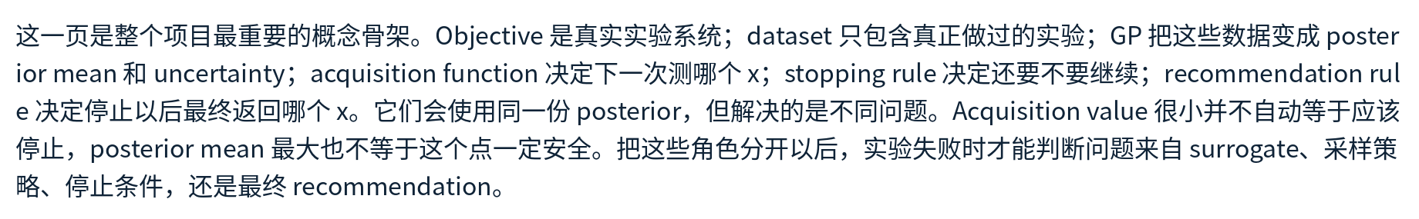
Delivery cue: pause after the main claim, point to the visual or formula, then explain why it matters for the project.

SLIDE 04

What the Gaussian process learns
English speaker script
A Gaussian process represents uncertainty over functions. Before seeing data, the mean function describes the baseline and the kernel describes which shapes are plausible. After observing data, conditioning gives a posterior distribution. At any new point, the posterior mean is the current prediction and the posterior standard deviation measures uncertainty under the fitted model. In the small example, we observe 0.8 at x equals 0.25 and 0.2 at x equals 0.75. With an RBF kernel, length scale 0.25, and small observation noise, the posterior prediction at the midpoint is about 0.533, but the standard deviation is still about 0.594. The model interpolates between the two values but admits that many curves remain possible. The qualification matters: this uncertainty is conditional on the kernel, hyperparameters, and noise model. A narrow interval means the fitted GP is confident. It does not prove that the real function lies inside that interval.
Chinese speaker script
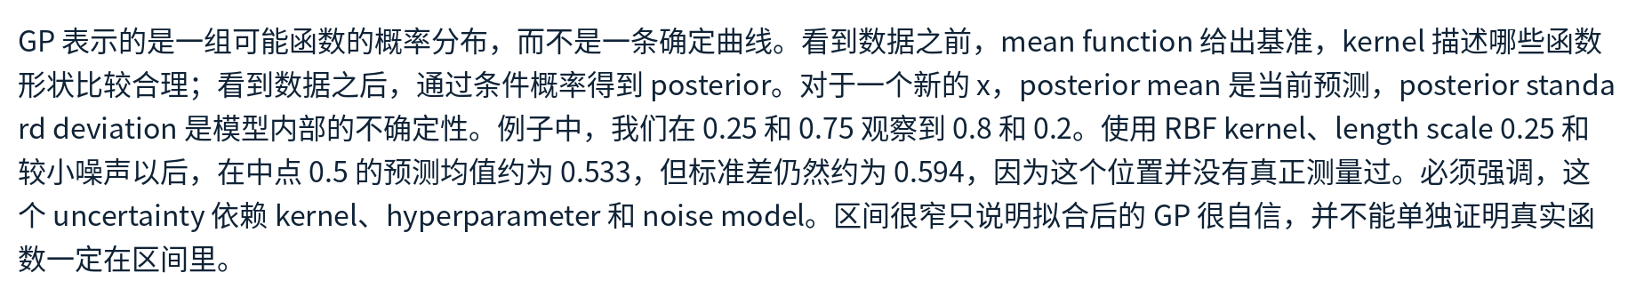
Delivery cue: pause after the main claim, point to the visual or formula, then explain why it matters for the project.

SLIDE 05

Choose next, stop, and recommend
English speaker script
The posterior becomes useful only when we turn it into decisions. An acquisition function chooses the next experiment. UCB adds the posterior mean to an uncertainty bonus. Expected improvement asks how much improvement we expect above the current incumbent. A stopping rule answers a different question: is another evaluation worth doing? A probabilistic regret rule can stop when the posterior probability that the final recommendation is within epsilon of the unknown optimum reaches at least one minus delta. Then the recommendation rule chooses the final x, for example the best observed point or the maximizer of the posterior mean. In the UCB example, candidate A has the larger predicted mean, but candidate B has enough uncertainty to obtain the larger score when kappa equals two. So B becomes the next evaluation. The stopping rule could still conclude that the possible benefit is too small relative to the cost. Sampling, stopping, and returning a result must stay separate.
Chinese speaker script
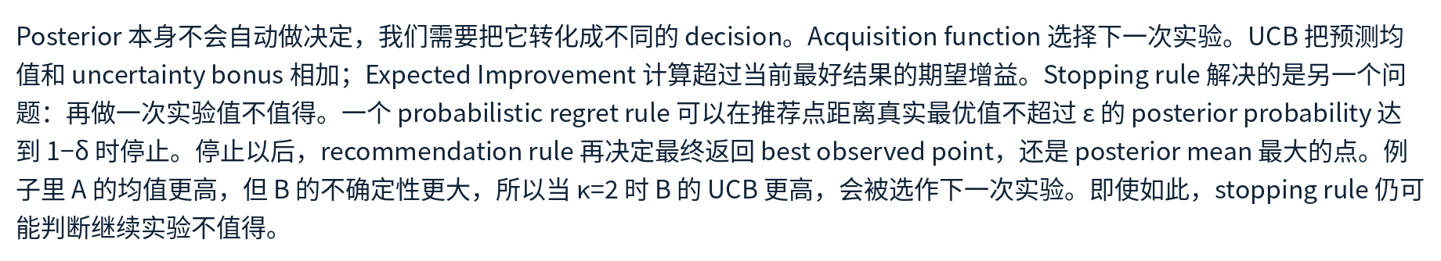
Delivery cue: pause after the main claim, point to the visual or formula, then explain why it matters for the project.

SLIDE 06

One BO iteration with simple numbers
English speaker script
Here is one complete iteration with simple numbers. We have tested three temperatures, and the best observed yield is 0.72 at 60 degrees. The fitted GP summarizes two new candidates. At 65 degrees, the predicted mean is 0.74 and the standard deviation is 0.05. At 78 degrees, the mean is only 0.66, but the standard deviation is 0.18. With UCB and kappa equal to two, the first score is 0.84 and the second is 1.02, so the algorithm evaluates 78 degrees. Suppose the real experiment returns 0.83. We add that point to the dataset, refit the GP, and recompute the posterior. The fitted length scale, output scale, and noise can also change after this observation. Finally, the stopping rule examines the updated state. If it continues, we choose another point. If it stops, the recommendation rule returns the final temperature.
Chinese speaker script
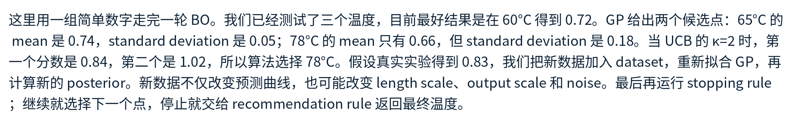
Delivery cue: pause after the main claim, point to the visual or formula, then explain why it matters for the project.

SLIDE 07

Everyday analogy: tuning an espresso recipe
English speaker script
A useful everyday analogy is tuning an espresso recipe. The input x contains controllable settings such as water temperature and grind size. The outcome y is a taste score, and the noise represents variation in the beans, brewing process, or taster. After a few cups, the GP becomes a map of recipes that may taste good and regions that remain uncertain. The acquisition function chooses the next cup. It might try a recipe with a high predicted score, or a more uncertain recipe that could reveal a better region. The stopping rule asks whether making another cup is likely to improve the final decision enough to justify the cost. The recommendation rule saves one recipe for future use. This analogy also shows why uncertainty matters. If the model assumes taste changes very smoothly but there is actually a narrow sweet spot, an overly long length scale can hide that region and make us stop too early.
Chinese speaker script
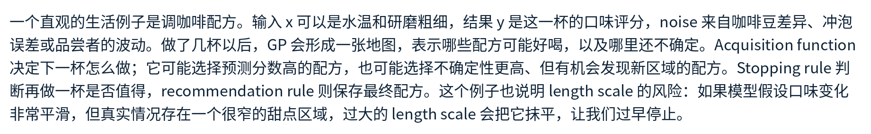
Delivery cue: pause after the main claim, point to the visual or formula, then explain why it matters for the project.

SLIDE 08

A minimal BoTorch implementation
English speaker script
This is the minimal implementation pattern in BoTorch. SingleTaskGP creates the surrogate from train X and train Y. Standardizing the outcome makes the parameter scales easier to interpret. ExactMarginalLogLikelihood defines the fitting objective, and fit gpytorch mll optimizes the model parameters. LogExpectedImprovement creates a numerically stable acquisition function. Optimize acqf then searches for the candidate that maximizes that acquisition. Multiple restarts and raw samples help because the acquisition surface can have local optima. After x next is selected, we evaluate the real objective exactly once, append the new observation, and refit. BoTorch does not decide the scientific stopping tolerance for us. Our project must implement stopping observers, define the recommendation rule, log the fitted parameters, and score the result against benchmark truth. The dense true curve can appear in plots for evaluation, but the optimizer cannot use it when selecting points.
Chinese speaker script
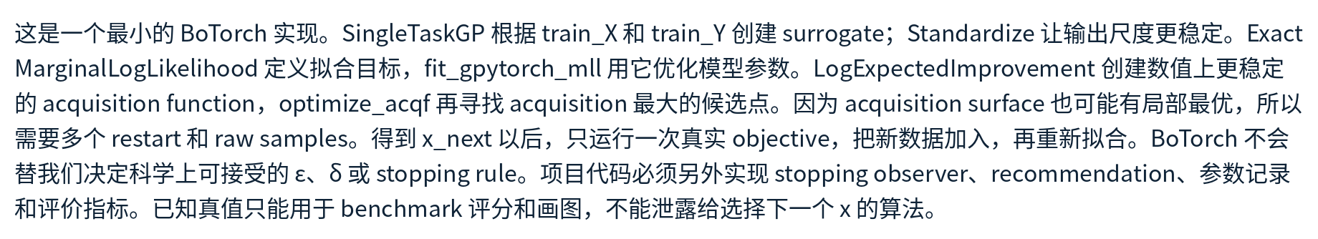
Delivery cue: pause after the main claim, point to the visual or formula, then explain why it matters for the project.

SLIDE 09

How GP hyperparameters change the decision
English speaker script
These hyperparameters change the posterior itself. In the RBF kernel, the output scale sigma f squared multiplies the covariance, while each length scale divides distance along one input dimension. A short length scale means correlation decays quickly, so observations only inform a local neighborhood. A long length scale spreads information farther and produces a smoother model. At distance 0.2, length scale 0.1 gives correlation about 0.135, while length scale 0.5 gives about 0.923. That is why an overestimated length scale can create false confidence in unsampled regions. Output scale controls expected vertical variation. Noise variance appears on the covariance diagonal and controls how strongly measurements are trusted. The mean function controls the fallback prediction far from data. ARD uses one length scale per normalized dimension. Kappa, epsilon, and delta are different: they change the decision made from the posterior, not the posterior itself. Jitter is only a numerical safeguard.
Chinese speaker script
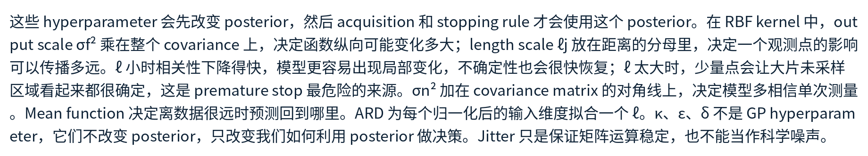
Delivery cue: pause after the main claim, point to the visual or formula, then explain why it matters for the project.

SLIDE 10

Model fitting and the next project phase
English speaker script
The GP hyperparameters are usually fitted by maximizing the log marginal likelihood. The quadratic term measures how well the covariance model explains the observed values. The log determinant supplies a complexity tradeoff, and the final term normalizes the probability density. In practice, I should normalize every input dimension, standardize the outputs, optimize positive parameters in log space, use Cholesky solves rather than a matrix inverse, and use multiple restarts or priors because small datasets can create several plausible explanations. I will refit after new observations but also record the parameter trajectory, since a sudden length scale increase may create premature confidence. The immediate project task is to build a varied suite of two-dimensional test functions. Each function needs a known optimum, a property label, a consistent domain, plots, and tests. Then I will add the acquisition strategies and stopping observers, run a small pilot, inspect calibration and false stops, and only then scale to the full experiment matrix.
Chinese speaker script
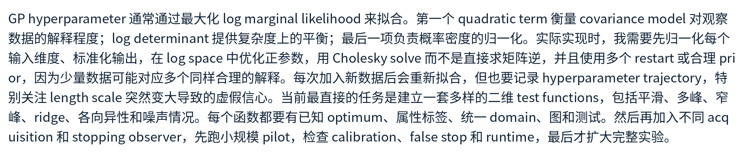
Delivery cue: pause after the main claim, point to the visual or formula, then explain why it matters for the project.

