***GOLDEN RATIO***

The project is made on Django framework along with java script, HTML, CSS, Bootstrap.

The website is not static entirely. The idea behind making it dynamic was to reduce the amount of

Html code. The data is added from backend admin panel and is reflected on the front

Backend is used so as to avoid same code in the html files

Data will automatically be parsed from the backend.

**The db.sqlite file is important as it contains the data.**

To run the project python should be installed along with pip

Commands required to run Django

Python is required to be installed

Open command prompt(cmd(windows)) or terminal(linux/unix) inside golden_ratio_project folder

run the following command

**pip install -r requirements.txt**

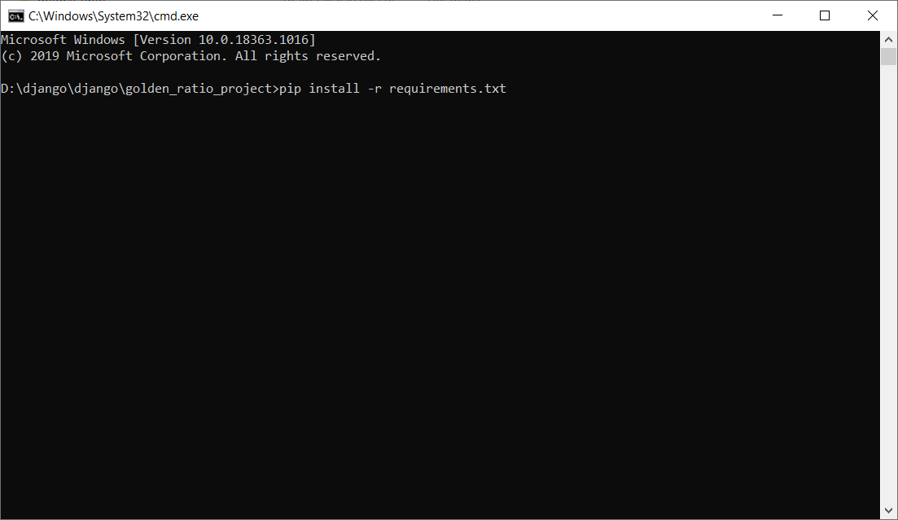

It will automatically install required libraries provided in requirements.txt

If you face any issue you can install it individually

pip install Django==3.0.5 (use pip3 install Django for linux)

pip install pillow (use pip3 install pillow for linux )

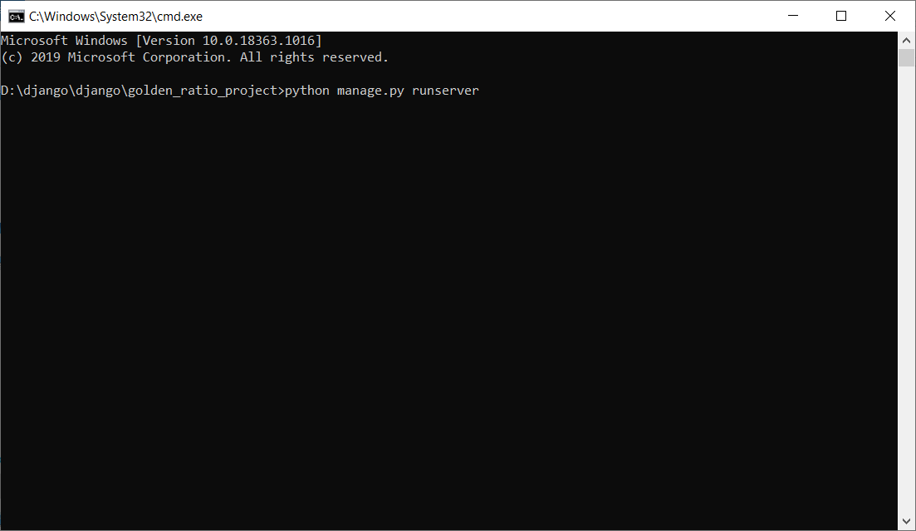

**python manage.py runserver**

the server is now up and running

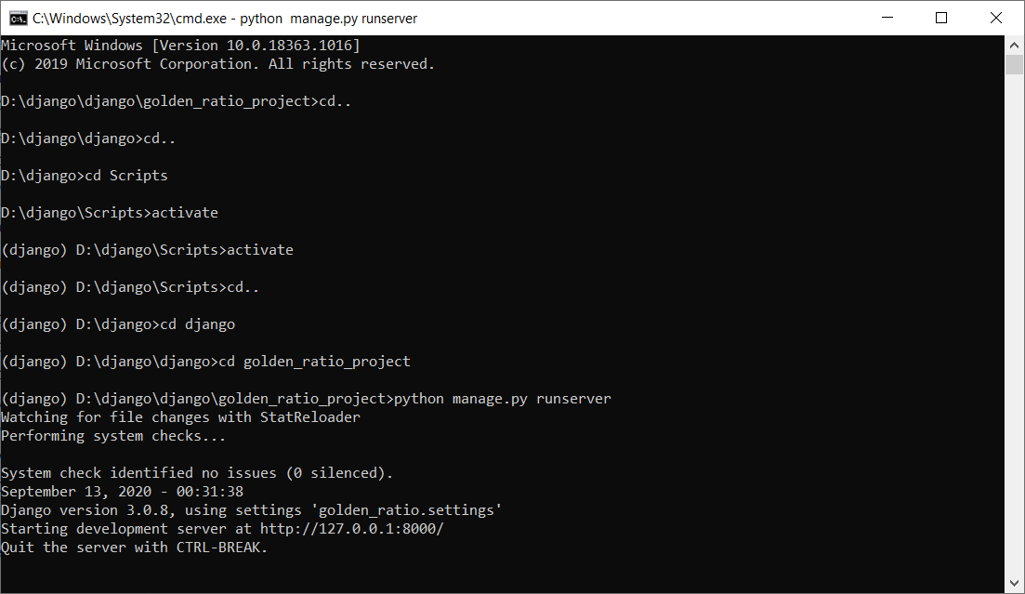

To access website, go to 127.0.0.1:8000

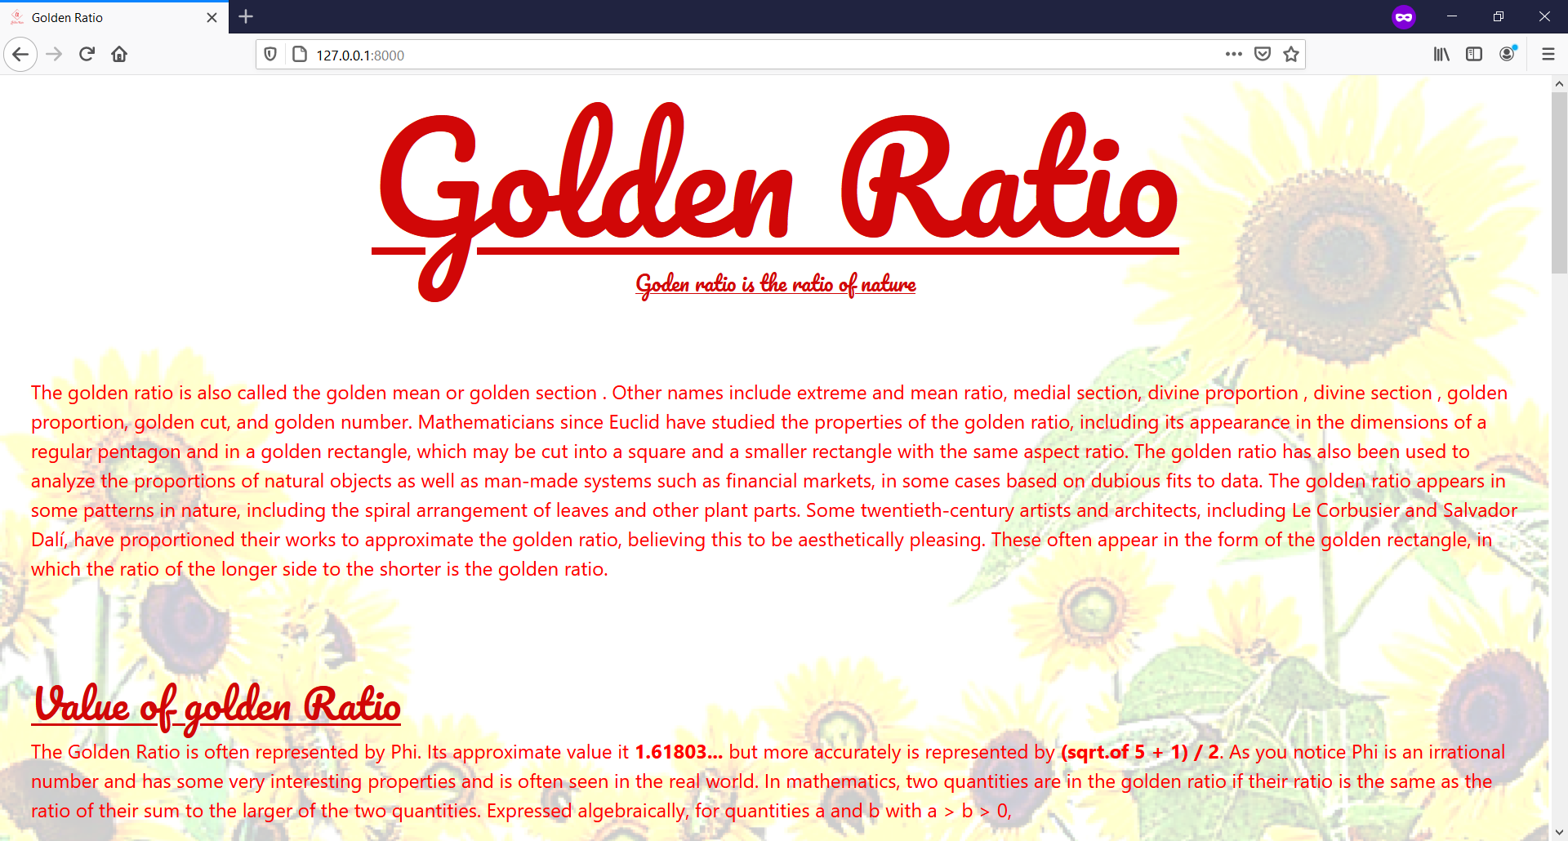

To access backend admin panel, go to 127.0.0.1:8000/admin

the credentials of admin panel are

username: admin

password: admin

