Canada SharePoint Migration
Tracking & Sync Solution Architecture
Prepared by Varun Jindal, vNext Group · September 23, 2026 · Draft for review

1. Executive summary
We will replace the Canada team's manual, multi-copy tracking with one governed SharePoint register plus Power Automate flows, while leaving Emma O'Shea's enterprise master workbook exactly as it is.
The enterprise workbook stays the read-only source of truth: Power Automate can read it but not write to it, and the design relies only on read access. On the Canada side, we build a scheduled import, a single site register with lifecycle stages, an enterprise update queue that tracks every change we send to Emma's team, and automated steward reminders. The solution needs no ServiceNow or AvePoint access.

2. Current state and pain points
Data flows one way today: the enterprise workbook (about 13,000 sites) feeds a Canada SharePoint list (about 4,020 sites) through ad hoc macros. Nothing records what we send back upstream.
Area | Today | Impact
Refresh | Trevor Cahill runs macros ad hoc, roughly weekly | No schedule, no run history, unpredictable data
Working copies | Separate Excel extracts, e.g. the Sep 4 Group & Operations extract | Manual colouring and grouping; copies drift from the master
PII holds | Separate hold workbook with lookups | Hold counts don't match the enterprise source
Updates to Emma's team | Individual emails and messages | No tracking; later refreshes can silently undo corrections
Steward follow-up | Manual chasing | Delinquent responses slow the migration
Status visibility | Held across people and inboxes | No single view of where each site stands

3. Target architecture
The enterprise workbook stays untouched; everything new sits in a Canada layer that reads from it and reports back to Emma's team in a tracked, batched way.
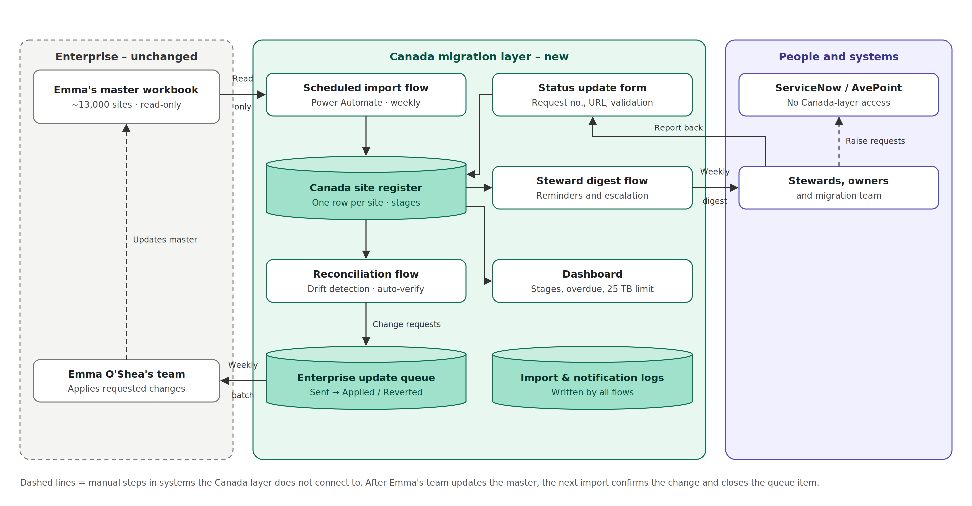

4. Components
Five components, each with a single clear owner and job.
Component | Technology | What it does | Replaces
Canada site register | SharePoint list | One record per site: mirrored source fields, Canada decisions, lifecycle stage, PII status, destination and validation | Canada list, Excel extracts, hold workbook
Scheduled import | Power Automate (Excel Online connector) | Weekly read of Emma's workbook; upserts mirrored fields only; pulls whole hierarchies containing Canada sites; logs each run | Ad hoc macros
Reconciliation and update queue | Power Automate + SharePoint list | Logs each change requested from Emma's team; sends one weekly batch; auto-verifies on next import; flags reverts | Individual emails
Steward digests and status form | Power Automate, shared inbox, list form | One weekly email per steward listing pending actions; escalates overdue items; form captures request numbers, URLs and validation | Manual chasing
Dashboard | List views, optionally Power BI | Counts by stage, overdue actions, collection size against the 25 TB read-only limit | Status in people's heads

Lifecycle stages: Triage → Ownership confirmation → Awaiting decision → Dependency clearance → On hold (PII) or Destination requested → Migrating → Customer validation → Pending legacy deletion → Closed. Deletions follow a shorter path, and any detected activity sends a site back for re-review.

4.1 ServiceNow and AvePoint: no access required
The Canada layer never connects to ServiceNow or AvePoint; the people who use them report results back into the register.
Touchpoint | How it works without access
Destination request number and URL | Steward submits in ServiceNow, then reports both through the status update form linked in their digest; URL checked against the tenant domain
Migration and customer validation | Migration team and stewards update validation status through a filtered view or the same form
Knowledge article and request links | Collected once from Joseph; stored in a configuration list the digest emails read from
AvePoint renewal reminders | Schedule confirmed once with Joseph; steward digests timed to avoid overlap
Orphaned-site ownership | Emma's workbook fields plus steward confirmations; unresolved cases go to weekly triage for the migration team to check in AvePoint

Trade-off: status depends on people updating it, and ServiceNow ticket closure is not detected automatically. Overdue reminders limit the lag; read-only reporting access can be added in a later phase if needed.

5. Weekly operating cycle
Day | Step | Automated or manual
Monday | Import runs; reconciliation flags drift and closes verified updates | Automated
Tuesday | Steward digest emails and escalations sent | Automated
Thursday | Team triage of flagged, blocked and overdue sites | Manual (30-min meeting)
Friday | Batched update list sent to Emma's team | Automated, reviewed by Canada team

6. Design principles and guardrails
- Enterprise source untouched. Power Automate reads Emma's workbook but has no write access; all corrections go to her team as tracked requests.
- Field-level ownership. Source-mirrored columns are written only by the import; Canada decision columns are never overwritten by it.
- One record per site. Views replace Excel copies; PII hold is a field on the record, not a separate workbook.
- Stable key. Enterprise Site ID if available, otherwise a normalized site URL, enforced as unique.
- Hard stops on risky steps. List validation blocks legacy deletion before customer validation passes, and blocks destination requests for PII sites.
- Hierarchy rule. A top-level site cannot move to destination request while any sub-site is undecided or has mixed ownership.
- Scale-ready. Key columns indexed from day one to stay within the 5,000-item list view threshold; the import uses pagination or an OData filter to read the full workbook.

7. Technology and prerequisites
The design runs on standard Microsoft 365 tools; no new platform or premium licensing is assumed.
Item | Detail | Needed from
SharePoint Online | Register, update queue, configuration and log lists on the SharePoint Data Migration Canada site | Site owner access
Power Automate | Standard connectors: SharePoint, Excel Online, Outlook; workbook must be formatted as an Excel table | Flow ownership / service account
Shared migration inbox | Send As or Send on Behalf for flows | Exchange admin
Power BI (optional) | Dashboard beyond list views | Pro licence, if chosen
Access for Varun | Project workbook, landing page, group inbox (no ServiceNow or AvePoint access needed) | Joseph, Chirag

8. Risks, assumptions and open questions
Risk or assumption | Mitigation
Confirmed: flows can read Emma's workbook but cannot write back | Read-only by design; the update queue is the only path back to the master
No stable Site ID in the source; URLs change on rename | Normalize URLs; confirm with Emma's team whether an ID exists
Emma's team may not accept a batched list | Keep the batch as a readable email; fall back to per-item emails
Including whole hierarchies may push the list past 5,000 items | Indexed columns and filtered views from the start
Mailbox permissions may take time; status entered by people may lag | Request permissions early and send from a named account meanwhile; overdue reminders chase missing updates

Open questions
- Does "KEEP" in the working extract mean migrate, or retain in place?
- Does Emma's workbook carry a stable Site ID?
- How exactly does Trevor's refresh work today, and can we retire it?
- Which renewal and escalation emails does AvePoint already send, and how often?

9. Phased delivery and decisions needed
Delivery is sequenced so the data is trustworthy before any automated emails go out.
Phase | Scope | Outcome
1. Discovery | Document Trevor's refresh; confirm key, columns, KEEP meaning | Agreed data model
2. Register | Build the register; migrate current Canada list and Group & Operations extract; fold in PII holds | One working record per site
3. Import and reconciliation | Scheduled import, run log, update queue, weekly batch to Emma's team | Tracked, self-verifying sync
4. Notifications | Steward digests, escalation and the status update form | Automated follow-up
5. Dashboard | Stage, overdue and capacity views | Status visible to leadership

Decisions needed from the manager
- Approve keeping Emma's workbook unchanged and building the Canada layer
- Agree to propose the weekly batched update format to Emma's team
- Support access and mailbox permission requests
- Confirm whether Power BI is in scope or list views are enough

